# **Connected Fitness: Overview**



Most new entrants into the connected fitness space have AI and machine learning capabilities that simulate working with a human personal trainer, enabling the device to give personalized instructions. Broadband technology advancements have led to improvements in internet speeds and bandwidth, making new developments possible in content and live streaming. Online communities have become a key attribute of connected fitness products, as features like leaderboards and chat/feedback features create an atmosphere of competitiveness and community designed to feel similar to working out at a gym. Popular fitness accessories, such as Apple Watch, Fitbit, and other Bluetooth wearables also support the new product experiences entering the market.

## **Evolving business models making connected fitness more accessible**

Connected fitness platforms are evolving their pricing models to become more accessible and affordable, with a wide range of pricing options across different product offerings. Subscription-based models and pay-per-class options provide flexibility and affordability for users of all budgets. For example, Peloton has tweaked its business model with a shift toward its [fitness-as-service (FaaS) strategy](https://investor.onepeloton.com/static-files/6fc0b035-ea15-4617-9558-8ebd348c1169#page=2) that combines the cost of connected fitness equipment and its subscription service into a single monthly fee.

Very few disruptors have also started offering alternative pricing options to target fitness enthusiasts who want to try the entire connected fitness workout experience at home without making significant financial commitments to purchasing fitness equipment right away. For instance, Peloton has targeted such a niche through a differentiated pricing strategy with fee-based pricing for its connected fitness offerings in Canada. Peloton launched ‘[Peloton Rental](https://www.onepeloton.com/press/articles/peloton-rental-canada),’ its connected bike rental program, across Canada in [April 2023](https://sp-edge.com/updates/18124) after a successful US launch, allowing users to rent monthly. The monthly rental fees include the subscription fee of Peloton membership, which provides access to Peloton’s entire library of live and on-demand classes, and all rental users are eligible for free returns at any time.

Brands, such as [Lululemon](https://sp-edge.com/companies/98046) (smart mirror) and [Peloton,](https://sp-edge.com/companies/88276) often collaborate with renowned trainers with dedicated followings to create training videos that they offer users to grow the client base. The subscription model makes accessing fitness training and trainer advice far more affordable than paying for in-person classes or sessions. Most of these at-home exercise devices give users access to multiple disciplines, such as cardio, boxing, strength training, yoga, barre, Pilates, and high-intensity interval training (HIIT)—all features that traditionally cost extra with standard gym memberships.

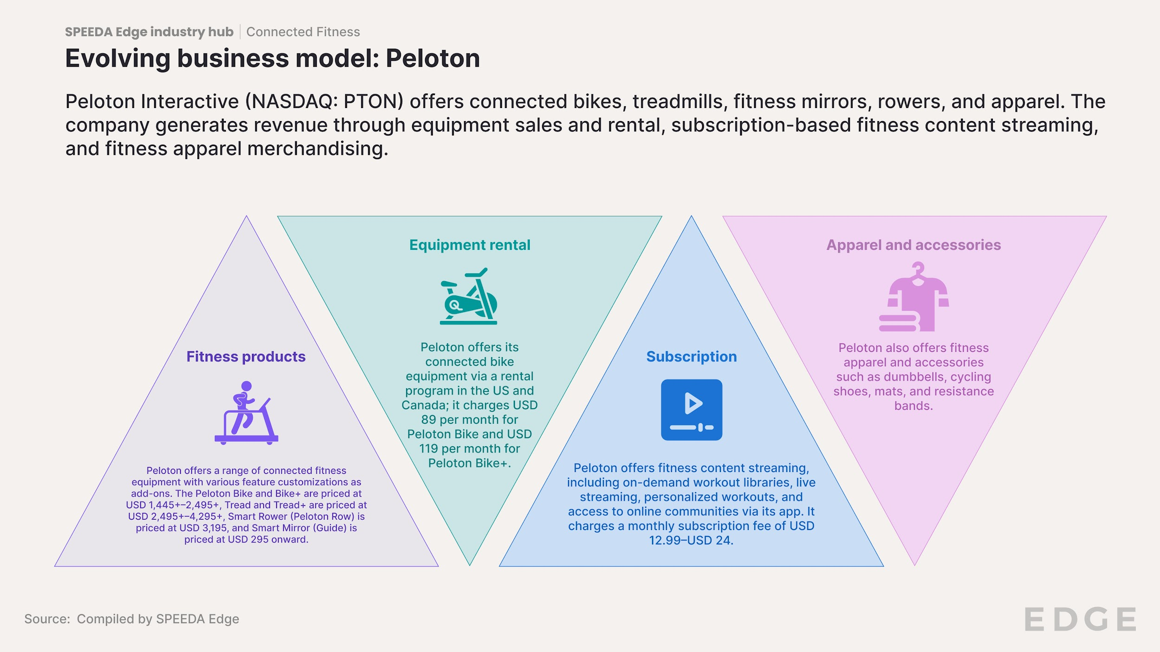

# 

# **Driving factors**

## **1. Growing preference for convenience, personalization, and social connectivity**

The Covid-19 pandemic accelerated the adoption of connected fitness products as people sought alternative ways to stay active and maintain their fitness routines while adhering to social distancing guidelines. The shift toward remote work and home-based activities has fueled the demand for at-home fitness options. Connected fitness allows users to exercise from the comfort of their homes, eliminating the need to travel to gyms or fitness centers. This convenience especially appeals to busy individuals or those with limited access to gym facilities.

Peloton in [collaboration](https://sp-edge.com/updates/23238) with the National Basketball Association (NBA) and Women's National Basketball Association (WNBA), leveraged NBA and WNBA expertise on fitness, lifestyle, and sports to create special access, offers, and experiences for Peloton members and fans, including streaming of live matches through NBA League Pass across compatible Peloton devices, allowing users to watch the 2023–20224 NBA season under the platform’s entertainment hub.

Many connected fitness platforms feature social elements such as virtual classes, leaderboards, and online communities, where users can connect, compete, and interact with others. Some notable players such as Peloton have taken a step further with fitness content personalization by partnering with [TikTok](https://sp-edge.com/companies/84212) in January 2024 to launch a new fitness hub on TikTok, [#TikTokFitness](https://sp-edge.com/updates/26254), which will feature Peloton’s live classes, fitness workouts, and social content. [Peloton](https://sp-edge.com/companies/88276) has an ongoing [five-year partnership](https://sp-edge.com/updates/22277) with [Lululemon](https://sp-edge.com/companies/98046) since announced in [September 2023](https://sp-edge.com/updates/22277) to leverage Lululemon’s athletic apparel and place a select number of Peloton’s instructors as ambassadors for its merchandise. Conversely, Peloton will develop and share fitness content with Lululemon to be featured on the latter’s connected smart mirror.

## **2. Rising corporate wellness programs embedded with connected fitness offerings**

Companies are increasingly investing in connected fitness products and services as part of corporate wellness programs to promote employee health and productivity. These embedded wellness offerings include hosting group workouts, finding colleagues as workout partners, access to custom-made features to boost engagement, and measuring the impact. It also allows organizations to offer their employees discounts on connected fitness products and subsidized subscriptions.

Notable players such as [Peloton](https://sp-edge.com/companies/88276) have recently rebranded their [corporate wellness offering](https://sp-edge.com/updates/242) following its debut in 2021. Peloton announced its rebranded B2B offering in August 2023, [Peloton for Business](https://investor.onepeloton.com/news-releases/news-release-details/peloton-announces-peloton-business-offering-full-service-well), targeting seven business verticals: 1) hospitality, 2) corporate wellness, 3) multi-family residential, 4) education, 5) healthcare, 6) gyms, and 7) community wellness. Sequoia, Hilton, YMCA, Volvo, and DropBox were among the few notable corporate clients of Peloton for Business.

# **Risks to Growth**

## **1. Premium pricing curtails demand**

Most connected fitness equipment is priced at a substantial premium compared to traditional at-home equipment. For example, the “Peloton Bike+” and “Peloton Tread+” are priced significantly higher than their traditional counterparts. The company has, however, introduced lower-priced, compact versions of its bike and treadmill, reflecting Peloton's intention to broaden its target users. In addition to [Peloton,](https://sp-edge.com/companies/88276) several other connected fitness product manufacturers including [Echelon,](https://sp-edge.com/companies/1143566) [Nautilus](https://sp-edge.com/companies/125462), [Tempo,](https://sp-edge.com/companies/276242) [CityRow,](https://sp-edge.com/companies/676959) and [MYX Fitness](https://sp-edge.com/companies/784513) have also introduced cheaper versions of equipment for the price-conscious consumer. As such, given the high overheads of R&D and marketing costs, connected fitness startups must achieve greater scale to benefit from the subscription model.

## **2. Technological limitations and regulatory challenges**

Dependence on internet connectivity and compatibility with various devices can pose challenges for users in areas with poor internet service or for those using older technology. As of May 2023, about 42 million Americans, particularly in rural and low-income areas, lacked access to high-speed broadband internet. Without a stable internet connection, many features of connected fitness products, such as live streaming workouts, real-time feedback, and progress tracking may be unavailable or function poorly. Fluctuations in internet speed can lead to buffering, lagging, or interruptions during workouts, which can be frustrating and disrupt the flow of exercise. Older devices may not support the latest versions of apps or software required to use connected fitness products, leading to incompatibility or suboptimal performance.

Compliance with health and safety regulations, data privacy laws, and intellectual property rights can be complex and costly. For example, [Peloton](https://sp-edge.com/updates/228) has recalled its product offerings multiple times over the past, due to system malfunctions and other failures that resulted in injuries—which led to product-recall related costs of USD 100.0 million (FY2021), USD 62.3 million (FY2022,) and USD 80.9 million (FY2023) over the recent years.

The increasing integration of technology in fitness equipment raises concerns about data breaches and the security of personal information. For example, in July 2023, cybersecurity firm [Check Point](https://sp-edge.com/companies/5692) reported multiple security issues in Peloton's internet-connected treadmills, and, in [May 2021,](https://sp-edge.com/updates/231) both [Echelon](https://sp-edge.com/companies/1143566) and Peloton were faced with leaky API issues—which they rectified soon after identification.

## **3. Urban clients present new challenges for product designers**

Limited space factors strongly in purchase decisions for at-home fitness equipment and should be a key consideration in design. In urban living arrangements, it might not be practical—or possible—to have a separate space for a home gym. However, several startups including [Peloton,](https://sp-edge.com/companies/88276) [Interactive Fitness,](https://sp-edge.com/companies/13848) [Fittar,](https://sp-edge.com/companies/1276626) and [Fiture](https://sp-edge.com/companies/782223) have added compact versions of their products to the portfolio, while some, such as [Treadly](https://sp-edge.com/companies/1258901) and [Frame Fitness,](https://sp-edge.com/companies/1611102) develop their flagship product in a compact or foldable manner, mainly targeting such home users. Similarly, [Nautilus](https://sp-edge.com/companies/125462) launched [Schwinn 490 Elliptical](https://sp-edge.com/updates/22277), featuring a space-saving footprint, ergonomic updates for comfort, fingertip control of workouts, and compatibility with the JRNY adaptive fitness app.

The noise created by equipment is also a concern for many users, according to reviews. With homes located in close quarters in most metropolitan cities, people have been wary of noise and/or noise complaints from neighbors. This makes some disciplines, such as boxing, cardio, and HIIT, impractical for apartments, suggesting that urban residents may hesitate to use connected fitness equipment. To address this issue, [Hydrow](https://sp-edge.com/companies/667823) developed its connected rowing machines to cater to urban living—its strokes are smooth and silent compared to the conventional indoor rowers.

*Last updated: March 2024*

©2024 Uzabase, Inc. All Rights Reserved. The information contained herein: (1) is proprietary to Uzabase Inc. and/or its content providers; (2) may not be copied or distributed; and (3) is not warranted to be accurate, complete or timely. Neither Uzabase Inc. nor its content providers are responsible for any damages or losses arising from any use of this information.