# **Smart Packaging Tech: Overview**



## **Packaging the Future: Unboxing Smart Packaging Technologies**

Traditionally, when we think of “packaging,” our mind immediately goes to blank cardboard boxes that merely protect products; however, today, packaging has taken on an entirely new meaning. Incorporating various technologies like Internet of Things (IoT), bioplastics, and computer vision has revolutionized the traditional packaging landscape, making it a key element in branding and customer experience. The Smart Packaging Tech industry now offers services that encompass product tracking to improve security and prevent loss, promote sustainable practices with reusable materials, monitor freshness, and extend shelf life.

Surveys done on consumers in the UK show that nearly two-thirds of respondents are looking for new technologies in packaging, while nearly all Gen-Zers prioritize “sustainability” factors when shopping online. This shift toward minimalism and efficiency in packaging design reflects changing consumer preferences and the drive for cost-effectiveness and environmental responsibility. As a result, new technologies have developed across the packaging supply chain, and large players such as TriVision, Avery Dennison, and Identiv are providing indicators, sensors, and other monitoring devices to support smart packaging. Notably, startups like Boox and Packoorang are also focusing on recyclability, reducing environmental impact with biodegradable or recyclable options.

## 

## 

## **What is Smart Packaging Tech?**

Smart Packaging Tech includes using technologies such as AI/ML, IoT, computer vision, and advanced design technologies to design, fabricate, manufacture, and deliver smart packaging solutions. These solutions also include advanced digital printing, phase change materials (PCMs), and solid-state thermal processes to feature smart labeling, self-chilling, self-heating, and other custom packaging choices.

### Traditional packaging vs. smart packaging

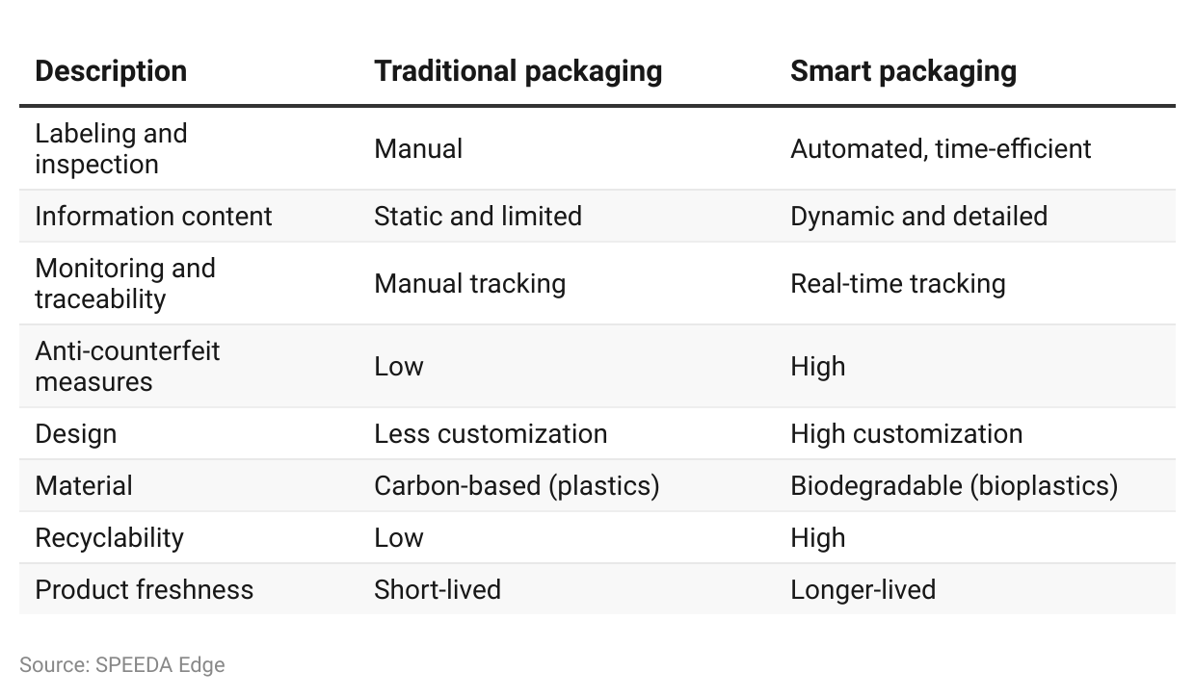

Smart Packaging Tech covers hardware solutions such as cameras equipped with computer vision systems, labels with QR codes, and near-field communication (NFC) and radio-frequency identification (RFID) tags to inspect and trace packages and ensure product safety and quality. It also includes software-based solutions, such as package customization, innovative designs, and online marketplaces, where customers can quickly connect with many package solution providers offering various packaging solutions.

## 

## Categorization of Packaging Tech companies

## 

| **Segment** | **Description** | **Key startups** | **Key incumbent products** |
| --- | --- | --- | --- |
| Packaging design and inspection | Companies that offer computer vision systems to identify packaging errors and damages during production. Also includes companies that provide 3D-printing solutions and AI-powered package design software to create packaging in all shapes and sizes | Elementary Robotics, Velox, Unetiq | VisioPointer by Trivision |
| Reusable packaging | Companies that sell or provide reusable packages on an as-a-service basis, which can be used multiple times before recycling | Boox, BIBAK, Pyxo | - |
| Package traceability and analytics | Companies that provide solutions to improve package traceability, anti-counterfeit, and analytics solutions. Covers companies that use technologies like QR codes and RFID and NFC tags | ScanTrust  Ennoventure,  ImpacX | Intelligent Labels by Avery Dennison |
| Online packaging marketplaces | Platforms that connect providers of packaging solutions and customers online | Impacked, Open Packaging Network, Circulate | Post-purchase order tracking by Narvar |
| Self-chilling and self-heating packages | Packaging that can heat or chill contents when a user requires it, without external heat sources or power—typically using a chemical reaction | HeatGen, Tempra Technology | - |

Source: SPEEDA Edge

Smart packaging solutions also complement innovations around the supply chain, such as the use of advanced hardware to improve packaging. Additionally, packaging technologies lend support to the cold chain industry for temperature-sensitive product packaging and storage *(for more information on this, please refer to the* [*Supply Chain Tech*](https://sp-edge.com/industry/157) *and* [*Cold Chain Innovation*](https://sp-edge.com/industry/184) *industry hubs)*.

Smart Packaging Tech companies provide solutions at various stages across the supply chain; certain companies cover the entire supply chain, from manufacturing to delivering the products to end consumers. [LivingPackets](https://sp-edge.com/companies/790442) is a good example of a startup that provides reusable secure parcels with tracking capabilities using real-time geolocation and locking systems. Meanwhile, others, such as [Unetiq](https://sp-edge.com/companies/766191) (which provides services at the manufacturing and distribution stage using its computer-vision-based package inspection solutions), only cover a specific area in their offerings.

## Prominence of packaging technology over the supply chain cycle

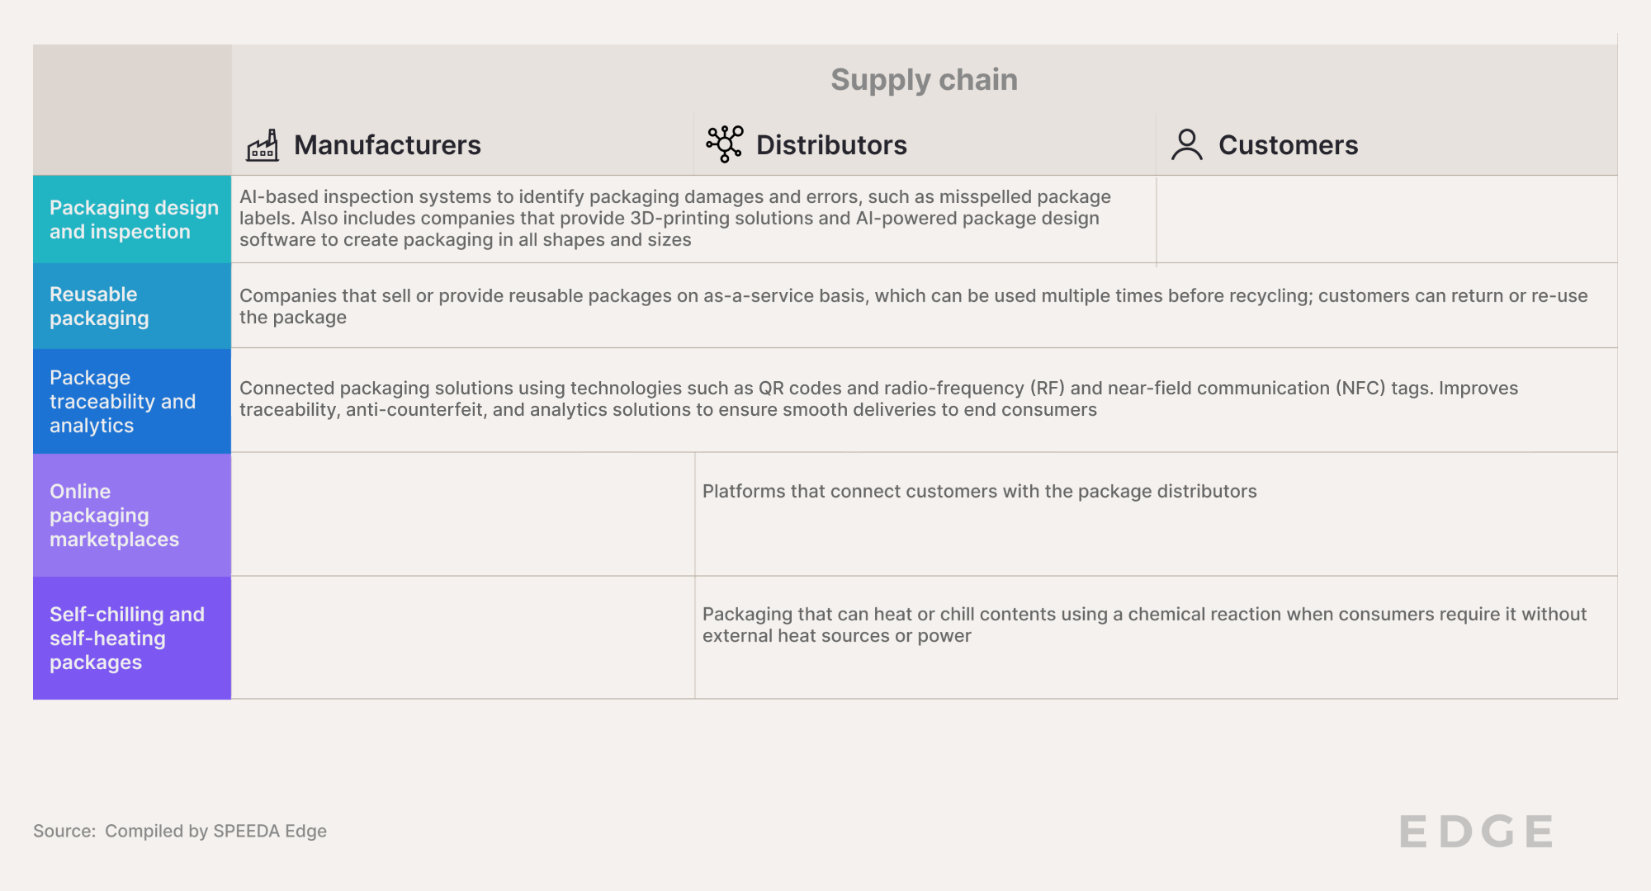

## **What technologies are shaping the Smart Packaging Tech industry?**

Developments in IoT, 3D printing, and advanced materials have led to significant technological advancements in packaging.

IoT technologies that cover a range of applications, including QR codes and NFC and RFID tags on packages, assist in traceability and provide valuable information to consumers. Companies such as [TapWow](https://sp-edge.com/companies/1058535) use barcodes, QR codes, or NFC tags to create a unique digital ID for customers to monitor and track products. Another breakthrough in the packaging space is the use of computer vision inspection systems with advanced imaging technology, machine-learning algorithms, and AI to detect and verify defects in packaging. For instance, [Intravis](https://sp-edge.com/companies/1260129) provides vision inspection systems for various plastic packaging, such as bottles, containers, and decorated products.

Advanced manufacturing technologies, such as additive manufacturing (also known as 3D-printing technologies), allow designers to create custom packages of any size to market products. Companies such as [Studio Blackthorns](https://blackthornsdesign.com/en/) offer flexible film packaging designs for crisp bags, sweet packets, fresh food, etc.

Growing consumer awareness of the environmental cost of packaging has led to the growing popularity of recyclable packaging. This has been aided by advances in bioplastic technology, which provides durable packaging while maintaining recyclability with its use of environmentally friendly plastic. [Packeroong](https://sp-edge.com/companies/2294815) claims that its recyclable packaging is made from 100% recycled clothing and avoids the use of CO2-heavy plastic *(for more information on these recyclable materials, please refer to the* [*Bio-based Materials*](https://sp-edge.com/industry/45) *hub)*.

Although digital printing has been used on packaging materials for quite some time, recent advances in printing technologies, such as inkjet printing, have assisted companies in printing on multiple surfaces, such as stainless steel, metals, glass, and plastic. Companies like [Fujifilm](https://sp-edge.com/companies/56340) have developed their own [imprinting solutions](https://fujifilmprint.eu/wp-content/uploads/2023/07/Label-Packaging-Range-Brochure-EN.pdf) that allow digital printing to be integrated into existing production lines of labeling and packaging.

Moreover, packaging now includes self-heating technologies like heat cans and temperature-controlled food boxes. These innovations utilize solid-state thermal and chemical reactions to improve functionality. Startups such as [HeatGen](https://sp-edge.com/companies/39903) turn ordinary packaging into a self-heating package using a flameless thermal reaction.

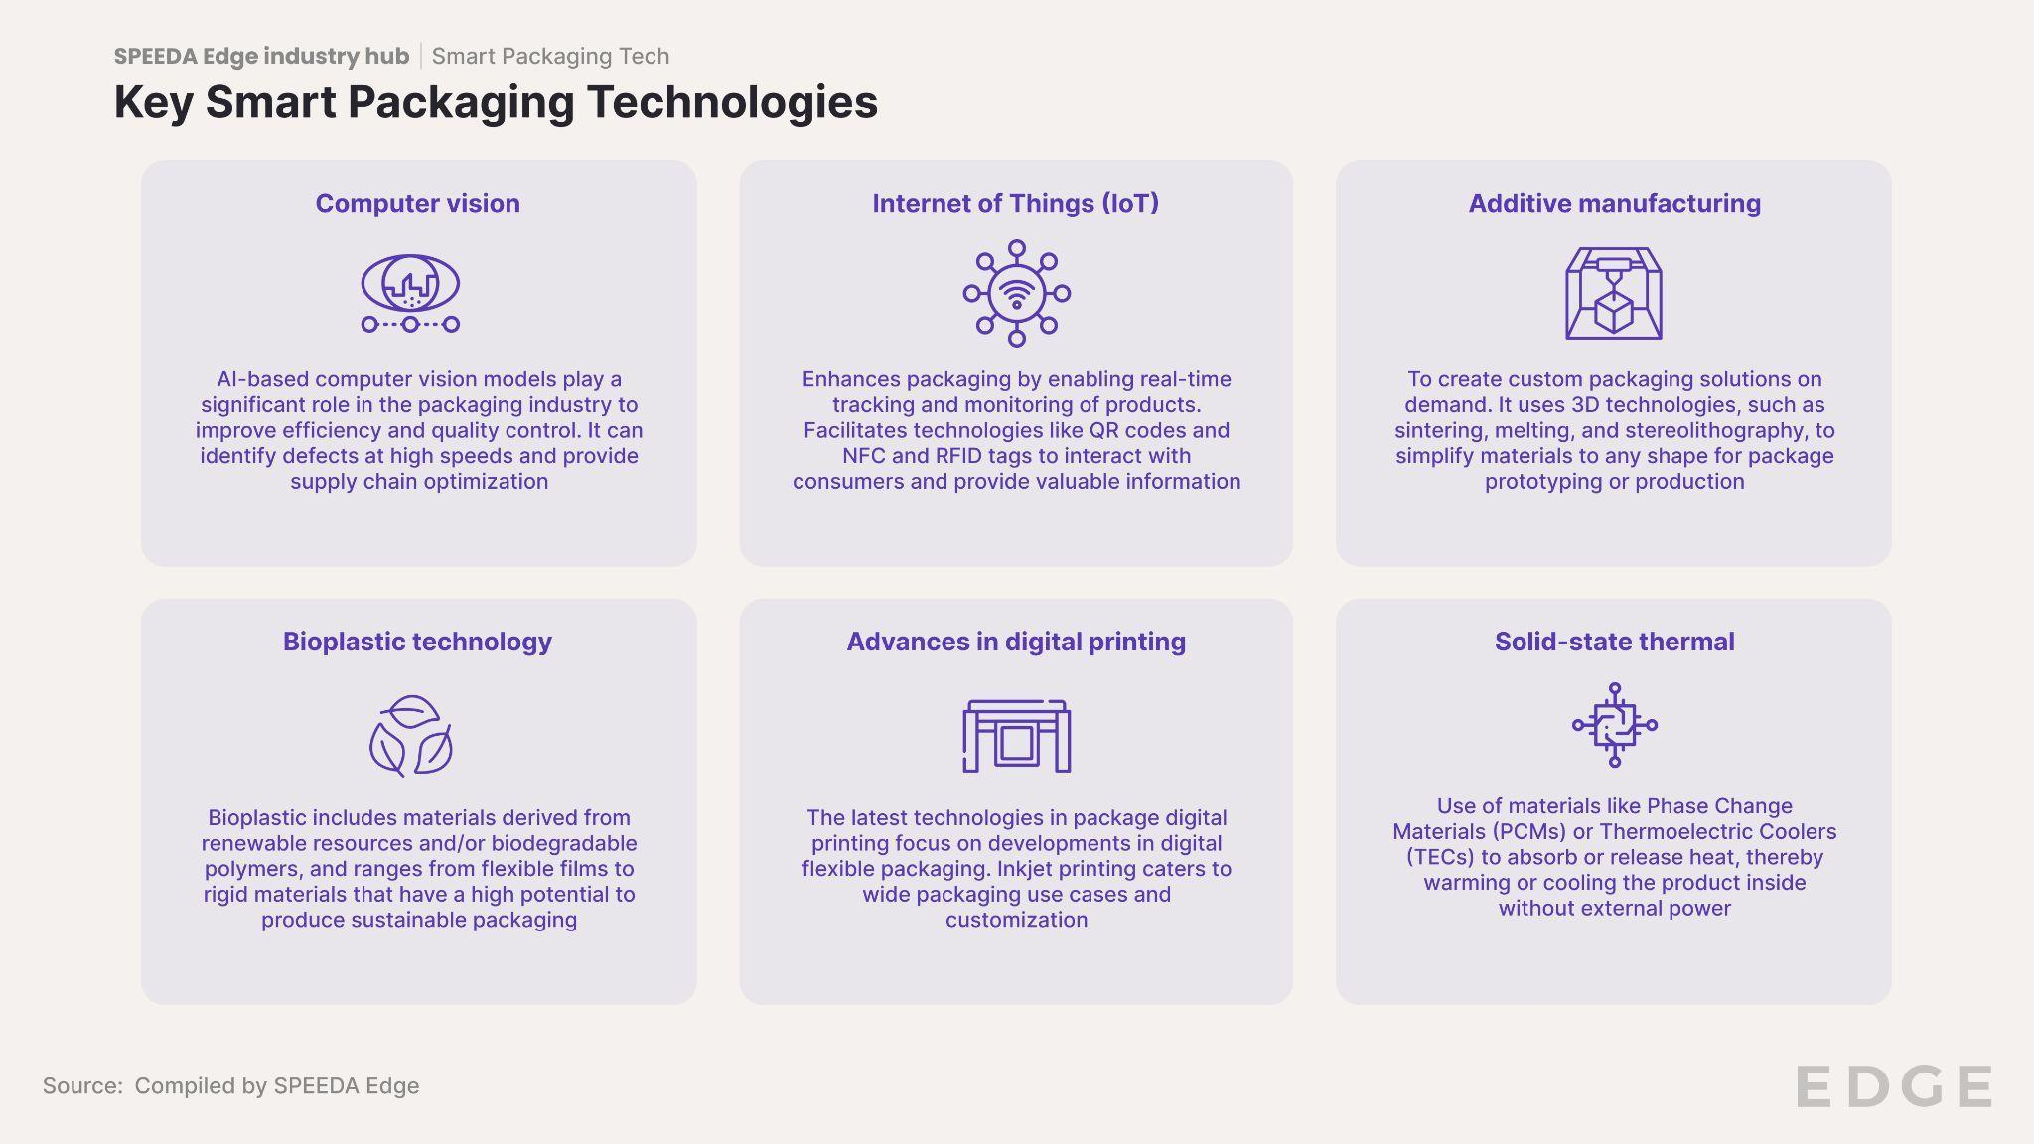

Source: Compiled by SPEEDA Edge based on company case studies

## 

# 

# **What are the use cases of Smart Packaging Tech?**

We have listed a few instances where packaging technology is used.

* **Package inspection:** Packaging defects can be identified using technologies such as computer vision and image recognition software, improving the speed and efficiency of defect detection. Incumbents such as [TriVision](https://sp-edge.com/companies/427347) automated their clients’ packaging inspection process and provided more accurate labeling.
* **Traceability**: IoT advancements through RFID sensors, NFC, and Bluetooth have streamlined the process of monitoring product packages during transport. The installation of automated systems to monitor packaging has gained popularity due to its ability to validate product authenticity. [Avery Dennison](https://sp-edge.com/companies/76708) incorporated RFID technology to monitor prescription drugs in the pharmaceutical industry and thereby avoid fake medicine distribution.
* **Reusable packaging:** Packaging technologies assist in reusable packaging using less plastic and lighter packaging materials. Further, real-time geolocation and locking systems make it easier to track reusable packages. Using reusable cups and boxes has led to a significant reduction in carbon footprint. Startups such as [LivingPackets](https://sp-edge.com/companies/790442) provide recyclable parcels that can be used over 100 times to replace cardboard boxes.
* **Customer-supplier matching:** B2B platforms that leverage data analytics streamline the process by guiding customers to select packaging vendors that suit their specifications. Companies like [Open Packaging Network](https://sp-edge.com/companies/664948) have facilitated links between pharmaceutical companies and recyclable packaging suppliers, aiming to diminish environmental impact by lowering carbon emissions.

# **What is driving demand?**

**1. Growth in ecommerce drives the need for high-quality packaging solutions**

Ecommerce has seen enormous growth since the Covid-19 pandemic, where, according to [Forbes Advisor](https://www.forbes.com/advisor/business/ecommerce-statistics/#general_e_commerce_statistics_section), global ecommerce sales stood at USD 6.3 trillion in 2023 and are expected to reach USD 8.1 trillion by 2026. Retail ecommerce sales are also expected to follow an upward trend, with a forecasted increase to USD 7.5 trillion in 2026. This is mirrored in the performance of ecommerce giants such as Amazon, which achieved sales of [USD 4.2 trillion in 2020](https://tblocks.com/articles/how-e-commerce-has-changed-over-the-last-10-years/) compared with USD 572 billion in 2010.

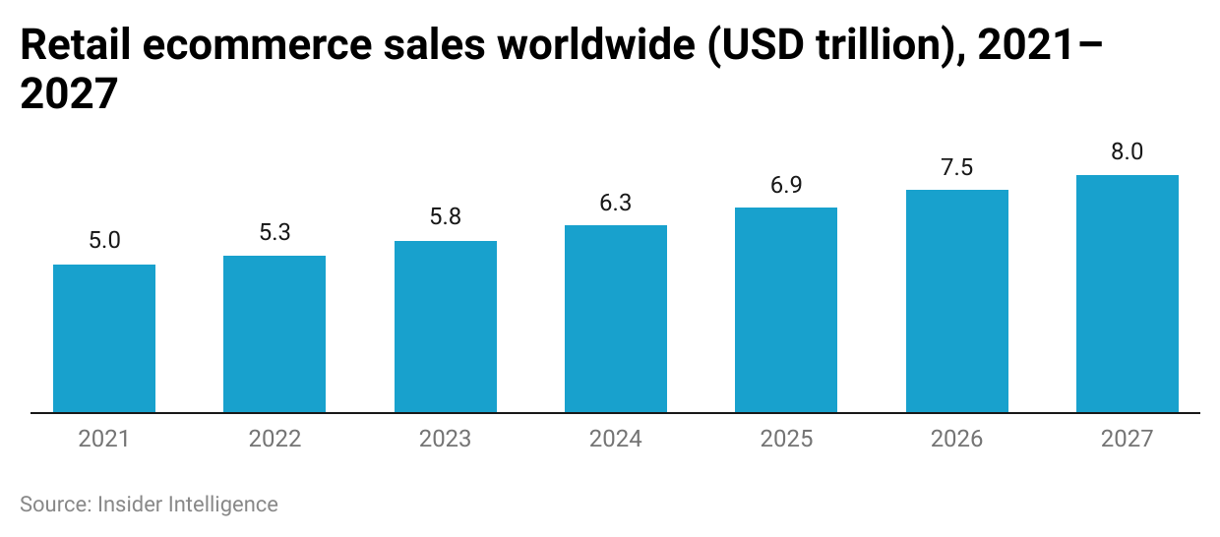

Alongside the growing volume, an increasing variety of goods are shipped globally. It is expected that in 2027, the [majority of e commerce sales in the US](https://www.insiderintelligence.com/content/us-ecommerce-by-category-forecast-2023) will be generated from apparel and accessories, furniture and home furnishings, and computer and consumer electronics.

Simultaneously, customers are becoming less patient and expect their packages on their doorstep faster than ever before. The popularity of Amazon’s “One-day Delivery” service for its Prime customers reflects this trend. According to [CNBC](https://www.cnbc.com/2023/07/31/amazon-says-its-delivering-more-products-than-ever-in-one-day-or-less.html), Amazon had delivered [1.8 billion units](https://www.cnbc.com/2023/07/31/amazon-says-its-delivering-more-products-than-ever-in-one-day-or-less.html) to US Prime members by mid-2023, 4x more than the same period in 2019. This increased speed of delivery has also led to the growth in demand for online grocery shopping mirrored in the increase in sales for [Amazon Fresh](https://signalytics.ai/amazon-fresh-and-pantry/). Beauty and personal care products, along with online food delivery services, have emerged as the [fastest-growing categories in the ecommerce space](https://vahitha.medium.com/top-10-fastest-growing-e-commerce-categories-in-2023-2a5a88071e8a).

These trends in ecommerce growth will require innovative packaging that allows the faster inspection of products, ensures product safety and security, withstands varying climate conditions, and maintains product freshness. Meanwhile, recyclable packages and automated inspection systems can be leveraged for groceries and food and beverages to ensure products are delivered within hours.

**2. Change in consumer preferences and growth in recyclable packaging solutions**

According to a product packaging survey conducted by [McKinsey](https://www.mckinsey.com/industries/packaging-and-paper/our-insights/sustainability-in-packaging-inside-the-minds-of-us-consumers) across 10 countries in 2020, respondents cited hygiene, food safety, and shelf life as their top concerns. Shelf life can be improved with packaging technologies such as modified atmosphere packaging and oxygen scavengers to avoid oxidation and the growth of harmful microorganisms. Incumbents like [Amcor](https://sp-edge.com/companies/389292) offer “[Clear-Tite Shrink Bags](https://www.amcor.com/product-listing/clear-tite-shrink-bag),” which provide benefits such as a high-oxygen barrier to maximize shelf life.

It was estimated that [~1 million tonnes of plastic](https://sdg.iisd.org/commentary/guest-articles/addressing-plastic-packaging-waste-in-e-commerce-retail/#:~:text=In%202019%2C%20the%20e%2Dcommerce,to%20have%20turned%20into%20waste) were used in packaging in 2019 and almost all of it was assumed to have turned into waste. This type of data makes consumers even more conscious of their carbon footprint. Recyclable packaging has gained popularity in recent years, evident through the [Buying Green 2023](https://www.triviumpackaging.com/media/pe5hfxsp/2023buyinggreenreport.pdf) survey by Euromonitor, where 79% of consumers are looking for products in recyclable packaging. The survey also highlighted that 71% of consumers engage in activities such as buying local and re-filling bottles and containers, while 58% participate in reducing food packaging waste.

This poses significant growth opportunities for disruptors such as [Bibak](https://sp-edge.com/companies/1871321) and [Cuploop, which](https://sp-edge.com/companies/1321248) specialize in the food services and consumer discretionary industries. They aim to make reusable services easier by offering reusable cups and boxes and technologies, such as QR codes and RFID tags. Companies such as [Algramo](https://sp-edge.com/companies/150717) let consumers order products, such as detergents, rice, or pet food, and get them delivered directly to their smart reusable packaging at home, encouraging consumers to use refillable packages and mitigate plastic wastage.

Leading players such as Amazon have also caught on to this trend, shifting to [recyclable paper-padded mailers](https://consumergoods.com/behind-amazons-packaging-strategy-machine-learning-powered-optimization) from plastic-based packaging where machine-learning technologies are used to identify products suitable for such flexible packaging.

Further opportunities for recyclable packaging are presented by Gen-Z shoppers, where those between 18 and 24 years conduct most of their shopping online. Survey results show that Gen-Z shoppers displayed the highest consideration for sustainability ([94% of Gen-Z shoppers) when it came to making purchase decisions.](https://www.just-style.com/news/sustainability-conscious-consumers-leading-value-purchases-study/#:~:text=Gen%20Z%20and%20Millennial%20respondents,and%2077%25%20of%20Baby%20Boomers.)

**3. Consumer concerns about product originality and quality**

Consumers often seek original products due to their desire for authenticity, quality, and reliability. Original products guarantee that consumers get what they pay for in terms of performance and compliance with safety standards. However, counterfeit products are a widespread problem and negatively impact consumer trust, safety, and experience. According to a report by the [US Intellectual Property Enforcement](https://www.businessinsider.com/why-sales-of-knockoffs-have-soared-2023-9), counterfeit items and piracy cost legitimate US businesses more than USD 200 billion a year and 750,000 jobs.

Smart Packaging Tech plays a crucial role in this context, serving as the first point of authenticity verification. Anti-counterfeit is an important concern for beauty and personal care packaging, where RFID tags contain unique serial numbers or QR codes linked to digital authenticity certificates so consumers can distinguish genuine products from counterfeits. Companies such as [Authentix](https://sp-edge.com/companies/68518) offer DigiTrax, a solution that can authenticate products with a unique physical tag from any smartphone. [Avery Dennison](https://sp-edge.com/companies/76708) also provides labeling with security features using RFID technology to authenticate product packaging.

# **What are the risks to growth?**

## **Regulatory compliance and safety**

Compliance and regulation are key challenges to packaging, as each country has its own set of regulations relating to consumer information, safety, and environmental impact. Packaging regulations have mainly impacted the pharmaceutical industry, ensuring that products are safe from contamination and important information related to usage, dosage, and expirations are displayed without errors.

In November 2022, the European Commission announced the [Packaging and Packaging Waste Regulation (PPWR)](https://www.foodpackagingforum.org/news/european-parliament-adopts-amended-packaging-and-packaging-waste-regulation) under the new circular economy action plan, which focuses on packaging waste reduction by promoting reusable packaging. To make the regulation more stringent, the European Commission has set mandatory [reuse targets](https://publyon.com/packaging-and-packaging-waste-regulation-is-your-business-ready-for-new-packaging-requirements/) of 10% and 20% for the sales packaging of beverages to be achieved by 2030 and 2040, respectively, while packaging for takeaway food should achieve 40% by 2040. Similarly, in the US, the [Poison Prevention Packaging Act (PPPA)](https://www.ncbi.nlm.nih.gov/books/NBK572141/#:~:text=The%20Poison%20Prevention%20Packaging%20Act%20has%20critically%20impacted%20the%20procedures,pharmaceuticals%20in%20the%20consumers%27%20homes.) was implemented to keep children under the age of five safe from hazardous products by enforcing the use of child resistant packaging (CRP) for such contents. Non-compliance can lead to fines and litigation. In the UK, Angel Springs Holdings Ltd. was fined [GBP 24,329 (~USD 28,157)](https://www.linkedin.com/pulse/what-happens-you-do-comply-your-packaging-obligations-jordan-girling) in 2018, as it failed to recover and recycle packaging waste.

With these regulations in place, packaging companies should ensure they comply and labels are appropriately printed to avoid possible penalties and fines. Continuous investments would also be required to meet these standards.

## **Heavy technological investments and failed packaging design**

Packaging companies rely heavily on technologies for improved packaging and tracing solutions, necessitating the need for significant and continuous investments. Investments in smart packaging technologies, recyclability initiatives, and production processes are needed to increase packaging efficiency and reduce waste. The need for significant finance on investment could make it difficult for startups to compete with incumbents such as [TriVision](https://sp-edge.com/companies/427347) and [Cognex](https://sp-edge.com/companies/55032), which have invested in specialized inspection technologies and computer vision equipment in the packaging space. The overall cost of computer vision systems is largely based on scenarios where selected use cases and sophisticated hardware and software are needed to improve the [accuracy of inspection](https://www.infopulse.com/blog/computer-vision-project-cost-estimate), which can drastically increase costs.

## Estimated startup costs of launching a computer vision system

| Description | Cost (USD) |
| --- | --- |
| Development of specialized software solutions | 50,000–150,000 |
| Designing custom computer vision solutions for specific industries | 100,000–500,000 |
| R&D cost for hardware solutions | 500,000–1 million |
| Hiring skilled software and hardware engineers | 150,000–500,000 |
| Legal fees and intellectual property costs | 10,000–50,000 |
| **Total** | **810,000**–**2.2 million** |

Source: Findomodelslab  
  
This cost burden becomes a significant barrier for startups. Moreover, a compromise on technological investments may lead to failed packaging designs, resulting in financial costs and negative environmental and brand reputational impacts for firms.

## **High cost of switching to recyclable packaging**

While growing consumer preferences and regulations have prompted companies to review their packaging portfolio and redesign packaging to ensure recyclability, the increased cost for packaging companies affects the price and competitiveness of products. Generally, packaging cost makes up around [10%–40%](https://packmojo.com/blog/understanding-packaging-pricing-economies-of-scale/) of the total product price.

Despite consumer preference for recyclable packaging and pressure from regulatory bodies, a key barrier for brands to adopt more environmentally friendly packaging is the [inability to charge a premium and the comparatively high cost of sustainable packaging.](https://www.raconteur.net/climate-crisis/sustainable-packaging-difficult-journey) The need to secure a steady supply of recyclable materials also poses a challenge, leading to additional expenses and logistics requirements.

**Responses on challenges to recyclable packaging**

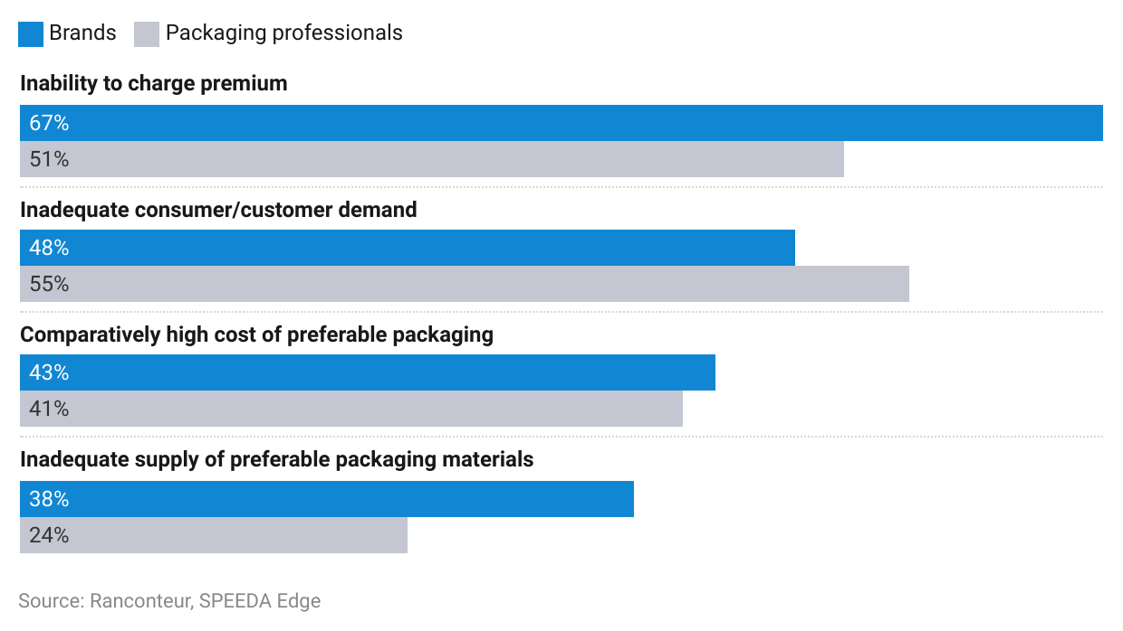

Additionally, recyclable packaging raises concerns about the integrity of the materials used, as their thinness can cause [tears during transportation](https://goodordering.com/blogs/blog/4optionsforsustainablepackaging-for-an-ecommerce-business). Another issue is the transparency of the packaging, which may attract thieves if the contents of the package are visible. Moreover, the recycling process for paper-based packages necessitates using harmful substances, posing environmental and health risks.

# **Emerging technologies to shape Smart Packaging Tech’s future**

## **Augmented reality in packaging**

Augmented reality (AR) is set to significantly impact the packaging industry in several innovative ways, enhancing consumer engagement and operational efficiency.

**Some of the important uses of AR and its potential benefits**

| **Feature** | **Description** |
| --- | --- |
| Interactive packaging | With AR, consumers can use their smartphones or AR glasses to see additional information about a product. This could include nutritional information, usage instructions, or the product's history. Platforms such as [Vossle](https://www.crunchbase.com/organization/vossle) provide immersive and 3D experiences to customers using AR to engage them in a unique manner |
| Anti-counterfeiting measures | AR can improve product authentication processes with a unique code on the packaging, allowing consumers to verify the product’s authenticity and protect them from counterfeit goods. This is especially useful for luxury goods, pharmaceuticals, and other high-value items |
| Personalized experiences | Scanning a package using AR could unlock personalized content, offers, or recommendations based on user preferences and past behaviors. This level of customization can significantly enhance customer satisfaction and loyalty |

Source: Compiled by SPEEDA Edge

## **Nanotechnology**

Nanotechnology in packaging involves using nanoscale materials and processes to improve the functionality and performance of packaging solutions. [Nanoparticles in food packaging materials](https://foodsafetytech.com/column/applications-of-nanotechnology-in-food-packaging-a-bright-future-ahead/) are proven to improve food safety. Although this is at an early stage, companies such as [Titan Bioplastics](https://sp-edge.com/companies/2211321), [Infinite Nanotech](https://sp-edge.com/companies/1417762), and [Toraphene](https://sp-edge.com/companies/1271596) have already implemented nanotech solutions, leading to high-quality and cost-effective packaging solutions.

**Development of nanotechnology in the food industry**

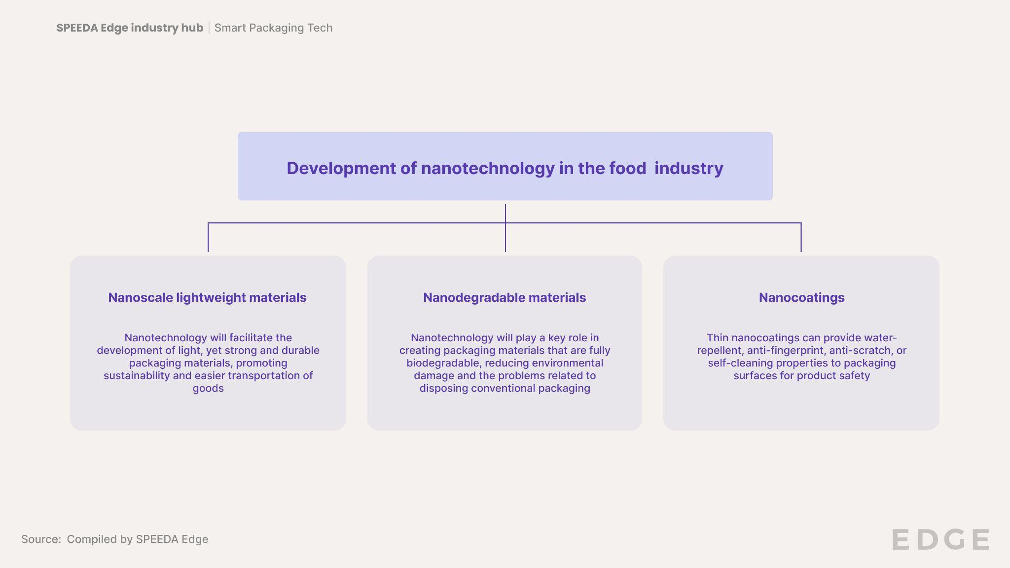

Edible packaging, which is used to wrap or contain food and can be consumed with the product, uses biodegradable materials made from natural substances, such as seaweed, rice, potatoes, or corn, offering a sustainable alternative to traditional plastic packaging.

Nanotechnology is expected to advance [edible packaging](https://www.pkgbranding.com/blog/examples-of-edible-packaging) with the use of nanocoating produced from biopolymers and lipid proteins to extend shelf life and product safety through microbial properties *(for more information on these materials, please refer to the bio-based packaging materials segment on the* [*Bio-based Materials*](https://sp-edge.com/industry/45) *hub.)*

## **Advances in digital printing**

The integration of machine learning and AI into digital printing has significantly enhanced customization and personalization capabilities. This technological advancement enables effortless modifications to packaging, regardless of the order size. Further benefits to be achieved by this include faster printing speeds, reduced waste, and minimum inventory requirements. This is expected to particularly benefit the food and beverage, healthcare, pharmaceutical, and household industries.

[Kodak](https://sp-edge.com/companies/111710)’s latest “[Imprinting Systems](https://www.kodak.com/en/print/blog-post/kodaks-solution-for-digital-packaging-printing/)” achieve high-speed package printing and provide increased personalization based on consumer preferences.

**Emerging developments in digital printing**

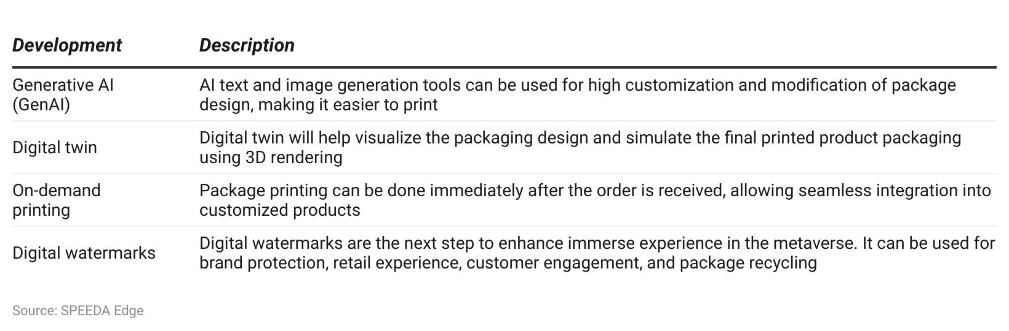

## 

## 

## 

## 

*Last updated: March 2024*

©2024 Uzabase, Inc. All Rights Reserved. The information contained herein: (1) is proprietary to Uzabase Inc. and/or its content providers; (2) may not be copied or distributed; and (3) is not warranted to be accurate, complete or timely. Neither Uzabase Inc. nor its content providers are responsible for any damages or losses arising from any use of this information.