# **Mental Health Tech: Overview**



## **Mental health tech: Improved accessibility and affordability for mental health care**

Mental health tech refers to services that help treat mental health conditions via mobile and/or online platforms. A main function of mental health tech platforms is to connect physicians and practitioners directly to individuals without barriers such as a lack of proximity, prohibitive cost, or long wait times in the doctor’s office.

The mental health tech ecosystem is broad and includes telepsychiatry platforms, digital therapeutics, monitoring/measuring tools, and peer-to-peer apps. Telepsychiatry is at the forefront of the industry and has been gaining traction with a growing number of users. Monitoring/measuring tools follow, but the services have yet to see mass adoption. Digital therapeutics (software-based therapeutic interventions given directly to individuals for preventing, managing, or treating mental disorders) is an emerging segment with just a few successful product launches, and it shows great potential.

For the purpose of this analysis, meditation apps such as Calm and Headspace have been excluded, as this report focuses on mental health rather than wellness tech, which focuses on stress reduction and improving daily habits. The report also excludes provider tools such as provider search engines and back-office resources, which are better suited for an analysis of business infrastructure solutions.

### **Business segments in detail**

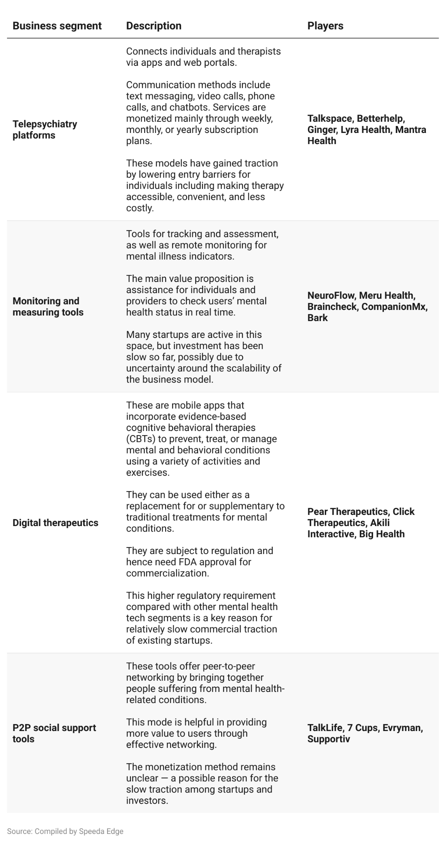

## **Smartphone proliferation, advances in biometric sensors, and AI-powered chatbots spur the growth of mental health tech**

**Proliferation of smartphones** — The US has a smartphone penetration rate of 97% among 18 to 49 year-olds. This is a huge factor in allowing mental health tech companies to scale effectively. As of 2022, there were around 20,000 apps in the market that provide mental health support.

**Advancements in biometric sensors** — Powerful sensors help capture biometric data through devices such as virtual reality (VR) headsets and wristbands to allow an individual's progress to be monitored effectively online. NeuroFlow, an app that aggregates individual biometric data from wearables, completed around 1 million assessments in 2021.

**Emergence of AI-powered chatbots** — Advances in AI facilitate the development of intelligent chatbots to provide automated CBT sessions for individuals (virtual CBT startup Woebot’s AI-powered chatbot service currently reaches people in 135 countries who send around 4.7 million messages per week).

Advances in VR technology, coupled with declining VR device costs, is a powerful potential enabler in the future of mental health tech. VR aids in diagnosing and treating mental conditions by creating controlled simulations and scenarios to provoke symptoms.

## **Business models vary per segment**

Telepsychiatry players generally prefer a subscription model, which lets corporate clients scale according to workforce requirements. Monitoring and measuring startups have more widely adopted the freemium model. Digital therapeutics businesses leverage the reimbursement model of traditional pharmaceutical companies in its prescription-based segment. As for P2P startups, the business model remains unclear: they adopt a mixture of pricing models such as subscription-based and event- or program-based.

## **1. Subscription model is popular among telepsychiatry players in both D2C and B2B**

The subscription model is common for telepsychiatry players because of the scalability it offers for corporate clients—companies can increase or decrease their employee base via the platforms as needed.

Most new telepsychiatry startups initially adopt the subscription model for a D2C approach, which allows them to assess acceptability and get user feedback on products. The subscription model is used in the B2B segment to include companies, health plans, and healthcare insurers, who provide a much wider network of users in terms of employees, insured, etc. Several telepsychiatry startups (such as Talkspace and Betterhelp) have transitioned successfully from a D2C model to a B2B one to extend their reach to such enterprise clients. Many of these companies now generate larger proportions of their revenues through B2B models (such as Talkspace, Ginger, and Lyra Health).

## **2. Freemium model popular for monitoring and measuring startups**

Monitoring and measuring startups generally prefer a freemium pricing model. This way, companies can offer some basic features for free and charge for access to enhanced features. Alternatively, the product can be offered as a free trial (especially in the B2B space) for later conversion into a subscription. Braincheck, for example, provides a cognitive monitoring tool for physicians to assess an individual's cognitive health, offering a 30-day free trial followed by a monthly subscription.

## **3. Digital therapeutics leverage traditional pharma model**

Digital therapeutics (DTx) are prescription-based, meaning they must be administered by licensed clinicians and therapists. DTx can therefore offer a reimbursement system similar to that of traditional pharmaceuticals, where insurers can reimburse users for the DTx solutions they pay for.

Digital therapeutics can also partner with big pharma to leverage marketing capability to commercialize and expand product reach.

Pear Therapeutics, for example, secured a partnership with Novartis’ division Sandoz in April 2018. The partnership formed to commercialize Pear Therapeutics' reSET portfolio is globally one of the first between a DTx startup and a large pharmaceutical company. Although it was short-lived (it ended in October 2019 because Sandoz pivoted to focus on its core products), it remains a viable model for other partnerships.

# **Driving factors**

## **1. Sizable untreated population**

Anxiety disorders are one of the most prevalent mental illnesses among children and adults in the US. The Anxiety & Depression Association of America (a US-based nonprofit organization) found more than 40 million American adults (around 19% of the population) suffer from anxiety disorders, and a lack of access to treatment has been a critical issue for individuals with these treatable conditions. Only 37% of adults receive treatment, while over 28.3 million people with mental illnesses are currently not receiving treatment due to lack of confidence in treatment methods, lack of knowledge, preferring self-help, lack of access, and negative stigma An untreated population of such vastness presents a large addressable market for the next generation of mental health tech companies.

## **2. Tech companies are best-positioned to leverage high rates of mental illness among tech-savvy millennials**

Mental health conditions are recorded among millennial and Gen-Z populations at a much higher degree than with previous generations. The prevalence of mental illness among young adults (aged 18 to 25) is 33.7%, higher than the 28.1% reported for the 26 to 49 age group and 15.0% for the population over 50. Around 49.5% of adolescents (aged 13 to 18) have a lifetime prevalence of a mental disorder, of which around 22.2% are severe. Just 44.6% of young adults have sought help for mental illness, compared with 48.1% in the 26 to 49 age group and 47.4% in the 50+ age group.

## **3. Mental health tech is a cost-effective alternative for employers benefits**

Employers are increasingly concerned about employee mental health and its impact on productivity and performance. Proactive measures that address mental health conditions can tangibly benefit organizations. A study by the WHO estimated that every USD 1 investment to scale up treatment for common mental disorders generates USD 4 in improved productivity and performance. More employers are including mental health tech services (by subscribing to telepsychiatry corporate packages) as part of employee assistance programs (EAPs).

# **Risks to growth**

## **1. Scalability and retention barriers**

For startups attempting to provide similar products with minimal differentiation, scalability might become challenging. This could be especially the case for the new B2C entrants in the telepsychiatry and monitoring and measuring segments, which need user traction. Service differentiation is key in the long run. Individual users may opt out after short stints, so companies need to either invest in continuously winning new customers or in extending their stay. As a work-around, some early startups such as Talkspace have expanded into the B2B market by building partnerships with healthcare providers and employers.

## **2. High initial investments**

When it comes to digital therapeutics, product development and the stringent FDA approval process call for high investments. Overrunning costs and the challenge of recouping high investments through commercialization are the segment’s potential risk factors. Even after successful approval, traction in commercialization depends on physicians’ acceptance of the novel digital product over traditional drugs.

*Last updated: June 2023*