# **Climate Risk Analytics: Overview**

## 

## **Climate risk analytics predicts physical climate risks**

Climate risk refers to probable socio-economic impacts of climate change. There are two types of climate risks: 1) physical and 2) transition. Physical risks result from adverse changes in weather and climate. These include short-term and one-off extreme weather events like floods, cyclones, droughts, and wildfires, as well as long-term and ongoing climate impacts such as global warming. Transition risks arise from moving into a low-carbon future and include policy and regulatory risks, technological risks, competitive risks, and economic losses from shifting to sustainable technologies. **This industry hub focuses on physical risks.**

### 

### **The duality of climate risks: Physical vs. transition risks**

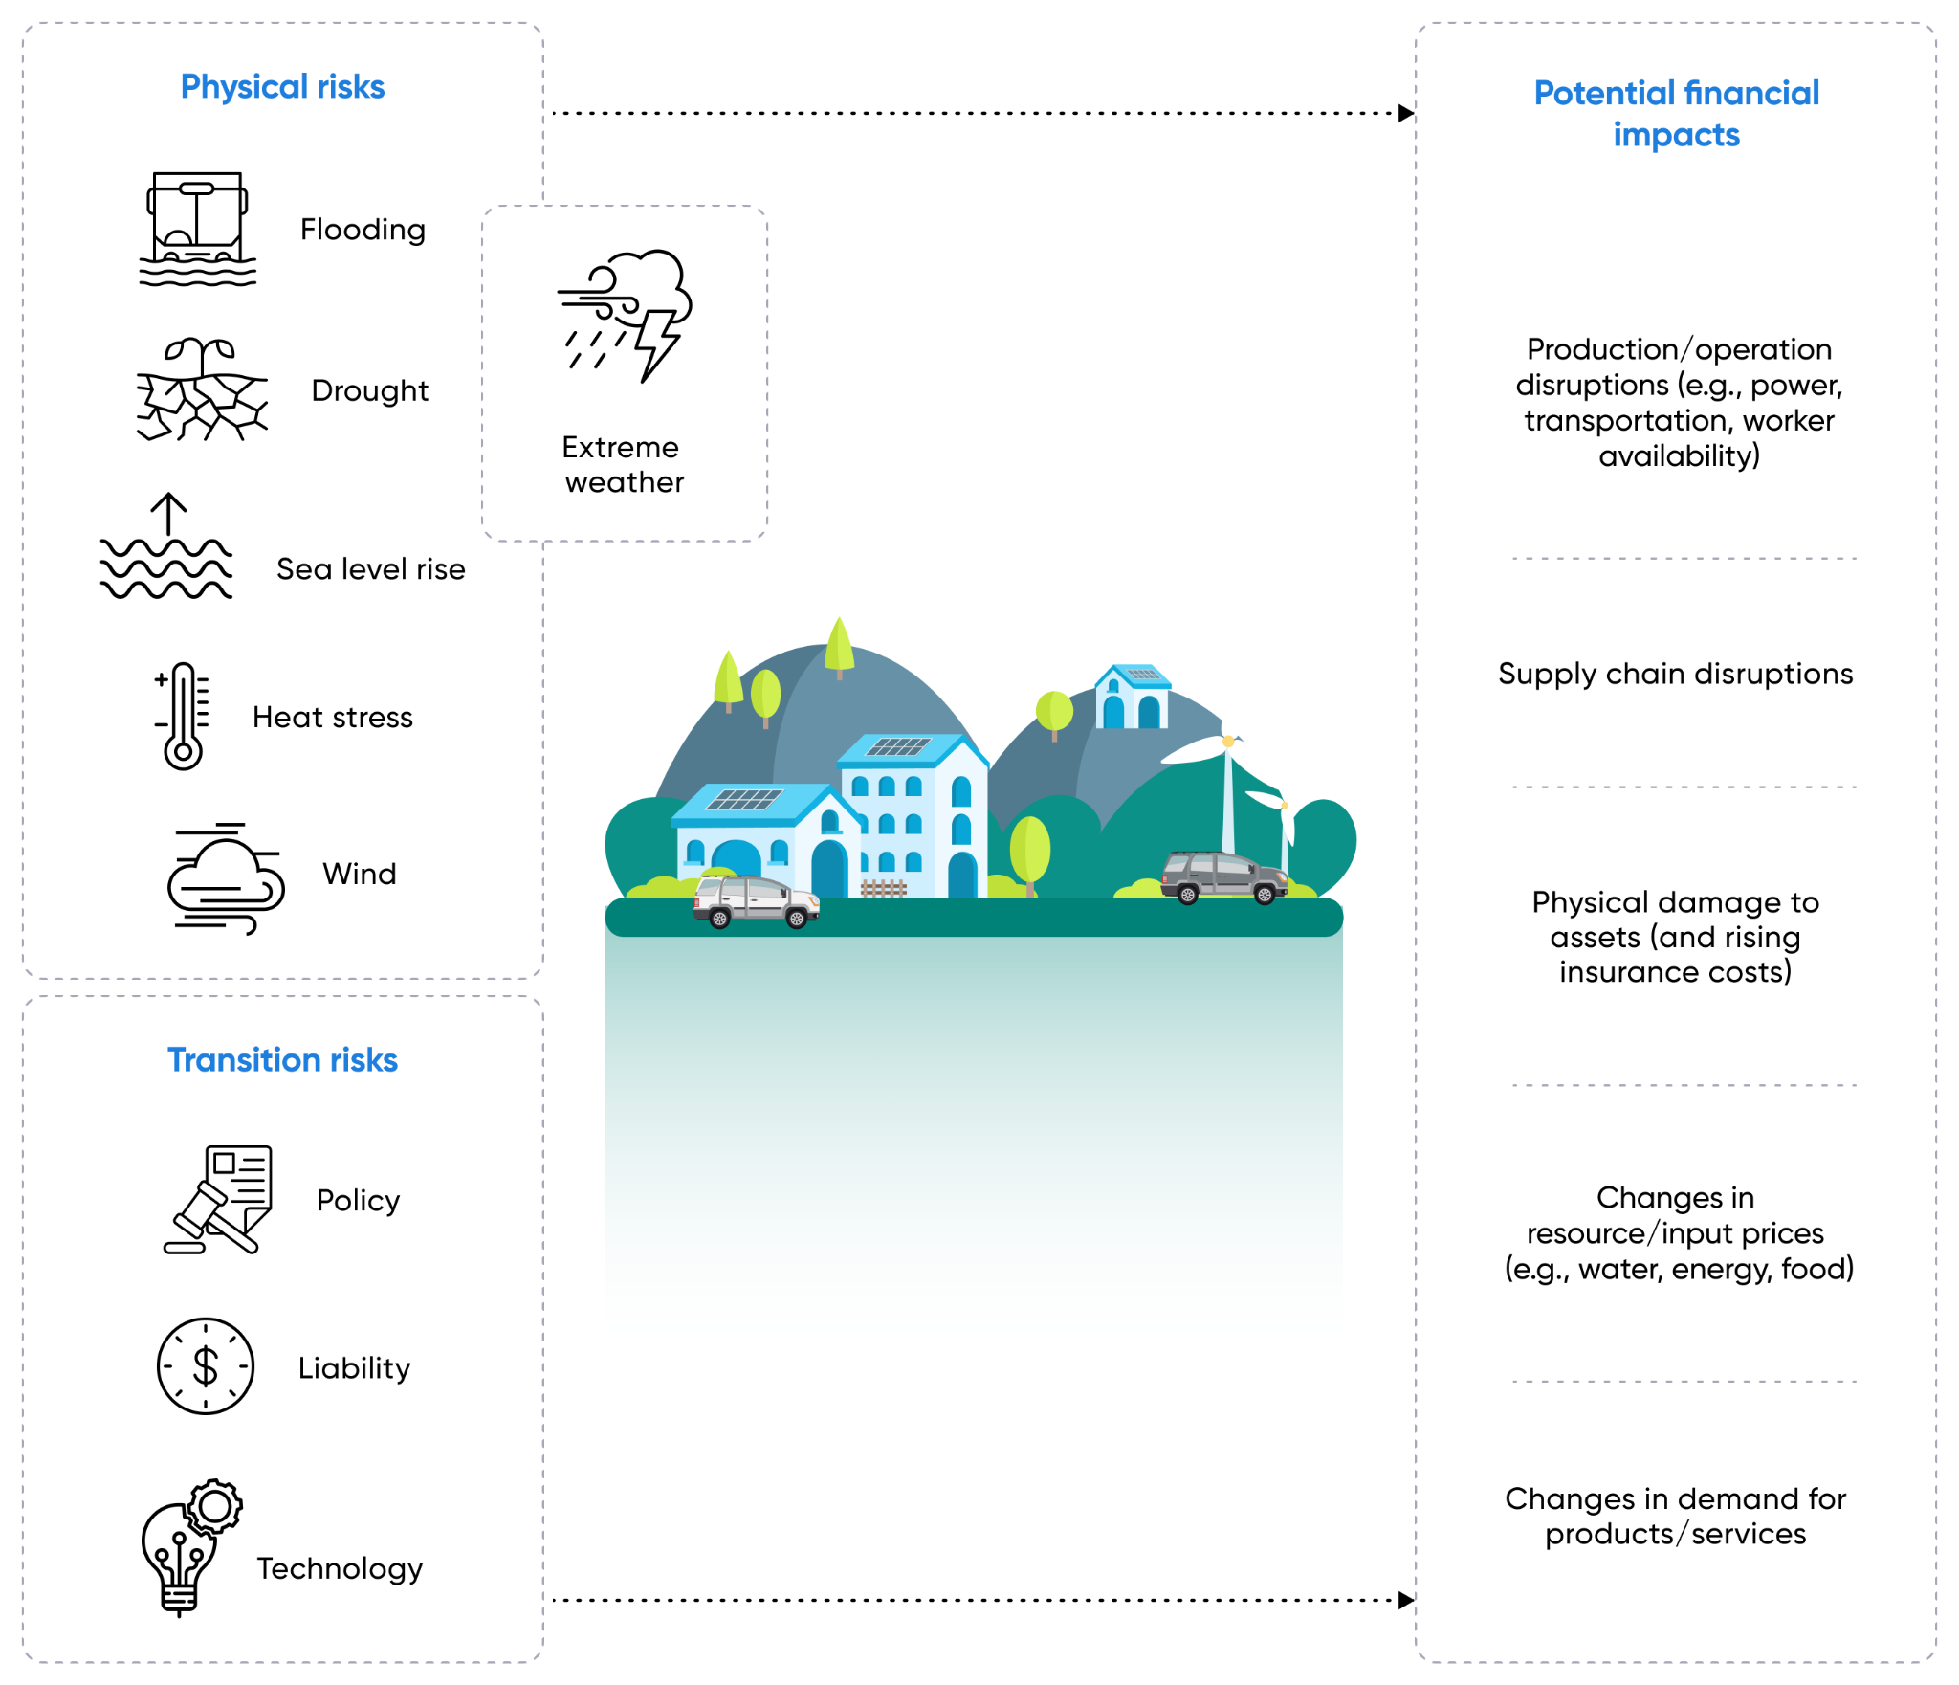

Source: Center for International Climate Research

**Climate risk analytics uses data and analytical models to predict the occurrence and impact of extreme weather events and climate change.** Climate risk analytics outperform legacy NWP models with next-generation AI-/ML-driven predictive analytics tools, among other technologies.

### 

### 

### 

### 

### 

### **Key segments**

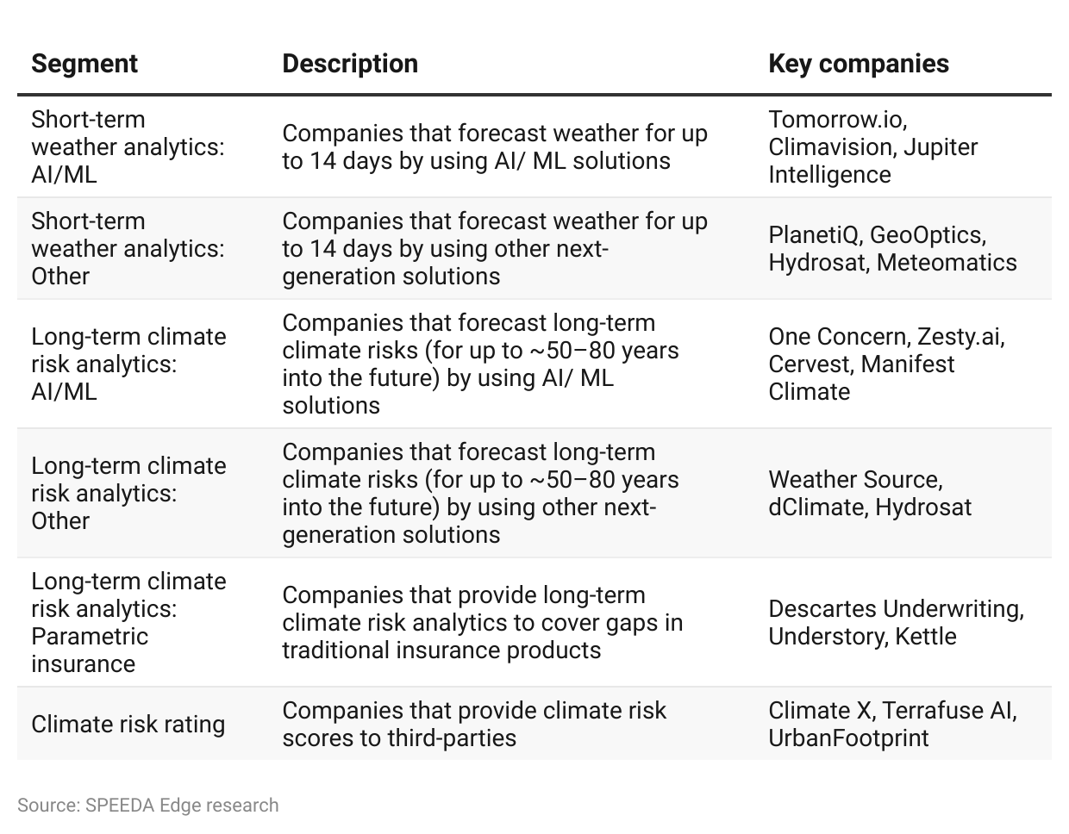

The industry hub excludes weather alerting solutions, traditional weather forecasting systems, and traditional insurance companies that cover climate-related risks.

## **Advancements in AI are a key enabler**

Advancements in AI and data sciences have made it possible to identify more granular and hyperlocal patterns in weather data. This enables more accurate and longer-term weather forecasts.

AI has made it possible to predict longer-term climate risks for up to [80 years into the future](https://cervest.earth/earth-science-ai) in some cases. For more short-term forecasts, B2B weather analytics platform [Tomorrow.io](https://sp-edge.com/companies/454628) claims to have the ability to provide an accurate five-day advanced warning of any adverse weather impact on business operations. Meanwhile, Google’s AI-subsidiary [DeepMind](https://sp-edge.com/companies/173438) has reportedly developed a solution that could forecast rain [up to six hours](https://ai.googleblog.com/2020/01/using-machine-learning-to-nowcast.html) in advance.

Collecting weather data 24/7 across a wider geography is nearly impossible. These data gaps are also a reason for the somewhat lower accuracy of legacy forecasts. AI/ML technologies fill these gaps in weather data. For instance, [OneConcern](https://sp-edge.com/companies/321187) is using AI to develop a digital twin of the Earth, to more accurately model the impact of natural disasters. In [January 2024](https://sp-edge.com/updates/26004), [Riskthinking.AI](https://sp-edge.com/companies/1837966) launched CDT, a climate digital twin, for commercial use. In [March 2024](https://nvidianews.nvidia.com/news/nvidia-announces-earth-climate-digital-twin), NVIDIA unveiled Earth-2, a climate digital twin platform, with weather analytics companies such as Spire and [Meteomatics](https://sp-edge.com/companies/593501) as early adopters.

Another advantage of AI is its faster computational power, allowing weather forecasts to be based on (almost) real-time data. For instance, DeepMind’s “Nowcast” rain prediction model has a latency of only 5–10 minutes, while legacy NWP models have a computational latency of 1–3 hours.

### **AI models outperform legacy NWP forecasting models: Conventional versus AI-based weather prediction methods**

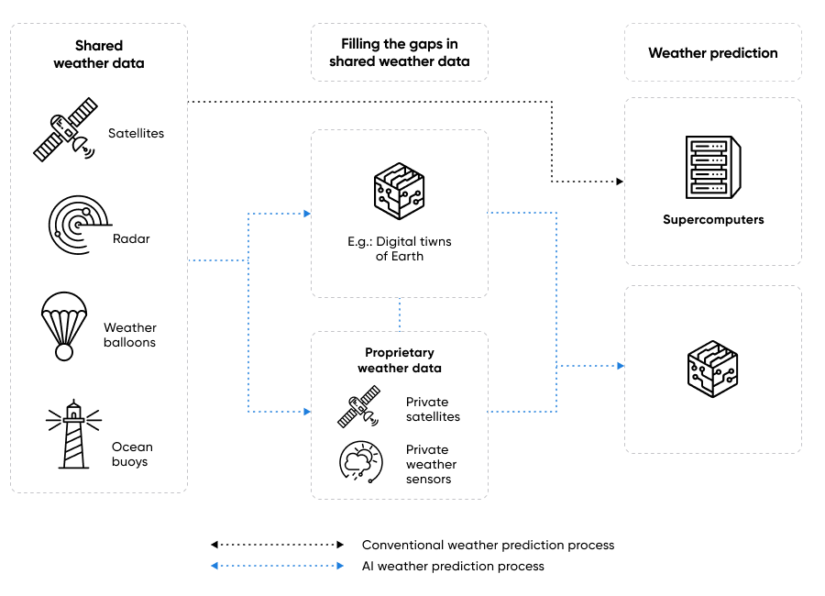

Source: SPEEDA Edge research

## 

## 

## 

## **Other next-gen solutions focus on better Earth observation data**

AI is not the only way that weather and climate risk analytics startups are looking to provide more accurate predictions. An alternative is to collect additional weather data from in-house observations. [Climavision](https://sp-edge.com/companies/1404278) deploys a private network of radars to fill the gaps in weather data. The company states that these additional data points enable it to provide more accurate predictions than those solutions that only use legacy weather data.

Parametric insurance company [Understory](https://sp-edge.com/companies/205066) deploys proprietary weather sensors at its insured assets to accurately price the climate risk. Tomorrow.io also plans to launch its own satellite constellation by the end of 2024, with its first satellite, Tomorrow-R1, launched in April 2023 and its second satellite, Tomorrow-R2, launched in [June 2023](https://sp-edge.com/updates/19726) to provide more accurate climate risk assessments.

Some startups are also developing technologies to capture weather data that legacy monitoring tools have failed to. [PlanetIQ](https://sp-edge.com/companies/603047) has developed an advanced space-based weather sensor that can see through clouds and storms to provide more accurate visual imagery for forecasting. Another company, [Hydrosat](https://sp-edge.com/companies/792955), uses thermal infrared imagery to monitor ground temperatures from space. This data could accurately track global warming patterns and catastrophic incidents like wildfires. Current spatial imagery-based space systems are unable to provide such data.

# 

# 

# 

# 

# 

# **Driving Factors**

## **Tightening of climate risk disclosure rules**

## In [March 2024](https://sp-edge.com/updates/28288), the US SEC approved the first US-wide climate disclosure mandate. The new rule requires all US-listed companies to disclose climate-related risks with a material impact. This could create opportunities for the climate risk analytics startups focused on monitoring short- and long-term adverse weather events. The SEC’s timeline for climate risk will come into effect in 2025.

## The final rule requires public companies to disclose information about the following:

## Climate-related risks that are deemed to have a “material” impact on the company’s business strategy, results of operations, or financial condition, as well as the company’s business model and outlook. It is estimated to apply to 2,800 US companies and ~600 non-US companies.

## Board’s oversight of climate-related risks and management’s role (if any) in assessing and managing the company’s material climate-related risks

## The company’s processes (if any) to assess and manage material climate-related risks and how these processes are integrated into the company’s overall risk management systems

## Impacts resulting from actions taken under a transition plan (if any)

## Activities (if any) to mitigate or adapt to material climate-related risks, including transition plans, [scenario analysis](https://www.persefoni.com/blog/tcfd-scenario-analysis), and carbon pricing, if used

## Climate-related targets or goals (if any) that affect—or are reasonably likely to affect—the company’s business, financial condition, or results of operations

## Notes to the financial statements will also be required to disclose capitalized costs, expenditures expensed, charges, and losses resulting from severe weather events and physical climate risks.

## Climate risk analytics providers cater to the requirements of this regulatory framework by demonstrating an organization’s climate risk data and visualizations across geographical locations. This allows organizations to assess their climate risk exposures at an asset level. Public companies could also integrate climate risk analytic solutions into their business models and strategies to formulate the cost of adverse weather events on their financial statements.

## The SEC rules also apply to emissions reporting, which is covered under the [Carbon Management Software](https://sp-edge.com/industry/49) industry hub.

## 

## 

## **Increasing natural disaster-related losses**

Rising economic losses associated with extreme weather events have been a key driver for the adoption of climate risk models. In 2023, the global cost of natural disasters amounted to around USD 380 billion, an increase of nearly 7% from 2022 (USD 355 billion). According to the US National Oceanic and Atmospheric Administration (NOAA), the average cost of natural disasters in the US was around USD 111.7 billion per annum for the past decade (2014-2023), up 50.8% from the previous decade (2004-2013).

### **Significant increase in the annual cost of US natural disasters over the past decades**

## 

## **Strong demand from agriculture and insurance industries**

The agriculture and insurance industries have the two most common use cases for weather and climate risk analytics. However, leading players like Tomorrow.io offer customized solutions for around [20](https://www.tomorrow.io/solutions/) sectors, including aviation, energy, sports, and events.

The agriculture industry uses longer-term climate forecasts to identify suitable land and crops, while accurate short-term forecasts are also necessary to prevent unexpected crop losses and process disruptions. Tomorrow.io, a startup that offers warnings around five days before an extreme weather event, claims to have reduced crop losses by [20%](https://www.tomorrow.io/solutions/agriculture/) and saved USD 41 per acre. Climate risk analytics startups like [ClimateAI](https://sp-edge.com/companies/899178) and Hydrosat cater specifically to the agriculture industry.

SwissRe estimates a gap of [USD 172 billion](https://www.swissre.com/press-release/New-record-of-142-natural-catastrophes-accumulates-to-USD-108-billion-insured-losses-in-2023-finds-Swiss-Re-Institute/a2512914-6d3a-492e-a190-aac37feca15b) between the economic (USD 280 billion) and the insured costs (USD 108 billion) of natural disasters in 2023. Traditional insurance players find it difficult to price climate risks accurately. This has created opportunities for parametric climate insurance platforms like [Understory](https://sp-edge.com/companies/205066), [Descartes Underwriting](https://sp-edge.com/companies/727521), [Kettle](https://sp-edge.com/companies/1082464), and [Arbol](https://sp-edge.com/companies/771808). Through proprietary data and AI-driven models, these platforms claim to accurately assess and price climate risks, resulting in lower premiums. Furthermore, energy companies have optimized these climate risk platforms to monitor grid performance and maximise energy production while protecting these grids from adverse weather.

### **Key use cases of climate risk analytics**

| **Industry** | **Key startups** | **Use case** |
| --- | --- | --- |
| Agriculture | Tomorrow.io, Climavision, Jupiter Intelligence, PlanetIQ | • Decide on ideal conditions for planting crops  • Avoid over- or under-watering by monitoring rainfall  • Decide on ideal weather for spray applications |
| Automotive | Tomorrow.io | • Avoid weather-related delays by monitoring road conditions  • Prepare for poor road conditions  • Monitor weather to maximize battery range in electric vehicles |
| Aviation | Tomorrow.io, Climavision | • Manage take-offs and landings based on weather  • Monitor weather during flight  • Determine optimal flight routes based on weather |
| Construction | Tomorrow.io | • Prevent material losses due to bad weather  • Ensure crew safety with weather alerts |
| Digital marketing | Tomorrow.io | • Weather-targeted marketing (seasonal clothing, food, etc.) |
| Drones | Tomorrow.io, Climavision | • Make flight decisions based on weather (rain, heat, etc.)  • Monitor weather to improve aerial photography |
| Energy | Tomorrow.io, Climavision, Jupiter Intelligence, UrbanFootprint, PlanetIQ | • Monitor when and where grids are compromised by weather  • Protect solar and wind assets from severe weather |
| Financial services | One Concern, Climavision, Jupiter Intelligence, Cervest | • Determine climate risks of the investment portfolio  • Make investment decisions based on climate exposure |
| Freight | Tomorrow.io, Climavision, Jupiter Intelligence, PlanetIQ | • Avoid routes affected by weather  • Weather-based port operations  • Identify railroads at risk due to bad weather |
| Healthcare | Tomorrow.io | • Weather-based medical resource allocation  • Prepare for uninterrupted operations during bad weather |
| Insurance | Tomorrow.io, Descartes Underwriting, One Concern, Jupiter Intelligence, Zesty.ai, PlanetIQ, Cervest | • Accurate risk pricing  • Help policyholders prepare for weather events to reduce losses |
| Municipalities | Tomorrow.io, Climavision, Jupiter Intelligence, UrbanFootprint, | • Prepare for adverse weather events  • Weather-focused street/city maintenance  • Weather-focused first-responder resource allocation |
| Real estate | One Concern, Jupiter Intelligence, UrbanFootprint | • Accurate property pricing based on weather risks  • Help property owners prepare for weather events to reduce losses |
| Sports and events | Tomorrow.io, Climavision, | • Schedule events/games and practices based on weather |
| Warehousing | Tomorrow.io | • Weather-based storage decisions (location, packaging, etc.) |
| Media | Climavision | • Real-time and accurate weather forecasts |
| Mining and oil & gas | Jupiter Intelligence, PlanetIQ | • Identify weather risks at a specific mine location  • Prepare for supply chain and freight risks |
| NGOs | Jupiter Intelligence | • Mitigate climate risks in vulnerable communities |

Source: SPEEDA Edge research

### 

## **Increased incumbent activity drives innovation**

In [April 2024](https://www.cdomagazine.tech/aiml/google-releases-genai-model-for-efficient-weather-forecasting), Google launched the Scalable Ensemble Envelope Diffusion Sampler (SEEDS), a GenAI model that produces weather forecast ensembles at a fraction of the computational cost of traditional NWP methods. Google has also introduced other weather models, such as MetNet-3 and GraphCast.

In [June 2024](https://cybernews.com/tech/microsoft-ai-model-aurora-extreme-weather-forecasting/), Microsoft unveiled its AI-driven climate model, “Aurora,” a foundational model that predicts extreme weather events. Aurora produces five-day global air pollution forecasts and 10-day high-resolution weather forecasts in less than a minute, outperforming state-of-the-art classical simulation tools and deep learning models.

Big Tech companies bring significant investment and technological resources to the table, enhancing the credibility of the climate risk analytics industry. Additionally, they often collaborate with startups and academic institutions, creating a vibrant ecosystem that drives innovation across the climate risk analytics space.

## **Risks to growth**

# **1. Limited accuracy of climate monitoring tools**

AI too has limitations when it comes to predicting weather. The most common is accuracy. According to the NOAA, legacy NWP forecasts of up to five days are only 80%–90% accurate. The accuracy falls to around 50% for a seven-day forecast, and foreseeing weather for even a few weeks or months into the future is nearly impossible with the current NWP models.

### **Legacy NWP forecast accuracy declines gradually**

## 

Source: NOAA

In 2020, an AI model developed by Rice University in Houston, Texas, made five-day forecasts with [85% accuracy](https://www.meteorologicaltechnologyinternational.com/news/extreme-weather/scientists-use-deep-learning-to-predict-extreme-weather.html). However, this wasn’t much of an improvement from some of the [current accuracy levels](https://www.reference.com/science/national-weather-service-accurate) of legacy models. Moreover, DeepMind’s Nowcast rain-forecasting AI [lags legacy NWP models](https://ai.googleblog.com/2020/01/using-machine-learning-to-nowcast.html#:~:text=It%20is%20important%20to%20note%2C%20however%2C%20that%20the%20HRRR%20model%20begins%20to%20outperform%20our%20current%20results%20when%20the%20prediction%20horizon%20reaches%20roughly%205%20to%206%20hours.) when the forecast window is 5–6 hours. Therefore, despite the promises made by some companies about their AIs being able to foresee climate risks for about 50–80 years into the future, the accuracy of such predictions is still very much doubted.

### **2. Location-biasness of AI models**

Given the sectoral and geographical specificity of climate risks—physical risk exposure is highly location-specific. In an [interview](https://time.com/collection-post/5950007/gro-intelligence/) with TIME, Sara Menker, the founder and CEO of Gro Intelligence, stated that climate AIs developed in the western world are too location-biased and are often ineffective in other markets.

This makes it difficult to adopt AI-based climate modeling tools across regions.

*Last updated: August 2024*

©2024 Uzabase, Inc. All Rights Reserved. The information contained herein: (1) is proprietary to Uzabase Inc. and/or its content providers; (2) may not be copied or distributed; and (3) is not warranted to be accurate, complete or timely. Neither Uzabase Inc. nor its content providers are responsible for any damages or losses arising from any use of this information.