# **Additive Manufacturing: Overview**

## 

## **Additive manufacturing makes objects by systematically adding material via a CAD program**

Additive manufacturing (AM) refers to the manufacturing of 3D objects—components, parts, or entire products—by systematically adding material, layer upon layer, according to software-based instructions (usually a CAD program). The materials used could be metal, polymer, or ceramics.

Generally, the terms 3D printing and AM are used interchangeably. However, AM relates to the entire workflow, from design and prototyping to printing, as well as post-processing solutions, whereas 3D printing is just one aspect of AM.

In this report, we look at companies that develop and sell AM solutions for industrial purposes, including the sale of 3D printer systems, AM materials, AM software, and post-printing solutions, along with companies that develop technology to offer on-demand AM services.

This report excludes 3D-printed houses, which are covered in the [Prefab Tech](https://sp-edge.com/industry/60) report. Also excluded are 3D printed food and bioprinting.

### 

### 

### **Traditional manufacturing methods vs. AM**

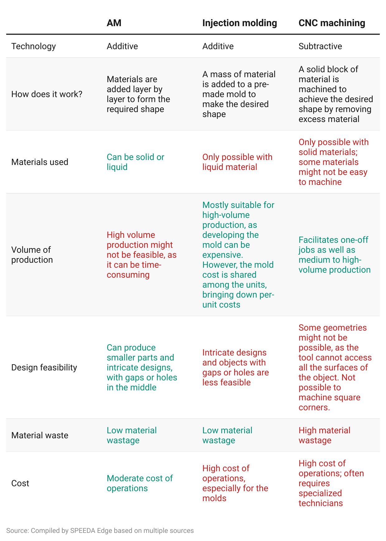

## **AM is widely used in industries that require rapid prototyping as well as mass customization and precision printing**

Due to its compelling attributes, AM has been used across industries and use cases, with the most prominent one being rapid prototyping. In a 2022 survey by [Sculpteo](https://www.bing.com/ck/a?!&&p=3be3d8ca5f75f24eJmltdHM9MTY5MzI2NzIwMCZpZ3VpZD0xYzk1OTQxYi05MDJkLTZmNWQtMjhiZC04NzI0OTEyYzZlYzcmaW5zaWQ9NTE5OQ&ptn=3&hsh=3&fclid=1c95941b-902d-6f5d-28bd-8724912c6ec7&psq=sculpteo+the+state+of+3d+printing&u=a1aHR0cHM6Ly93d3cuc2N1bHB0ZW8uY29tL2VuL2Vib29rcy9zdGF0ZS1vZi0zZC1wcmludGluZy1yZXBvcnQtMjAyMi8&ntb=1), around 49% of respondents (mostly from an engineering background including CEOs and R&D teams) reported using AM for proof of concepts. Prototyping was in second place (31% of respondents), followed by production (16%) and mass production (4%).

**Typical AM use cases**

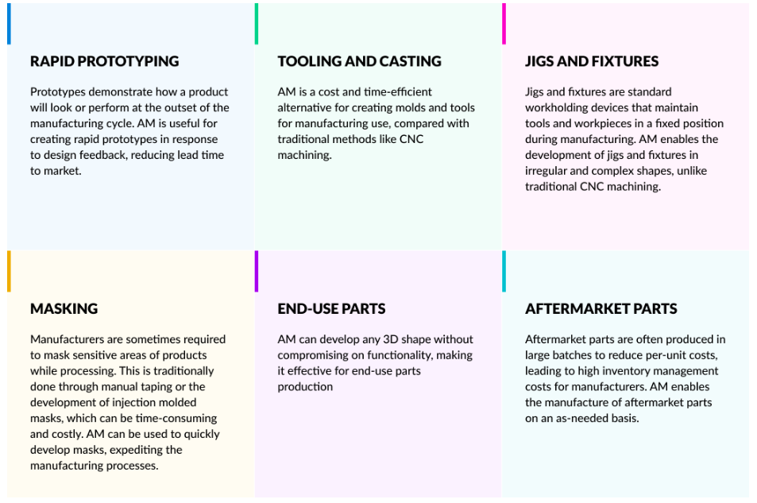

AM is widely used in automotive and aerospace applications to make small components that require precision manufacturing and mass customization. Other notable applications include the manufacturing of medical devices, components/parts in the energy and defense sectors, sporting goods, and consumer goods. AM is also an emerging trend in the fashion industry.

### 

### 

### **AM applications by industry**

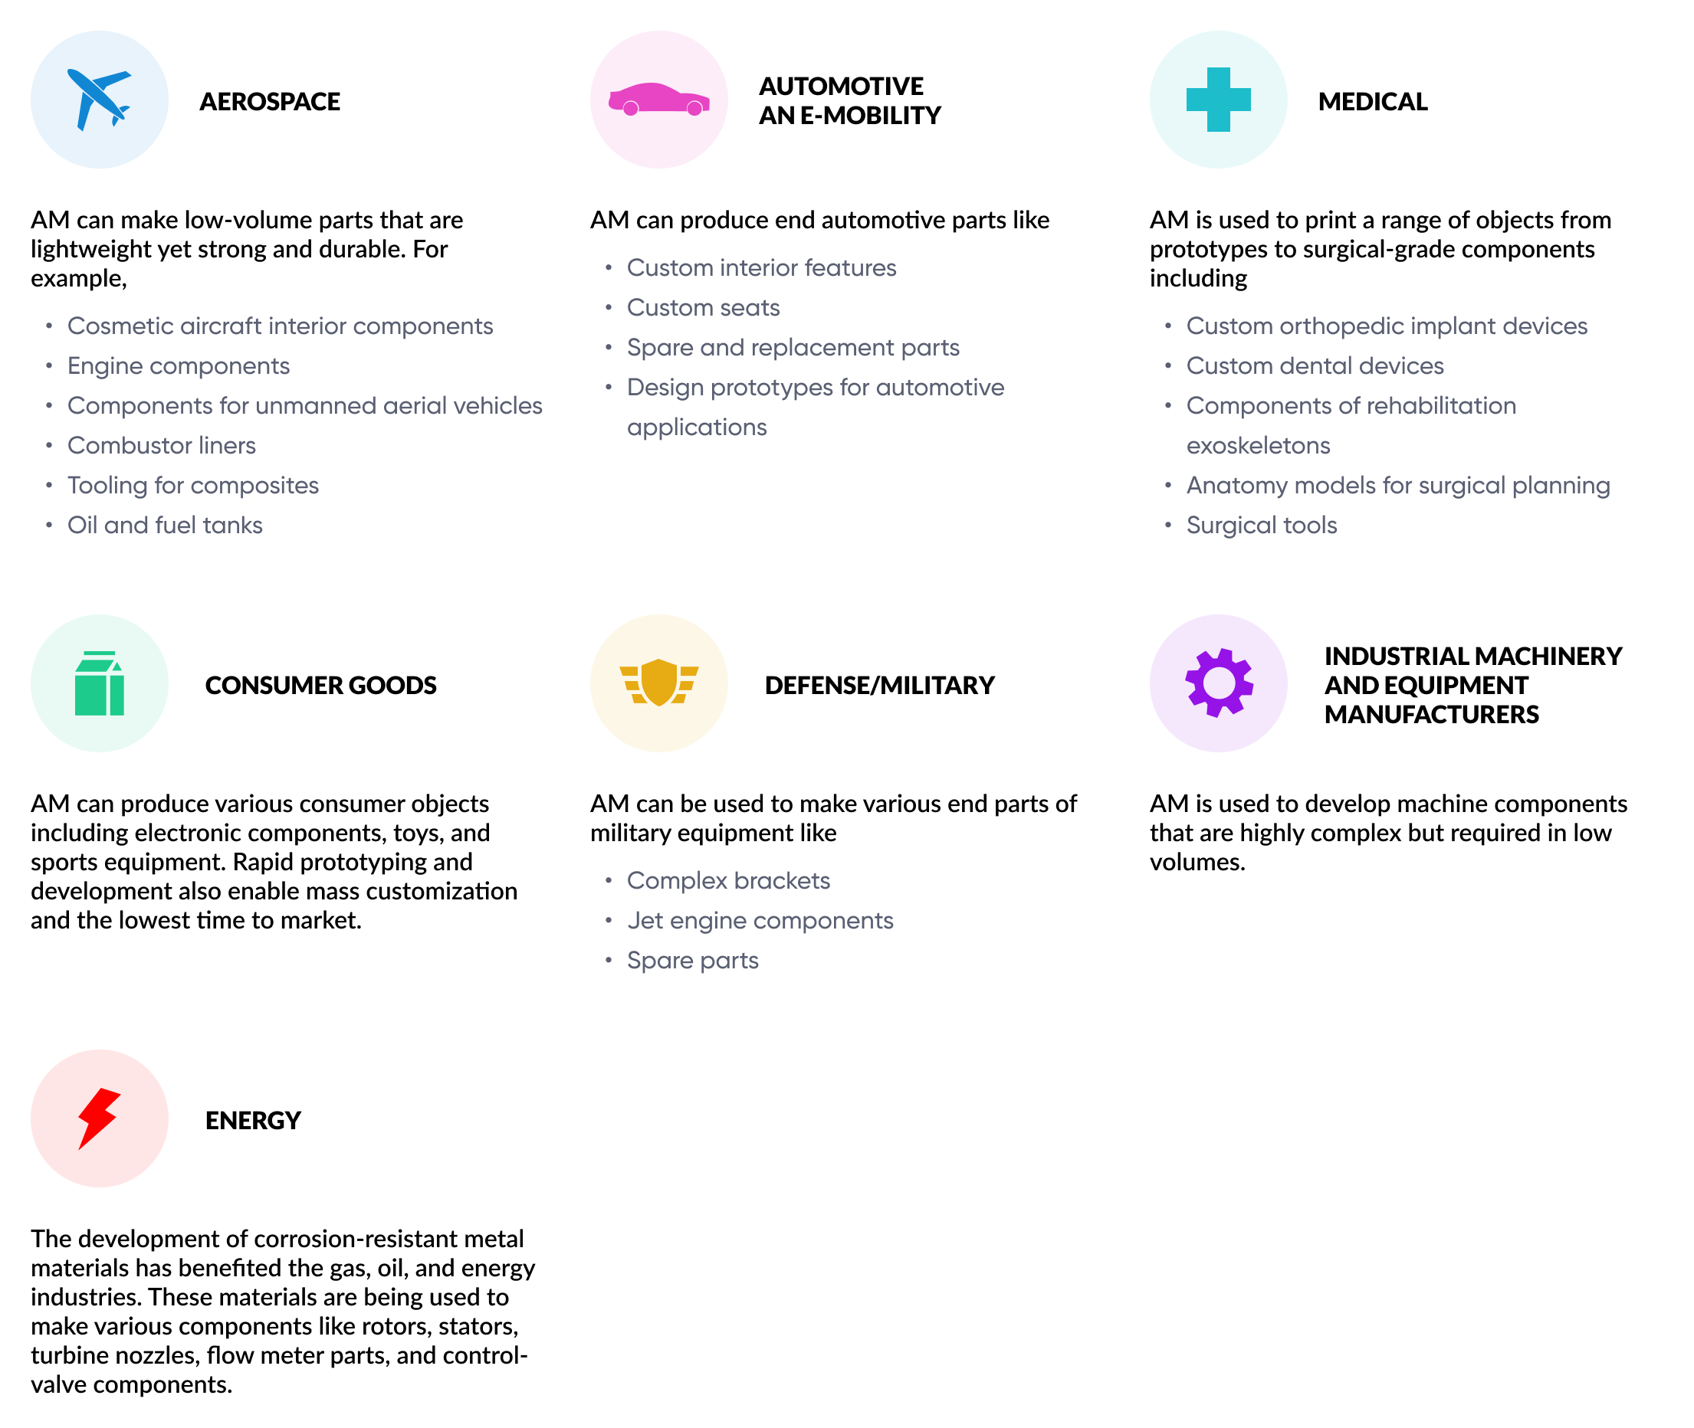

## **Widespread adoption of AM was triggered by the expiry of several patents during 2009–2014**

AM technology has been in development since the early 1980s. However, R&D in the market only truly flourished between 2009 and 2014, after several early patents had expired. Before that point, the market had been dominated by a handful of companies. The subsequent period saw an influx of players entering the market with proprietary technologies.

### 

### 

### 

### 

### **Timeline of industrial AM market growth**

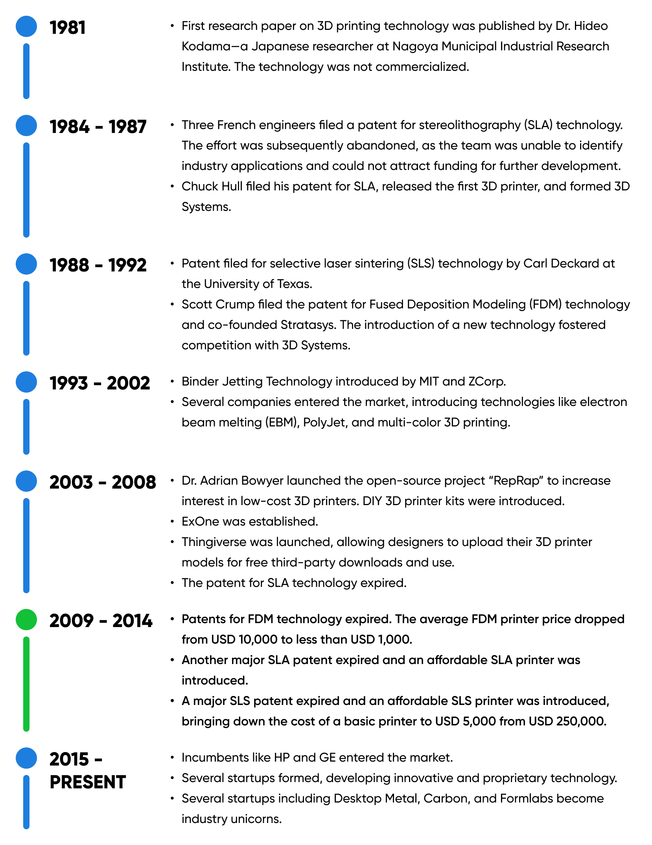

## 

## 

## **Startups are developing proprietary tech to improve functionality and enable high-volume printing**

Legacy AM technology was limited by its inability to accommodate high-volume printing. However, companies are increasingly developing advanced tech aimed at improving the speed of printing and the functionality of printed objects. These technologies are either derivative of existing AM tech or are novel, disruptive approaches that may displace legacy tech.

### 

### 

### 

### 

### 

### 

### 

### 

### 

### 

### 

### 

### 

### 

### 

### 

### 

### **Current AM technologies and derivative technologies**

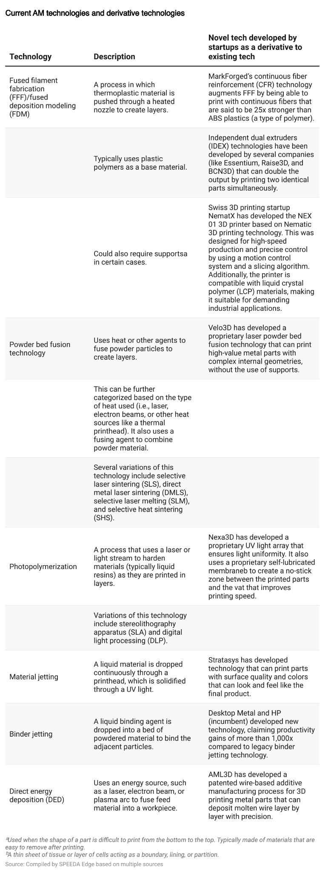

Some companies have developed completely new technologies, which are not derivatives of existing technologies. For example,

1. MELD Manufacturing has developed patented technology that can print large metal parts without melting the material, which is claimed to be 10x faster than traditional powder bed fusion tech.
2. [Norsk Titanium](https://sp-edge.com/companies/393430)’s patented Rapid Plasma Deposition tech, which uses melting titanium wire, is claimed to be capable of printing parts 50x–100x faster than powder-based AM systems.
3. Rapidia’s water-based metal paste is a new AM technology that is free of harsh chemicals, which makes it more suitable in office settings for uses like prototyping.
4. NUBURU released BL-1000-F, a high-brightness blue laser with a 1 kW power output. This enhances laser performance for applications like metal 3D printing and EV battery welding, enabling faster processing, micron-level precision, and improved quality of welds.

## **Advancements in material sciences contribute to the growth of AM**

**Materials with advanced properties:** Materials have seen significant development to achieve the strong, durable, and lightweight nature required for AM. For example, [MarkForged](https://sp-edge.com/companies/174035) claims that using its patented continuous fiber reinforcement (CFR) technology, carbon can be made strong enough to replace aluminum. Most AM companies have developed proprietary materials that offer advanced properties like the ability to withstand high temperatures and long-term UV exposure (e.g., Inkbit) as well as steel materials that are corrosion-resistant and acid-resistant.

**Fully recyclable materials:** Companies like [Evolve Technologies](https://sp-edge.com/companies/681551) and Materialise have also introduced fully recyclable materials, which cater to the sustainability aspect as well.

**Improved compatibility:** AM companies offer materials that are compatible with other printers, which broadens the availability of choices for manufacturers, eliminating the need to stick to one technology, system, or brand. (e.g., Nexa3D’s XiP Pro 3D printer is compatible with a broad range of high-performance materials—from resins such as xABS, xPP, and xCE to elastomeric materials).

## **Improvement in functionality is enabled through the use of advanced software, robotics, and cloud connectivity**

AM often uses generative design software, which leverages AI algorithms to create and evaluate hundreds of potential designs, improving the accuracy and speed of the design process.

Emerging technologies, such as generative AI (GenAI), are also gradually making their way into this space. For example, Desktop Metal launched a GenAI [software Live Suite](https://sp-edge.com/updates/16892) in March 2023 to provide advanced design capabilities for a wide range of materials, while Authetise launched [3DGPT,](https://sp-edge.com/updates/19163) a GenAI tool that enables users to ask questions related to additive manufacturing processes.

Other improvements in functionality have also bolstered the space. Startups like [Continuous Composites,](https://sp-edge.com/industry/71) [Arevo,](https://sp-edge.com/companies/402370) and [3DEO](https://sp-edge.com/companies/440429) use advanced robotic arms in their printers, backed by software that helps automate the process. These improvements enable employees to perform the work without needing specialized skills or training. The technologies offered by companies like [Evolve](https://sp-edge.com/companies/681551) (selective thermoplastic electrophotographic process or STEP), [Inkbit](https://sp-edge.com/companies/684805) (vision-controlled jetting or VCJ), and [3DEO](https://sp-edge.com/companies/440429) (proprietary sensor-based tech with a closed-loop process to correct errors) also improve print speed and accuracy. Advancing to the next stage, some companies have even demonstrated unattended production by using robotic systems.

## 

## 

## 

## 

## 

## 

## **Companies developing unattended production systems using robotics**

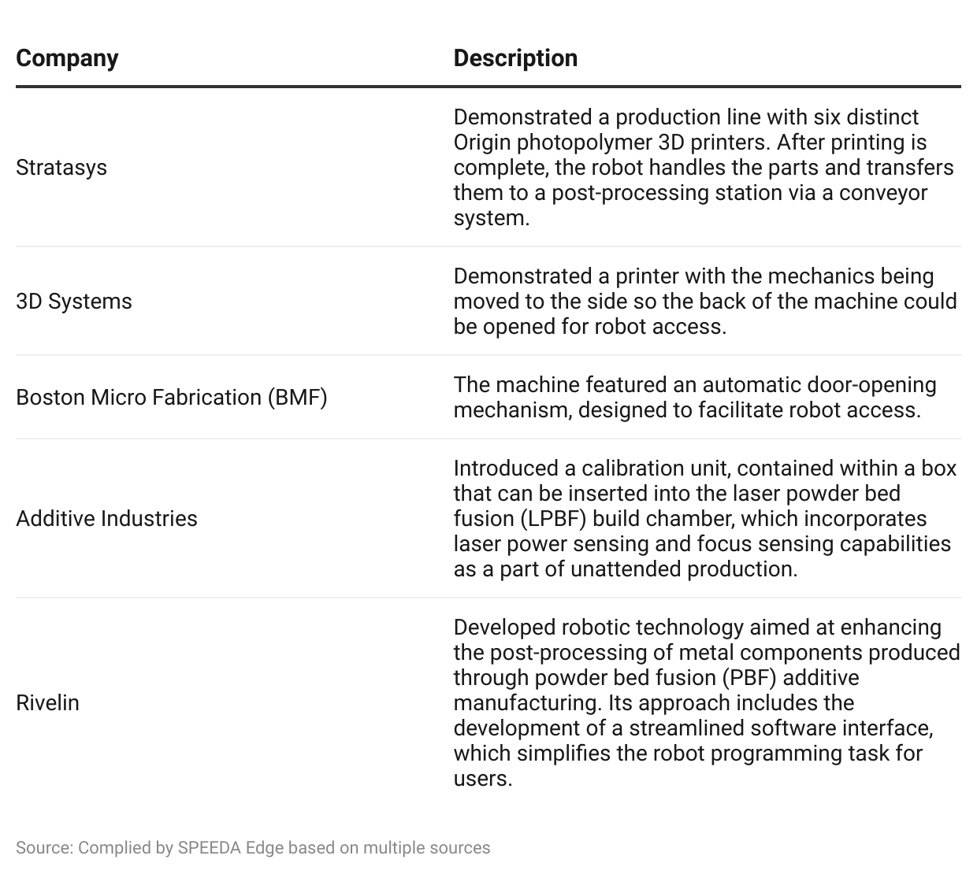

Moreover, modern AM printers can also be connected to the cloud (via software) to collect data from the existing fleet of printers to enhance future R&D capabilities (e.g., Blacksmith software by [MarkForged](https://sp-edge.com/companies/174035)). These printers can also be operated remotely, allowing engineers to access and control printers remotely to develop and produce designs.

## **Availability of standards relating to AM promotes wide-scale industrial adoption**

Several international as well as national institutions have introduced various standards relating to AM, helping achieve conformity among the players in the market and enabling large-scale industrial adoption. Some prominent institutions that have introduced standards include the International Organization for Standardization (ISO-international level), the American Society for Testing and Materials (ASTM-US), National Aeronautics and Space Administration (NASA-US), European Union Aviation Safety Agency (EASA-EU), and the FDA. These institutions have introduced 1) general standards (concepts, common requirements, guidelines, and safety requirements), 2) standards relating to broad categories of materials and processes, and 3) standards relating to specific materials, processes, and applications.

# **Demand drivers**

## **1. The requirement to innovate faster and reduce lead time to the market**

Changing market dynamics requires manufacturers to innovate and introduce new products to the market faster. For starters, customers tend to switch brands if a product is not available when they look for it. A 2023 [PwC](https://www.pwc.com/gx/en/industries/consumer-markets/consumer-insights-survey.html) survey carried out across 25 countries revealed that 43% of respondents highlighted improved product availability and competitive pricing as crucial factors influencing their purchase decisions. These demands have driven manufacturers to improve time to market through technologies like AM. Increasingly, consumers also look for personalized products. Around 83% of respondents in a 2020 [CITE Research](https://www.3ds.com/newsroom/press-releases/ces-2020-survey-cite-research-dassault-systemes-consumers-want-personalized-products-wont-wait-them-and-expect-cost-benefit-their-data) survey on personalization in healthcare, mobility, and retail industries indicated that they want to see adaptations to products or services within hours, with only around 21% willing to wait for four or more days. Businesses that were highly responsive to market trends were more likely to report outperformance in areas like innovation, growth, financial performance, and operational resiliency, relative to slower counterparts.

### 

### 

### 

### 

### 

### 

### **% of respondents to a survey reporting outperformance compared to peers**

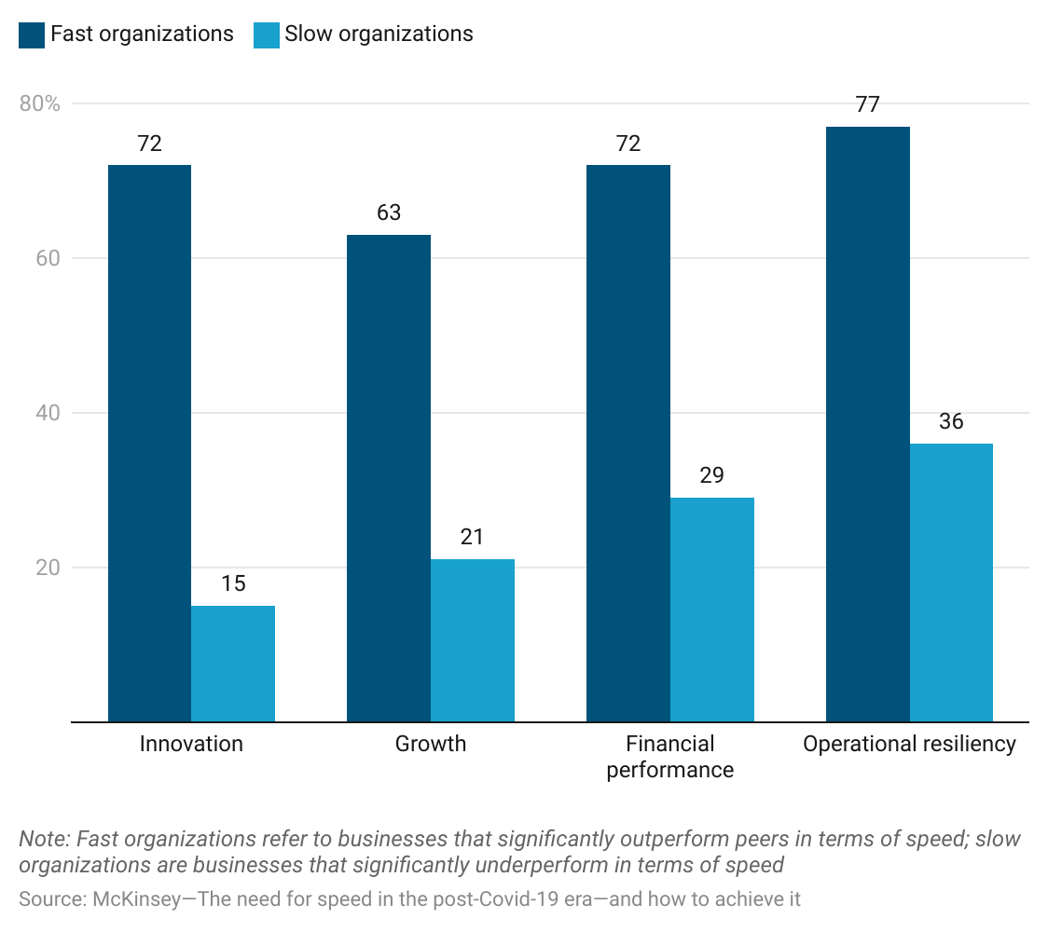

In improving speed to market, one of the major limitations manufacturers face is the time it takes for design and prototyping, as traditional subtractive methods can take weeks or even months to design and develop prototypes, adding to the cost and lead time. This limitation is addressed by AM, with its ability to design and print parts instantly or in less than 24 hours. The availability of desktop 3D printers further expedites prototype development at a lower cost.

## **2. Ability to create almost any 3D shape with precision**

Around 24% of respondents (mostly from an engineering background), in a 2022 survey by [Sculpteo,](https://www.bing.com/ck/a?!&&p=3be3d8ca5f75f24eJmltdHM9MTY5MzI2NzIwMCZpZ3VpZD0xYzk1OTQxYi05MDJkLTZmNWQtMjhiZC04NzI0OTEyYzZlYzcmaW5zaWQ9NTE5OQ&ptn=3&hsh=3&fclid=1c95941b-902d-6f5d-28bd-8724912c6ec7&psq=sculpteo+the+state+of+3d+printing&u=a1aHR0cHM6Ly93d3cuc2N1bHB0ZW8uY29tL2VuL2Vib29rcy9zdGF0ZS1vZi0zZC1wcmludGluZy1yZXBvcnQtMjAyMi8&ntb=1) indicated that the most important thing achieved by 3D printing was its ability to accelerate the product development process. AM allows the creation of innovative designs, such as hollow designs (objects with cavity/space inside) as a single piece, which is unattainable with conventional manufacturing techniques. This eliminates steps like bonding, drilling, and plating, which need to be performed if several parts are to be made and combined into a single piece. The ability to produce lightweight parts (with advances in materials explained previously) without compromising on functionality also improves demand for AM.

## **3. AM helps minimize inventory costs and limits supply chain disruptions**

A 2021 research study compared AM costs with traditional manufacturing (TM) methods and revealed that AM costs less than TM when the total cost of a part (including inventory holding cost) is considered. The cost differential is more pronounced for the production of spare parts or after-sale parts where annual tool maintenance and storage costs in the traditional manufacturing model can drive inventory holding costs to over 4x the production cost.

### **Comparison between AM and TM cost**

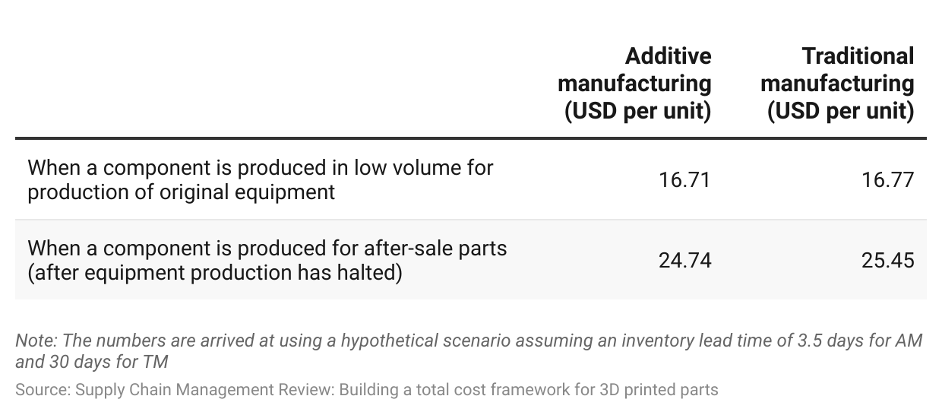

In general, AM allows manufacturers to streamline the supply chain and minimize disruptions without having to hold costly inventory. Components can be printed when needed, within hours or days, without the need for costly and time-consuming activities like forging or casting. AM also helps companies to be less reliant on transportation infrastructure and respond well to demand fluctuations by printing on-premise on demand.

## **4. Growing focus on sustainability in manufacturing**

The global move to reduce carbon footprints and shift to a circular economy will disrupt traditional approaches to manufacturing. Moreover, investments are likely to be directed toward sustainable operations and companies, with major economies focused on green investments like the EU Green Deal.

As one of the major industries to use virgin materials like aluminum and iron, the manufacturing sector will face increasing pressures to innovate. According to a 2022 report by social enterprise Circle Economy, 101.4 billion tonnes of virgin materials were used globally in 2021, up from 100 billion tonnes in 2019. Meanwhile, recycling and reusing stagnated at 8.6% of the materials used. If climate targets are to be achieved, the level of virgin material usage has to be limited and recycling improved. AM will enable the manufacturing sector to achieve these targets, as it significantly reduces material waste while promoting recyclability. For instance, In October 2022, Desktop Metal announced a partnership with Siemens to promote additive manufacturing, with a focus on binder jetting technology, reducing waste, and streamlining supply chain operations.

# **Risks to growth**

## **1. Small-scale manufacturers may lag in adoption due to financial and demand uncertainties**

Small manufacturers represent around 99% of all US manufacturing companies. These players usually lag behind larger-scale counterparts in terms of technology adoption. Concerning AM specifically, small manufacturers may face certain issues with adoption according to the American Economic Association. Specifically, these companies may lack affordable access to the financing required to support the initial investment and not see clear demand signals from customers on the willingness to accept 3D AM products.

Five large US manufacturers (GE Aviation, Honeywell, Siemens Energy, Raytheon Technologies, and Lockheed Martin) have taken steps to mitigate this issue. In May 2022, the companies announced “AM Forward,” a voluntary agreement that enables and supports their suppliers in the adoption of AM. The Federal Government also pledged support to offer financial, technical, and training support to small firms as well as to develop the necessary standards for the use of AM.

## 

## 

## **2. Practical use of AM could require integration of different vendor solutions, which is sometimes unfeasible**

Despite the availability of various AM solutions in the market, manufacturers may still face integration issues when combining designing, manufacturing, and post-processing solutions from different vendors. Moreover, 3D printer systems typically require vendor-specific software, which may not integrate well with other software solutions.

For example, Desktop Metal’s build preparation software is compatible with only a few leading third-party software providers like Materialise and Autodesk. Further, its system cannot use third-party materials, as this would result in the cancellation of the system warranty. Apart from the integration issues, this could also mean that companies developing only the AM software or AM materials will not have adequate opportunities to penetrate the market.

## **3. Potential health hazards for workers**

While any manufacturing process is susceptible to health hazards, AM presents several unique health threats to workers. This includes

* Inhalation of powders and dermal exposure: AM typically uses materials in powdered form, which could be inhaled by workers or come into contact with their skin or eyes, causing possible irritation, allergic reactions, or other damage.
* Exposure to potentially hazardous energy sources: AM uses various energy sources like lasers and electron beams that could cause harm to the eyes and skin.
* Thermal hazards: The use of heated nozzles can result in thermal burns if not handled properly.

These health hazards will require the development of AM-specific occupational health and safety protocols. The American National Standards Institute (ANSI) has introduced several standards to address these AM-specific health hazards.

*Last updated: September 2023*

# ©2024 Uzabase, Inc. All Rights Reserved. The information contained herein: (1) is proprietary to Uzabase Inc. and/or its content providers; (2) may not be copied or distributed; and (3) is not warranted to be accurate, complete or timely. Neither Uzabase Inc. nor its content providers are responsible for any damages or losses arising from any use of this information.