**Next-gen Satellites: Overview**

**What is a satellite?**

A satellite is anything that orbits a planet or star; by this definition, the Earth and the moon are natural satellites. However, the word satellite generally refers to an artificial, man-made machine that is launched into space to orbit a planet or star. While satellites come in different sizes and shapes, they typically have at least two parts: the antenna and the power source. The antenna sends and receives information, and the power source is usually a solar panel or battery. Satellites could also carry other instruments such as cameras and scientific sensors. Some satellites are even habitable, such as the International Space Station (ISS), which functions as a lab, observatory, and landing base for expeditions. Satellites are launched into space on rockets, and they orbit Earth when their speed is balanced by the pull of Earth's gravity.

The bird's-eye view of a satellite allows it to see broader areas of Earth as well as space simultaneously, enabling it to collect more data faster than instruments on the ground.

Observation satellites (used for Earth observation from orbit to gather information about Earth's physical, chemical and biological systems through remote sensing technologies and cameras), communication satellites (transmits the signal via a transponder), and nanosats (satellites weighing less than 10 kilograms) collect data in their respective orbits which is then is transmitted to ground stations on Earth. Using data centers and the cloud, tech firms can process the data and send it directly to people's devices.

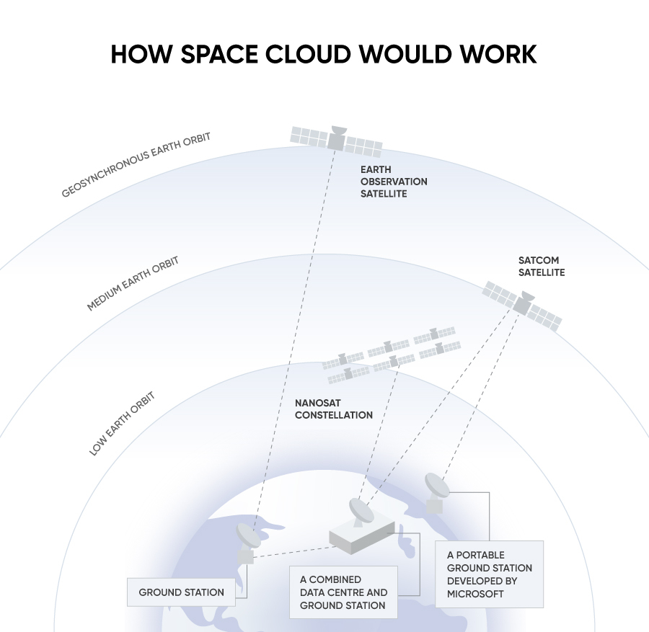

Source: BBC

**What are satellites used for?**

As mentioned, satellites play a crucial role in modern society, supporting varied industries and, ultimately, the world economy. Satellite-powered services have come a long way since the launch of Sputnik I, the first satellite, back in 1957. Their uses range from simple navigation systems on our phones to real-time guidance for weapons systems and aircraft used by the military as well as the booming IoT and AI technologies.

While satellites were traditionally used for weather forecasting, communications, and TV services, they are now attracting tech giants such as Microsoft to support cloud computing services with a global network of satellites.

**Uses of satellites**

|  |  |  |  |
| --- | --- | --- | --- |
| **Purpose** | **% of total satellites** | **Description** | **Example** |
| Communications | 70.0% | • Used for television, radio, and internet broadcasting    • This sector has gained traction in the recent past, with many companies launching satellites to provide internet everywhere on the globe | • Starlink: A satellite internet constellation operated by SpaceX providing satellite internet access coverage to most of the Earth  • OneWeb: A communications company whose focus is to deliver broadband satellite internet services worldwide  • Iridium: An operational constellation of 66 active satellites used to provide global satellite phone service  • GlobalStar: A satellite phone and low-speed data communications |
| Earth observation | 19.4% | • Provide information about earth resources, weather, climate, and environmental monitoring  • Imaging satellites (a sub-segment) produce high-resolution data of almost the entire landmass on earth | • Landsat program: A joint NASA/USGS program launched on July 23, 1972  • Doves Satellites: Operated by Planet Labs PBC, the Doves Satellites weigh only 5.8 kg each and provide 3-meter multispectral image resolution for humanitarian and environmental applications, from monitoring deforestation and urbanization to improving natural disaster relief and agricultural yields around the world |
| Localization | 2.9% | • Localization via satellite navigation systems is widely used in almost all industries: transportation, emergency response, farming, banking, military, science  • These satellites determine the location, velocity, and current time of small electronic devices (like the ones on smartphones) | • GPS: The US' Global Positioning System, originally Navstar GPS, was launched in 1973, by the US Department of Defense  • GLONASS: The Russian space based satellite navigation system. Its development began in 1976  • BeiDou: The Chinese global navigation system. The first system was launched in 2000  • Galileo: Created by the EU through the European Space Agency, which went live in 2016 |
| Space observation | 1.7% | • Have been critical to understanding phenomena like pulsars and black holes as well as measuring the age of the universe | • James Webb Space Telescope: A collaboration between NASA, ESA, and Canadian Space Agency (CSA), this is the largest optical telescope in space with the capability to take high-resolution images, launched in 2021  • Hubble Telescope: Launched into low Earth orbit (LEO) in 1990 and remains in operation today |

Source: SatelliteXplorer, NASA

**Next-gen Satellites: Segmental Overview**

While there are many areas in the spectrum of satellite services, our Insight focuses on Earth-based services including satellite launch, satellite management, miniature satellite developers, miniature satellite components, data platforms, and mapping and location intelligence.

**Next-gen Satellites - Segments**

|  |  |  |
| --- | --- | --- |
| **Segment** | **Description** | **Notable startups** |
| Satellite launch | Companies that offer launch capabilities to get satellites into orbit, including last mile delivery of satellites and value-added services including launch mission planning and execution | [SpaceX](https://sp-edge.com/companies/26250), [Rocket Lab](https://sp-edge.com/companies/273679), [Terran Orbital](https://sp-edge.com/companies/337087), [Firefly Aerospace Inc](https://sp-edge.com/companies/712983), [Loft Orbital](https://sp-edge.com/companies/568896) |
| Satellite management services | Companies that provide satellite management services once they are deployed | [D-Orbit](https://sp-edge.com/companies/309851), [Astrocast](https://sp-edge.com/companies/511852), [Open Cosmos](https://sp-edge.com/companies/528132) |
| Miniature satellite developers | Includes companies that develop satellite buses and payloads for mini, micro and nano systems | [German Orbital Systems](https://sp-edge.com/companies/507475), [Endurosat](https://sp-edge.com/companies/611637), [AerospaceLab](https://sp-edge.com/companies/785464) |
| Miniature satellite components | Includes companies that manufacture components for mini, micro, nano, and picosatellite systems | [AAC Clyde Space](https://sp-edge.com/companies/1059392), [Morpheus Space](https://sp-edge.com/companies/733918), [Novo Space](https://sp-edge.com/companies/818105) |
| Data platforms, mapping, and location intelligence | Satellite companies that offer location-based intelligence, navigation, mapping, spatial awareness, and data analytics services as their offering | [Satellogic](https://sp-edge.com/companies/120473), [Umbra,](https://sp-edge.com/companies/574930) [Ursa Space Systems](https://sp-edge.com/companies/341972), [Capella Space](https://sp-edge.com/companies/406546) |

*Source: SPEEDA Edge research*

However, we do not include companies operating in the following areas:

1. Companies using satellites to supplement their operations, but not mainly focussing on satellite-based services (e.g., telecom companies, broadcasting service providers).
2. Companies engaged in orbital refueling, repairs, satellite life extension, and end-of-life service (these are covered under the *Space Debris Management* segment in [*Next-Gen Space Tech*](https://sp-edge.com/industry/77)).
3. Companies providing space exploration solutions (these are covered under the [Space Travel and Exploration Tech](https://sp-edge.com/industry/77))

**What’s driving the increase in satellite launches?**

**Number of satellite launches per year**

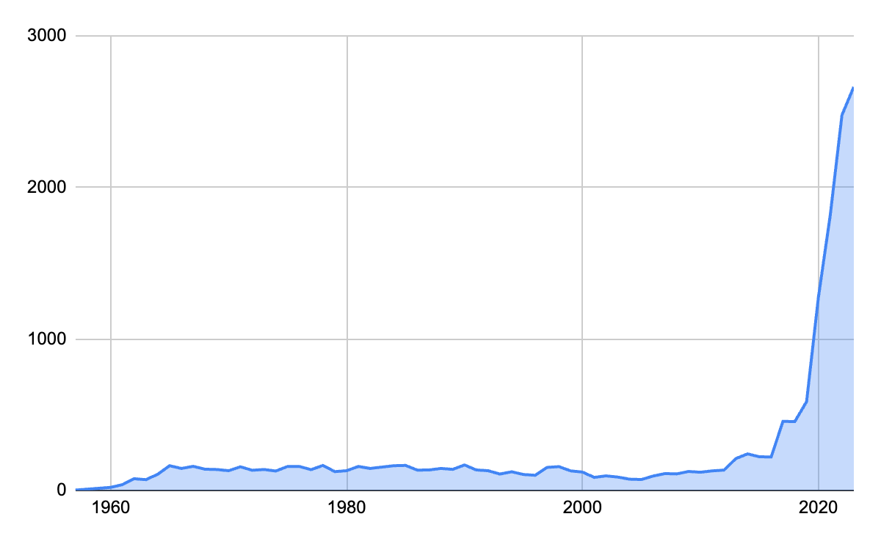

Source: UN Office for Outer Space Affairs

1. **Declining launch costs have enabled easier access to orbit**

The involvement of the private commercial space sector has led to innovation and technological advances. These have modernized traditional and pricey space practices and brought down the per-launch cost by building more efficient spacecraft and reusing rockets and components. NASA’s space shuttles, which were retired in 2011, cost USD 1.6 billion per flight on average (~USD 30,000 per pound of payload in 2021 dollars) to reach LEO, while, in 2022, [SpaceX](https://sp-edge.com/companies/26250) charges only around USD 67 million per launch on average (~USD 1,300 per pound of payload).

Furthermore, the environment is more competitive, with technology giants driving demand and consolidation in the value chain, helping establish economies of scale to reduce costs.

**Heavy launch vehicle costs of US spacecraft over the years**

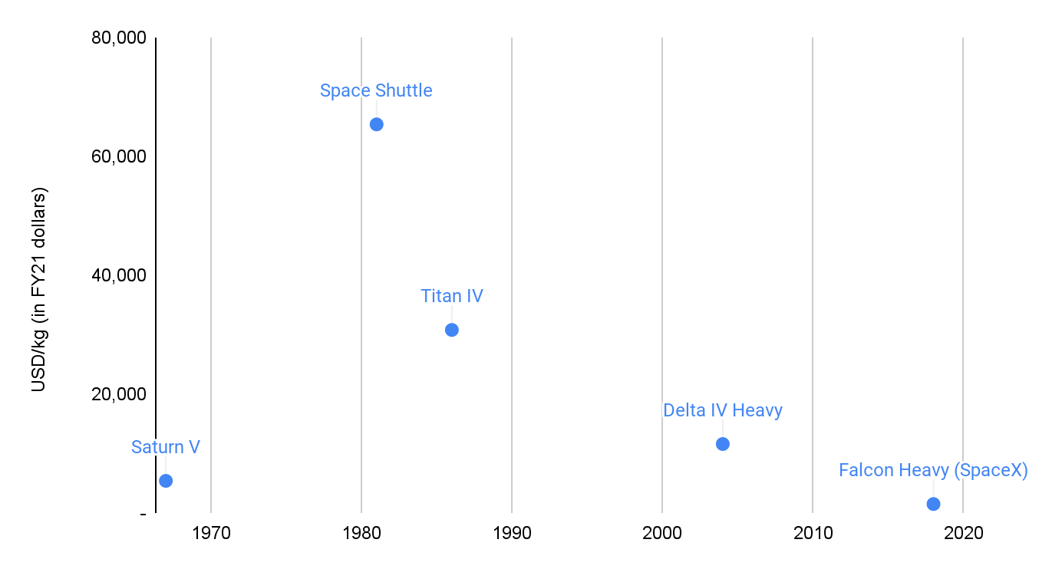

Source: CSIS Aerospace Security Project

|  |  |
| --- | --- |
| **Tech giants increasing exposure to satellites** | |
| **Company** | **Description** |
| Microsoft | Partnered with SpaceX through Azure Space, which plans to combine Microsoft's cloud computing services with a global network of satellites. |
| Amazon | Amazon's subsidiary Kuiper Systems LLC is preparing to launch two test satellites for its Project Kuiper satellite internet constellation in early 2023. |
| Apple | Partnered with Globalstar to provide emergency satellite texting services and announced a [USD 450 million investment](https://www.apple.com/newsroom/2022/11/emergency-sos-via-satellite-made-possible-by-450m-apple-investment/), a majority of which will go to Globalstar. |
| Alphabet | Sold its satellite imaging business, Terra Bella, to Planet Labs in [2017](https://www.reuters.com/article/us-alphabet-terra-bella-sale-idUSKBN15I2Y8). |
| Meta | Partnered with Eutelsat to provide broadband services via satellite across several regions in sub-Saharan Africa. |

Source: SPEEDA Edge research

1. **Smaller satellites allow easy mass production**

In addition to lower launch costs, satellites are now much smaller and cheaper than their predecessors. Traditionally, the cost of developing and launching a satellite to enable communications or collect data has been in the hundreds of millions of dollars range; at present, a nanosatellite could be launched to LEO for as low as USD 100,000, opening up the space to private and academic entities.

**Nanosatellite vs traditional satellite**

|  |  |  |
| --- | --- | --- |
|  | **Nanosatellite** | **Traditional satellite** |
| Weight | 25–50kg | 2–6 tonnes |
| Dimension | ~2 shoe boxes | ~1 bus |
| Price | USD 100,000–1 million | USD 500 million–3 billion |
| Orbit | LEO (160–1,000km above the Earth) | Geostationary orbit (35,786km above the Earth) |

Source: BBC Research

One of the biggest advantages of a nanosatellite is that it could be developed and launched in less than eight months[1]. This is much faster than with larger satellites, which could take years (even up to 15 years). Therefore, nanosatellite constellations offer a system in which useful life and obsolescence are no longer concerns. Due to the very nature of nanosatellites, constellations are always replenished, resulting in a consistent, cutting-edge system that always keeps up with new technology.

Micro-launchers have also emerged because of smaller satellites, ones specially designed to launch batches of small satellites, further reducing launch costs and increasing the number of satellites placed in orbit per rocket launch. Another significant advantage of smaller satellites is that if one fails or is destroyed, a replacement could be rapidly put up, from anywhere on Earth.

**Satellite mass classification**

|  |  |
| --- | --- |
| **Type** | **Mass** |
| Large satellites | Over 1,000kg |
| Medium satellites | 500-1,000kg |
| Small satellites | Less than 500kg |
| * Minisatellites | 100-500kg |
| * Microsatellites | 10-100kg |
| * Nanosatellites | 1-10kg |
| * Picosatellites | 100g-1kg |
| * Femtosatellites | 10-100g |
| * Attosatellites | 1-10g |
| * Zeptosatellites | 0.1-1g |

Source: [Nanosats.eu](https://www.nanosats.eu/cubesat)

**What are the risks?**

Humans rely heavily on satellites for smooth day-to-day operations ranging from banking to transport and defense; this high reliance is also linked to inherently growing risks. Any disruption to satellites could have significant effects, which could disrupt the global economy and even put lives at risk.

1. **The rise in orbital debris increases the risk of collision**

The rapid increase in spacecraft and satellites, especially mega constellations, has resulted in increased space debris, threatening the orbital space. If space waste is not managed, it could lead to Kessler Syndrome, where orbital junk around Earth reaches a point where it creates more and more space debris through collisions, causing problems for satellites, which could disrupt internet, weather, and communication services. Furthermore, the growth in satellites has polluted the night sky for stargazers and astronomers.

In May 2022, over 31,000 debris objects were tracked by space surveillance networks. While not all debris objects are tracked, based on estimates from statistical models, there were ~36,500 pieces of space junk greater than 10cm. Even smaller space debris (~1 million space debris objects between 1cm to 10cm and 130 million space debris objects from greater than 1mm to 1cm[2]) is considered dangerous, as these objects travel at extreme orbital speeds, posing a risk to human and robotic spaceflight.

**Increase in tracked space debris over the years**

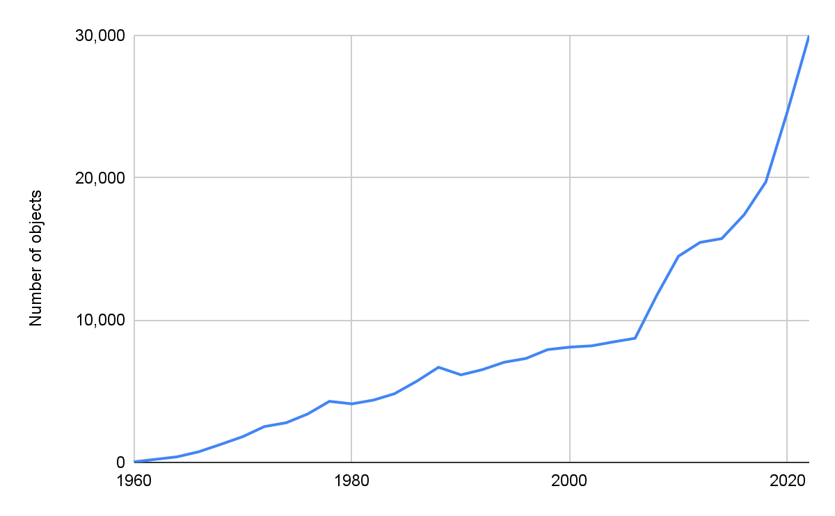

Source: ESA Space Environment report 2022

1. **Regulations and possibility of international disputes**

The current rules of space stem from the Outer Space Treaty that was developed around 50 years ago. It is somewhat outdated, as it was not designed to deal with the high volume of space activities we currently have. The treaty requires the exploration and use of outer space to be free, in the interests of all countries, and not subject to any claim of national sovereignty. However, space is not democratic, and countries with high space funding such as the US, China, and Russia account for the most number of satellites in space, possibly taking away the opportunities of other countries that currently do not have sufficient funding.

Currently, in the LEO, the placement of satellites is on a first-come-first-served basis, contradicting the Space Treaty. Furthermore, there is no law regarding whether or not a company or nation can claim ownership over asteroids, the lunar surface, and rare metals and minerals found in space. Any international disputes are likely to have a significant impact on the activities of the private companies involved in this industry.

Furthermore, some countries (such as China and Russia) limit their citizens' access to the internet. However, inter-satellite communication could allow constellations to get around those limitations and could result in unfavorable political and economic repercussions.

1. **Increased risk for potential radio frequency interference**

The increasing satellite constellations will use microwave radio waves, which could carry a risk of ground-based receivers being overloaded with electromagnetic radiation, causing potential radio frequency interference.

**What’s next?**

Satellites have become increasingly popular with the internet's impact on global communications connectivity and the reliance on IoT-connected devices. With many new innovations solely based on the power of satellites, coupled with the decrease in size and cost, the industry is poised to continue its growth momentum over the next decade.

**The world space industry over two decades**

|  |  |  |
| --- | --- | --- |
|  | **2012–2021** | **2022–2031** |
| Number of satellites to be launched | 3,816 | 17,041 |
| Satellite mass to be launched in tonnes  *Of which commercial constellations* | 2,604  *14%* | 5,422  *46%* |
| Satellite industry revenues over the decade  *Of which commercial constellations* | USD 230 billion  *5%* | USD 320 billion  *8%* |
| Manufacturing revenue  *Of which commercial constellations* | USD 173 billion  *4%* | USD 234 billion  *15%* |
| Launch revenues  *Of which commercial constellations* | USD 57 billion  *6%* | USD 86 billion  *10%* |

Source: Euroconsult estimates

Much of future demand would be driven by constellations, and there are several initiatives on mega-constellations of small satellites in LEO planned for the next decade. Companies like SpaceX have applied for permission to deploy nearly 30,000 broadband craft, out of which the US Federal Communications Commission approved the deployment of 7,500 Starlink 2.0 satellites in LEO in December 2022.

Physical and digital worlds are merging thanks to technologies like 5G, blockchain, and AI as well as big data, all of which are made possible by satellite networks.

1. <https://alen.space/basic-guide-nanosatellites/>
2. https://www.esa.int/Safety_Security/Space_Debris/Space_debris_by_the_numbers