# **Buy Now, Pay Later: Overview**



## **Buy now, pay later brings installment financing to the checkout**

Buy now, pay later (BNPL, also referred to as “point-of-sale financing” or “installment financing”) is an evolution of traditional layaway plans that allows customers to purchase a product and pay over time. However, unlike layaway plans, mainly used for big-ticket items such as furniture or electronics that the customer receives upon full payment, BNPL allows a consumer to own the product immediately. It is even suited for short-term financing for smaller-ticket items, driving its recent surge.

BNPL provides deferred payment options to shoppers at checkout, either online or in-store. The BNPL provider pays the merchant in full for the goods upfront. The customer then pays for the goods in installments, typically over 2–6 months, which go to the BNPL provider instead of the merchant. The BNPL provider screens the shopper (soft check or hard check; the latter is reported to the credit bureau), approves the plan, and assumes the credit risk. The provider partners with third-party lenders to originate loans and pays interest in return. Although this is the most common way to fund loans, larger BNPL providers also offer loans through their balance sheets (e.g., Affirm).

### 

### 

### **How BNPL works**

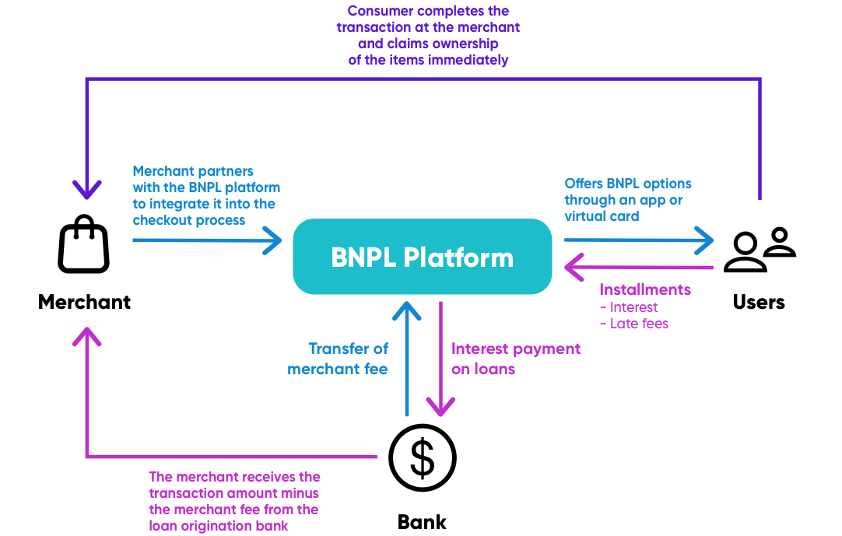

Source: SPEEDA Edge research

Increased smartphone penetration (~88% in 2024 vs. 71% in 2015) coupled with increased smartphone usage (~50% of US citizens spend nearly 5–6 hours on their smartphones daily, as of 2024) and advancements in machine learning and AI have contributed to more sophisticated underwriting models, allowing BNPL companies to minimize their credit risk.

BNPL is commonly considered a substitute for credit cards with a number of noteworthy advantages, including greater accessibility via merchant checkouts, shorter credit approval processes with no impact on customer credit scores, and more favorable repayment terms.

### 

### **BNPL vs. credit cards**

BNPL solutions can be categorized into four broad segments: Business-to-consumer (B2C) apps, B2C apps and virtual cards, Business-to-business (B2B) solutions, and BNPL infrastructure solutions.

### **The BNPL landscape**

## **The US market lags in BNPL adoption, while Sweden, Germany, and Norway are among the top-ranked**

The BNPL market has witnessed a higher uptake in European and Australian markets, which are dominated by large players such as Klarna, Afterpay, and Zip Co. Sweden, Germany, and Norway rank among the top three in BNPL adoption across Europe, where BNPL’s share of ecommerce payments accounts for 21% in Sweden and Germany, and 15%in Norway as of 2024. Australia is also a notable market, with a 15% share of ecommerce payments, placing them in the top five. In the Middle East and Africa region, 2% of ecommerce payments are through BNPL channels in the UAE, South Africa, and Nigeria, followed by 1% in Saudi Arabia as of 2024.

While there is a growing number of startups in the US, it ranks outside of the top 10 countries, as BNPL transactions account for only 5% as of 2024 (vs. 4% in 2021) of ecommerce payments. The low penetration rate reflects the growth potential, making it a key market for prominent players looking toward the future. In line with this, in 2024, startups such as [Zip](https://sp-edge.com/updates/25676) and [Sezzle](https://sp-edge.com/updates/29582) raised funding to expand existing operations in the US, and [Klarna](https://sp-edge.com/updates/25907) and [Affirm](https://sp-edge.com/updates/30241) launched new offerings targeted at the US market.

### **BNPL adoption in ecommerce payments among top 10 countries**

## **Commission-based merchant fee is the key revenue generator**

A majority of BNPL providers operate in the B2C segment, and a commission-based model is common across both B2C and B2B segments. They provide short-term financing at no cost to shoppers while charging interest on long-term financing, depending on the transaction value. BNPL providers generate the majority of revenue through merchant fees (a percentage of the transaction value), followed by customer fees, and interest income. Companies providing infrastructure also charge a one-off implementation fee in addition to commission-based revenue from merchants. Common revenue streams for B2C BNPL platforms are detailed below.

### **Common revenue streams for BNPL products**

# **Driving factors**

## **1. Financial insecurity among Millennial and Gen-Z populations could drive BNPL usage**

Millennials and Gen-Z have emerged as the leading users of BNPL, accounting for 32% and 37%, respectively, of BNPL transactions in the US in 2023. Furthermore, Millennials and Gen-Z rank below their generational counterparts in terms of average credit card debt in the US as of 2024. For the age groups of 18–34 and 35–44, median credit card debt amounted to USD 1,700 and USD 2,900, respectively. It was higher for age groups of 45–54 and 55–64, amounting to USD 3,000 and USD 3,500, respectively. This can be partly attributed to below-average credit scores (due to high amounts of student debt, particularly by millennials), making it difficult to secure credit.

### **BNPL usage across age groups**

Millennials and Gen-Z have become more financially insecure following economic instability coupled with specific issues such as mounting student loan debt. These consumers often turn to BNPL as an alternative to high-interest credit cards and other costly credit options. In addition, BNPL is sought after by individuals with low credit scores, those who have filed for bankruptcy, and those with limited liquid assets.

According to survey data collected by the Federal Reserve Bank of Boston, on average, BNPL users had USD 2,179 in their checking account, whereas non-users had USD 6,638 in 2023. It was also reported that 71% of BNPL users revolved on their credit cards in 2023 compared with 40% of non-users.

### **Financial characteristics of BNPL users vs. non-users**

## **2. Growth in consumer spending and ecommerce sales boosts BNPL transactions**

The US Census Bureau estimates that the top 5% of earners would experience 23.5% growth in incomes between 2019 to 2022. It was also reported that the collective net worth of the bottom 20% of income earners has also grown by 27% to USD 4.2 trillion at the end of Q2 2023, up from USD 3.3 trillion in 2019. As consumers have more disposable income, they are more likely to spend on non-essential goods and services, increasing overall retail sales. Increased discretionary spending often aligns with a desire for convenience and improved lifestyle, which can drive consumers to seek flexible payment options like BNPL.

Retail trade in the US has increased to USD 7.2 trillion at a CAGR of 8.2% over 2018–2023, while ecommerce sales have increased to USD 1.1 trillion at a CAGR of 21.4% over the same period. The percentage of ecommerce sales to retail sales has increased to 15.3% in 2023 from 9.6% in 2018. The double-digit growth in ecommerce sales can be attributed to the increased convenience provided for shoppers with access to a wide range of products and services, often integrated with BNPL options at checkout. Ecommerce sites leverage data analytics to target consumers with personalized offers, including BNPL promotions, which can increase the usage of such installment payment options.

### 

### **Growth in annual retail and ecommerce sales between 2018 and 2023**

### 

## **3. BNPL improves customer experience while increasing order values and conversions**

Merchants view BNPL as a solution to improve the consumer shopping experience and acquire new customers. The additional payment option allows companies to appeal to younger adults, given that 42% of Gen-Z and 69% of Millennial shoppers are more likely to purchase if a BNPL payment method is offered.

Typical credit card interchange fees (the fee that the retailer pays the card-issuing bank) range between 1.3% to 3.5%. This is notably below average merchant fees of 2%–8% of the purchase price, charged by BNPL providers. However, merchants are willing to accept the trade-off in return for lower cart abandonment rates, which range between 56% to 81% in 2024 (down from 82% in 2021).

Further benefits include higher order values, increased conversions, and lower cart abandonment rates. For instance, merchants using Klarna witnessed a 65% increase in order values in-store and a 35% bump online. Moreover, merchants using Splitit reported an 11% decrease in their cart abandonment rates.

### **Top reasons for merchants to use BNPL**

# **Risks to growth**

## **1. Industry regulations could tip the scale to help or hinder the sector**

The BNPL sector is underregulated, but it recently attracted the attention of regulators in key markets due to its exemption from policies focused on interest-bearing products (e.g., credit cards). BNPL providers are able to skirt the regulations as they do not lend to consumers but facilitate installment financing. Regulatory changes can toughen the playing field by standardizing practices across the industry, potentially reducing the competitive advantage of BNPL platforms over traditional consumer credit products such as credit cards.

If regulations require BNPL providers to conduct more rigorous credit assessments on their users, platforms might need to invest in better credit scoring technologies and processes. It could reduce the ease and speed of approvals, potentially deterring some BNPL users who prefer the simplicity of current BNPL offerings. It could also lead to a shift in consumer behavior as users become more aware of the implications of using BNPL services and reduce the impulsive purchases that BNPL services often facilitate.

Regulators are tasked with striking a balance between the short-term growth of their players and the long-term sustainability of the sector while protecting consumer interests. Failing to achieve a desirable balance could lead to undesirable outcomes in the short term, such as stifling the growth of players or a growth bubble that would ultimately hinder the long-term prospects of the BNPL industry.

Regulatory authorities have scrutinized the lack of stringent credit checks and transparency in the sector. As a result, credit reporting agencies such as [Equifax](https://sp-edge.com/updates/7544), [Experian](https://sp-edge.com/updates/8091), and [TransUnion](https://sp-edge.com/updates/8391) announced plans to include BNPL transactions in consumer credit files, which could potentially alleviate concerns over the sector’s lack of transparency and fair treatment of customers. Recent developments in the regulatory space are listed below.

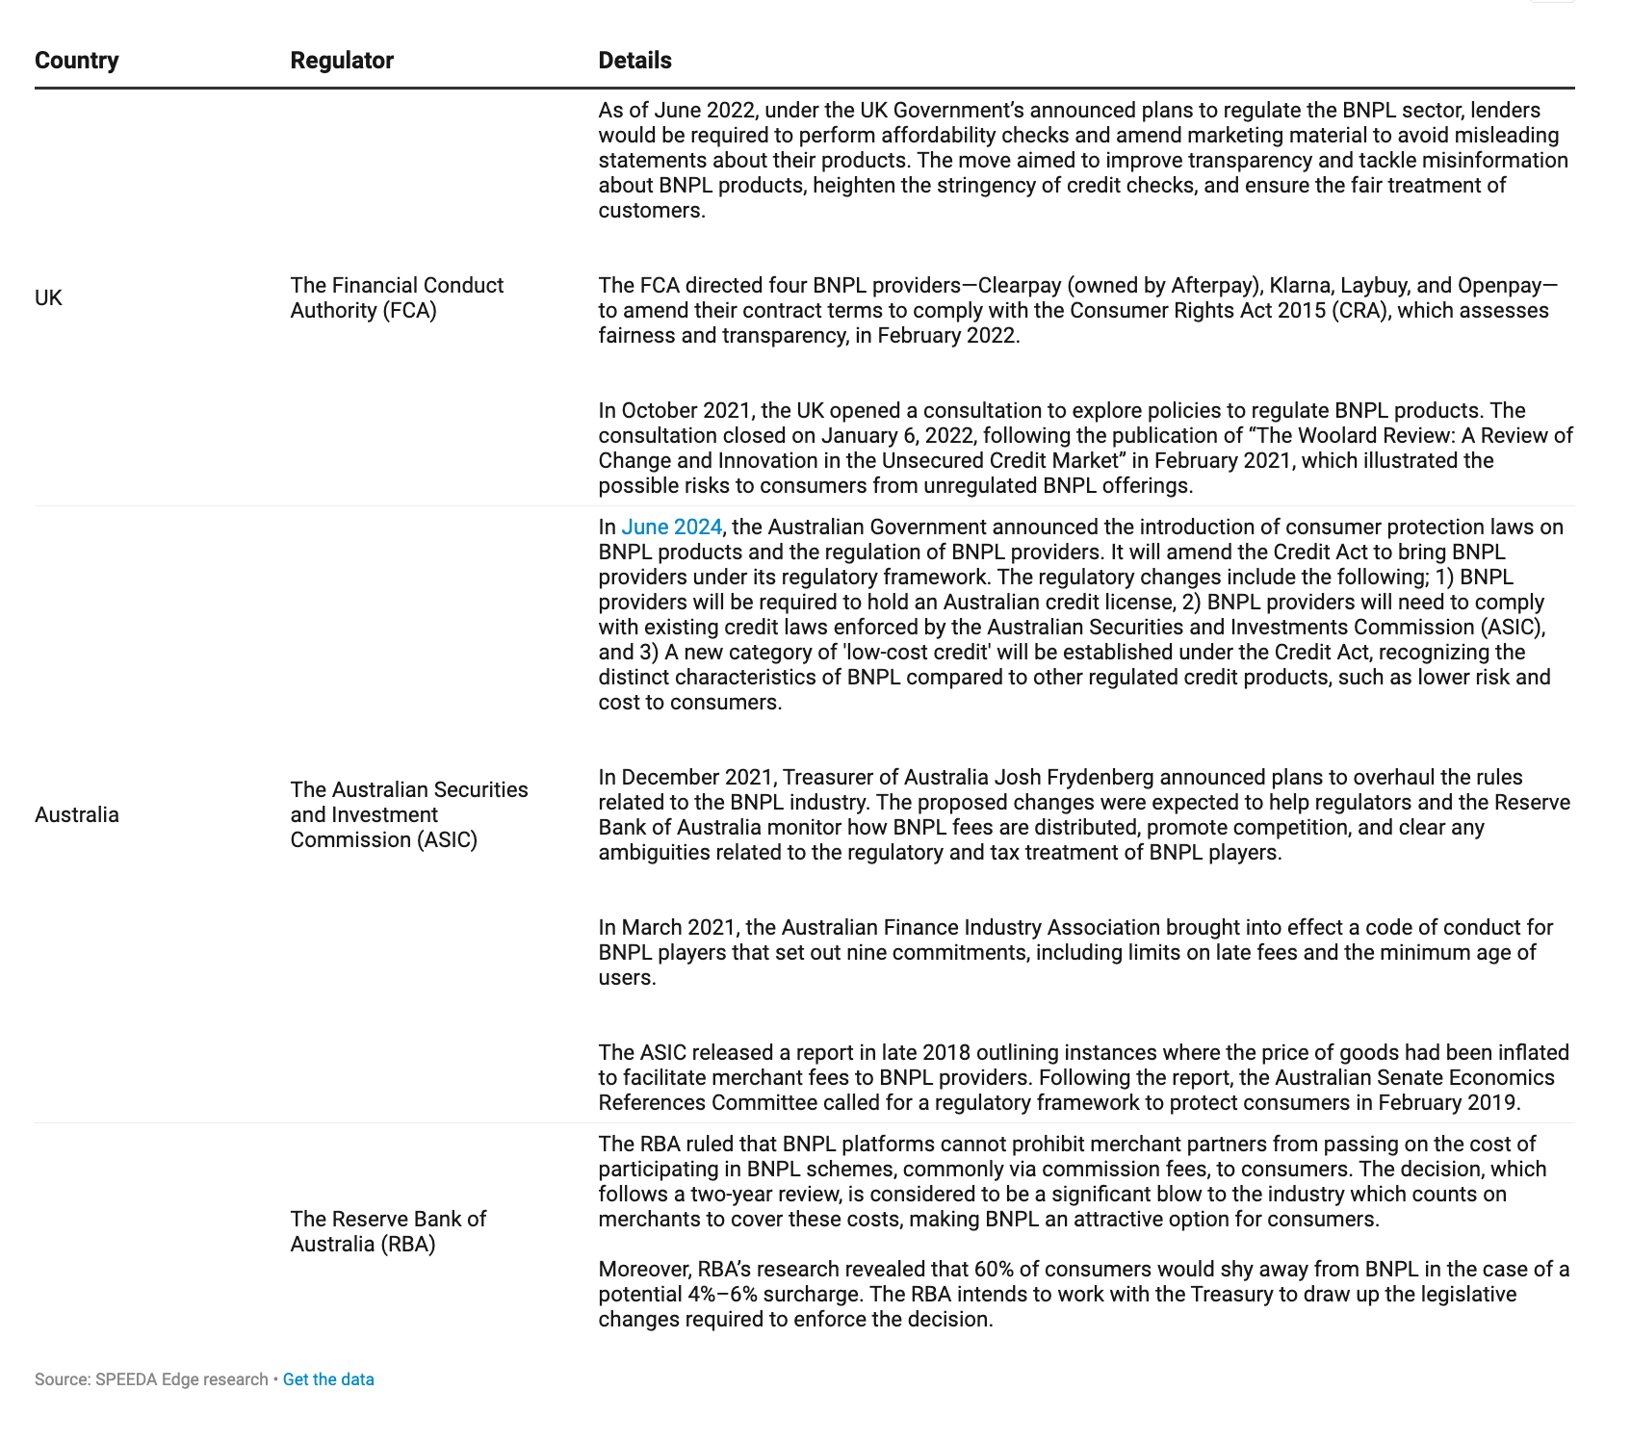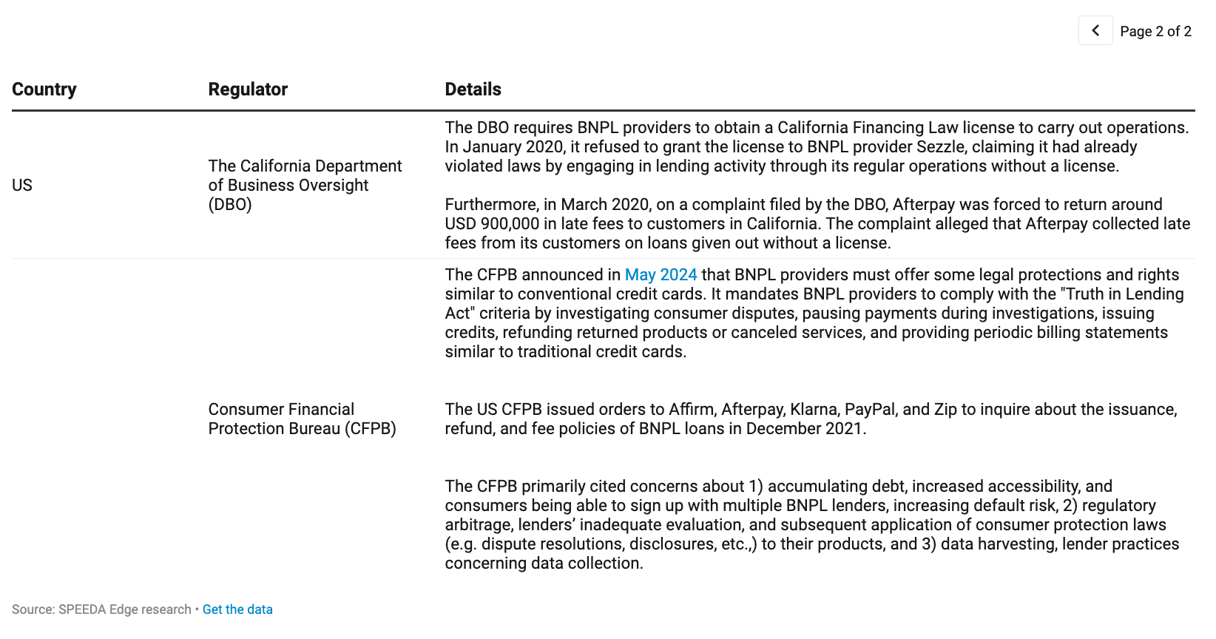

## **2. Profitability hinges on the ability to minimize credit and interest rate risk**

The easy access to credit offered by BNPL providers is likely to attract an adverse selection of customers (those with a higher default risk), which can expose providers to higher credit risk. Delinquency rates on credit cards stood at 3.2% by Q1 2024, and annualized delinquency rates on credit card balances were at 8.9%, as reported by New York Fed. Furthermore, due to the homogeneous nature of the services, merchants have a decreasing marginal benefit in signing up with many BNPL providers. As a result, a first-mover advantage is more pronounced; leading BNPL providers need to expand credit to gain market share. Therefore, the inability to correctly assess credit can threaten their quest for profitability.

While financial institutions have a distinct advantage in assessing credit risk, BNPL providers do not possess the same level of underwriting capabilities. This is especially true when players expand into new markets. For instance, Klarna cited the increase in credit losses in new markets as the main factor in posting an annual loss for the first time in FY2019.

Moreover, the rising interest rate environment witnessed in 2022 posed a significant threat to BNPL providers due to the higher cost of funds and lower demand for BNPL loans resulting from the consumer spending crunch amid rising inflation. As a result, BNPL leader Klarna [trimmed](https://sp-edge.com/updates/10641) its workforce and took a [significant hit](https://sp-edge.com/updates/11559) to its valuation. Block announced the [laying off](https://sp-edge.com/updates/26111) of around 1,000 employees associated with Cash App and Square in January 2024 due to declining revenues and growing losses with its subsidiary business units.

## **3. High merchant concentration could increase business risk for BNPL platforms**

Companies offering BNPL services do not compete solely on their product but also on the quality of retail partners where their offering is integrated. In partnering with popular merchants, they are able to attract a higher customer base, but they run the risk of being highly dependent on these merchants to drive their business. For instance, Affirm reported that its top five merchants represented nearly 42%, 32%, and 30% of total GMV for the financial years 2023, 2022, and 2021, respectively.

High reliance on a small number of merchants increases business risks to BNPL platforms arising from changes in those merchants' business decisions or financial health. If a key merchant decides to stop offering BNPL services or faces financial difficulties, the BNPL platform could lose a significant portion of its business, negatively impacting its revenue and growth. Merchants with high concentration can have significant leverage over the BNPL platform. They may demand lower fees or better terms, which may reduce the platform's profitability and limit the BNPL platform's ability to generate revenue and invest in further growth.

*Last updated: June 2024*

©2024 Uzabase, Inc. All Rights Reserved. The information contained herein: (1) is proprietary to Uzabase Inc. and/or its content providers; (2) may not be copied or distributed; and (3) is not warranted to be accurate, complete or timely. Neither Uzabase Inc. nor its content providers are responsible for any damages or losses arising from any use of this information.