**Cold chain innovation**

In our daily hustle and bustle, we rarely think about the sophisticated systems that make possible our mundane day-to-day activities like buying groceries, flowers, or medicine. What links these seemingly disparate activities is the cold chain, which is imperative in ensuring these temperature-sensitive products make their way to us in optimal conditions.

While we typically associate cold chains with basic refrigeration and cooling of goods, emerging technologies such as IoT, AI, and advances in packaging technologies have broadened the applications of the cold chain, allowing it to enhance efficiency, efficacy, and scope. These cold chain innovations are vital to keep up with evolving demands as a result of the expansion of the frozen food market, shifts in consumer dietary choices, and the globalization of food systems.

This Insight delves into the expanding world of cold chain innovations, examining the trends driving demand and the industry’s key players, challenges, and future outlook.

## **What is cold chain innovation?**

Cold chain refers to the process of transporting and storing temperature-sensitive products, such as perishable foods, pharmaceuticals, and vaccines, under controlled temperatures to maintain quality and safety. Our focus, cold chain innovation, refers to the development and implementation of new technologies, strategies, and practices within the cold chain industry.

These innovations typically involve the integration of temperature monitoring, IoT, AI, blockchain, automation, robotics, data analytics, etc. to improve the performance of cold chains by increasing efficiency and reducing waste and cost.

Solutions in the cold chain innovation space can be broadly divided into five: 1) packaging, 2) storage, 3) transportation, 4) temperature monitoring, and 5) cold chain management.

**Cold chain innovation segments**

|  |  |  |  |
| --- | --- | --- | --- |
| **Segment** | **Description** | **Notable startups** | **Notable incumbent products** |
| Temperature-sensitive packaging | Companies that design and produce packaging solutions to safeguard the integrity of temperature-sensitive products during transport. | va-Q-tec, Vericool, Woolcool | ORCA packaging by Intelsius  Sonoco Thermosafe healthcare packaging |
| Cold chain storage | Companies that provide cold chain storage solutions such as refrigerated facilities and warehouses for the secure storage of temperature-sensitive goods. | Ember, Zero2Cool, NewCold | UPS HealthcareTM Cold Chain Storage  United States Cold Storage owned by Swire |
| Transportation | Companies that facilitate the safe and controlled movement of temperature-sensitive goods from one location to another, employing specialized equipment and logistics. | Green Rabbit, Lineage Logistics, Tobin Scientific | One Partner. Many Solutions® by Burris Logistics |
| Temperature monitoring | Companies that offer technologies to track and maintain precise temperature conditions through the entire supply chain such as IoT sensors and temperature monitoring devices. | Samsara, Process Sensing Technologies, Sensaphone | SenseAware® sensors by FedEx  SmartSolutions IoT by DHL |
| Cold chain management | Companies that provide technology-driven solutions to optimize and manage parts or all of the cold chain process. | SkyCell, Modality Solutions, Roambee | AeroChain by Aerosafe  Captain Peter, virtual refrigerated cargo assistant by Maersk |

*Source: SPEEDA Edge research*

### 

Cold chain innovations are mostly implemented from the packaging phase of the supply chain. Sometimes, particularly in the pharmaceutical industry, these innovations extend to the stages of raw material procurement and processing. This occurs when chemicals integrated into medications need stringent temperature control throughout these earlier stages.

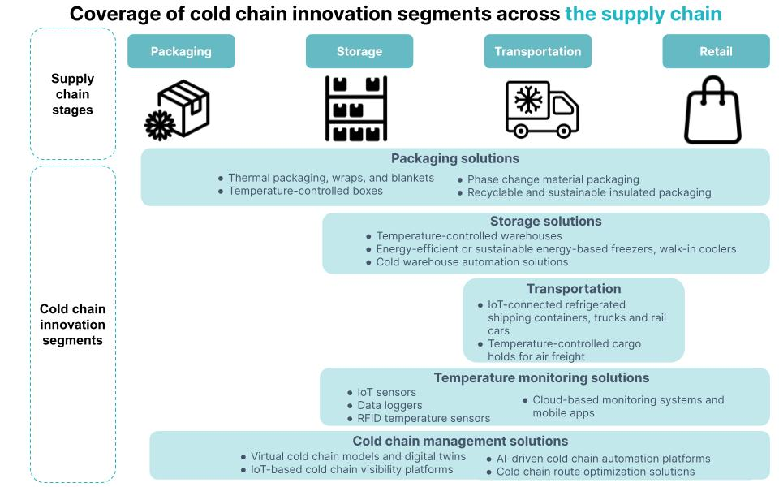

*Source: SPEEDA Edge research*

## 

## **What technologies are shaping the cold chain industry?**

**Refrigeration, cooling, and insulated packaging technologies have led to compact, long-lasting, and energy-efficient cooling technologies.** Refrigerated systems maintain the required temperature range in storage facilities, trucks, and containers. They include compressors, evaporators, and refrigerants. The development of packaging technologies such as insulated containers, thermal blankets, phase change materials, and vacuum-insulated panels help regulate temperatures and protect products during transit.

In addition, **a range of emerging technologies** are increasingly harnessed in modern cold chain solutions, significantly expanding their efficiency and capabilities.

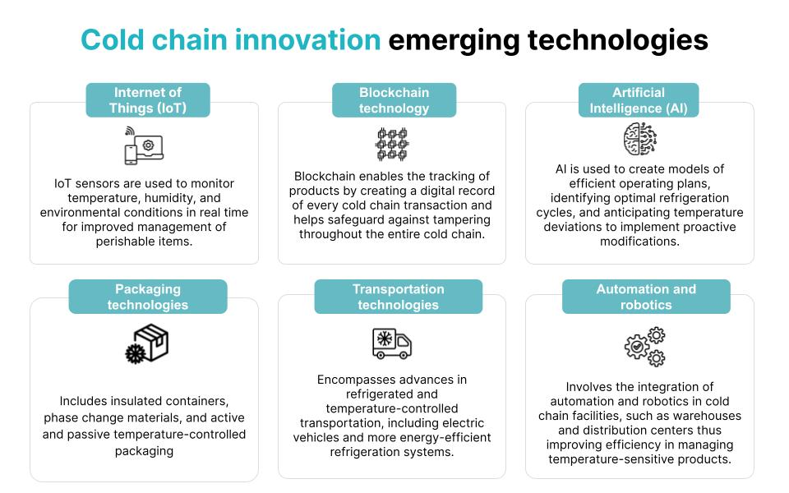

*Source: SPEEDA Edge research*

Investing in cutting-edge technologies like cloud computing, IoT, and RFID (radio frequency identification) allows cold storage operators to monitor and track their inventory in real time. This proactive approach helps reduce the risks associated with food waste, spoilage, and product recalls.

## **What is the industry landscape?**

### **Incumbents focus on comprehensive cold chain solutions and engage in partnerships to strengthen market positioning**

Analysis of the cold chain innovation industry reveals that incumbents and startups in the industry typically operate within distinct market segments. Amongst established firms, global logistics firms such as [UPS](https://sp-edge.com/companies/102727), [Maersk](https://sp-edge.com/companies/187599), and [FedEx](https://sp-edge.com/companies/84795) provide cold chain transportation and storage as well as comprehensive cold chain solutions. Incumbents such as [Swire](https://sp-edge.com/companies/88748), [Carrier](https://sp-edge.com/companies/176206), and [Americold Logistics](https://sp-edge.com/companies/3137920) tend to specialize in cold chain transportation and storage. This can be attributed to the high capital investment required for entry into cold chain transportation and storage service provision, largely restricting the transportation and storage segments of the market to incumbents. In the US, just a few companies account for [over 60%](https://rlslogistics.com/how-rls-cold-storage-warehouses-outshine-the-national-3pl-companies/) of public cold storage operations.

Incumbents also enter partnerships with logistics providers, carriers, and technology companies to expand market share and introduce new product offerings such as for temperature-sensitive product transportation.

**Cold chain partnerships**

|  |  |  |  |
| --- | --- | --- | --- |
| **Cold chain company** | **Partner** | **Date** | **Partnership details** |
| [Americold](https://sp-edge.com/companies/3137920) | Canadian Pacific Kansas City (CPKC) | [June 2023](https://www.railwayage.com/intermodal/cpkc-americold-partner-on-cold-storage-facility-co-location-initiative/) | Strategic partnership to establish a facility in Kansas City, Missouri, where cold storage and value-added services will be integrated, connecting key markets in the US Midwest and Mexico. |
| [Sonoco (ThermoSafe](https://sp-edge.com/companies/226660)) | Cargolux | [May 2023](https://www.thermosafe.com/news/sonoco-thermosafe-and-cargolux-airlines-sign-global-master-lease-agreement/) | Global partnership lease agreement for Sonoco ThermoSafe to provide its Pegasus ULD passive temperature-controlled air freight shipping container through Cargolux's air freight pharma shipping services and solutions. The Pegasus container holds the distinction of being the first globally FAA and EASA-approved container for pharmaceutical use. |
| [Lineage Logistics](https://sp-edge.com/companies/414909) | Parsyl | [January 2023](https://lineagelogistics.com/news-stories/lineage-partners-cold-chain-cargo-insurer-parsyl-eliminate-waste-food-supply-chains) | Partnership to provide cargo insurance solutions to its food and beverage sector customers. |

*Source: SPEEDA Edge research*

### **Startups specialize in software-based niche offerings; other providers offer customized solutions**

Startups tend to occupy niche or specialized segments of the market more associated with software, technology, and services such as packaging and temperature monitoring solutions. Noteworthy startups in this space include

1. [SkyCell](https://sp-edge.com/companies/595736), which provides cold chain packaging and other solutions for transporting medicine
2. [Sensaphone](https://sp-edge.com/companies/42954), which offers cold chain monitoring products, including temperature and humidity monitors that provide alerts and proactive monitoring data to help protect product integrity
3. [Modality Solutions](https://sp-edge.com/companies/1254826), which provides a proprietary platform that uses AI and machine learning (ML) modeling to enhance the cold chain by selecting the best cold chain transportation and packaging alternatives

More recently, many cold chain solutions firms have become increasingly adept at creating customized solutions for individual companies or products, departing from the traditional approach of offering standard solutions. These include [Nordic Cold Chain](https://nordiccoldchain.com/custom-solutions/) and [Agile Cold Storage](https://www.agilecoldstorage.com/) as well as [Modality Solutions](https://www.modality-solutions.com/solutions/engineering-consulting/), which provide customized cold chain consultation services. Another example is [SkyCell](https://sp-edge.com/companies/595736), which offers [customized](https://www.skycell.ch/custom-solution/) pharmaceutical transport, packaging, and cold chain solutions, leveraging an in-house team of diverse engineering experts to design and refine the perfect protection for individual medication transport needs, including direct-to-patient requirements. Other companies also offer custom solutions targeting particular industries; for example, in [January 2023](https://www.coldchaintech.com/news-item/cold-chain-technologies-expands-portfolio-to-provide-solutions-for-cell-and-gene-therapy-industry-cct-therashield), [Cold Chain Technologies](https://sp-edge.com/companies/776360) introduced the CCT TheraShield portfolio, tailored for the gene and cell therapy industry.

## **What is driving demand?**

1. **Rise in consumption of meat and frozen foods, making cold chain solutions essential for quality assurance**

[World Bank](https://data.worldbank.org/indicator/NY.GDP.PCAP.CD?end=2022&locations=XD-XP-XM&most_recent_year_desc=true&start=1960&view=chart) statistics show that the global GDP per capita of middle-income countries has increased nearly 5x between 2000 and 2022, indicating a trend of rising incomes. Global [expansion of the middle class](https://data.worldbank.org/indicator/NY.GDP.PCAP.CD?end=2022&locations=XD-XP-XM&most_recent_year_desc=true&start=1960&view=chart) and rising incomes are expected to result in changes in dietary preferences, whereby countries will reduce the share of cereals, roots, and tubers in their diets and increase their consumption of meat and [dairy](https://www.fao.org/3/cb5332en/Dairy.pdf). As such, the [FAO](https://www.fao.org/3/cb5332en/Meat.pdf) estimates that global meat consumption is to increase by 14% by 2030. This must also be weighed against the growing awareness of climate change and the consequent trend toward sustainable consumption. Along with the projected rise in meat consumption, the trend of [increasing](https://www.fortunebusinessinsights.com/frozen-food-market-104138) consumption of [frozen foods](https://affi.org/the-latest-trends-in-the-frozen-food-industry/)and evolving consumer demands such as demand for higher-quality and organic produce emphasizes the importance of robust and efficient cold chains.

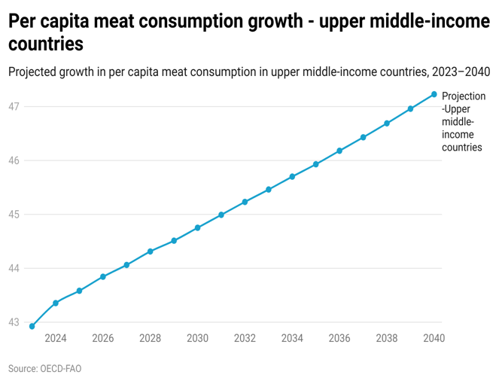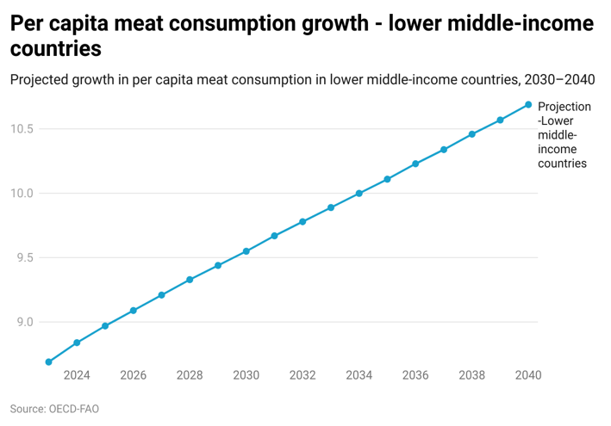

1. **Economic benefits of reducing food wastage motivate firms to build more resilient supply chains**

The [FAO](https://www.fao.org/3/i3991e/i3991e.pdf) notes that almost one-third of global food production is wasted, and [over 12%](https://www.unep.org/news-and-stories/press-release/amid-food-and-climate-crises-investing-sustainable-food-cold-chains) of this wastage occurs due to inadequate storage and handling practices during transportation. Apart from reducing the supply of food for the end consumer, food wastage also adversely impacts producers, slashing their revenues by ~[15%](https://www.weforum.org/agenda/2019/12/how-to-reduce-food-waste-end-hunger/). As such, **businesses can make significant savings** and cost reductions by improving cooling in their supply chains. A few examples of businesses that have used cold chain innovations to cut costs and streamline operations are given in the table below.

In addition to producers, innovations in cold chains can also benefit suppliers and improve their profits by allowing them **greater flexibility in deciding the timing of their product marketing**. For instance, cold storage innovation has extended the lifespan of crops, allowing producers to decide the best time to sell their produce without fear of spoilage. One such example is [Maersk](https://sp-edge.com/companies/187599), which, through its use of controlled atmosphere containers and temperature monitoring systems, is able to extend the [shelf life](https://www.maersk.com/digital-solutions/captain-peter) of produce.

**Benefits of cold chain innovation**

|  |  |  |  |  |
| --- | --- | --- | --- | --- |
| **Cold chain tech provider** | **Segment** | **Technology used** | **Case studies/benefits claimed** | **Source** |
| **Samsara** | Temperature monitoring | Internet of Things (IoT) | Samsara’s technology allowed ice cream distributor Simco Logistics to accurately monitor temperature, which the firm claims to have saved the company **tens of thousands of dollars** in preventing product spoilage, as Samsara’s technology provides instant alters when temperature abnormalities in trucks are identified. | [Company case study](https://www.samsara.com/customers/simco-logistics/) |
| [**Sonoco Thermosafe**](https://sp-edge.com/companies/226660) | Temperature-sensitive packaging | Packaging technologies | Sonoco Thermosafe’s Orion cold reusable packaging system delivered **50%+ cost savings** per cold chain box to one of its customers, a global biotechnology company based in California. | [Company case study](https://www.thermosafe.com/case-studies/transitioning-to-rental-packaging-for-sustainable-clinical-operations/) |
| [**Lineage Logistics**](https://sp-edge.com/companies/414909) | Transportati  on | Automation and robotics | In 2018, Preferred Freezer Services (which was subsequently acquired by Lineage Logistics in 2019) inaugurated the largest automated frozen food warehouse in North America. The organization highlights that its automated storage and retrieval system (AS/RS) results in significant benefits, including up to an 80% reduction in labor expenses, up to 60% savings in storage space, and up to a 40% decrease in energy costs. | [Press release](https://www.mmh.com/article/preferred_freezers_new_take_on_automation) |

Source: SPEEDA Edge research

1. **Rise in ecommerce and DTC businesses, leading to specialized cold chain services**

Direct-to-consumer (DTC) sales saw a global growth of [26% in 2020](https://www.forbes.com/sites/brinsnelling/2023/05/11/what-the-growth-of-direct-to-consumer-brands-means-for-retail-real-estate/?sh=38f8339117c0) compared with the previous year, and [KPMG](https://kpmg.com/xx/en/home/insights/2022/10/the-rise-of-direct-to-consumer.html) predicts that this trend is set to persist with an estimated CAGR of ~12% from 2020 to 2025. [Stax](https://www.stax.com/insights/direct-to-consumer-the-growing-pains-of-a-modern-market) notes that this growth in DTC brands is expected to continue, mirroring the broader trend, where traditional department and specialty retailers are progressively transitioning to a focus on online platforms. In particular, food and beverage is estimated to be one of the [fastest-growing](https://explodingtopics.com/blog/dtc-trends) DTC categories. Food startups that employ the DTC business model include companies that prepare and deliver ready-to-eat meals or meal kits directly to customers. Such companies will require cold chain services for packaging, tracking, and timely delivery.

The cold chain industry has responded to this trend by providing specialized services catering to DTC businesses. For example, [Lineage Logistics](https://sp-edge.com/companies/414909) features [services for DTC](https://lineagelogistics.com/services/direct-to-consumer-fulfillment) businesses and noted it had 100 DTC clients as of October 2023. Green Rabbit also claims that its solutions are [purpose-built](https://www.greenrabbit.com/our-services/#fulfillment) for the ecommerce and DTC industry.

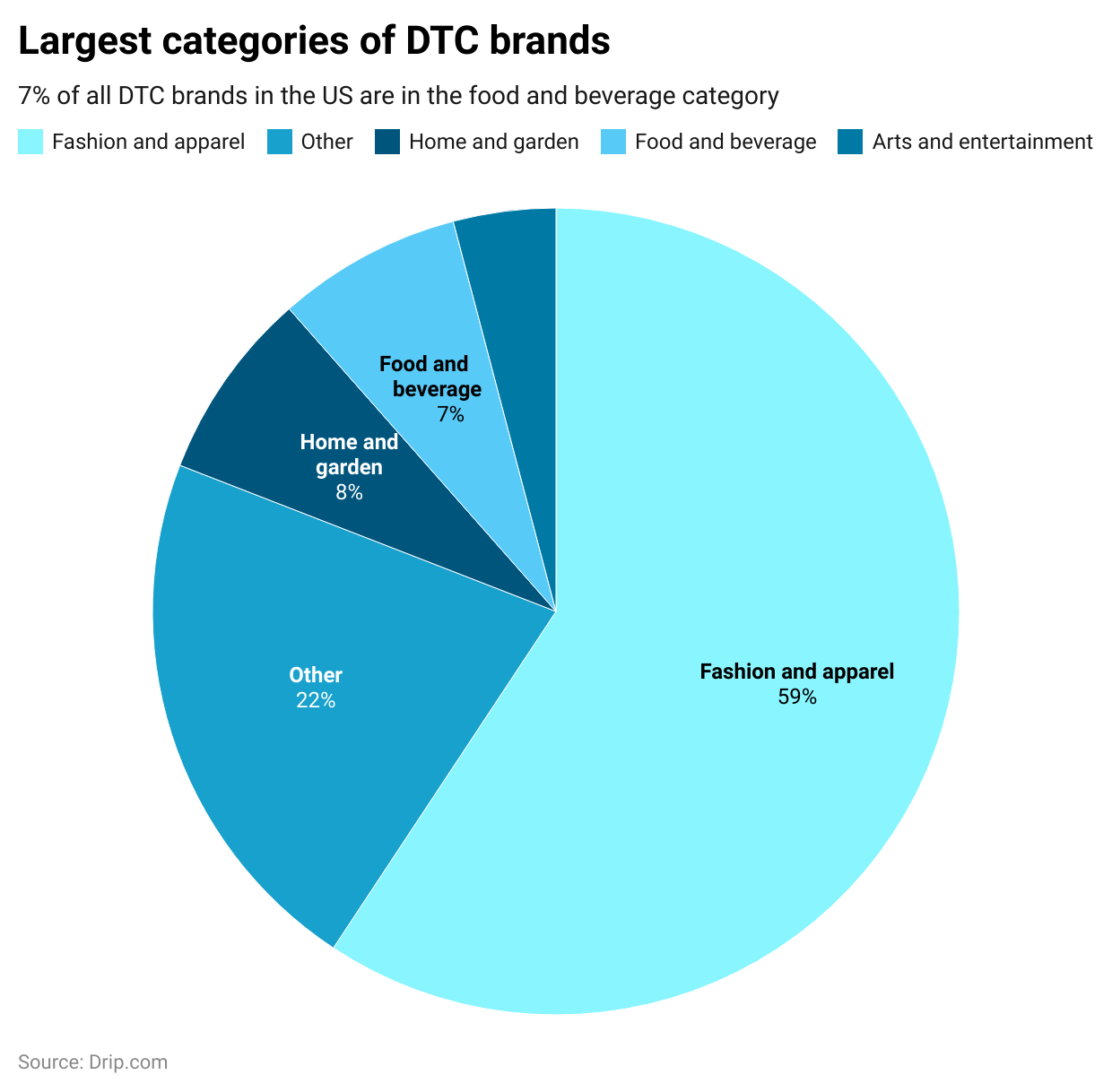

1. **Globalization of food systems and rise in world population highlight need for greater monitoring and transparency**

The [FAO](https://www.un.org/en/chronicle/article/feeding-world-sustainably#:~:text=According%20to%20estimates%20compiled%20by,world%20population%20of%209.3%20billion.) estimates that global food production will need to increase by 60% by 2050 to meet the food demands of the growing global population. Hence, transporting perishable goods such as meat and dairy products while minimizing wastage will become increasingly critical to ensure global food production will be sufficient to meet the growing demand.

Recent years have also witnessed widespread [globalization of food systems](https://www.fao.org/3/y5736e/y5736e.pdf), with increasingly interconnected and complex networks of food production, distribution, and consumption that span multiple countries and regions. Globalized food systems mean that food travels longer distances, increasing the risk of loss or damage of food products due to various reasons such as inappropriate temperature and contamination.

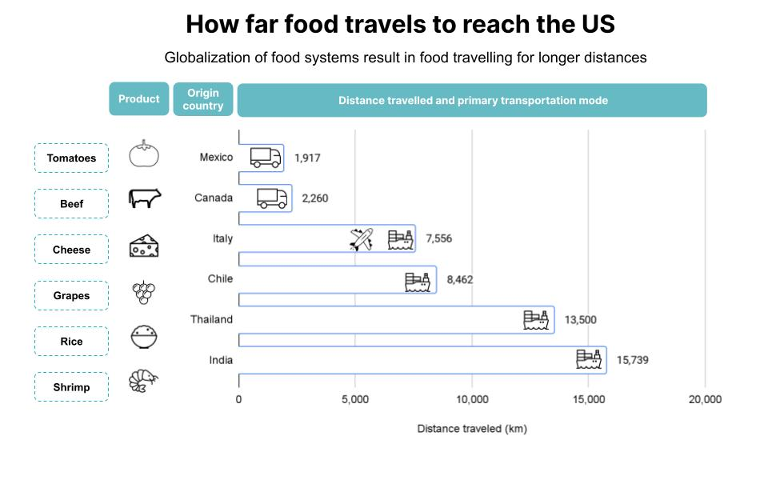

*Source: SPEEDA Edge research*

These developments drive innovations in cold chain systems, such as IoT sensors and smart packaging in cold chains that provide real-time monitoring of the products during transit to prevent food losses. An example is Process Sensing Technologies, which provides its [SensoScientific](https://www.sensoscientific.com/application-category/food-safety-temperature-monitoring/) brand of wireless sensors for monitoring food temperatures in cold storage, transmitting real-time data to the cloud for immediate access, enabling wireless temperature monitoring.

## **What are the risks?**

1. **Cost of adopting cold chain innovations may be barrier to adoption**

One of the primary challenges for innovations in cold chain technologies is the high initial cost. Integrating new technologies and establishing any required infrastructure changes can be a significant investment. For example, the adoption of automated cold chain warehouse solutions is estimated to cost USD 15 million–25 million. Establishing and maintaining this infrastructure can also be costly and complex. Such innovation adoptions may also require overhauls or upgrades of existing infrastructure, which is not always financially feasible.

1. **High energy requirements and sustainability concerns**

Cold storage and transportation facilities require a significant amount of energy for temperature control. The typical refrigerated storage facility uses over [70%](https://www.yogeshdahiya.com/how-much-electricity-is-required-to-run-a-2000-mt-cold-storage/#:~:text=In%20chilly%20storage%20facilities%2C%20refrigeration,natural%20gas%20per%20sq%20foot.) of its overall electricity consumption for cooling, representing an estimated consumption of [25 kWh](https://www.asidoors.com/improve-energy-efficiency-in-cold-storage-with-cold-storage-doors/) of energy per square foot each year to cover cooling expenses. This is an average of more than 9,000 BTUs of natural gas used per square foot annually. As such, balancing the energy-intensive nature of cold chain operations with sustainability goals is a continual challenge. Innovations that reduce energy consumption or offer more environmentally friendly solutions can be more expensive to implement but are necessary for long-term sustainability.

1. **Evolving regulatory environment adding to cost and complexity of cold chain solutions**

Developers of cold chain innovations, particularly for specialized industries such as pharmaceuticals, will need to ensure their technologies meet the compliance requirements and regulations relevant to the industries they serve. Within the pharmaceutical sector, adherence to regulations imposed by governing authorities is imperative for cold chain procedures to ensure that drug quality, safety, and effectiveness are not compromised. The FDA and ICH have [established guidelines](https://www.linkedin.com/pulse/fda-ich-cold-chain-regulations-jon-nakagawa/) to ensure the highest standards in product storage and handling, particularly in cold chain logistics, necessitating top-quality storage equipment, backup power systems, digital data loggers for temperature monitoring, physical temperature checks, and thorough documentation, including contingency plans, to ensure compliance. As such, innovations must be adaptable and compliant with various regulatory frameworks, which can add complexity and cost to development, which may be particularly prohibitive to startups.

## 

## 

## 

## **What’s next? Emissions, circular operations, and alternative energy likely to get more attention**

Sustainability is a key aspect of the outlook for the cold chain innovation industry. Food cold chains are particularly energy-intensive due to the need to control temperatures. In line with [UN SDGs](https://www.cleancoolingcollaborative.org/wp-content/uploads/2021/05/Enhancing-NDCs-with-climate-friendly-cooling.pdf), many countries and companies are aggressively moving toward the reduction of greenhouse gas emissions, with many targeting to cut their emissions in half by 2030 and become carbon neutral in 2050.

Hence, companies in the cold chain industry are engaging in a variety of sustainability initiatives, tying sustainability into their offerings by either adopting clean energy sources, using sustainable materials in products, or reducing carbon footprints.

Sustainability trends in the cold chain industry therefore primarily center around three aspects: 1) emissions reduction, 2) circular economy, and 3) alternative energy sources, which will push innovations in cold chain technology that align with the climate agenda.

### **Emissions: Optimizing** **cold chain operations to meet emissions targets**

The food system is a significant contributor to greenhouse gas (GHG) emissions, and the United Nations Environment Program estimates that the food cold chain accounts for 4% of global GHG emissions. Hence, companies are looking for eco-friendly and energy-efficient solutions to reduce their carbon footprint, and, as part of their sustainability goals for 2030 and 2050, many firms such as Nestlé and Heineken have made commitments to reduce emissions associated with their supply chains. Given that cold chains use significant energy, improving their sustainability will be a key part of fulfilling these commitments. A few examples of companies that are seeking to create more sustainable supply chains as part of their emissions goals are listed below.

**Commitments made by firms to create more sustainable supply chains**

|  |  |
| --- | --- |
| **Firm** | **Summary of activities** |
| [**Nestlé**](https://sp-edge.com/companies/17478) | In line with its [Net Zero Roadmap](https://www.nestle.com/sites/default/files/2020-12/nestle-net-zero-roadmap-en.pdf), Nestlé has set itself targets for emissions reductions in its supply chain. |
| [**Heineken**](https://sp-edge.com/companies/135170) | As part of its [Net Zero Roadmap](https://www.theheinekencompany.com/newsroom/heineken-shares-its-net-zero-carbon-roadmap/#:~:text=As%20a%20signatory%20of%20the,barley%20to%20bar%20by%202040.), Heineken is partnering with logistics and cooling companies on carbon-neutral innovations. The company aims to slash its scope 1 and 2 emissions by 90% and scope 3 emissions by 21% by 2030 and further achieve net zero emissions from barley to bar by 2040. |
| [**Carrier Transicold**](https://sp-edge.com/companies/1488320) | Cold chain solutions provider Carrier Transicold is investing in [sustainable cold chain technology](https://www.dhl.com/global-en/home/press/press-archive/2022/science-based-target-initiative-confirms-climate-targets-of-dpdhl-group.html#:~:text=Starting%20from%20a%20base%20year,by%2042%20percent%20by%202030.) to cut its carbon emissions by half. The company uses a combination of R-452A refrigerant and its all-electric E-Drive technology to achieve its emissions targets. |
| [**DHL**](https://sp-edge.com/companies/102727) | DHL has committed to achieving [net zero emissions](https://www.dhl.com/global-en/home/press/press-archive/2022/science-based-target-initiative-confirms-climate-targets-of-dpdhl-group.html#:~:text=Starting%20from%20a%20base%20year,by%2042%20percent%20by%202030.) with regard to its logistics operations by 2050. |

*Source SPEEDA Edge research*

These movements toward the reduction of GHG and the carbon footprint of cold chains create demand for innovations in cold chains such as the use of natural refrigerants and energy-efficient cooling systems.

### **Circular economy: Sustainable packaging to reduce carbon footprint**

Sustainable packaging is a low-hanging fruit for cold chain companies seeking to incorporate sustainability into their offerings or for their customers looking to reduce their carbon footprint. For example, [Planet Protector](https://sp-edge.com/companies/1297256) offers thermal packaging solutions for the food, beverage, and pharmaceutical industries under the brand Woolpack, which uses sheep's wool as the primary insulation material, thus seeking to adopt a circular economy approach. Similarly, [TemperPack](https://www.temperpack.com/) provides eco-friendly packaging solutions for the cold chain, crafted from paper and cornstarch, with applications including shipping perishable food, pharmaceuticals, and flowers. The company's insulation foam product ClimaCell is designed to provide temperature protection for up to 80 hours and is entirely curbside recyclable, which the company claims contributes to reducing carbon emissions by 90%.

1. **Energy: Alternative energy sources to drive sustainability and reliability**

Cold chains using alternative energy sources are emerging, driven by sustainability and locational necessity. Developing nations such as Ghana, India, and Nigeria have been home to companies that have developed solar-powered cold storage houses. In developing countries, post-harvest losses can reach as high as 80%, compounded by the lack of a reliable cold storage chain, due to the prohibitively high costs of equipment and unreliable electricity supply. In such countries, these self-powered cold storage houses provide farmers with the means to reduce their food spoilage, thus reducing their losses and ultimately benefiting end consumers through enhanced food security and lower food prices. The table below describes such cold chain innovations using alternative energy sources.

|  |  |  |
| --- | --- | --- |
| **Company** | **Country** | **Description** |
| ColdHubs | Nigeria | ColdHubs has developed a modular and solar-powered walk-in cold room for round-the-clock off-grid storage and preservation of perishable foods. ColdHubs offers a flexible pay-as-you-store subscription model to farmers who can pay a daily flat fee for each crate of food they store, making the service accessible and cost-effective. |
| Ecozen Solutions | India | Ecozen has introduced a solar-powered cold storage room known as Ecofrost, which can operate using either grid power or an alternative supply from a generator set. Ecofrost distinguishes itself by not relying on chemical batteries or diesel and employs a thermal energy-based technology that optimizes compressor usage and offers an economical, battery-free backup of up to 30 hours. |
| Solar Freeze | Kenya | SolarFreeze offers portable cold storage units powered by solar energy, allowing smallholder farmers to effectively store temperature-sensitive fresh agricultural produce. Additionally, it provides a cold storage service through a mobile application that allows smallholder farmers and traders to locate the nearest cold storage facility, which offers a convenient solution for handling fresh produce and results in cost savings in terms of food preservation, hardware, and space. |
| Inficold | India | Inficold designs and manufactures solar-powered cold storage in both container and indoor cold room options, offering a continuous cooling solution without the need for electrical batteries. Notably, the three largest solar cold storage facilities in India using thermal energy storage have been designed and installed by Inficold. This solar integration technology resulted from a collaborative effort with the National Institute of Solar Energy, an autonomous institute under the Ministry of New and Renewable Energy in the Government of India. |
| AkoFresh | Ghana | AkoFresh offers solar-powered refrigerated storage units.  Farmers have the option to rent storage space in these cold stores, with the daily fee determined based on the weight of their produce or they can opt for a weekly subscription. Alternatively, they have the choice to use their crops as payment for the cold storage instead of cash. AkoFresh also provides a mobile app that facilitates connections between farmers and food aggregators. |
| SelfChill | Kenya | The SelfChill Cold Room is a self-sustaining cooling system powered by solar energy, capable of storing agricultural products such as fruits, vegetables, herbs, seeds, and various commodities at their optimal temperature without the need for any external power source. The system operates using R290, a natural refrigerant with an exceptionally low Global Warming Potential. The cold room has been purposefully designed and rigorously tested to withstand the challenging conditions typically found in tropical regions. |

*Source: SPEEDA Edge research*

©2023 Uzabase, Inc. All Rights Reserved. The information contained herein: (1) is proprietary to Uzabase Inc. and/or its content providers; (2) may not be copied or distributed; and (3) is not warranted to be accurate, complete or timely. Neither Uzabase Inc. nor its content providers are responsible for any damages or losses arising from any use of this information.