# **Extended Reality: Overview**

## 

## **Stepping into a new reality**

Extended reality (XR) is the umbrella term that includes Augmented Reality (AR), Virtual Reality (VR), and Mixed Reality (MR). These segments are characterized by the varying degrees at which reality interacts with the virtual world.

* **AR** refers to the overlay of computer-generated (CG) content (e.g., video streams, images, interactive data, holograms) in a real-world environment. In this case, the real-world content is not able to interact with the CG content (e.g., an AR object covered by a real-world object would not make the AR object disappear).
* **VR** is a fully immersive world made with real-world (360-degree video) or CG content or a mix of both prepared in advance.
* **MR,** as the name suggests, falls between the AR and VR mediums and refers to CG content that interacts with objects in the real world. This medium removes the boundaries between real and virtual interaction via occlusion. Occlusion refers to CG content that can be visibly obscured by objects in the physical environment. Notably, the Apple Vision Pro launch popularized the term “spatial computing,” which can be considered the next iteration of MR, enabled by improvements in the field (improved spatial anchoring of content and manipulation of real-world content with digital elements).

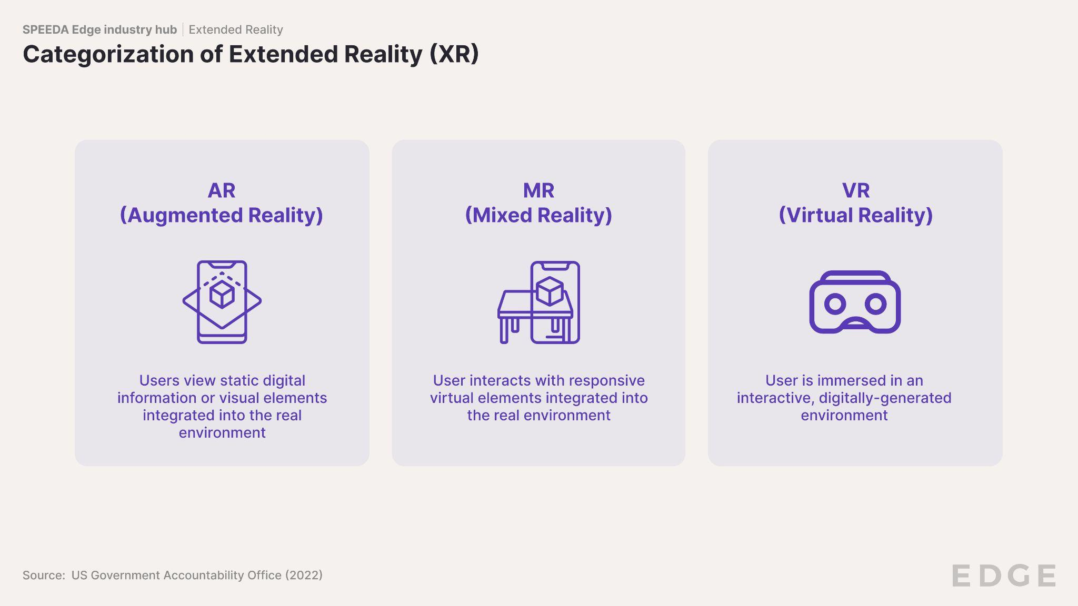

|  |  |  |  |
| --- | --- | --- | --- |
| **Factor** | **AR** | **MR** | **VR** |
| **Premise** | Real world becomes the framework within which objects and images are placed | Real and virtual worlds are intertwined by projecting objects onto the real-world environment | A fully immersive environment is also called a computer-simulated reality |
| **Projected data** | 2D and/or 3D video | 3D video | 3D video |
| **Interaction with the virtual world** | x | ✓ | ✓ |
| **Type of device** | * AR glasses * Smartphone/tablet * AR head-mounted display (HMD) * Smart mirrors * AR heads up displays (HUDs) | See-through head-mounted display (HMD) | Non-see-through head-mounted display (HMD) |
| **Product examples** | * ThinkReality A3 smart glasses (Lenovo) * RealWear Navigator Z1 * Xreal Air 2 * Rokid Max * DigiLens ARGO * Pokemon Go (Niantic) * AR mirror (Zero10) * AR HUDs (Envisics, WayRay) | * Apple Vision Pro * Meta Quest 3 * Microsoft HoloLens 2 * Magic Leap 2 * Varjo XR-4 | * Sony PSVR 2 * Bigscreen Beyond * Pico 4 Enterprise * Pimax Crystal |

Source: SPEEDA Edge research

## **Outright sales and subscription offerings are common XR business models**

Headset, tracking, and other hardware device manufacturers mainly generate revenue through outright sales. Prices of consumer-oriented devices generally range from USD 400 (XReal Air 2) to USD 1,800 (Pimax Crystal), although Apple’s Vision Pro headset is a notable exception (starting at USD 3,499). Enterprise-oriented device price ranges vary from USD 3,200 (Magic Leap 2) to USD 10,000 (Varjo’s XR-4 Focal Edition). Location-based VR players resort to ticket sales that vary based on a combination of experience type, location, and booking date. Subscription-based offerings are common among content development platforms (e.g., DEVAR), with AR/VR gaming platforms generating revenue from in-app purchases (e.g., Niantic).

### **Examples of XR business models**

|  |  |  |  |  |  |  |
| --- | --- | --- | --- | --- | --- | --- |
| **Company** | **Segment** | **In-app purchases** | **Outright sales** | **Subscription-based** | **Ticket sales** | **Comment** |
| Meta | Hardware manufacturers |  | ✓ |  |  | The Meta Quest 3 is priced at USD 499. |
| Apple | Hardware manufacturers |  | ✓ |  |  | The Apple Vision Pro is priced at USD 3,499 |
| Microsoft | Hardware manufacturers |  | ✓ |  |  | Versions of the Microsoft HoloLens 2 range USD 3,500-5,200. |
| ByteDance | Hardware manufacturers |  | ✓ |  |  | ByteDance subsidiary Pico Interactive’s Pico G3 headset is priced at EUR 399 (~USD 430). |
| Xreal | Hardware manufacturers |  | ✓ |  |  | Xreal’s smart glasses, Xreal Air 2, retails at USD 399. |
| Matterport | Content |  |  | ✓ |  | Cloud-based subscription revenue for hosting its clients' virtual tours amounted to USD 157.7 million in 2023. |
| DEVAR | Content |  |  | ✓ |  | Monthly subscription costs range USD 39–1,199. |
| Niantic | AR/VR platforms | ✓ |  |  |  | As of June 2022, Niantic was estimated to have generated over USD 6 billion in revenue from Pokemon Go since its inception. |
| Rec Room | AR/VR platforms | ✓ |  | ✓ |  | Paid membership plan priced at USD 8 per month, with in-app purchases ranging USD 5–50. |
| 8th Wall | AR/VR platforms |  |  | ✓ |  | Subscription pricing ranges from USD 9-99. |
| Meow Wolf | Location-based AR/VR |  |  |  | ✓ | Prices range USD 40–64 depending on the experience type and booking date. |
| Sandbox VR | Location-based AR/VR |  |  |  | ✓ | Prices range USD 50–60 based on location. |

Source: SPEEDA Edge research

## **XR use cases beyond the gaming Industry**

According to Market.us (February 2024), gaming is the most prominent use case for XR, accounting for an estimated 45% of XR revenue. Incorporating XR in gaming allows players to interact in virtual worlds and adds to the realism of gaming genres. While this use case is already well established, the debate always has been when and in which areas XR will go mainstream. Additionally, eMarketer predicts that the number of users for the AR and VR market in the US is expected to reach 185.4 million by 2027.

While gaming has been a focal point for XR, the February 2024 debut of the Apple Vision Pro marked a shift toward a broader spectrum of XR applications such as immersive viewing experiences, productivity (meetings using Apple’s Persona avatars) and enterprise applications (3D visualization and surgical planning). In line with this, a survey by Amdocs (January 2024) revealed that while nearly half the consumers are interested in AR for gaming (49%), non-gaming-related applications (workouts, shopping, etc.) account for a sizable amount of interest as well.

Further, a YouGov survey from January 2024 indicated that 48% of consumers see gaming as being enhanced by VR or spatial computing headsets, while 30% and 32% believe watching movies and learning about destinations before visiting, respectively, can also benefit from the tech. Future advancements in headset field of view, eye-tracking, and pass-through capabilities, are likely to continue to improve these perceptions.

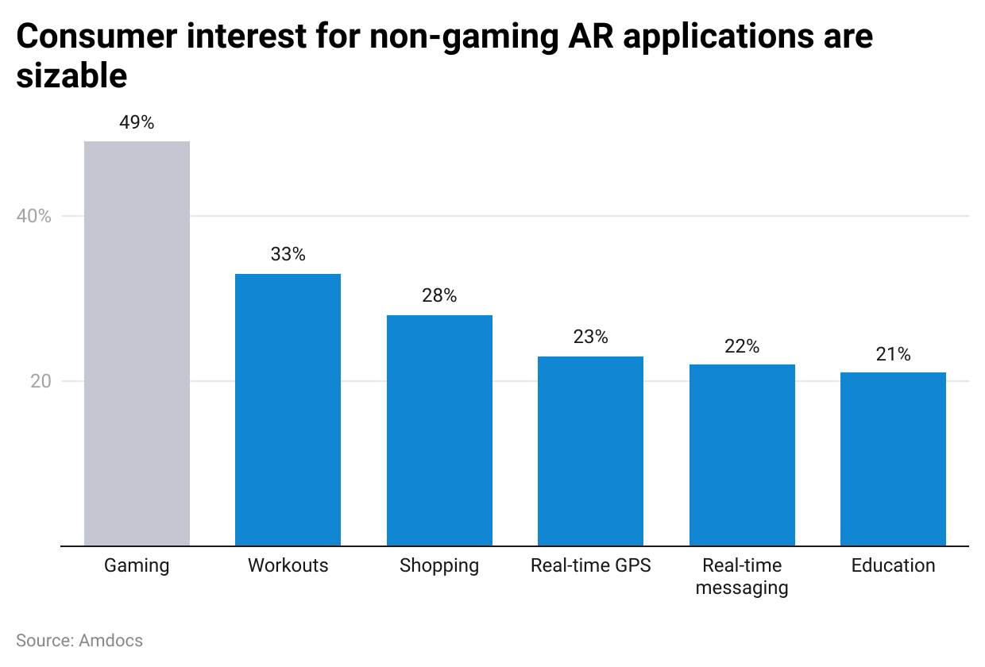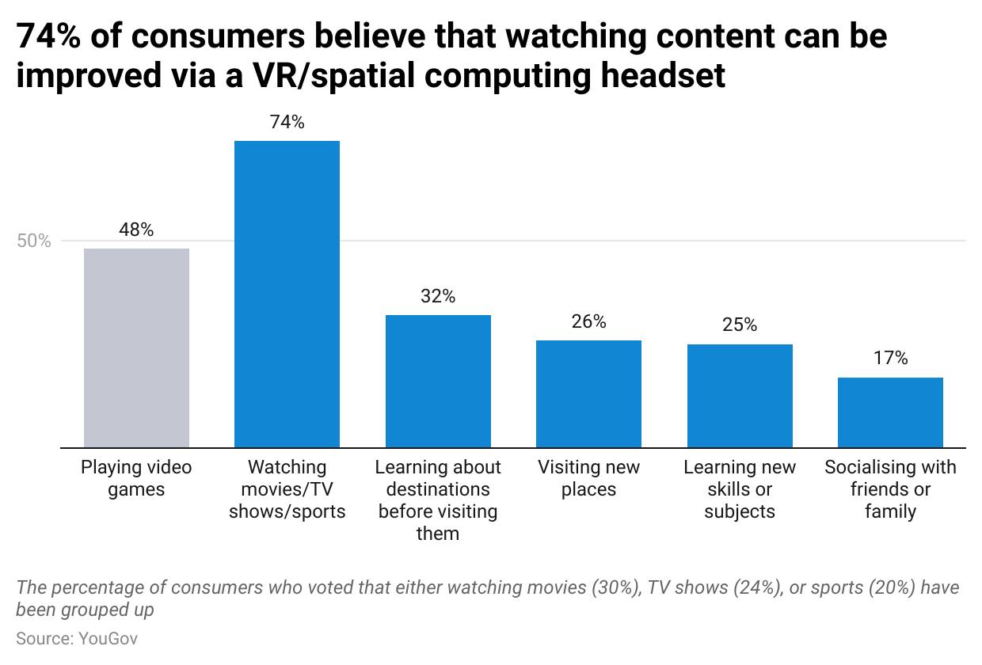

The use of XR headsets is pivotal to the social experiences and human connection that the metaverse, which is a network of interconnected virtual spaces, promises. Pure-play social platforms (e.g., [Rec Room](https://sp-edge.com/companies/669986), [VRChat](https://sp-edge.com/companies/322187)) are a common testing ground for social connections in the metaverse; the use of XR is also present in the digital retail, remote work, factory assembly, therapy, defense, and automotive sectors. We have identified common XR use cases (non-gaming) below, with training, product demos, and field assistance use cases being the most widely adopted across industries:

* **Field assistance and factory process training:** Common use cases include real-time remote AR field service assistance to technicians ([TechSee](https://sp-edge.com/companies/405298)); AR solutions for assembly manufacturing, maintenance, and repairs ([New Forge](https://sp-edge.com/companies/2027594)); and VR simulations for process and safety training solutions for industries including automotive, aerospace, manufacturing, and construction ([Transfr](https://sp-edge.com/companies/662653)).
* **Product demos, visualizations, and virtual fitting rooms:** [Lowe’s](https://sp-edge.com/companies/122021) “Style Studio” mixed reality app allows users to visualize kitchen fittings, with companies such as [Zero10](https://sp-edge.com/companies/2197434) building AR mirrors for apparel retail to enhance ecommerce experiences. Additionally, XR environments created on [Unity](https://sp-edge.com/companies/14927) can be used for pre-experiencing capital-intensive project outcomes, while companies such as [Matterport](https://sp-edge.com/companies/102115) develop virtual home tours for real estate listings.
* **Virtual therapy, medical training, surgical assistance, and health monitoring:** This includes the use of XR technology to offer digital therapies for brain repair and neurorehabilitation ([MindMaze](https://sp-edge.com/companies/274434)), on-demand remote health monitoring solutions and therapy for behavioral health, memory and cognitive training ([XRHealth](https://sp-edge.com/companies/512074)), VR training for medical practitioners ([Osso VR](https://sp-edge.com/companies/410647)), AR-based surgical guidance in operating theaters ([Augmedics](https://sp-edge.com/companies/412275)), and combating social isolation of seniors through virtual tours of significant landmarks from the past ([Rendever](https://sp-edge.com/companies/461650)).
* **Facilitating remote work:** Meta’s VR remote work platform, Horizon Workrooms, emulates the office environment using spatial audio and 3D-animated spaces. Similarly, Microsoft Mesh, a platform accessible through Microsoft Teams, enables users to meet virtually in 3D spaces by appearing on screen as avatars or animated characters.
* **Interactive educational experiences and training:** In the education sector, XR can facilitate interactive educational experiences and training. XR content developed using 3D images can explain abstract concepts through visual learning, especially for Science, Technology, Engineering, and Mathematics (STEM) courses. Specific examples include adding AR content to textbooks ([Ludenso)](https://sp-edge.com/companies/927604), VR environments such as virtual biology labs ([Dreamscape Learn)](https://sp-edge.com/companies/2603259) and gamified VR learning scenarios ([Prisms VR](https://sp-edge.com/companies/1596654)).
* **Military operations and training:** Microsoft's HoloLens Integrated Visual Augmentation System (IVAS) is designed for US military use and includes features like position identification, virtual terrain mapping, thermal imaging for low-light conditions, microdrone management, and health monitoring via biometric trackers. Additionally, [SimX](https://sp-edge.com/companies/233368) offers VR modules for military medical training, while [VRgineers](https://sp-edge.com/companies/495343) and [Red 6](https://sp-edge.com/companies/1061172) offer XR systems for military pilot training.
* **Driver experience and vehicle safety:** [WayRay](https://sp-edge.com/companies/255946) and [Envisics](https://sp-edge.com/companies/661597) offer AR heads-up displays (HUDs) that overlay real-time information on dashboards to drivers with features such as mapping, navigation guidance, and hazard warnings, without blocking the driver’s field of view.

# **Driving factors**

## **1. Retail ecommerce boom**

As consumers shifted away from brick-and-mortar retail shopping post-pandemic, total US ecommerce sales hit an all-time high in 2023, reaching USD 1.1 trillion. Moreover, the share of retail ecommerce is expected to grow to 20.6% of total retail sales by 2027 from 15.6% in 2022. The use of XR has continued to grow since the pandemic-induced retail ecommerce boom, as it offers new ways to engage customers and cater to their general tendency toward the “try-before-you-buy” concept. The product’s fit and appearance tend to feature high among reasons for returns. The use of XR can solve multiple retailer pain points arising from this—the risk of low conversion rates and higher returns—by increasing consumer confidence. This was evidenced by Snap’s June 2022 survey, which reported that two out of three shoppers are less likely to return a product after using AR.

Further, a consumer survey published by Klarna in May 2023 revealed that 74% of Gen Z and Millennial consumers expect AR to enhance their in-store shopping experiences, with most fashion shoppers opting for non-physical clothing try-ons (48% want to use virtual dressing rooms; 28% want to use AR). In line with this, the virtual fitting room market is expected to grow at a CAGR of 25.2% to USD 4.3 billion by 2028, which bodes well for the XR market.

### **Ecommerce sales are expected to account for an increasing share of US retail sales**

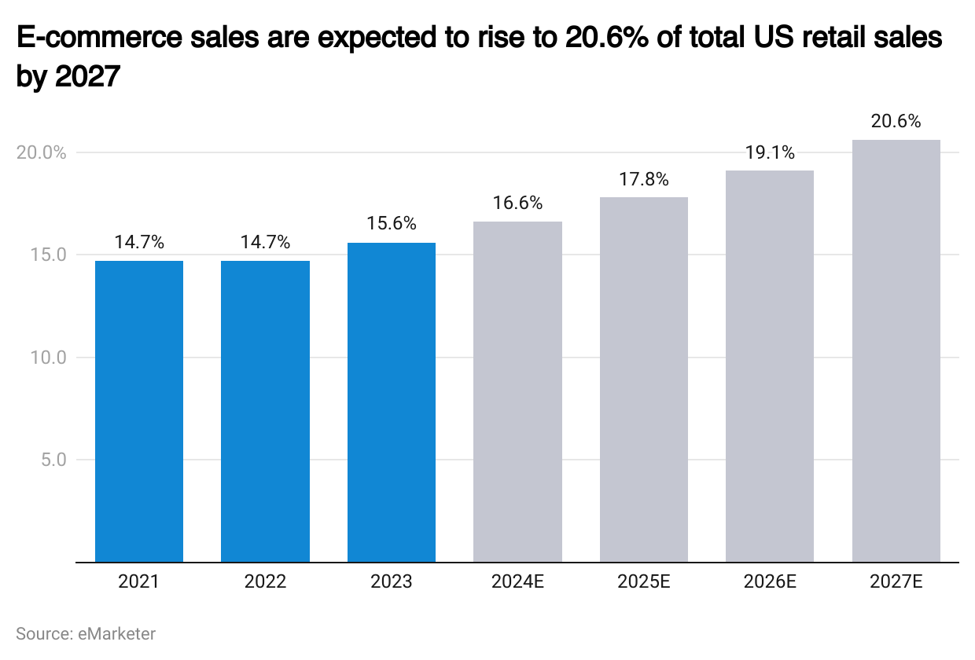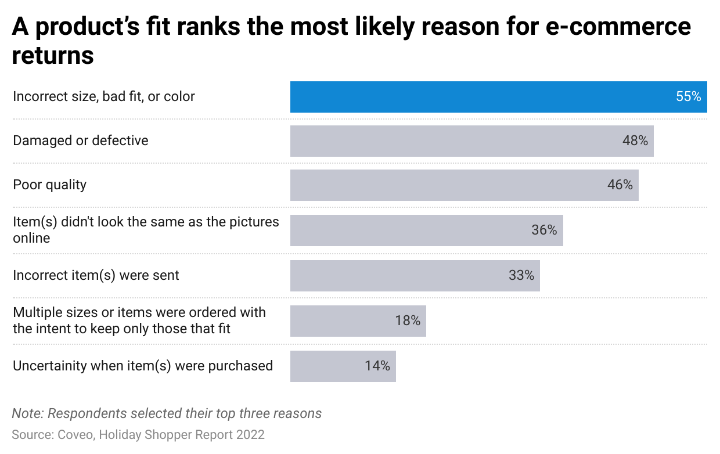

## **2. Growth in streaming services and remote work arrangements**

The growth in streaming services in the US, alongside an increasing preference toward remote work post-Covid-19, has allowed XR to emerge as a sector to facilitate and enhance such use cases. Specifically, data from Nielsen showed that streaming accounted for the highest percentage (38.4%) of total TV usage (April 2024), beating out cable TV (29.1%). The trend complements the launch of the Meta Quest 3 and Apple Vision Pro, which offer high-fidelity immersive viewing experiences on a large virtual canvas. In addition, the use of spatial audio, which allows for a 3D listening experience, has helped the headsets recreate a cinema-like experience.

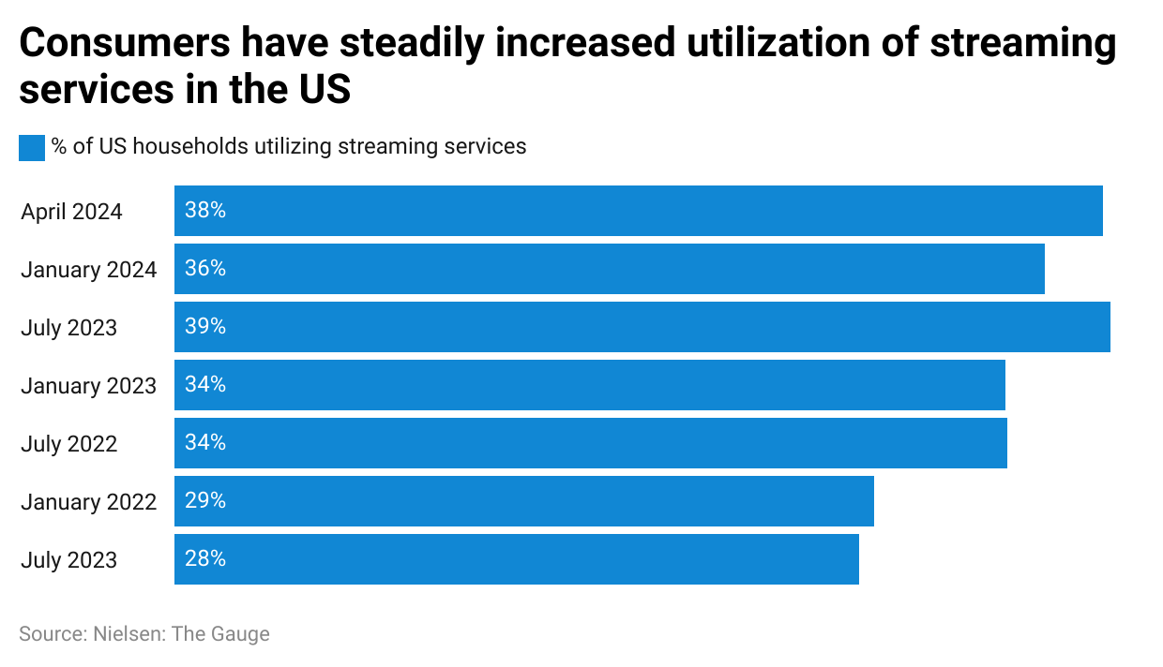

Concurrently, the pandemic has accelerated the shift toward hybrid work arrangements, with 40% of US employees working remotely at least one day a week (July 2023). Further, data from Upwork estimated that ~22% of the workforce (32.6 million Americans) would be working remotely by 2025. The availability of remote work software on mixed reality headsets capable of displaying ultra-wide virtual screens streamlines this process.

## **3. Inclusion of social aspects in gaming that appeal to Millennial and Gen Z gamers further supports XR**

The development of new forms of social gaming, such as ones consisting of vast open worlds, is also likely to further support the XR industry. XR brings real-time interaction and engaging content to game development that could appeal to Millennial and Gen Z demographics, given that individuals aged 18–34 and 35–44 account for 36% and 13% of dedicated gamers in the US, respectively (2022). The latest available data (as of October 2022) on the core gamer base of Pokemon Go, an AR mobile game developed by Niantic, also indicated that users in these demographic groups dominated. Therefore, it is favorable that Millennials and Gen Z will continue to account for a significant portion of the (38%) of the US population by 2030.

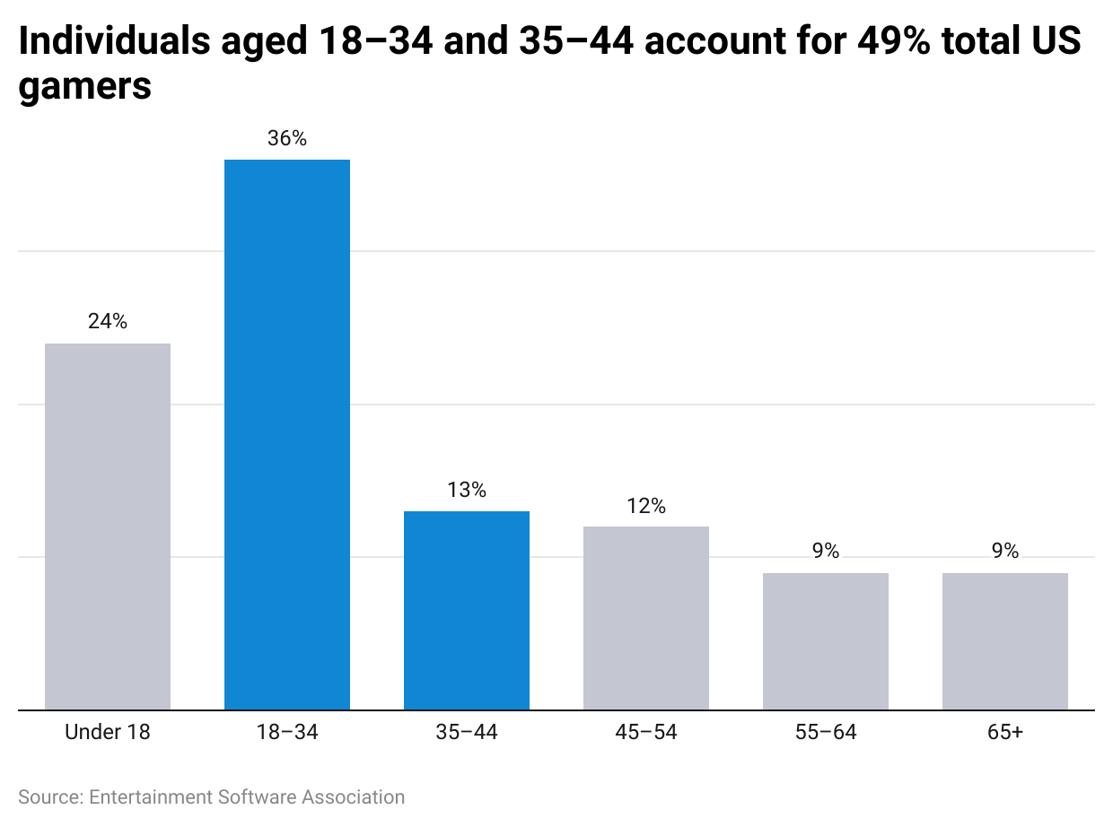

**4. Increasing adoption of OpenXR and the growth of generative AI tools**

The increasing adoption of the OpenXR standard (a protocol that aims to standardize the development of VR and AR applications) by key players in the XR market has allowed content developed to be democratized across multiple VR headsets, without requiring specialized code for each device. XR devices compatible with the standard include those by Meta and Microsoft (July 2020), HTC (November 2020), Pico Interactive (February 2023), and Magic Leap (April 2023).

Additionally, the growth of [generative AI (GenAI)](https://sp-edge.com/industry/163) has led to improvements in the ease of content creation for XR purposes. Notable GenAI-focused startups with applications in the XR space include Inworld AI (AI-powered non-player character [NPC] interactions), Atlas, and Zibra AI (AI-powered in-game asset creation). Given its potential, more GenAI startups are likely to proliferate the sector, especially as GenAI’s incremental revenue for the gaming market is forecasted to grow at a CAGR of 23% until 2032, driven by developments in level generation, creation of NPCs, and the enhancement of in-game graphics.

Apart from GenAI-focused startups, existing players in the XR space have also started integrating GenAI capabilities into their products, with applications that streamline asset creation, improve in-game interactions, and improve field service assistance.

### **Recent integrations of GenAI features into existing XR products**

|  |  |  |  |  |  |
| --- | --- | --- | --- | --- | --- |
| **Company** | **Segment** | **Stage** | **Use case** | **Description** | **Date** |
| Niantic | AR/VR platforms | Growth | Personalized in-game interactions | Utilizes LLMs to analyze real-world objects captured by the phone's camera, converting them into words for the AI to interpret and respond to in its Peridot geo-location AR game | November 2023 |
| JigSpace | Content | Growth | Business process improvement | Launched Spark, a tool that uses GenAI to create 3D product presentations for AR devices | November 2023 |
| Snap | Content | Incumbent | Asset creation | Launched Lens Studio 5.0 Beta, which introduces a ChatGPT Remote API for generating text-based content for lenses developed, such as a randomly generated quiz | November 2023 |
| Microsoft | AR/VR platforms | Incumbent | Asset creation | Introduced Copilot into its Dynamics 365 Guides application for field assistance, allowing for mixed reality content generation | November 2023 |
| Nanome | AR/VR platforms | Early | Business process improvement | Launched MARA, a GenAI copilot designed to assist chemists in biopharma R&D (exploring, preparing, and rectifying various molecular file formats; complex multi-step processes across different tools and databases) | October 2023 |
| Niantic | Content | Growth | Asset creation, Personalized in-game interactions | Launched GenAI modules for developers to integrate with tools such as DALL·E for text-to-image input, Blockade Labs for 360-degree images, Inworld AI for lifelike interactive characters, and more | August 2023 |
| Strivr | AR/VR platforms | Early | Asset creation | Launched GenAI features which allowed for improved storytelling, animation, and asset creation, alongside optimization of visual and content-driven features | May 2023 |
| Talespin | Content | Early | Asset creation | Launched Copilot Designer allowing for the creation of custom XR simulations for conversational training–without the use of coding | April 2023 |
| NVIDIA | Content | Incumbent | Personalized in-game interactions | Upgraded its Audio2Face app to include GenAI APIs for realistic facial animations of in-game characters from audio | April 2023 |
| DEVAR | Content | Growth | Asset creation | Launched the world’s first GenAI neural network for AR that allows people to create 3D objects and other AR assets | March 2023 |
| NextechAR | Content | Growth | Asset creation | Launched GenAI tech which allows for texture upscaling of AR models | February 2023 |

# Source: SPEEDA Edge research

# **Risks to growth**

## **1. Capital-intensive nature of hardware development**

Hardware manufacturers run on high funding that is spent on extensive research and development required to improve accessibility. This includes headset portability, a higher field of view (the extent of the observable world at any given moment), and degrees of freedom (power of in-VR movement). As a result, it is common for startups to be unprofitable and even file for bankruptcy; prime examples are Osterhout Design Group (ODG) and “Meta Glasses,” who put their assets up for sale in 2019. This also includes Magic Leap, which narrowly avoided bankruptcy in 2020 and Sandbox VR's Glostation USA subsidiary, which emerged from Chapter 11 bankruptcy after reorganization in 2020.

## **2. Mass adoption restricted due to hardware limitations**

The mass adoption of XR could be restricted due to steep hardware price points (ranging ~USD 350–3,500), the short battery life of untethered VR/MR headsets (ranging two to three hours on average), and the weight of the headset (ranging ~400 g–600 g on average), which may lead to neck pain from prolonged usage. Additionally, concerns about motion sickness could limit usage, with 25%–40% of VR headset wearers experiencing motion sickness and 48% citing motion sickness as their reason for not using VR more frequently. The risk of users experiencing recurring motion sickness is negligible, with only 3% of users being unable to adapt after continued use, although it still results in a barrier to adoption. Further, research from Stanford University noted that prolonged mixed reality headset use could result in eye strain, nausea, and headaches, despite not being fully immersed in a virtual environment.

## **3. Intellectual property (IP) licensing issues**

The incorrect use of IP in the industry can bring about hefty fines for players. One such incident, related to the use of real-world IP in the virtual world, led to Meta settling a lawsuit with video game company ZeniMax for an undisclosed amount. Meta was initially directed to pay USD 500 million due to the copyright infringement of ZeniMax’s trademark technology in its VR products.

## **4. Privacy and security concerns**

XR products face scrutiny due to the amount and sensitivity of the data they collect. Personal data, including appearance, body movements, location, and biometrics, are collected. Although policies specific to XR are not widely applied, the existing federal and state laws on data privacy regulate the collection of such data for immersive experiences. State laws include the California Consumer Privacy Act (CCPA) while Illinois, Texas, and Washington have issued regulations for biometric data collection and facial recognition technologies. Implementing stricter laws could hinder certain functionalities of XR (e.g., eye and motion tracking).

*Last updated: May 2024*

©2024 Uzabase, Inc. All Rights Reserved. The information contained herein: (1) is proprietary to Uzabase Inc. and/or its content providers; (2) may not be copied or distributed; and (3) is not warranted to be accurate, complete or timely. Neither Uzabase Inc. nor its content providers are responsible for any damages or losses arising from any use of this information.