# **Hydrogen Economy: Overview**



## **Hydrogen as a source of clean energy**

The **Hydrogen Economy** represents an envisioned future in which hydrogen is readily used as a source of clean energy.

Hydrogen can be used to generate electricity or energy using either fuel cells or combustion. Both processes are clean and do not generate any carbon emissions. However, the same cannot be said about hydrogen production. Nearly all commercially produced hydrogen is currently generated from steam-methane reforming (SMR) and is done by heating methane (CH4) and water to separate hydrogen and carbon (CH4 + H2O = CO + 3 H2). Natural gas is the most common source of methane, while biogas and coal are also used, albeit rarely. All three sources result in carbon emissions. They are known as **black or gray hydrogen** and are not really any cleaner than fossil-fuel-sourced energy.

### 

### 

### 

### 

### **An overview of the hydrogen economy**

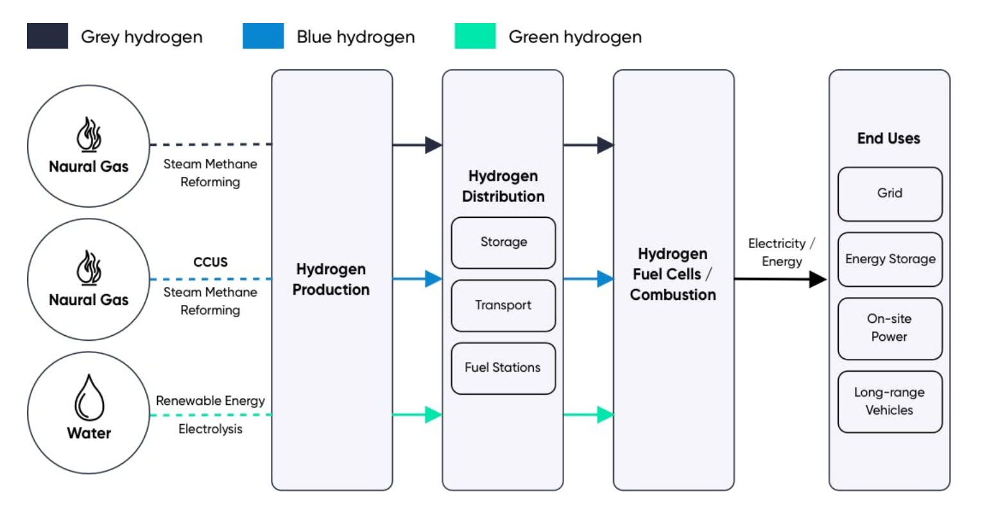

Source: Edge

However, carbon capture, utilization, and storage (CCUS) technologies can be used to capture and sequestrate carbon emissions from the SMR process to make hydrogen energy somewhat cleaner (CCUS cannot remove emissions entirely and the standard efficiency of CCUS technologies is around 85%–90%). This is known as low-carbon hydrogen or **blue hydrogen.**

The next most common method of producing hydrogen is through electrolysis of water. This method passes an electric current through water, using electrolytic cells to separate hydrogen and oxygen (2 H2O = 2 H2 + O2). The process consumes electricity and is therefore only a source of clean energy if the electricity is generated from renewable sources. This is known as **green hydrogen**.

There are also other methods of producing low-carbon or clean hydrogen, such as methane pyrosis (turquoise hydrogen), thermochemical water splitting (yellow hydrogen), and biomass gasification, which are at the very early stages of development.

### 

### 

### 

### 

### **Hydrogen color spectrum by method of production**

## 

## 

## **Hydrogen Economy: Sector overview**

We categorize hydrogen startups into five broad segments: low-carbon hydrogen production, clean hydrogen production, next-gen hydrogen distribution, hydrogen fuel cells, and hydrogen vehicles.

Only low-carbon and clean hydrogen production are covered in this industry hub, while conventional hydrogen production processes that generate carbon emissions (black or gray hydrogen) are not. Conventional hydrogen distribution technologies such as pipelines and mechanical compression and non-energy-related hydrogen applications such as fertilizers, food and beverage, chemicals, etc. are also omitted.

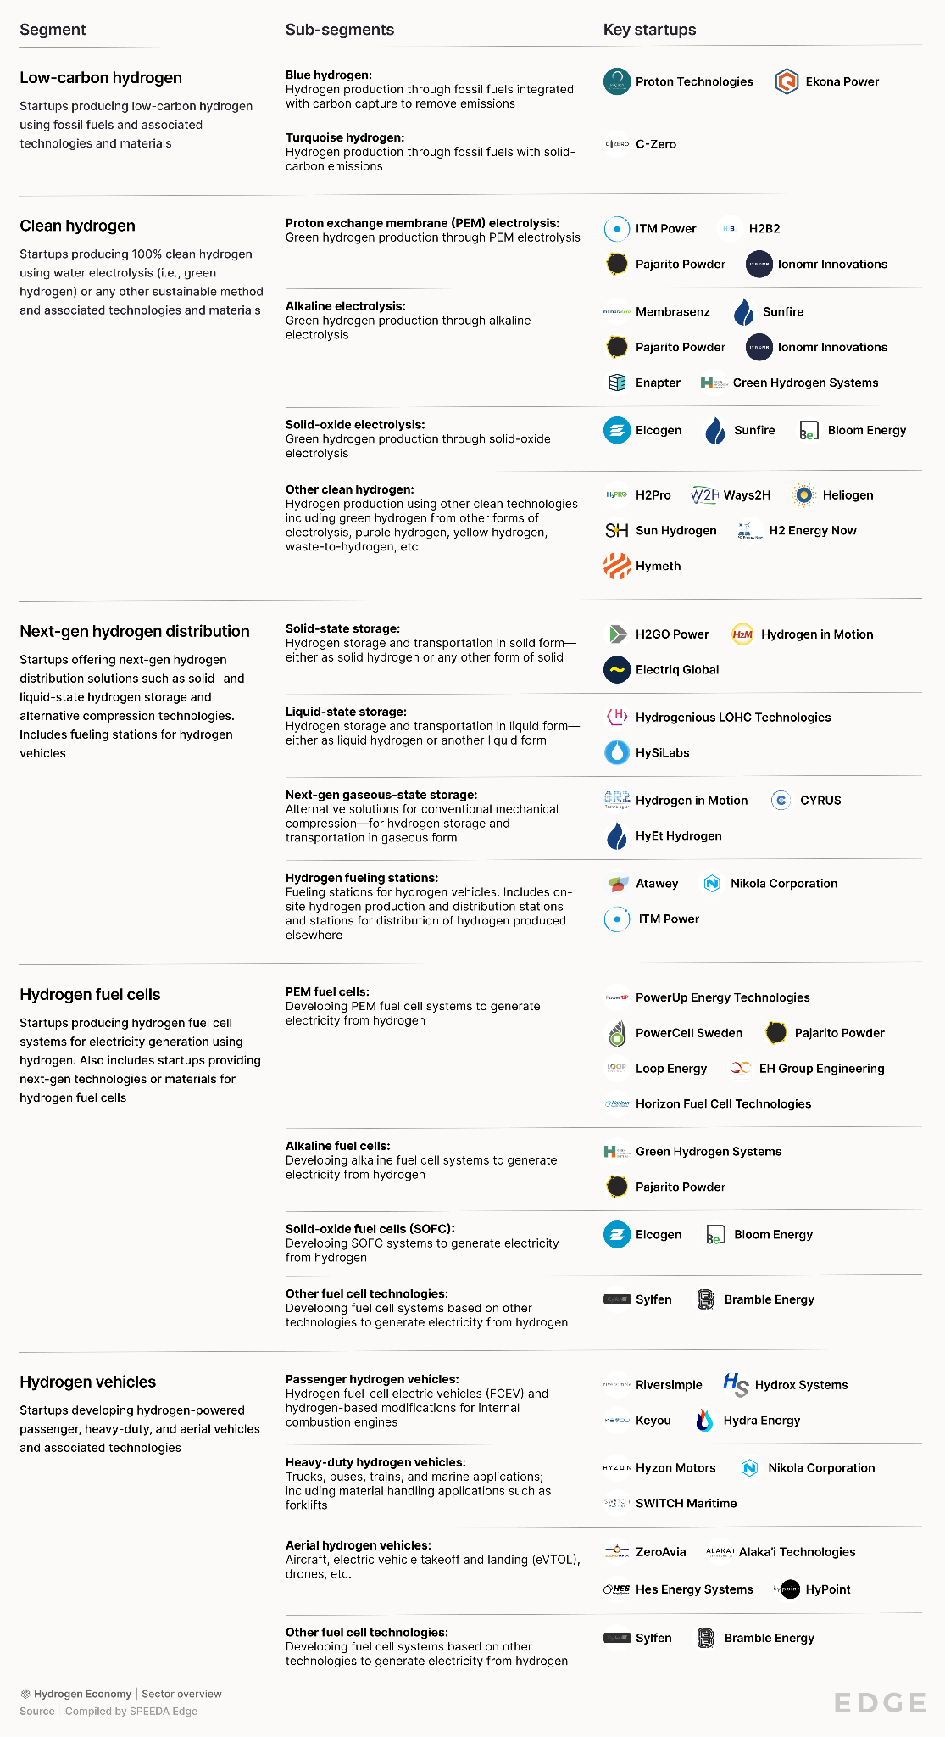



## **Declining costs close the gap between blue and grey hydrogen**

Gray hydrogen is significantly cheaper (around USD 0.98–2.93 per kg) than green hydrogen (around USD 4.5–12 per kg) at spot electricity markets. The average cost of green hydrogen would need to come down by around 67% to reach parity with gray hydrogen.

The cost of renewable electricity inputs accounts for around 50%–60% of the total cost of green hydrogen, with capital costs of electrolyzers accounting for most of the remainder at 30%–40%. The cost of solar and wind energy has fallen considerably over the past decade but is unlikely to continue to decline at the same rate now that both technologies are somewhat mature. The levelized cost of electricity (LCOE) of solar and wind in the US is expected to decrease by only around 21% through 2040.

Electrolyzers are still at an early stage of development and their cost could fall significantly as the technology scales. The US Energy Information Administration (EIA) expects the cost of fuel cells, which operate based on similar technologies to electrolyzers, to fall by around 42% between 2023 and 2040. This would still put green hydrogen at a cost disadvantage over gray hydrogen, representing a 45% premium in average cost by 2040 compared with a 67% premium in 2023.

Blue hydrogen is also costlier than gray hydrogen at around USD 1.8–4.7 per kg, but the average price (USD 3.1) only needs to fall by around 32% to reach parity with the average price of gray hydrogen (USD 2.1). The current cost of carbon capture is around USD 65 per metric ton (MT) and is expected to decrease by around 54% to USD 30 per MT by 2030 as the technology scales. This would result in blue hydrogen declining around 14% in average cost, narrowing its significant cost disadvantage compared with gray hydrogen. The International Energy Agency (IEA) estimates that around 40% of the long-term demand for hydrogen will be linked to CCUS technologies (for more details about the CCUS industry, please refer to our [Carbon Capture, Utilization & Storage (CCUS)](https://sp-edge.com/industry/63) industry hub).

### **Average cost of hydrogen by type**

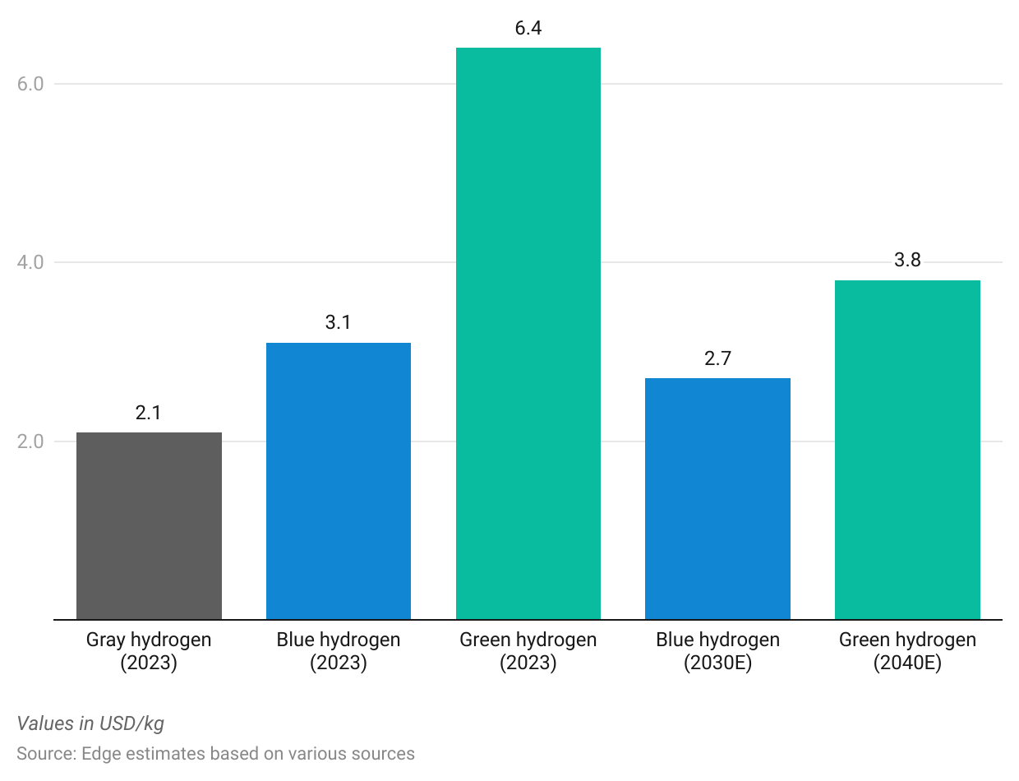

# 

# 

# 

# **Driving Factors**

## **1. Green hydrogen’s uniqueness makes it attractive despite cost**

The LCOE of natural gas in the US is around USD 45 per megawatt-hour (MWh), but even at a hydrogen cost of USD 2 per kg, the LCOE generated from hydrogen is estimated to be around USD 100–200 per MWh. This is mainly due to hydrogen being a relatively weak energy carrier—the energy content in hydrogen is around 3,000 BTU per gallon (BTU/gal) compared with 33,000–38,000 BTU/gal and 109,000–125,000 BTU/gal for natural gas and gasoline, respectively. This makes hydrogen a less attractive source of energy to power a grid and better suited for the application-specific use cases listed below:

**a) Alternative energy storage:** Renewable energy when in abundance can be used to produce green hydrogen and then converted back to electricity during shortages. Unlike long-duration batteries, which have an average discharge of six to 10+ hours, hydrogen can be stored for extended periods—even weeks or months—before being used in electricity generation. This provides a truly long-duration source of energy storage that is effective in extreme winter-like conditions where solar and wind energy are in shortage for long periods.

**b) On-site industrial power generation:** Unlike its gray and blue counterparts, which require large dedicated plants or facilities, electrolyzer systems can be modularized and installed on-site at industrial facilities or fueling stations to reduce infrastructure costs and eliminate expensive storage and transportation costs.

**c) Gasoline alternative for long-distance transport:** Hydrogen fuel cell electric vehicles (FCEV) are also at a significant disadvantage over battery electric vehicle (BEV) counterparts in terms of electricity conversion efficiency. This is because more energy is lost during electrolysis, storage, and fuel cell conversion. The conversion efficiency of a hydrogen FCEV is around 40% compared with around 80% for a BEV. This makes hydrogen FCEVs a relatively less attractive alternative to gasoline vehicles compared with the likes of BEVs.

While a few years ago BEVs were not considered a viable option for long-distance transport, advancements in BEV technology have now positioned them on equal footing with FCEVs. For example, both Tesla's BEV truck, the Tesla Semi, and Nikola's FCEV have a range of 500 miles. However, FCEVs offer a faster refueling time—20 minutes for Nikola compared with 30 for Tesla.

With industrial and grid power generation and mobility representing the top-end markets within the hydrogen economy, green hydrogen makes an attractive case over gray and blue variants, though somewhat expensive. The IEA estimates that around 59% of the long-term demand for hydrogen will come from green hydrogen.

## **2. Aggressive net-zero emission commitments**

Governments around the world have imposed aggressive targets to lower carbon emissions over the next few decades. Over 140 countries, representing around 88% of global emissions, have already established or are working toward establishing net-zero emission targets to be achieved by 2050. The US plans to halve emissions by 2030 (from 2005 levels) and achieve net-zero emissions by 2050. The Biden Administration also announced plans to eliminate fossil fuels as a form of energy generation in the US by 2035. Hydrogen—due to unique use cases in long-range transportation, renewable energy storage, and on-site power generation—would play a vital role in helping economies pursue these aggressive carbon targets over the next few decades.

Additional initiatives such as carbon pricing would increase the effective cost of fossil fuels and allow relatively expensive alternatives like clean hydrogen to be cost-competitive. As of 2023, 52 national and 42 subnational jurisdictions globally had implemented carbon pricing initiatives through carbon taxes and emission trading systems (ETS). As of early 2024, the US was yet to introduce any national-level carbon pricing initiatives, although the Biden Administration increased the social cost of carbon to nearly 4x from USD 51 per ton in 2021 to USD 190 per ton in December 2023.

## **3. Strong apex-level support for clean hydrogen**

**a) Clean hydrogen plays a vital role in President Biden’s climate push:** Ensuring that the market can access green hydrogen at the same cost as conventional hydrogen within a decade was included in President Biden’s electoral campaign literature around climate goals. In June 2021, the US Department of Energy (DOE) announced the “Hydrogen Shot” program—an initiative to drive the cost of green hydrogen to USD 1 per kg by 2030—followed by a formal "Request for Information" on ideas for viable hydrogen demonstration projects to achieve this goal. President Biden’s USD 2 trillion American Jobs Plan also allocates USD 15 billion for next-gen climate technologies including hydrogen.

In October 2023, the US DOE announced that the Bipartisan Infrastructure Law will invest USD 7 billion to create seven regional clean hydrogen hubs and will collectively produce 3 million metric tons of hydrogen annually, reaching nearly one-third of the US 2030 production target. In December 2023, the US Department of the Treasury and the Internal Revenue Service released the proposed regulations for the 45V Hydrogen Production Tax Credit introduced in the Inflation Reduction Act. This outlines the proposed rules in the statute, including lifecycle greenhouse gas emissions, qualified clean hydrogen, and qualified clean hydrogen production facility. The offered credit will vary (ranging from USD 0.60 to USD 3 per kg of hydrogen) based on the emissions rate of the production process and will be available for 10 years from the time a hydrogen production facility is placed into service.

**b) The EU’s strategic roadmap for hydrogen:** In July 2020, the European Commission announced a hydrogen roadmap to increase the share of hydrogen in the EU's energy mix from less than 2% in 2020 to 13%–14% by 2050. The EU [REPowerEU](https://commission.europa.eu/strategy-and-policy/priorities-2019-2024/european-green-deal/repowereu-affordable-secure-and-sustainable-energy-europe_en) plans to increase domestic renewable hydrogen production to 10 million metric tons per year and import an equivalent amount by 2030. This includes installing 6 GW of electrolyzers producing around one million metric tons of clean hydrogen by 2024, going up to 40 GW producing around 10 million tons by 2030. In June 2023, the European Commission adopted two delegated acts that set out rules for the EU's definition of renewable hydrogen, which requires hydrogen to be produced from renewable energy sources and achieve 70% emissions savings.

## **4. Robust growth in renewable energy and CCUS**

Renewable adoption has picked up over the past decade with solar and wind becoming cost-competitive with fossil fuels. Renewables accounted for around 21% of the US electricity mix in 2023 and are expected to increase to around 44% by 2050. Widespread renewable energy adoption would not only benefit green hydrogen production but would also drive the demand for hydrogen as a source of renewable energy storage. The global carbon capture capacity is set to increase by at least 3x between 2020 and 2030, which bodes well for the future of blue hydrogen production.

### **Share of renewables in the US energy mix**

# **Risks to Growth**

## **1. Lack of cost improvements of underlying technologies**

Cleaner hydrogen applications are still at a very nascent stage—accounting for less than 1.0% of total global hydrogen production in 2022—with companies just beginning to carry out commercial-scale production. The scale-up of low-emission hydrogen production depends on both blue and green hydrogen becoming cost-competitive with gray hydrogen as well as other fossil fuel alternatives. This requires the cost of underlying technologies such as renewables, electrolyzers, fuel cells, and CCUS to come down drastically over the next few decades.

Solar and wind energy costs have fallen significantly over the past decade, but further cost improvements could be few and far between. At the same time, the likes of electrolyzers, fuel cells, and CCUS technologies are at their early stages of development, and their potential cost curves are relatively speculative. Failures or delays in projected cost improvements of these underlying technologies could impede cleaner hydrogen’s cost competitiveness, ergo its path to commercialization.

## **2. Competing technologies**

Hydrogen as a source of energy storage faces heavy competition from next-gen energy storage technologies. Several next-gen long-duration battery energy storage startups such as Energy Vault (Switzerland), ESS, Quidnet Energy, and Azelio (Sweden) have successfully demonstrated discharge periods of more than 10 hours, while Form Energy has developed a battery that could last for up to 100 hours. These solutions, with their cost advantages over green hydrogen, are better positioned to fulfill long-duration energy storage requirements for daily balancing. However, green hydrogen would still be the preferred source for very long-duration energy storage (i.e., a few days, weeks, or months).

Meanwhile, the BEV driving range has been improving by around 10% per year since 2018—reducing the gap between FCEVs and BEVs.

*Last updated: March 2024*

©2024 Uzabase, Inc. All Rights Reserved. The information contained herein: (1) is proprietary to Uzabase Inc. and/or its content providers; (2) may not be copied or distributed; and (3) is not warranted to be accurate, complete or timely. Neither Uzabase Inc. nor its content providers are responsible for any damages or losses arising from any use of this information.