# **Conservation Tech: Overview**

## 

## **Technology for biodiversity conservation and regeneration**

Conservation Tech refers to the application of technology to biodiversity conservation efforts, such as tracking, monitoring, and regenerating forest and marine ecosystems. These technologies include drones, aerial imagery, unmanned surface vehicles (USVs), biologgers, bioacoustic devices, sensors, environmental DNA (eDNA), and AI and machine learning (AI/ML).

### 

### **Technology addresses the challenges tied to traditional conservation methods**

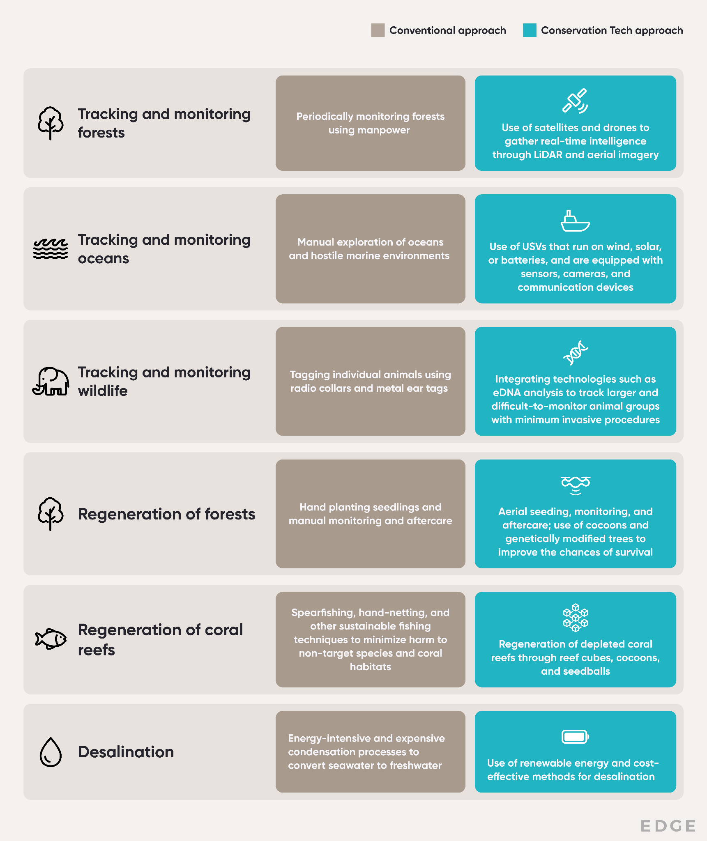

Source: SPEEDA Edge research

We have categorized Conservation Tech companies into seven segments based on the aforementioned operations and complementary solutions.

### 

### 

## **Drones, aerial imagery, eDNA, and USVs are cornerstones of Conservation Tech, alongside AI/ML**

### **Drones and aerial imagery are prevalent in tracking and conservation efforts**

Startups such as [Mast Reforestation](https://sp-edge.com/companies/360907) and [Dendra Systems](https://sp-edge.com/companies/471722) are using drones, coupled with light detection and ranging (LiDAR) and aerial imagery, to monitor and regenerate forests. The former also analyzes soil quality, water runoff, and sun exposure to map the most-suited species for each area and the best planting patterns for successful reforestation, while its aerial planting operations are reportedly 6x faster than hand-planting seedlings. Meanwhile, startups such as [Conservation Metrics](https://sp-edge.com/companies/384725) and [Global Surface Intelligence (GSI)](https://sp-edge.com/companies/616228) use aerial imagery alongside acoustic sensors, camera traps, and machine-learning algorithms to gather data on wildlife species to identify population changes, breeding patterns, and rare species.

**eDNA emerges as a promising tool for detecting rare or targeted species**

eDNA, which is still in its infancy, typically involves collecting water, soil, or other samples from the environment, extracting the DNA from them, and then using biotechnologies such as polymerase chain reaction (PCR) to identify and analyze the genetic material. Startups like [SpyGen](https://sp-edge.com/companies/1113103) and [Nature Metrics](https://sp-edge.com/companies/696724) provide eDNA services to monitor biodiversity by allowing the use of DNA that species leave behind in their environment to track and identify them. For instance, SpyGen’s VigiDNA solution can detect the presence of target species from samples of water, feces, or honey.

#### 

**USVs have reinvented the traditional approach to ocean monitoring**

Traditionally, ocean monitoring was done via manual ocean mapping, which involved nautical surveys that mobilized ships and equipment to specific areas of the ocean to collect data on water depth, seafloor features, and other oceanographic information. However, this was costly, time-consuming, and had limitations in continuous monitoring and coverage. In contrast, startups such as [Saildrone](https://sp-edge.com/companies/277754) and [Liquid Robotics](https://sp-edge.com/companies/31203) offer USVs that are either wind- or solar-powered and utilize sensors and machine learning for autonomous long-range ocean data collection. For instance, Saildrone operates USVs capable of conducting ocean mapping operations for up to 12 months, delivering ocean mapping to depths of up to 900 ft while being cost-effective with no restrictions on the scope and frequency of surveys.

# 

# 

# 

# 

# **Driving factors**

## **1. Ongoing deforestation and inadequate reforestation efforts**

There are two forms of forest loss. The first is the permanent removal of forest lands for cultivation, mining, and urbanization, which is commonly referred to as **deforestation**. The second is a decrease in tree density due to logging, shifting agriculture, and wildfires, which is referred to as forest **degradation**.

Global deforestation peaked during the 1980s and has been declining since, due to increasing crop yields demanding lower agricultural land. In 2022, around 6.6 million hectares of forest land was lost due to deforestation. **Tree loss due to degradation is even higher, at roughly 15 million hectares per year.**

### **Global forest cover loss in 2023 was driven by wildfires and forestry**

### 

### In 2023, forest cover loss was around 28.3 million hectares globally, an increase of 23.8% compared with the previous year (22.8 million hectares in 2022). Canada experienced the highest forest cover loss (8.5 million ha), followed by Russia (3.4 million ha).

### Over the last two decades (2000–2020), the global gain in forest cover was around 130.9 million hectares aggregate as a result of natural regeneration, restoration, and plantations. More tree cover was lost than gained, with an overall net loss of 100.6 million hectares, leaving a significant gap to be filled. Nevertheless, 36 countries, including those in Europe and Central and South Asia, gained more tree cover than they lost.

## **2. Increased danger of species nearing extinction**

Animals are also facing an increased risk of extinction due to escalating climate change and human-caused habitat destruction, such as deforestation and coral reef degradation. [Studies](https://www.theworldcounts.com/challenges/planet-earth/forests-and-deserts/species-extinction-rate) show that as of October 2024, approximately 29% of the Earth's species are threatened with extinction, and this proportion could reach 50% by the end of the century if immediate action is not taken.

The International Union for Conservation of Nature's (IUCN) Red List of Threatened Species includes more than 45,300 species that are in danger of disappearing forever; this is 28% of all species assessed. This group of threatened species includes a wide range of creatures: 41% of amphibians, 37% of sharks and rays, 36% of coral-building species, 34% of certain trees (conifers), 26% of mammals, and 12% of birds. The increase in the number of threatened species highlights the urgency of necessary conservation action, underscoring the importance of taking steps to identify and protect threatened species while using appropriate technology to monitor conservation efforts.

### **Number of threatened species assessed continues to rise**

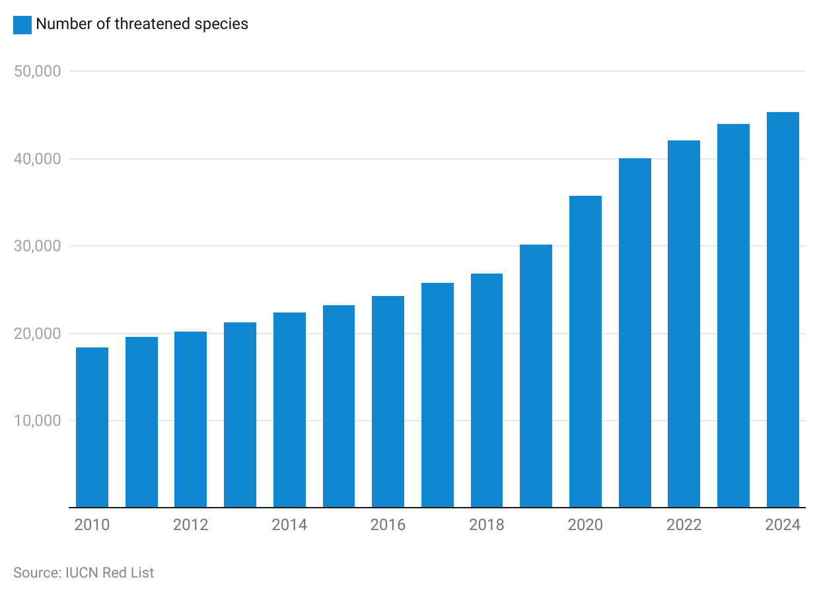

## **3. Apex-level support through policies, frameworks, and investments**

As biodiversity loss accelerates, [laws](https://www.business-biodiversity.eu/en/biodiversity/legal-framework/european-legislation), [standards](https://www.business-biodiversity.eu/en/biodiversity/biodiversity-management), and initiatives, such as the [Kunming-Montreal Global Biodiversity Framework](https://www.un.org/sustainabledevelopment/blog/2022/12/press-release-nations-adopt-four-goals-23-targets-for-2030-in-landmark-un-biodiversity-agreement/#:~:text=Among%20the%20global%20targets%20for%202030%3A&text=Have%20restoration%20completed%20or%20underway,ecosystems%20of%20high%20ecological%20integrity) (GBF), the [Taskforce on Nature-related Financial Disclosures](https://tnfd.global/about/) (TNFD), and [Business for Nature](https://static1.squarespace.com/static/5d777de8109c315fd22faf3a/t/635930f22c677e36eefb6807/1666789622524/Make+it+Mandatory+Report_final.pdf), are emphasizing the need for countries and companies to regularly monitor, assess, and transparently disclose their biodiversity risks and impacts.

The Kunming-Montreal framework emphasizes urgent action to halt the loss of biodiversity and improve the health of ecosystems and is closely aligned with the broader objectives of the [Convention on Biological Diversity (CBD) goals](https://www.cbd.int/doc/c/e6d3/cd1d/daf663719a03902a9b116c34/cop-15-l-25-en.pdf). This framework replaces the [UN Strategic Plan for Biodiversity 2011–2020](https://www.cbd.int/undb/media/factsheets/undb-factsheet-sp-en.pdf), including the [Aichi Targets](https://www.cbd.int/sp/targets/) adopted in Nagoya, Japan in 2010. The Kunming-Montreal framework outlines a set of measures in the form of 23 targets for 2030 and four goals for 2050 to address biodiversity loss and restore natural ecosystems on a global scale and was adopted by nearly 196 countries in December 2022.

Some of the key targets of the framework that promote the potential use of conservation technologies include:

* Bring the loss of high biodiversity areas close to zero by 2030
* Conserve at least 30% of the world’s lands, inland waters, coastal areas, and oceans
* Restore 30% of already degraded terrestrial and marine environments
* Implement measures to halt the human-induced extinction of known threatened species and to recover and conserve species
* Progressively phase out or reform subsidies that harm biodiversity (by at least USD 500 billion per year) and strengthen positive incentives for the conservation and sustainable use of biodiversity

## 

In addition to supportive policies and frameworks, **conservation programs and efforts continue to attract funding.**

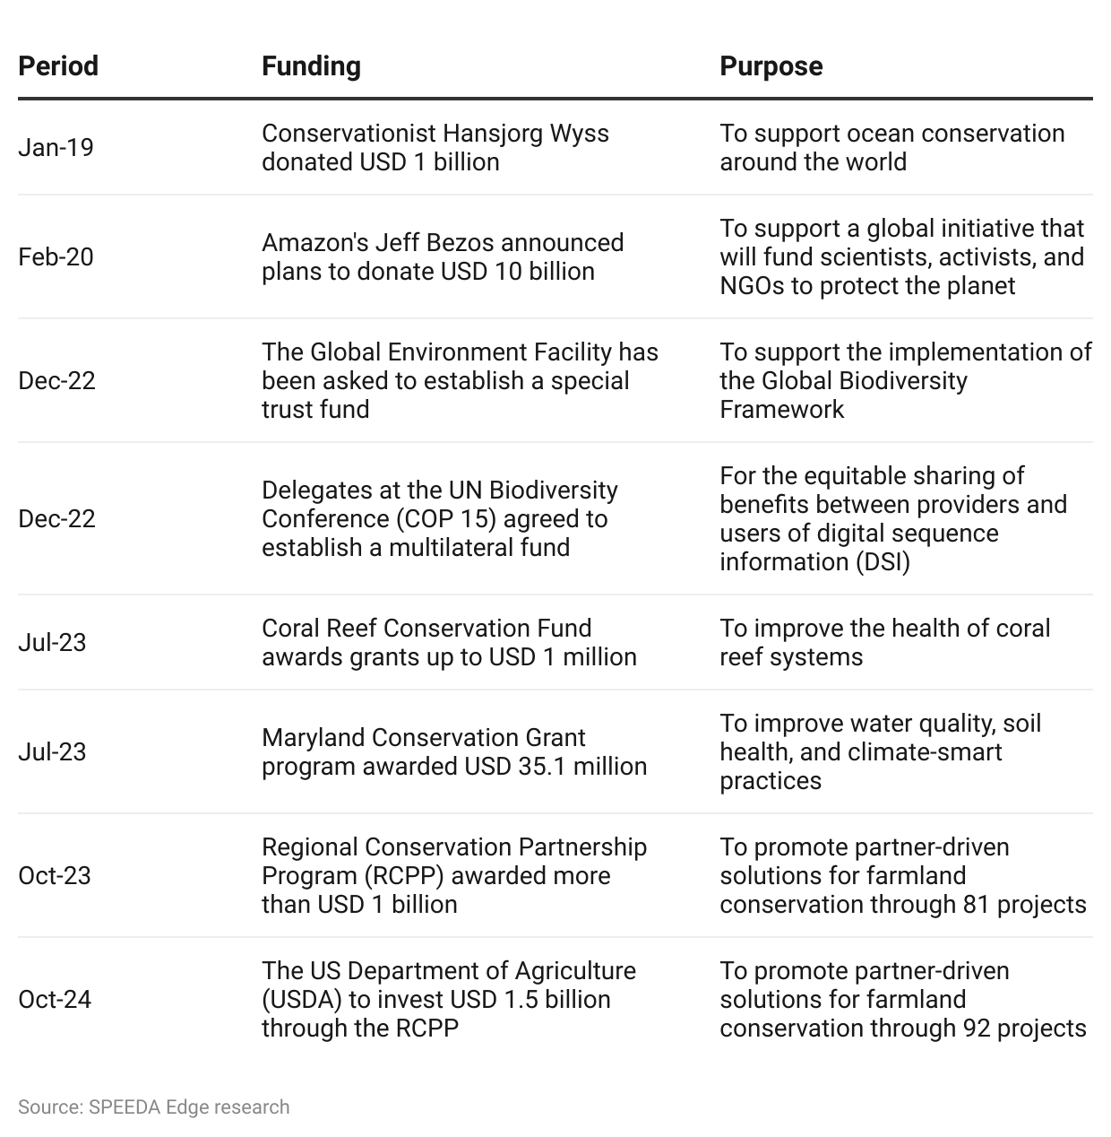

## **4. Aggressive net-zero targets and the need for carbon offsetting**

Governments have begun enacting ambitious targets to lower emissions over the next few decades. Around 139 countries, representing around 90% of the world’s GDP, have established (or are working on establishing) net-zero emission targets to be achieved by 2050. Carbon offsetting is one of the quickest ways to reach these aggressive targets, especially for hard-to-decarbonize sectors (such as steel, cement, and chemicals) and sectors with indirect carbon footprints, such as construction and data centers.

**Reducing Emissions from Deforestation and Degradation in Developing Countries (REDD) and afforestation (planting trees) have gained prominence as effective carbon offsets.** REDD is an international program aimed at reducing emissions from deforestation and forest degradation in developing countries. REDD credits work by quantifying the emissions reductions achieved through forest conservation and sustainable management efforts. These emissions reductions are converted into carbon credits, which can be sold to entities seeking to offset their emissions, providing a financial incentive for countries to protect their forests and combat climate change. Offsets from REDD+ forest conservation projects are by far the most popular in terms of volume, accounting for ~52% of total carbon offsets in 2022, followed by renewable energy offsets and tree planting.

Tree planting accounted for nearly ~8% of total carbon offsets, but has become one of the most accessible offsetting methods for retail users with the advent of remote tree-planting platforms aimed at offsetting individual carbon footprints (such as Treedom and Ecologi). Planting trees is also one of the most cost-effective ways to remove existing atmospheric CO2 (USD 7.5 per ton of CO2; [October 2024](https://8billiontrees.com/carbon-offsets-credits/new-buyers-market-guide/carbon-credit-pricing/)). Human-made technologies that can do the same are somewhat limited. [Direct Air Capture](https://sp-edge.com/industry/63) (more than USD 100 per ton of CO2) is one such solution in focus, but it is both nascent and expensive at this point.

## **5. Freshwater needs drive desalination**

Barely 1% of the Earth's water is fresh and accessible. Globally, the per capita supply of renewable freshwater has continuously declined from 7,500m3 in 2000 to 5,500m3 per person in 2020. As of 2022, approximately 2.2 billion People around the world lack access to clean freshwater, and roughly half of the world’s population experience water shortages for at least part of the year. According to the World Bank's population projections, by 2050, around two billion people living in 44 different countries could face water scarcity, with 95% of these people living in developing countries.

However, many areas facing freshwater shortages are in close proximity to the ocean,

making desalination a viable solution. Global freshwater production by desalination was 120 million m3 per day by mid-July 2022. Nearly 74% of the existing 20,000 desalination plants currently in operation use membrane reverse osmosis (RO) technology for salt separation, 21% use thermal evaporation, and 5% use other salt separation technologies, such as electrodialysis and ion exchange to produce freshwater. Total global desalination capacity is expected to reach 150 million m3 per day by 2024 and to almost double to over 250 million m3 per day by 2030. Desalination efforts have ramped up, and nations are investing heavily in desalination technology to reduce freshwater stress and enhance water security in response to climate-related challenges.

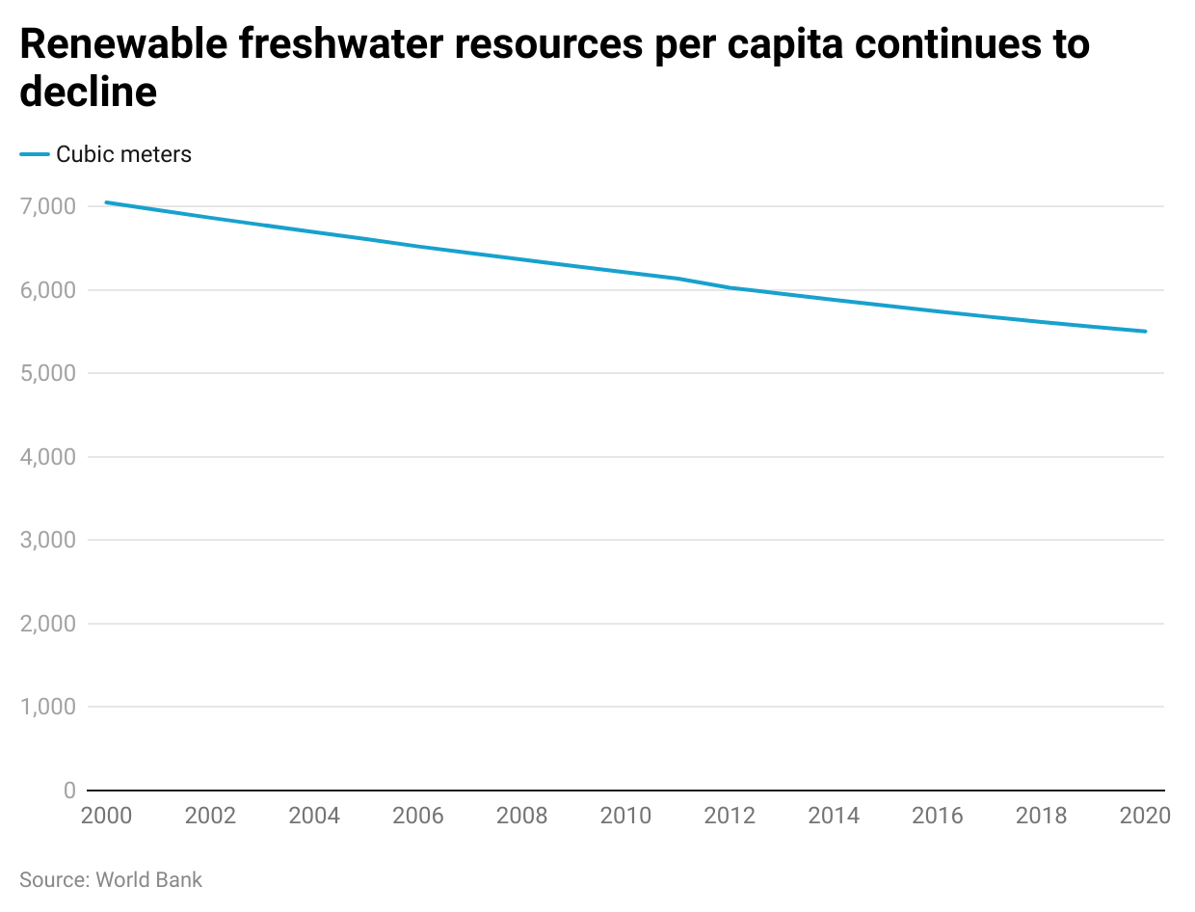

**Risks to growth**

# **1. Limited monetization opportunities and commercial scope**

Conservation Tech startups face a significant hurdle in commercializing and scaling their innovations. Despite developing functional technologies and solutions, some companies struggle to bring them to market. This is primarily due to the lack of clear monetization pathways and the limited applicability of their technologies, which are primarily used for non-commercial purposes such as research and conservation efforts, which restricts their market potential.

According to experts, a potential solution to tackle this challenge involves diversifying revenue streams. For example, forest-based solutions could explore generating revenue through the sale of carbon offsets. Similarly, companies offering USVs have broadened the applications of their technology to logistics and military operations.

## **2. High upfront cost of adoption**

A study conducted by [WILDLABS and Colorado State University](https://wildlabs.net/state-conservation-technology-2023), involving 175 participants in 2022 from various backgrounds, aimed to assess the current landscape of conservation technology. The findings revealed that **financial constraints** and **technical barriers** are significant challenges for end users of conservation technology, with 56% of respondents citing **upfront costs** as a major limitation. In contrast, developers and testers emphasized the importance of securing consistent funding, with 50% highlighting challenges in maintaining funding throughout the development process and 43% noting difficulties in obtaining initial project funding. The survey also identified broader issues, such as local access to suppliers, engineering challenges, and lack of standards, as critical barriers to the effective deployment of conservation technologies.

### **Upfront costs and local access to suppliers drive user constraints in 2022**

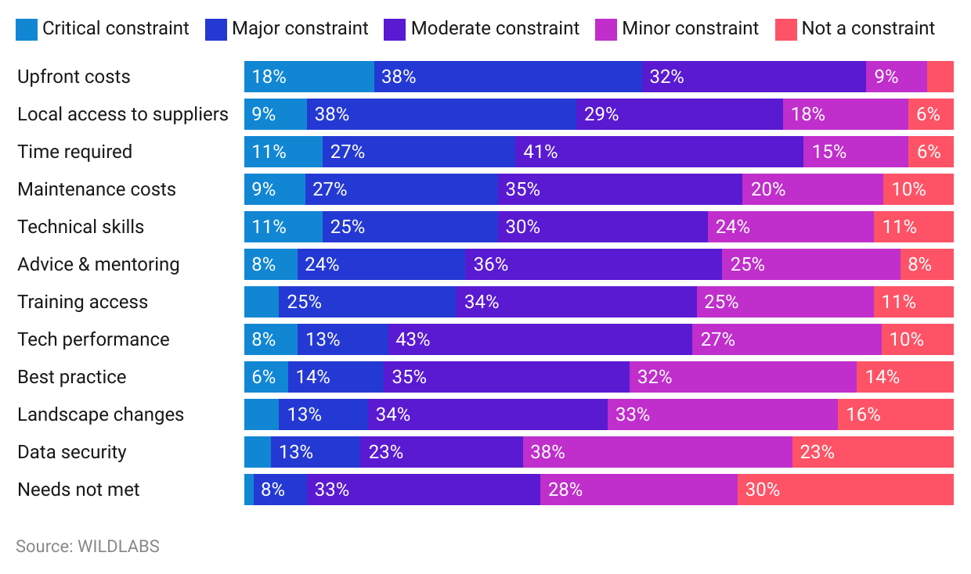

### **Maintaining funding and access to seed funding drive developer constraints in 2022**

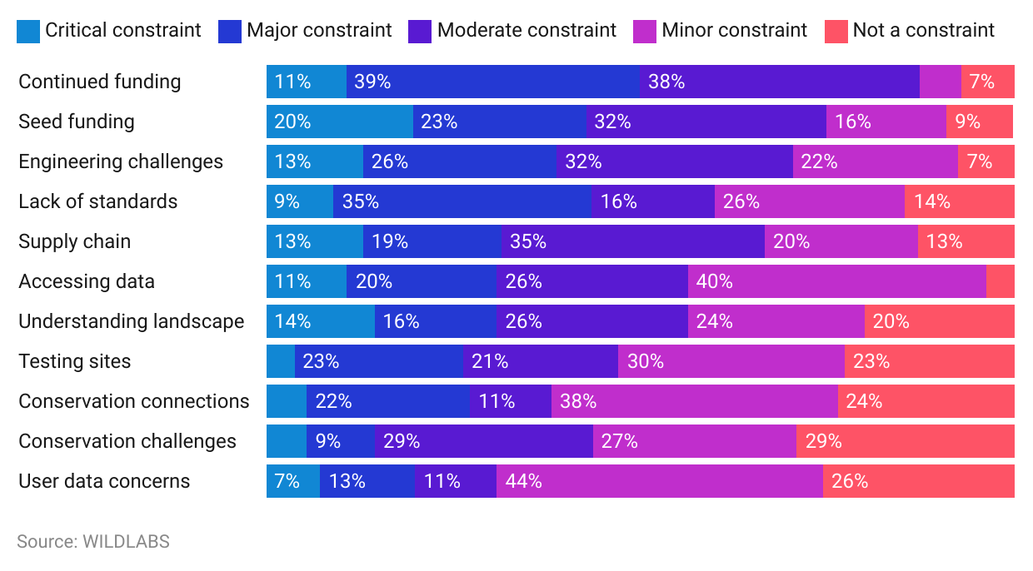

*Last updated: October 2024*

©2024 Uzabase, Inc. All Rights Reserved. The information contained herein: (1) is proprietary to Uzabase Inc. and/or its content providers; (2) may not be copied or distributed; and (3) is not warranted to be accurate, complete or timely. Neither Uzabase Inc. nor its content providers are responsible for any damages or losses arising from any use of this information.