# **InsurTech: Personal Lines - Overview**



## **Novel insurance models are providing coverage for the connected consumer**

Insurers offer fully digitized personal line insurance products entirely via digital channels, leveraging cutting-edge technologies such as AI, machine learning, and Big Data to deliver innovative insurance models that prioritize personalization and convenience.

These insurance models in the personal lines segment are heavily focused on enhancing the customer experience by offering personalized products that closely align with individual circumstances, enabling on-demand coverage and delivering services seamlessly through digital platforms. These advancements address the growing demand for more flexible and tailored insurance policies while overcoming the traditional pain points associated with a one-size-fits-all approach, where customer relationships are often managed by brokers and agents.

Digital personal line insurance products are enabled through the development of InsurTech, which drives digitalization throughout the insurance value chain. These key technologies include:

* **Internet of Things (IoT) devices:** Connected equipment such as smart home sensors, fitness trackers, and telematic devices collect data that can then be applied to carry out predictive analytics, real-time monitoring, enhance risk assessment and claims processing, and even incentivize good behavior. For example, fitness trackers are frequently used by life and health insurance companies to monitor policyholders' physical activity and promote healthy lifestyles. The goal is to reduce related claims and, in turn, offer lower premiums to customers. On average, insurers utilizing IoT technology experience a 70% improvement in loss ratios.
* **AI and machine learning:** Using these technologies, insurers can automate and enhance customer onboarding, underwriting, claim processing, and fraud detection processes, combining data from IoT devices and other sources such as geospatial imagery and electronic health records. AI also powers chatbots, allowing users to engage in conversations to receive personalized recommendations, ask questions, or use them as a first point of notification for losses. Additionally, insurers use GenAI technology to provide personalized customer experiences by creating tailored policy options based on customer’s responses and automating customer service interactions.

### **Example of new insurance products that take advantage of the above technologies**

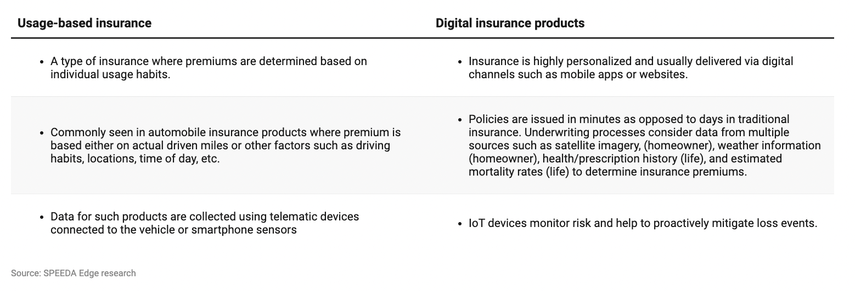

## 

## **Key segments of InsurTech: Personal Lines**

The InsurTech: Personal Lines hub focuses on personal lines insurance, encompassing various policies catering to individuals' unique needs. This includes automobile insurance, homeowners and renters insurance, life and health insurance, and coverage for personal belongings. The hub also delves into travel and pet insurance. Beyond these offerings, the hub explores companies that offer platforms for comparing and purchasing personal line policies, providing consumers with easy access to the best options available in the market.

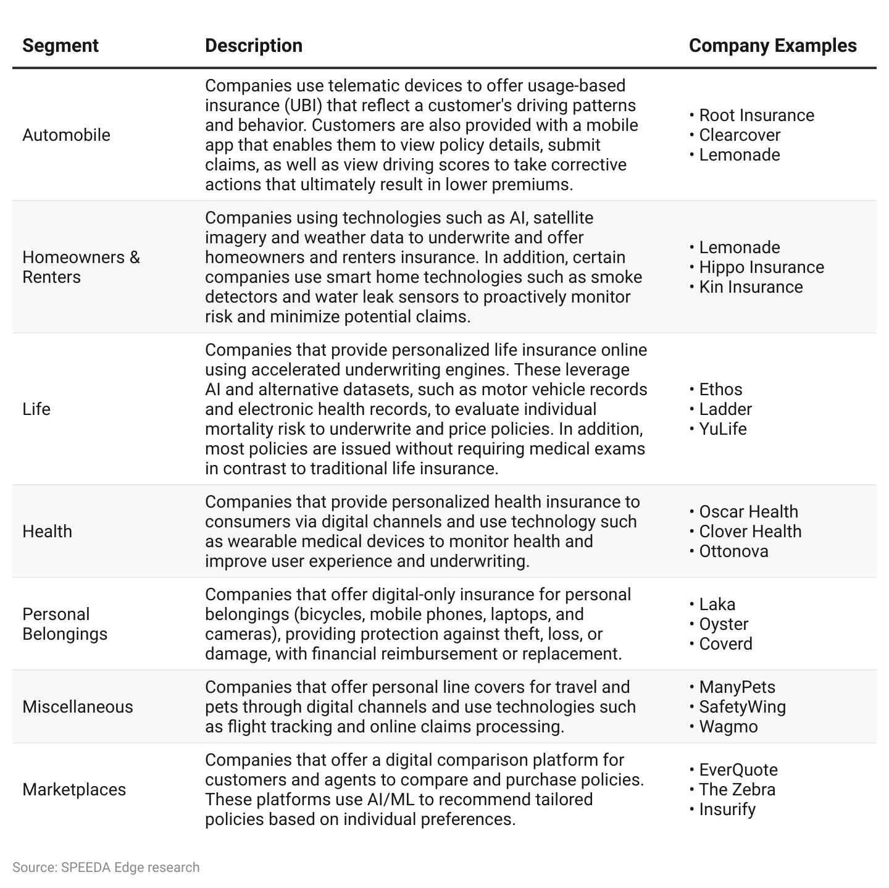

*For information on companies offering commercial insurance focusing on startups and SMEs, as well as those providing insurance related to cybersecurity protection, please visit the* [*InsurTech: Commercial Lines*](https://sp-edge.com/industry/125) *and the* [*Cyber Insurance*](https://sp-edge.com/industry/52) *hubs, respectively.*

*In addition, for information on companies offering infrastructure solutions to help insurers enhance their operations, such as turnkey solutions and underwriting and claims processing platforms, please visit the* [*InsurTech: Infrastructure*](https://sp-edge.com/industry/187) *hub*.

# **Driving Factors**

## **1. Convenience and personalization call for new approaches to insurance**

Customers are increasingly seeking a tailored experience from their insurers, with nearly 90%desiring product offerings that more accurately match their needs and preferences. This has resulted in increased demand for insurance products based on consumer lifestyle, behavior, micro-events (on demand), and actual use of the asset (usage-based). A study conducted by Accenture revealed that the demand for life insurance services that determine premiums based on consumers' lifestyles has grown significantly—52% in 2018 to 62% in 2022. Similarly, the preference for auto insurance services calculating premiums based on driving behavior rose from 64% to 76% in 2022.

**Customers are demanding more personalized offerings**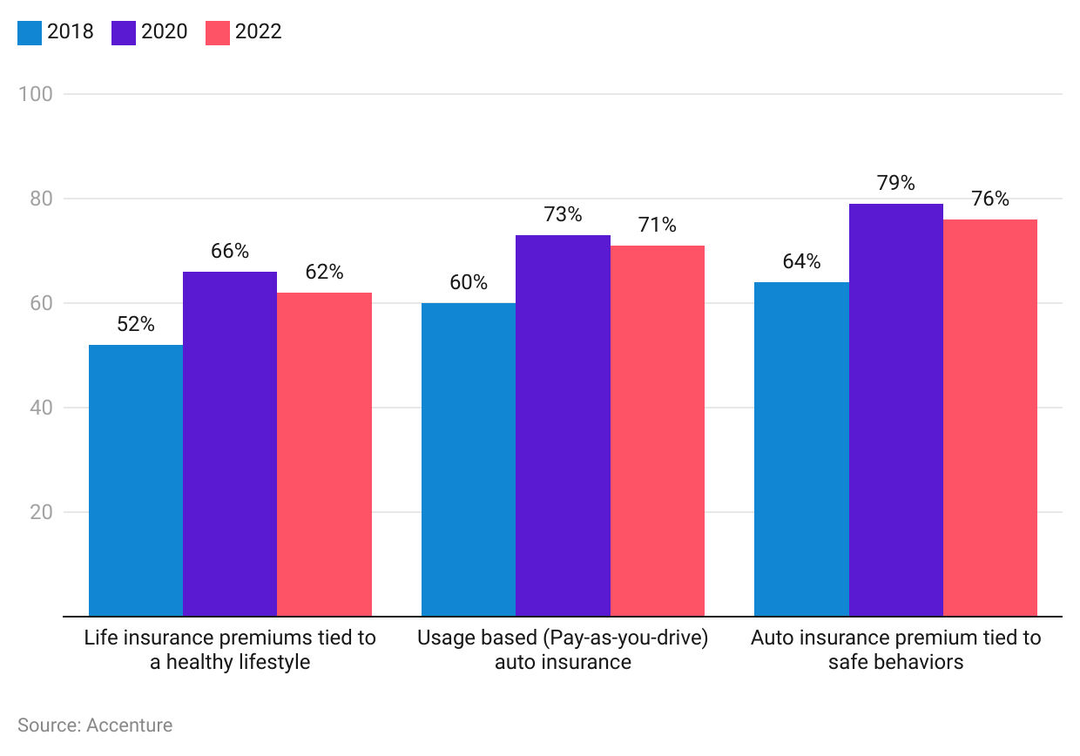

Customers are increasingly willing to share personal data to meet the growing demand for personalized insurance services. According to a survey conducted by Capco in 2023, nearly 87% of customers are open to sharing extensive information about their health, exercise routines, and driving habits with their insurers. Among these customers, 46% are motivated by the prospect of lower premiums, while 41% are willing to share their data in exchange for more tailored services.

### **Customer's willingness to share personal information with insurers**

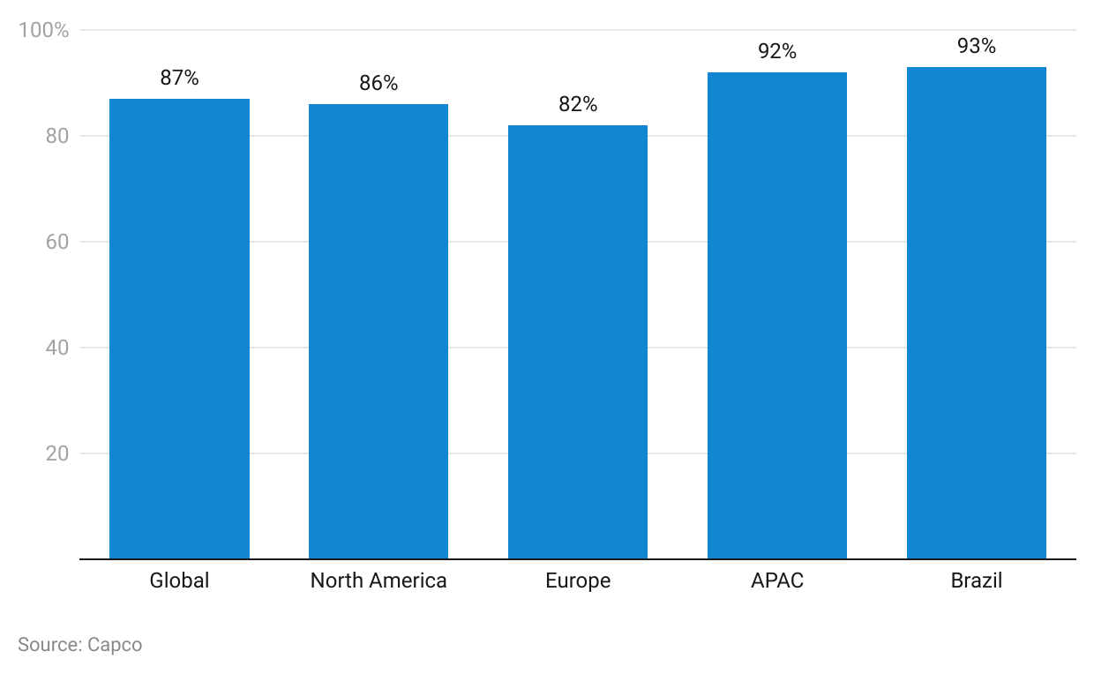

### 

### **Reasons for sharing personal data with insurers**

~~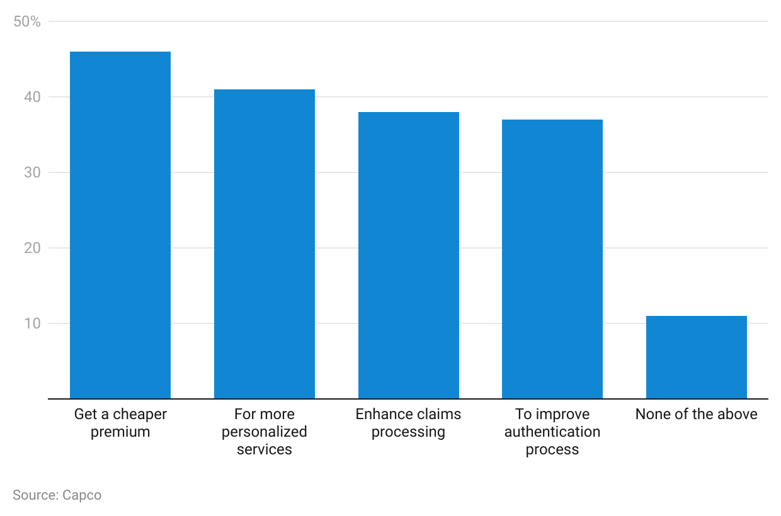~~

Millennials accounted for 21.7% of the US population in 2023 and represent a significant segment of the adult population. This generation is more likely to prefer speed and convenience compared to the generations that precede them. Similarly, Gen-Z, born between 1997 and 2012, makes up 20.7% of the US population. Both segments have high technology adoption rates, with nearly 100% internet penetration and significant smartphone usage. Startups such as [Lemonade](https://sp-edge.com/companies/3938) provide an end-to-end digital experience from instant onboarding to faster processing of claims through a mobile app and utilize AI to underwrite policies, while automobile insurance startup, [Root](https://sp-edge.com/companies/416778), leverages smartphone sensors to provide behavior-based car insurance through its app.

Embedded insurance, which integrates insurance offers seamlessly into the purchase process of other products and services, is also gaining popularity. This approach leverages the convenience of one-stop shopping and the personalization of relevant insurance offers at the point of sale. Moreover, online reviews have increasingly taken over the traditional role of insurance advisors, with 89% of insurance purchase decisions influenced by online reviews and ratings (2023).

Additionally, insurers benefit significantly from providing data-driven and personalized insurance products, as this approach allows them to stand out in a crowded industry. On average, insurers offering personalized coverage see an 81% increase in customer retention, an 89% increase in customer engagement, and a 60% increase in revenue per customer.

**2. Emerging industries present new risks**

**Traditional insurance lags to keep up with emerging industries**

In 2023, approximately 160 million consumers were estimated to be engaged in the US sharing economy. Full-fledged commercial insurance is typically not cost effective for those offering their personal assets into the sharing economy, while personal insurance on its own does not cover commercial activity. Startups such as [Buckle](https://sp-edge.com/companies/884699) and [Zego](https://sp-edge.com/companies/500838) meet this need by offering UBI to individuals that provide their personal vehicles for rideshare services.

Fully autonomous vehicles are on track to reduce motor accidents due to human error-which accounted for 94–96% of motor accidents in the US in 2016. While traditional auto insurance policies are purchased by vehicle owners, driverless cars present a paradigm shift for auto insurance as accountability moves from the vehicle owner to the manufacturer and network providers. By 2025, it is expected that roughly 3.5 million autonomous vehicles will be traversing the roads of the US, with this number projected to increase to around 4.5 million by 2030. It is expected that insurers might lose nearly USD 25 billion in premiums by 2035 resulting from decreased vehicle ownership and overall safer vehicles, approximately 34% of net written premiums of private automobile insurance in 2021.

Given that these are new developments, vehicle manufacturers are leveraging telematics and built-in technologies to roll out their own insurance products, as is the case with Toyota, Tesla and General Motors, or partner with other insurance companies such as BMW’s partnership with Swiss Re.

### **Increase in vehicle mileage of autonomous and shared vehicles over 2017 to 2030**

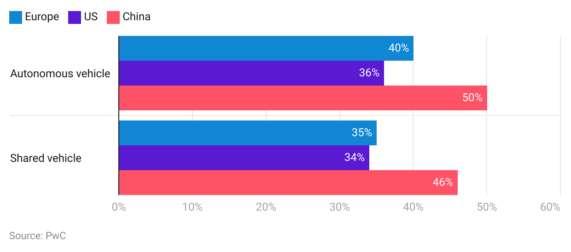

### **3. The Covid-19 pandemic has accelerated demand for personalized and digital personal line insurance cover**

In light of public health guidelines in relation to the Covid-19 pandemic, customers began opting for digital alternatives. As a result, insurance companies expedited the implementation of mobile apps and other process efficiencies, such as touchless claims processing and digital distribution, to meet this growing demand.

Life insurers, in particular, have experienced a direct increase in demand as a result of the pandemic as consumers rush to protect themselves and their family members. In the US, life insurance application activity saw a 3.4% YoY increase in 2021, following 3.9% YoY growth in 2020. These figures mark a significant turnaround from the three consecutive years of decline experienced between 2017 and 2020. Moreover, consumers were increasingly seeking digital life insurance policies that could be conveniently purchased from their homes, without conducting invasive medical exams, which are typically required for traditional life insurance policies. Startups such as [Ethos](https://sp-edge.com/companies/419648) were well-positioned to benefit from this trend, as they utilize AI to analyze personal data along with other public data points, instead of relying on medical exams to underwrite policies.

The Covid-19 pandemic also brought on a change in the lifestyle of consumers such as remote and hybrid working practices leading to less commute. Nearly 30% of consumers who drove before the pandemic claimed that they expect to drive less in the long term than they did before the pandemic, which drives demand for UBI cover that only charges premiums based on the actual usage of the asset.

Positive impacts on select startups owing to the Covid-19 pandemic:

* During 2020, [Lemonade](https://sp-edge.com/companies/3938), a digital homeowners, renters, life, and auto insurance provider, recorded 55.6% customer growth YoY and more than doubled its gross earned premiums during the same period.
* [Root Insurance](https://sp-edge.com/companies/416778), a usage-based automobile insurance provider, saw the number of active policies increased 14.7% YoY during 2020, with direct written premiums growing 36.7% YoY during the same period. Direct loss ratios improved to 82.0% from 99.9% during 2019, as driving fell during the pandemic.
* [Bestow](https://sp-edge.com/companies/497951), a digital term life insurance provider experienced 450% YoY growth in sales during the period from January to October due to surging demand resulting from the pandemic. The company also acquired traditional life insurer Centurion Life in December 2020 to expand its national footprint.
* Germany-based [GetSafe](https://sp-edge.com/companies/290793) grew 20% more than expected during March to May 2020.
* [Policygenius](https://sp-edge.com/companies/96502), an insurance marketplace, introduced three no-medical-exam life insurance options on its platform in 2020, which increased to seven by 2021, as the business segment witnessed 30x volume growth over the past two years, as of March 2022.

### **Risks to growth**

### **1. Stringent capital requirements**

Full-stack insurance providers have to comply with multiple current and future regulations including, but not limited to, minimum (risk-based) capital and solvency requirements, which in the case of the US, vary across different states. Startups typically lack capital reserves compared to traditional insurers. The regulations also include extensive disclosure requirements on controlling investors, which may disincentivize private venture capital investors from future funding rounds. In response to this, some startups in this space are establishing themselves as managing general agents (MGAs) or partnering with other MGAs. MGAs provide critical insurance services such as underwriting, marketing, and policy issuance but do not assume insurance risk. This allows them to innovate and implement new insurance products, without the need to meet large capital requirements.

**2. Privacy concerns amidst large-scale data collection**

Most new insurance products rely on telematics and user data throughout their value chain and will be subject to existing and upcoming regulations related to the privacy and collection of such data. These regulations have the potential to significantly impair the effectiveness of these technologies.

“Proposition 103” which was passed in 1988 in the state of California is one specific example which prohibits insurance providers from using data collected from telematics into consideration when pricing insurance policies. While these laws are intended to protect consumer privacy and prevent potential biases, they may also limit insurers' ability to offer personalized and potentially more accurate pricing based on individual driving behaviors, which could result in lower premiums. Moreover, to overcome privacy concerns, insurers use novel technologies such as blockchain to ensure the security and integrity of sensitive information of policyholders and telematics data.

*Last updated: September 2024*

©2024 Uzabase, Inc. All Rights Reserved. The information contained herein: (1) is proprietary to Uzabase Inc. and/or its content providers; (2) may not be copied or distributed; and (3) is not warranted to be accurate, complete or timely. Neither Uzabase Inc. nor its content providers are responsible for any damages or losses arising from any use of this information.