# **Food Waste: Overview**



# 

# **Food waste serves better purpose than in landfills**

**Food waste management refers to various techniques to reduce food waste—by prevention or by redistribution—or to produce goods using food waste as raw materials.** In the food supply chain, waste that occurs at any point from industrial processing to post-consumption can be defined as “food waste,” while waste that occurs at the initial stages, such as production, harvesting, and initial processing, is generally referred to as “food loss.” This report focuses on “food waste” management rather than “food loss” management. For technologies that improve the efficiency and process of food production, please refer to our [Smart Farming](https://sp-edge.com/industry/50) and [Vertical Farming](https://sp-edge.com/industry/11) industry hubs.

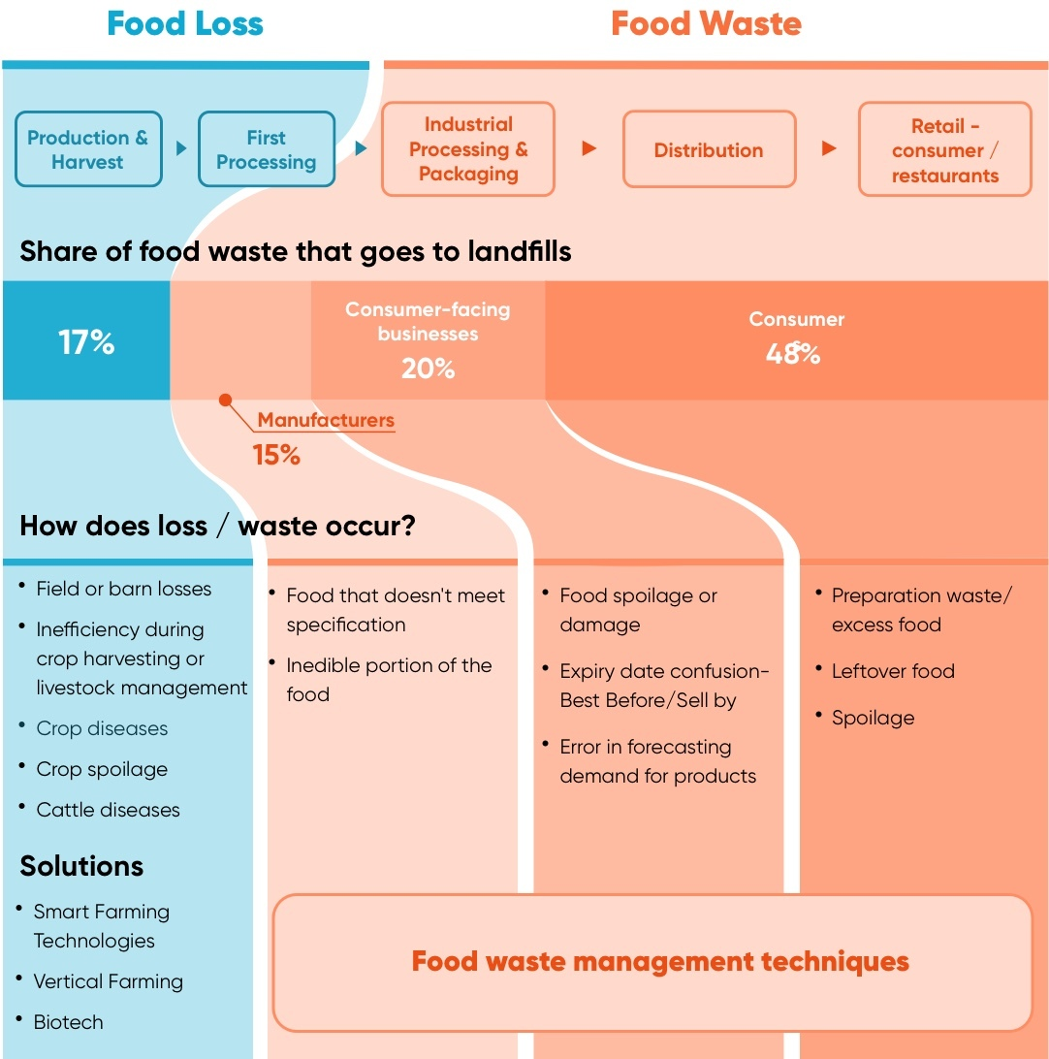

Source: Created by SPEEDA Edge based on various industry sources

The food waste management tech ecosystem includes developers of products that 1) prevent food waste (i.e., reduce the volume of surplus food), 2) optimize food surpluses (resale or donation of food waste and oversupply), and 3) recycle waste for food, beverages, animal feed, or industrial use (also referred to as “upcycling”).

Accordingly, we have broken down the industry into three segments:

1) Food waste prevention

2) Food waste redistribution

3) Food waste recycling

### 

### **Leading food waste management methods**

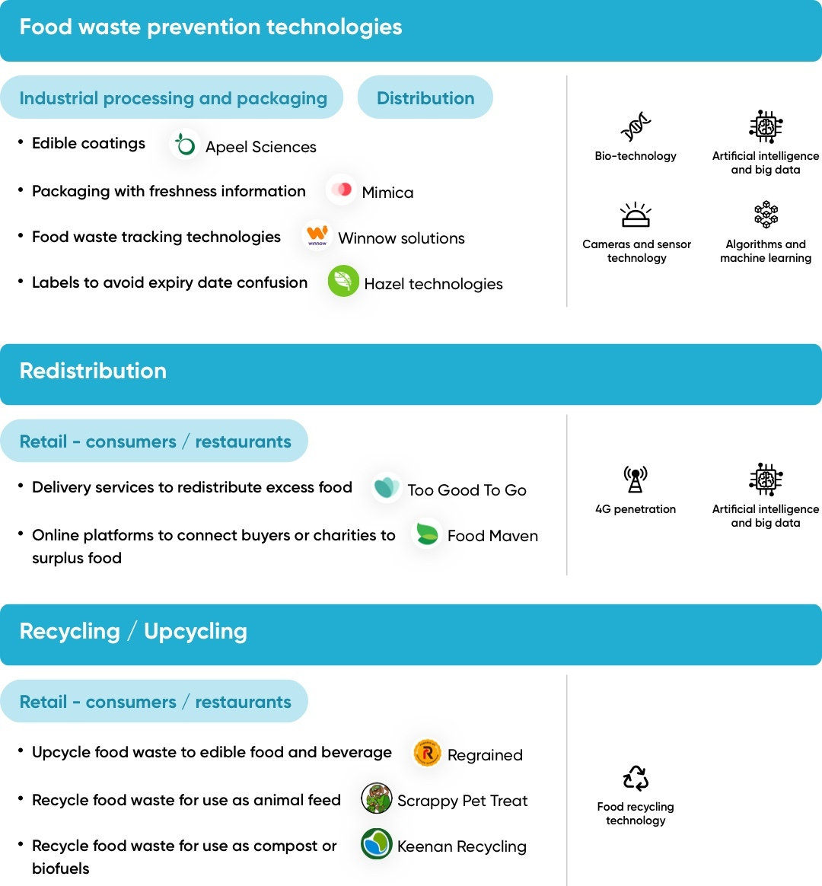

*Colors match technology enabler with the key solutions*

Source: Created by SPEEDA Edge based on various industry sources

### 

### **Biotech and Big Data analytics support the latest food waste management techniques**

Technologies enabled by advancements in biotechnology, sensors, cameras, machine learning, and Big Data analytics are helping prevent food waste at the early stages of the food supply chain by extending the potential shelf time of products and helping track and forecast demand.

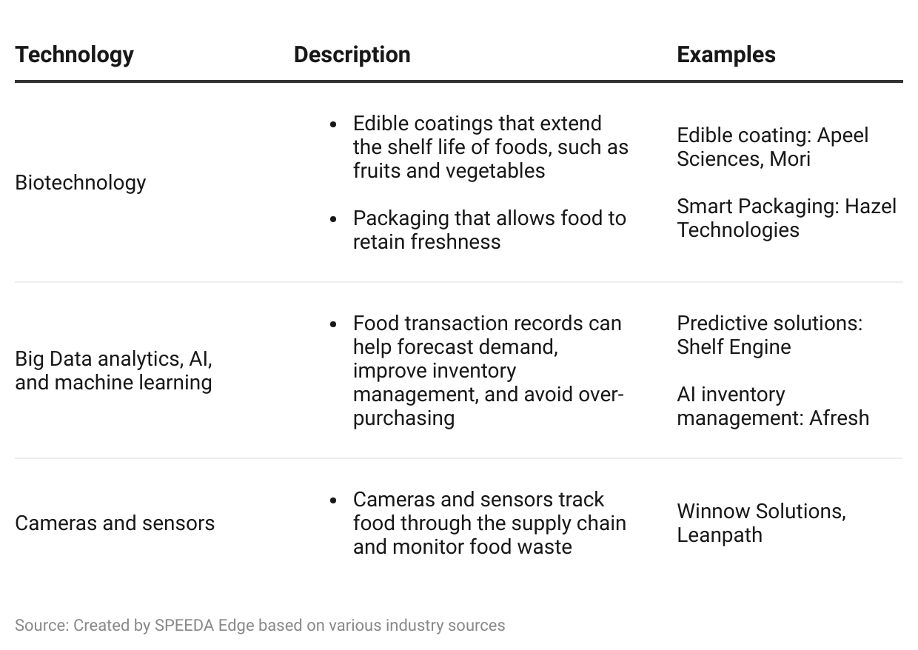

# 

# 

# 

# 

# **Driving Factors**

## **1. Ambitious US waste reduction goals**

Global food waste accounted for ~2.5 billion tons every year (August 2023)—over one-third of all food produced—and the US leads the way with ~66 million tons. This is estimated to be ~40% of the entire US food supply, equating to ~325 lbs per person. In fact, food is the single-largest component taking up space inside US landfills, making up ~22% of municipal solid waste (MSW). The amount of food waste in America was valued at nearly USD 218 billion, equivalent to 130 billion meals.

To combat this, in September 2015, the US set a 2030 Food Loss and Waste Reduction goal to reduce food going to landfills by 50% to 164 lbs per person (from 328 lbs in 2016). In 2023, the US Department of Agriculture (USDA) announced over [USD 9.4 million](https://sp-edge.com/updates/16182) in funding for 45 Compost and Food Waste Reduction (CFWR) cooperative agreements and invested an [additional USD 25 million](https://sp-edge.com/updates/22110) to further food loss and waste reduction efforts under the American Rescue Plan Act (ARPA).

Despite these efforts, US food waste has been increasing, with the majority going to landfills. In order to meet the 2030 goal, emerging food waste management methods, such as tech-enabled recycling or redistribution systems, are deemed exponentially necessary.

The economic cost of food waste is overwhelmingly saddled onto consumer businesses (restaurants and grocers) and households. Emerging food waste management startups are therefore targeting these types of enterprises, with proposals to improve business results while adopting sustainable practices. For example, [Apeel Sciences](https://www.apeel.com/) claims its edible produce coating leads to a 50% reduction in waste on average, alongside a 5–10% growth in sales.

### 

### 

### 

### 

### 

### 

### 

### 

### 

#### **Food waste in the US continues to grow**

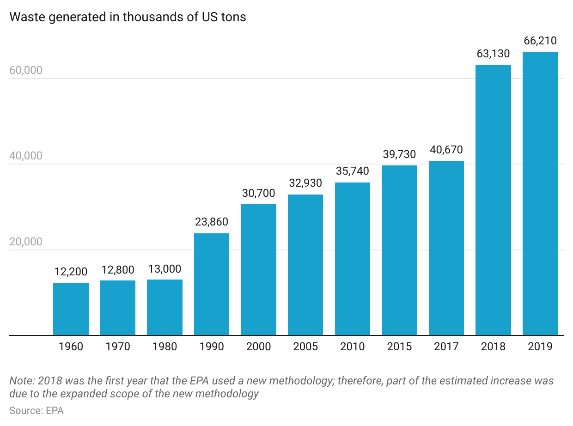

#### **Majority of food waste ends up in landfills**

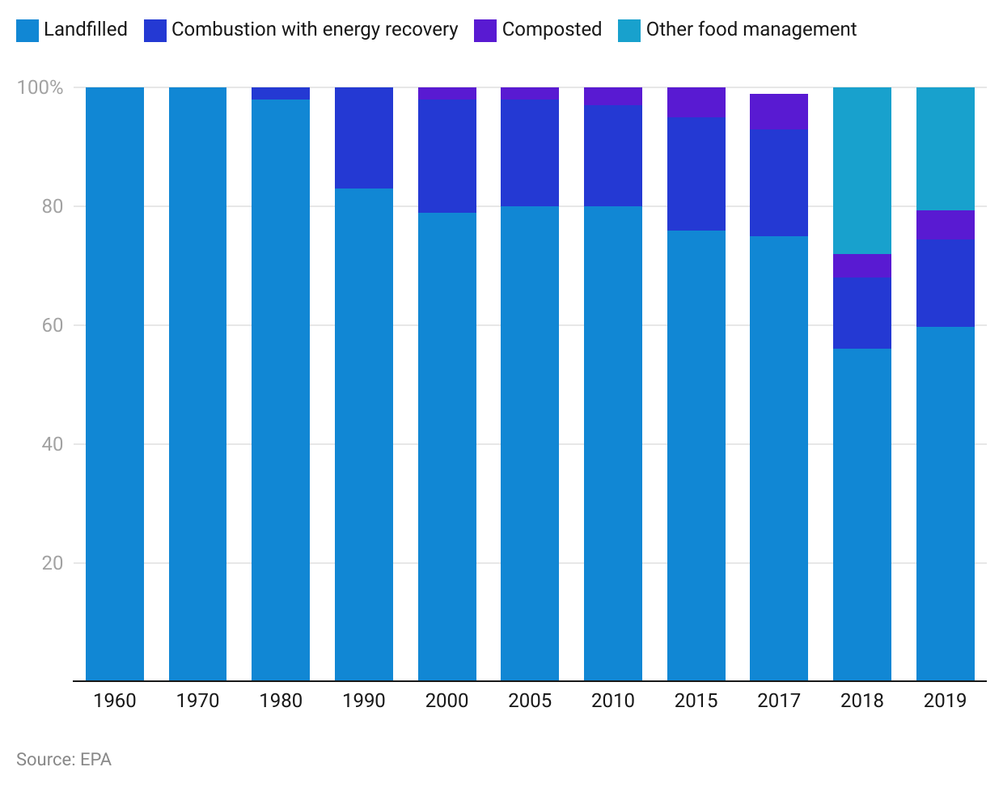

#### **Cost of surplus food highlights the potential market for emerging food management companies**

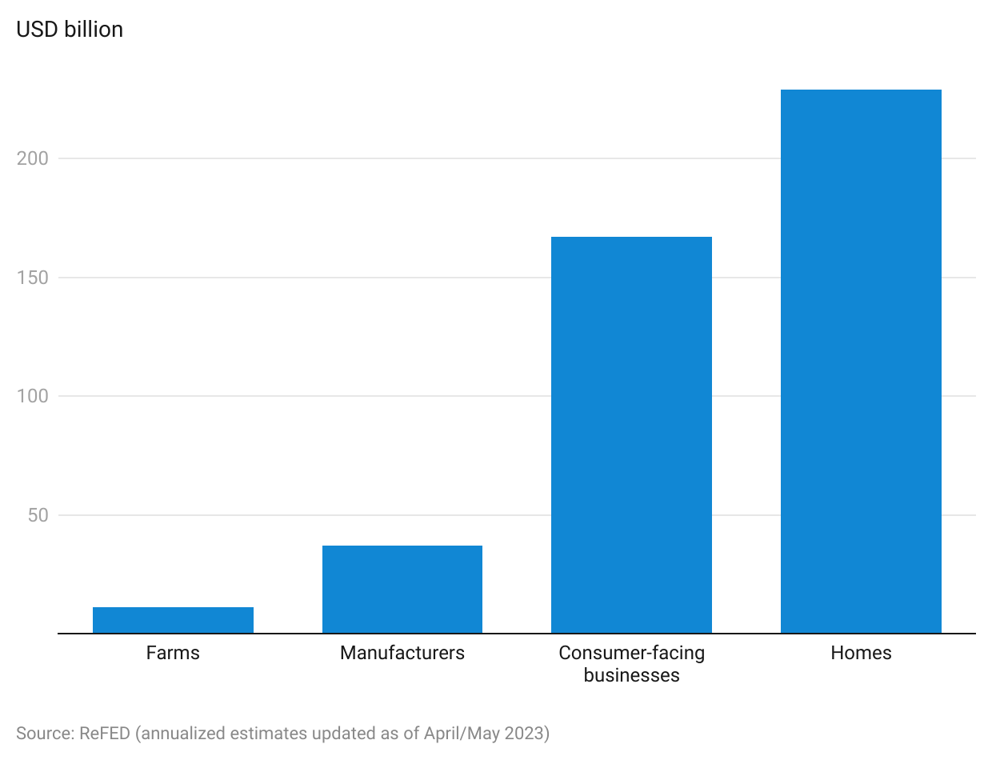

## **2. Rising consumer awareness**

Young consumers are increasingly reporting their concern over food waste and are thus more likely to support initiatives like food recycling and redistribution. According to the Food and Health survey 2022, around 57% of respondents reported that they are concerned about food waste in general, with Gen-Zers, Millennials, and Gen-Xers likely to be more concerned. Another 2019 survey found that 88% of respondents take steps to reduce food waste at home. However, only 53% of the respondents were aware that food waste was a problem.

Accordingly, efforts are being made to increase awareness on food waste. Food@MSU, an initiative of Michigan State University (MSU)’s AgBio research, is working to bridge this knowledge gap by conducting food literacy surveys and holding in-person forums for the public to engage with agriculture scientists and experts. Its last survey in 2019 indicated that consumers are beginning to recognize the food waste problem, with 41% of Americans correctly indicating that 30%–40% of annual US food production goes to waste and reporting that they are taking steps to reduce waste in their homes. Around 71% of those surveyed said they proactively reduced their household food waste by not purchasing excess food and consuming it before it spoils, while 34% said that they share excess food when possible.

Furthermore, food waste apps gained popularity during the pandemic, highlighting the consumer demand for more sustainable options. For instance, [Too Good To Go](https://sp-edge.com/companies/668942), a Danish startup that connects consumers with restaurants and stores that have unsold or surplus food, saw a 200% YoY increase in revenue in 2019 compared to 2018, reaching nearly 38,000 partners and more than 18 million users. As of March 2023, the company had more than 75 million registered users.

#### **Survey: Percentage of respondents that thought about food waste while shopping, eating out, and at home**

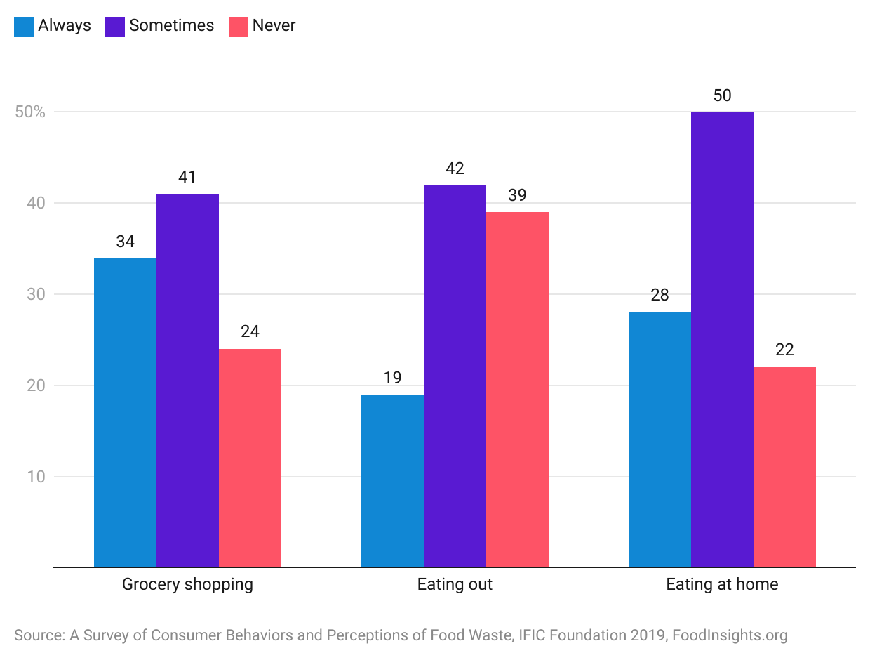

## **3. Multiple levels of regulations**

Within the US, policies and goals are being set to shift attention and practice toward recycling and redistribution methods of food management, as well as banning food waste in landfills. The UN Sustainable Development Goal 12.3 aims to halve per capita global food waste (at consumer and retail levels) by 2030. The US Consumer Goods Forum (CGF) supports the UN goal and goes further, seeking to halve food waste within its 400 retail and manufacturing members by 2025.

In 2019, a joint agreement (Federal Interagency Collaboration) between the USDA, the US Environmental Protection Agency (EPA), and the U.S. The Food and Drug Administration (FDA) was formed to improve coordination and communication across federal agencies to better educate Americans on the impacts of food loss and waste. In 2017, more than 30 bills addressing food waste were introduced across 12 US states. Since January 2022, US states have introduced or actively carried more than 70 bills on food loss and waste, 14 of which have passed.

### **Regulations and Initiatives Across US to Keep Waste Out of Landfills**

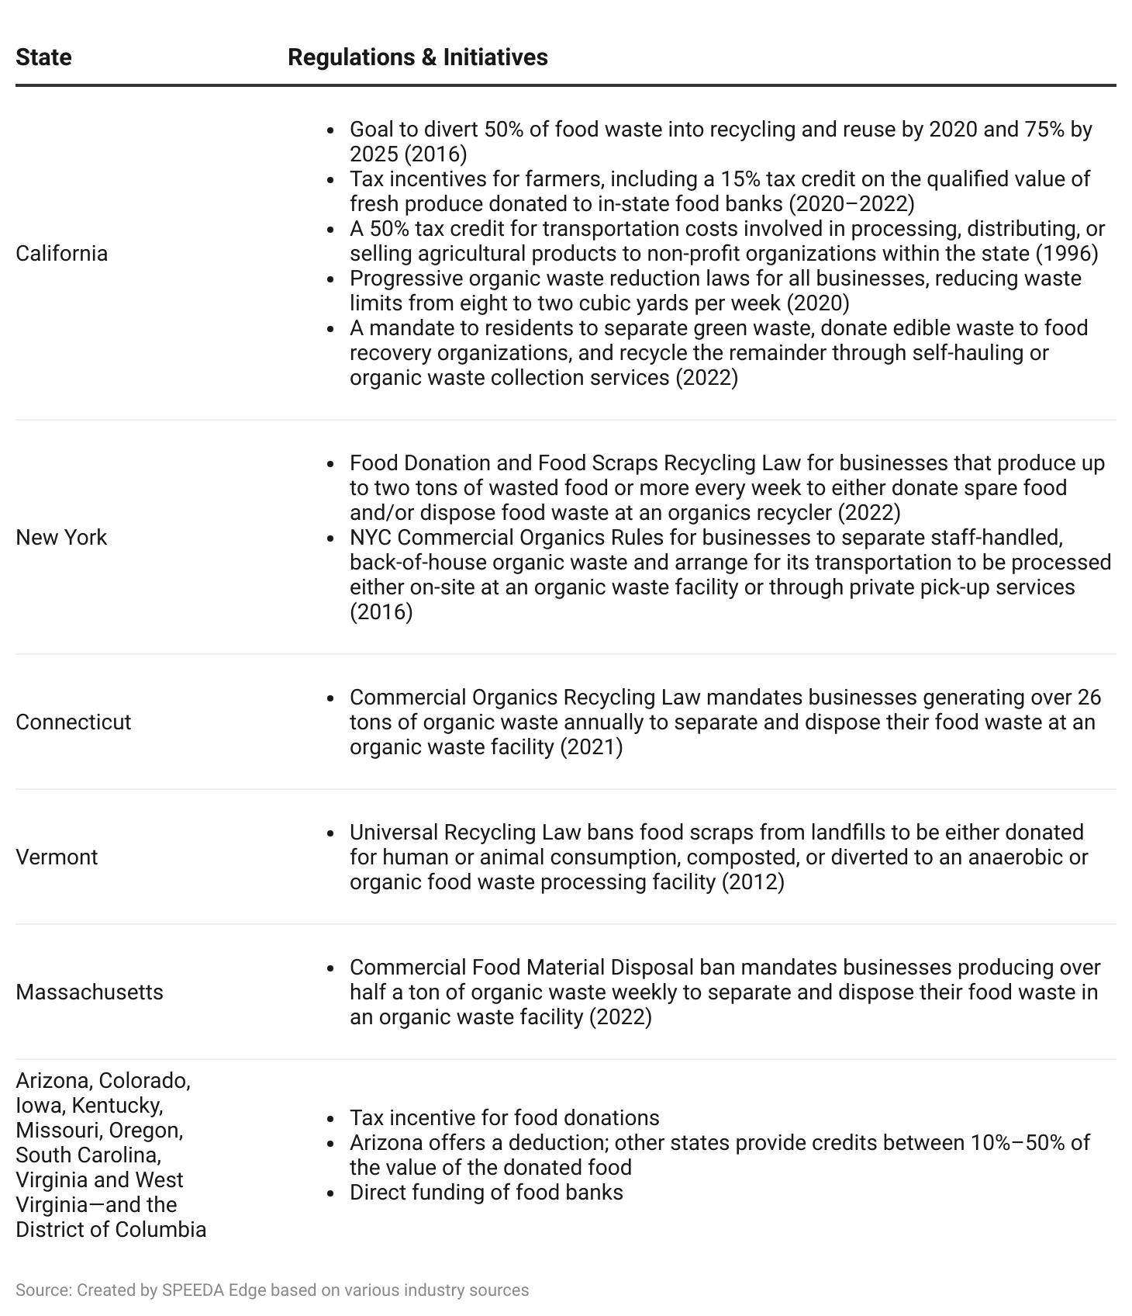

# **Risks**

## **1. Shifting behavior toward best practices**

Despite years of regulatory and civic efforts, a majority of food waste still goes to landfills, and households and businesses have yet to adopt sustainable food waste management techniques. Further, research shows that companies are putting less effort and investment into reducing food waste. Karma, a startup dealing with tracking food waste at restaurants, reports having to argue with restaurants that adding an extra minute of time to manage food waste will benefit them 10x in the future by reducing costs and increasing long-term sustainability and positive community relations. Nevertheless, as awareness grows and governments implement stricter legislation on food waste, grocers are facing increasing pressure to take action—whether it be through better demand forecasting or optimizing transportation and storage conditions.

## **2. High premiums on upcycled food**

While a growing number of startups are aiming to create edible products out of food waste, it should be noted that these upcycled food, beverage, and pet food products are generally sold at a very high premium. For instance, startups like Barnana that use wasted fruits and vegetables to produce upcycled chips sell the product at a premium of 100% on average compared to similar conventional products like Lay’s and Doritos. A key upcycled pet food player, Scrappy Pet Treats, currently sells its product at a premium of around 4,200% compared to conventional pet food products like Pedigree.

So, while upcycling is gaining momentum, continued success will depend on the industry’s ability to stabilize prices to compete with conventional products, as studies show that consumers are willing to pay a premium of around 133% at most for an upcycled product. If the upcycling players do not manage to bring down costs that maintain profitability with price levels of 100%–150% premium above current conventional product prices, the long-term viability of the food-upcycling sub-segment could be challenged.

*Last updated: October 2023*

©2024 Uzabase, Inc. All Rights Reserved. The information contained herein: (1) is proprietary to Uzabase Inc. and/or its content providers; (2) may not be copied or distributed; and (3) is not warranted to be accurate, complete or timely. Neither Uzabase Inc. nor its content providers are responsible for any damages or losses arising from any use of this information.