# **Overview**

# **Online Food Delivery: Overview**

## 

## **New players focus on niche segments to stay competitive**

An online food delivery platform is a website or mobile app that allows users to place food orders, make payments, and track delivery orders in real time. The earliest and most popular model in the industry is the aggregator model, in which the platform hosts menus from multiple restaurants for users to order from. Newer players in the industry have ventured into niche segments such as prepared meals and meal kits. Already a growing segment, online food delivery gained immense traction recently due to restaurant closures and social distancing practices to mitigate the spread of the Covid-19 pandemic.

Online delivery platforms differentiate themselves from online restaurant and fast food delivery services, as they offer consumers a variety of options from several different venues. These platforms have created a marketplace for restaurants to build larger loyal customer bases and have provided an opportunity to broaden geographic reach without the need for multiple locations or owning a substantial in-house delivery fleet. The actual delivery of food is often carried out by independent contract workers who are either registered with the platform or employed directly by the platform.

Big data analytics has been crucial to the success of food delivery platforms, as it allows players to personalize the customer experience and ensure fast delivery. For instance, DoorDash and Grubhub use big data analytics to gather and analyze data to understand customer behavior and preferences in order to guide them to the appropriate dishes from nearby restaurants.

Platform operators also advise restaurants on how to maximize their sales and compete online by using data analytics including advice on menu prices, peak hours for delivery, and other metrics. UberEats has used its historical data to create a dispatch system that can predict the time it takes for restaurants to prepare the meal and to approximate the delivery time from restaurants to consumers. This way, Uber Eats’ delivery staff can maximize efficiency and the number of deliveries they make during a given shift.

Besides the popular aggregator model adapted by incumbents such as UberEats and GrubHub, newer players have evolved over the past few years in attempts to capture promising niche segments.

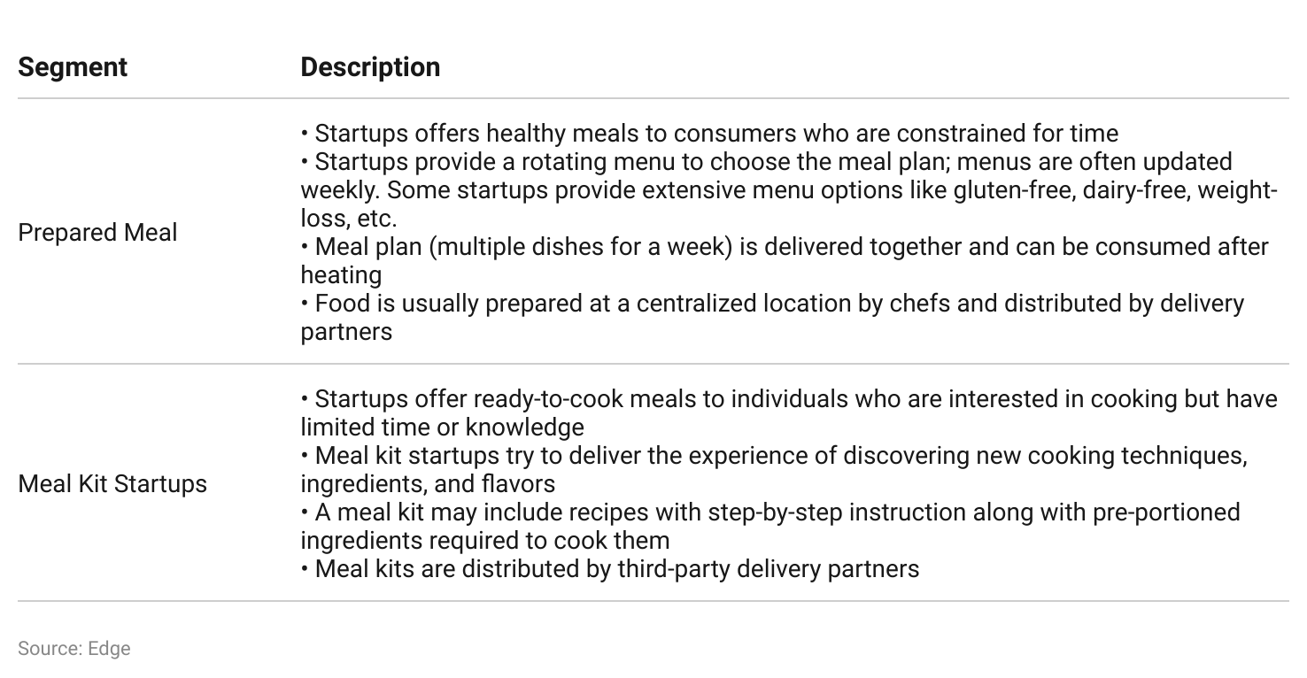

# **Driving Factors**

## **1. Millennials and Gen Zs account for a larger share of the population and spend**

Millennials (born 1981–1996) and Gen Z customers (born 1997–2012), who make up more than half of the US population, are the main drivers for online food delivery startups. Collectively, this group is approaching its spending prime and is predisposed toward using online delivery services.

According to data released by the US Census Bureau, Millennials, Gen Z, and younger age groups comprised 50.7% of the population, as of July 2019 (up from 40.7% in 2010). As of 2020, the two generations accounted for 32% of the total retail spend in the US. This share is predicted to grow to 48% by 2030, as more Gen Zers enter the workforce. In 2021, the average household income for a Millennial was USD 73,000, while the average household income for Gen Z was USD 32,500.

Millennials and Gen Z also prefer the convenience of delivery services. Over 55% of those aged 18–34 and over 60% of those aged 35–44 have more delivery subscriptions (Amazon Prime, DoorDash, UberEats, etc.) than streaming service subscriptions (Netflix, Hulu, Disney+, etc.). According to the US National Restaurant Association, 71% of millennials in the country report a preference for delivery services. Moreover, 72% of Millennials and 66% of Gen Zers consider takeout and food delivery essential to their lifestyles.

Millennial and Gen Z customers are also among the most active users of online food delivery due to high mobile and internet penetration. Insider Intelligence estimates that by 2024, internet penetration levels for US Millennials will be at 97.4% with Gen Z at 99.1%.

## **2. Busy lifestyles drive demand for convenient and time-saving choices**

Surveys of US online food delivery platform users reveal that convenience and time-saving have the most influence on the decision to order a given meal, rather than the specific meal itself. In a 2021 survey, 30.3% of respondents cited “not wanting to travel to a restaurant” as their key reason for using an online food delivery service, while 9.31% of respondents claimed that they use the apps due to a “lack of time to cook at home.”

The drive for convenience and time savings is likely to intensify as lifestyles grow busier and dual-income households become more prevalent. From 2010 to 2019, the percentage of dual-income households rose from 51.9% to 53.3%. In 2021, 68% of employed Americans did some or all of their work at their workplace (as opposed to home) and spent an average of 7.8 hours per day in the workplace.

**Cost, speed and variety were the top reasons for ordering online food delivery**

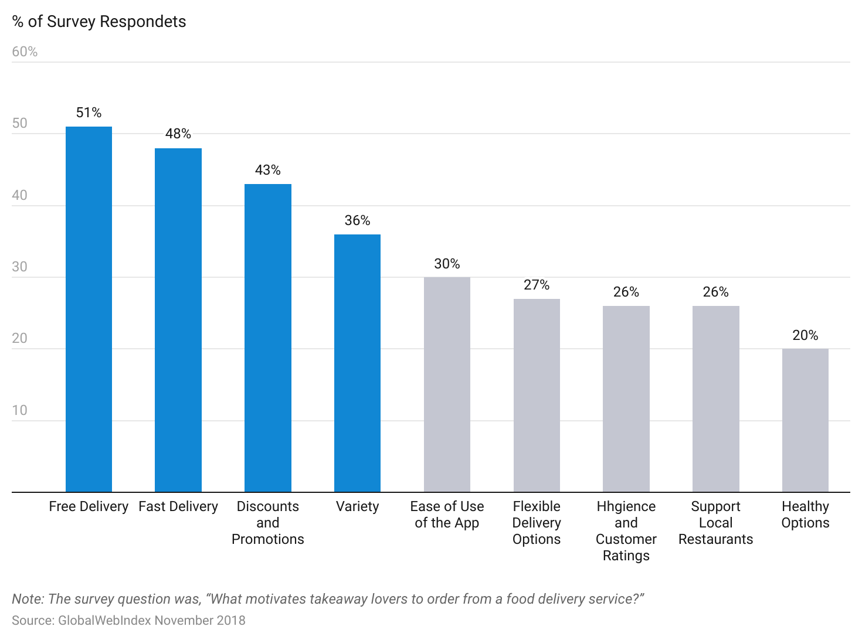

## **3. Offering better variety, discounts, and healthier options relative to incumbent restaurants customer experience**

Customer preference for variety, discounts, and healthier options influences their decision to use online food delivery services.

* **Variety:** In a 2021 survey, a majority of respondents (nearly 43%) claimed that they use online food delivery apps because of the variety of options offered by the platforms. A survey conducted by Nextbite revealed that the majority (77%) of consumers consider speed and variety as the key factors when selecting restaurants on an online food delivery platform. Aggregators such as Grubhub, Grab, and Uber Eats offer a variety of cuisines from a large number of restaurants. As of 2023, Grubhub featured more than 365,000 restaurant partners across the US, while UberEats features more than 400,000 restaurants, as of 2022. Meanwhile, food delivery services such as Blue Apron, Hellofresh, and Home Chef further expand their variety by introducing seasonal menus and celebrity-inspired menus.
* **Discounts:** Users value app discounts and promotions available on a platform. A 2021 study showed that 58% of consumers considered promos or discounts as “extremely” or “very” important when selecting a delivery restaurant.
* **Healthier options:** A 2022 survey revealed that at least 70% of US consumers prefer to adopt a healthier lifestyle and nearly 50% of consumers across age groups considered healthy eating a top priority. Meal kit delivery services such as Blue Apron and Hellofresh specifically cater to customers that have healthier dietary preferences by designing menus in partnership with dieticians, offering menu options such as “carb conscious” recipes, featuring menu items that are “600 calories or less,” and offering special menu plans in partnership with weight-loss companies such as Weight Watchers.

## **4. Growing preference among restaurants for third-party food delivery platforms**

As of 2023, there were 156,715 single-location full-service restaurants in the US. For restaurants operating on a smaller scale or just starting their businesses, using a third-party delivery service offers greater convenience and cost savings compared to setting up their own delivery fleet. Notably, third-party delivery platforms provide restaurants with access to an on-demand delivery fleet for a standard commission fee.

These platforms also enable smaller restaurants to reach a wider audience. DoorDash had 34 million users, as of 2022, while Just Eat Takeaway had over 30 million active consumers in its North American segment, as of 2023.

While the high commission rates charged by delivery platforms could threaten the profitability of such restaurants, cities like Chicago, Cleveland, Denver, and Oakland introduced mitigating measures like fee caps to protect restaurant profitability.

# **Risks to Growth**

## **1. Low margin business model leads to high failure rates**

Over the years, startups such as Munchery, Spoonrocket, and Sprig have closed down despite raising close to USD 200 million in funding. The commonalities between these three startups are that they specialized in preparing their own food and that they focused on reliable and faster delivery by investing in their own fleet.

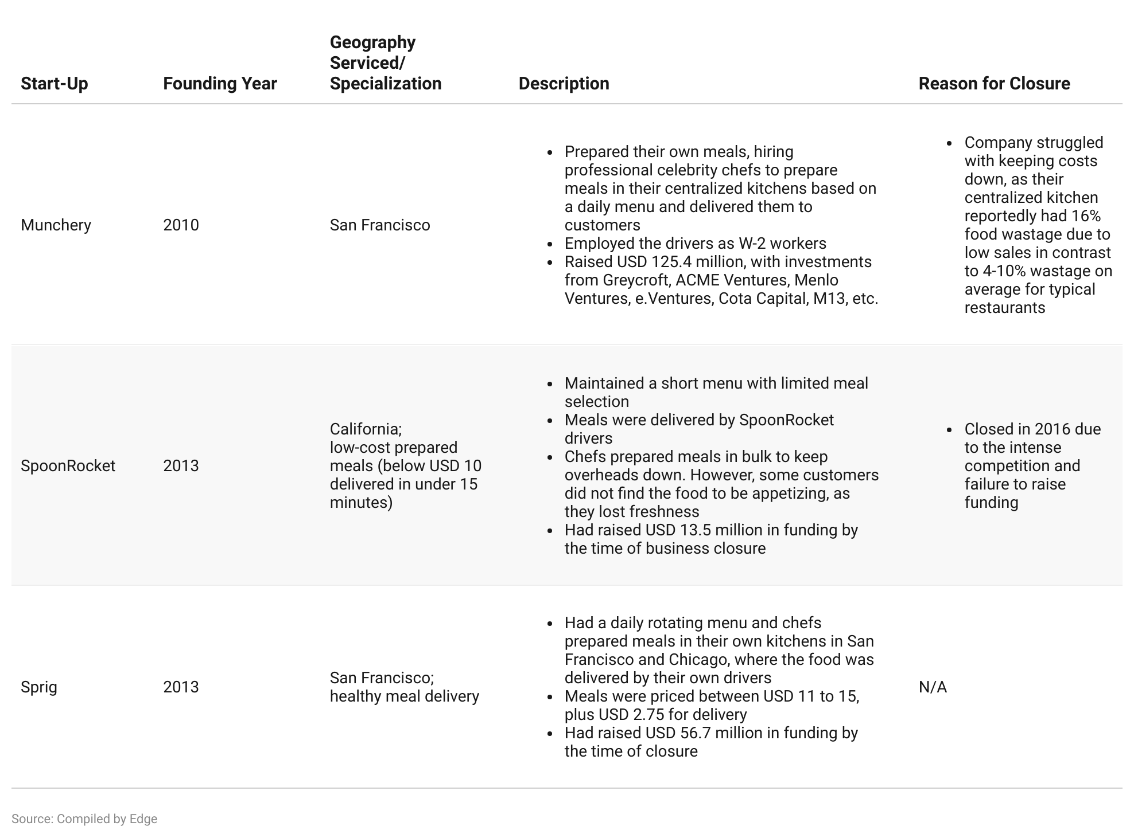

Amazon Restaurants, launched in 2015 in Seattle, operated in 20 states by 2019, prior to its closure. Having partnered with OLO (a POS software provider), the venture mainly targeted Amazon Prime users and allowed users to place orders and charge them to their existing Amazon accounts. In June 2019, Amazon closed down its US division following the shutdown of its London business back in November 2018. A main reason for the closure was the intense competition that led to steep promotions and discounts driving down revenue, along with weak brand recognition. The company has also shut down Daily Dish, Amazon’s workplace lunch delivery service.

OFD company margins could also be impacted in cities such as [New York](https://sp-edge.com/updates/4619) and San Francisco, where permanent commission caps have either been proposed or enacted.

## **2. Waning customer loyalty due to lower switching costs**

While OFD players previously saw customer stickiness, companies are now seeing an increasing trend of existing, previously loyal customers ordering from multiple competing platforms while new customer additions are already multi-platform users. Given that customers don’t really have a switching cost, they can easily move between platforms to capitalize on promotional offers and to increase their breadth of restaurant access, as some restaurants have signed exclusive delivery partnerships with specific OFDs. Grubhub, for example, has reportedly seen its percentage of single-platform customers drop from 61%, as at end June 2019, to around 46% by June 2021. Doordash appears to be the least impacted thus far, with around 58% exclusive customer usage by end 2Q2020, while Postmates has the lowest customer stickiness at roughly 34%.

With easy customer wins, simply due to industry tailwinds such as smartphone penetration and pandemic-fuelled demand, no longer being a guarantee, competition to win customers is likely to intensify going forward. Diminishing customer loyalty has already impacted growth rates for some players. Grubhub, for example, estimated a 300+ bps impact on its growth rate in 3Q19 on the back of customer “sharing”.

## **3. Return to in-door dining or takeaway in a post-pandemic environment**

While safety became paramount during the height of the pandemic, OFD players could also see increased competition for customer wallet share from restaurants in a post-pandemic environment, as customers increasingly return to indoor dining. Price-sensitive customers may also reduce their spending via third-party food delivery apps given the significant pricing differential vs direct orders from a restaurant. Bypassing the use of third-party platforms would also be attractive to restaurants given the high commission fees.

In 2022, players such as [Grab,](https://sp-edge.com/updates/15337) Chownow, [DoorDash, Wonder](https://sp-edge.com/updates/15026), [Lunchbox](https://sp-edge.com/updates/11831), [ChowNow](https://sp-edge.com/updates/11704), [Nextbite](https://sp-edge.com/updates/11609), [Just Eat Takeaway](https://sp-edge.com/updates/8921), and [Deliveroo](https://sp-edge.com/updates/14712) adopted various cost-cutting measures such as hiring freezes, layoffs, and closing operations in less profitable markets in order to adjust to the post-pandemic market environment.

**Average pricing differential of third party apps relative to restaurant meal list**

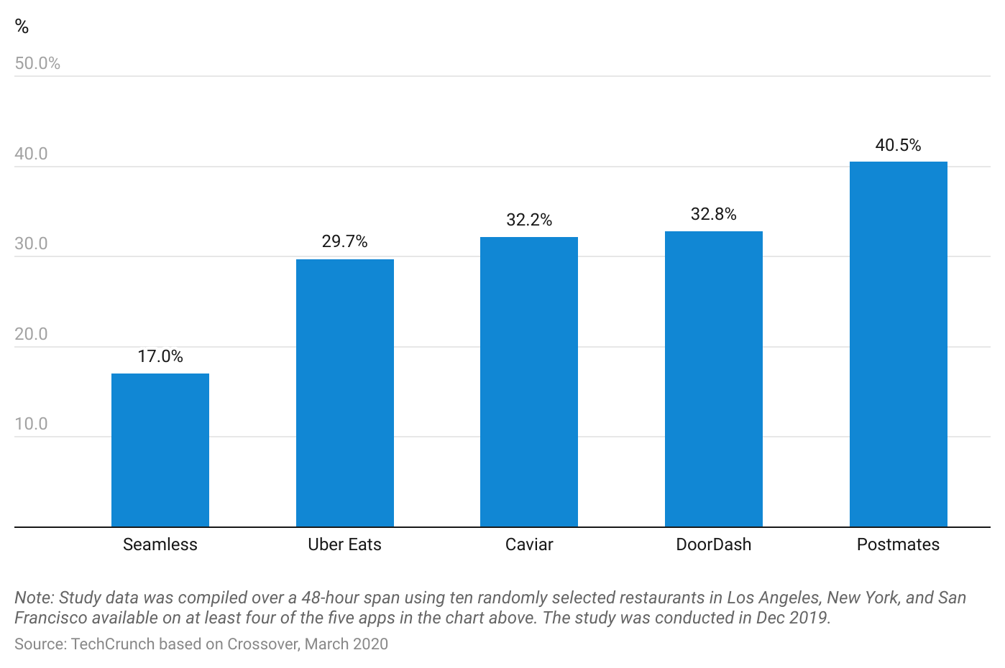

## **4. Negative impact on cost structures stemming from regulatory changes regarding worker classifications**

In 2021, the UK and Spain introduced regulatory changes regarding the classification of delivery riders as employees rather than self-employed independent contractors, which will provide them with the general level of statutory benefits for employees (health insurance, minimum wage, collective bargaining/ability to form a union, etc.). With growing criticism of OFD players over their “gig worker” delivery models, the rest of Europe could soon follow similar regulations. This would have a significant impact on cost structures/margins. Deliveroo announced its exit from Spain following the regulatory change. In October 2022, the US Department of Labor also released a proposal for gig workers to be reclassified as employees rather than contractors, leading to a drop in share prices of gig companies like DoorDash (down 6%) and Uber (10.4%).

*Last updated: May 2023*

©2024 Uzabase, Inc. All Rights Reserved. The information contained herein: (1) is proprietary to Uzabase Inc. and/or its content providers; (2) may not be copied or distributed; and (3) is not warranted to be accurate, complete or timely. Neither Uzabase Inc. nor its content providers are responsible for any damages or losses arising from any use of this information.