# **Retail Trading Infrastructure: Overview**



## **Retail trading infrastructure: The future of low-cost wealth management**

Retail trading infrastructure encompasses the digitization of wealth management solutions, which enables individuals, businesses, and financial advisors to carry out wealth management activities via digital platforms. This has taken many forms and includes new developments such as robo-advisors, online trading platforms, and digital infrastructure solutions.

The development of retail trading infrastructure has been enabled by many factors, with technological advancements such as high smartphone penetration being at the forefront.

Additionally, growing smartphone penetration, machine learning, and big data are the key technologies that have facilitated the development of robo-advisory and online trading platforms. In its early stages, the industry attracted younger generations that lacked investment experience, and those who could not meet the minimum investment requirements of traditional advisory firms. With time, wider service offerings (such as hybrid services and B2B) have drawn in other demographic groups, including the mass affluent, predominantly baby boomers.

#### 

#### 

#### **Retail trading infrastructure segmentation based on product offering**

## 

## **Retail trading platforms offer automated investment services, reducing the need for human advisors and brokers**

Robo-advisory platforms use algorithms to provide automated investment advice and management services (asset allocation, portfolio rebalancing, and other related services) based on clients’ investment goals and risk tolerance. Machine learning algorithms use data to determine optimal asset allocations (i.e. to generate either the highest returns for a given level of risk or the lowest risk for a given level of return). Machine learning algorithms have grown increasingly complex over time, and have enabled platforms to create more tools such as for tax-loss harvesting (i.e., selling an asset at a loss to offset capital gain taxes), cash flow management, and retirement planning.

Most robo advisors use either low-cost exchange-traded funds (ETFs) or index funds as investment vehicles. Robo-advisory platforms have an advantage over human advisors as they are easily accessible online, carry out portfolio management tasks for large numbers of clients simultaneously, and involve much lower fees and initial minimum account balances.

#### 

#### **Robo-advisors vs. human advisors**

#### 

#### 

#### **Machine learning algorithms automate the investment process**

#### **28_robo_advisory_overview_image1**

#### Source: Actual Intelligence

Robo-advisors have evolved in terms of features and service offerings over the years; from using basic algorithms to offer investment or portfolio allocation suggestions (based on a questionnaire) and filter options across stocks, bonds, ETFs, and other financial instruments to providing fully automated investment management services using self-learning trading algorithms that allow automated portfolio allocation and rebalancing based on changing market conditions and client-specific investment needs such as profit, risk appetite, and liquidity.

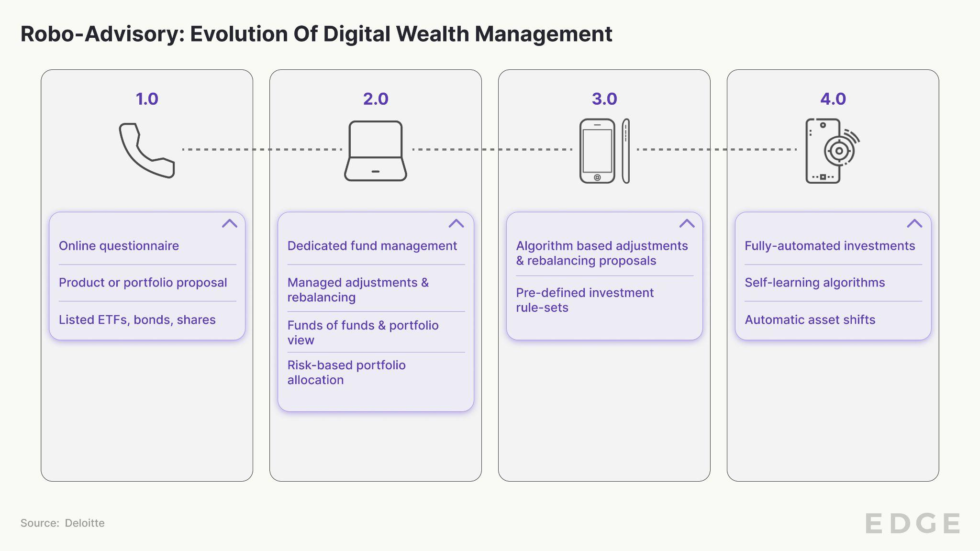

Apart from robo-advisory services, online trading platforms have also emerged as a tool for investors to actively trade various securities such as stocks, ETFs, and options directly via digital platforms. These platforms offer direct access to trading securities, removing the need to trade via a traditional brokerage.

In addition to consumer-facing platforms, the industry has also seen the emergence of B2B digital infrastructure solutions for wealth management. This mainly includes solutions for financial advisors and asset managers to automate wealth management and administration functions, allowing them to dedicate more time to areas such as customer relationship management (CRM).

## 

## **Robo-advisory startups expand into B2B, hybrid, and banking services**

The implied breakeven for robo-advisors varies primarily based on their geographical focus market and fee structure. In the US, many robo-advisory platforms charge a standard 0.25% fee on client account balances. Based on this charge, research shows that a robo-advisory platform would need USD 11.3 billion-21.5 billion worth of assets under management (AUM) to break even (implying a fixed cost of around USD 28.3 million to USD 53.8 million). Whereas in Europe, most robo-advisory platforms charge a slightly higher standard fee of 0.45% based on client AUMs. With a higher standard fee, European robo-advisors would require lower AUMs in the range of USD 3.5 billion–5.3 billion to break even compared with US counterparts.

Most startups are yet to turn profitable, mainly because of the small average portfolio sizes of their millennial clients (mostly below USD 50,000), coupled with low fees. This means most robo-advisory platforms must scale up significantly and invest in new client acquisitions to cover expenses. However, client-acquisition costs remain steep, resulting in long payback periods.

#### **Top two robo-advisory startups with exceeded break-even AUM levels**

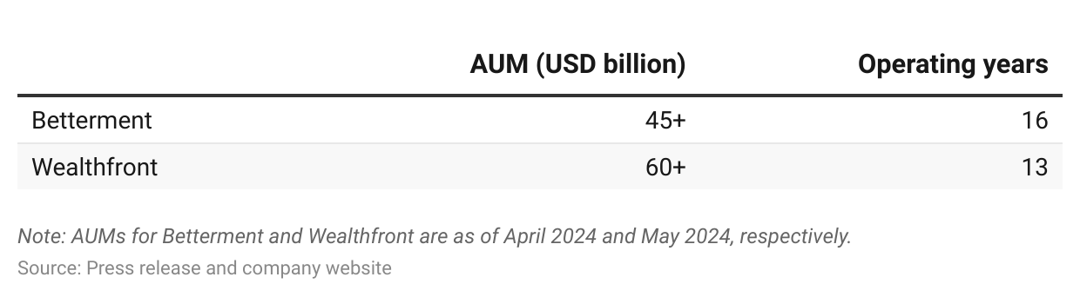

To become more profitable, some robo-advisory startups have taken either one or a combination of the below initiatives:

1. Offering digital platforms to businesses (i.e. companies and financial institutions) in order to scale and minimize client-acquisition costs;
2. Offering premium hybrid services (digital platform and human advisors) and advanced investment tools to obtain high average portfolio sizes and charge higher fees (i.e. target the mass affluent); and/or
3. Offering banking services (high-yield savings and checking accounts) to generate additional fee revenue from the banks through which the funds are deposited. Robo-advisory startups also hope these clients will eventually invest through the platforms after opening banking accounts with them.

#### 

#### **Service offerings include B2B, hybrid and banking**

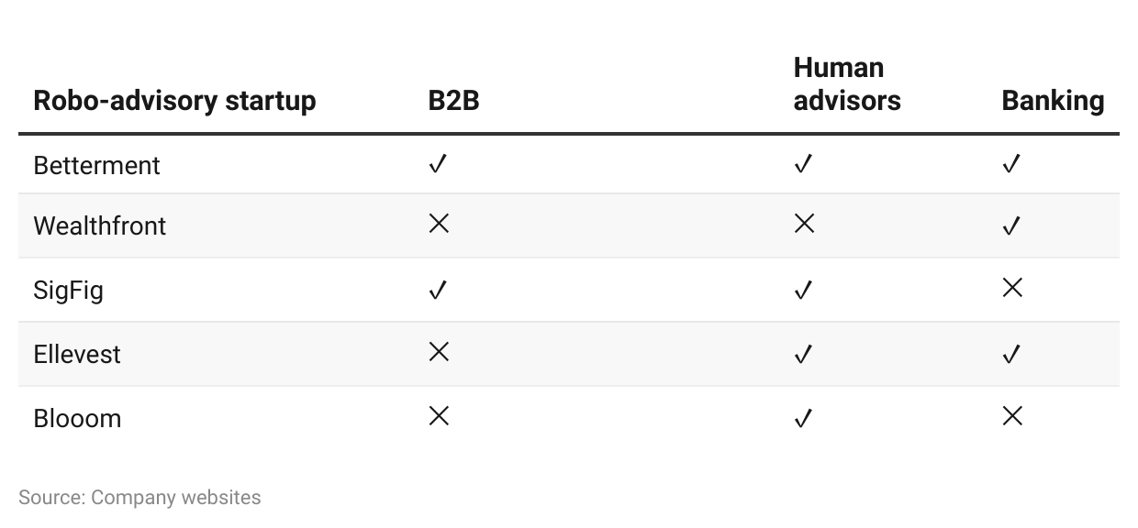

## 

## **Driving Factors**

### **1. Increased accessibility, supported by low fees and small minimum account balances**

Retail trading platforms are accessible to more users because they charge low fees and require small minimum account balances. So far, they have attracted both the young generation still in their wealth accumulation stage (the average client age for Betterment is 37 years and for Robinhood it’s 31 years) and the mass affluent (some platforms have average portfolio sizes of between USD 100,000 and USD 1 million). All this is enabled by lower labor costs, overhead expenses (e.g. office rents) and investment costs (i.e. low-cost ETFs and/or index funds) compared with those of advisory firms.

#### 

#### **Comparison of robo-advisory, online trading, and traditional human advisors**

### **2. Robo-advisors offer professionally-managed custom investment portfolios for the mass market**

Robo-advisory platforms can customize well-diversified investment portfolios automatically for anyone using ETFs and/or index funds that represent different asset classes (such as stocks and bonds). Customization is based on the results from client questionnaires that help determine their investment goals and risk profile. Wealthfront, for instance, offers investment options in real estate, natural resources, and dividend stocks, on top of stocks, bonds, ETFs, and cash, while SoFi offers access to cryptocurrency, fractional shares, and IPO participation in addition to traditional investments. In contrast, traditional investment portfolios typically tend to be limited to traditional asset classes such as stocks and bonds.

### **3. Online trading platforms offer more convenience and flexibility to trade, at lower costs**

Due to the elimination of middlemen, online trading platforms typically offer commission-free investment options for investors, marketing themselves as more cost-effective options to trade securities, compared to traditional forms of investing. Online trading platforms typically focus on the trading of securities such as stocks and ETFs, but many platforms have also branched out to facilitate the trade of alternative assets such as cryptocurrencies, in addition to offering banking services such as savings or checking accounts.

#### 

#### **Comparison between online and offline modes of trading**

## 

## **Risks to Growth**

### **1. Technological constraints in handling complex financial situations**

Critics of the robo-advisory model highlight its commoditized nature, with its “one-size-fits-all” questionnaires and lack of human knowledge for distinguishing scenarios. Current technologies are inadequate to handle more complex tasks such as estate planning and trust administration. Even if robo-advisory platforms include human advisors in their service offerings, this requires these platforms to enter the traditional space, where incumbents have much stronger competitive advantages.

Similarly, online trading platforms completely remove the need to leverage the knowledge and expertise offered by human advisors and may result in clients making uninformed trading decisions, which could lead to a greater chance of incurring losses.

### **2. Challenges with regulatory hurdles and investor protection laws**

Regulations control various operational and functional aspects of robo-advisors and online trading platforms, including the marketing of such financial products. Failure to comply with these requirements can result in enforcement action such as fines, sanctions, or even loss of license. These actions can damage the platform’s reputation and lead to revenue loss. For instance, [M1 Finance](https://sp-edge.com/companies/367094) was fined USD 850,000 by FINRA in [March 2024](https://sp-edge.com/updates/27705) for violations related to its social media influencer program used for customer acquisition. [Titan](https://sp-edge.com/companies/515869) was charged by the SEC in [August 2023](https://sp-edge.com/updates/21474) with violating marketing rules, resulting in a cease-and-desist order, censure, and USD 192,454 in disgorgement, as well as a USD 850,000 penalty for misrepresenting investment performance and other compliance breaches.

Investor protection laws help protect the interests of clients but can restrict certain activities of robo-advisors and trading platforms. Transparency and disclosure requirements impose mandatory detailed disclosures of fees, investment strategies, and risks. Maintaining transparency is challenging, and mishandling it can undermine client trust. Meeting fiduciary obligations requires careful oversight and can restrict certain revenue-generating activities. [TD Ameritrade](https://sp-edge.com/companies/14008) was fined USD 600,000 by FINRA in [April 2024](https://sp-edge.com/updates/28954) for its inconsistent automated approval system that improperly assessed options trading levels and allowed inexperienced traders to trade such options.

*Last updated: June 2024*

©2024 Uzabase, Inc. All Rights Reserved. The information contained herein: (1) is proprietary to Uzabase Inc. and/or its content providers; (2) may not be copied or distributed; and (3) is not warranted to be accurate, complete or timely. Neither Uzabase Inc. nor its content providers are responsible for any damages or losses arising from any use of this information.