# **Metaverse Platforms: Overview**



**The metaverse: Stepping into a new immersive world wide web**

The metaverse is an integrated network of interactive and persistent virtual worlds. It is expected to replace the current iteration of the internet as well as some elements of real life, with an infinite number of users interacting with each other via digital avatars. Such an interoperable network is complex and consists of four distinct layers, which include core enabling technologies such as [extended reality](https://sp-edge.com/industry/65), the blockchain ([consumer](https://sp-edge.com/industry/144) and [enterprise](https://sp-edge.com/industry/121)), cloud/edge computing, 5G, and developing technologies such as [6G](https://sp-edge.com/insights/13497). This industry hub focuses exclusively on the “experience” layer of the metaverse, which consists of the interactive and persistent virtual worlds (metaverse platforms) the end-users interact with.

**The metaverse layers**

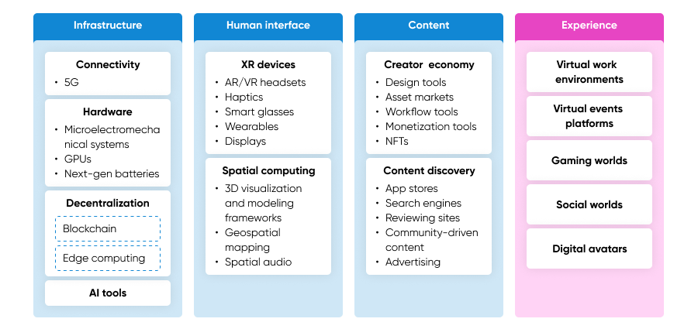

Source: “Building the Metaverse,” Jon Radoff

While many of today’s interactive virtual worlds (e.g., [Second Life](https://sp-edge.com/companies/178), [Roblox](https://sp-edge.com/companies/22278), [EVE Online](https://sp-edge.com/companies/487754)) have been in operation for a while, the metaverse concept calls for the interoperability of these platforms to enable users to switch between platforms swiftly, along with their unique identity and digital assets. However, until recently, these platforms operated in relative isolation, which led prominent developers in the industry, including [Meta](https://sp-edge.com/companies/5), [Nvidia](https://sp-edge.com/companies/4353), [Unity](https://sp-edge.com/companies/14927), [Microsoft](https://sp-edge.com/companies/201465), and the World Wide Web Consortium (W3C) to jointly create the Metaverse Standards Forum in June 2022. It aimed to create open standards to solve the issues associated with the interoperability of digital assets and identities across platforms. The Metaverse Standards Forum claims that over 2,400 member organizations across these layers are working on building an open metaverse, as of October 2023.

**The metaverse expands beyond the bounds of virtual reality**

## The metaverse and virtual reality are sometimes used interchangeably and its definition varies across companies and individual developers, as the metaverse is still a developing concept. For instance, Meta’s plans to create a metaverse do not seem to prioritize Web3 concepts such as decentralization, despite advocating for an open and interoperable metaverse built by many developers. In contrast, Web3-focused developers believe in a metaverse built using open-source tech, centered around Web3 concepts such as decentralization, user ownership of data, and NFTs.

## 

## **Comparing the metaverse, virtual reality, and Web3**

|  |  |  |  |
| --- | --- | --- | --- |
|  | **The metaverse** | **Virtual reality** | **Web3** |
| Definition | A fully interoperable network of interactive, persistent, and immersive virtual worlds where an infinite number of users can interact with each other and content via digital avatars | Technology for constructing 3D virtual worlds with specified functionality that can be experienced using special equipment | A new iteration of the internet that fully incorporates concepts such as decentralization, blockchain technologies, and token-based economics |
| Scope | Envisions a large network of interconnected open virtual worlds | VR is a technology that supports the metaverse vision and can also be limited to centralized and closed applications | Focuses on creating a large trustless and permissionless (no third-party governing entity) network of web services that gives the users the ownership and control of the data and digital assets they create |
| Accessibility | Ideally should be accessible via any device at any time | Use of specific devices such as VR headsets is required and some VR platforms may not be accessible at all times | Ideally should be accessible via any device at any time |
| Interactivity | Facilitates immersive virtual interactions with other users and content | Can be limited to a single-person experience | Web3 does not dictate how users can interact with each other |
| Objective | Envisions replacing the current iteration of the internet (in terms of how users interact with it) | Designed for specific applications | Envisions replacing the current iteration of the internet (in terms of who controls and governs it) |

Source: SPEEDA Edge research

**Metaverse platforms:** **The interactive virtual worlds that form the metaverse**

Metaverse platforms broadly refer to interactive and persistent virtual worlds/environments that are hypothesized to integrate and form the metaverse. These platforms are an integral component in the metaverse ecosystem, given that they represent the consumer-facing layer used to fulfill a multitude of diverse needs and wants. These include a range of B2B activities (or enterprise use cases*), such as collaborative remote working, education and training simulations, as well as B2C use cases like gaming and social interaction. In this report, we also cover digital avatar platforms that give life to digital identities in virtual worlds/environments. We have separated metaverse platforms into five segments, mainly based on the use cases mentioned above.

*Note: For a more extensive list of enterprise metaverse use cases, refer to the* [*use case map*](https://sp-edge.com/industry/132)*.*

## **Types of metaverse platforms**

|  |  |  |  |
| --- | --- | --- | --- |
| **Segment** | **Description** | **Use case examples** | **Examples** |
| Social gaming platforms | Platforms that offer virtual worlds for multiplayer social gaming experiences enable users to create experiences and conduct transactions (e.g. buying virtual land) | Entertainment, networking, socialization, monetization | Horizon Worlds (Meta), [Roblox](https://sp-edge.com/companies/22278), [The Sandbox (Animoca Brands)](https://sp-edge.com/companies/224072) |
| Pure-play gaming platforms | Platforms that focus on multiplayer gaming experiences in virtual worlds | Entertainment, socialization, monetization | [LootMogul](https://sp-edge.com/companies/1854450), [Star Atlas](https://sp-edge.com/companies/1293976), [Singularity 6](https://sp-edge.com/companies/640440) |
| Pure-play social platforms | Platforms that focus on social interaction, experience creation, and virtual land purchases | Entertainment, networking, socialization, monetization | [Decentraland](https://sp-edge.com/companies/509934), [Second Life (Linden Lab)](https://sp-edge.com/companies/178), [Rec Room](https://sp-edge.com/companies/669986) |
| Work platforms | Platforms that offer collaborative 2D and 3D environments for enterprise and education-related use cases | Training, product demos, distance learning, remote work, virtual meetings, and remote assistance | Horizon Workrooms (Meta), Microsoft Mesh, [Gather](https://sp-edge.com/companies/1193400) |
| Digital avatars | Platforms that enable the creation of avatars that are used as digital identities in metaverse platforms | Digital identity solutions for metaverse platforms, social media platforms, chatbots, and virtual assistants | Meta (Digital avatars store) NVIDIA, [Genies](https://sp-edge.com/companies/198802), [Wolf3D](https://sp-edge.com/companies/1862976) |
| Virtual events platforms | Platforms that facilitate virtual events and concerts | Music concerts, art exhibitions, virtual conferences, corporate events | Horizon Worlds (Meta), [Wave](https://sp-edge.com/companies/408945), [Soundscape VR](https://sp-edge.com/companies/2001355) |

Source: SPEEDA Edge research

## 

## **Commission-based monetization models common among gaming and social platforms**

Work platforms and virtual events platforms typically operate a subscription-based monetization model or use custom pricing. Social gaming platforms such as Roblox and Horizon Worlds are generally free to use and generate revenue via various sources (e.g., virtual assets, trading fees, in-game currency, advertising, and licensing agreements). Pure-play gaming platforms such as Dusk Breakers ([Metatheory](https://sp-edge.com/companies/2039838)) and pure-play social platforms such as [Decentraland](https://sp-edge.com/companies/509934) are also free to use and generate revenue primarily from sales of in-game tokens and virtual land, as well as in-game marketplace trading fees. Most digital avatar solution providers offer their services for free, with some companies such as [Didimo](https://sp-edge.com/companies/494103) leaning toward subscription-based models.

### **Common monetization models**

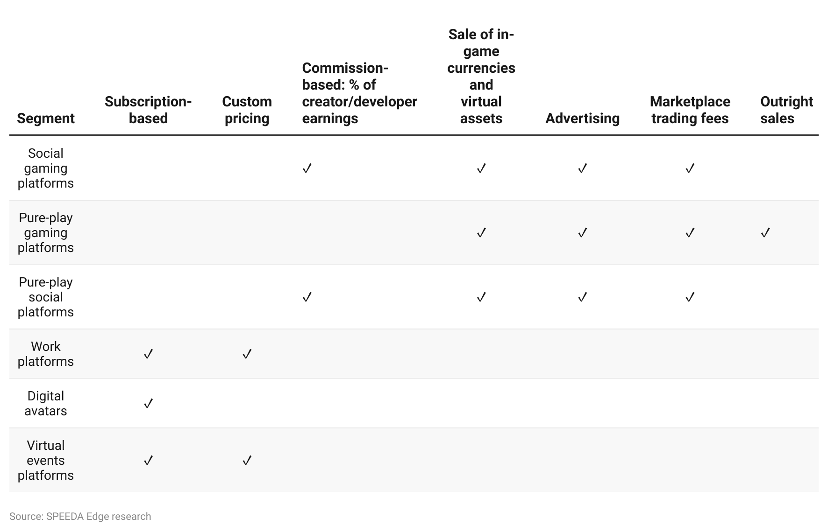

## 

# **Driving Factors**

## **1. Growth in the Gen Z demographic**

Growth in the Gen Z population, their income levels, and their natural inclination to spend time on the metaverse will likely be key driving factors for the industry. Gen Z users (born between 1997 and 2012) account for ~60% of the users in the metaverse (April 2022) despite having a ~26% share of the global population. They spend approximately eight or more hours online per day and are generally more immersed in digital culture than any other generation. A report (March 2021) commissioned by Snap Inc. estimates that the number of Gen Z workers in the US will triple to 51 million by 2030; a report (November 2020) by Bank of America estimates Gen Z income will grow 5x to USD 33 trillion by 2030 and surpass millennials by 2031.

**Gen Z workforce participation and income expected to grow significantly over 2020–2030**

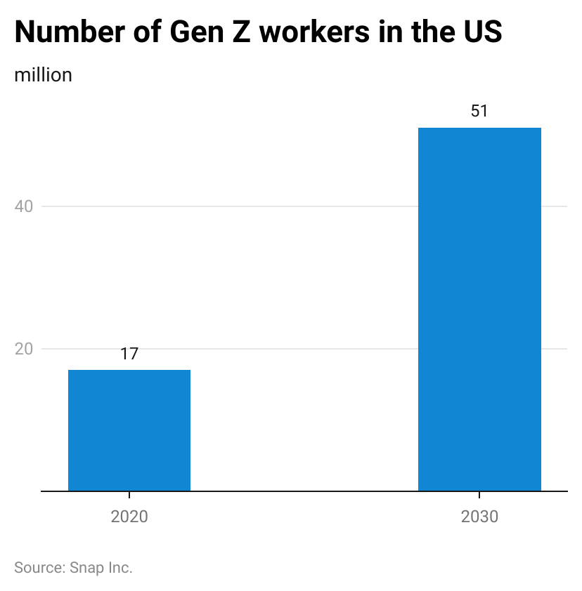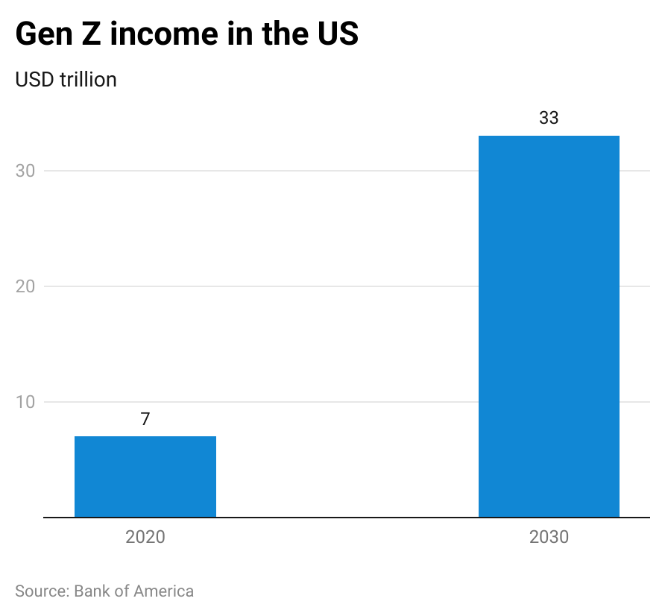

A study conducted in April 2022 also revealed that 15% of Gen Z’s entertainment budget is spent in the metaverse and this is expected to hit 20% in five years. Moreover, the study also revealed that 52% of Gen Z individuals feel more like themselves in the metaverse than in real life and 65% believe their online relationships are just as meaningful as offline ones.

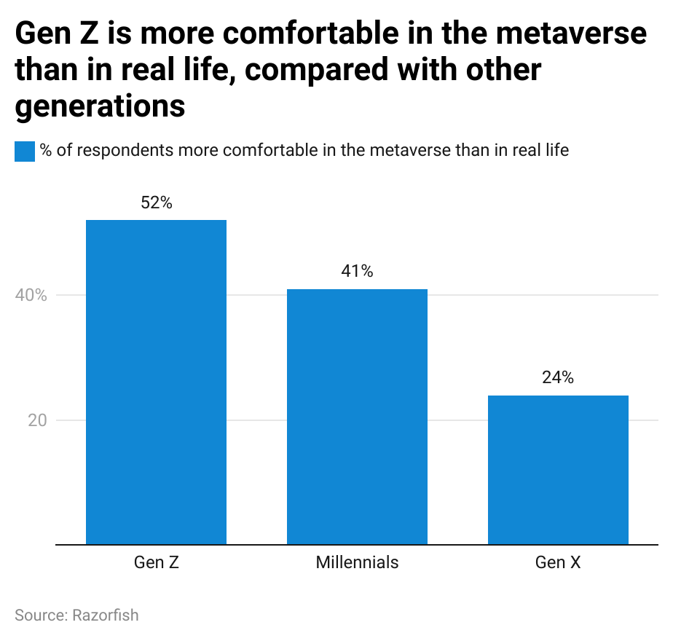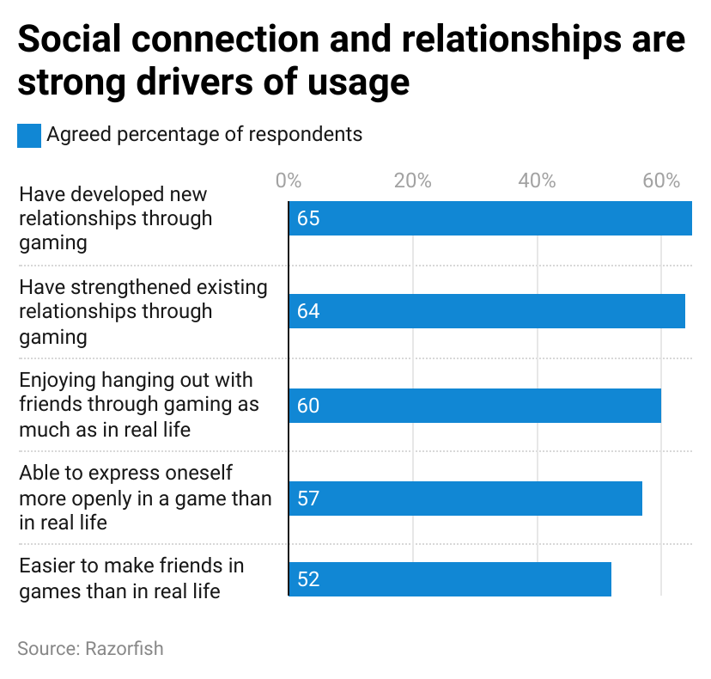

## **2. Monetization opportunities for creators to expand the reach and development of platforms**

The majority of metaverse platforms enable creators to monetize their content, and tapping into the [Creator Economy](https://sp-edge.com/industry/42) not only accelerates the development of metaverse platforms but also helps bring new users to the metaverse, as many creators have large and loyal fanbases. These include 1) Meta’s virtual item sales on Horizon Worlds and a creator bonus program (April 2022); 2) Roblox allowing developers to charge subscriptions for access to their experiences (September 2023); and 3) Epic Games launching its “Creator Economy 2.0,” which included a 40% payout pool for experiences launched by creators on its platform (March 2023).

User-generated content (UGC) is a crucial component, especially in gaming and social platforms, as it enables metaverse platforms to introduce new in-game assets and experiences at scale. Roblox is a prime example of this phenomenon, as its growth to become a platform with 65.5 million average daily active users (June 2023) was driven primarily by UGC. Roblox’s annual payments to creators and developers for their contributions grew at a 72% CAGR to USD 624 million in 2022 from USD 72 million in 2018.

### **Roblox creator payouts have grown at a CAGR of more than 70% over 2018–2022**

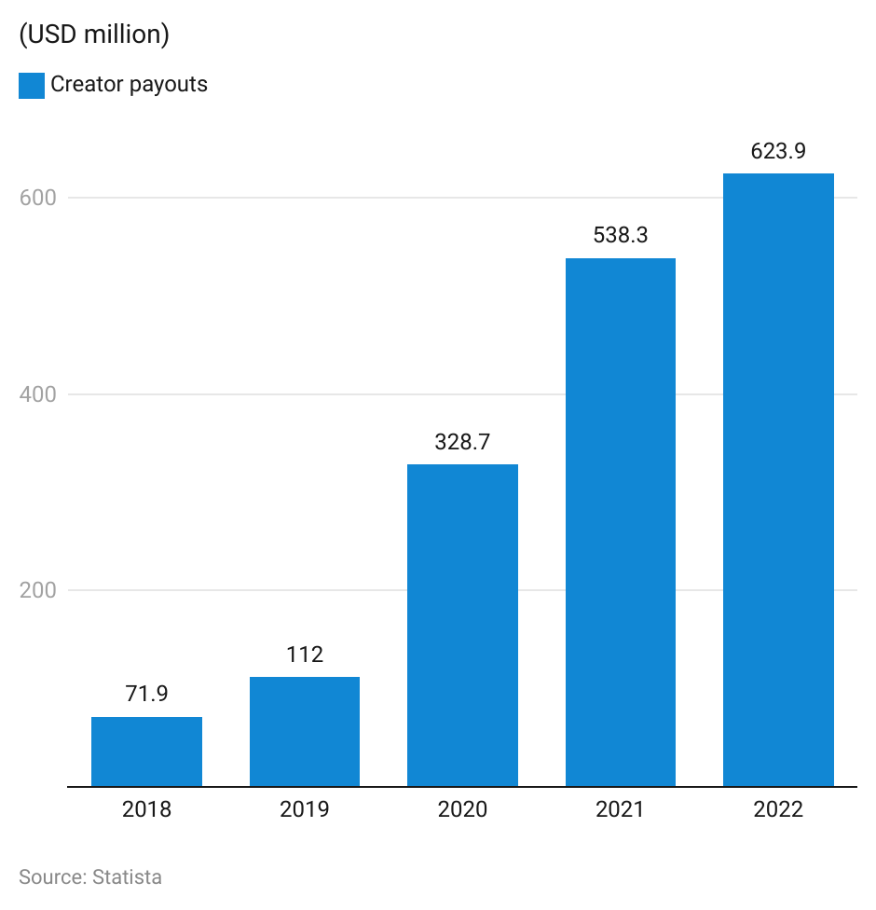

## **3. Preference for user-controlled platforms**

Some of the key concerns among users of Web2 platforms is the lack of control and ownership of their own data and the lack of user control over platform development and governance. A survey conducted by Cisco (2021) indicated that 86% of consumers care about data privacy and want more control; 47% indicated they have already switched companies or providers over their data policies or data sharing practices.

Many metaverse platforms are already decentralized and upcoming platforms are also likely to adopt Web3 concepts such as decentralization, blockchain technologies, and token-based economics. This will likely eliminate the power hierarchy, enabling users to take control of their data and community and creators to take control of their businesses, driving more users from Web2 platforms to metaverse platforms. For instance, [Decentraland](https://sp-edge.com/companies/509934) is built, owned, and governed by its community through Decentraland DAO, a decentralized autonomous organization. Preference for user-controlled platforms is further highlighted by the 8x growth in the overall number of DAOs, the total number of governance proposals put forward, and the number of votes cast in DAOs in the 12 months preceding June 2022.

**4. Growth in GenAI tools with metaverse use cases**

The growth of [GenAI tools](https://sp-edge.com/industry/163) in 2023 has led to improvements in the ease of content creation for metaverse platforms. In fact, the incremental revenue from GenAI for the gaming market is forecast to grow at a CAGR of 23% until 2032, with development improvements made in terms of level generation, creation of non-playable characters, and the enhancement of in-game graphics. This will help streamline metaverse content development, with startups in the space already experimenting with the tech.

This includes [Roblox’s](https://sp-edge.com/updates/16497) and [Hiber’s](https://sp-edge.com/updates/21526) launch of GenAI tools for virtual world creation, and [Wolf3D’s](https://sp-edge.com/updates/16122) Ready Player Me platform trialing tools for GenAI avatar creation. Other possibilities to bolster realism in gaming metaverse platforms include the potential launch of AI-powered non-playable characters (NPCs)—of which [Inworld AI](https://sp-edge.com/companies/1560762) is a notable player in the space.

# 

# **Risks to Growth**

# **1. Crypto market instability and imposition of new regulations**

Many metaverse platforms—both currently in operation and slated for future platforms—are blockchain-based in order to be decentralized and where cryptocurrencies facilitate transactions. However, several factors have culminated in the crypto winter” and led to a decline in metaverse activity, reflected in investor funding interest for the sector, which saw a 89% YoY drop in [Q3 2023](https://sp-edge.com/insights/22941).

The collapse of blockchain company Terra’s cryptocurrency tokens and the crypto exchange FTX in 2022 caused turmoil in crypto markets and had significant spillover effects on metaverse platforms. Furthermore, the inherently volatile nature of cryptocurrency can hinder user spending interest on the platforms, limiting growth prospects for the sector. Notable platforms, including Decentraland and The Sandbox which use cryptocurrency to facilitate in-game transactions, recorded YoY declines in October 2023 of 51% and 58% in

their native token prices, respectively.

Subsequently, governments have imposed various regulations on blockchain-based assets, such as cryptocurrencies, which facilitate transactions citing fraudulent activities like money laundering and scams. For instance, in September 2021, China banned all crypto-related transactions for their role in facilitating financial crimes and the risk it poses to the country’s financial system due to its highly speculative nature. Furthermore, the US Securities Exchange (SEC) labeled The Sandbox metaverse SAND token and Decentraland’s MANA token as “unregistered securities,” which could impede investments by cautious investors.

Finally, significant energy-related concerns surrounding crypto also expose it to potential future regulations. For example, in March 2022, the Markets in Crypto Assets (MiCA) legislation proposed making crypto assets within the EU subject to “minimum environmental sustainability standards,” which would have effectively banned the mining and transactions of energy-intensive cryptocurrencies, such as Bitcoin. Though this proposal was rejected, regulators continue to push for energy-saving initiatives. Such legislation has a direct negative impact, as the user activity of decentralized metaverse platforms is closely related to the performance of the crypto market.

## **2. High cost of XR hardware**

The mass adoption of metaverse platforms may be restricted due to high XR hardware price points (ranging between USD 300 and USD 3,500). For instance, Meta’s Quest 3 headset is priced at USD 499, whereas the Quest 2 was priced at USD 400 in July 2022. However, from the consumers’ perspective, price remains one of the primary concerns with XR devices among other technical issues, such as lack of portability and motion sickness from prolonged use. The Apple Vision Pro, which seeks to solve these issues, is set to retail in early 2024. However, it will retail at USD 3,499—a price 7x higher than the Quest 3, further signaling the rising cost of XR hardware.

XR device prices are often compared to other entertainment alternatives such as gaming consoles. If XR device manufacturers are unable to rationalize the cost of production and address these concerns, the growth of metaverse experience platforms may be restricted, as devices are beyond reach or rejected by the average consumer.

## **3. Privacy, safety, and security concerns**

As the technologies used to build metaverse experience platforms are relatively new, usage of these platforms opens up users to a host of privacy, safety, and security concerns. Blockchain technology, a core element of most metaverse experience platforms, has previously been subject to various security threats and attacks. These include phishing attacks, privacy leakages, “51% attacks” (where malicious users gain majority control over the hashrate of a blockchain), and “routing attacks” that leak confidential data and extract monetary benefits by anonymously intercepting data during transmission to internet service providers.

Additionally, consumers are likely to be concerned about their privacy in the metaverse in the short term. This is evidenced by S&P’s Global 2023 Worldwide Metaverse Consumer Survey, which saw ~28% of consumers being very concerned about the current level of user privacy and data collection the metaverse offers.

Blockchain endpoint vulnerabilities are another common security concern, as attackers can observe user behavior and target endpoint devices like mobile phones and computers to steal the users’ keys. For instance, in February 2022, USD 1.7 million worth of NFTs were stolen in a phishing attack, which included tokens from Decentraland. The attack leveraged flexibility in the Wyvern Protocol, an open-source standard underlying most NFT smart contracts on OpenSea which was later patched by the company. However, unattended security concerns could hinder platform growth in the future.

Other metaverse-specific risk factors include avatar theft, which can be used for nefarious purposes, and sexually explicit material running rampant on these platforms, as user behavior (which can take many forms compared to Web2 social networking sites) is difficult to moderate.

## **4. Lack of lasting business and consumer interest**

Metaverse experience platforms saw significant growth during the pandemic when consumers were restricted from engaging in social activities in real life. However, many metaverse experience platforms saw a decline in active users in 2022, as pandemic-related restrictions were lifted. This was also evident in the fewer metaverse-related job postings by Google and Meta by July 2022. As per a Bloomberg survey, 70% of individuals were not interested in playing games in VR on a regular basis, despite gaming and VR being core elements of many metaverse experience platforms.

The lack of interest in metaverse work platforms continued into 2023, with many Big Tech firms mandating permanent in-office days as they moved away from being fully remote work-based. This is further supported by findings from GlobalData’s “The Thematic Intelligence: Tech Sentiment Polls Q3 2023” survey. Results showed that the metaverse was overwhelmingly viewed as “all hype and no substance” (59% of respondents) among a group of seven emerging technologies.

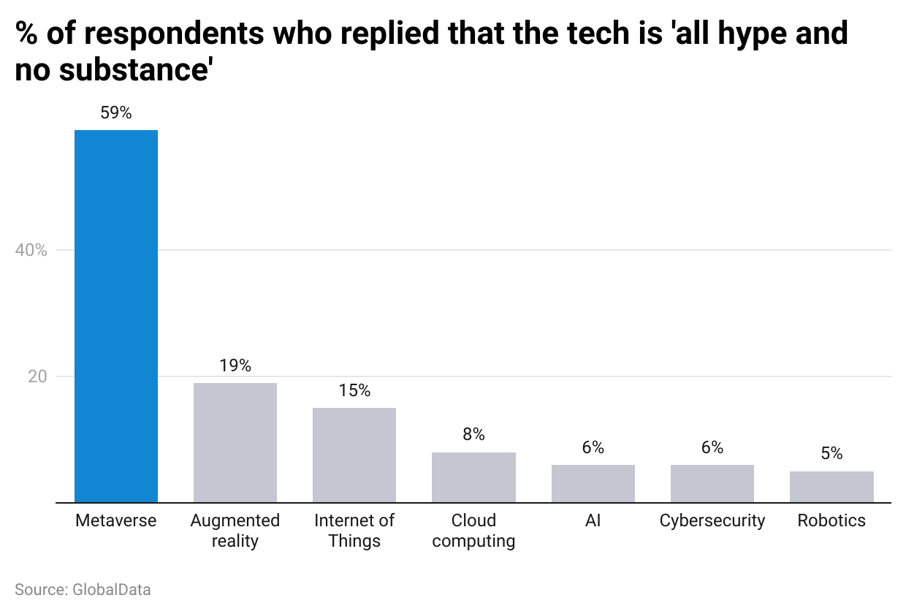

The platforms also failed to live up to expectations of immersion, with the graphical fidelity on metaverse platforms lagging significantly behind modern games. This is due to most metaverse platforms being accessible via a VR headset or a web browser, limiting performance capabilities, as opposed to traditional PC-downloaded applications. Further, since the pandemic has shown that virtual meetings and remote work use cases in the metaverse in its current state are not comparable to real-life interactions, the inability to create new and exciting use cases will directly impact the growth potential of metaverse experience platforms.

*Last updated: November 2023*

©2024 Uzabase, Inc. All Rights Reserved. The information contained herein: (1) is proprietary to Uzabase Inc. and/or its content providers; (2) may not be copied or distributed; and (3) is not warranted to be accurate, complete or timely. Neither Uzabase Inc. nor its content providers are responsible for any damages or losses arising from any use of this information.