# **Age Tech: Overview**



## **Tech driven products and services aimed at improving the independence and quality of care for the elderly**

Age Tech broadly refers to technology-related products and services targeting the senior population (usually defined as aged over 65). In general, these include solutions to enhance seniors’ quality of life and enable independent living or aging at home. These products and services range from advanced wheelchairs, smart hearing aids, and customized communication devices/platforms to virtual reality (VR)-based monitoring, end-of-life planning, and platforms for social interaction.

We have identified seven broad segments in the Age Tech ecosystem. This includes products and services directly offered and used by seniors, as well as those offered to the family, professional caregivers, and healthcare providers, with the intention of improving the quality of care provided for the elderly person as well as senior’s overall quality of life.

### **The age tech market comprises product offered directly to the elderly and for their caregivers**

### 

## **Advancements in technology make Age Tech solutions more accessible**

In the past, seniors were somewhat resistant to change with regard to adopting “new” technology. In 2015, seniors surveyed by Pew Research noted that only 30% of US adults over the age of 65 owned a smartphone. However, with the speed of innovation increasing day by day, it is only a matter of time before tech adoption among seniors becomes widespread. In fact, in 2023, 76% US adults over the age of 65 owned a smartphone, demonstrating the shift toward the use of technology. Increasing awareness and simpler designs have contributed to making technology more accessible to seniors.

A survey by the American Association of Retired Persons (AARP) in 2023 showed that seniors were quickly becoming a larger piece of the technology-consuming pie. While average spending on technology reduced from USD 912 per person in 2022 to USD 798 in 2023, tech purchases among seniors in their 60s and 70s during the same period were noted to increase. Additionally, around 79% of seniors surveyed noted they use some sort of technology to stay in contact with friends and family, while streaming digital media amongst seniors grew from 64% in 2019 to 86% in 2023.

With all this technology, the senior age demographic becomes a more accessible market for technology-based solutions, encouraging new entrants and disruption in the market, further helping drive the Age Tech industry’s growth.

# **Driving Factors**

## **1. Increasing share of the elderly population leads to a larger market**

The share of the elderly population in the US has increased steadily and is forecast to continue expanding. In 2023, the share of the US population over the age of 65 rose to 17.6%, from 13.1% in 2010, and is forecast to reach 20.6% by 2030. This trend will drive demand for the age tech economy.

A survey conducted in 2023 indicated that, among seniors above the age of 50, one in three reported feeling isolated from others. This feeling of isolation is also likely to drive demand for products that provide companionship, increase independence, and otherwise enhance the quality of life for the growing senior population.

### **Shares of the US population above and below the age of 65 years**

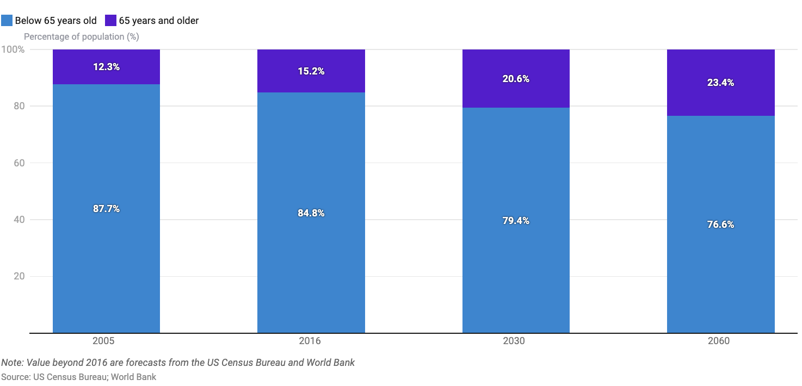

## 

## **2. Superior wealth levels of the elderly enable them to spend on themselves**

In 2023, seniors, specifically Baby Boomers, held around USD 80 trillion in assets, compared with Millennials, who held USD 14 trillion. The wealth levels of the senior population have also been steadily growing over the years. According to the Federal Reserve, the median net household wealth of the population above the age of 65 has grown at a compound annual growth rate (CAGR) of 2.4% from 1989 to 2022. During this period, the household wealth of those aged 55–64 rose at a CAGR of 1.5%.

The population above the age of 65 years has emerged as the wealthiest since 2010. In 2022, the median net household wealth of individuals over the age of 65 was between USD 334,700 and USD 410,000, around 1.02x the net household wealth of the 55–64 age group. Whilst these wealth levels ensure financial stability, the wealth of the senior population is further supported by inherent advantages such as a longer time to accumulate wealth, fewer social and financial commitments, and home equity.

### **The median net worth of the US population aged above 55**

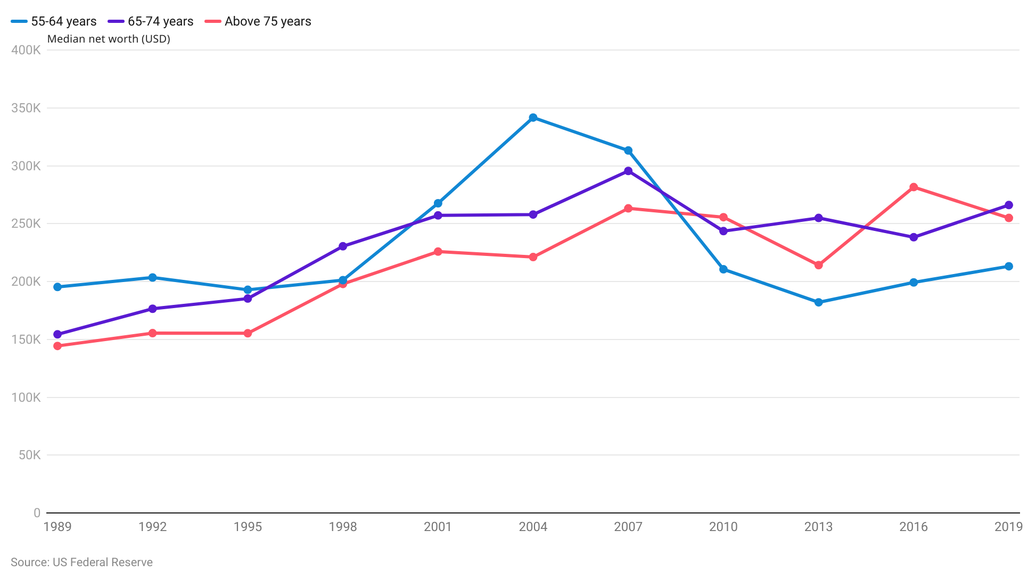

## 

## **3. A shortage of capable caregivers creates a higher demand for solutions to improve the independence of the elderly**

The US faces a rising shortage of caregivers, with the shortage of formal caregivers expected to amount to 151,000 and 355,000 in 2030 and 2040, respectively.

In addition to the shortage, caregivers in the US also tend to be relatively old (on average, almost 50 years of age). The US Department of Health and Human Services has found that around one in five caregivers are in fair to poor health, making them unsuitable for caregiving roles.

The shortage of caregivers together with the reliance on elderly unpaid caregivers is expected to primarily drive the demand for products that enhance the independence of the elderly population. It is expected to also drive the demand for products that improve the quality of caregiving services or link the elderly population with professional caregivers.

## **4. Inclination among seniors to live more active lives increases the need for independence**

Today, the elderly community tends to be willing to remain employed for longer, even after retirement. A survey conducted by the Employee Benefit Research Institute and Greenwald Research in 2023 indicated that Americans, on average, expect to retire at the age of 65 compared with 60 years in 1995. A 2022 survey of employed adults indicated that 73% of respondents intend to continue working post-retirement, either out of the desire to remain active and involved or because they enjoy working or even just because a job opportunity came along.

The senior population needs to ensure that their willingness is coupled with an independent lifestyle to ensure they are up to the task. As such, this would increase the demand for new solutions that would foster an independent lifestyle, including products geared toward mobility, healthcare, and caregiver communication and services.

# 

# **Risks to Growth**

## **1. Lower willingness of the elderly to share personal data could prevent the adoption of new technologies**

The elderly population tends to be more skeptical of sharing personal/private data compared with younger age groups. In certain cases, it has been found that seniors tend to be skeptical about sharing information even in some medical and healthcare contexts compared with younger age groups. A 2023 survey reports that only 12% of senior respondents were unconcerned about sharing such personal data.

Given that Age Tech-related products such as mobile apps apps and wearables require such personal data, skepticism around sharing personal data would be a barrier to the adoption of these Age Tech-related products. In this context, companies may also face challenges in adhering to increasingly tightening data regulations.

### 

**2. The elderly population may not adopt tech if it is not simple and user-friendly**

In general, technology that is perceived as complicated and difficult to use is less likely to be adopted by seniors. In 2023, a survey conducted by a third party for the BT Group showed that a key aversion to tech adoption is that seniors are not aware of how to use technology and find new technology complicated and overwhelming.

As such, design and ease are likely to remain a key concern for platforms and devices targeting seniors, such as apps for ride hailing and delivery services, medication management platforms, and sensory aids. However, this may be less of a concern for companies offering certain types of wearables and services, such as companionship services that require less input from the users themselves.

*Last updated: November 2024*

©2024 Uzabase, Inc. All Rights Reserved. The information contained herein: (1) is proprietary to Uzabase Inc. and/or its content providers; (2) may not be copied or distributed; and (3) is not warranted to be accurate, complete or timely. Neither Uzabase Inc. nor its content providers are responsible for any damages or losses arising from any use of this information.