# **Overview**

# **Beauty Tech: Overview**

## 

Beauty tech refers to the intersection between technology and the beauty industry, with a focus on how technology is redefining the development, marketing, and sale of beauty products. This includes a wide range of personal care products, including skincare, hair care, and cosmetics.

Notably, personal care products are no longer one-size-fits-all or loosely tailored to predefined customer segments. Meanwhile, the intersection of beauty and technology is no longer limited to Web 2.0 applications like social networking, influencer marketing, and ecommerce. Instead, every individual makeover has the potential to be powered by gadgets, ranging from AR-based immersive experiences to AI-driven hyper-personalized skincare to IoT-powered smart devices for DIY beauty, and next-gen, lab-grown ingredients.

### 

### **Types of beauty tech**

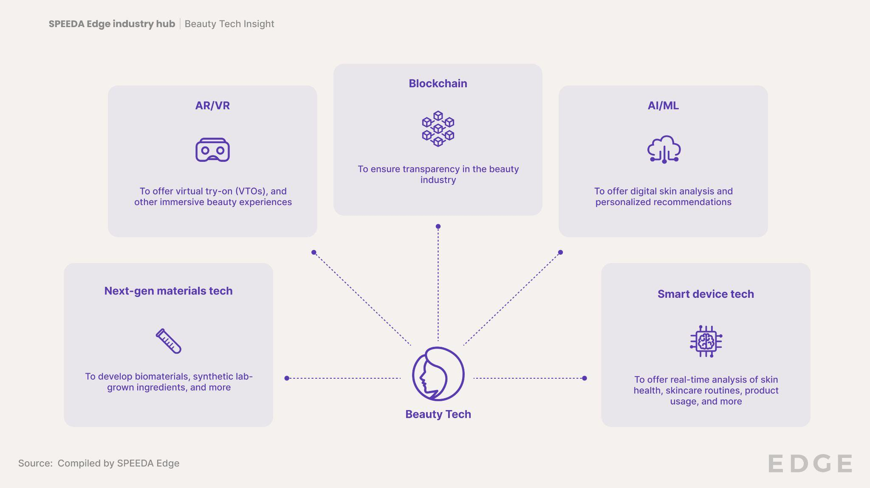

The earliest days of beauty tech were characterized by Web 1.0 technologies, with a limited focus on static brand websites featuring product information. Subsequently, Web 2.0 technologies drove the rise of beauty ecommerce, social media marketing, and omnichannel experiences. However, Web 2.0 tools have reached maturity and no longer represent noteworthy tech differentiators among beauty brands.

Hyper-personalization, inclusion, transparency, and immersive experiences are central themes in the current generation of beauty tech, which now leverages various Web 3.0 technologies like AR/VR, AI/ML, IoT, and blockchain to offer novel virtual experiences, bespoke products, and smart devices while promoting sustainable procurement.

**Evolution of beauty tech from Web 1.0 to Web 3.0**

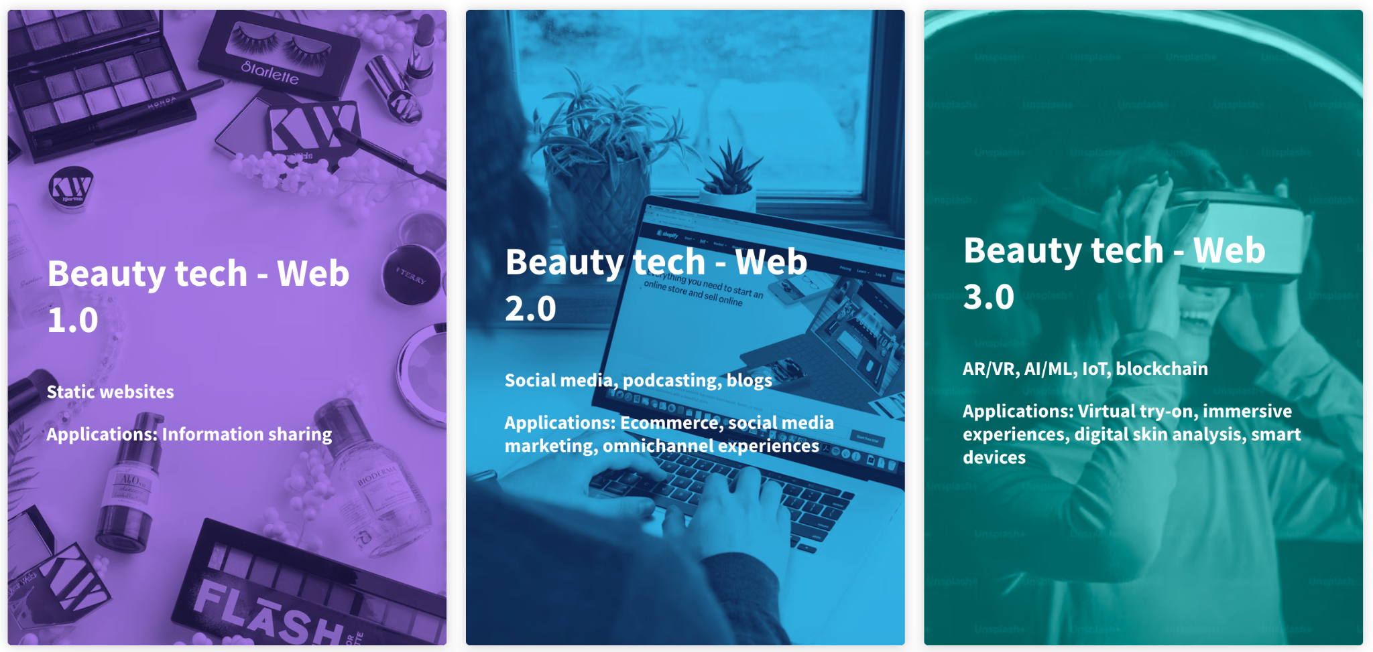

Beauty tech also leverages innovations in biotechnology and nanotechnology to develop sustainable ingredients and enhance the efficacy of personal care products. The current wave of biomaterial innovations, for instance, leverages biotechnology to develop lab-grown skincare ingredients that are identical to naturally sourced ingredients.

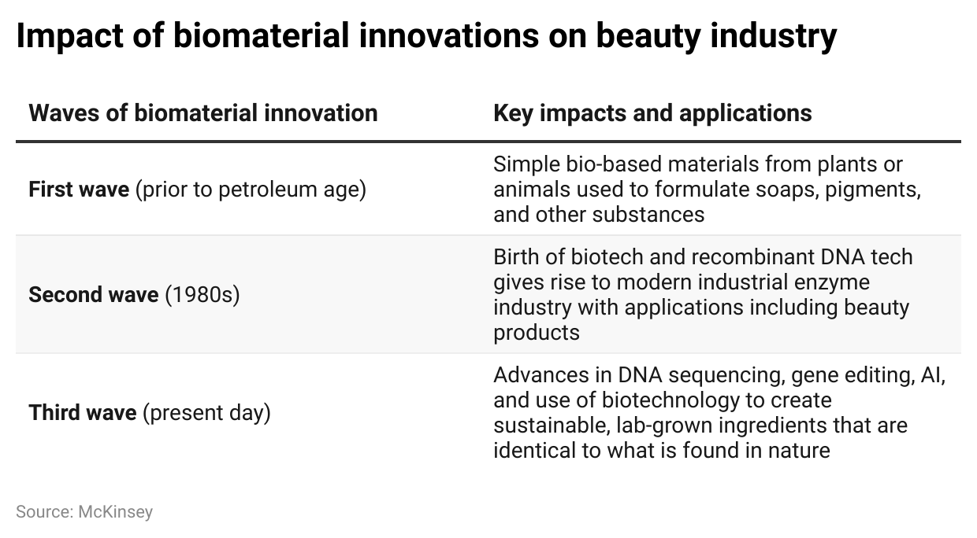

Meanwhile, the use of nanoparticles as active ingredients in skincare formulations is noteworthy for strengthening product properties, such as entrapment efficiency, dermal penetration, physical stability, moisturizing power, and UV protection.

# **Driving Factors**

## **1. Shift toward hyper-personalized beauty**

Personalization defines the beauty industry, and so has long been a driver of innovation within the space. In the past, beauty companies would leverage data (usually first- or third-party data) to tailor products and experiences according to broad preferences and behaviors of customers within pre-defined segments. Increasingly, there is a shift toward hyper-personalization, which harnesses real-time user data through techniques like digital skin analysis (zero-party data) and processes it via AI/ML to formulate products and experiences that are unique to the individual customer.

According to a 2023 Bolt survey of over 1,000 US consumers, ~75% of shoppers reported that they would pay more for beauty products if they received a personalized online shopping experience. Moreover, ~62% of shoppers indicated a greater willingness to buy beauty products if user-specific technology had been leveraged to develop custom formulations. Meanwhile, ~43% of shoppers revealed they would rather shade-match their foundation via AI online than test in-store, with Gen-Z, Millennial, and Gen-X cohorts being key adopters. Proven Skincare is a Beauty Tech company that has capitalized on this demand for hyper-personalization, harnessing zero-party data from its shoppers to create a skin genome database and using AI to generate personalized skincare routines. In 2021, the company had over 100,000 customers—~70% of whom were repeat customers (reportedly ~20x the industry average for repeat beauty purchases).

## **2. Post-pandemic push for hybrid retail experiences and at-home beauty**

While the pandemic was a catalyst for the digital testing of beauty products, consumers have since continued to demand hybrid retail experiences for their convenience, flexibility, and value in exploring a brand’s product range. In eye makeup alone, for instance, Perfect Corp’s VTO enables customers to test over 1,000 virtual eyeshadow palettes and eyelash patterns as well as over 800 eyeliner patterns across a range of eye colors. Since the start of the pandemic, Perfect Corp’s YouCam technology saw a 32% increase in VTOs. Beauty brands that implement AR-based VTO solutions reportedly also experienced an increase of ~50% in the average sales conversion rate, with customer engagement growing by 4x and basket size increasing by an average of 15% while product returns were minimized.

The pandemic was also a time of experimentation, with increasing demand for at-home beauty products like DIY hair color/nail care and smart devices. In 2020, the beauty device market in the US grew by ~7%. Even in the post-pandemic environment, at-home personal care devices continue to be popular, particularly for applications like nail care. For instance, Nimble Beauty is a 2024 CES Innovation Awards honoree that offers an at-home manicure machine harnessing machine vision, robotics, and advanced AI. Similarly, 10Beauty offers a fully automated home manicure machine that leverages robotics and automation and has drawn investments from venture capitalists like Oversubscribed Ventures and Imaginary Ventures.

## **3. Growing emphasis on sustainability**

In a 2022 study of over 2,000 US beauty consumers, ~64% indicated that “sustainability” (defined as “products made with ingredients that are renewable”) was an important consideration in their beauty product purchases; this is also one of the main factors in ingredient development and product formulation in the industry. Biotech beauty, in particular, represents a new frontier in sustainable ingredient development for personal care products.

Broadly, biotech beauty refers to ingredients generated with DNA editing and the help of organisms like algae, yeast, or bacteria. The term can also apply to lab-made ingredients that serve as a sustainable alternative to naturally occurring ingredients. Biotech beauty is a cut above clean beauty, which emphasizes the use of clean ingredients harvested directly from nature. Although over 65% of consumers indicate a preference for clean ingredients in their beauty purchases, the development of clean beauty products is not necessarily eco-friendly. For instance, rose oil is a clean beauty ingredient, but harvesting it is an unsustainable process, requiring ~200,000 rose petals to distill a few millimeters of rose oil. Biotech beauty, by contrast, is more eco-friendly.

Incumbents like L’Oréal actively leverage biotechnology to create new ingredients and reproduce the actions of microorganisms. By 2022, ~61% of the ingredients in L’Oréal formulas were bio-based (derived from abundant minerals or circular processes), and the company is pursuing a goal of 95% by 2030. The startup ecosystem also comprises a wide variety of biotech beauty players, including white biotechnology companies Biolie and Ellis Brooklyn, blue biotech players Microphyt and One Ocean Beauty, and green biotech players Geltor and Orveda.

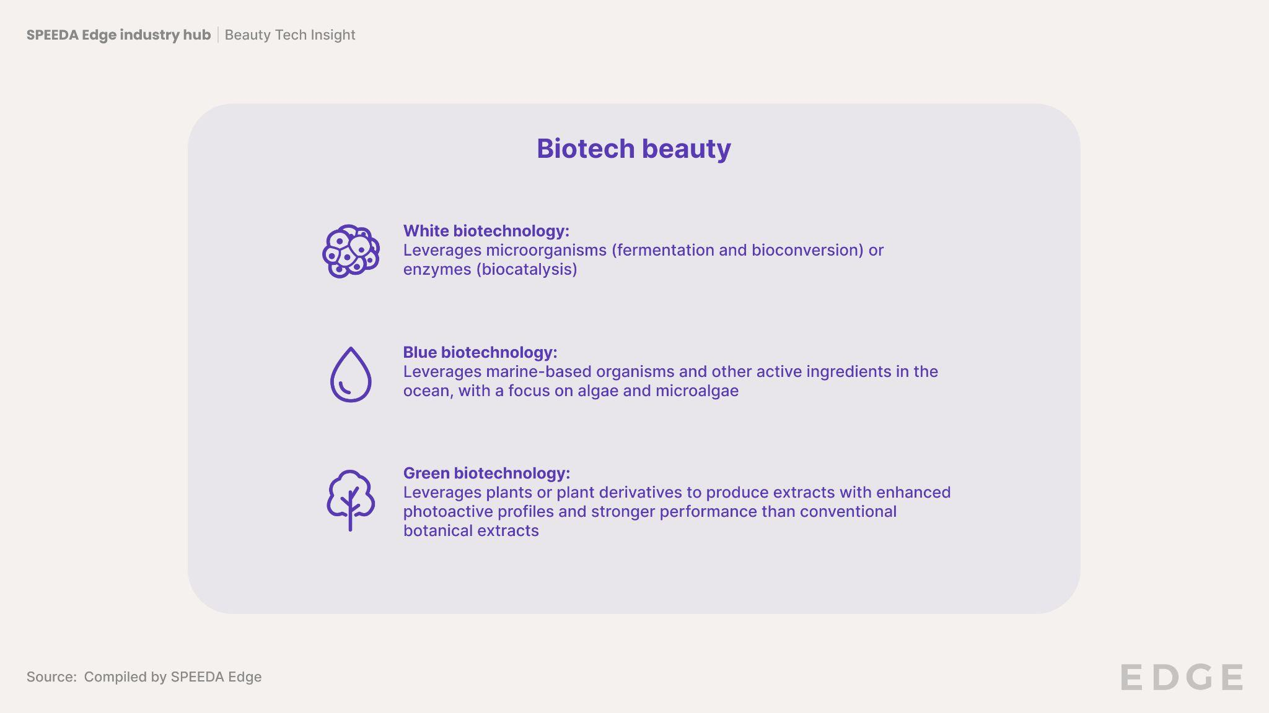

#### 

## **4. Growing expectations of supply chain transparency**

Today, consumers expect greater transparency from the beauty industry. A 2018 study of ~1,800 global respondents indicated that ~65% of consumers are interested in product ingredients, while 72% sought explanations on product benefits. The rise of clean beauty seems to have intensified this expectation, as indicated by 91% of US consumers in a 2023 survey. Yet, other research suggests that ~80% of shoppers had doubts on the sustainability claims made by brands, with fewer than 25% of consumers strongly agreeing that brands were sufficiently transparent about the environmental and social impact of their products.

Blockchain technology is seen as a solution to these growing demands of transparency, providing beauty brands with a secure means of logging and verifying product claims (e.g., “100% natural,” “cruelty-free,” or “sustainably sourced”) by storing information on a decentralized digital ledger with dated accreditation or certification to verify the claims. Disruptor Provenance offers a blockchain-based solution that supports supply chain transparency across industries, including beauty. In 2019, it worked with Cult Beauty on the first use case of blockchain for a beauty retailer, installing “proof points” (proof-backed sustainability badges) across 2,000+ products and 110+ brands, leading to a 35% higher purchase rate and 5% higher post-purchase shopper sentiment.

# **Risks to Growth**

## **1. Compliance with the Modernization of Cosmetics Regulation Act (MoCRA) of 2022 and state laws**

The Modernization of Cosmetics Regulation Act of 2022 was passed in December 2022, expanding federal oversight and marking the first update to the regulation of cosmetics in over 80 years. The new law is focused on ensuring consumer safety and requires all “responsible persons” and facilities manufacturing cosmetics and personal care products to register with the FDA no later than one year after the law’s enactment.

Among other provisions, MoCRA grants the FDA the ability to issue mandatory recalls of unsafe products (as opposed to voluntary recalls in the past). The new law is expected to necessitate beauty companies to invest in scientific expertise and adequate substantiation of ingredient safety.

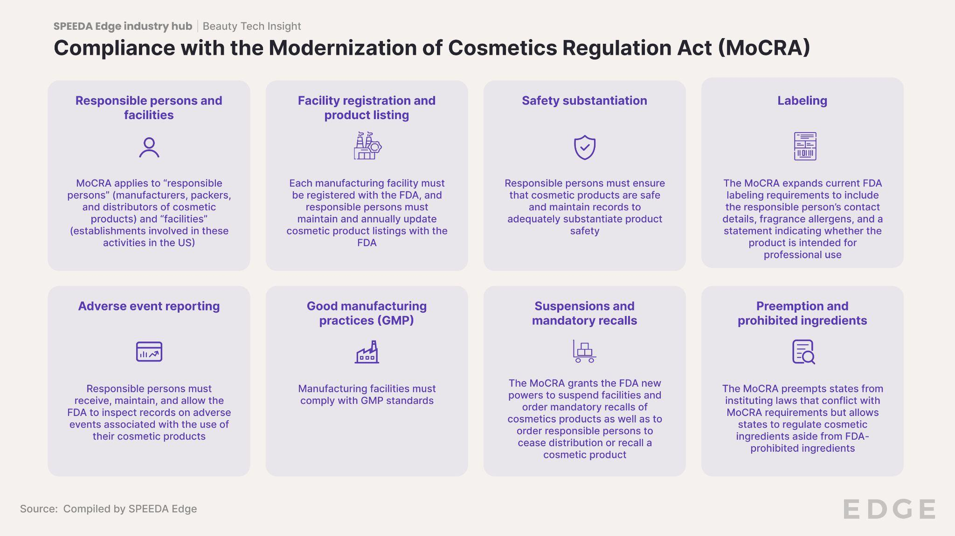

Notably, MoCRA is not the only regulation applicable to Beauty Tech companies; additional laws also apply at the state level, complicating the process of compliance. In September 2020, for instance, California passed the Toxic-Free Cosmetics Act (Assembly Bill 2762), which comes into effect in January 2025 and bans 24 ingredients from being used in cosmetic products. Effective from December 2022, New York legislated limits on the levels of 1,4-dioxane allowed in cosmetic products. Meanwhile, Washington State’s Toxic-Free Cosmetics Act (HB 1047), which was signed into effect in May 2023, also bans the use of certain chemicals in cosmetic and personal care products, including PFAS, phthalates, and formaldehyde. As next-gen material tech players work to develop new ingredients, there will be greater urgency in proving the safety of these ingredients.

## **2. Compliance with privacy and security laws like HIPAA and GDPR**

Privacy issues underscoring the use of beauty tech typically involve the collection of sensitive personal data about a user’s health and ethnic origins (i.e., information on skin color or tone) to deliver hyper-personalized products and experiences.

In the US, these collection methods are protected by HIPAA (which covers all individually identifiable health information relating to past, present, or future physical or mental health; the provision of healthcare to the individual; and more). Meanwhile, in the EU, Article 9 of the GDPR prohibits the collection of data revealing racial or ethnic origins, genetic data, biometric data, health data, and other personal data without prior consent.

The onus is on Beauty Tech brands to ensure that they are compliant with these privacy legislations. In 2022, for example, Perfect Corp completed the HIPAA certification for its AI skin analysis solution, which gathers health-related data, including diagnosis data, clinical care data, and lab results like images and test results. The certification enabled Perfect Corp to protect end consumers from the loss of private healthcare information and minimize potential corporate liability for the brands using its solutions. For non-compliant companies, however, the penalties for violating laws like HIPAA and GDPR can be significant, depending on the nature of the violation and level of culpability. The lack of consistency in regulations across geographies further complicates compliance.

## **3. Steep costs of development in biotech beauty**

The development of sustainable lab-based beauty ingredients tends to come at a cost. Amyris, a beauty biotech forerunner and former parent company of startup Biossance, is a case in point. After it received funding from the Bill & Melinda Gates Foundation at its inception in 2003, the company went on to capture ~50% of the global market in squalane, a skincare humectant that mimics squalene, naturally found in shark liver oil and vegetable oils.

According to Amyris’ chief science officer and head of R&D, the costs of developing a single new biotech molecule ranged from USD 500,000 to USD 3 million annually, although the R&D costs, upfront investments, development timelines, and commercialization journeys were expected to improve over time.

In August 2023, Amyris filed for Chapter 11 bankruptcy, citing a tight liquidity position and significant liabilities (USD 1 billion–10 billion) resulting in a lack of marketing spend and dwindling consumer revenues (a fall from ~USD 175 million in 2022 to USD 59 million by June 2023). Subsequently, the company auctioned off four of its beauty brands, including its biotech brand, Biossance, for USD 20 million (bought by beauty ecommerce company THG Beauty).

Although there are many causes of Amyris’ bankruptcy, including its transition from manufacturer to incubator for celebrity beauty brands, biotech beauty remains one of the more costly undertakings in the Beauty Tech space.

*Last updated: March 2024*

©2024 Uzabase, Inc. All Rights Reserved. The information contained herein: (1) is proprietary to Uzabase Inc. and/or its content providers; (2) may not be copied or distributed; and (3) is not warranted to be accurate, complete or timely. Neither Uzabase Inc. nor its content providers are responsible for any damages or losses arising from any use of this information.