# **InsurTech: Commercial Lines: Overview**



## **How is InsurTech disrupting commercial insurance?**

InsurTech in the commercial lines space refers to using technologies such as AI and data analytics to develop and deliver commercial insurance products and services to businesses via digital platforms.

Disruption in this field is slow compared to the personal lines space, largely due to the relatively straightforward nature of personal insurance data and the higher risk of writing commercial lines insurance. The sector is rapidly catching up as startups work to eliminate the need for traditional intermediaries, such as agents and brokers.

### 

### 

### 

### 

### 

### 

### 

### 

### **Key segments across InsurTech: Commercial Lines**

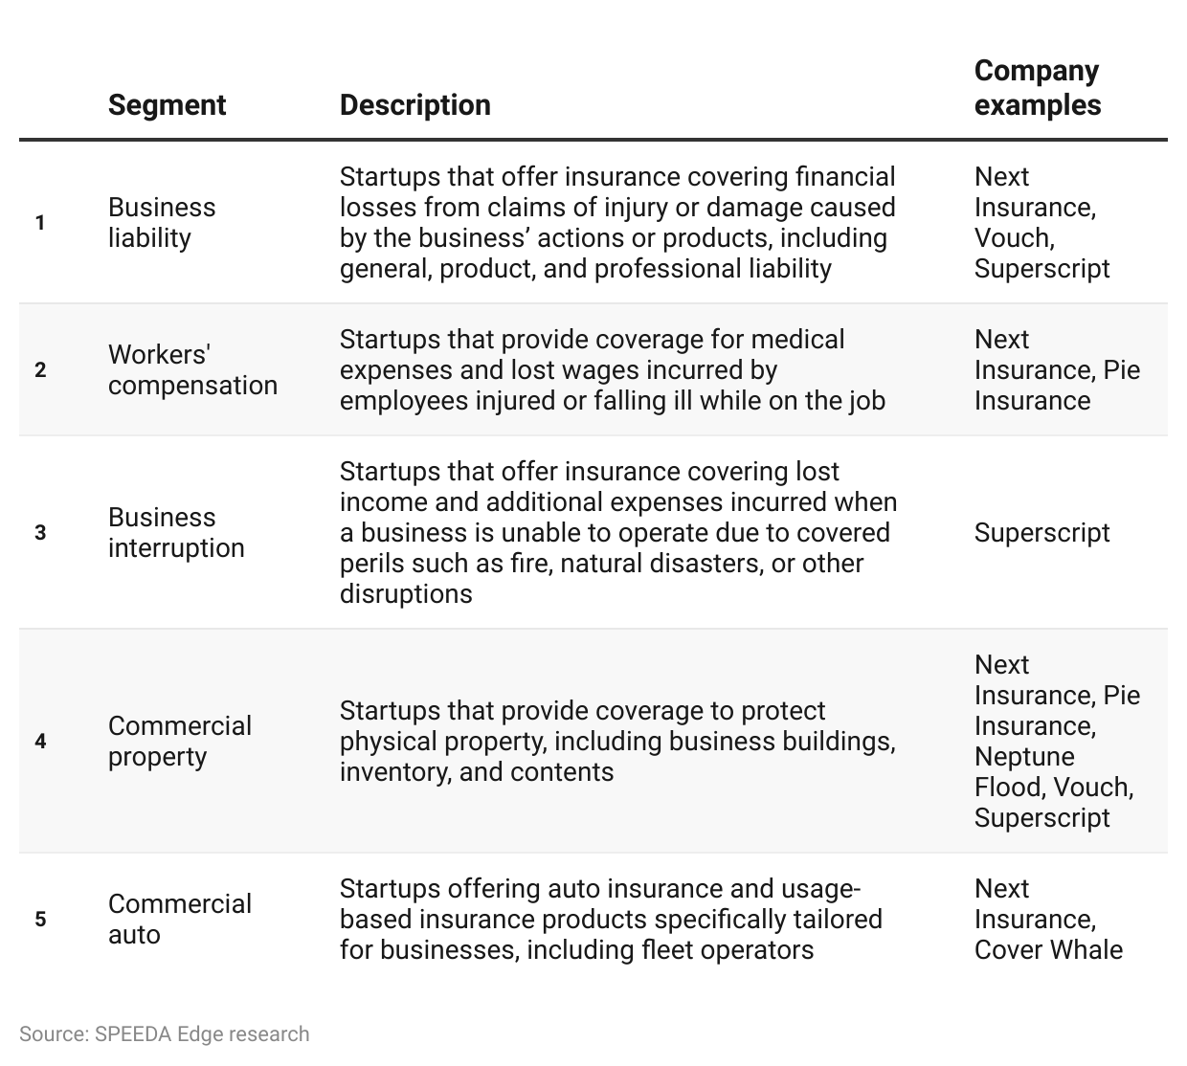

Business insurance, including liability insurance, is emerging as a key focus within this segment as evidenced by a survey conducted by Next Insurance in January 2024, which identified business liability insurance as the most commonly purchased type of commercial insurance.

### 

### 

### 

### 

### 

### 

### **Most commonly purchased insurance policies**

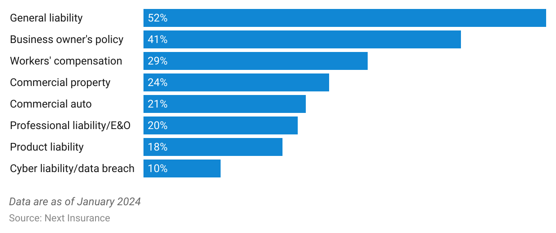

## **Rapid AI developments boost efficiency in insurance, with IoT devices unlocking new data**

Developments in AI have not only helped streamline insurance purchasing but have also significantly improved the process of underwriting policies and claims management through automated intake and assessment, enhancing overall operational efficiency in the industry.

In addition, technological developments can be used to cross-sell insurance policies. For instance, mandatory insurance such as directors and officers (D&O) policies often serve as initial touchpoints for acquiring business insurance policyholders, while predictive analytics further identify opportunities for cross-selling products like cyber insurance and business interruption coverage.

### **Key technologies and tools enabling digitization of the insurance value chain**

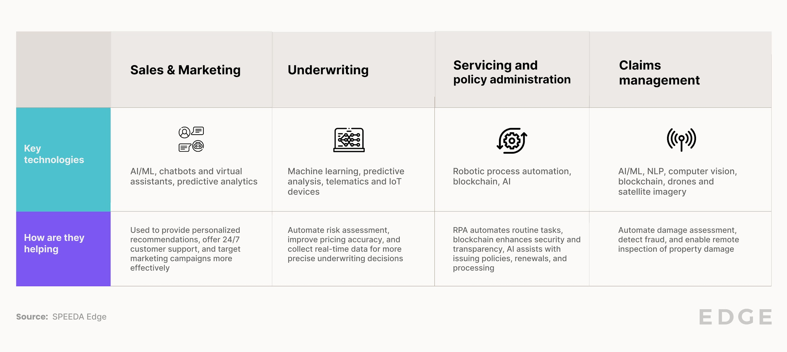

*Note: For a detailed market map of companies providing technology solutions for insurance companies, refer to* [InsurTech: Infrastructure](https://sp-edge.com/industry/187)

While adoption in the commercial InsurTech space is still in its infancy, developments in [GenAI](https://sp-edge.com/industry/163) are also opening up new use cases across the insurance value chain. For example, GenAI startup [Sixfold](https://sp-edge.com/companies/2915159) is applying the technology to the underwriting process, helping insurers expedite the evaluation and rating submission process, and automation startup [Appian](https://sp-edge.com/companies/5881) is leveraging GenAI to help insurers automate policy document analysis and provide real-time support through its AI copilot.

# **Driving factors**

## **1. Lack of coverage for SMEs by traditional insurers opens new opportunities for tailored insurance products**

Commercial InsurTech startups have emerged as a direct response to the prevailing issue of underserved SMEs in the insurance market. Traditionally, SMEs, which constitute about 99% of all businesses in the US, have faced significant challenges with insurance offerings from traditional insurers. Despite accounting for most businesses, this segment has often been overlooked by traditional insurers who have primarily focused on the corporate sector, often providing complex, one-size-fits-all policies that fail to meet the needs of smaller enterprises adequately. Traditional insurers tend to rate small businesses based on generalized risk exposures rather than considering the specific and diverse characteristics of each business.

According to a survey conducted by Next Insurance in January 2024, 29% of small business owners in the US reported having no insurance coverage. Of those that did, a large majority claimed that they did not possess the adequate level of coverage required.

### **Share of insurance coverage among small businesses in the US**

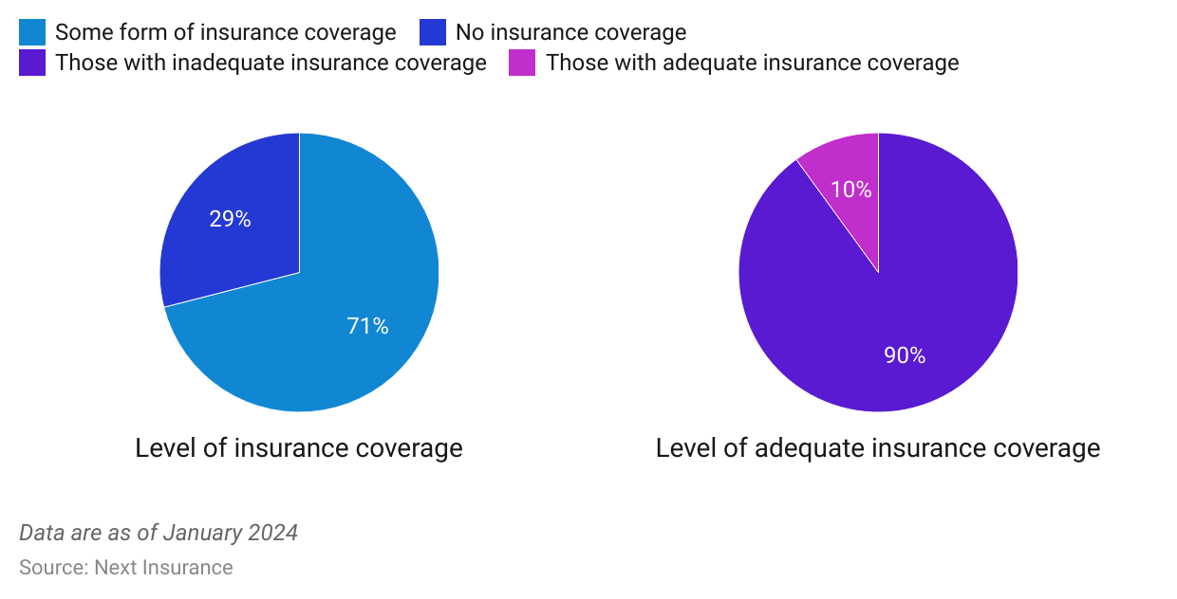

According to management consulting firm Oliver Wymann, the SME insurance market is highly fragmented, with no single player having a market share of more than 10%. Despite being a price-sensitive market, research indicates that they are willing to pay a premium of as much as 10% for brands they know and trust. This market has proven quite profitable, reporting a below-average combined ratio over the years, thus indicating a significant opportunity for companies willing to invest in the personalization and technology required to tap into this market. In response, several startups such as [Next Insurance](https://sp-edge.com/companies/374531), [Vouch](https://sp-edge.com/companies/790458), and [Embroker](https://sp-edge.com/companies/306174) have focused on offering insurance policies specifically designed for small businesses by incorporating business-specific factors into policy proposals.

## **2. Rise of the gig economy calls for specialized insurance products**

The rise of the gig economy has spurred significant demand for specialized insurance solutions tailored to the unique needs of independent contractors, freelancers, and participants in the sharing economy. As of May 2024, 36% of the US workforce was estimated to be engaged in gig work. However, a survey by Cake & Arrow in June 2024 revealed that only about 30% of gig economy workers has adequate insurance coverage, indicating a significant gap in insurance coverage.

### **Number of full-time independent workers in the US**

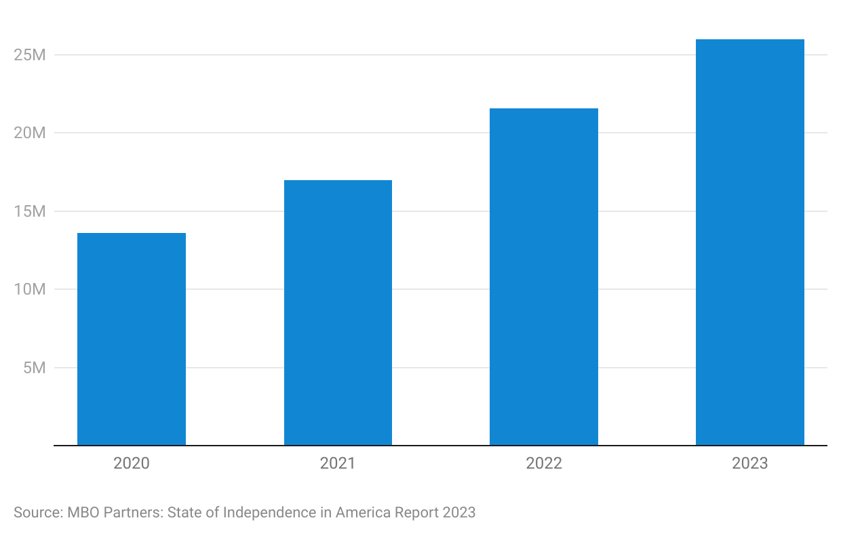

Given the unique and diverse nature of the gig economy, the industry does not typically fall within the scope of personal or commercial lines. For example, standard homeowners' and personal auto insurance policies often exclude or have limitations for activities related to the gig economy, such as hosting through platforms like Airbnb or driving for rideshare services like Uber and Lyft. Traditional insurers have therefore struggled to meet gig workers’ diverse and dynamic insurance needs, leaving many unprotected against risks such as illness, injury, and other professional liabilities.

The diversity within the gig economy—spanning various professions and industries—calls for customized insurance solutions. In response, several startups in the InsurTech: Commercial Lines space have emerged to fill this void, offering on-demand insurance products that can be tailored to specific gigs or projects. For instance, InsurTech: Commercial Lines startups offer innovative solutions that address the unique risks associated with ridesharing, such as liability coverage for accidents and injuries occurring during rides.

Startups such as [Insify](https://sp-edge.com/companies/1646172), [Finanzchef24](https://sp-edge.com/companies/97943), and [Inshur](https://sp-edge.com/companies/419353) specialize in providing flexible coverage options to gig economy workers that traditional insurers typically do not offer. These startups leverage data analytics and AI to customize insurance policies quickly, accommodating changes in work patterns, income fluctuations, and unique risk profiles of gig workers.

**3. Rising commercial auto premiums create opportunities for usage-based alternatives**

The Commercial auto insurance sector has consistently observed a significant increase in average premiums over the past few years, with a reported growth of 7.3% YoY in 2023. This upward trend can be attributed to several key factors such as worsening driving habits and the growing number of vehicles on the road. For instance, data from the National Highway Traffic Safety Administration indicates an 18% rise in car crashes from 2019 to 2022, highlighting the increasing risk environment.

Additionally, worsening weather conditions, particularly in California and Florida, have exacerbated these challenges. Severe weather events have strained insurance providers, leading to shortages in coverage availability and subsequent premium adjustments. As a result, traditional insurers face greater complexity in their underwriting processes, necessitating higher premiums to manage rising risks and ensure financial sustainability.

To overcome these challenges, the commercial auto insurance industry has been increasingly turning toward more sustainable pricing models to underwrite policies, largely characterized by usage-based models. These models assess factors such as driver behavior, vehicle usage patterns, and financial management to price premiums accurately. Automated processes facilitate the collection and analysis of this data, enabling insurers to tailor coverage more precisely to individual business requirements, including fleet operations with multiple drivers and vehicle types. Adopting usage-based models in this segment can also incentivize safer driving habits among customers, ultimately leading to lower premiums.

**Premium savings offered by InsurTech startups compared to traditional insurers**

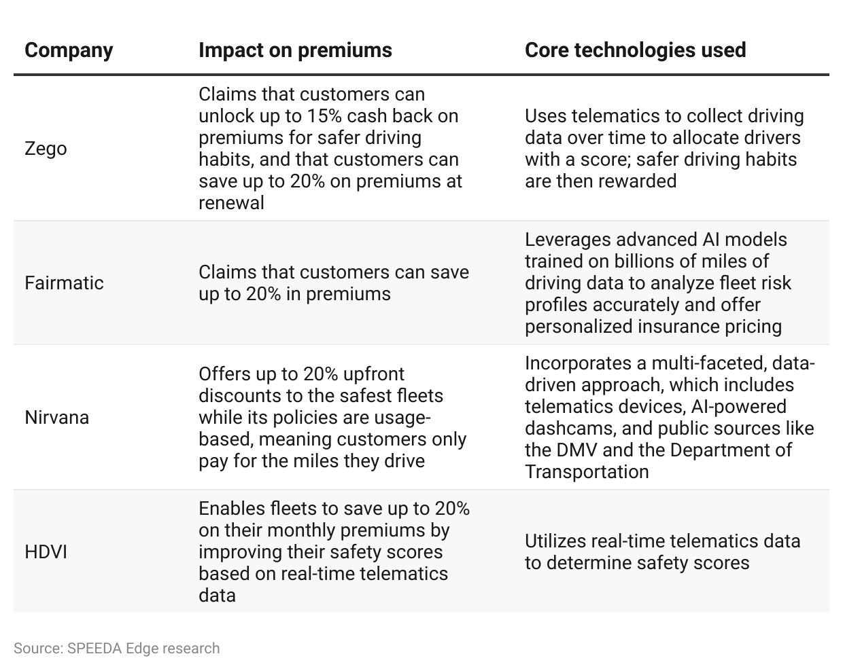

As of October 2023, approximately 65% of commercial auto insurers in the US were offering usage-based insurance policies to some extent, with 38% stating that adoption was still in the early stages. A third of commercial auto insurers in this survey expect to launch a new product in 2024 or 2025.

In comparison, startups in the commercial InsurTech space that focus on the commercial automobile sector appear to have a headstart on traditional insurers in implementing usage-based insurance solutions. These agile newcomers have leveraged advanced telematics and data analytics to offer more personalized and flexible policies, potentially disrupting the established market.

# 

# 

# **Risks to Growth**

## **1. Using general agents can ease capital needs but may limit long-term growth**

Full-stack insurance providers must adhere to numerous existing and forthcoming regulations, such as minimum risk-based capital and solvency standards, which vary per US state. This may be challenging for startups as they generally have fewer capital reserves than traditional insurers. The regulations also involve detailed disclosure mandates concerning major investors, potentially discouraging private venture capital investors from participating in subsequent funding rounds.

Many InsurTech startups, including [Superscript](https://sp-edge.com/companies/283704), [Foxquilt](https://sp-edge.com/companies/692017), and [Joyn Insurance](https://sp-edge.com/companies/1454072), have adapted to market challenges by becoming or partnering with managing general agents (MGAs), who offer essential services like underwriting, marketing, and policy issuance, but cannot assume insurance risk themselves. While this approach allows startups to enter the market, it may limit their long-term growth potential due to restrictions on the risks they can cover and their inability to underwrite policies directly.

## **2. Low customer awareness of needed coverage may limit demand**

Lack of awareness among businesses about commercial insurance can significantly hinder the growth of InsurTech: Commercial Lines. Many businesses may not fully understand the types of insurance they need or the appropriate coverage levels required to protect their operations adequately. According to a survey by Next Insurance in January 2024, 53% of small business owners identified a lack of awareness about the necessary coverage as a major barrier to obtaining sufficient insurance. This lack of understanding can lead businesses to underinsure or not purchase insurance at all, limiting the demand for tailored insurance solutions offered by InsurTech startups.

## **3. Managing large data volumes risks privacy and data breaches**

Stringent regulations such as the General Data Protection Regulation (GDPR), California Privacy Rights Act (CPRA), and sector-specific laws impose strict requirements on the collection, processing, and storage of personal and business data. Failure to adhere to these regulations can result in legal penalties, damage to reputation, and loss of customer trust. Moreover, concerns over data breaches and misuse can deter businesses from adopting InsurTech solutions that rely on data from connected devices for risk assessment and policy pricing.

### 

### **Recent incidents of cybersecurity threats faced by insurers**

