# **Space Travel and Exploration Tech : Overview**



## **New solutions to explore opportunities beyond Earth**

Space Travel and Exploration Tech broadly involves the development of solutions that may be used for travel or activities outside of the Earth's atmosphere, mainly including the development of spaceflights, space exploration, and communication and navigation. Space activities have undergone significant technological improvement over the past few decades. From the landing on the moon in 1969 and the launch of the Hubble Space Telescope in 1990 to the current advancements in space technology, with startups working toward space tourism, the advancement of space tech has spurred innovation and business growth and made contributions that directly impact people every day.

Curiosity about the universe has always been the underlying force for space-related activities, and advancements in space tech have captured the attention of the population and inspired many to explore and learn about activities beyond Earth. The space agencies, which are in charge of civilian space activities as well as space research and exploration, have grown in prominence in recent decades. While there are many space organizations across the globe, NASA, CNSA, ROSCOSMOS, ESA, ISRO, and JAXA are the six government space organizations having complete launch and extraterrestrial landing capabilities as of 2023.

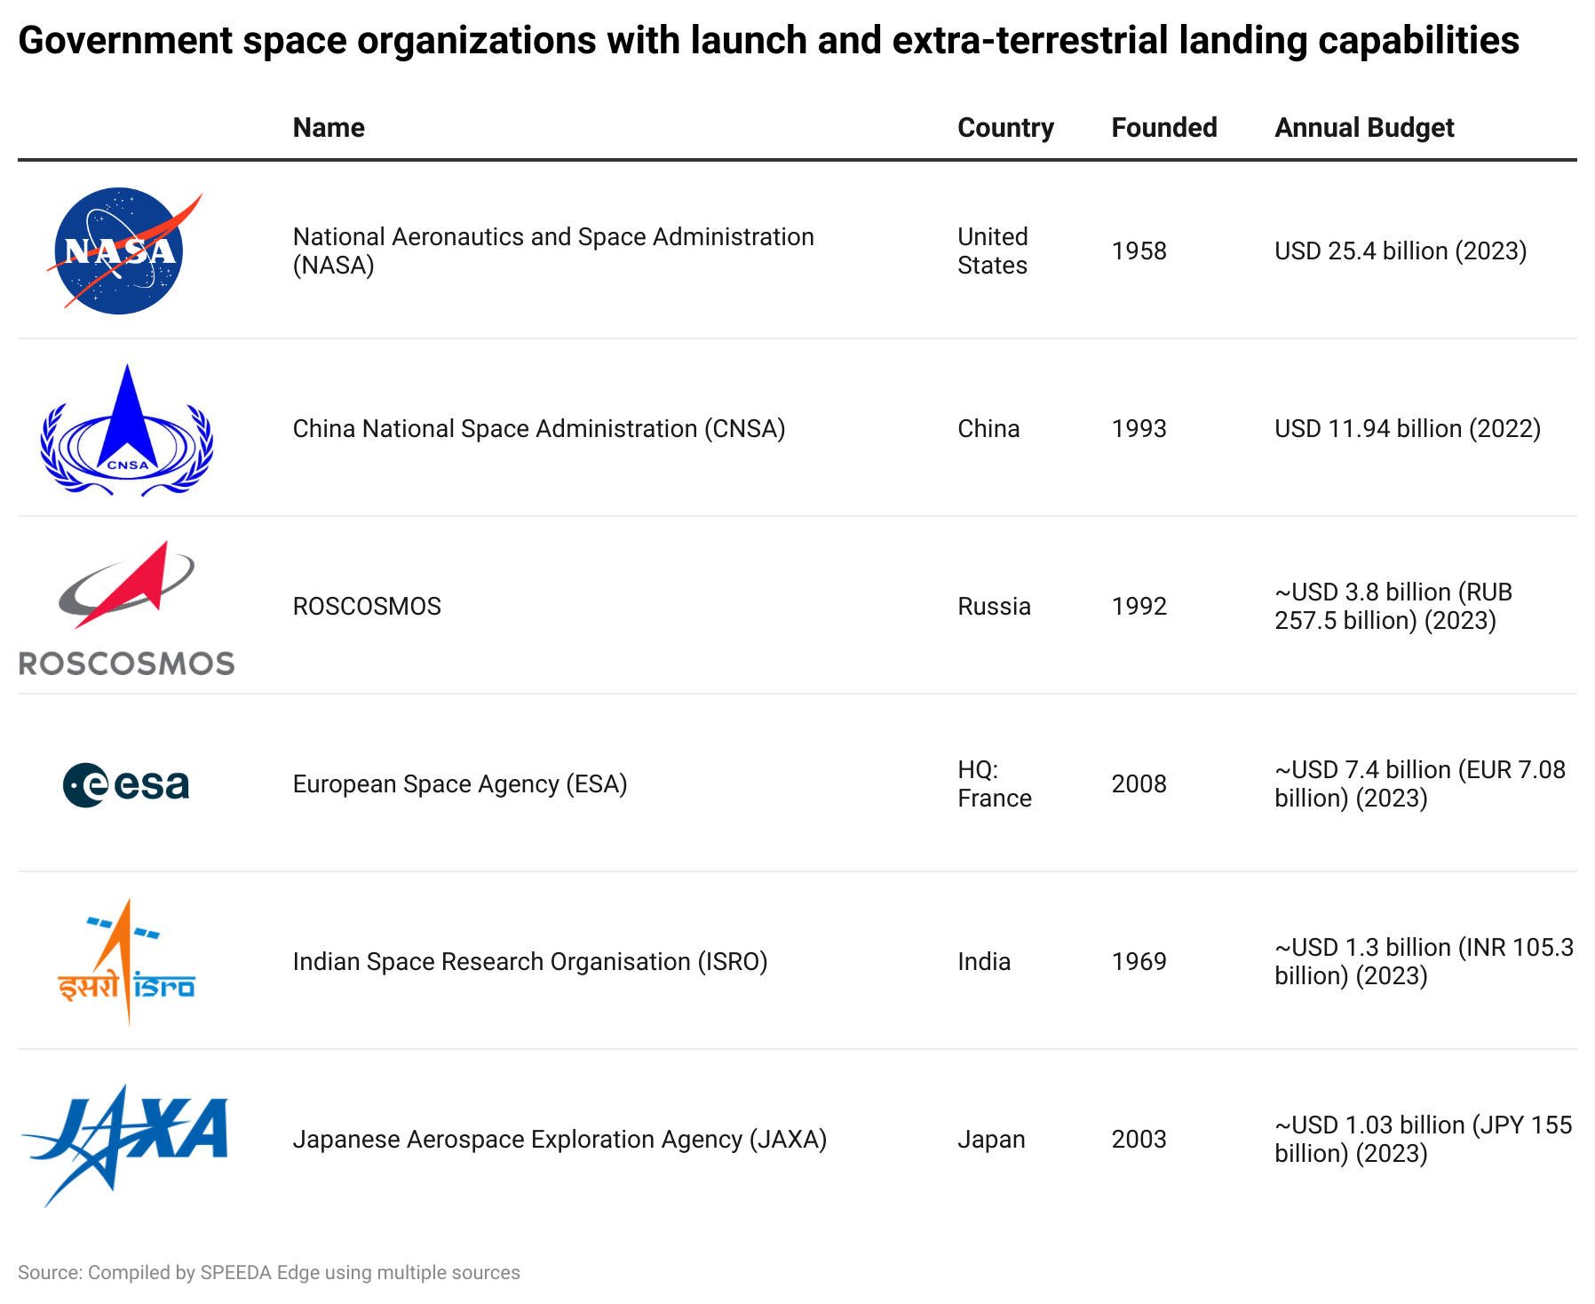

**Space Travel and Exploration Tech: Segmental overview**

Space tech is often defined very broadly, with some research including as much as [12,000+ companies](https://www.spacetech.global/dashboard) in some definitions. However, in this industry hub, we specifically focus on the next step of space-related activities, which goes beyond traditional scientific and R&D purposes. Our focus areas include space travel, space stations, space exploration robotics, space debris management, and space mining. Also, we specifically exclude companies related to satellites and components, which are covered under the [Satellite Management](https://sp-edge.com/industry/152) hub. 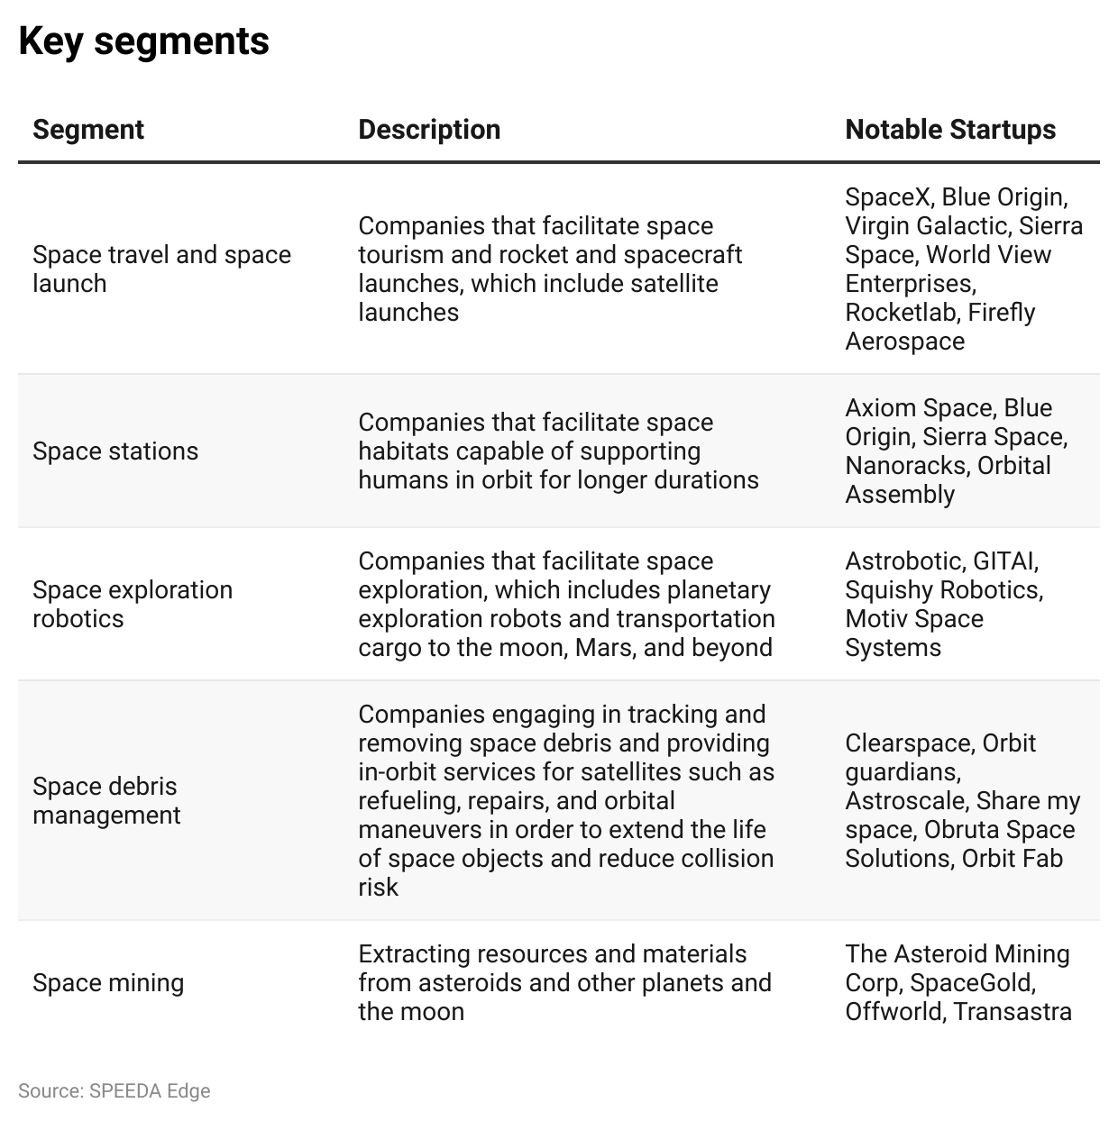

## 

## 

## 

## 

## **Deregulation in US space-related activities encourages private startups to join the space economy**

Deregulation in US space activities has taken place since the Communications Satellite Act of 1962, which gave private companies the ability to own and operate commercial satellites. More recently, President Obama signed the 2015 US Commercial Space Launch Competitiveness Act, allowing US companies and citizens to engage, own, and sell space resources. While this was the most important regulation related to the emergence of the commercial space sector, there were also other regulations in between such as the Commercial Space Act of 1998, which supported free and competitive markets, as it created the most efficient conditions for promoting development.

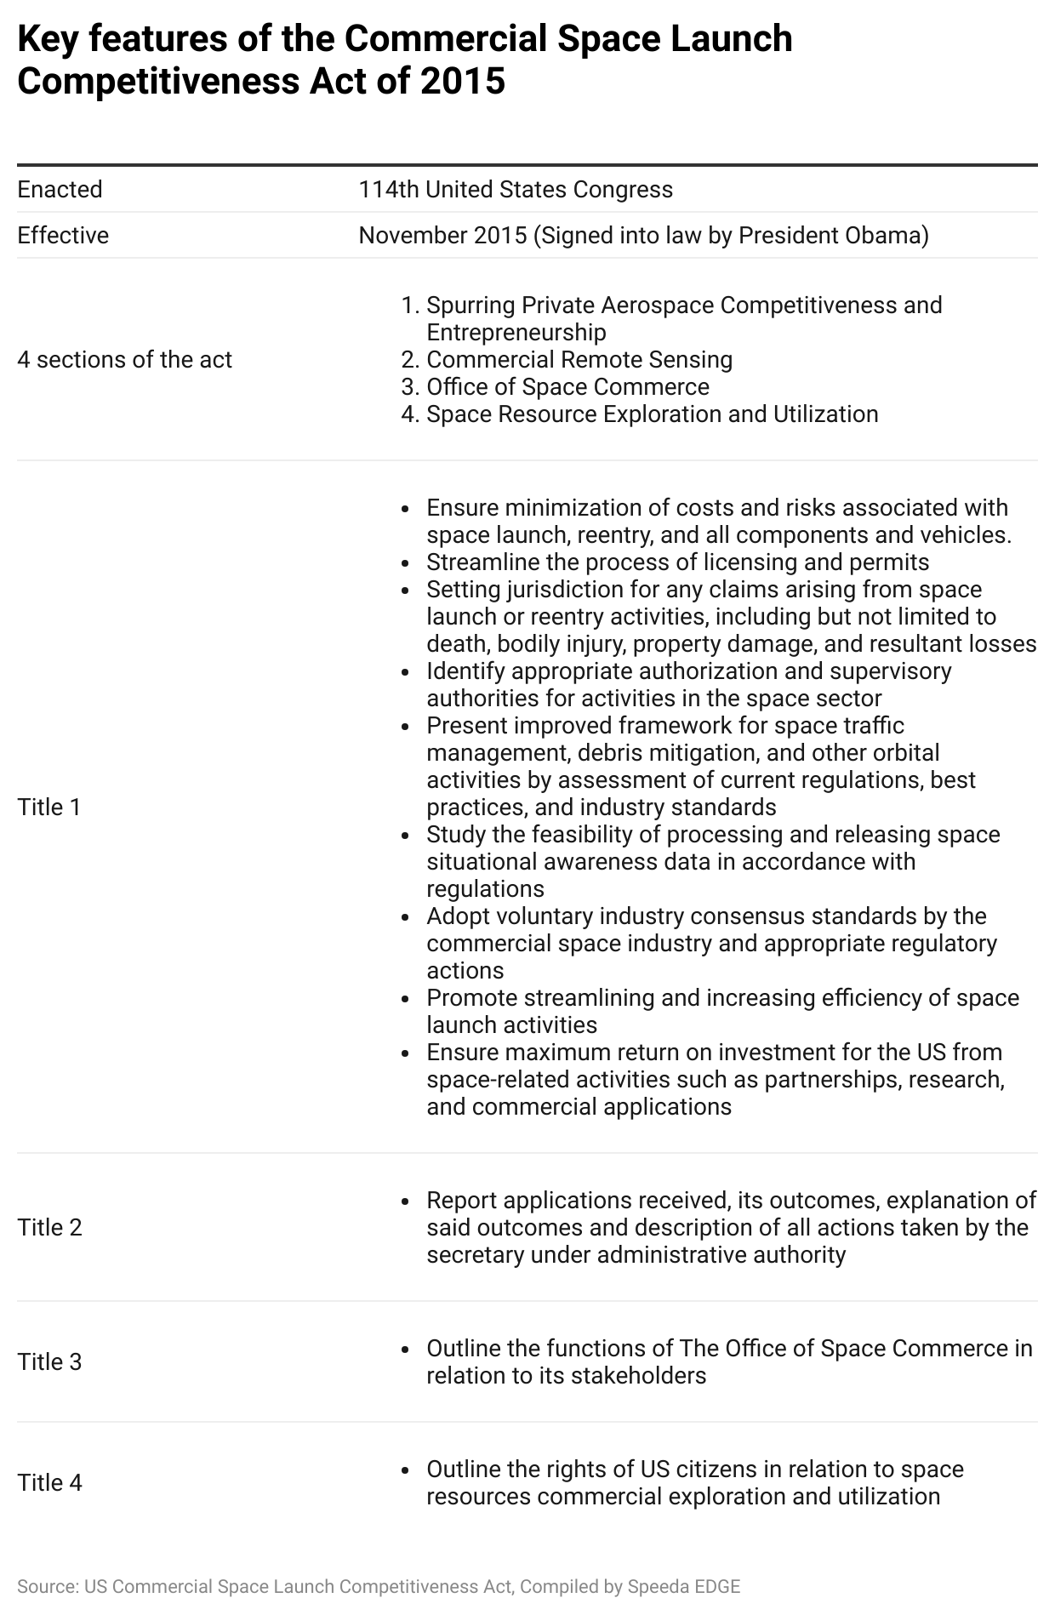



With the gradual deregulation in the US aimed at encouraging the commercial exploration and exploitation of space, commercial space activity tripled over the past few years, increasing from USD 110 billion in 2005 to ~USD 427.6 billion in 2022, with commercial activity accounting for ~78% of the estimated USD 546 billion global space economy in 2022.

**Declining launch costs enable the gradual introduction of space activity to the general population**

The private commercial space sector's role has resulted in innovation and technological advances, thereby modernizing traditional and costly space practices to bring down the per-launch cost by building more efficient spacecraft and reusing rockets and components. NASA’s space shuttles, which were retired in 2011, cost USD 1.6 billion per flight on average (~USD 30,000 per pound of payload in 2021 dollars) to reach low Earth orbit, while, at present, SpaceX charges only around USD 62 million per launch on average (~USD 1,200 per pound of payload). Furthermore, consolidation in the value chain has helped establish economies of scale to reduce costs, making the environment more competitive. 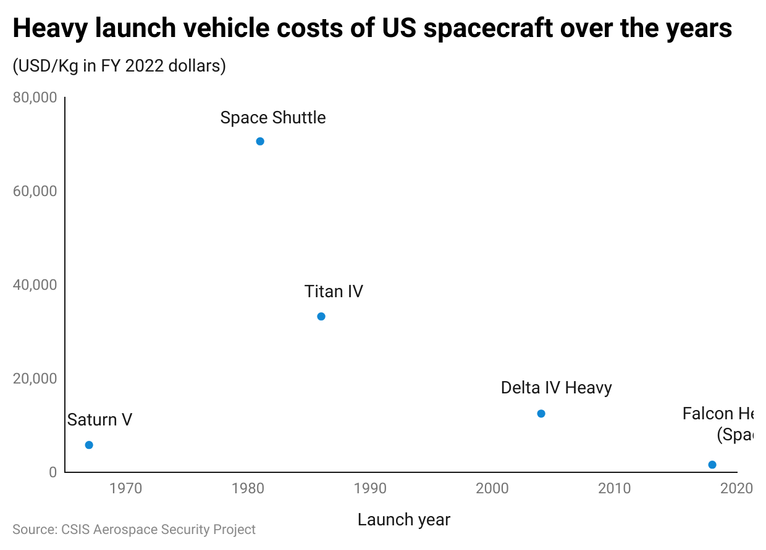

**Success of new technologies stemming from space exploration has helped other industries**

Space tech has enabled life-changing technologies and the growth of many other industries that affect individuals, organizations, and governments through the advancement of telecommunication, GPS, weather forecasts, etc. It has also allowed us to monitor climate change through Earth-observation satellites and provided opportunities to preserve the Earth and its resources by exploring new energy and material resources in outer space and moving certain high-pollution industries into space. Space tech has become an important aspect in the internal economic development of countries as well as external capability and national security. Other industries have also benefited from technology stemming from space tech.

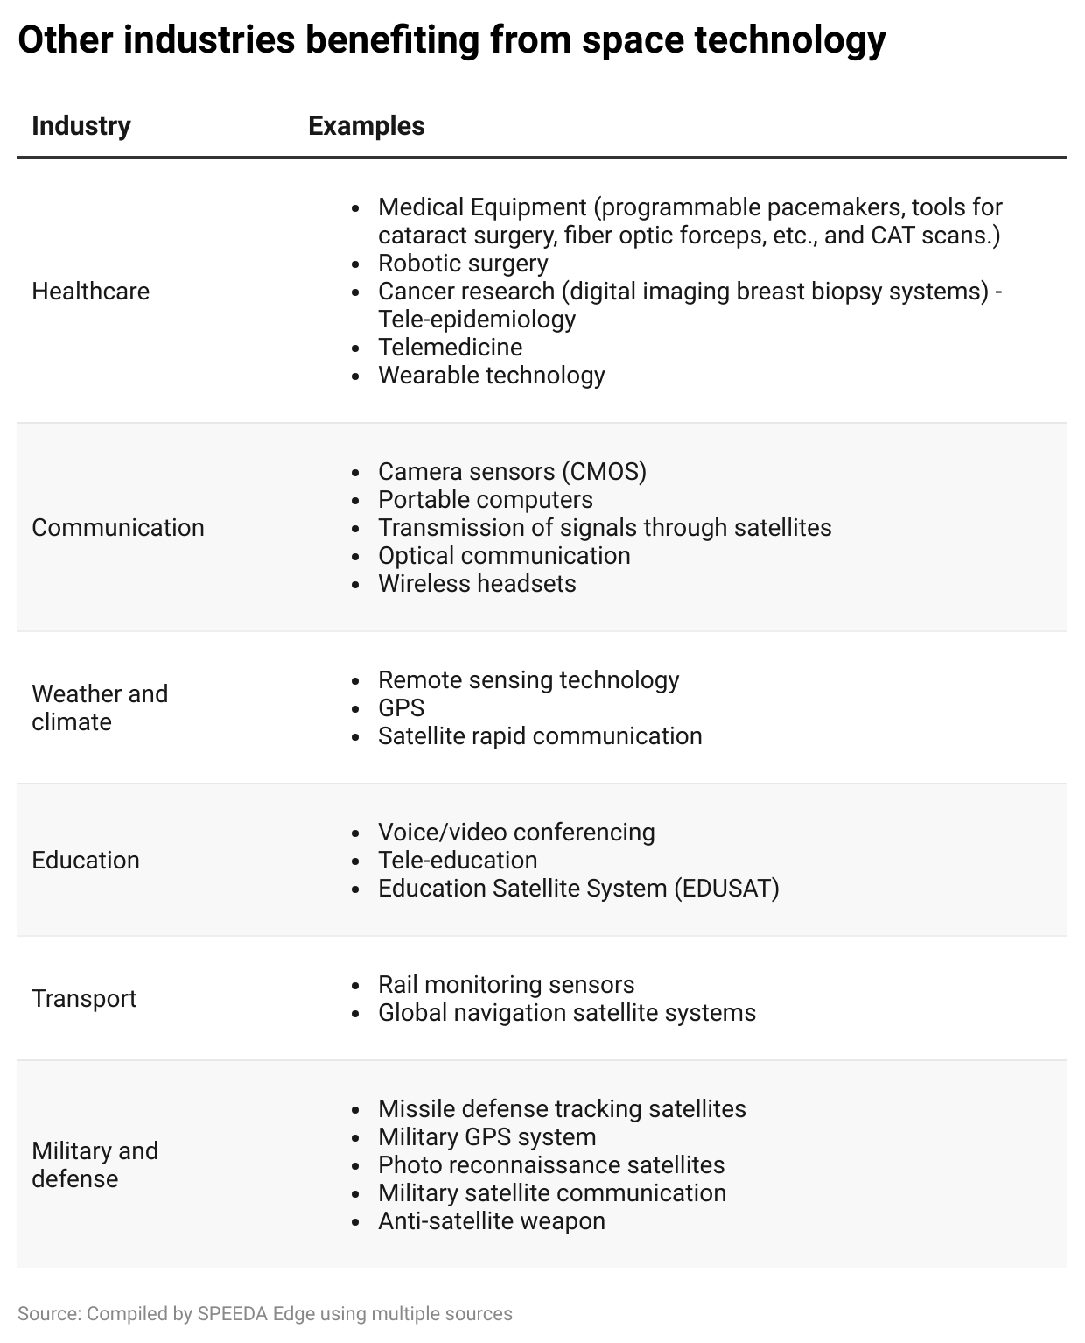

If space mining becomes a success, Earth could also benefit from additional resources that are currently scarce on Earth. While this could benefit the global economy, it could also positively impact the environment by preventing the need for harmful mining techniques on earth while also providing an avenue for the creation of solar power satellites.

**Driving drivers**

## **1. National governments pushing to outsource space activities has resulted in the new space economy**

Industry transformation has led to new players entering a domain traditionally occupied by institutional players (old Space; space agencies such as NASA working with large companies), with governments pushing to outsource space activities, which brought on a commercialization trend for the industry, providing more room to innovate. NASA’s space shuttle program came to an end in 2011, after three decades of operation, due to safety issues, high costs, and slow turnaround, forcing American astronauts to turn to Russian rockets. However, a decade later (i.e., in 2021), this paved the way for a new space economy, with NASA partnering with private companies such as SpaceX building, on NASA’s space shuttle legacy, to transport NASA’s astronauts on private spacecraft.

These were further boosted by notable government funding toward space technology, with the US government providing funds toward space technology every year (the 2023 budget for NASA alone was USD 25.4 billion, less than 0.005% of the annual government spending).

In December 2021, NASA announced that it had awarded over USD 415 million in total to Blue Origin, Nanoracks, and Northrop Grumman to develop privately owned and operated commercial space stations. With the International Space Station (ISS) potentially expected to shut down at the end of this decade, these awards reflect NASA’s efforts to tap private companies to enable a US-led commercial economy in low Earth orbit (LEO) with a smooth transition from the ISS. Furthermore, in 2023, NASA [partnered with seven private companies](https://sp-edge.com/updates/19476) as a part of its Collaboration for Commercial Space Capabilities 2 (CCSC-2) initiative, in a bid to advance the US commercial low-Earth orbit (LEO) economy.

The new space economy has resulted in players competing in new segments such as space tourism and commercial space stations to open up space access to humans and not just NASA and sovereign nation astronauts. While space tourism is currently aimed at the elite wealthy society due to its high price tag, it has the potential to be more accessible in the future when costs decline (making space a vacation destination). Virgin Galactic is at the forefront of this and had successfully concluded two commercial space flights as of August 2023, with plans to conduct 400+ flights annually. While this carries a price tag of USD 450,000 per flight, companies such as World View Enterprise, Space Perspective, and Halo Space offer multiple-hour commercial space flights between USD 50,000 and USD 220,000.

## 

## **2. Managing orbital debris and the threat of a possible Kessler Syndrome**

The increasing threat of orbital debris from old spacecraft and satellites has created the demand for space debris management from private companies as government agencies struggle to track orbital debris. If space waste is not managed, it could lead to a Kessler Syndrome, where orbital junk around Earth reaches a point where it creates more and more space debris through collisions, causing problems for satellites, astronauts, and mission planners, which could disrupt the internet, weather, and communication services.

In August 2023, over 32,000 debris objects were tracked by space surveillance networks. While not all debris objects are tracked, based on estimates from statistical models, there were ~34,000 pieces of space junk greater than 10cm. Even smaller space debris (~900,000 space debris objects between 1 cm to 10 cm and 128 million space debris objects from greater than 1 mm to 1 cm) is considered dangerous, as these objects travel at extreme orbital speeds, posing a risk to human and robotic spaceflight. Furthermore, the rise in space mining could increase lunar dust, causing damage to space vehicles, which would contribute to more space debris.

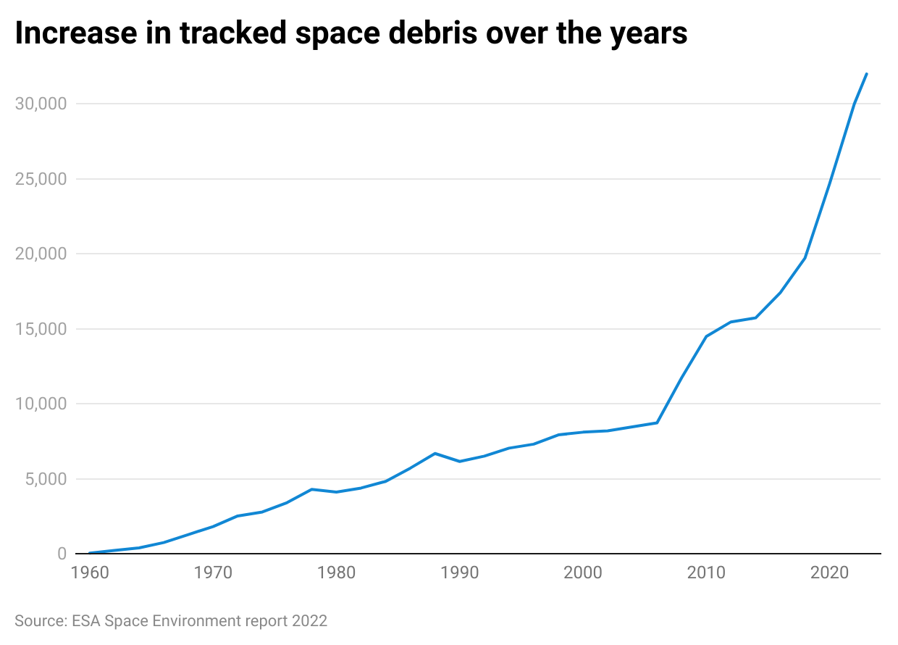

## **3. Demand for new energy and material resources**

Increasing population and limited resources on Earth have resulted in the need to find additional sources of energy and move industries that stress Earth into space. In addition, there are very valuable metals and minerals found in the large number of asteroids, planets, and moons. The era of commercial space resource extraction has begun to take shape, with NASA selecting four companies to collect lunar regoliths (Lunar Outpost, Masten Space Systems, ispace Europe, and ispace Japan). In addition, NASA’s Psyche mission, set to launch in October 2023, would investigate the metal-rich Psyche asteroid, which is estimated to be worth USD 10 quintillion (worth almost 100x the USD 105 trillion world economy as of August 2023). These developments have resulted in startups focusing on the potential off-Earth commercial mining market.

Space resources could either be used in space, for in-space refueling, etc., or they could be sent to Earth. By extracting water or ice in space and then breaking it down to hydrogen and oxygen, a combustible fuel could be produced, which could then be sold in space as a propellant for other missions. Asteroids are rich in minerals that are rare on earth with quintillion dollars worth of minerals including platinum, iron, gold, and nickel. The most valuable asteroid, Davida, is estimated to have a value of almost USD 27 quintillion. Also, Jeff Bezos, founder of Blue Origin and Amazon, believes that humans could limit pollution on Earth by moving all heavy industries and high-polluting industries to space, thereby making Earth a residential area.

# 

# **Risks to growth**

## **1. Regulations and possibility of international disputes**

The current rules of space stem from the Outer Space Treaty that was developed 50 years ago and is somewhat outdated under current scenarios, as it was not designed to deal with the high volume of space activities we currently have. The treaty requires the exploration and use of outer space to be free, in the interests of all countries, and not subject to any claim of national sovereignty. However, space is not democratic, and countries with high space funding such as the US, China, and Russia account for the most number of satellites in space, possibly taking away the opportunities of other countries that currently do not have sufficient funding. While scientific knowledge drove the first space economy, the second space economy seems to be driven by the desire for sovereignty and has become a race of private entities funded by governments investing in the commercialization of space.

Low Earth orbit is becoming critical for the placement of satellites and is based on a first come first served basis, contradicting the space treaty. Furthermore, there is no law regarding whether or not a company or nation can claim ownership over asteroids, the lunar surface, and rare metals and minerals found in space, estimated to be worth much more than the current global economy. Any international disputes are likely to have a significant impact on the activities of the private companies involved in this industry.

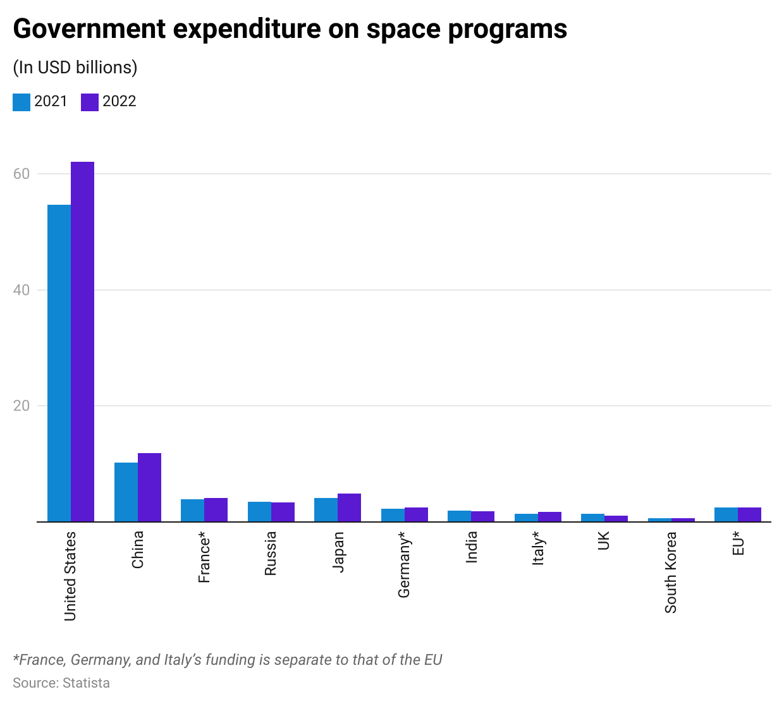

**2. Devaluation of precious metals can adversely impact the profitability of startups**

With the vast amounts of precious metals estimated in certain asteroids, space mining could flood the market with precious metals and minerals, thereby devaluing the prices of these precious metals. A situation was simulated by researchers at Tel Aviv University in which they concluded that one shipment of space minerals has the ability to devalue gold prices by 50%. While space mining involves significant costs to extract, mine, and then transport precious metals to Earth, the risk of falling precious metals and mineral prices could impact the profitability of the startups that invest in space mining.

*Last updated: October 2023*

©2024 Uzabase, Inc. All Rights Reserved. The information contained herein: (1) is proprietary to Uzabase Inc. and/or its content providers; (2) may not be copied or distributed; and (3) is not warranted to be accurate, complete or timely. Neither Uzabase Inc. nor its content providers are responsible for any damages or losses arising from any use of this information.