Smart Factory: Overview



Smart factories–the next transformation for manufacturing

Smart factories broadly refer to the fully connected and flexible production systems that leverage persistent data streams from connected manufacturing devices to learn and adapt to dynamic conditions. It represents a leap forward from traditional automation by allowing autonomous operation of entire production processes. The latest technology, including smart sensors and advanced robotics, allows next-generation interconnectivity between equipment, facilities, and processes across the value chain. IoT advances allow a new level of real-time data transmission and synthesis between smart devices and machines. The result is more efficient and agile manufacturing systems with less production downtime and better competitive advantages in the marketplace.

The smart factory concept is often discussed quite broadly across the production value chain, starting from the procurement of raw materials to the final shipment of goods. However, for the purpose of this report, we mainly focus on production and assembly as well as quality control systems. We exclude raw material sourcing and distribution solutions, as they are not related to core factory operations.

Upon carefully looking at the type of solutions provided by the startups in this space, we have identified the following segments that form the smart factory concept:

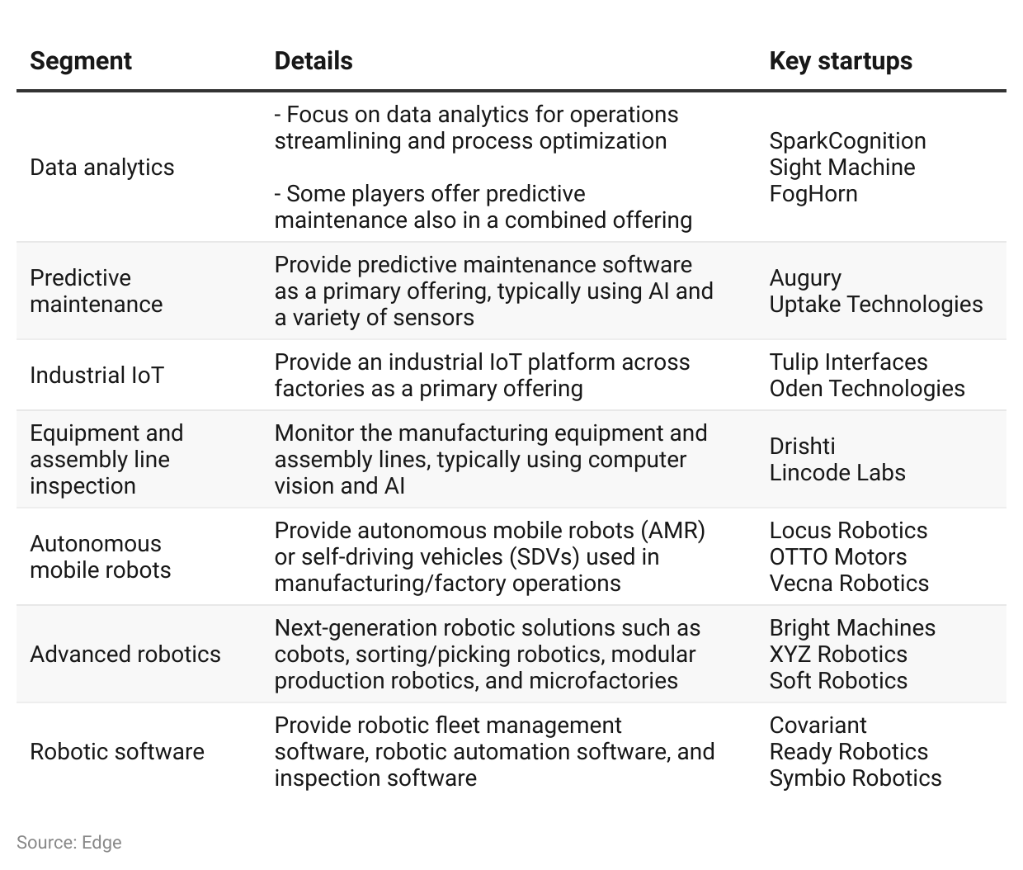

Inside the smart factory: Typical operations and activities

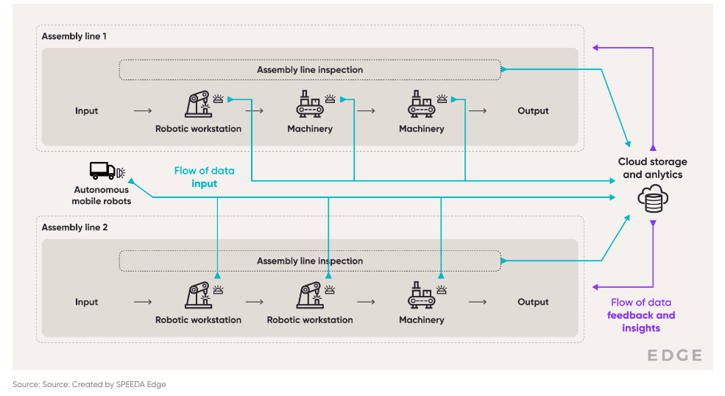

Advancements in technologies like smart sensors, AI, and edge computing are making IIoT within reach for manufacturers

The real advancement in smart factory technology lies in the fact that industrial devices can now operate within a connected network, enabling them to collect data, communicate with each other, and interface with central business systems in real time–collectively referred to as the industrial internet of things (IIoT). This has been enabled through technological advancements in several areas.

Steady improvements and cost reductions in smart sensors: Today’s sensors come with embedded algorithms and digital interfaces, granting them self-diagnosis and self-calibration capabilities (processing at the edge), therefore requiring far less human intervention. For instance, smart sensors can predict maintenance requirements based on factors like the frequencies of a machines' vibrations, changes in ambient temperatures, humidity, water and airflow, touch, and pressure.

Moreover, with the advent of new sensor technologies, it is now possible to integrate analog machines with IoT gateway devices such as cameras and gauges, thereby enabling even traditional manufacturing equipment to work as connected devices.

The cost of sensors decreasing over time also makes the technology more accessible. The average IoT sensor price has dropped by more than 3x over 2004–2021 to USD 0.41 (from USD 1.3 in 2004). These sensors have also enabled the use of technology such as the digital twin, which is employed in smart factory operations to create simulation models of factory processes.

Power of edge and cloud computation: As explained above, the intelligent sensor has the ability to not just gather information, but also analyze it (at the edge) and transmit operational commands directly to factory machinery. This eliminates the need to transmit data to a central location or local computer racks, allowing real-time decision-making. This information could then be sent to the cloud for deeper, less urgent analysis, and storage–improving the on-demand availability of data and insights.

Use of AI and machine learning: Data collected through sensors, combined with other systems like manufacturing execution systems (MESs) and enterprise resource planning (ERP), can be processed to generate insights on operations, allowing manufacturers to take proactive actions in real time–known and predictive and prescriptive analytics. Companies can gain more complicated and sophisticated insights to help them compete, save money, and meet customer needs, as systems learn over time and as data sets get bigger and more precise. With new technology advances like generative AI, manufacturers can now generate augment data sets in the form of text, images, audio, and other signals using unstructured data. This enables customers to use these data in areas in which it was not previously possible.

Improvements in connectivity: Low latency and high reliability available through the 5G network enables manufacturers to achieve data collection and analysis in real time, factory floor production reconfiguration, layout modifications, and alterations with greater flexibility, at a cheaper cost, and with shorter lead times.

Advancements in robotic capabilities and increased accessibility through subscription pricing

Another major enabler of smart factory adoption is the advancement in robotics and automation capabilities. Robots can work 24/7, reduce downtime, and increase production output. Industrial robotics has developed alongside advances in cloud computing and wider adoption of AI that enables robots to interpret their visual surroundings, gather data, manipulate objects, increase mobility, and work safely alongside humans. Together, these have made it possible to use robots across applications, from low-skill repetitive tasks to more dangerous activities such as heavy lifting.

The principal roles that robots currently take on in smart factories are shown below.

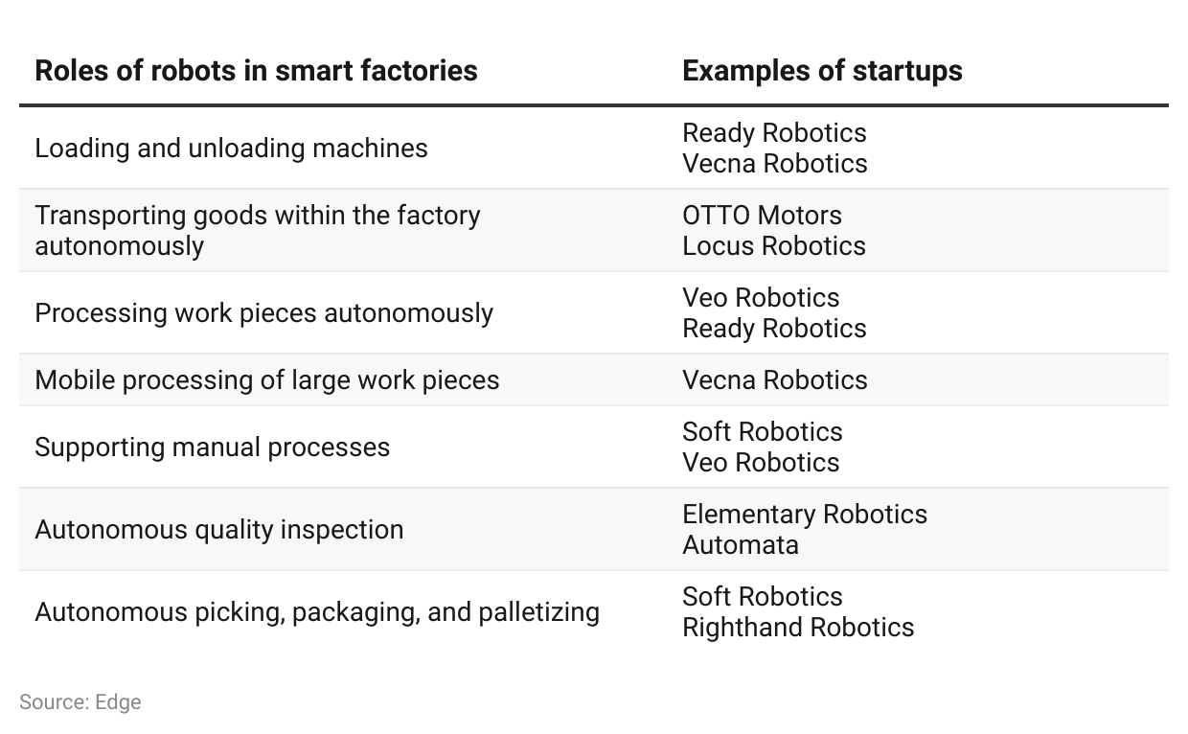

Some notable robotic technological advancements are as follows;

Improvements in robotic grasping and picking capabilities: According to the National Institute of Standards and Technology (NIST), palletizing was the most widely used robotic application in 2021 (with an adoption rate of 35% vs. 2% for assembly). The reason being that assembly requires precise gripping and sensing capabilities compared to other robotic applications. Companies like Soft Robotics have continuously engaged in developing advanced gripping capabilities–with the introduction of its mGripAI technology combining 3D vision and AI to provide traditional industrial robots with more accurate hand-eye coordination, allowing them to handle various types of products (including food) with precision.

Sensors and light detection ranging (LiDAR) to improve mobility of robots: Advancements in sensing capabilities like the use of 3D LiDAR for mobile robots have enabled them to operate fully autonomously, avoiding people, other machines, and unexpected obstructions. The 3D LiDARs offer a wide angle of view of surroundings, offering different ranges of vertical scanning angles and resolution.

Furthermore, many of these advanced robotic systems are available on a subscription basis, making them accessible to even small and mid-scale businesses without them having to incur heavy initial infrastructure costs.

Public sector support to boost smart factory tech development and adoption

Across major economies, the public sector is beginning to support smart factories with an eye toward building internationally competitive manufacturing profiles. For example, the “Manufacturing USA” initiative (launched in 2012) consists of 16 institutions that aim to accelerate manufacturing innovation and commercialization by leveraging existing resources, collaborating, and co-investing. The initiative focuses on areas like robotics manufacturing, smart sensors and digital process controls, digital manufacturing and design technologies, and energy-efficient manufacturing. A German government strategic initiative, “Industrie 4.0,” aims to increase the digitization of manufacturing and tighten the integration of products, value chains, and business models. Similarly, China, the world’s largest manufacturing economy, famously launched “Made in China 2025”, an initiative to restructure and streamline key industrial sectors by shifting to smart factories.

Driving Factors

1. Possible cost savings achieved through predictive maintenance

“The true cost of downtime 2022” report (covering the 2021–2022 period) by Senseye revealed that unplanned downtime cost Fortune global 500 companies USD 1.5 trillion annually–translating to 11% of their annual turnover. It was further reported that despite a decline in the number of incidents (20 per month in 2021–2022 compared to 26 in 2019–2020), the cost is at least 50% more due to inflation and stressed supply chains.

Senseye also estimates that adoption of predictive maintenance practices (at Fortune global 500 companies) could enable them to achieve annual savings of 1) USD 734 billion by improving productivity by 6% and 2) USD 236 million by reducing maintenance cost by 40%.

2. Shorter product life cycles and more customization

Manufacturers face multiple challenges arising from rapid technological shifts that can shorten product life cycles. Customers, meanwhile, demand bespoke products that must still be delivered more quickly and at a lower cost quarter after quarter. To adapt, factories require more efficient, flexible, and connected production systems—while also managing their bottom lines.

3. Disparity in global labor costs

Manufacturing-based economies such as Germany’s face increased competition from emerging markets due in part to access to a relatively cheap domestic labor pool. To level the playing field, smart factories are an essential option to produce better quality products while appealing to cost-conscious counterparties and consumers.

4. Labor costs versus robot costs

Rising labor costs and global trade uncertainties call for more factory automation, and increasing demands for agility and scalability demand it. At the same time, the cost of the types of robots used in advanced manufacturing has been steadily in decline. By 2025, it is estimated that automation with industrial robots would reduce labor costs in the US by more than 22%.

Risks to Growth

1. Global manufacturing industry slowdown

Geopolitical tensions with China led to slowing growth for automation in the US in 2019, with manufacturing dropping to levels not seen since the global financial crisis. In 2020, due to the Covid-19 pandemic, the IMF estimated 3.4% global manufacturing growth—just slightly above the depths of the recession a decade ago. Similarly, late 2022 and early 2023 saw declines in manufacturing outputs in the US owing to slow demand, higher borrowing costs, labor struggles, and supply chain disruptions. From May to December 2022, industrial production has declined 6x–indicating manufacturers are facing a recession.

2. Cybersecurity threats

Regardless of digital maturity, all manufacturing companies are exposed to cyber risk. However, cyberattacks can be particularly devastating for manufacturing firms as operations become increasingly automated via network connectivity and system digitization. Research published in 2020 ranked manufacturing as the industry with the highest risk of sensitive file exposure and in 2021, 44% of manufacturers were found to have 1,000+ sensitive files open to all employees, putting data at risk. For example, aerospace parts manufacturer Visser Precision recently suffered a data breach that led to client and proprietary information leaking online. Smart factories also face a potential reputational hit along with any financial losses stemming from cyberattacks that lead to data breaches and/or intellectual property theft.

Last updated: July 2023

©2024 Uzabase, Inc. All Rights Reserved. The information contained herein: (1) is proprietary to Uzabase Inc. and/or its content providers; (2) may not be copied or distributed; and (3) is not warranted to be accurate, complete or timely. Neither Uzabase Inc. nor its content providers are responsible for any damages or losses arising from any use of this information.

