# **Enterprise Blockchain: Overview**



It was around a decade ago that, with the emergence of Bitcoin, the term “blockchain” first entered the public conversation. Since then, [Cryptocurrencies](https://sp-edge.com/industry/94) have generally acted as the foundation for various novel use cases of blockchain tech. Concepts such as [Web3](https://sp-edge.com/industry/144) and [Decentralized Finance (DeFi)](https://sp-edge.com/industry/64) have become the talk of the town, each with a similar premise—moving control away from Big Tech and the big banks. Despite this, enterprises too are starting to leverage the blockchain across their own processes as the technology starts opening up new use cases for business.

Enterprise blockchains are unlocking new ways for companies to collaborate. They help to eliminate silos from disconnected supply chains and securely handle sensitive data. Blockchain and smart contracts also support companies in managing and monetizing their tangible and intangible assets. With 90% of companies in the US, UK, and China stating that they have begun to use blockchain in some capacity,, many enterprises are seeing the value in this and coming together via consortiums to fast-track adoption. However, this technology is not without its risks, which include the lack of regulation and interoperability standards. Also, to most people, blockchain and crypto are interchangeable terms, even though crypto is just one such application of blockchain technology. Furthermore, a series of recent market dips and high-profile scandals have not exactly helped enterprise confidence in the tech.

# **Full view**

## **Bringing the benefits of the blockchain to enterprises**

Enterprise blockchains work similarly to public blockchains such as Bitcoin and Ethereum. They differ in how their permission levels have been set. Unlike their permissionless counterparts, where all records on the blockchain are available to anyone, only authorized users can access the data in an enterprise blockchain.

Modern businesses use client-server architecture for their computing needs, where users store and access information through centralized servers either on the cloud or on-premise. This approach comes with a big flaw—a central point of failure. Such architecture also offers limited scalability, often operates in silos within the company, and is vulnerable to tampering. Blockchains, in contrast, are decentralized, with every member across the network having a copy of the ledger, making any unauthorized changes virtually impossible. The blockchain can also integrate with existing enterprise applications via APIs to send or receive data and complement the existing technology stack of companies.

According to research from [Blockdata](https://medium.com/technicity/how-is-blockchain-being-used-by-the-top-100-public-companies-287ef80d9e43#:~:text=According%20to%20their%20research%2C%20Of,and%20R3's%20Corda%20at%2013%25), in 2022, 77 of the top 100 public companies globally used blockchain technology in some form—this includes Microsoft, Home Depot, and Alibaba. Of the options, the open-source blockchain framework Hyperledger Fabric was the preferred solution, with a user base of 38% of the top 100 companies. Ethereum followed closely behind with 24%, and Quorum, a permissioned blockchain protocol, came in third with 17%.

**Types of enterprise blockchains**

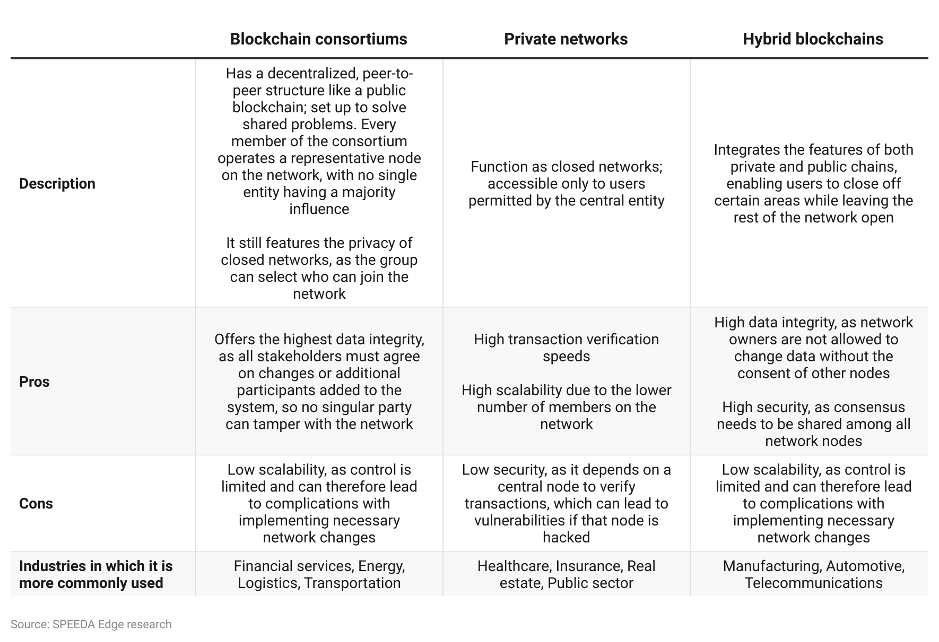

## **Consortiums are helping fast-track the adoption of enterprise blockchains**

A blockchain consortium has a decentralized, peer-to-peer structure like a public blockchain; it is set up to solve shared problems. Every member of the consortium operates a representative node on the network, with no single entity having a majority influence. Many enterprises are using blockchain consortiums to fast-track the adoption of this technology into their processes and explore use cases to solve shared problems. These consortiums also help cut down costs and the other resources needed by a single company, as the cost of developing and maintaining the infrastructure is shared by all members. While companies from the financial services industry remain the largest group, as seen by the growth of various other consortiums, other industries have begun participating as well.

**Notable blockchain consortia**

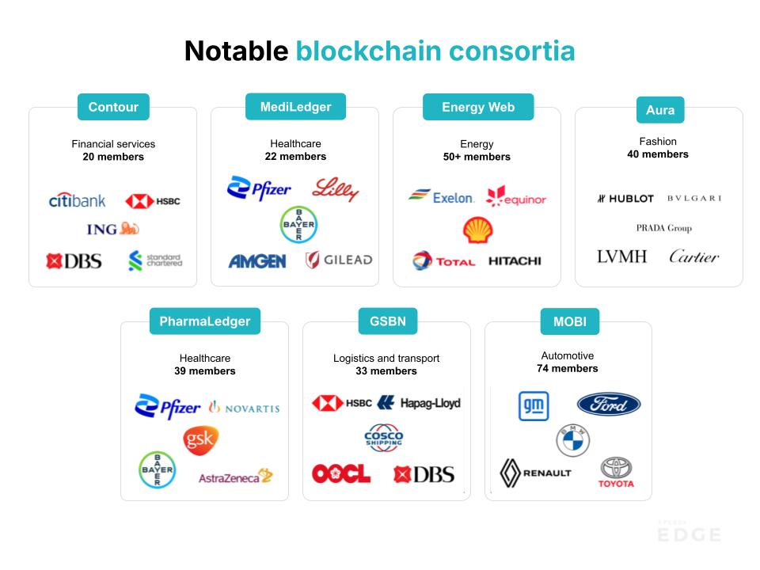

Source: Source: SPEEDA Edge research

**Notable initiatives from consortiums**

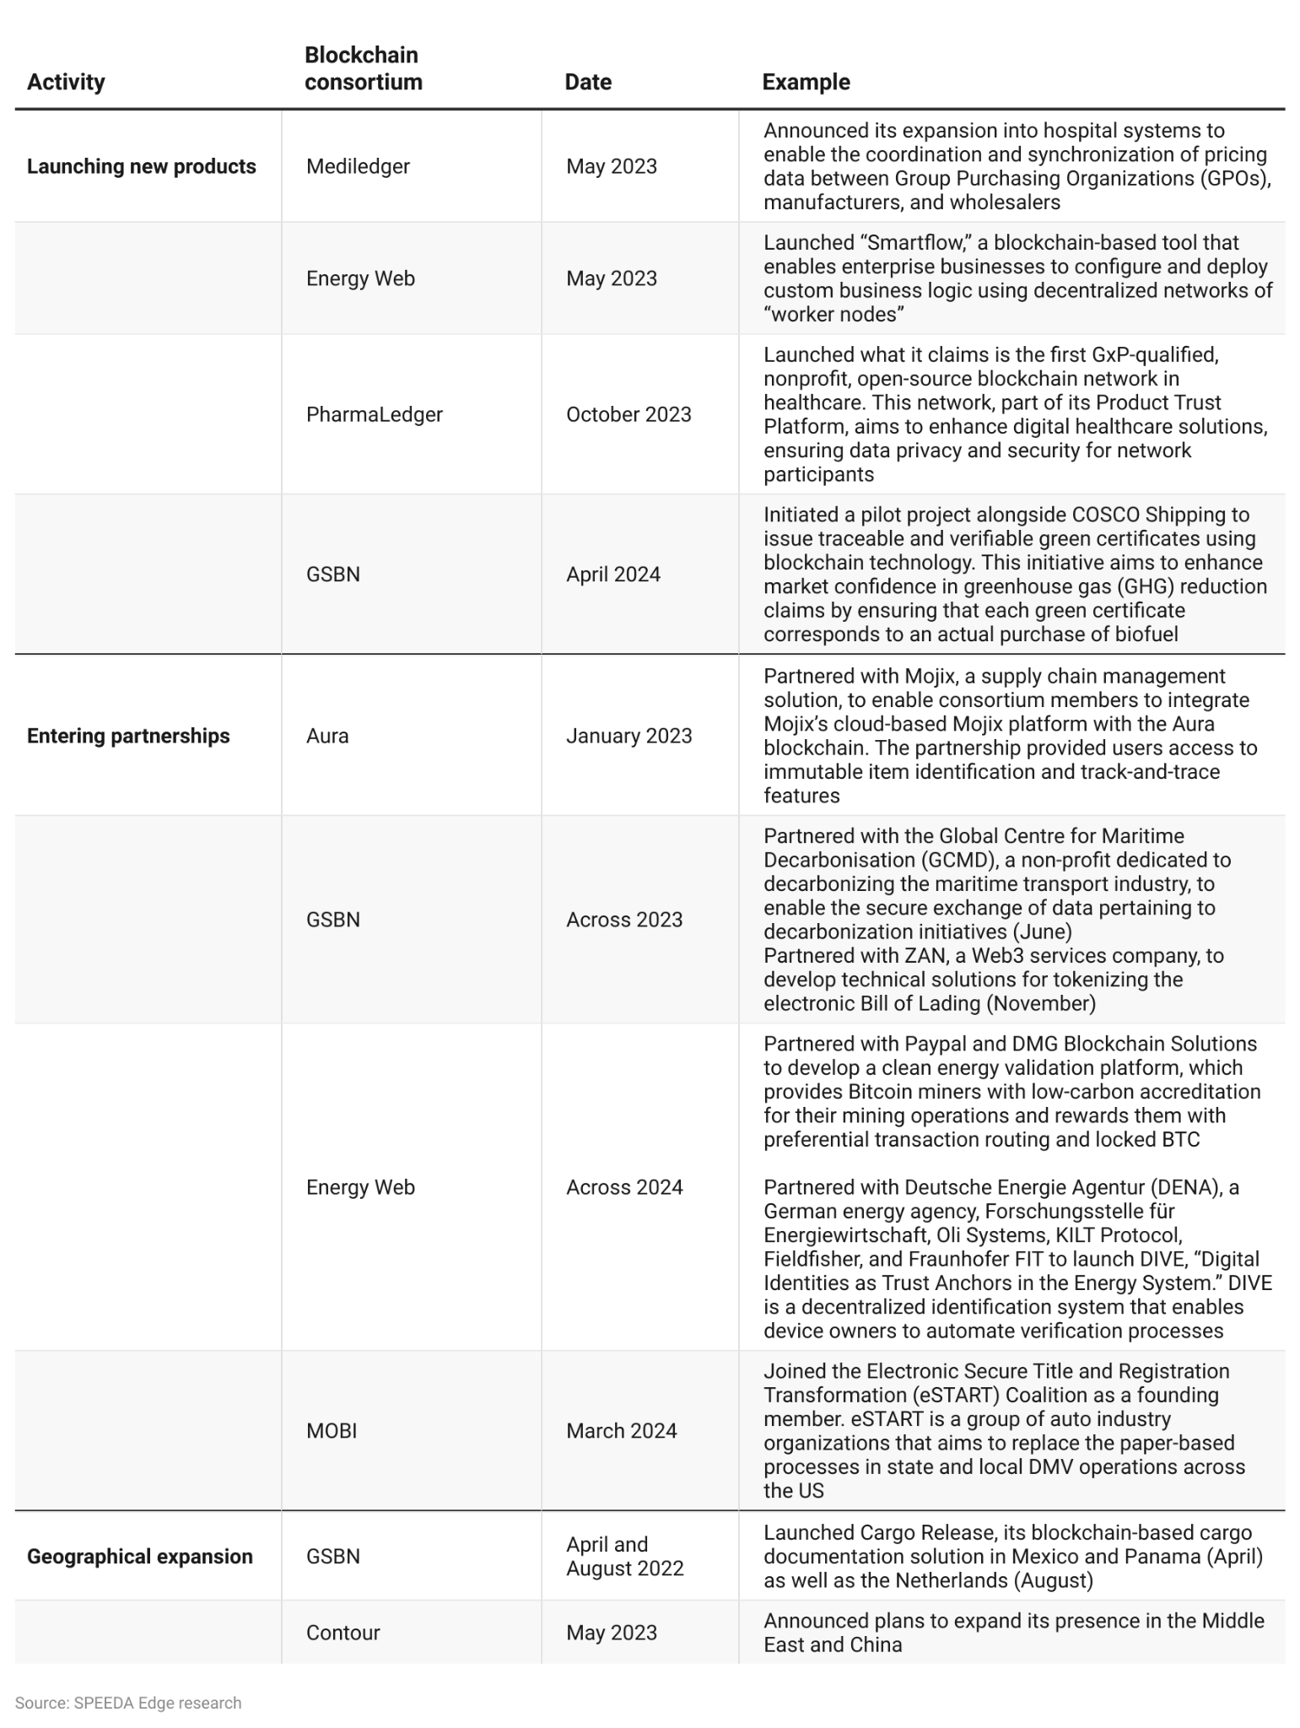

Blockchain consortiums are no silver bullet to enterprise adoption either—as seen by the shutting down of some of these consortiums in 2022. A notable closure was B3i, a 2016 initiative from insurers Aegon, Allianz, Munich Re, Swiss Re, and Zurich, which was shut down in July 2022 due to a lack of support from its members, despite promising results. Meta’s attempt to form a consortium for blockchain-based payments (Diem Network) also failed due to regulations that never let the project take off.

## **Key segments across the enterprise blockchain landscape**

Blockchains are most useful when there is a need to share data and transactions between multiple parties that may not fully trust each other and when there is a benefit from having a single source of truth that is immutable and transparent. Applications across supply chain management, IP management, hosting content, and managing databases have emerged, with blockchain-as-a-service (BaaS) providers offering enterprises a turnkey solution to kickstart their enterprise applications without needing their own blockchain infrastructure. We also observe that most of the players focus on a single use case, such as supply chain management, content delivery, or database management. Therefore, we have grouped the players (except for BaaS) by their use cases.

#### **Key segments of enterprise blockchain solutions**

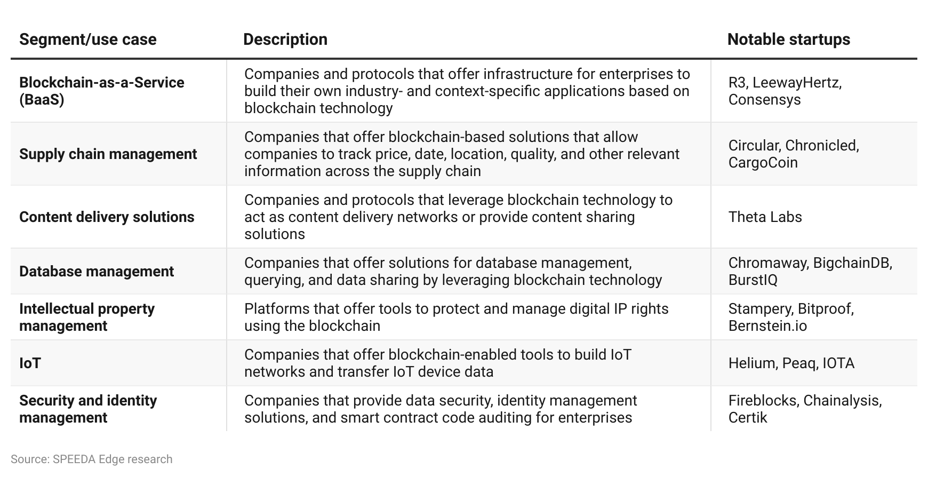

## 

## 

## **Driving factors**

1. **Blockchain solutions complement the supply chain stack by improving trust and providing real-time tracking and verification**

The supply chains of today are more complex than ever. They are global networks that include everything from manufacturers, suppliers, transport, and logistics to wholesalers and retailers. The current supply chain technology stack includes software such as enterprise resource planning systems and warehouse management systems, along with hardware such as radio-frequency identification (RFID) scanners and IoT devices along each step. Often, these technologies aren’t interoperable, resulting in data silos, which lead to poor visibility on products and shipments across the chain and other operational challenges such as inaccurate supply and demand forecasts, high costs due to wastage, errors and fraud, and, ultimately, lower customer satisfaction. This is further evidenced by a [McKinsey survey](https://www.mckinsey.com/capabilities/operations/our-insights/taking-the-pulse-of-shifting-supply-chains) (August 2022), which found that 45% of respondents stated they “either have no visibility into their upstream supply chain or that they can see only as far as their first-tier suppliers.”

The blockchain complements the current supply chain stack by storing data such as product information, quality certificates, transaction records, and any raw data directly from connected devices, with smart contracts helping enforce rules and automate transactions. The immutable nature of the blockchain means any data recorded cannot be changed or deleted, helping build trust between the different parties. The blockchain also offers participants the ability to track the product across the supply chain in real time and independently verify transactions as well as track a product's provenance to confirm authenticity.

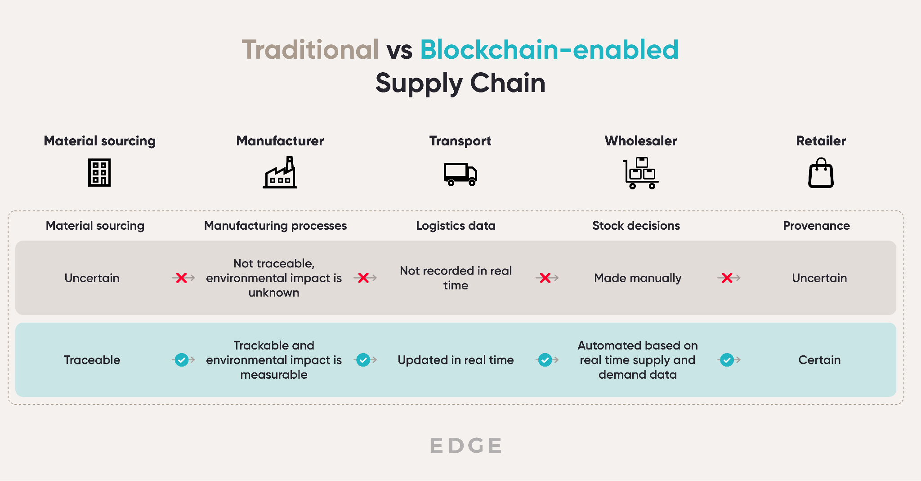

Source:SPEEDA Edge research

Furthermore, the complexity of modern supply chains means that it is increasingly unlikely for centralized systems integrators and end-to-end supply chain management solutions to meet all the requirements of potential users. With only 25% of supply-chain leaders in 2021 reporting that they “felt their objectives are aligned with the incentives of their systems integrators,” it's clear that the best approach for digital transformation of modern supply chains is a combination of solutions from different providers and integrators. This can be difficult when customers are limited to the functionality and interoperability of the specific centralized platform of choice. This is where the programmability of blockchain can enable enterprises to build on top of solutions and create value across different functions of their supply chain instead of being locked into one vendor.

Companies are seeing the value the blockchain brings, with brands such as [Home Depot](https://www.ibm.com/case-studies/the-home-depot/), [Honeywell Aerospace](https://blog.bigchaindb.com/ares-tech-and-bigchaindb-collaborate-for-blockchain-gaming-use-cases-5c0d0733beca), and [Prada Group](https://www.pradagroup.com/en/news-media/news-section/aura-saas-luxury-brands.html) all adopting the technology in some form in their supply chains. Industry adoption is also expected to keep growing. This is also supported by a [PwC study](https://www.pwc.com/gx/en/news-room/press-releases/2020/blockchain-boost-global-economy-track-trace-trust.html#:~:text=The%20analysis%20suggests%20a%20tipping%20point%20in%202025,COVID-19%20pandemic%2C%20has%20the%20largest%20economic%20potential%20%28US%24962bn%29.) that predicts that blockchain’s ability to track provenance will contribute USD 962 billion to global GDP from 2020 to 2030.

1. **Blockchain technology offers a cheaper and safer alternative to building and maintaining centralized physical infrastructure networks**

With the number of connected Internet-of-Things (IoT) devices across the globe increasing to over 15.9 billion in 2023, the need for effective infrastructure management has become more important than ever. However, existing centralized physical infrastructure networks often suffer from a number of risks, such as data privacy leakage, service disruptions, and the substantial costs of network expansion.

This was evidenced by the July 2024 global IT outage caused by cybersecurity giant [CrowdStrike](https://sp-edge.com/companies/75532), which paralyzed critical industries and drove the digital world to a halt in a matter of hours due to a faulty update. With an estimated 8.5 million worldwide devices running on Windows succumbing to the dreaded “blue screen of death” (BSOD), this event showcased the dangers of relying on these centralized systems with single points of failure.

Blockchain technology provides enterprises with an alternative to this type of network architecture through the use of “Decentralized Physical Infrastructure Networks” (DePIN). These networks decentralize the control and ownership of real-world physical infrastructure, enabling enterprises to create applications for hardware interconnectivity and executing complex transactions. Contributors can receive financial compensation and an ownership stake in the networks they support via digital tokens, while enterprises and end users benefit from the security and privacy provided by blockchain technology.

**Centralized vs. decentralized network architecture**

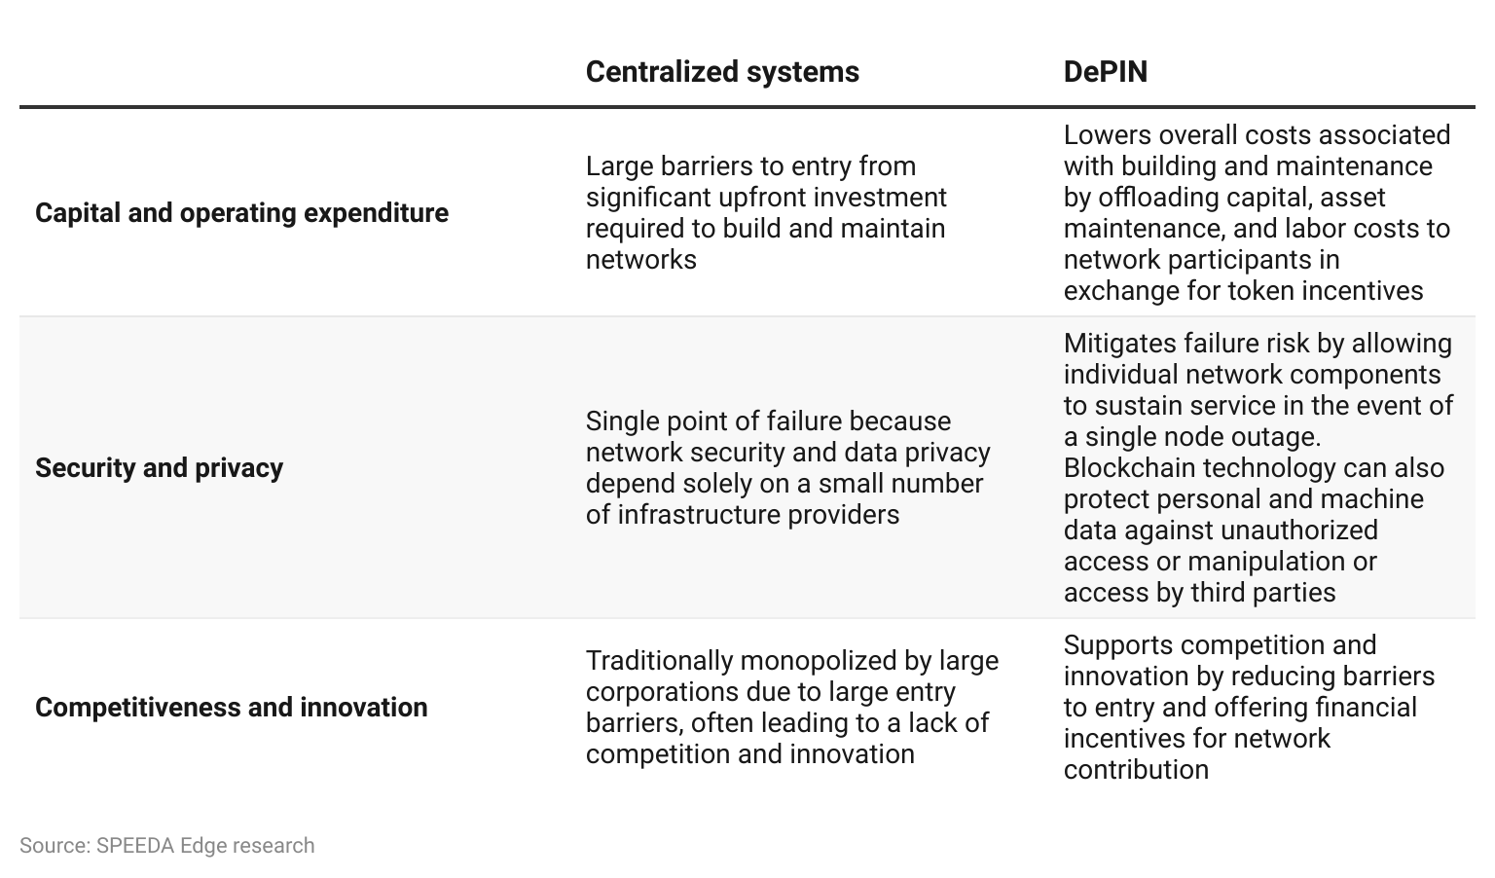

DePINs have the potential to disrupt a range of large industries such as energy, wireless, compute, AI services, and IoT. For example, they can be used to power energy systems for peer-to-peer renewable energy trading, telecommunications networks for internet access, and even transportation for decentralized mobility.

These opportunities have not gone unnoticed; the segment has seen an influx of investor interest over the course of 2024. Enterprise-focused DePIN infrastructure startups like [Uplink](https://sp-edge.com/companies/2368178), [IoTeX](https://sp-edge.com/companies/622489), and [Peaq](https://sp-edge.com/companies/1092307), raised USD 10 million, [USD 50 million](https://sp-edge.com/updates/28177), and [USD 15 million](https://sp-edge.com/updates/27962), respectively, over the course of March and April. Moreover, in July 2024, the total market cap of DePIN projects rose to USD 24.4 billion with over 17.6 million connected devices. While these numbers may seem large, they only represent a small fraction of the total market (less than 1% of the total number of connected devices mentioned above). Therefore, there is also a high potential for further growth within the segment.

1. **Data breaches can be costly; blockchain can unlock new means of data sharing and identity management for enterprises**

In addition to eliminating data silos in the supply chain, the blockchain can aid with overall data management for the enterprise. The technology’s immutability characteristics make it ideal for managing master data such as records on employees, customers, and suppliers, as accidental loss of such information can be catastrophic for a business. According to IBM, the average total cost of a data breach was [USD 4.5 million](https://www.ibm.com/reports/data-breach) in 2023.

Moreover, the permissioned architecture of the blockchain and cryptographic methods, such as zero-knowledge proofs, allow enterprises to verify transactions and identities without knowledge of the underlying sensitive information. This also allows for secure sharing and processing of sensitive data while remaining compliant with privacy regulations such as the GDPR and CCPA or even industry-specific rules such as HIPAA.

Enterprises can take data security a step further by implementing decentralized IDs (DIDs) to replace traditional, centralized identity mechanisms that rely on a single point of storage and can be prone to hacks and fraud. A DID does not depend on a specific service provider and allows organizations to issue and verify credentials and documents in seconds compared to traditional processes that could take weeks. Enterprises can also store less user information as a result of a DID, helping reduce the risk of data breaches. DID technology can be applied across a range of use cases such as banking KYC processes, government ID issuing, healthcare data management, and social media.

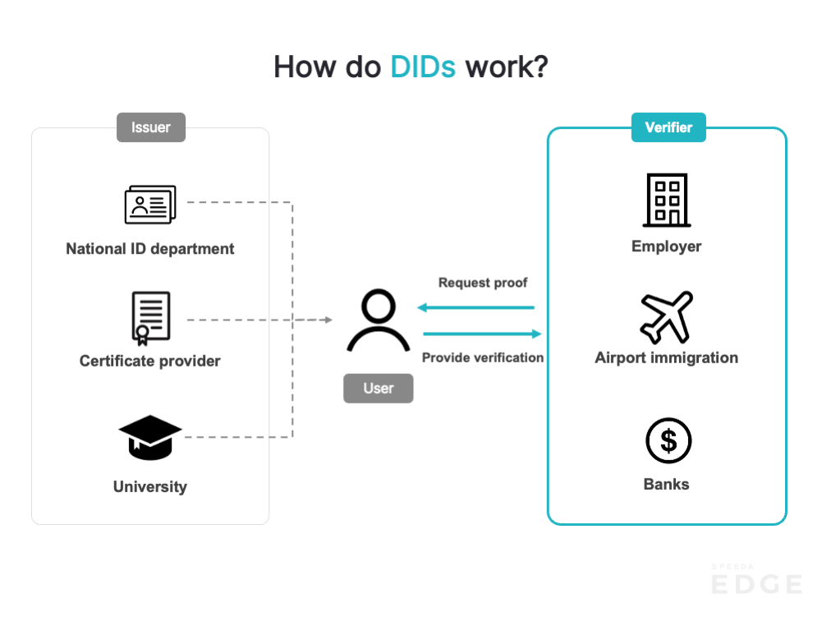Source: SPEEDA Edge research

Large incumbents have already begun applying this technology via dedicated identity management software products. For example, [Microsoft](https://sp-edge.com/companies/201465) started its work on a decentralized identity scheme in 2017 with its “Azure Active Directory” platform, and has been gradually developing the infrastructure over the past few years. Based on the Bitcoin blockchain, the system uses an open-source protocol called Sidetree to add identity verifications to the blockchain. Organizations can run their own nodes to verify and store identifiers for their users without Microsoft having any direct access to user data.

1. **Smart contracts can cause efficiencies in business transactions with high potential in IP management**

Originally introduced with the Ethereum blockchain, smart contracts are programs that are stored on the blockchain that run automatically when a certain criterion is met. In an enterprise context, using smart contracts can help improve efficiency and transparency in transactions by reducing paperwork and the need for manual processing as well as streamlining the approval flow.

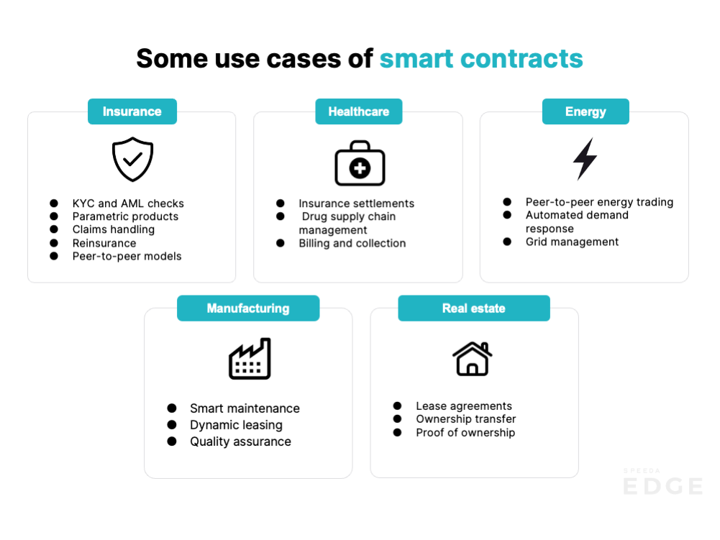

Source: SPEEDA Edge research

Annual costs from IP losses in the US range between USD 225 billion and USD 600 billion in 2021. Enterprises with IP can use the blockchain to record and manage their IP rights and use smart contracts to generate royalties from those who use their innovations (similar to how royalties work on secondary NFT sales within the [Creator Economy](https://sp-edge.com/industry/42)). IP marketplaces like IPwe are addressing the USD 1 trillion problem of IP underutilization by helping companies monetize their IP using “patent NFTs” and smart contracts that offer transaction automation and digital rights management. While IPwe’s digital asset platform is based on [Casper Labs’](https://sp-edge.com/companies/756579) private blockchain, solutions such as [Bernstein](https://sp-edge.com/companies/440980) are also leveraging the public Bitcoin blockchain to record and generate the needed documentation to enforce IP rights on trade secrets, trademarks, copyrights, and more.

The asset management capabilities of the blockchain are not limited to just IP and digital rights. Other asset classes such as real estate or private financial instruments can be [tokenized](https://sp-edge.com/insights/6443), allowing companies to generate liquidity from otherwise illiquid business assets. Furthermore, non-transferable digital tokens called “soulbound tokens” (SBT) have recently emerged as an extension of decentralized identity. They can enable users to represent social identity that can store various types of information that make up a person or entity, such as education history, medical records, work experience, and membership status.

## 

## **Risks to growth**

1. **Poor public image of blockchain tech due to cryptocurrency volatility**

In 2022, the cryptocurrency landscape saw a massive market crash, which caused a massive loss of faith, with many investors exiting the market. With over USD 2 trillion wiped from market value, the impact of this collapse can also be seen across the rest of the blockchain landscape. Since then, a number of decentralized lending platforms and cryptocurrency exchanges also fell victim to poor market conditions, hacks, and misappropriation of funds. These include Blockfi, Celsius, and, most notably, FTX, all of which shut down operations or went bankrupt. With 54% of respondents stating that they still see “blockchain” and “crypto” as interchangeable terms in a [poll conducted by Casper Labs](https://www.globenewswire.com/en/news-release/2023/01/12/2588247/0/en/Casper-Labs-Unveils-2023-Enterprise-Blockchain-Report-Revealing-Widespread-Interest-in-Blockchain-Adoption-Despite-Persistent-Knowledge-Gaps.html) (a BaaS company), it is imperative that the enterprise blockchain industry educates potential users on the distinction between the two applications.

**Price of Bitcoin**



The enterprise blockchain industry has also seen its fair share of the failure and shutdown of a number of projects such as Microsoft's own Azure BaaS platform in June 2021 and ShipChain in December 2020. Although these shutdowns weren’t tied to market conditions, they can have a significant impact on enterprises' willingness for adoption, with studies indicating that perceived technological volatility had a significantly negative impact on an organization's intent to adopt blockchain technology. The perception was that the constant evolution of blockchain tech was a barrier to adoption, with organizations stating that they felt there was a risk of investing in one blockchain, only to have it be replaced or become defunct.

1. **Benefits of enterprise blockchains unclear compared to more established, traditional alternatives**

While hybrid solutions that combine public and private blockchains have been shown the most interest from enterprises, many users don't want to reveal proprietary information such as order numbers, inventory levels, prices, and margins to unknown participants. Enterprises that are unwilling to give up control and trust third-party collaborators could potentially favor centralized decentralized environments (CeDe) over completely decentralized blockchains. CeDe solutions can help blockchain innovations work with safeguards like KYC, custodial services, fraud detection, and escrow services.

However, existing cloud-based supply chain management solutions already combine central databases and analytical tools to offer supply chain visualization at scale. These solutions offer high levels of control and can record transactions or store data faster than blockchain currently can while also following standardized compliance practices such as Standard Occupational Classification (SOC) and General Data Protection Regulation (GDPR).

With private blockchains costing up to USD 1,500 per month and 15%–25% of overall project cost going into the maintenance of the network, centralized cloud solutions could also offer a comparative advantage in terms of cost and deployment options. Cloud-based solutions can be easier to deploy because they do not require extensive customization or collaboration with other parties. They also offer greater flexibility and scalability by allowing users to adjust their usage and capacity according to their needs. Therefore, the benefits for companies that opt for blockchain solutions over cloud-based tools remain unclear.

1. **Interoperability standards lagging behind innovation**

In spite of the growing use cases of the technology, the lack of a predefined standard that governs how different chains communicate with each other is severely limiting the ability of enterprises to exchange data and assets across networks. For example, a shipping company that uses Hyperledger Fabric has no way of sharing information with a retail outlet store that uses R3’s Corda to manage its inventories.

While certain industry groups such as Hyperledger and Enterprise Ethereum Alliance have already begun taking steps to define standards to enable interoperability, it remains unclear as to when this will meaningfully impact the rate of adoption due to the complex nature of the technology and the vast landscape of offerings. For further penetration, service providers will need to provide solutions to this growing concern to justify the cost of implementing blockchain technology for their users.

1. **Regulatory clarity needed to promote adoption**

The distributed nature of the blockchain also presents a challenge for regulators to establish jurisdiction and establish rules around data storage and sharing. Unlike decentralized applications such as cryptocurrencies and DeFi, which have thrived off of the absence of any regulatory oversight, enterprise blockchain solutions require it for adoption on a global scale. Even though the blockchain has proven to be a useful medium to share sensitive data while retaining privacy, its immutable nature has become a cause of conflict with other provisions of the GDPR, specifically the right to amend or delete user information. While alternatives such as deleting private keys have been proposed, regulatory clarity is needed to ensure these techniques fulfill the erasure requirements in order to encourage more adoption.

## 

*Last updated: July 2024*

©2024 Uzabase, Inc. All Rights Reserved. The information contained herein: (1) is proprietary to Uzabase Inc. and/or its content providers; (2) may not be copied or distributed; and (3) is not warranted to be accurate, complete or timely. Neither Uzabase Inc. nor its content providers are responsible for any damages or losses arising from any use of this information.