# **Telehealth: Overview**



## **Affordable healthcare delivered remotely**

Telehealth is not a new phenomenon; video consultations, for example, have been used starting as early as the 2000s with the emergence of online video and chat tools like Skype. Companies like Teladoc, Amwell, and MDLive were the frontrunners in this early phase of telehealth.

The industry started to gain momentum by the early- to mid-2010s. [One study](https://jamanetwork.com/journals/jama/fullarticle/2716547) found that telehealth visits among the members of a leading health plan in the US increased at a compound annual growth rate (CAGR) of 261% from 2015 to 2017, which was significantly higher than the 52% CAGR reported over 2005-2014.

### **Remote service delivery is the common factor among different telehealth models**

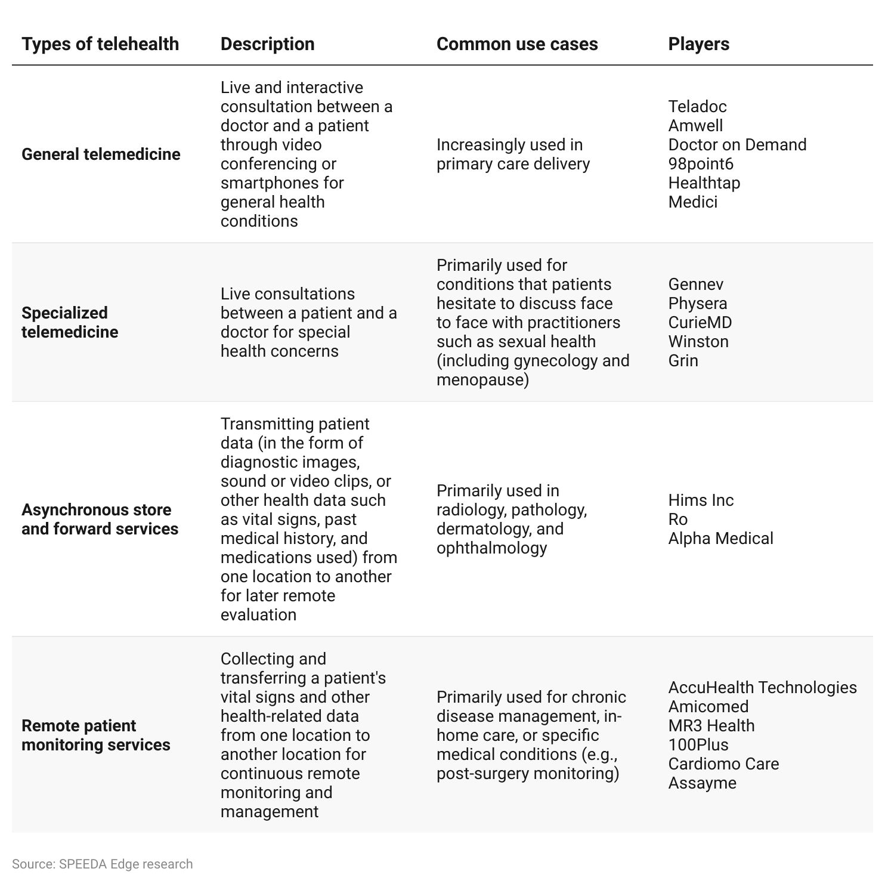

### 

### **Portable diagnostic tools, declining cost of ultrasound devices, AI, and smartphones bring telehealth into the mainstream**

The key enablers of telehealth can be summarized as follows.

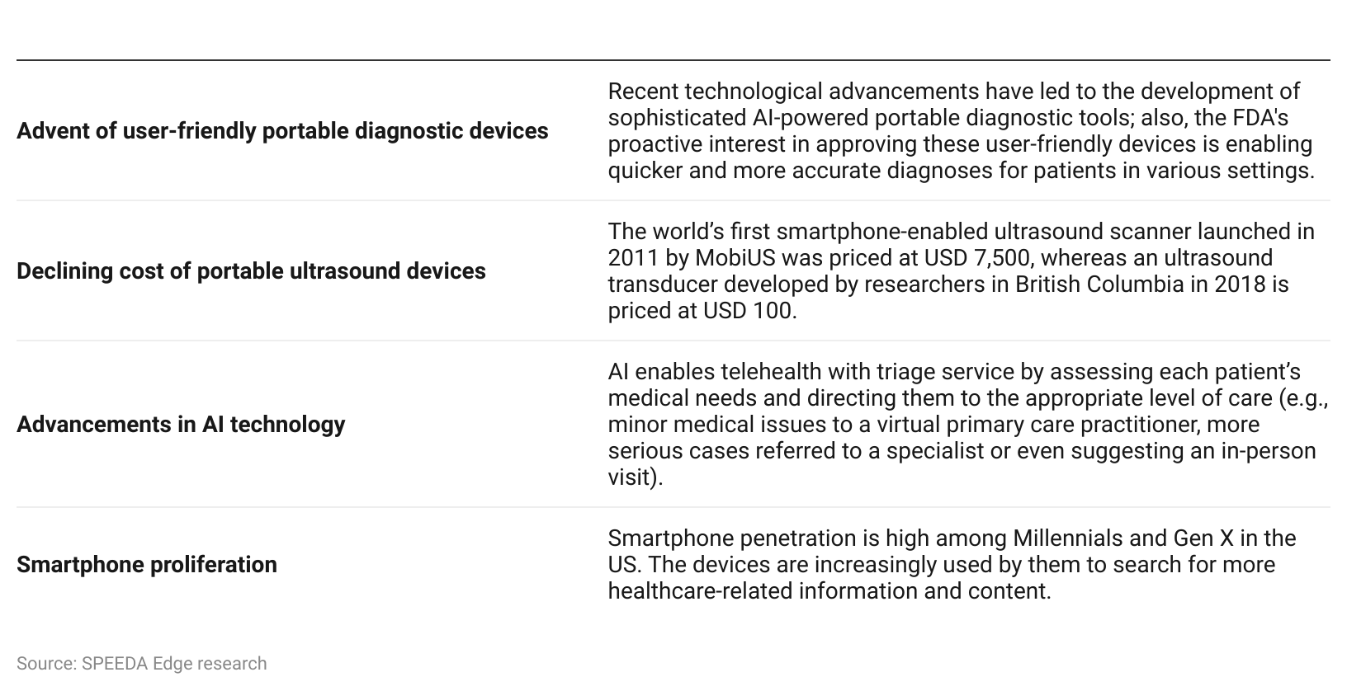

### 

### 

### **Subscription and pricing structure**

Many telehealth players use a hybrid approach, consisting of business-to-business (B2B) and business-to-consumer (B2C) channels. Through the B2B channel, a telehealth company forms partnerships with employers, hospitals, and insurance plans to cover the partners’ respective clients. Such partnerships enable the telehealth players to establish long-term relationships and have access to a huge user base, thereby providing a long-term recurring revenue stream. On the other hand, through the B2C channel, services are directly offered to patients who usually do not have insurance coverage.

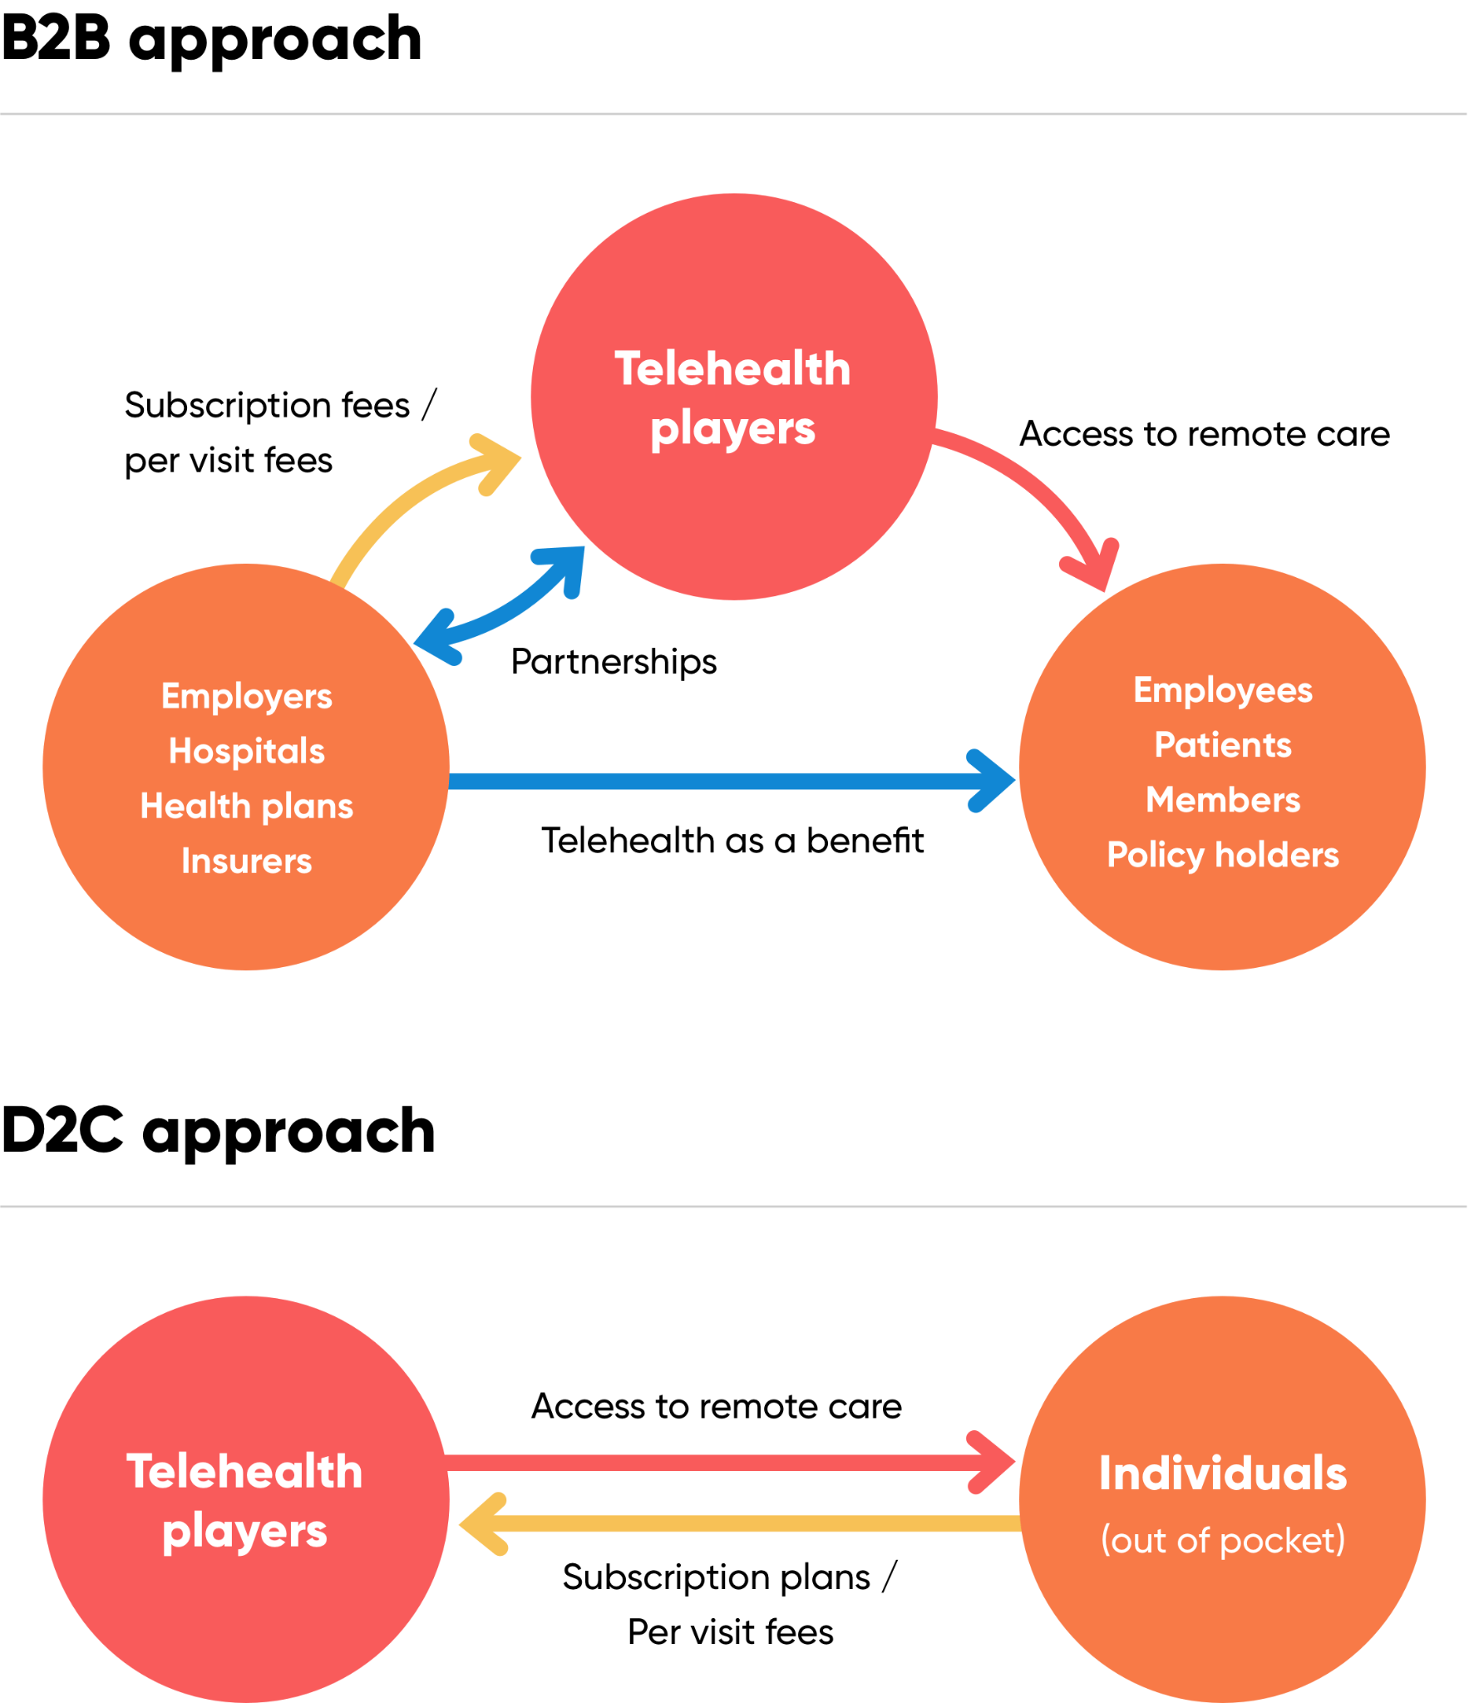

Source: SPEEDA Edge research

In the B2B channel, telehealth providers commonly adopt the subscription model. However, in some instances, per-visit arrangements are made available to clients. For example, Teladoc predominantly uses subscription plans but also has some contracts on a per-visit basis. In practice, companies could also seek contracts that would entail higher subscription fees with unlimited visits or lower subscription fees with additional per-visit fees.

### 

### **B2B revenue impact from different pricing models**

As for B2C channels, per-visit fees are the common pricing model (e.g., Doctor on Demand charges per-visit fees only), while subscription plans (annual or monthly) are used by some companies (e.g., Healthtap has a monthly subscription plan). The visit fees vary substantially depending on the specialty involved. Basic primary care consultations usually cost less than specialized services like telepsychiatry.

# **Driving factors**

## **1. Surging healthcare costs create a demand for affordable services**

According to [Federal data](https://www.reuters.com/business/healthcare-pharmaceuticals/us-healthcare-spending-rises-48-trillion-2023-outpacing-gdp-2024-06-12/), healthcare spending was estimated to have risen 7.5% YoY in 2023. The average spend per person on healthcare per year was estimated to be USD 14,423 in 2023 and is estimated to increase to USD 15,074 in 2024. Patients historically have also favored using emergency room care over preventive healthcare, either due to lack of insurance coverage or lack of access, [resulting in strains on the healthcare system](https://www.fiercehealthcare.com/payer/two-thirds-ed-visits-avoidable#:~:text=UnitedHealth%3A%20Healthcare%20could%20save%20%2432B%20annually%20by%20diverting%20avoidable%20ED%20visits,-by%20Jacqueline%20Renfrow&text=The%20cost%20is%20even%2010,primary%20care%20or%20urgent%20care.), further driving costs.

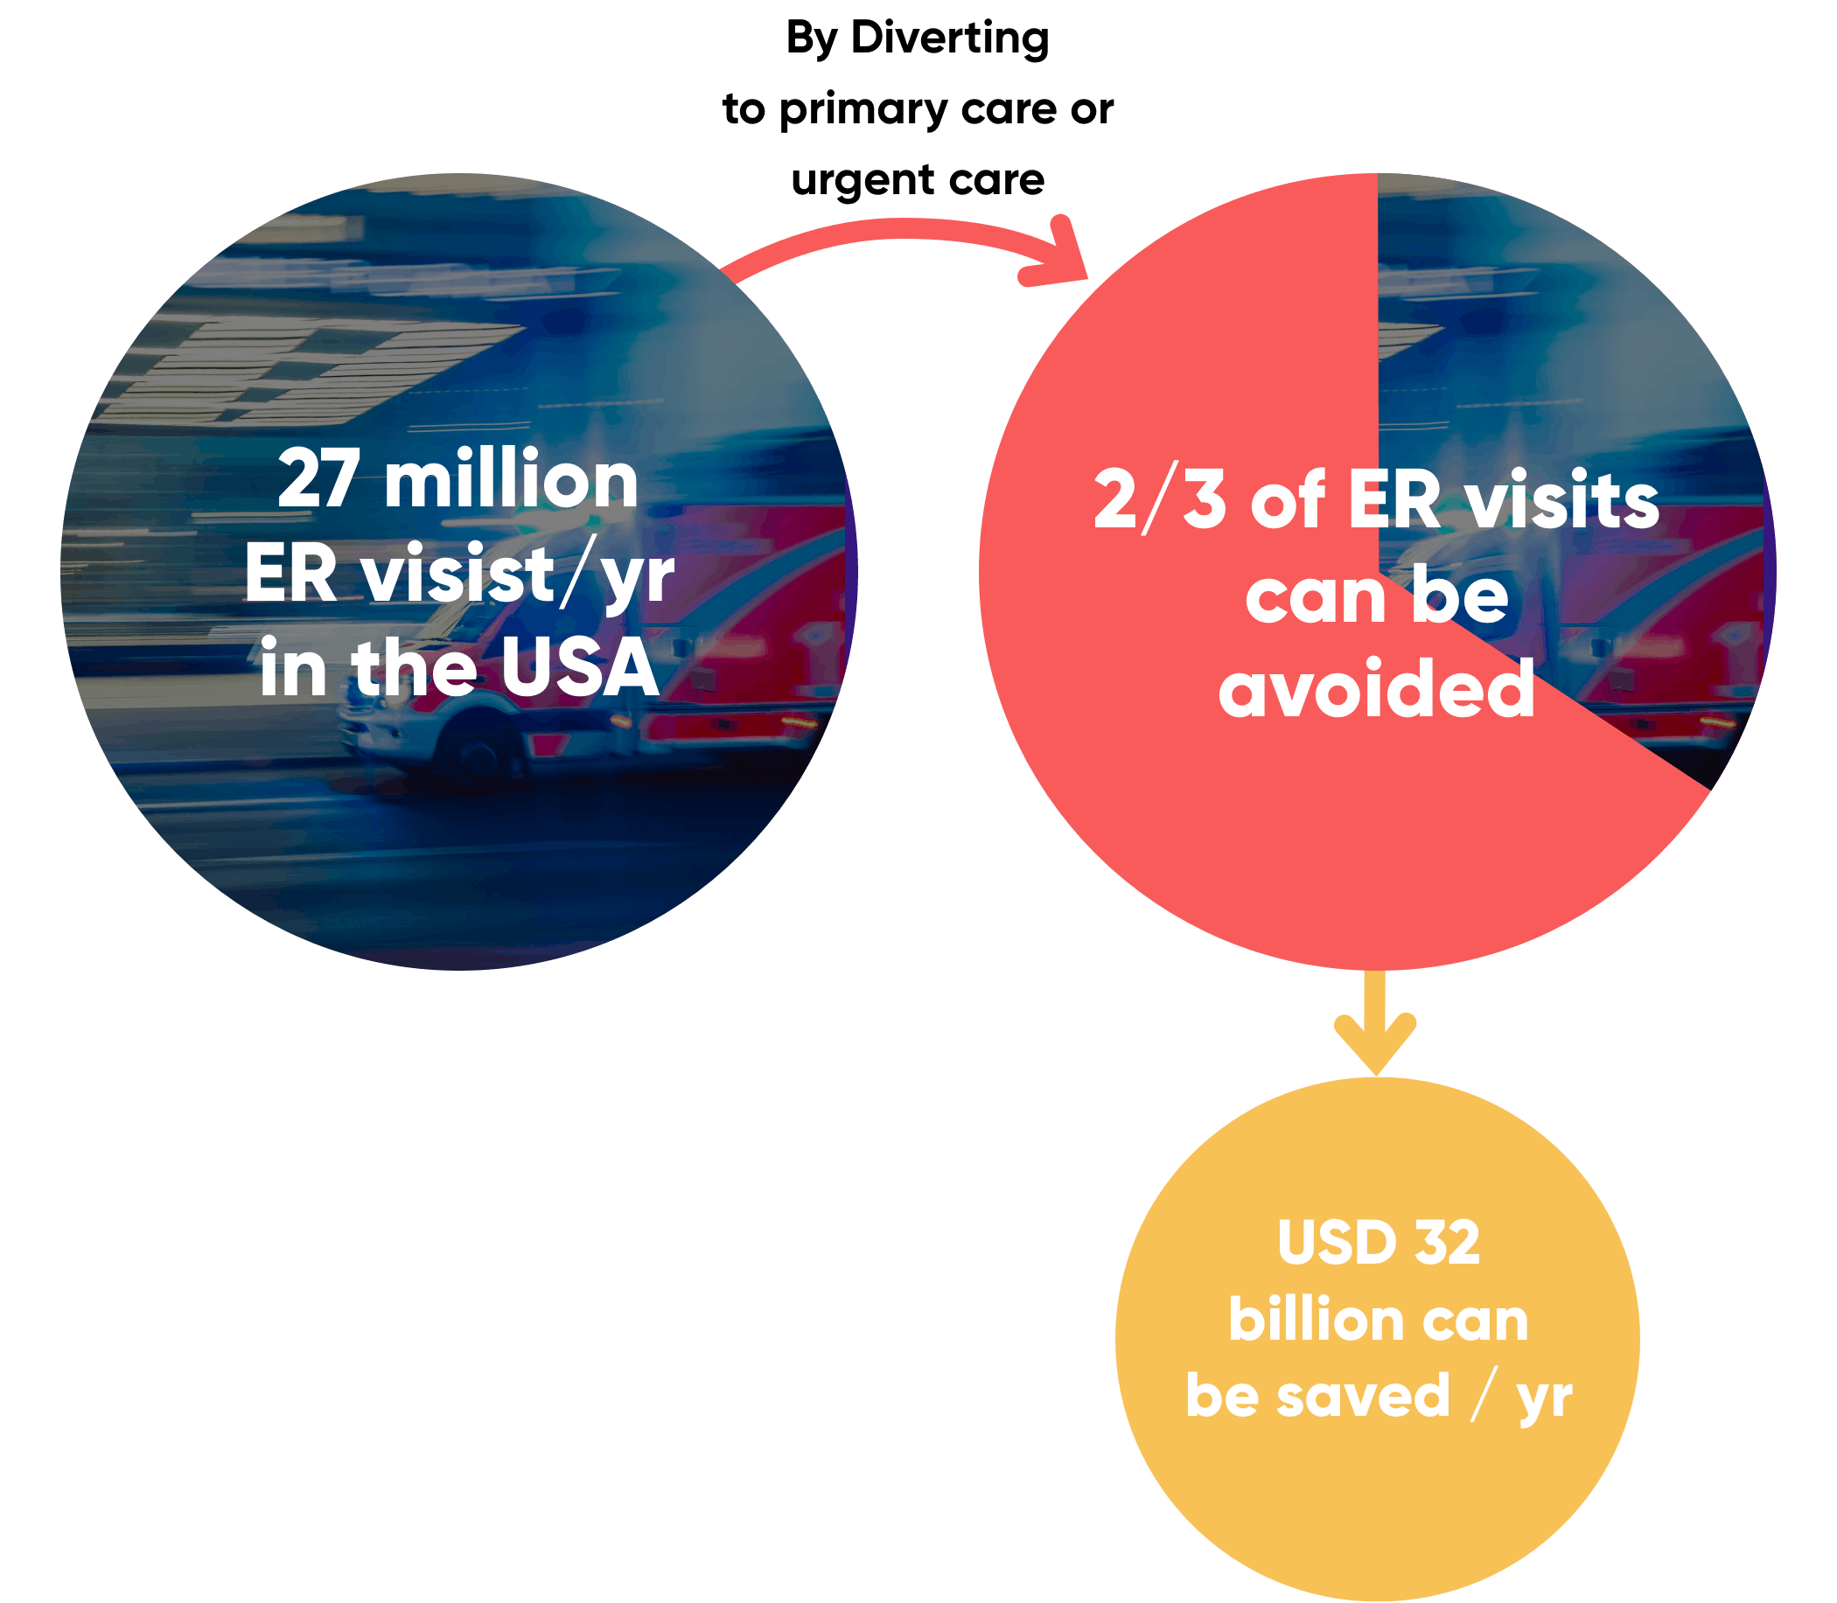

As a result of higher spending requirements and higher costs, patients end up skipping scheduled visits for [even routine healthcare needs](https://www.ama-assn.org/practice-management/digital/how-telemedicine-helped-health-system-s-patients-avoid-ed). A report published in 2023 noted that [more than a third of insured Americans skipped a healthcare visit](https://www.managedhealthcareexecutive.com/view/more-than-a-third-of-americans-have-skipped-a-healthcare-visit-due-to-inability-to-pay) within the last year due to financial reasons. For uninsured Americans, this was high as 83%. One way to alleviate this is via telemedicine consultations. A study carried out by the [American Medical Association in 2019](https://www.ama-assn.org/practice-management/digital/how-telemedicine-helped-health-system-s-patients-avoid-ed) estimated that patients and their payers can save considerably through telemedicine by avoiding costly and unnecessary trips to the doctor’s office or hospital.

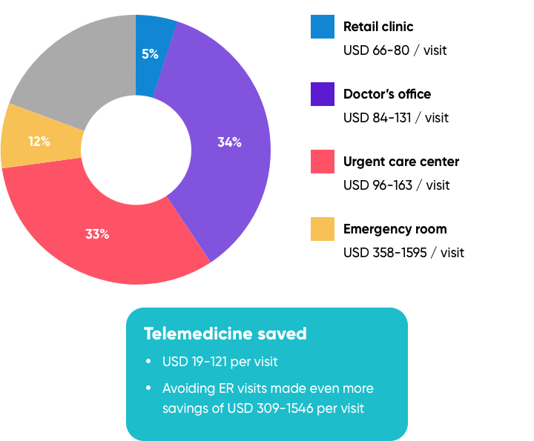

*Note: These percentages reflect the breakdown of the visit options that would have been done by the respondents in the absence of telemedicine*

Source: SPEEDA Edge research

High healthcare costs have major implications for the quality of healthcare delivery in the country. A study carried out in 2022 found that nearly 40% of American adults have either skipped care or put off attending to a medical need in the past year due to cost. The survey also revealed that participants felt that the main problem driving healthcare costs was the rate of inflation, which is noted to be the highest it has been in over 40 years.

Ever-increasing healthcare benefit costs are forcing employers to adopt various cost management initiatives as well. Many employers now prefer telehealth as a cost-effective healthcare benefit for their employees.

### **Telehealth increasingly gaining prominence among employes**

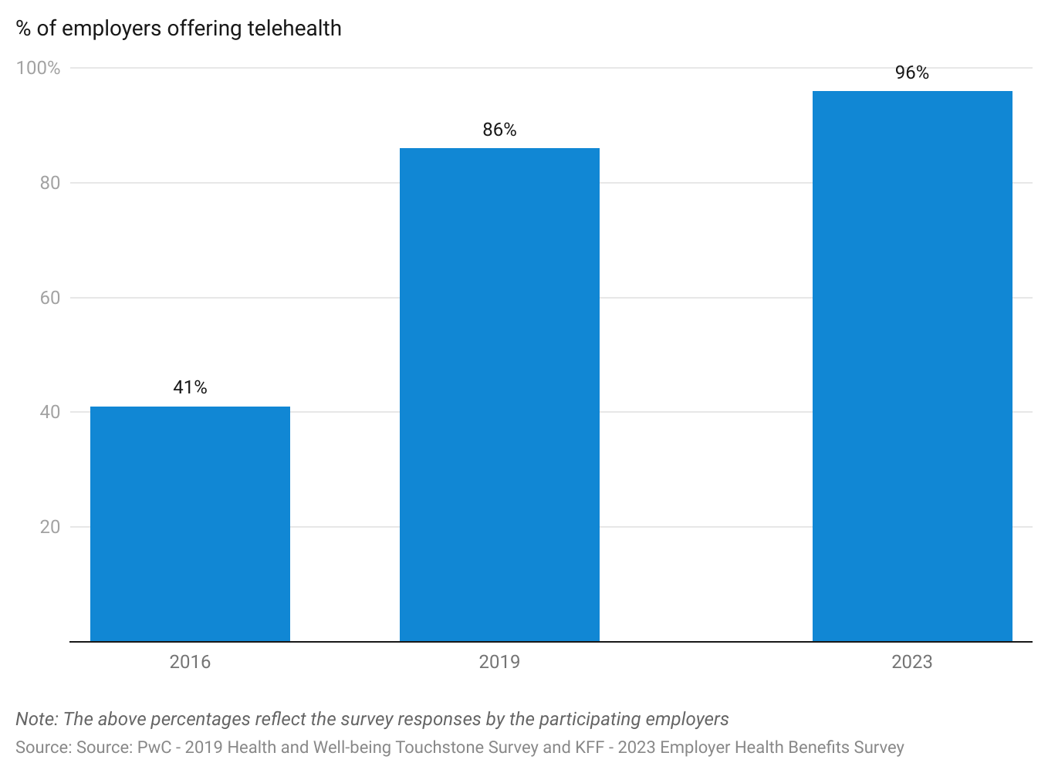

## 

## **2. Long commutes and lengthy wait times give rise to the need for improved and efficient access to healthcare**

The frequent long commute and routine lengthy wait time for a doctor’s appointment has been a major impediment to the provision of quality healthcare in the US. The expansion of health insurance coverage with the Affordable Care Act (ACA) [has increased the number of patients covered](https://www.americanprogress.org/article/10-ways-aca-improved-health-care-past-decade/), which has resulted in a greater demand for a limited pool of doctors, further increasing waiting times.

### **Healthcare services has the longest travelling and waiting time**

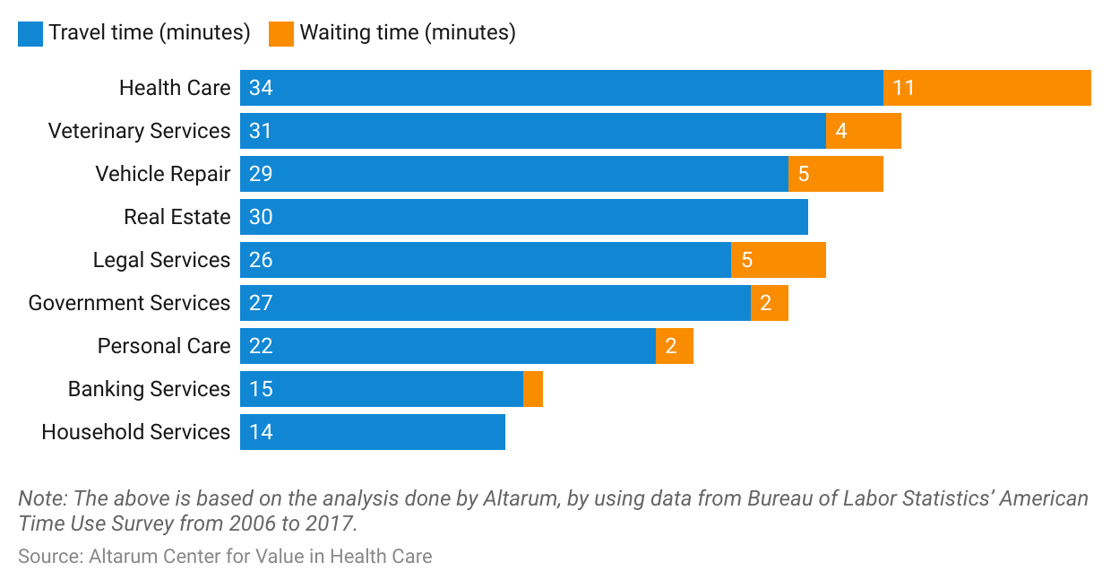

The wait time for appointments has become an important gauge of quality in healthcare delivery. A survey found that around [one-third](https://www.jotform.com/blog/doctors-office-waiting-room-survey/) of patients have walked out from an appointment citing the wait was too long. In this context, telehealth significantly reduces the wait time to see a doctor. As of [March 2023](https://www.everlywell.com/blog/virtual-care/how-long-to-wait-for-a-telehealth-appointment/?srsltid=AfmBOoq8bLX2ZCYV3VnuOzKblmAGPHRA-B2bWquL57Isy-gVrsutFZiU), it was found that telehealth appointments take an average of [13 and 15 minutes to complete](https://www.crossrivertherapy.com/research/telehealth-statistics) compared to the average of 36 minutes when seeing a doctor in person: a [wait time of 18 minutes](https://www.everlywell.com/blog/virtual-care/how-long-to-wait-for-a-telehealth-appointment/?srsltid=AfmBOoq8bLX2ZCYV3VnuOzKblmAGPHRA-B2bWquL57Isy-gVrsutFZiU) and an average consult time of another [18 minutes](https://jamanetwork.com/journals/jama-health-forum/fullarticle/2802144#:~:text=Time%20is%20a%20scarce%20and,average%20visit%20lasting%2018%20minutes.).

## 

## **3. Millennials’ lifestyle preferences create demand for more convenient, affordable, and speedy services**

American youth and young adults (mainly Millennials) are [increasingly demanding a new kind of healthcare system](https://www.accenture.com/us-en/insights/health/todays-consumers-reveal-future-healthcare) that suits their preferences for affordability and faster service. Often, people in these age groups view a physical visit to a doctor as a waste of time. Therefore, telehealth has become a natural choice for this demographic and is complementary to their tech-savviness and lifestyle preferences.

## 

## **4. Government policies implemented to support telehealth during the pandemic have led to increased demand**

The US government implemented sweeping regulatory changes to promote telehealth as a way of addressing social distancing requirements necessitated by the impacts of Covid-19. One important measure was [expanding the scope of telehealth for Medicare beneficiaries](https://www.healthaffairs.org/content/forefront/early-impact-cms-expansion-medicare-telehealth-during-covid-19), which resulted in patients being able to use the convenience of telehealth for their healthcare needs. This was a major change from Medicare’s prior stance, where telehealth was offered to Medicare beneficiaries with restrictions where telehealth reimbursements were limited to specified geographies (e.g., rural areas) and specific locations (e.g., a beneficiary needs to be present in an institutional setting like a rural health clinic or a nursing home). Moreover, the [government relaxed HIPAA privacy rules](https://www.forbes.com/sites/joeharpaz/2020/05/04/5-reasons-why-telehealth-here-to-stay-covid19/#66ed39d153fb) for telehealth platforms, which now enable using any standard video conferencing apps such as Zoom or Skype for telehealth services.

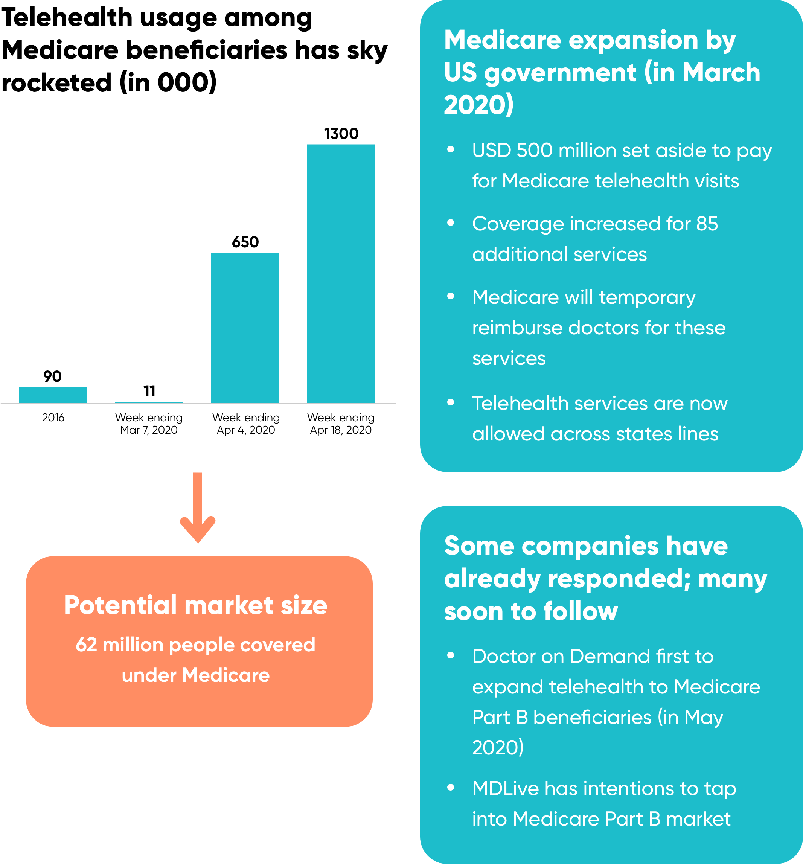

Source: SPEEDA Edge research

# 

# **Risks to growth**

## **1. Lack of uniform state telehealth policies may hinder nationwide telehealth expansion**

Over the years, a lack of telehealth reimbursement parity laws, differences in physician licensing regulations, and other regulatory requirements among the states have been key impediments to growth in the telehealth industry. Often, it can be found that policy guidelines tend to differ for site-of-service requirements, types of technology to use, whether private insurance is allowed for reimbursement, and other circumstances. Even though most states have taken measures to promote telehealth lately—and the recent Covid-19 outbreak stimulated the regulators to relax many of the suppressive telehealth-related policies, at least temporarily—progress remains to be made to create consistency among regulatory and policy players.

## **2. High cost of implementing telehealth discourages adoption by small practices**

The high cost of implementing telehealth infrastructure discourages small practices from adopting telehealth services. Considerable investment is needed, particularly in IT infrastructure, to mitigate cyberattacks and comply with HIPAA regulations to ensure patient confidentiality. Nevertheless, the US government’s temporary relaxation of HIPAA regulations to promote telehealth in the wake of the Covid-19 pandemic (e.g., allowing the use of non-compliant video tools) was a welcome sign. Additionally, in [September 2024](https://sp-edge.com/updates/33784), the House Committee on Energy and Commerce unanimously passed the Telehealth Modernization Act of 2024, improving access to telehealth services for non-English speakers and rural Americans, extending audio-only coverage for those with limited broadband access, and allowing hospitals to provide inpatient care at home. However, while US regulators appear to be continuing to support the industry, whether they will continue to support measures that will lower the costs of adoption of telehealth remains a question.

*Last updated: August 2024*

©2024 Uzabase, Inc. All Rights Reserved. The information contained herein: (1) is proprietary to Uzabase Inc. and/or its content providers; (2) may not be copied or distributed; and (3) is not warranted to be accurate, complete or timely. Neither Uzabase Inc. nor its content providers are responsible for any damages or losses arising from any use of this information.