# **Telehealth: Overview**



## **Affordable healthcare delivered remotely**

Telehealth is not a new phenomenon; video consultations, for example, have been used starting as early as the 2000s with the emergence of online video and chat tools like Skype. Companies like Teladoc, Amwell, and MDLive were the frontrunners in this early phase of telehealth. The industry started to gain momentum by the early- to mid-2010s. One study found that telehealth visits among the members of a leading health plan in the US increased at a compound annual growth rate (CAGR) of 261% from 2015 to 2017, which was significantly higher than the 52% CAGR reported over 2005-2014.

### **Remote service delivery is the common factor among different telehealth models**

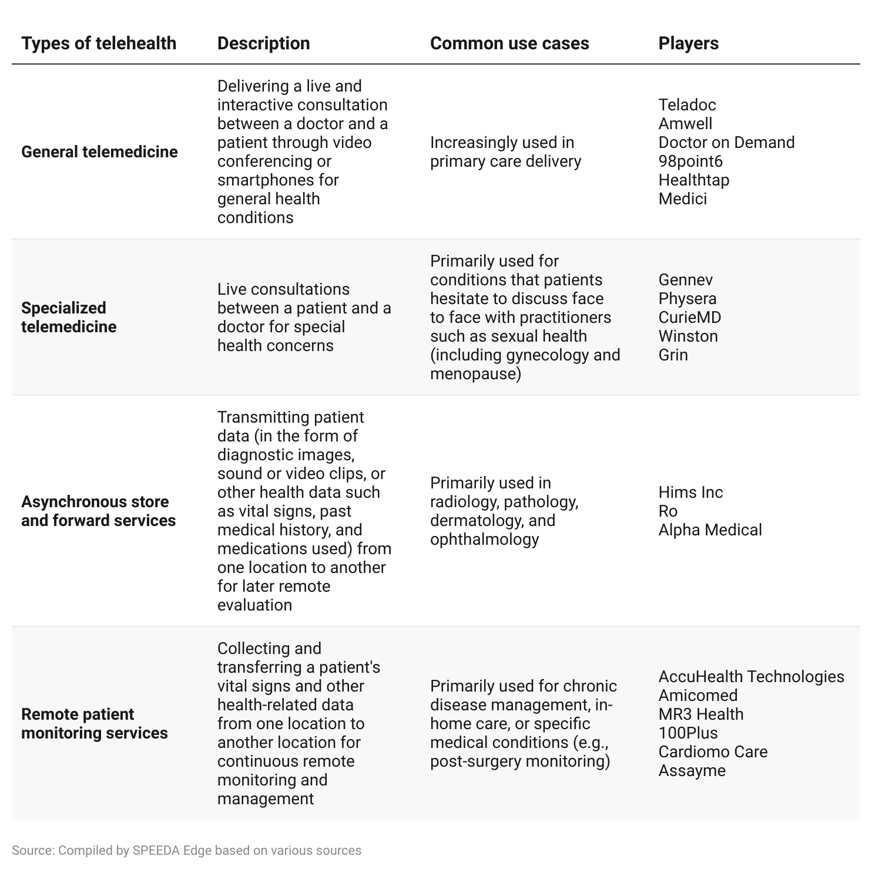

### 

### **Portable diagnostic tools, declining cost of ultrasound devices, AI, and smartphones bring telehealth into the mainstream**

The key enablers of telehealth can be summarized as follows.

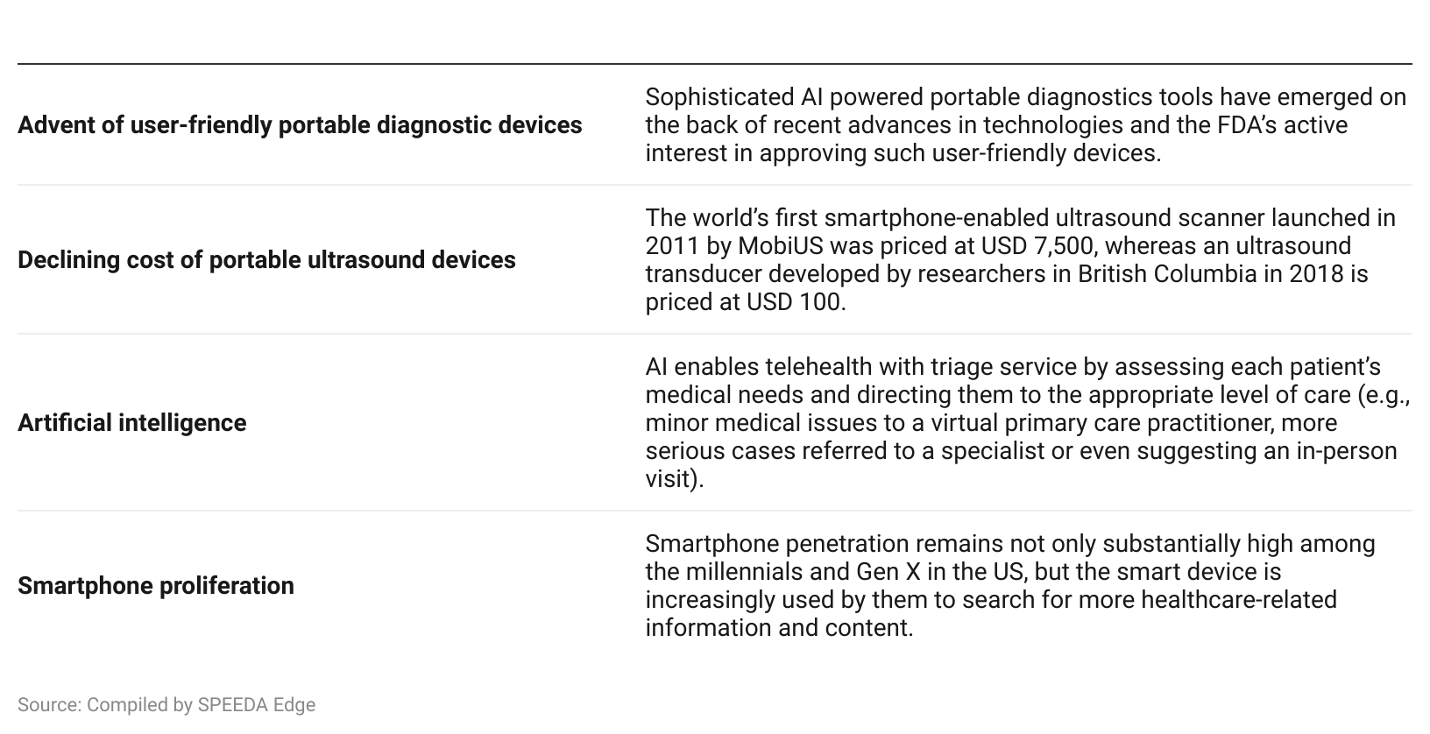

### 

### 

### **Subscription and pricing structure**

Many telehealth players use a hybrid approach, consisting of both business-to-business (B2B) and business-to-consumer (B2C) channels. Through the B2B channel, a company forms partnerships with employers, hospitals, and insurance plans to cover partners’ respective clients. Such partnerships enable the telehealth players to establish long-term relationships and have access to a huge user base, thereby providing a long-term recurring revenue stream. Through the B2C channel, services are directly offered to patients who don’t have insurance coverage.

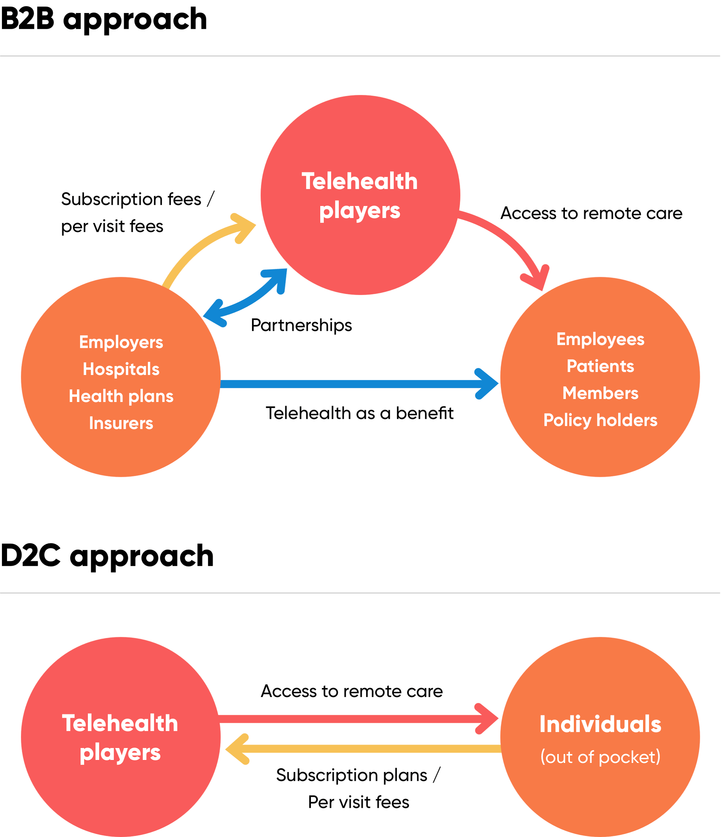

Source: Compiled by SPEEDA Edge

The pricing methods used are subscription fees and per visit fees in both B2B and B2C channels. While subscription plans (e.g., per member, per month [PMPM]) are more common in the B2B channel, in some instances per visit arrangements are also offered for some B2B clients. For example, Teladoc predominantly uses subscription plans but also has some contracts on a per visit basis. This means the company has contracts with higher PMPM fees with unlimited visits as well as lower PMPM fees with additional per visit fees.

### 

### **B2B revenue impact from different pricing models**

As for B2C channels, per visit fees are the common pricing model (e.g., Doctor on Demand charges per visit fees only), while subscription plans (annual or monthly) are used by some companies (e.g., Healthtap has a monthly subscription plan). The visit fees vary substantially depending on the nature of the specialty involved. Basic primary care consultations usually cost lower than those specialized services like telepsychiatry.

# **Driving factors**

## **1. Surging healthcare costs create a demand for affordable services**

A major contributor to the rising cost of healthcare is often cyclical: Patients are deterred from seeking preventative care due to high cost or lack of insurance coverage and often opt for emergency room care, driving up the number of unnecessary emergency room visits, which are costly for the healthcare system.

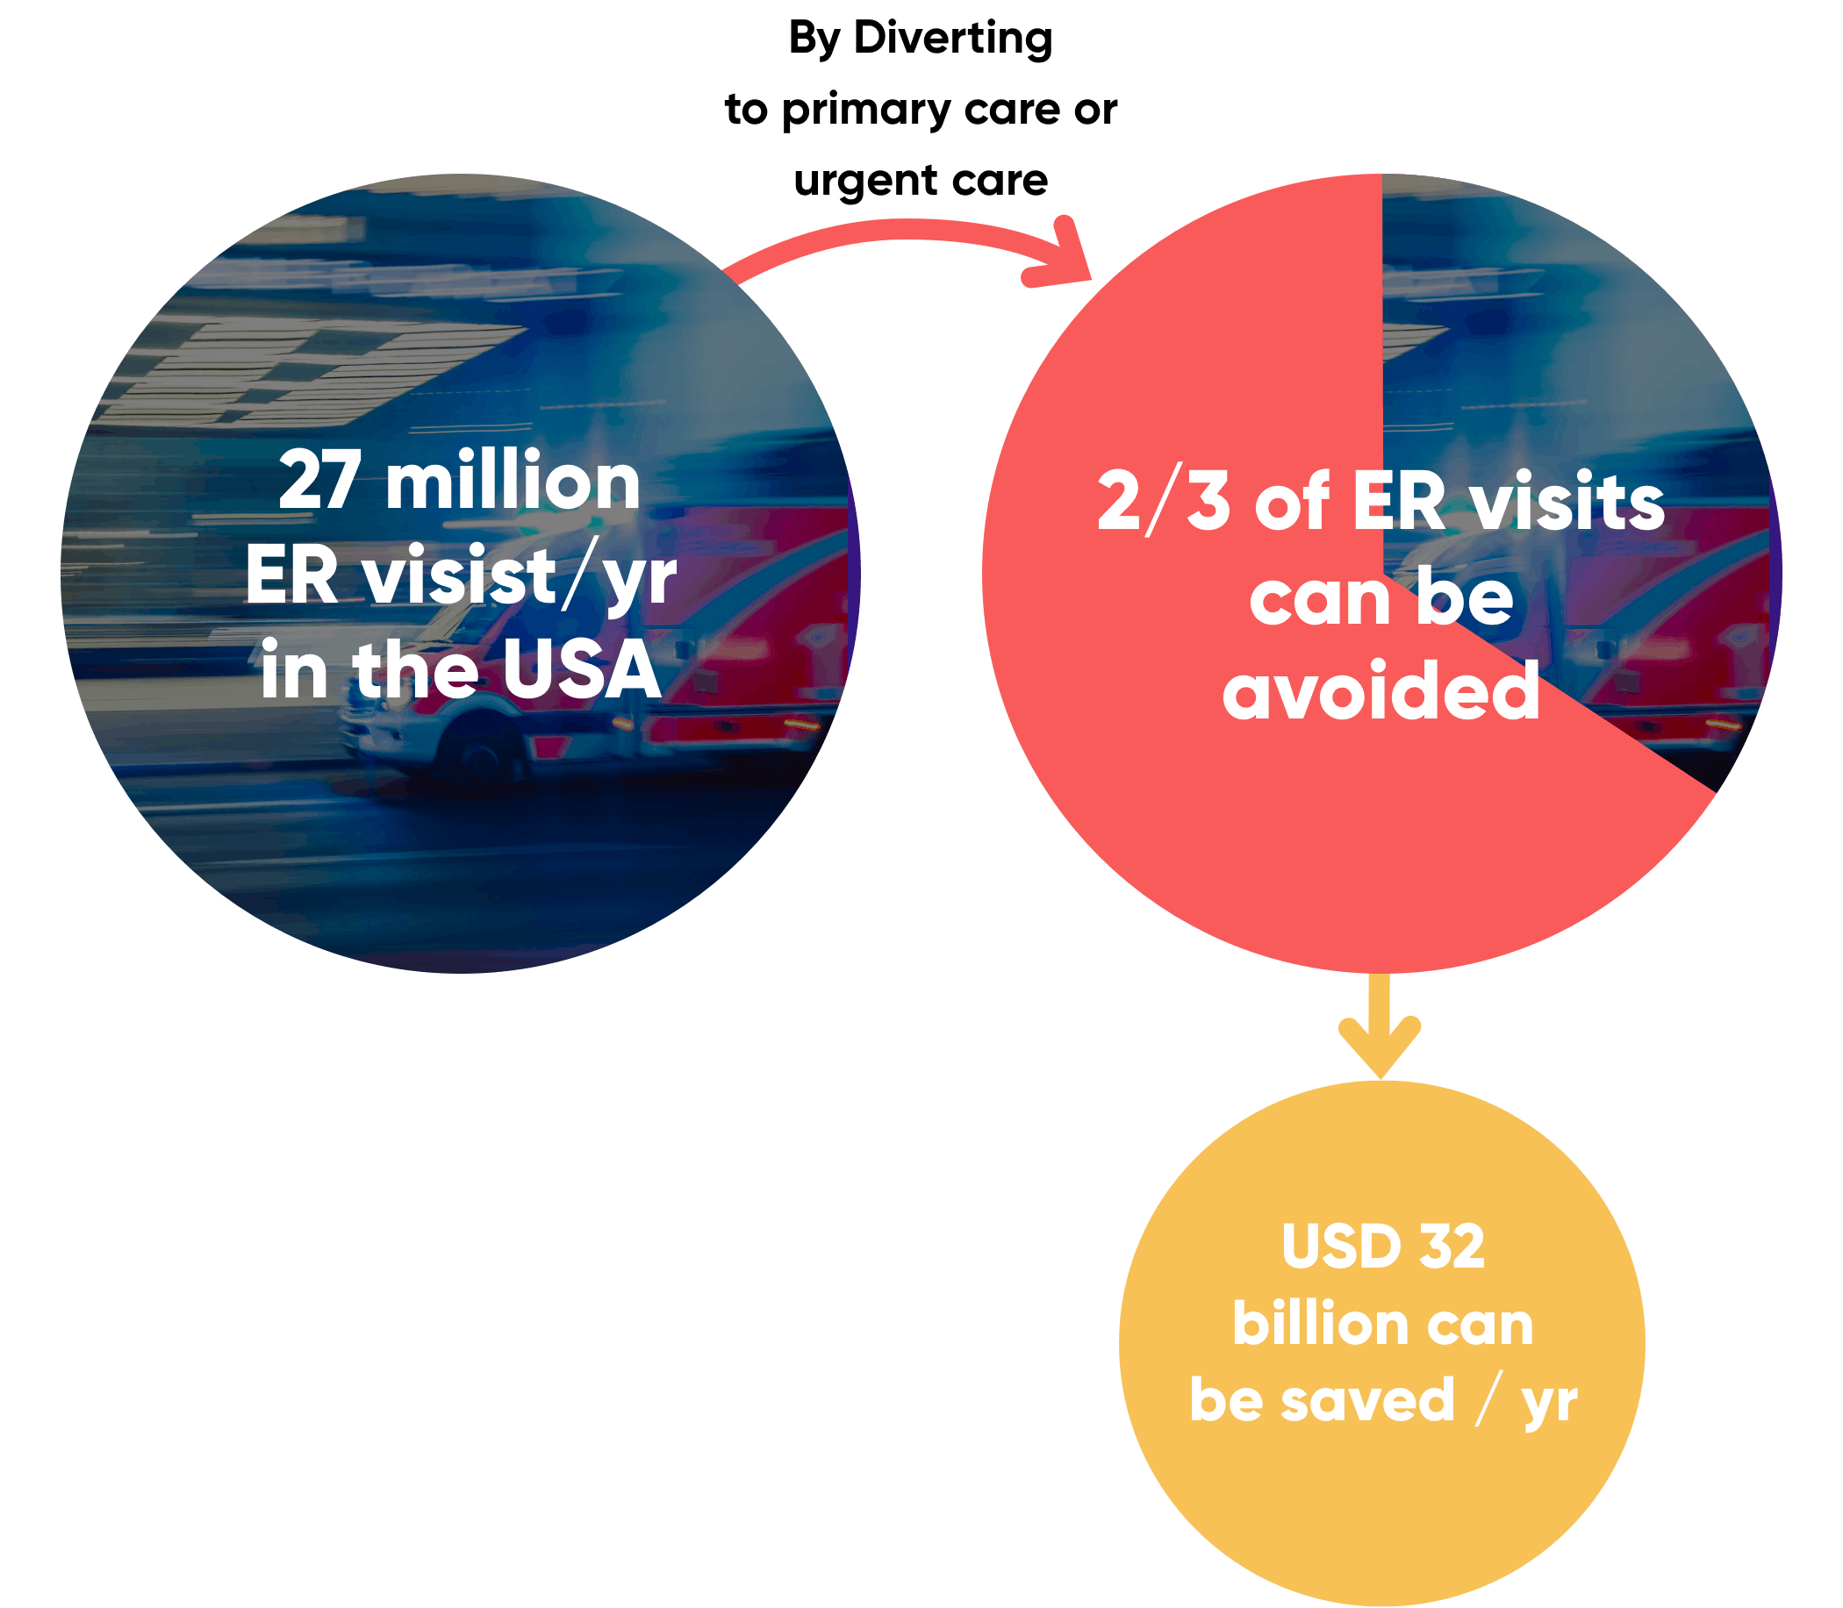

In other words, the high cost of healthcare is pushing people to skip scheduled visits for even routine healthcare needs. A recent study revealed that patients and their payers can save considerably through telemedicine by avoiding costly and unnecessary trips to the doctor’s office or hospital.

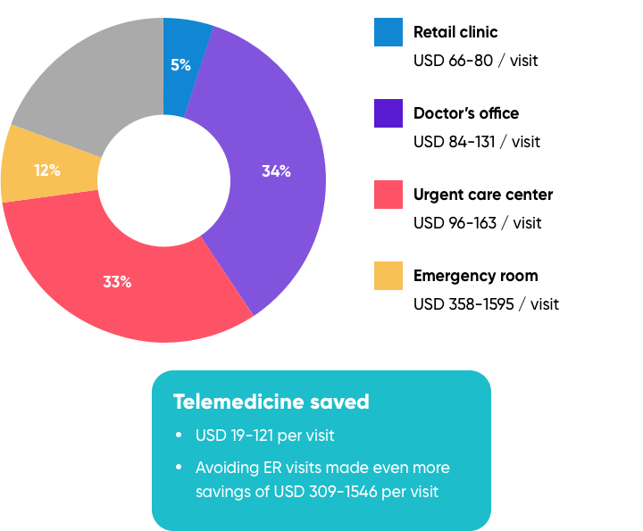

*Note: Those percentages reflect the breakdown of the visit options that would have been done by the respondents in the absence of telemedicine.*

Source: Compiled by SPEEDA Edge

High healthcare costs have major implications for the quality of healthcare delivery in the country. A study carried out in 2022 found that nearly 40% of American adults have either skipped care or put off attending to a medical need in the past year due to cost. The survey also revealed that participants felt that the main problem driving healthcare costs was the rate of inflation, which is noted to be the highest it has been in over 40 years.

Ever-increasing healthcare benefit costs are forcing employers to adopt various cost management initiatives as well. Many employers now prefer telehealth as a cost-effective healthcare benefit for their employees.

### **Telehealth increasingly gaining prominence among employes**

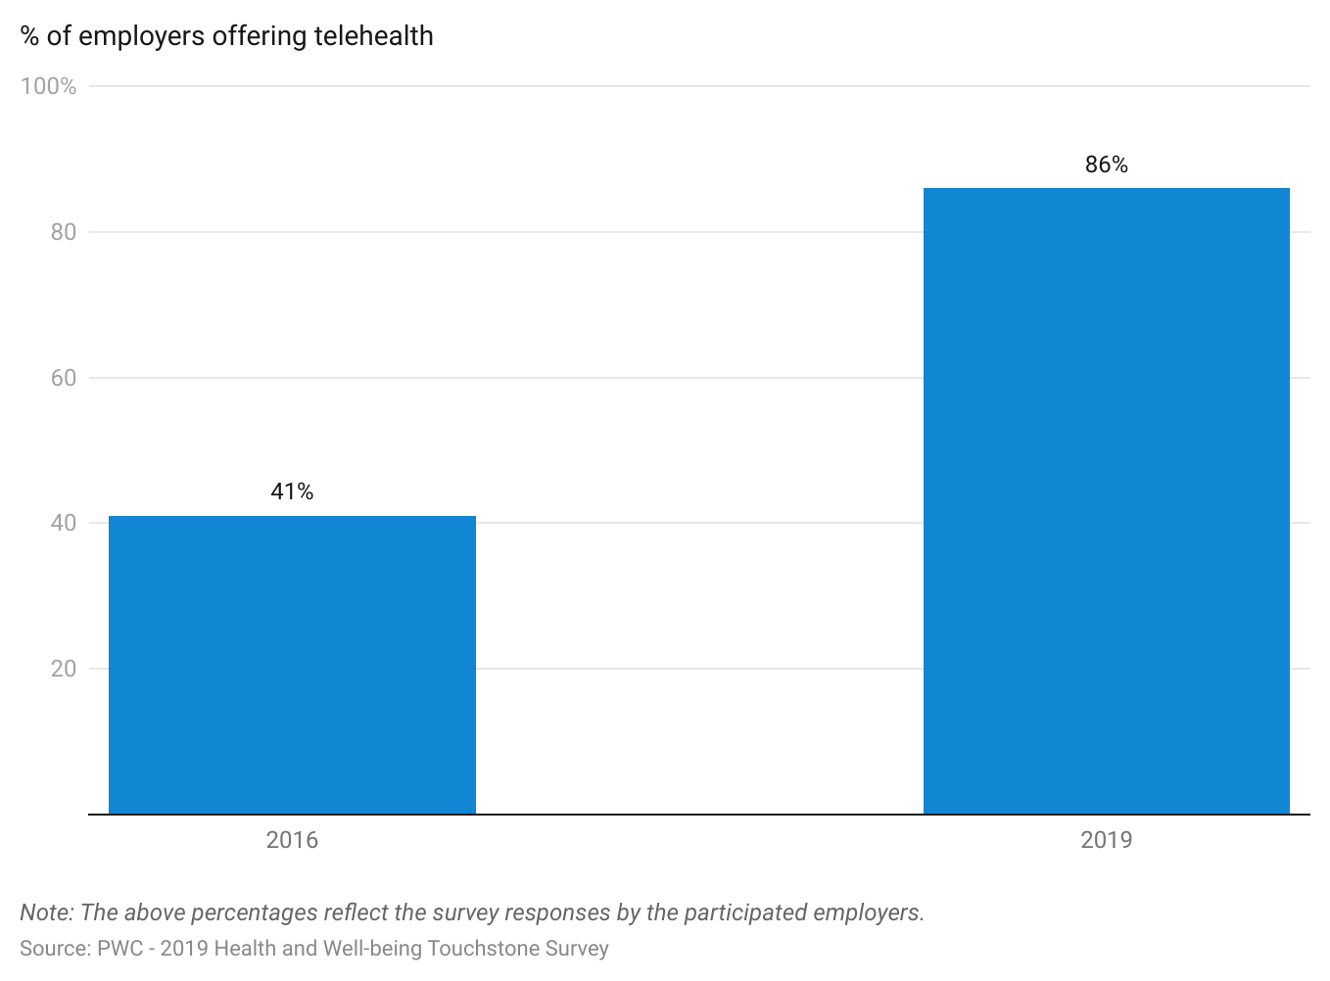

## 

## **2. Long commutes and lengthy wait times show need for improved and efficient access to healthcare**

The frequently long commute and routine lengthy wait time for a doctor’s appointment has been a major impediment to the provision of quality healthcare in the US. These have cost the US economy USD 89 billion annually in opportunity cost during 2006–2017. The expansion of health insurance coverage with the Affordable Care Act (ACA) has increased the number of patients covered, which has created a massive demand for the limited pool of doctors, hence increasing the waiting time.

### **Healthcare services has the longest travelling and waiting time**

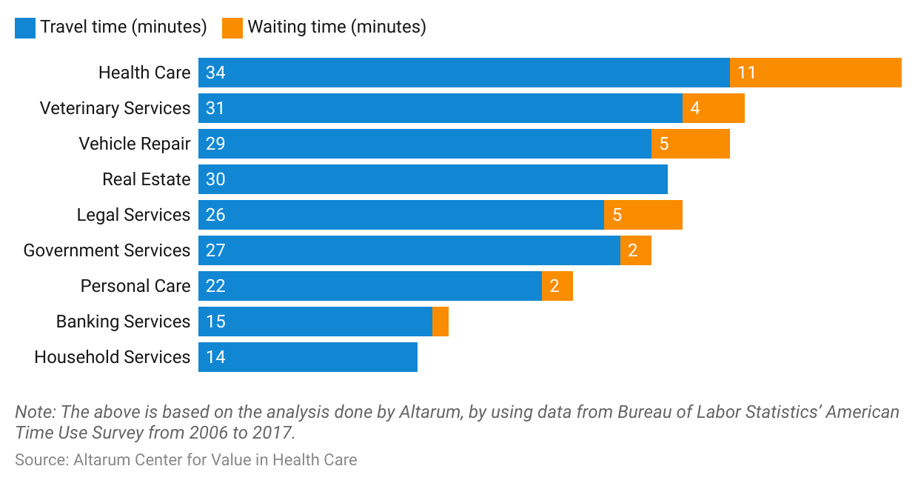

The wait time for appointments has become an important gauge of quality in healthcare delivery. A survey found that around 30% of patients have walked out from an appointment citing the wait was too long. Telehealth cuts down the wait time to see a doctor significantly. As per a study, telehealth has taken on average five minutes of wait time to register and another 8 to 10 minutes to consult with a doctor.

## 

## **3. Millennials’ lifestyle preferences for convenient, affordable, fast service**

American youth and young adults (mainly millennials) increasingly demand a new kind of healthcare system that suits their preferences for affordability and faster service. Increasingly, millennial patients view a physical visit to a doctor as a waste of time. Telehealth has become a natural choice for this demographic and is complementary to their tech savviness and lifestyle preferences.

## 

## **4. Accelerated demand for telehealth with the Covid-19 pandemic is likely to remain after the crisis**

The recent outbreak of the Covid-19 pandemic brought on lockdowns, with mandatory and self-imposed social distancing, and has fed a new wave of massive demand for telehealth services. This new wave of demand makes the new users realize telehealth’s potential benefits. New evidence suggests that more and more people now feel comfortable using telehealth, and, while the change was initially necessitated by the pandemic, they will continue to use it even after the pandemic crisis has died down.

### **More people continue to prefer telehealth**

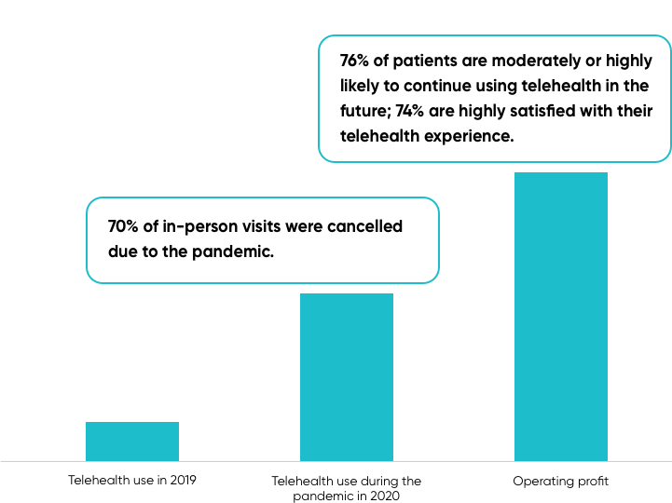

Source: Mckinsey Covid-19 Consumer Survey, April 2020

The US government too has implemented sweeping regulatory changes to promote telehealth as a way to address social distancing requirements necessitated by the ongoing impacts of Covid-19. One such important measure was expanding the scope of telehealth for Medicare beneficiaries, which covers the senior population of the country. This is a major change from the Medicare’s prior stance, where telehealth was offered to the Medicare beneficiaries with severe restrictions. Telehealth reimbursements were limited to specified geographies (e.g., rural areas) and specific locations (e.g., a beneficiary needs to be present in an institutional setting like a rural health clinic or a nursing home). Moreover, the government relaxed HIPAA privacy rules for telehealth platforms, which now enables using any standard video conferencing apps such as Zoom or Skype for telehealth services.

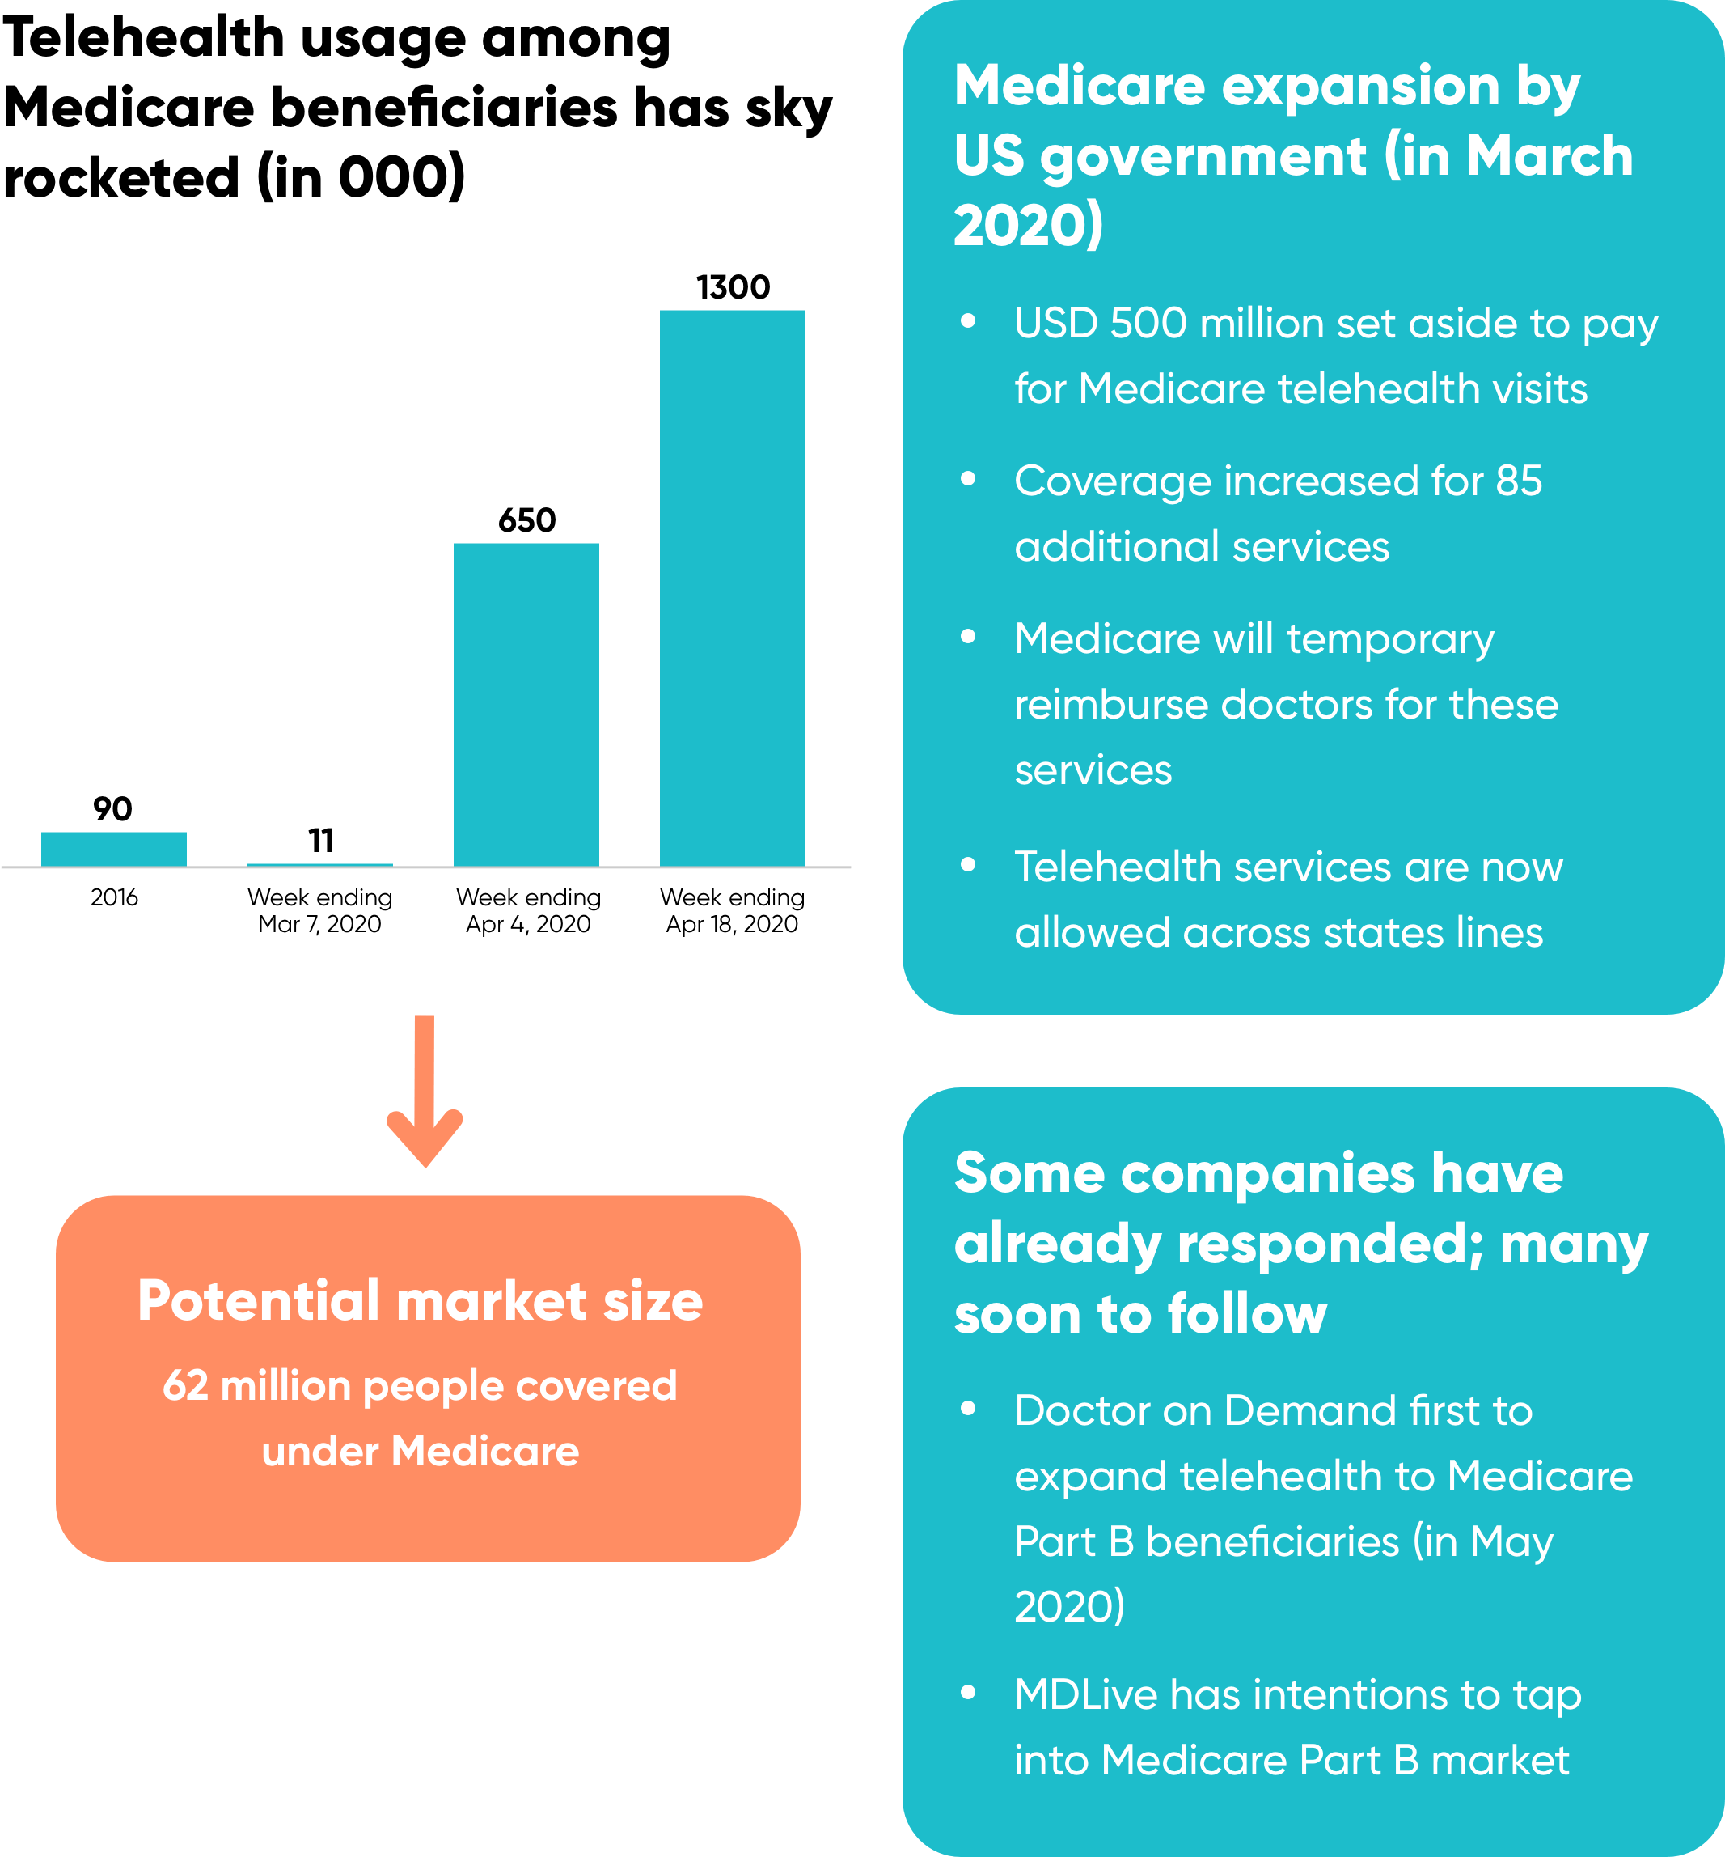

Source: Compiled by SPEEDA Edge

# 

# **Risks to growth**

## **1. Lack of uniform state telehealth policies may hinder telehealth expansion nationwide**

A lack of telehealth reimbursement parity laws, differences in physician licensing regulations, and other regulatory requirements among the states have been the key impediments for growth in the telehealth industry over the years. Policy guidelines remain different for site-of-service requirements, types of technology to use, whether private insurance is allowed for reimbursement or not, and other circumstances.

Even though most states have taken measures to promote telehealth lately—and the recent Covid-19 outbreak has stimulated the regulators to relax many of the suppressive telehealth related policies, at least temporarily—progress remains to be made to create consistency among these regulatory and policy players.

## **2. High cost of implementing telehealth discourages adoption by small practices**

The high cost of implementing telehealth infrastructure discourages small practices from implementing telehealth. Considerable investment is needed, particularly in IT infrastructure, to mitigate cyberattacks and to be compliant with HIPAA regulations to ensure patient confidentiality. The US government’s temporary relaxation of HIPAA regulations to promote telehealth in the wake of the Covid-19 pandemic (e.g., allowing the use of non-compliant video tools) has been a welcome sign. However, it remains a question whether the US regulators will continue with such progressive measures after the pandemic crisis.

*Last updated: June 2023*

©2024 Uzabase, Inc. All Rights Reserved. The information contained herein: (1) is proprietary to Uzabase Inc. and/or its content providers; (2) may not be copied or distributed; and (3) is not warranted to be accurate, complete or timely. Neither Uzabase Inc. nor its content providers are responsible for any damages or losses arising from any use of this information.