# **Longevity Tech: Overview**



# **Longevity tech focuses on extending lifespan and health span through innovative solutions**

Longevity tech has been defined as the development of various methods that allow humans to measure, track, and potentially modify the physiological changes associated with aging. The goal of longevity tech is to extend not only human *lifespan* but also the *health span*—the period of life spent in good health and free from chronic diseases that typically accompany aging. This distinguishes it from anti-aging solutions, which usually refer to cosmetic treatments and procedures to mitigate the effects of aging.

# **How does longevity tech work?**

Longevity tech is linked to *geroscience*, which is the study of aging processes and how they drive chronic diseases, to develop interventions that extend the human health span and prevent age-related diseases. Although the human body begins to physically decline at around age 30, longevity studies distinguish between *chronological age* and *biological age*. Chronological age is our age in calendar years and may differ from our biological age, which is our body’s internal age. Biological age is a better indicator of aging because it reflects the effects of genetics and lifestyle factors, such as diet, exercise, stress, and sleep. Accordingly, different organs can have different biological ages, which can be accelerated or slowed.

The three main targets of longevity tech are considered to be 1) longevity determinants, namely, genetics, environment, and lifestyle; 2) molecular drivers of aging that include the “nine hallmarks of aging” introduced in 2013; and 3) diseases that are strongly associated with aging. Consequently, Longevity Tech companies are organized around these targets, developing solutions that focus on one or more of the four “pillars” of longevity intervention:

1. Identifying health status and early detection of age-related damage (diagnostics)
2. Preventing or delaying the damage that causes aging (prevention)
3. Treating the damage caused by aging (treatment)
4. Reversing the damage that has occurred (renewal).

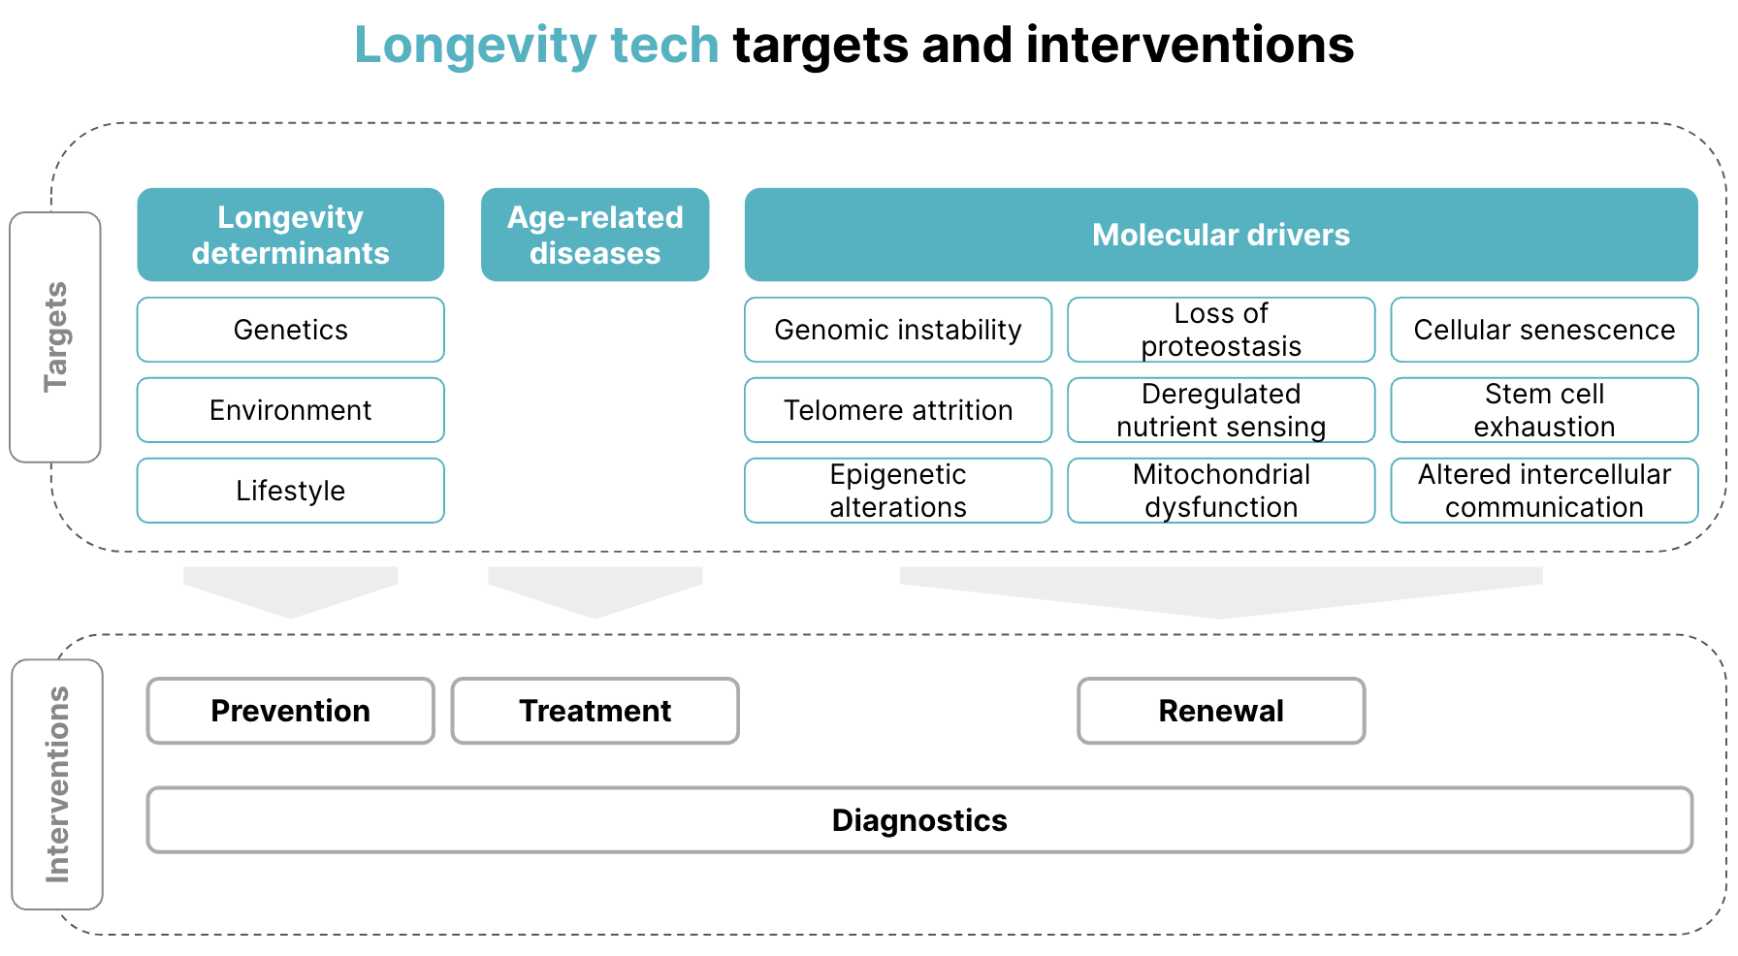

*Molecular drivers include the “nine hallmarks of aging,” which were introduced by Professor Carlos López-Otín in 2013*

Source: SPEEDA Edge research

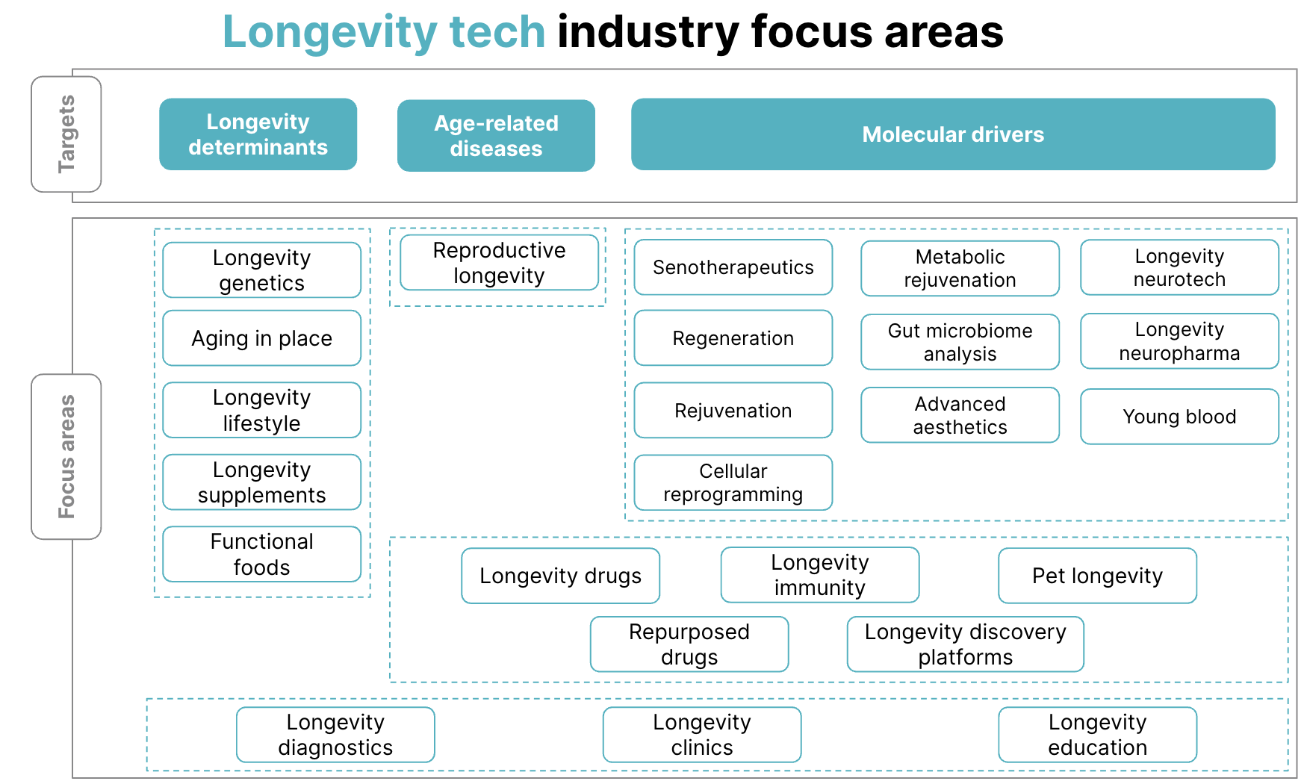

*A loose categorization of focus areas that may span more than one longevity tech target*

Source: SPEEDA Edge research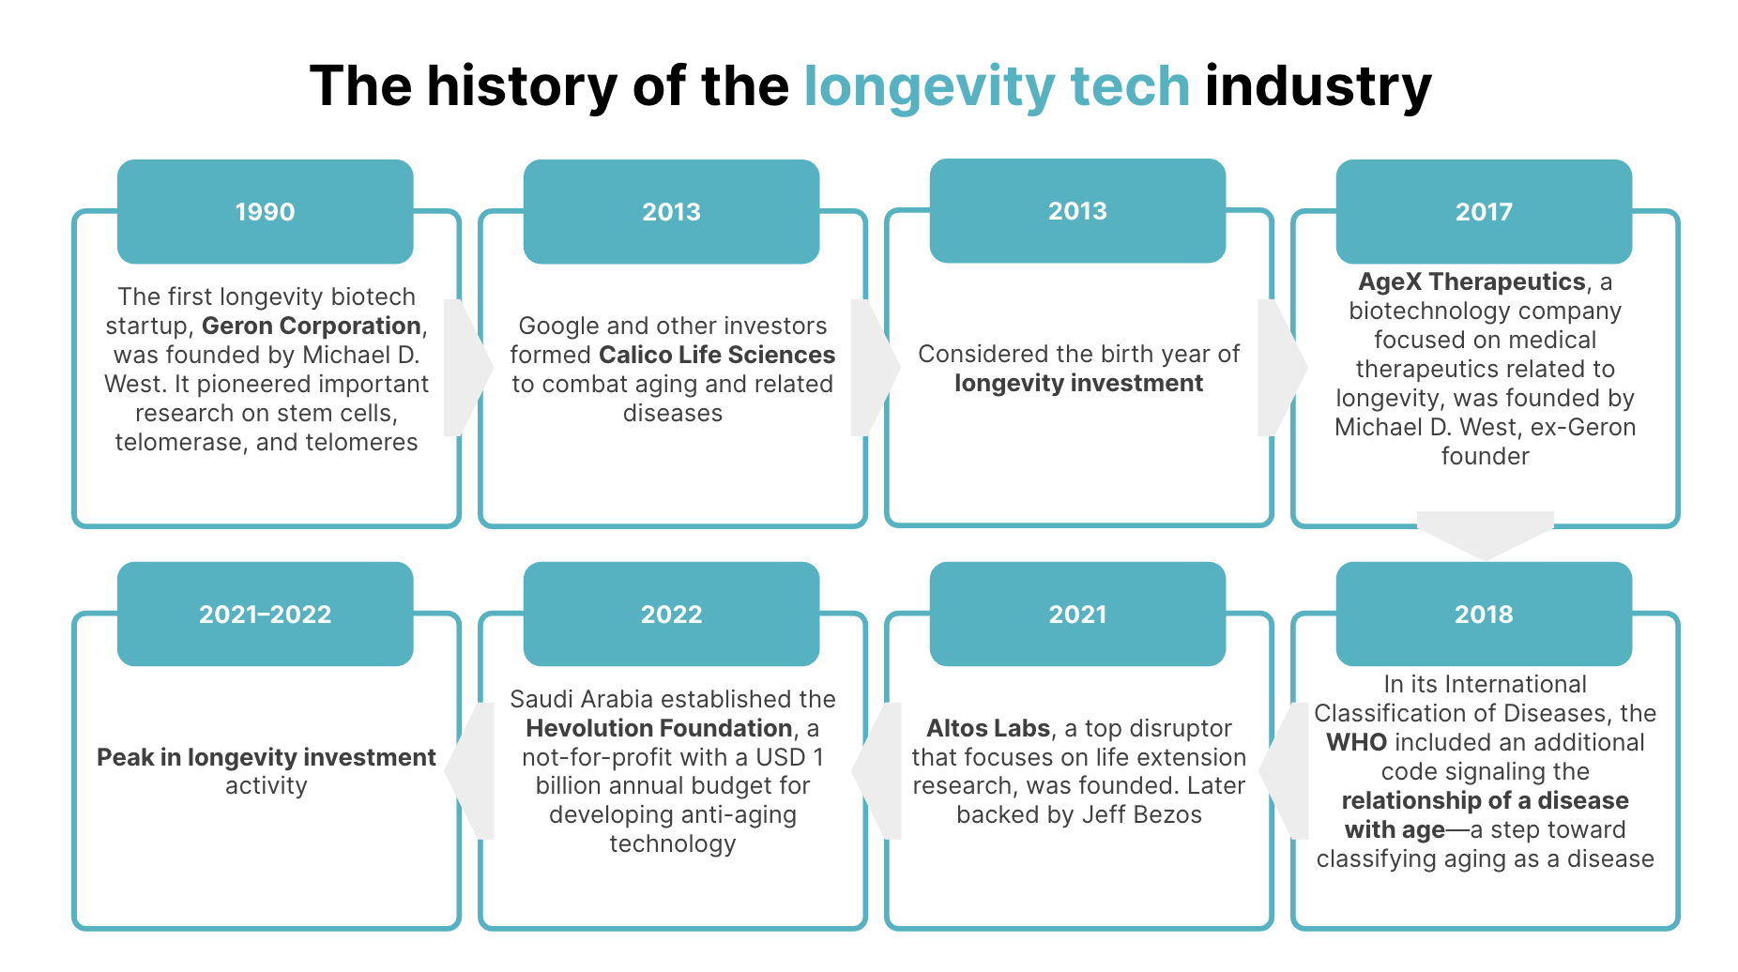

Source: SPEEDA Edge research

# 

# **The Longevity Tech ecosystem**

The Longevity Tech market is dominated by startups. Incumbents, many of whom entered the space through partnerships and integrations, include players from Big Tech (e.g., Apple, Alphabet, Microsoft) and Big Pharma (e.g., Roche, Novartis, Bayer, Pfizer).

Describing the trajectory of startups in this space as tumultuous is not an overstatement. Companies that started with a specific mission may have pivoted to a different therapeutic area due to the inherent challenges of drug development. Other startups either merged with or were acquired by other pharma and biotech companies, while some closed shop due to various reasons, such as leadership changes, shifting priorities, patent expirations, funding depletion, and the development of superior assets by competitors.

Take industry pioneer Geron Corporation as a case in point. After its founding in 1990, it focused on developing drugs based on telomerase activation and inhibition. However, the technical difficulties associated with this approach led to a different focus: The development of a therapy based on human embryonic stem cells. Meanwhile, the company’s director of molecular biology resigned in 1997, followed by its founder in 1998. Despite a breakthrough in stem-cell research in 1998, FDA approval to begin clinical trials did not arrive until 2010. However, the stem-cell program was discontinued shortly after in 2011, and Geron’s stem-cell assets were sold to BioTime (now Lineage Cell Therapeutics) in 2013. More than 30 years later, the company has circled back on its original focus of telomerase inhibition treatments.

Most startups in the Longevity Tech space can be [broadly categorized](https://www.stanete.com/history-longevity-biotech/) as 1) developing pre-clinical assets and platforms to attract the attention of other pharma and biotech companies, 2) following the traditional biotech route by treating an age-related disease with a drug that could be expanded to treat broader indications, or 3) commercializing products such as dietary supplements and treatments like gene therapies in jurisdictions with permitted regulations.

The industry is led by the US market, home to more than 60% of Longevity Tech companies. Its aging population is one of the largest (about 18% of the population is aged 65+ as of 2023) and one of the least healthy, with an increasing incidence of age-related chronic diseases.

### 

### 

### 

### 

### 

### **Longevity Tech: Key segments**

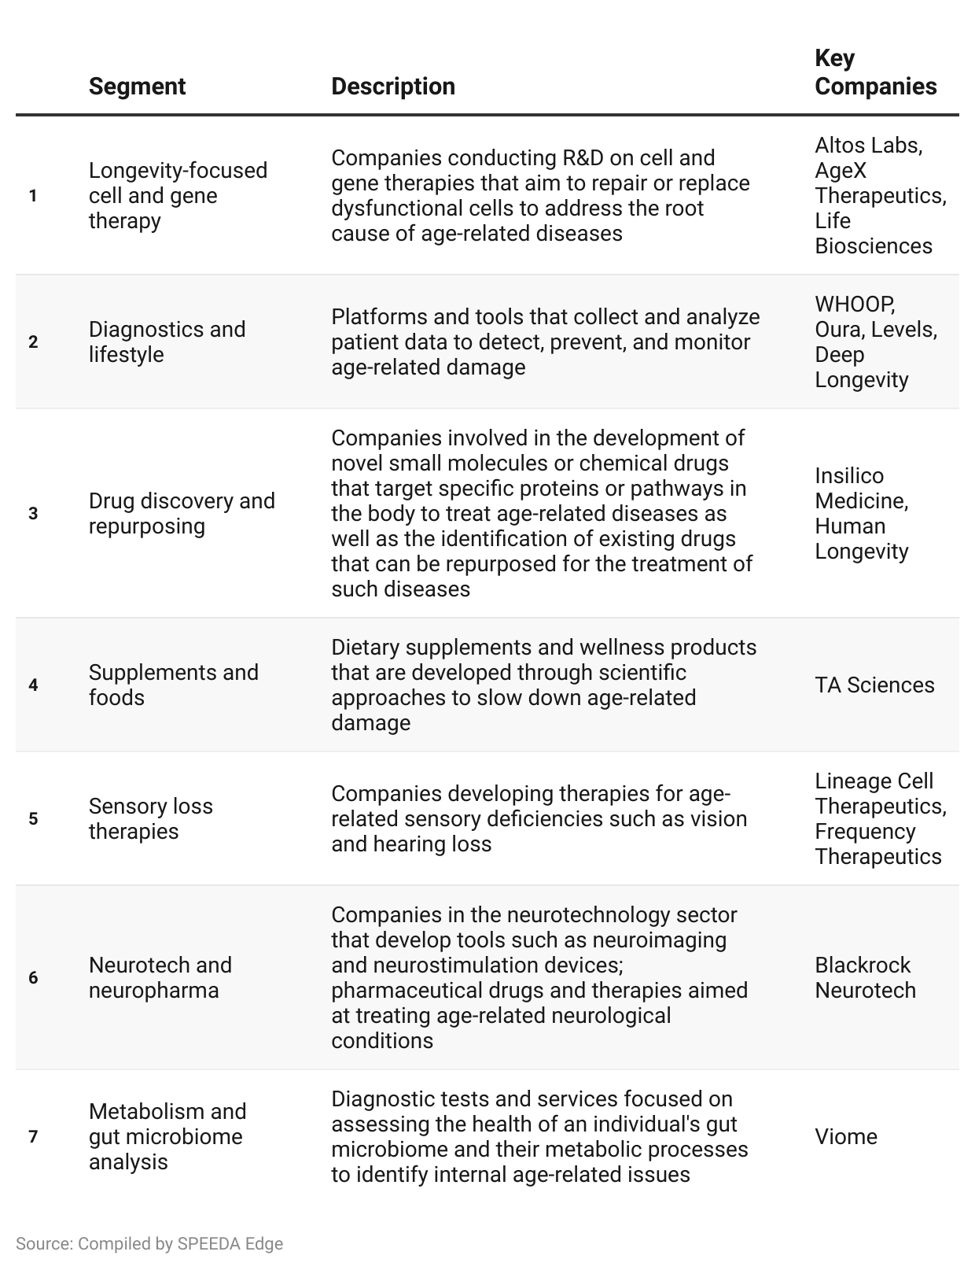

#### 

#### **However, we exclude the following areas when selecting companies for this industry:**

1. Anti-aging solutions that refer to cosmetic treatments and procedures to mitigate the effects of aging (covered in [Beauty Tech](https://sp-edge.com/industry/39)). This is because longevity tech aims to extend not just the human lifespan, but also the health span.
2. Technology solutions to enhance seniors’ quality of life and enable aging at home (covered in [Age Tech](https://sp-edge.com/industry/38))
3. Platforms and tools that provide personalized remedies for general well-being and mitigate the risk of conditions other than age-related diseases (covered in [Preventive Healthcare](https://sp-edge.com/industry/22) and [Digital Wellness](https://sp-edge.com/industry/32))
4. Technological solutions and therapies related to enhancing longevity in animals, as we primarily focus on solutions for humans in this hub.

# **Driving factors**

## **1. An expanding aging population**

In the second half of the 20th century, birth rates declined and life expectancy rose, increasing the proportion of older people worldwide. Globally, life expectancy increased by over six years between 2000 and 2023, from 66.2 to 73.3 years. The population of Americans aged 65 and older is expected to grow from 58 million in 2022 to 82 million by 2050, reflecting a 47% increase. This age group’s share of the US population is projected to rise from 17% to 23%. In addition, the population aged 80 years or over is expected to more than triple globally between 2024 and 2074.

This growing aging population, in turn, is accompanied by the following:

* **A desire for more than just longer lives among older adults.** The [WHO](https://www.who.int/data/gho/data/themes/mortality-and-global-health-estimates/ghe-life-expectancy-and-healthy-life-expectancy) reports that although life expectancy has increased by 5.7 years between 2000 and 2020, healthy life expectancy (HALE) increased by around 4.7 years, suggesting that those who live longer do not necessarily live well for longer.
* **The desire to prevent or delay age-related diseases.** Older adults are more likely to develop chronic diseases, such as cancer, diabetes, and cardiovascular disease, as well as sensory deficiencies like vision and hearing loss. In fact, according to data from the [US Centers for Disease Control and Prevention](https://www.cdc.gov/chronic-disease/about/index.html), approximately 60% of American adults have at least one such chronic condition.
* **Greater purchasing power and willingness to spend.** A consulting and marketing research firm specializing in older Americans [estimates](https://money.usnews.com/investing/articles/megatrends-the-longevity-economy) that annual spending on products and services by consumers aged 55+ is more than double that of consumers under the age of 35 (USD 2.9 trillion vs. USD 1.4 trillion) and nearly equal to that of consumers aged 35–54 (USD 3.1 trillion). According to the AARP’s [Global Longevity Economy Outlook](https://www.aarp.org/content/dam/aarp/research/surveys_statistics/econ/2022/global-longevity-economy-report.doi.10.26419-2Fint.00052.001.pdf), the population aged 50+ accounted for about half or more of global spending in the top five consumer categories in 2020, with the highest share of 60% in the health category. The [Boston Consulting Group](https://www.bbc.com/worklife/article/20190930-the-untapped-potential-of-the-longevity-economy) further estimates that by 2030, 55+-year-olds in the US will account for half of all domestic consumer spending growth since the global financial crisis (with even larger shares of 67% in Japan and 86% in Germany).

These trends show that the Longevity Tech market is being fuelled by a growing group of consumers with the desire and means to extend their health spans.

## **2. Growth in tech-enabled longevity research is increasing its accessibility and spurring consumer interest**

Numerous studies on biological aging consistently indicate that aging can be considered a modifiable process. The possibility that the aging process can be controlled to some degree has piqued consumer interest in healthy aging, and the perception that chasing longevity is a billionaire’s pastime is losing ground.

Ongoing R&D in this area also enables greater cost-effectiveness and ease of use. For example, Deep Longevity’s epigenetic clock, DeepMAge, can now use saliva samples after initially being designed to use blood samples, making it less intrusive and painful for customers. What’s more, collecting a blood sample requires a visit to the clinic, while a saliva sample could be collected at home, suggesting that longevity tech could potentially become easier on the wallet.

# **Risks to growth**

**1. Aging is not considered a disease—yet.** Although the WHO has signaled the relationship between disease and age in its International Classification of Diseases (in 2018), the FDA and the UK’s NHS do not recognize aging as a disease and is, therefore, not a target for drug development. Because the FDA considers aging a natural process, drugs designed to slow or reverse aging must instead target a disease resulting from aging to be eligible for approval. [Industry commentators](https://www.rimonlaw.com/classifying-aging-as-a-disease-could-speed-fda-drug-approvals/) expect the FDA to revisit this issue in response to increasing pressure from the scientific community and Congress. If the FDA approves drugs and therapies to treat aging, it would significantly impact research funding and greatly improve their accessibility.

**2. One trial doesn’t fit all.** The aging population is heterogeneous because each individual's aging process is unique. Therefore, longevity trials need to be redesigned with new perspectives and tools, as their populations need to be broad and more inclusive. This marks a significant departure from how clinical trials are typically designed.

**3. Limited accessibility due to high cost.** Although notable progress has been made in the field, longevity tech is still expensive, making companies’ solutions inaccessible, an issue that is particularly complex to remedy. For example, Eylea, the FDA-approved aflibercept targeting age-related macular degeneration, costs USD ~1,850–2,000 per dose.

**4. The impact of factors beyond human control.** Human longevity is influenced by many factors beyond our control, including genetics and environment. In addition, the benefits of lifestyle changes, while many, are limited and cannot counter inherent human vulnerabilities.

*Last updated: November 2024*