# **Alternative Energy: Overview**

## 

## **Energy solutions focused on reducing or substituting GHG emissions**

Alternative energy broadly refers to any technology that attempts to provide solutions to the climate crisis by substituting current GHG-emitting energy generation processes with cleaner solutions. This also includes energy storage technologies that stabilize the intermittent nature of renewable energy sources.

The transportation, electric power, and industrial sectors are the three largest polluting sectors in the US, accounting for ~76% (2021) of total US GHG emissions. All three sectors primarily emit GHGs through the combustion of fossil fuels to generate energy. Therefore, alternative energy solutions play a vital role in the global march toward environmental protection.

Overall, we categorize these solutions into four broad categories: 1) next-gen solar, wind, and hydropower; 2) next-gen bioenergy and sustainable fuels; 3) third-gen renewables; and 4) stationary energy storage.

### 

### **Key Segments**

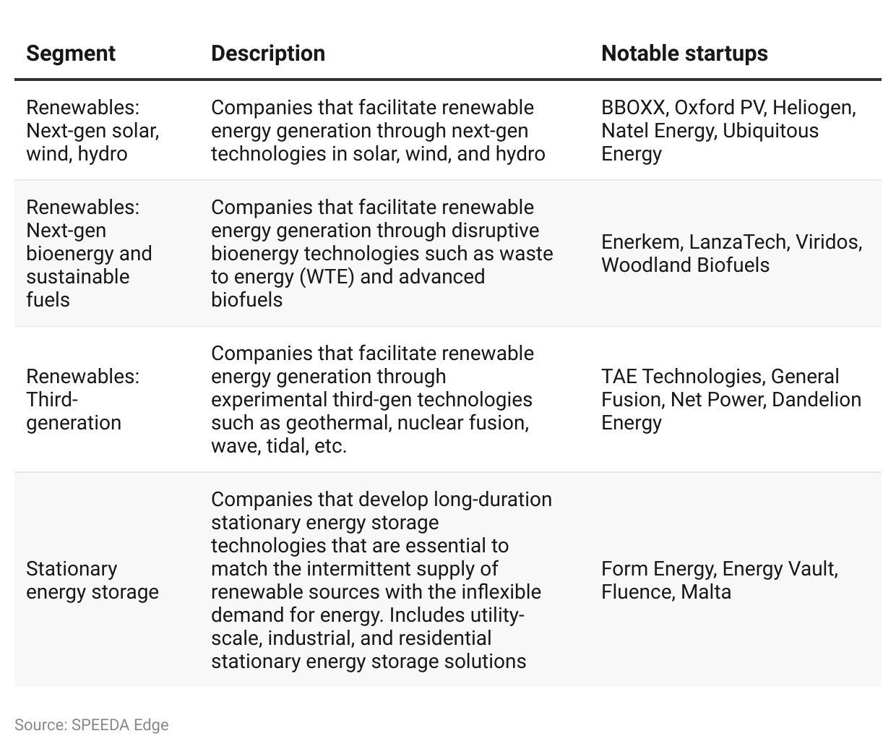Conventional renewable energy technologies such as solar, wind, hydropower, biofuels, and wood have reached maturity and many companies in these areas can no longer be considered startups. Therefore, they are not covered in this hub. Other relevant areas such as [Carbon Capture, Utilization & Storage (CCUS)](https://sp-edge.com/industry/63), [Hydrogen Economy](https://sp-edge.com/industry/57), and [Energy Optimization & Management Software](https://sp-edge.com/industry/176) solutions are covered as separate industry hubs.

## **Alternative energy attempts to tackle the “defining issue of our time”**

Global warming sets new record temperatures year after year and GHG-emitting human activities are directly responsible. The 2015 Paris Agreement, signed by 195 member countries, aims to maintain global warming “well below” 2°C and to try to limit global warming even further to 1.5°C. The pathways to the 1.5°C threshold would require halving current global GHG emissions by 2030 and achieving net-zero global GHG emissions by 2050.

However, there have only been limited tangible results so far, and global GHG emissions have continued to increase every year. Now, for the world to halve its GHG emissions within this decade and stay in line with the 1.5°C threshold, every sector of the global economy must transform and radically decarbonize over two business cycles. With the global rate of decarbonization declining only to 0.5% per year in 2022, which is significantly below the 15.2% rate needed to limit warming to 1.5°C, rapid commercialization of next-gen alternative energy solutions will be critical.

### **Global atmospheric carbon dioxide concentration**

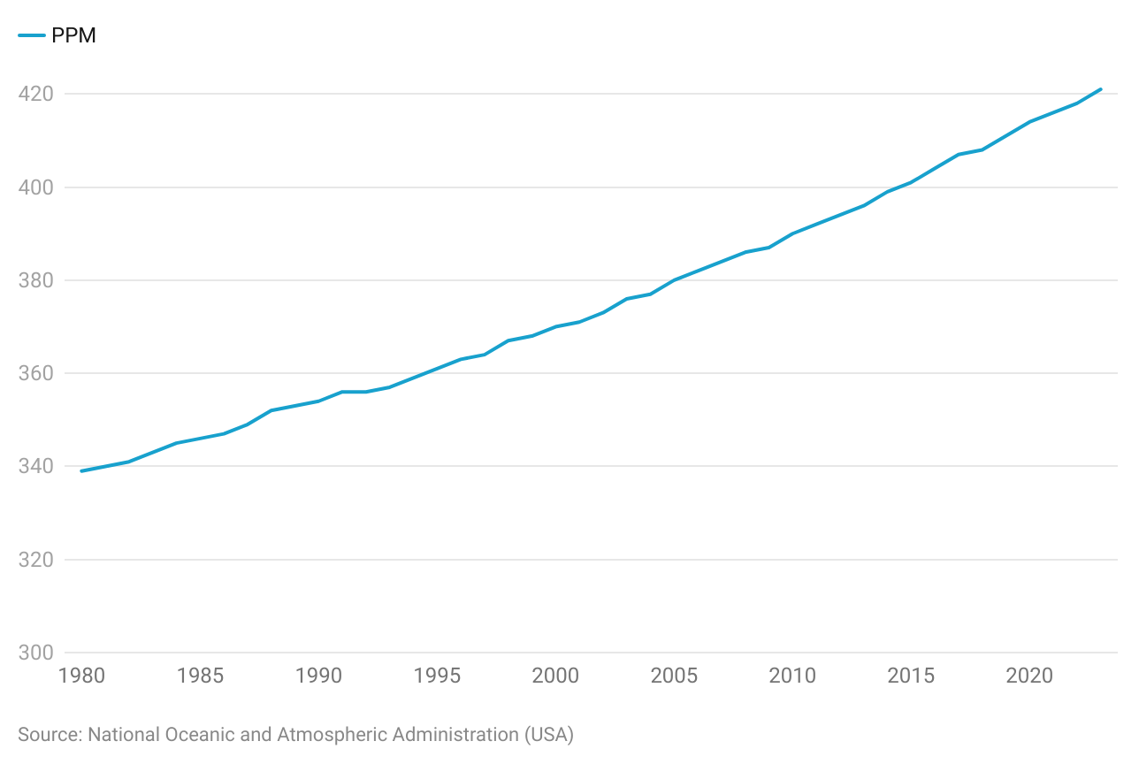

## **Declining cost is the top enabling factor for renewable energy**

The cost of renewable energy generation has come down considerably over the past decade and no longer faces a cost disadvantage over fossil fuels. One of the main reasons for this decline in cost is that renewable energy technologies follow learning curves, which means that with each doubling of the cumulative installed capacity, their prices decline by a relative fraction (similar to the fundamentals of Moore's Law). Historical data suggests that with each doubling of installed capacity, the price of solar photovoltaic (PV) modules has dropped on average by around 20%. There is a possibility that next-gen renewable technologies such as biofuels, fusion energy, geothermal, wave, tidal, etc. could also follow the same declining cost principles—bolstering the case for widespread adoption.

### 

### **The price of electricity by source in the US**

## **Intermittent solar and wind supply pushes for better energy storage; focus also on stronger renewable baseload**

Renewables accounted for nearly 21% of the US energy mix in 2022. This is expected to increase to around 44% by 2050 driven by rapid solar and wind adoption. One of the key downsides of solar and wind energy is that its supply can be intermittent owing to changes in weather and wind patterns. So, the widespread adoption of renewable energy bodes well for more efficient energy storage solutions, such as long-duration batteries, which can be used to fill the gaps in intermittent supply to cater to an inflexible demand. Current long-duration energy storage solutions last for around 10+ hours, but companies like [Form Energy](https://sp-edge.com/companies/768907) are looking to develop batteries that can last for more than 100 hours.

The intermittent supply of solar and wind is also encouraging the quest for a more stronger renewable baseload (i.e., renewable sources that can generate energy 24/7 regardless of the weather). Some of the top contenders for this right now are geothermal, ocean, and [fusion energy](https://sp-edge.com/insights/7569) solutions.

# **Driving Factors**

## **1. Consumers care about environmental protection**

Consumers are now more aware of the importance of climate protection and are increasingly adopting less resource-consuming lifestyles. About 72% of Americans now believe that global warming is happening, an increase of around seven percentage points over 2015–22. Nearly 64% of Americans are also either highly alarmed, concerned, or cautious about global warming.

### **Percentage of Americans that believe global warming is happening**

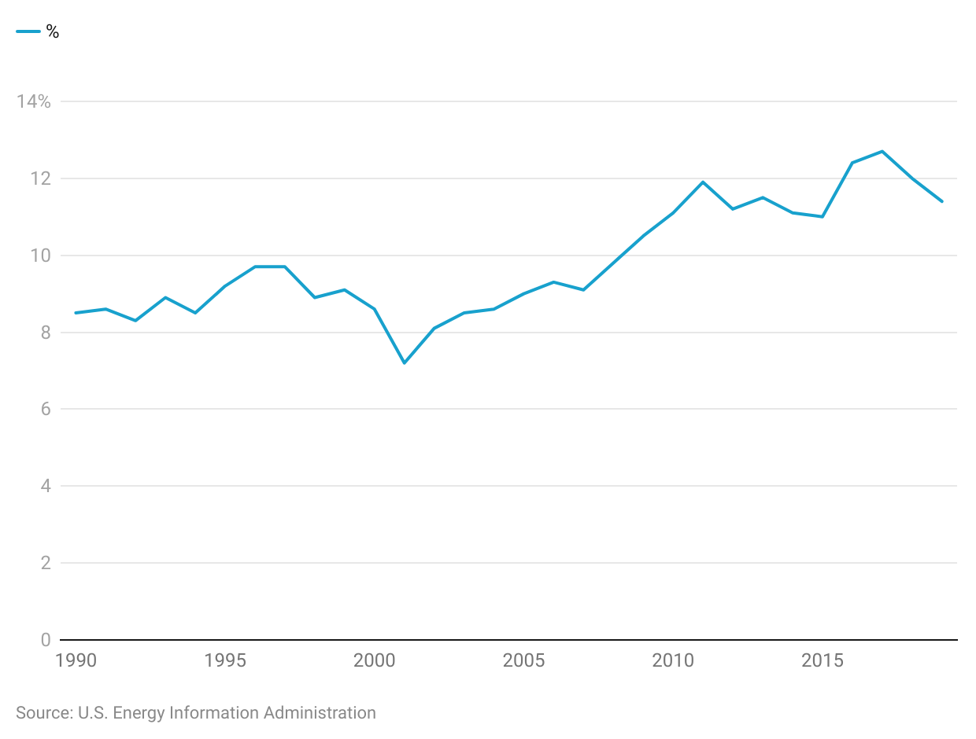

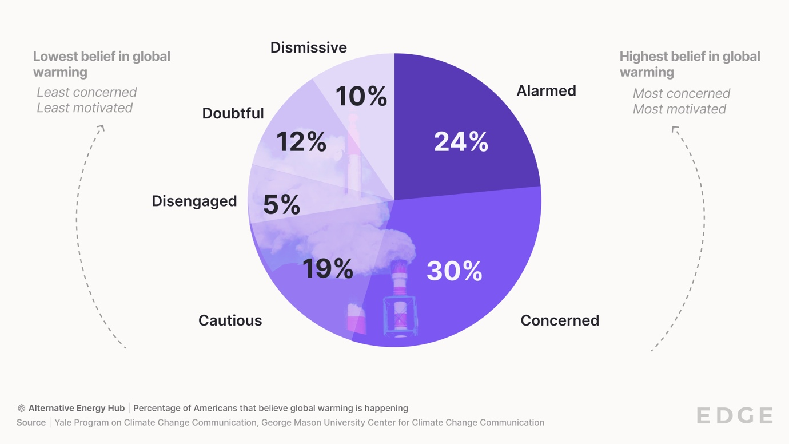

## **2. Aggressive net-zero emission commitments**

Governments around the world are now paying greater attention to environmental protection and have imposed aggressive targets to lower GHG emissions over the next few decades.

As of November 2023, 101 countries, including China, the US, and those of the European Union, have set net-zero targets, covering ~81% of global emissions. Furthermore, as of November 2023, over 3,900 businesses and financial institutions have set emission reduction targets approved by the Science-Based Targets Initiative (a partnership between CDP, the UN Global Compact, World Resources Institute, and the World Wide Fund for Nature to drive climate action in the private sector).

In April 2021, the US introduced a national target to reduce the country’s GHG emissions by 50%–52% from 2005 levels by 2030, with plans to reach a 100% carbon-pollution-free power sector by 2035 and a net-zero emissions economy by 2050.

## **3. The Biden-Harris climate plan could be conducive to Alternative Energy growth**

From opting out of the Paris Agreement to rolling back 98 environmental protection regulations, the US had a relatively weak climate policy under the Trump Administration. The climate crisis was one of the key talking points of the last presidential election, with President Joe Biden promising to make several progressive changes to the US climate policy. As such, the President has introduced the country’s first National Climate Task Force, which has established four national-level climate goals:

* Reducing US GHG emissions 50%–52% below 2005 levels in 2030
* Reaching 100% carbon-pollution-free electricity by 2035
* Achieving a net-zero emissions economy by 2050
* Delivering 40% of the benefits from federal investments in climate and clean energy to disadvantaged communities

These initiatives strengthen the US climate policy, which would be conducive to the growth of alternative energy solutions. So far, under the Biden Administration, the US has recommitted to the Paris Agreement, and the Bipartisan Infrastructure Law passed in November 2021 also made several allocations for clean energy: renewable energy (USD 1.03 billion), power grid updates (USD 65 billion), and energy storage (USD 1.33 billion). Furthermore, the Inflation Reduction Act passed in August 2022 also aims to offer funding, programs, and incentives to support the US’ transition to clean energy.

# **Risks to Growth**

## **1. Pressure from traditional energy sectors**

In the US alone, the traditional energy and energy efficiency sectors provide nearly seven million jobs (around 5% of the total workforce) and nearly 10% of the GDP. The shift to renewable energy threatens to derail these traditional energy industries. Hence, top oil and gas and energy companies often lobby governments to delay the transition to renewable energy. A 2019 report suggests that oil and gas companies—BP, Shell, ExxonMobil, Chevron, and Total—spend nearly a combined USD 200 million a year lobbying to delay, control, or block policies that tackle climate change. More specifically, in 2018, BP had allegedly donated USD 13 million to a campaign that successfully defeated a proposal to implement a carbon tax in the state of Washington. Such efforts could pose a significant risk to growth in alternative energy solutions.

## **2. Nascent technology, high capital intensity, and a long investment horizon**

There was a widely recognized boom in clean tech (an alternative energy predecessor) from 2006 to 2011, which saw venture capital investments of around USD 25 billion pour into the sector. However, falling oil prices and the credit crunch from the 2008 financial crisis impeded these cleantech startups from attracting the additional capital necessary for commercial deployment. As a result, around 150 cleantech startups founded in Silicon Valley during this period, including Nanosolar, Solyndra, and Miasole, eventually ended in bankruptcy.

Evidence from mature renewable energy technologies like solar and wind suggests that the investment horizon of renewable energy solutions would ideally range from five to 10 years or longer. In contrast, typical VC investments in software have a much shorter investment span of just three to five years. Alternative energy solutions are also highly capital-intensive, which carries relatively higher upfront costs and requires additional capital and infrastructure to scale, compared with a typical software investment. These factors could make the Alternative Energy sector somewhat less attractive for investment.

Additionally, alternative energy solutions such as next-gen renewable energy and alternative battery technologies are still at a nascent stage. In most instances, their commercial viability is yet to be proven and as such are relatively high-risk investments, which could potentially discourage funding. In turn, the lack of funding could restrict future technological advancements, creating a vicious cycle.

## **3. Expiring renewable energy subsidies**

Governments have introduced various incentives for renewable energy deployment through subsidies and tax exemptions to remove the cost disadvantage of renewable energy over fossil fuels. Now, as renewable energy has sharply declined in price and no longer faces significant cost disadvantages over fossil fuels, many governments have let renewable energy subsidies expire. For instance, US federal subsidies for renewable energy decreased by around 56% during 2013–2016. The expiration of these subsidies could affect returns of the renewable energy sector, which could potentially curtail investor interest, leading to lower funding, and thereby slowing down growth.

*Last updated: December 2023*

©2024 Uzabase, Inc. All Rights Reserved. The information contained herein: (1) is proprietary to Uzabase Inc. and/or its content providers; (2) may not be copied or distributed; and (3) is not warranted to be accurate, complete or timely. Neither Uzabase Inc. nor its content providers are responsible for any damages or losses arising from any use of this information.