# **Higher EdTech: Overview**

## 

Higher educational technology (higher EdTech) refers to the use of technology by higher and vocational education institutions to transform instruction, learning, assessment, and campus infrastructure to achieve their desired learning objectives and outcomes and enhance the student experience. It aims to allow students and faculty to learn and work more flexibly and help institutions function more efficiently. Higher ed institutions are those that provide post-secondary (or post K-12) education and include state university systems, public and private universities, and community colleges.

Besides supporting higher ed institutions (B2B), higher EdTech products also support college students and adults desiring post-secondary credentials (B2C). Some of these offer alternative learning experiences and pathways not provided by traditional players, directly competing with them.

### **A variety of higher EdTech products support the entire post-secondary learning experience.**

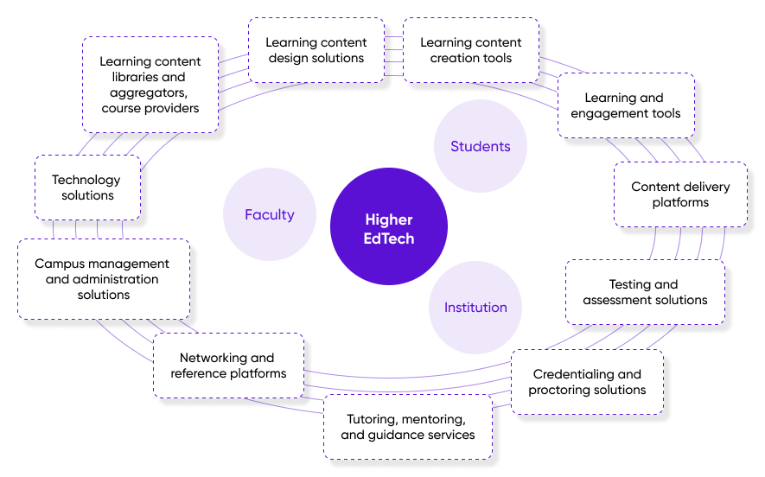

Source: Compiled by SPEEDA Edge

### **We exclude the following areas when selecting companies for this industry:**

1. Student loan/financing platforms
2. Student/graduate career opportunity/placement platforms
3. Technology-based campus infrastructure providers (e.g., access control and security, foot traffic and vehicular traffic management, facilities maintenance)

Before delving into some of the recent trends in the higher EdTech space, let’s take a look at some of the factors that are driving change in higher ed itself.

## **What's influencing the trends in higher education?**

**Evolving skill requirements across multiple industries.** The rapid pace of technological innovation and automation across numerous industries means that the skills required by their workforces are also continuously changing. Skills can quickly become outdated, and new competencies need to be learned. This makes learning even more important. Learning content has to be adapted accordingly and its delivery made scalable too.

**Evolving profile of higher ed students.** Students are increasingly fitting learning around other commitments such as work or family responsibilities. In [Salesforce’s Connected Student Report (second edition)](https://www.salesforce.org/wp-content/uploads/2021/06/connected-student-report-second-edition-06-23-21.pdf), which surveyed students and staff across 10 countries, 40% of students said that having more flexible learning options is very important. More than half (52%) reported having a part-time job, while 22% worked full-time.

The attention spans of students (and most others) are dropping, and they prefer to absorb information in ultra-fast, snack-sized, and attention-grabbing portions.

Students want to be better prepared for jobs and careers. In Salesforce’s survey, 49% of students considered future career prospects to be the most important factor in their enrollment decisions, with 30% stating that having more virtual connections to employers would help advance their careers.

**The pandemic’s toll on enrollment and revenue at higher ed institutions.** In the US, it was estimated that lost revenues (USD 85 billion), Covid-19-related expenses (USD 24 billion), and anticipated future decreases in state funding (USD 74 billion) cost institutions around [USD 183 billion](https://www.chronicle.com/article/how-to-fight-covids-financial-crush) in 2020.

Full-time equivalent (FTE) student enrollments at public higher ed institutions in the US declined over 10 years since 2011 to [10.6 million in 2021](https://shef.sheeo.org/report/#student-enrollment). The onset of the pandemic quashed any expectations of this trend reversing anytime soon.

**The cost of higher ed influences enrollment.** Over the 40 years to 2019–20, the cost of a college education increased dramatically. One source reported that the price of attending a four-year college full-time increased [180%](https://www.forbes.com/advisor/student-loans/college-tuition-inflation/) over this period. Interestingly, over the next two years to 2021–22, prices dropped. This could be attributed to stimulus funding that allowed institutions to grant aid to students and to tuition freezes by colleges to ease pandemic-induced economic pressures.

The cost of post-secondary education plays a major role in the decision to enroll. According to [The State of Higher Education 2022 Report by Gallup](https://www.gallup.com/analytics/391829/state-of-higher-education-2022.aspx), based on a survey of more than 11,000 adult students in the US, more than half of all unenrolled adults cited the cost of a college degree to be an important reason for not continuing their education. Similarly, about half of all enrolled adults reported that the financial aid they received played a key role in their remaining enrolled or enrolling in the fall of 2021.

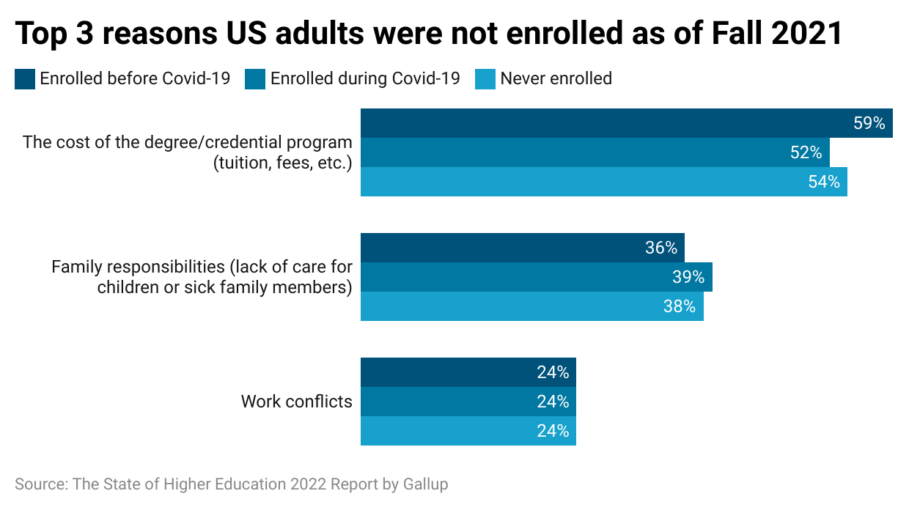

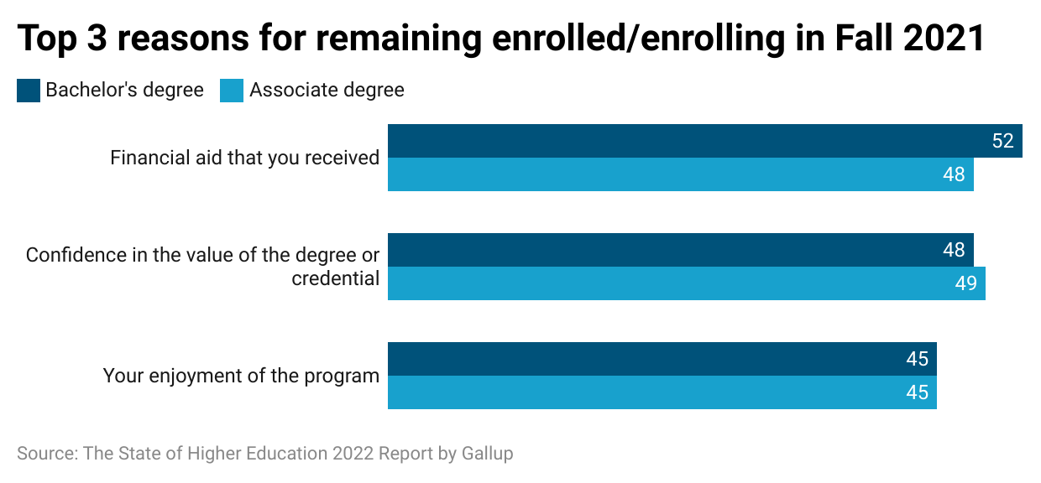

## **What are the recent trends in higher EdTech?**

### **1. The ongoing education model, facilitated by higher EdTech, is gaining traction.**

Subscription-based learning allows learners to pursue an ongoing education model, as opposed to front-loading learning at the start of their careers. This allows learners to keep abreast of evolving skill requirements. Accordingly, online course aggregators are continuously entering into new partnerships with educational institutions and engaging with instructors to broaden the content and credentials offered on their platforms.

**Online learning course providers are continuously broadening their offerings.**

|  | **HQ** | **Number of courses** | **Number of partnerships** | **Number of learners** |
| --- | --- | --- | --- | --- |
| **Coursera** | US | 5,000+ courses, professional certificates, and degrees | 250+ university and industry partners | 102 million learners |
| **LinkedIn Learning** | US | 16,400+ courses | Not applicable (Content created in-house and by registered instructors)* | 27 million+ users |
| **Udemy** | US | 204,000+ courses | Not applicable (Content created by registered instructors) | 54 million+ learners |
| **upGrad** | IND | Not available | 300+ university partners | 3 million+ learners |
| **Udacity** | US | 60+ nano-degree and executive programs and 200+ free courses | 200+ global industry partners | 16.9 million+ learners |

Note: * In August 2022, LinkedIn Learning announced its partnership with third-party certification providers including IBM, Meta, and Oracle.

Source: Compiled by SPEEDA Edge based on various sources

### **2. Physical campuses are embracing higher EdTech to be digitally flexible.**

Colleges and universities are increasingly investing in EdTech. Offering online, hybrid, and asynchronous learning options and providing more online services are some of their more recent front-end strategies, particularly since the pandemic. What’s more, a [Google consumer survey](https://www.bcg.com/publications/2021/investing-in-education-technology) revealed that 55% of students aged 18–24 expect hybrid learning modalities to continue post-pandemic.

With regard to a higher ed institute’s back-end tech stack, [analysts](https://www.bcg.com/publications/2021/investing-in-education-technology) believe that higher ed institutions that systematically invest in cloud, data, and analytics solutions can achieve better results in critical areas such as student enrollment, retention, employment, operational efficiency, research activity, and innovation in learning. Including digital experts in management can also help ensure digital investments meet student success goals.

Universities are also embracing IoT technology to convert their facilities into smart campuses. This allows institutions to optimize the use of infrastructure—through better operations management, security, etc.—and ultimately improve the overall student experience.

| [The University of Cambridge](https://www.cam.ac.uk/news/cambridge-advance-online-courses-open-up-university-of-cambridge-as-part-of-major-digital-learning) is rolling out 50 short, cross-disciplinary online courses over 2021–2026. |
| --- |
| [Kent State University](https://edtechmagazine.com/higher/article/2022/02/why-higher-education-institutions-are-investing-upskilling) is upgrading its technology to support upskilling programs designed to meet emerging workplace skills. |
| [Georgia State University](https://www.bcg.com/publications/2021/investing-in-education-technology) uses a predictive analytics model that uses hundreds of indicators to help faculty advisors identify and intervene with at-risk students. This led to a rise in the university’s graduation rate and a decrease in the average time to graduate. |
| [Northeastern University](https://nuflex.sites.northeastern.edu/classroom-technology/) outfitted 180+ classrooms to implement its proprietary hybrid, flexible learning model (“NUflex”). |

### **3. Higher EdTech solutions are adopting a more student success-centric approach.**

Recognizing the evolution of the higher ed student’s profile and changing skill requirements in several industries, EdTech solutions are embracing various technologies to maximize learner engagement and learning outcomes.

**a. Microlearning** (or nano-learning) in the form of micro-courses break learning down into smaller portions that can be completed in weeks or months, as opposed to years. In Salesforce’s survey, 46% of staff at higher ed institutions said the institutions had adjusted their business models to offer more shorter-term courses and programs.

| [Arizona State University](https://edtechmagazine.com/higher/article/2022/02/why-higher-education-institutions-are-investing-upskilling)’s upskilling portfolio includes an on-demand library of about 250 courses, digital boot camps, and corporate partnerships. Online learning platforms also offer short-term courses besides traditional degrees and multi-year courses. |
| --- |

**b. Immersive learning** through the use of augmented, virtual, and mixed reality technologies (AR/VR/MR) allow for more engaging learning experiences and can be used across several disciplines. These technologies allow the creation of simulated environments that closely resemble reality, where students can learn without risking harm to themselves or damage to equipment or learn difficult skills.

| The [University of Oxford](https://engagevr.io/oxford-lecture-series-on-engage-platform-radiotherapy-101-martin-christlieb/) collaborated with [Immersive VR Education](https://sp-edge.com/companies/268259), a VR/AR software company, in 2018, to publish a series of lectures on the company’s ENGAGE VR platform on the diversity of studies at the university. |
| --- |
| [Edstutia](https://www.globenewswire.com/en/news-release/2021/07/15/2263541/0/en/The-Glimpse-Group-Announces-Multiyear-Virtual-Reality-Software-License-and-Services-Partnership-with-Edstutia.html), an online modular higher ed alternative company, partnered with Adept XR, a subsidiary of [The Glimpse Group](https://sp-edge.com/companies/429411), a developer of enterprise-level AR/VR platforms, in July 2021, to use Adept XR's VR software platform Elevate to build an immersive VR campus to enhance learning experiences, presentations, classroom discussions, and video "road trips" and simulations. |

**c.** Artificial intelligence (AI) technologies enable **adaptive (or personalized) learning and automation**. AI technologies can be applied across different tools and functions such as learning management systems, student information systems, proctoring, grading and assessments, question generation, and library services.

| [Wayne State University](https://lp.amesite.io/wsu-case-study) partnered with [Amesite](https://sp-edge.com/companies/649692), an AI-software company, to develop a scalable learning platform to upskill alumni and other professionals using AI for content selection and to capture user reviews and behavior on the platform. |
| --- |
| [Winston-Salem State University](https://mainstay.com/case-study/winston-salem-state-university-combines-strategy-and-ai-to-increase-on-campus-readiness/) added an AI chatbot developed by [Mainstay](https://sp-edge.com/companies/241586) to its communication platform to increase on-campus readiness and student engagement. |

**d.** The pandemic expedited the use of **online assessments**. Online proctoring tools minimize manipulation and cheating, while AI-based assessments aid the generation of more accurate, insightful feedback.

| [Chartered Accountants Ireland](https://www.meazurelearning.com/resources/how-online-proctoring-helped-chartered-accountants-ireland-address-exam-challenges) implemented [Meazure Learning](https://sp-edge.com/companies/1232312)’s ProctorU Proctoring Platform for its examinations, which allowed it to overcome test center capacity issues, reduce exam delivery costs, comply with data protection regulations, and ensure reasonable test-taker welfare. |
| --- |

**e. Data analytics** are used to track teaching and learning performance. They can help educators track student progress and determine needed interventions. They can also track teaching and curriculum effectiveness as well as institutional performance.

| [The University of Southern Mississippi](https://www.heliocampus.com/usmcasestudy-2022?hsLang=en-us) partnered with [HelioCampus](https://sp-edge.com/companies/471366) to provide campus leaders with dashboards and visualizations that capture institution-wide data and use data to improve academic programming and enrollment management. |
| --- |
| [The University of North Carolina at Chapel Hill](https://explorance.com/news/unc-chooses-blue-for-decentralized-course-evaluations/) selected [Explorance](https://sp-edge.com/companies/377528)’s Blue Student Insight platform because the platform supported its decentralized course evaluation approach, allowing it to automate data collection and derive insights to improve teaching and learning. |

**f. Student/alumni communication tools** connect students to employment, internships, and professional networks. Alumni, on the other hand, value the opportunity to help students with their career prospects.

| [The Aix-Marseille University](https://www.salesforce.org/wp-content/uploads/2021/06/connected-student-report-second-edition-06-23-21.pdf) in France set up a constituent relations management (CRM) platform to boost alumni involvement and students' career prospects. |
| --- |
| [Hult International Business School](https://graduway.com/wp-content/uploads/2020/05/Graduway_Case_Study_Hult-International-Business-School_May-2020.pdf) engaged [Graduway](https://sp-edge.com/companies/98341), a provider of community software, to build a personalized platform that allows alumni to find relevant information and connect with each other. |

### **4. Higher EdTech providers are focusing on career readiness.**

Several higher EdTech players engage instructors who are also practitioners who are aware of current market developments. Additionally, they partner with corporates for course design or to offer their certifications.

| [LinkedIn Learning](https://www.socialmediatoday.com/news/linkedin-announces-new-certification-course-partnerships-with-meta-ibm-or/630881/) partnered with third-party certification providers including IBM, Meta, and Oracle. |
| --- |
| [The University of North Texas](https://news.unt.edu/news-releases/unt-partners-podium-education-global-tech-experiential-training) partnered with experiential education company [Podium Education](https://sp-edge.com/companies/736415) to provide undergraduate students the opportunity to collaborate with other students on projects from companies such as Netflix, Spotify, and AirBnB. |

### **5. Educational metaverses could be the next big thing in higher EdTech.**

Taking AR/VR-based immersive learning to the next level, some higher EdTech providers are developing educational metaverses where AR/VR and distributed ledger technologies allow students and educators to interact in new ways. This approach overcomes capacity constraints with in-person learning, incorporates the social and network benefits of interacting with peers and mentors, and allows the teaching of skills that require some in-person interaction. What’s more, tokenization (coin/token-driven transactions) can revolutionize higher ed funding—with students potentially being able to self-sponsor their education.

| India-based [Edverse](https://sp-edge.com/companies/2064333) [launched](https://www.livemint.com/brand-stories/edverse-launches-the-most-immersive-education-metaverse-ever-11657201671846.html) the pre-alpha version of its education metaverse earlier this year. The company has partnered with blockchain technology provider Polygon for a scalable infrastructure and with the Elysium blockchain for its green NFTs. |
| --- |
| [Arizona State University](https://news.asu.edu/devils-in-the-details/dreamscape-learn) partnered with VR company Dreamscape Immersive to launch Dreamscape Learn, an immersive curriculum. |

## **What does this mean for the future of the higher EdTech market?**

The global higher EdTech market was valued at USD 85.4 billion in 2021, accounting for nearly a third (31.9%) of the total EdTech market (USD 268 billion). It is forecast to grow at an impressive 10.3% CAGR to reach [USD 169.7 billion by 2028](https://www.fortunebusinessinsights.com/higher-education-market-104503).

The market opportunity is palpable. According to [The State of Higher Education 2022 Report by Gallup](https://www.gallup.com/analytics/391829/state-of-higher-education-2022.aspx), 44% of US adults not currently enrolled in a college degree or certificate program have considered doing so in the past two years.

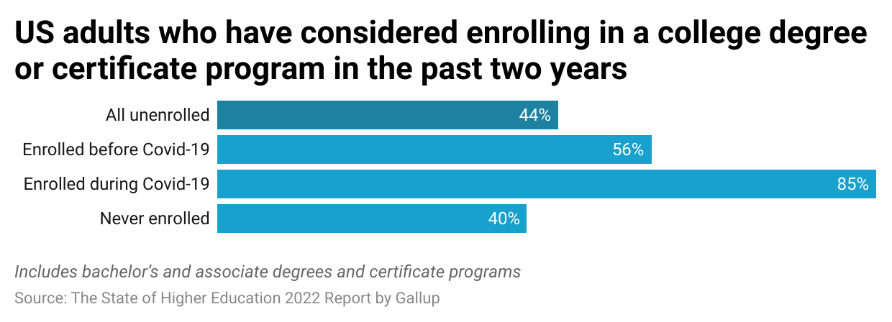

Higher EdTech market players targeting students (B2C) can play a pivotal role in seizing this opportunity and driving growth of the higher EdTech market. They are in a stronger position compared with traditional higher ed institutions to meet evolving skill requirements by employers and satisfy the modern student’s needs by offering lifelong learning models, cost-efficient and flexible learning options, and collaborations with employers. They also promise greater diversity, equity, and inclusion, being accessible by a broader range of students.

With regard to those who target higher ed institutions (B2B), [a higher ed consulting firm](https://www.edsurge.com/news/2022-06-21-higher-ed-is-investing-in-student-success-tech-is-it-a-new-golden-age-or-just-vague-talk) noted that their growth thus far mainly stemmed from relatively small, private, non-profit colleges for whom solutions could be more easily deployed. Solutions to support large institutions with multiple degree programs and multiple schools, however, is reportedly still a few years away.

The pandemic has certainly hastened the adoption and upgrade of higher EdTech among institutions. As they move into the post-pandemic era, higher EdTech providers are well-positioned to transform the higher ed landscape, provided they continue to meet evolving skill needs, adapt to student profiles, and improve accessibility.

©2024 Uzabase, Inc. All Rights Reserved. The information contained herein: (1) is proprietary to Uzabase Inc. and/or its content providers; (2) may not be copied or distributed; and (3) is not warranted to be accurate, complete or timely. Neither Uzabase Inc. nor its content providers are responsible for any damages or losses arising from any use of this information.