# **LegalTech: Overview**

## 

LegalTech has been gaining traction for some years now, and the case for its adoption is strong. In fact, a venture capital firm reported that the LegalTech market accounted for 20% of the legal industry in 2018. The pandemic, however, led to legal professionals working remotely and court proceedings moving online, and this catapulted the legal system’s adoption of technology. Consequently, the global LegalTech market, which was valued at USD 17.3 billion in 2019, with North America accounting for just under half, is expected to expand at a CAGR of 6.4% to reach USD 25.2 billion by 2025.

## **What is LegalTech?**

LegalTech, sometimes referred to as LawTech, is the application of technology and software to support the legal industry and provide legal services. It seeks to simplify, optimize, and automate various legal processes and operations. Some of the activities it supports include law practice management, contract management, document management, electronic discovery (e-discovery), and various legal needs of families.

Users of LegalTech can be broadly categorized as law firms and individual attorneys (B2B), small and medium-sized businesses and in-house legal departments of larger enterprises (B2B), alternative legal service providers* (ALSPs; B2B), and individuals and families (B2C). B2B tools support those entities with their legal workflow, while B2C tools include commoditized legal solutions that assist individuals and families with interpreting the law and accessing the justice system (B2C tools are also referred to as DIY and retail law tools). LegalTech tools can also be distinguished based on whether they support specific legal tasks, provide supporting processes, or form a technological infrastructure for legal workflows.

*\* ALSPs provide legal services without being law firms and include legal process outsourcers and the Big Four (Deloitte, EY, KPMG, and PwC).*

### **The LegalTech ecosystem has expanded over time to include several product categories**

### 

Source: Compiled by SPEEDA Edge

Statista reports that 76% of law firm practitioners surveyed in 2020 said that their law firm used LegalTech tools for legal research, followed by records management (64%) and e-discovery (62%). Meanwhile, 56% of in-house legal departments said they used LegalTech tools for contract management.

### **Top LegalTech tools used worldwide as of March 2020**

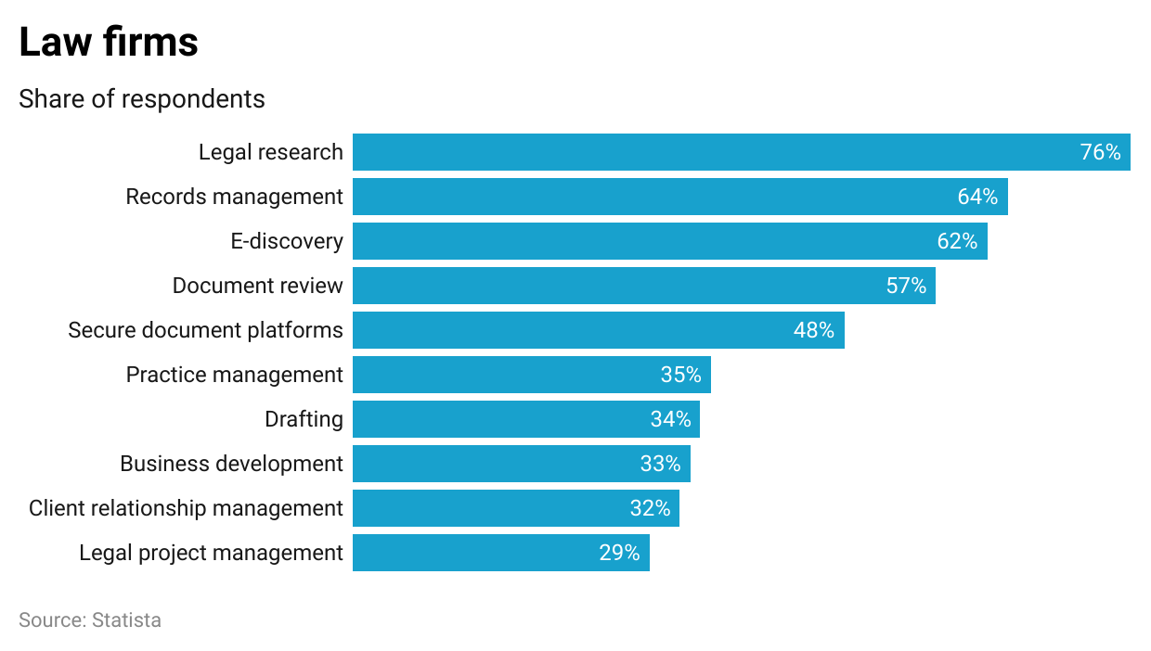

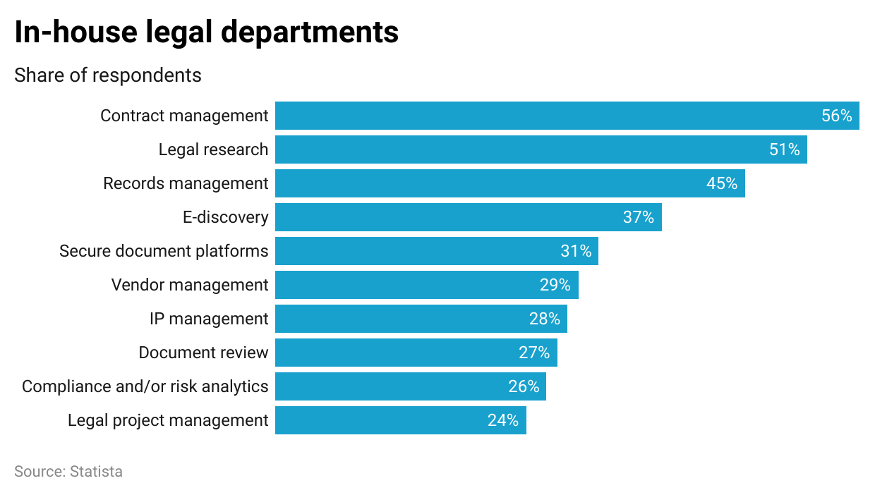

### **LegalTech (and non-LegalTech) can be applied across entire workflows to improve overall productivity as exemplified by this typical contracting workflow:**



Source: Radiant Law

## **How has the industry evolved?**

LegalTech is hardly new. The Bureau of National Affairs, a provider of legal, tax, regulatory, and business information for professionals founded in 1929 (acquired by Bloomberg in 2011 and now known as Bloomberg Industry Group), can be considered a pioneer in the space. Technology has catalyzed change in the legal industry, particularly since the dawn of the new millennium, with Legal Process Outsourcing gaining wide acceptance in the 2000s.

The tipping point for the LegalTech industry is considered to be 2010, following the Great Recession of 2007–2009. The financial crisis led to enterprises increasing their demands on law firms while exerting downward pressure on costs, building in-house legal teams as a more cost-effective option, and seeking to standardize legal processes (such as contract management) across departments. Law firms faced increased rivalry to attract and retain clients, competition from new entrants that didn't follow the traditional law firm model, and a data overload with email communication becoming an industry mainstay. That decade also saw the emergence of several LegalTech startups that helped individuals gain access to justice more easily with, or even without, a lawyer. In fact, 84% of the companies listed in the Stanford CodeX TechIndex, a directory of LegalTech firms, were founded after 2010.

More recently, technologies such as AI, blockchain, natural language processing (NLP), and robotic process automation (RPA) have boosted the industry. These technologies can be used to automate routine tasks, aiding consistency and reducing errors.

The Covid-19 pandemic is the latest catalyst in the evolution of the LegalTech industry. With remote work being the order of the day, legal practitioners were forced to reimagine their processes. A [study commissioned by American LegalNet](https://www.lawjournalnewsletters.com/2021/07/01/the-future-of-litigation-workflow-reimagining-technology-and-process-in-the-next-decade/) in 2021 to understand the pandemic’s short- and long-term impacts on litigation found that 79% of law firm leaders believed that it had indeed transformed the way litigators approach their work.

## **What’s driving demand?**

**Law firms and in-house legal teams on a quest to be more productive and cost-effective.** These entities have long resisted automation. Particularly since the outbreak of the pandemic, however, they have realized that LegalTech solutions allow them to manage time and other resources better and ultimately improve productivity and effectiveness.

By automating various activities usually handled by junior associates (one [article](https://spd.group/tech-for-businesses/legal-tech-in-2021/) estimated that more than 60% of lawyers’ tasks can be automated), law firms can reduce the risk of human error, provide more value to their clients, and even consider expanding their business. What’s more, critical, yet time-consuming, activities such as legal research can be improved with easier access to digitized documents and targeted search functionality. The availability of LegalTech solutions may even move clients to push back on billable hours, on the basis that some work carried out by junior lawyers can be automated.

In-house legal teams, moreover, are also under pressure to lower legal costs and reduce dependency on outside counsel, making them more open to applying LegalTech solutions. According to a [2020 Gartner survey](https://www.gartner.com/smarterwithgartner/5-legal-technology-trends-changing-in-house-legal-departments) of legal leaders, legal departments expect the proportion of their legal budget spent on technology to increase 3x over 2020–2025 (compared to a 1.5x increase over 2017–2020) and expect 50% of legal work related to major corporate transactions to be automated by 2024 (up from 33% in 2019).

**Expansion of the legal services ecosystem with the entry of new market players.** Particularly since 2010, the legal services industry has witnessed the entry of several LegalTech startups and ALSPs. Their entry into this lucrative market is not surprising; the LegalTech market alone is estimated to generate revenue in excess of USD 25 billion by 2025. What’s more, according to the [2022 Am Law 100 Rankings](https://abovethelaw.com/2022/04/a-detailed-breakdown-of-the-2022-am-law-100-rankings/), the average revenue per lawyer (across the 61 law firms that participated in the study) was USD 1.18 million in 2021 (up 12.5% YoY) and profits per equity partner averaged USD 2.66 million (up 19.4% YoY), indicating that the market is ripe for the picking. Greater funding opportunities, technological developments, and falling technology costs have also aided the entry of LegalTech startups.

Outside the US, legislative changes have fueled the entry of non-legal participants. The UK’s Legal Services Act 2007 allows non-lawyers to own and manage law firms. Similarly, in Australia, there are no limitations on the type of businesses a law firm can operate, and non-lawyers can own shares in law firms. Permissions and restrictions vary within the EU: in Germany, only lawyers can represent clients in court or give legal advice (subject to strict fee schedules), but in at least 14 other countries non-lawyers can provide legal advice; in Scotland, Italy, Spain, and Denmark, some non-lawyer involvement in firms is allowed, but most EU countries do not permit non-lawyer management and ownership of law firms. These developments may influence the industry in the US. Currently, in the US and Canada, non-lawyers are generally prohibited from representing clients in court, providing legal advice in specific areas of law, and owning and investing in law firms, but there are some limited roles for non-lawyers. For instance, they may play a limited part in areas such as business advertising, patents, tax, and immigration, and, of course, set up LegalTech firms.

Interestingly, the entry of these new firms creates competition for traditional law firms and propels their efforts to be more flexible and competitive, ultimately driving demand for LegalTech solutions.

**Clients demand more transparency, communication, and value for money.** When selecting legal counsel, clients value the opportunity to choose from among several and examine their track records. Thereafter, they want to be kept abreast of progress, legal billing hours, and next steps; in short, maximum value per legal fee dollar. Clients also want more convenience such as minimal paperwork, improved communications, faster response time, and fewer in-person meetings. Law firms’ increased customer focus is driving demand for LegalTech.

**Unmet need for legal services from people and businesses that can’t afford them.** According to a survey by the [World Justice Project](https://worldjusticeproject.org/sites/default/files/documents/WJP%20Access%20to%20Justice-Online%20Version%20%281%29.pdf) in 2018 of people’s legal needs and access to justice, only 38% of US respondents who experienced a legal problem in the previous two years were able to access legal or professional advice. Solutions provided by LegalTech firms help to meet this need.

**Cybersecurity risks of using on-premises software.** When the pandemic forced law firm employees to work remotely, accessing premises-based systems hampered their productivity and increased firms’ vulnerability to cyber attacks. This led law firms to invest in cloud-based solutions. According to the [2021 MyCase Legal Industry Report](https://info.mycase.com/rs/196-INY-394/images/MyCase_2021-Industry-Report.pdf), a survey of 2,000+ legal professionals revealed that 88% used cloud computing one year into the pandemic, up from 76% in the pre-pandemic era. Besides offering protection against cyberattacks, cloud computing systems are cost-effective and offer anytime-anywhere access.

**Challenges associated with sourcing and retaining legal talent.** Legal professionals have been part of the Great Resignation—their desire for more flexible work arrangements has been at odds with firm leaders’ mandated office attendance days. Moreover, law school graduates have more options to choose from, including becoming legal service delivery entrepreneurs in the LegalTech space. As a result, law firms and in-house legal departments are compelled to turn to LegalTech to cope with the shrunken talent pool amidst increased post-pandemic workflow, such as the growth in M&A and funding transactions.

**We exclude the following areas when selecting companies for this industry:**

* Regulatory technology (RegTech), which is the use of technology to help corporations (particularly financial service companies) manage their regulatory compliance.

## **What are the challenges?**

**Resistance to change.** The legal profession has long been resistant to technology adoption; this stemmed from a general resistance to change, fears of redundancy, and security concerns. Nevertheless, the upheavals caused by the pandemic are breaking down these barriers. According to [Thomson Reuters’ 2021 Report on the State of the Legal Market](https://www.lawyersweekly.com.au/biglaw/30934-resistance-to-legal-tech-fast-evaporating), 85% of law firms planned to increase their investments in technology during the year.

**Difficulty selecting best-fit solutions.** Given the large number of LegalTech solutions available, there can be confusion as to which are best suited to meet the needs of a specific law firm or legal department. Legal professionals themselves may require guidance in identifying and prioritizing their practice’s needs.

**Perceived loss of learning opportunities for junior lawyers.** Legal professionals have traditionally started their careers doing administrative, rules-based, and process-driven tasks that can now be automated with LegalTech. While some may consider this a loss of learning opportunities, it allows juniors to be redeployed to other tasks requiring analysis and judgment, resulting in a higher quality of training earlier in their careers.

**Interoperability remains a critical factor in purchasing decisions.** Legal teams need to find the mix of LegalTech products that works for them, and these need to work together seamlessly. Siloed solutions and one-size-fits-all models will only hinder market growth. According to [Bloomberg Law’s 2020 Legal Technology Survey](https://news.bloomberglaw.com/bloomberg-law-analysis/analysis-legal-tech-compatibility-is-more-than-just-integration), compatibility with technology already in use was the top consideration of law firms when evaluating third-party solutions.

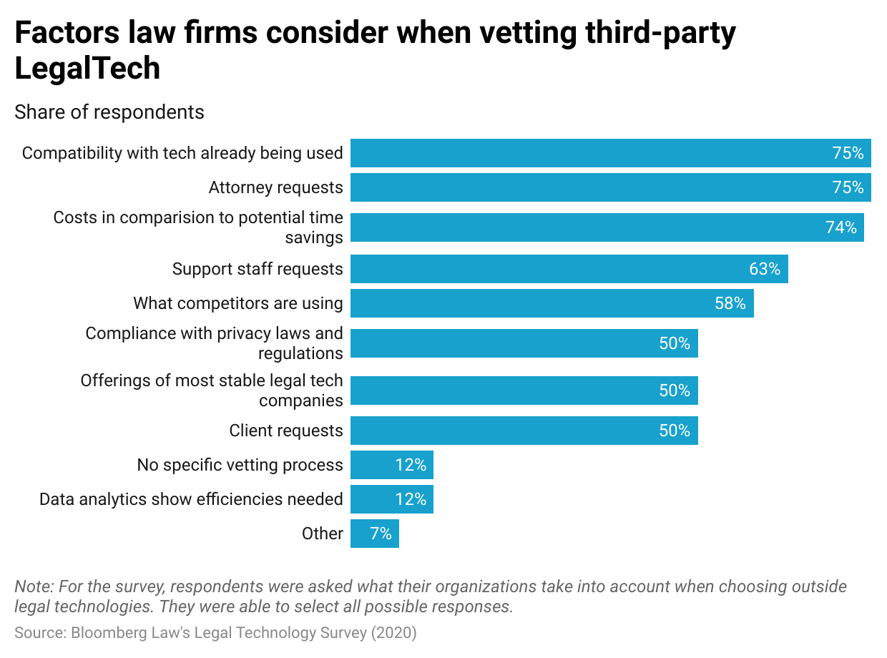

**Smaller firms minimizing the risk of cyberattacks.** According to cybersecurity firm [Coveware’s Ransomware Report for 2021](https://tech.co/news/82-of-ransomware-attacks-target-small-businesses-report-reveals), 81.6% of ransomware attacks targeted small- and medium-sized businesses with less than 1,000 employees. By industry sector, professional services firms made up 20%–25% of businesses that suffered ransomware attacks. This was attributed to a combination of ransomware gangs shifting to “mid-game hunting” (i.e., focusing on SMEs), given its lower operating cost and lower media and law enforcement attention, and a lack of cybersecurity preparedness among smaller firms who believed they were too small to be targeted. This lethargy poses a challenge to the adoption of secure, cloud-based LegalTech solutions.

## **What’s the verdict?**

The legal profession may have been resistant to change and slow to adapt, but world events, client demands, and technological developments have forced it to innovate or risk being left behind.

Law firms and legal departments that do embrace change put themselves in line to become technology leaders who are potentially more profitable, better able to adapt to changing market conditions, and more likely to continue investing in technology—further distancing themselves from late adopters. They are also likely to take a holistic approach to applying LegalTech solutions.

In light of this, we believe that the LegalTech market's long-term growth is dependent on LegalTech firms actively contributing to an ecosystem comprising interoperable and customizable solutions.

©2024 Uzabase, Inc. All Rights Reserved. The information contained herein: (1) is proprietary to Uzabase Inc. and/or its content providers; (2) may not be copied or distributed; and (3) is not warranted to be accurate, complete or timely. Neither Uzabase Inc. nor its content providers are responsible for any damages or losses arising from any use of this information.