# **Marketing Automation: Overview**



## **Making marketing more efficient and personal**

Marketing automation (popularly referred to as MarTech) refers to the tech-driven applications and tools used to enhance digital advertising and marketing functions. With the growth in digital channels and shifting consumer preferences toward personalized experiences and online activities, firms of all sizes have turned to MarTech for their marketing needs. This is reflected in such technologies accounting for the highest allocation in a firm’s marketing budget (30% in 2022) with 83% of chief marketing officers (CMOs) expecting a further increase in 2024.

There are a range of use cases that fall under marketing automation (referred to as the MarTech stack) ranging from identifying and attracting potential customers with personalized ads to managing and automating marketing campaigns to quantifying the impact of marketing campaigns. There are also many product names, such as account-based marketing (ABM), customer data platform (CDP), and search engine optimization (SEO), which are sometimes used interchangeably. Overall, we classify these tools into four broad categories: 1) AdTech 2) Marketing intelligence and management 3) Marketing campaign automation and 4) Marketing data and analytics.

These tools provide a “best-in-breed” solution for a specific component/s in the stack. There are also “all-in-one” platforms that provide the full suite of services covering the entire customer marketing experience, known as marketing cloud. Most of the incumbents (e.g., Oracle, SAP, Microsoft, and Salesforce) operate in the marketing cloud segment, while a few startups have also positioned themselves as offering an all-inclusive marketing platform. Startups in this space typically specialized in particular segments, and over time, through acquisitions, added services in order to become all-in-one platforms.

### 

### 

### 

### 

### 

### 

### 

### 

### 

### 

### 

### 

### 

### 

### 

### 

### 

### 

### 

### **Marketing automation stack taxonomy**

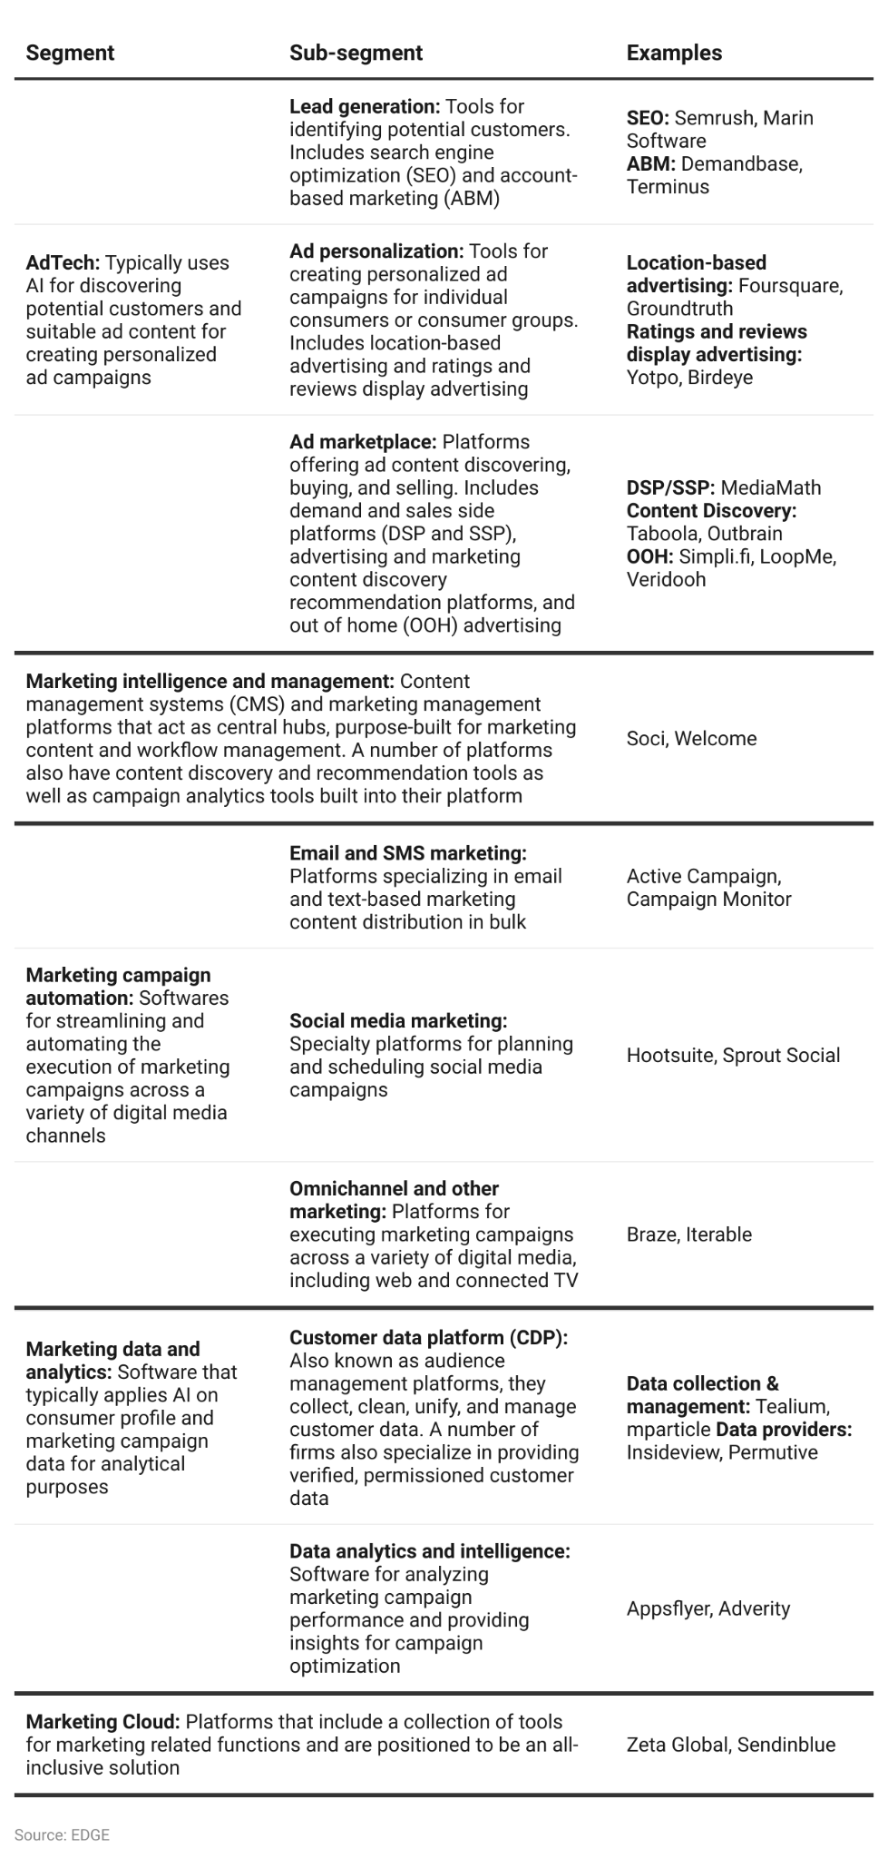

We have confined our report to startups where the primary use case of the services is to enhance marketing functions. Hence, we have excluded standalone tools, such as content creation and design apps (Contently, Canva) as well as website traffic analytics tools (Mixpanel, Hotjar), which have not been purpose-built for marketing teams. In addition, marketing consultancy services, including marketing campaign strategizing and MarTech stack optimization, which are primarily provided by marketing agencies, have been excluded from the scope, as it’s not an area of focus for many startups.

### **The MarTech stack**

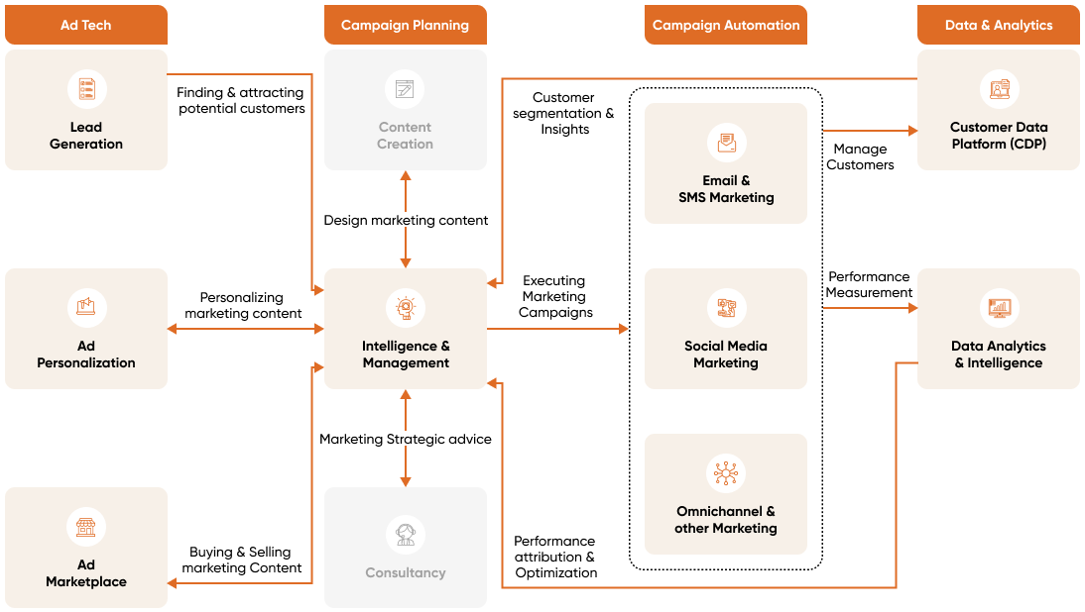

###### Source: EDGE

## **Digital transformation creates new customer touchpoints**

Improvements in communication technology (smartphones, broadband internet) have transformed or introduced new digital forms of communication (social media, smartphones), media channels (connected TV, podcasts), and marketplaces (ecommerce, online auctions), creating new opportunities for company-customer interaction. Next-gen technologies such as 5G are expected to further drive this trend with their use in the Internet of Things (IoT), wearable tech, voice-activated search as well as augmented and virtual reality.

This trend has brought about opportunities for digital marketing across a variety of consumer channels. Compared to traditional marketing channels (newspapers, billboards, magazines), digital marketing is able to reach a wider target audience and generate more interactions.

The digital transformation has also been accompanied by an explosion in the volume of customer data, generated by varied customer touchpoints.

Therefore, marketing automation is becoming essential for executing digital marketing campaigns on a mass scale, where key functions such as campaign scheduling, delivery, customer follow-ups, and performance reporting can be automated, saving businesses time.

## **AI and ML advancements revolutionizing marketing landscape**

While tools such as SEO and automated bulk email marketing systems have been in use for more than a decade, advancements in AI and ML have broadened the use cases of marketing automation tools, replacing or complementing marketing functions previously handled exclusively by humans. With its ability to sift through masses of consumer data generated from multiple marketing channels, AI and ML have the capability to 1) recommend suitable marketing content and predict its performance; 2) build a holistic consumer profile, allowing for granular segmentation of customers; 3) personalize consumer experiences in real time; 4) automate customer interactions; and 5) accurately measure and attribute the performance of marketing campaigns, widening its application.

### 

### 

### **Use of AI and ML in marketing automation**

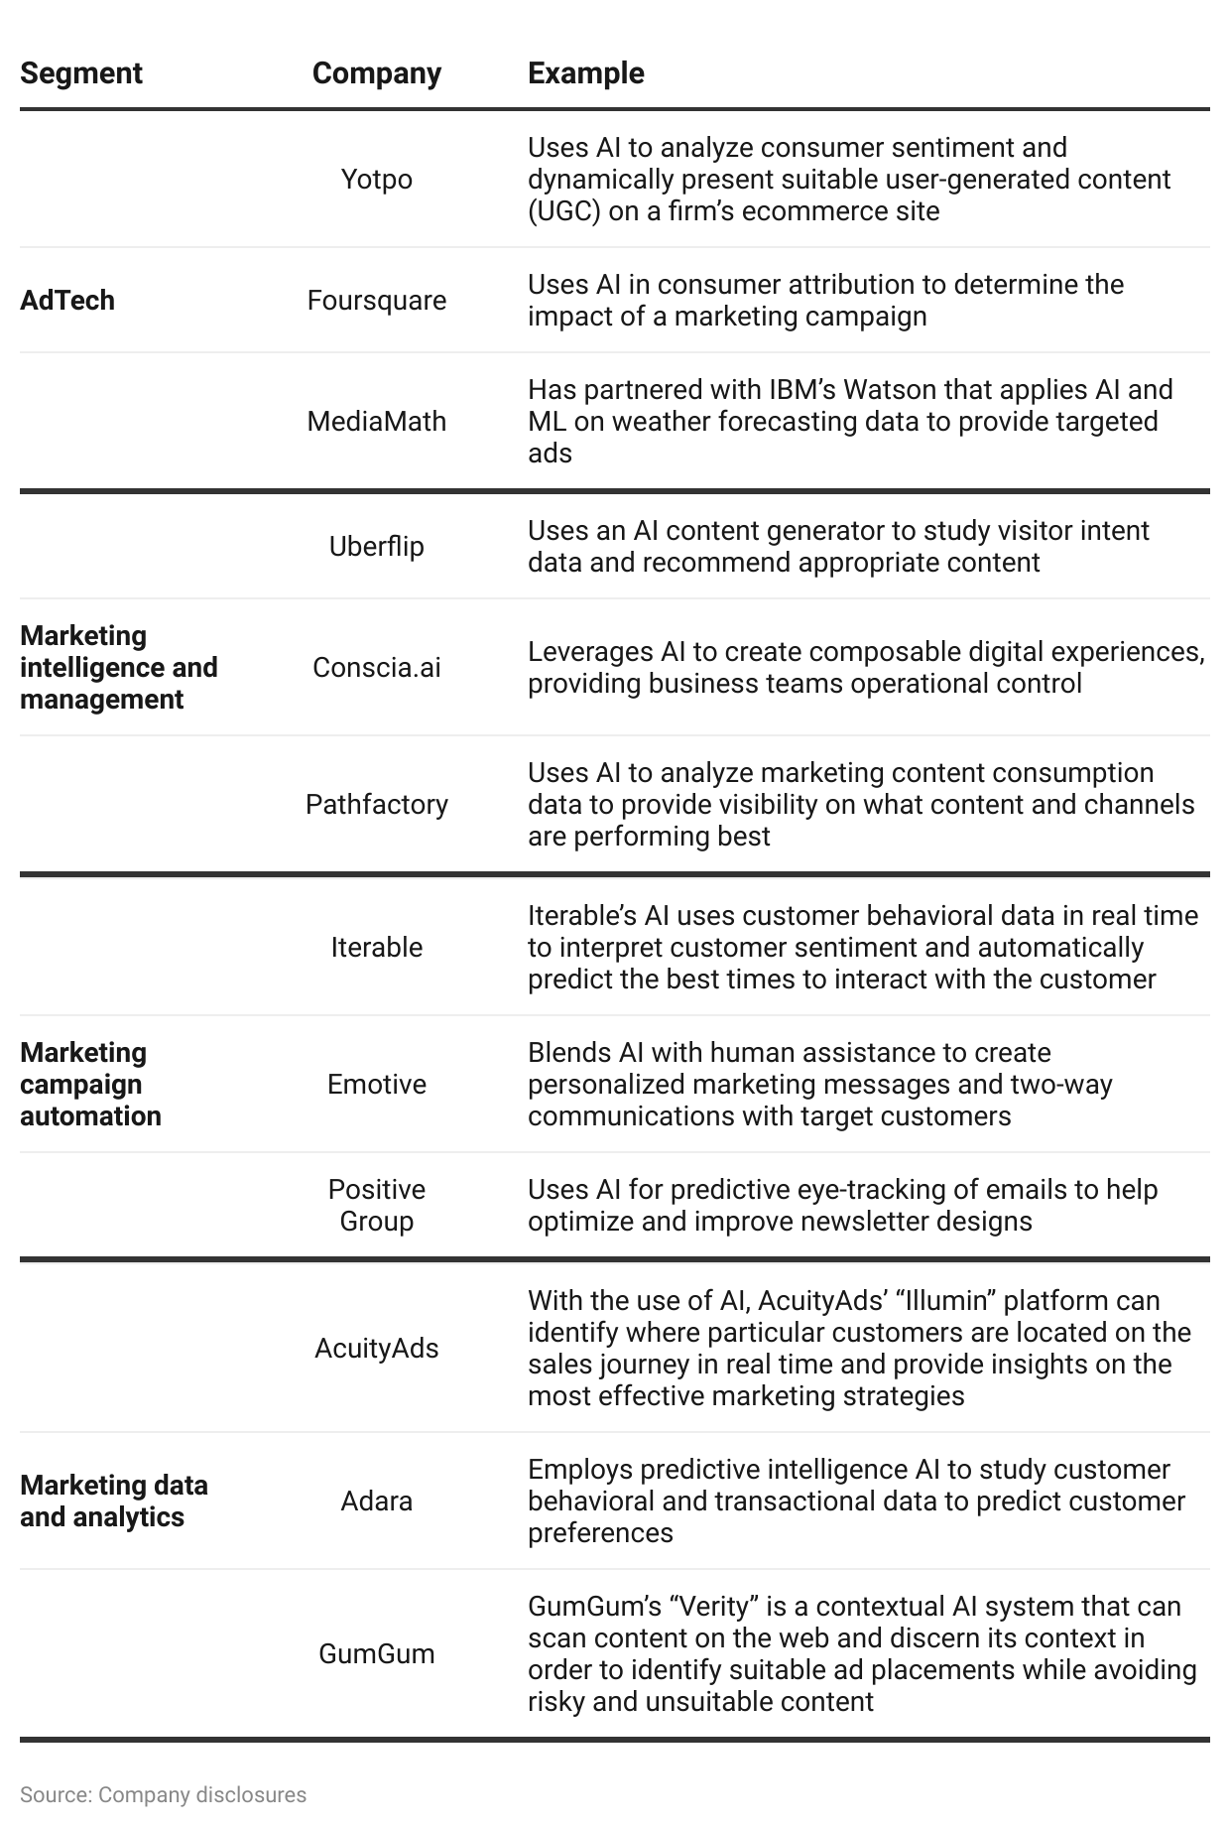

# **Driving factors**

## **1. Pivot to digital marketing as target audience moves online**

Over the past decade, consumers have increasingly been turning to digital channels to meet their entertainment and shopping needs. By 2022, US consumers were spending more than seven hours of their time consuming digital media over traditional mediums. At the same time, consumers are increasingly spending money via digital channels—online shopping in particular, as ecommerce sales have been steadily growing over the past decade, hitting an all-time high in 2022 with US sales reaching USD 1.04 trillion (a 8.5% YoY growth).

### **Ecommerce share of retail sales in the US (%)**

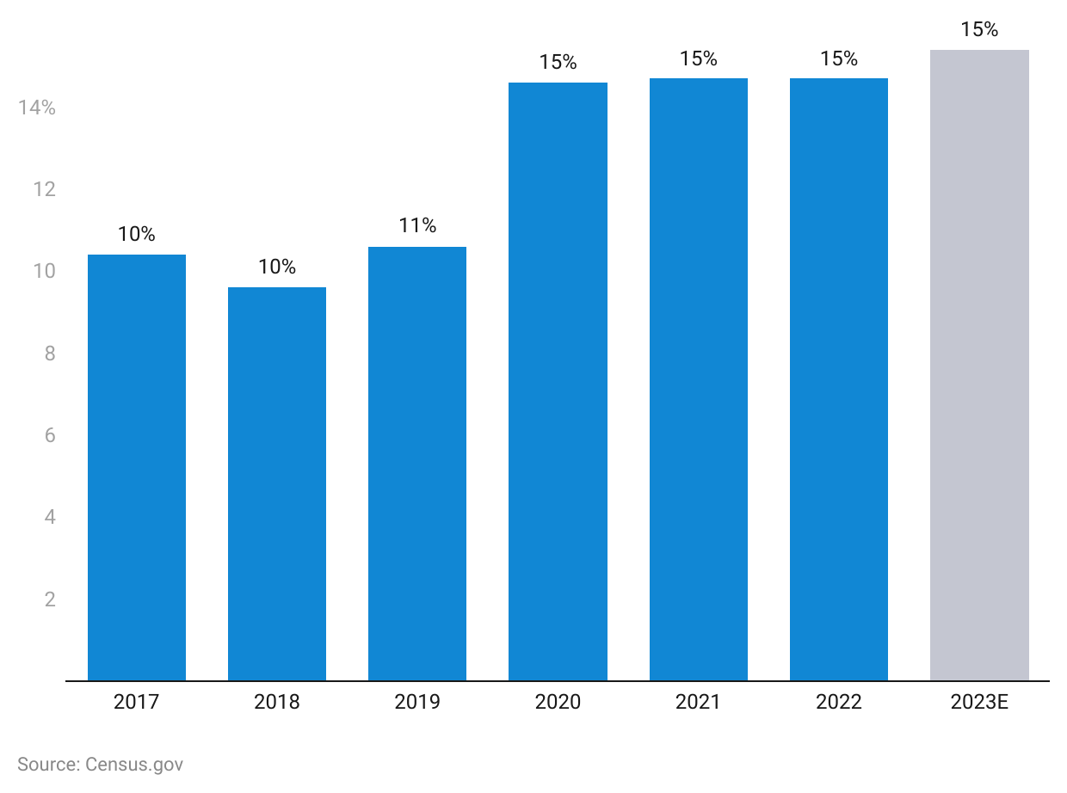

In response to these trends, a growing number of firms have realigned their marketing budgets away from traditional marketing channels (TV being the previous market leader) and toward digital advertising, which includes an ever-increasing number of channels (email, social media, web, mobile). These accounted for 67% of the total ad spend in the US in 2022 (USD 220.9 billion) and this share is expected to grow to around 70% of total ad spend by 2025.

As consumers move online and ad spending grows, the use case for a variety of marketing automation tools becomes stronger. For Instance, ecommerce brands would turn to lead generation tools such as SEOs to improve their brand’s visibility online, while campaign automation tools for sending consumer updates and reminders via a variety of digital channels would be essential for managing the growth in online shopping. In addition, managing the consumers’ digital footprint to provide customized experiences while adhering to data privacy standards, would make investing in CDPs a priority.

### **Digital ad spending accounts for the majority of ad spending**

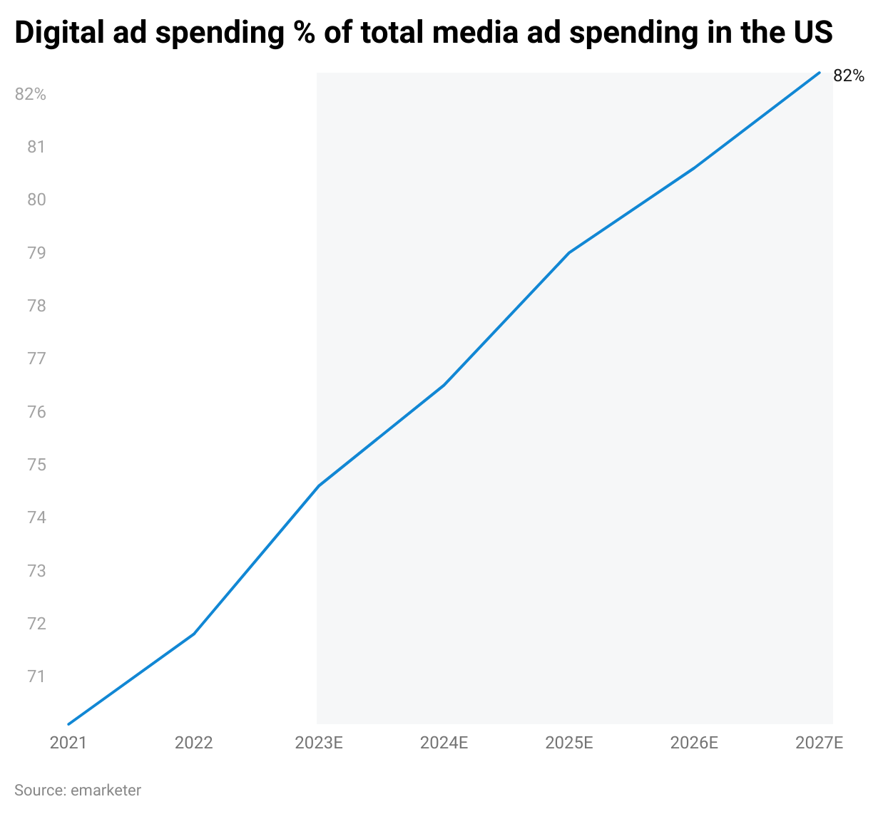

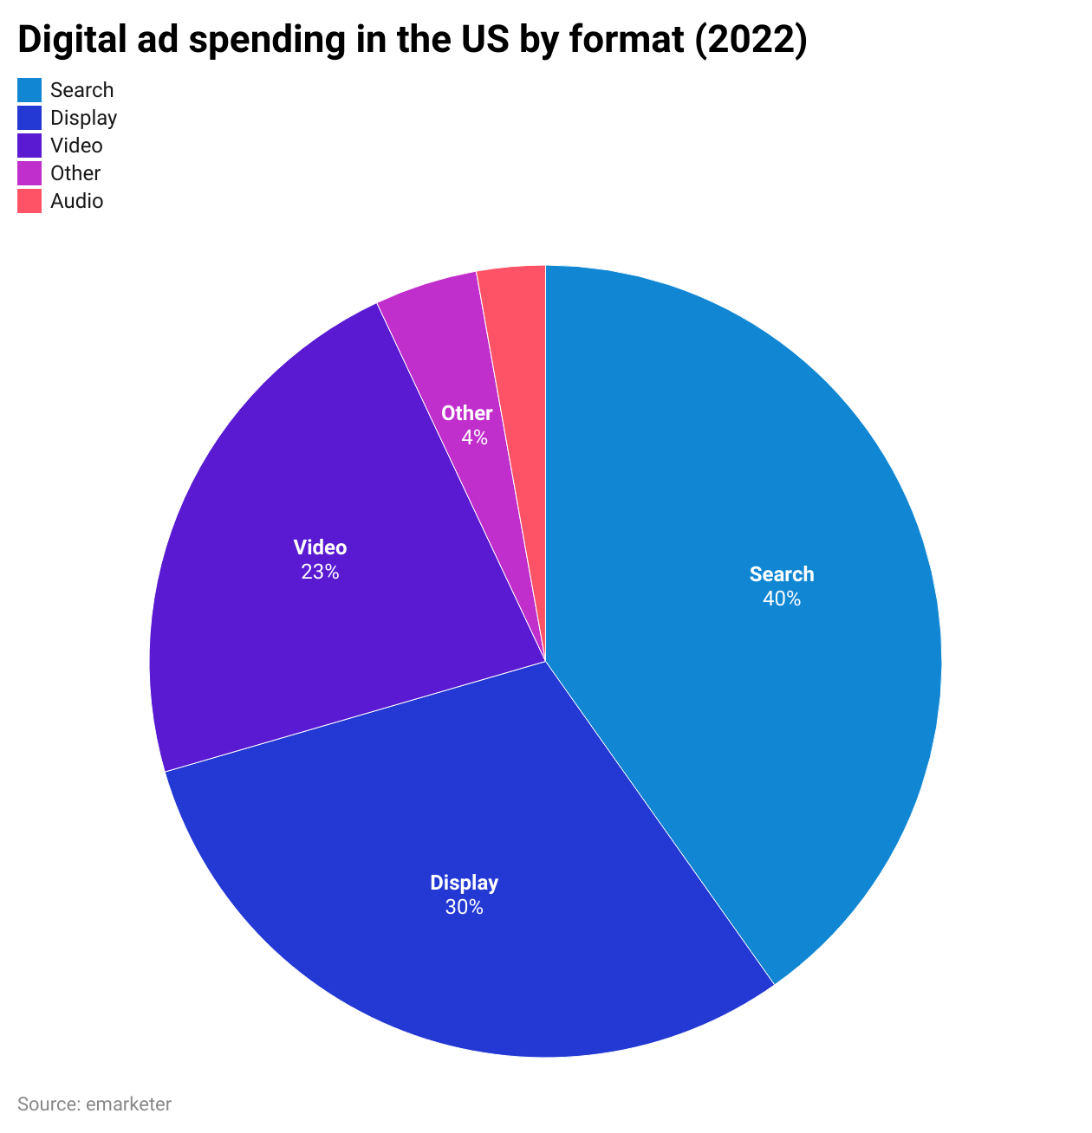

## **2. The rise of D2C brands and shift towards personalized experiences**

In recent years, consumers have stated that they are increasingly looking for personalized experiences when interacting with firms and their brands. For instance, 81% of shoppers are willing to provide their data for a more personalized experience. Delivering on this personalization has only been made possible through marketing automation. For instance, marketing automation allows brands to dynamically adapt their websites to customer preferences while executing personalized mass marketing campaigns.

This demand for a better consumer experience, coupled with the growing popularity of online shopping, has led both established brands as well as a growing number of entrepreneurs and small businesses to turn to direct-to-consumer (D2C) ecommerce. In 2020, D2C sales accounted for USD 17.8 billion of US ecommerce sales (a 24% YoY growth).

### **D2C buyers % of total Digital buyers**

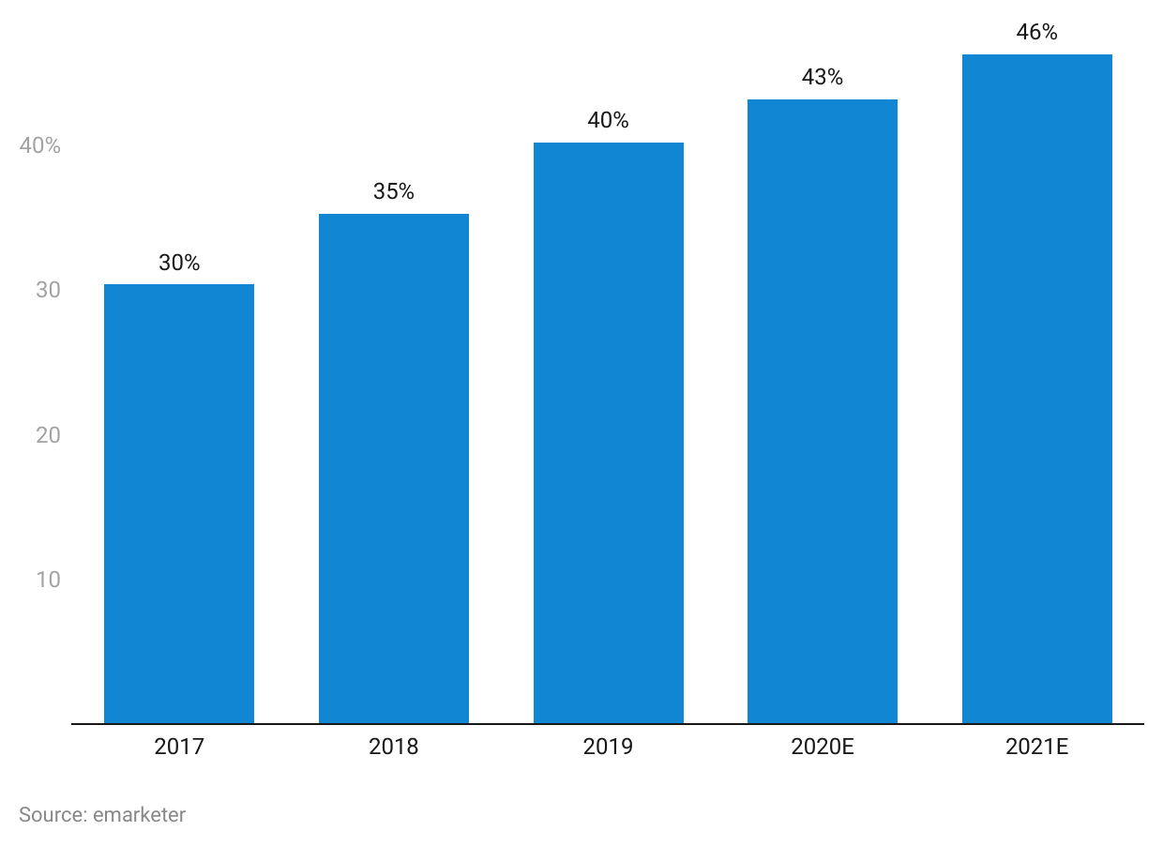

Email and marketing channel automation, UGC discovery platforms, SEOs, and AI-enabled chatbots and messaging services are some of the tools in demand by D2C brands. A case in point is [Simpli.fi](https://sp-edge.com/companies/32864), a DSP that has introduced new features to its platform, such as customer transaction insights, in response to increased demand from D2C brands. [Yotpo](https://sp-edge.com/companies/58246), an ecommerce marketing platform, has also launched a dedicated marketing course for D2C brands.

## **3. Marketing activities shift in-house with calls for greater visibility on expenditure**

In 2019, a CEO survey indicated that 83% believed marketing would be a key driver of its growth. Firms are becoming more aware of the need to align marketing spending with meeting financial objectives, with CMOs stating that they are coming under increasing pressure to demonstrate their value. Hence, improving marketing ROI and revenue attribution is amongst the top priorities of marketers.

This demand for visibility has also resulted in marketing activities shifting away from marketing agencies toward in-house development. In September 2020, CMOs stated that nearly 29% of marketing work previously carried out by agencies has been shifted in-house over the past year, while budgetary allocations to agencies continued to decline.

To facilitate this, marketing automation tools provide solutions where AI advancements have improved the precision for identifying and attributing the impact of marketing spending. The demonstrability of the value proposition of digital advertising has allowed marketers to justify increasing the marketing budget allocation for digital ad spend. This has meant a greater allocation toward hiring marketing talent as well as bigger investments in marketing automation.

### **The benefits of marketing automation improves over time**

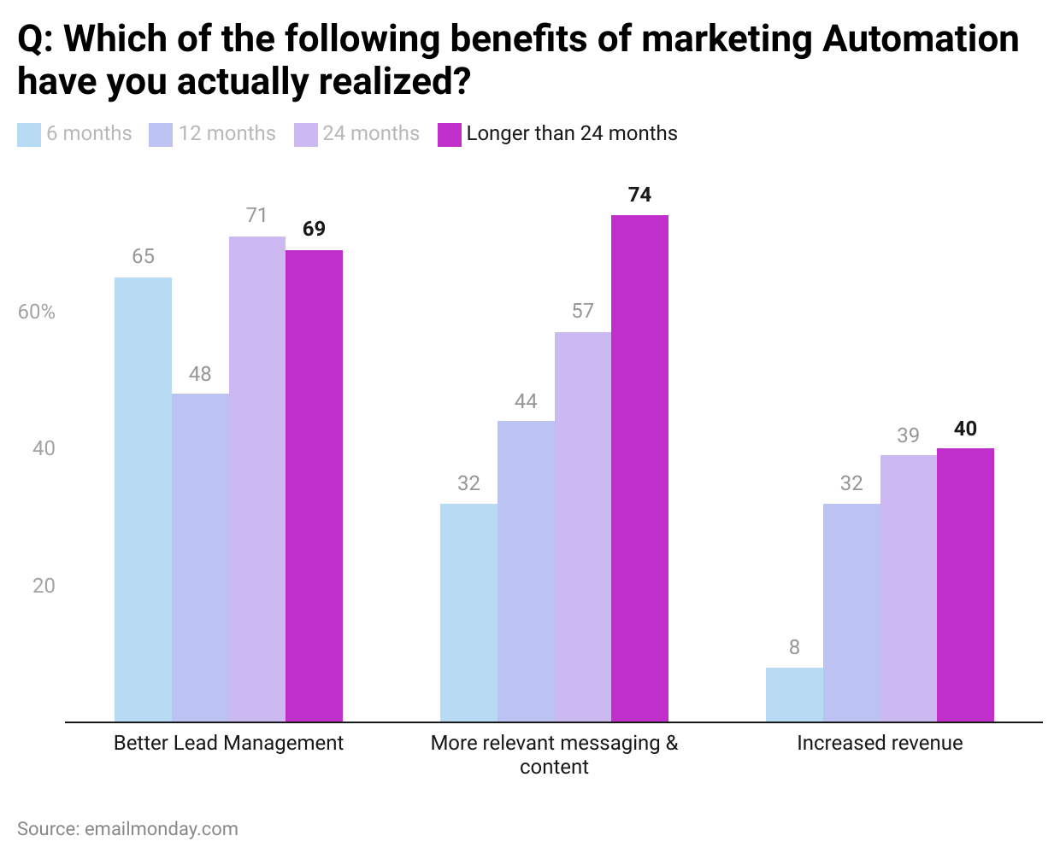

### **Increase in marketing budget allocation towards marketing automation**

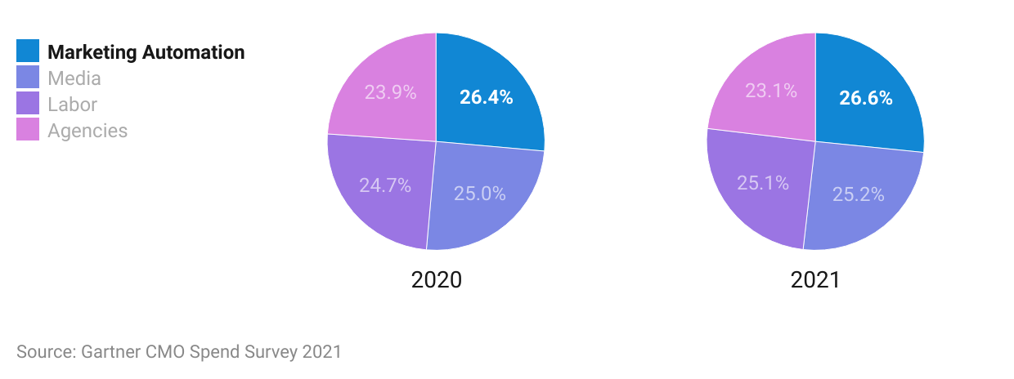

## **4. GenAI revolutionizes marketing and sales content creation**

Generative AI (GenAI) has revolutionized marketing by producing diverse, customized content for multiple platforms, enabling marketers to reach a broader audience without extensive manual effort. Generative algorithms, exemplified by platforms such as [Synthesia](https://sp-edge.com/companies/573127) and [Drafter.ai,](https://sp-edge.com/companies/780652) promise unlimited content generation, resulting in significant cost savings and reduced development efforts. In particular, GenAI excels at personalized content creation and has led to the development of dedicated content creation tools that have helped streamline and accelerate the marketing process. GenAI enables marketers to streamline processes, increase efficiency, and deliver personalized content that resonates with modern consumers. Read our [Insight](https://sp-edge.com/insights/17820) for more details.

According to a survey by [McKinsey,](https://www.mckinsey.com/capabilities/growth-marketing-and-sales/our-insights/ai-powered-marketing-and-sales-reach-new-heights-with-generative-ai) a significant number of marketing leaders expect the use of GenAI tools to increase over the next two years. The statistics highlight compelling reasons for this optimism: [90%](https://blog.hubspot.com/marketing/state-of-generative-ai) of marketers using AI find it effective for content creation, resulting in time savings of more than [five hours per week](https://venturebeat.com/ai/generative-ai-can-save-5-hours-of-marketing-hustle-every-week-salesforce-report/) for content creators. Additionally, 85% of marketing AI users use the technology for personalized content, demonstrating its role in catering to individual preferences. Deloitte's findings show that [82%](https://www2.deloitte.com/content/dam/insights/us/articles/4780_State-of-AI-in-the-enterprise/DI_State-of-AI-in-the-enterprise-2nd-ed.pdf) of early AI adopters have realized financial returns from their AI investments. Looking ahead, Forrester predicts that by the end of 2023, [10%](https://www.forrester.com/blogs/predictions-2023-ai/#:~:text=Ten%20percent%20of%20Fortune%20500,AI%2Dsupported%20digital%20content%20creation.) of Fortune 500 companies will be actively creating content with AI, indicating the growing influence of AI in marketing strategies.

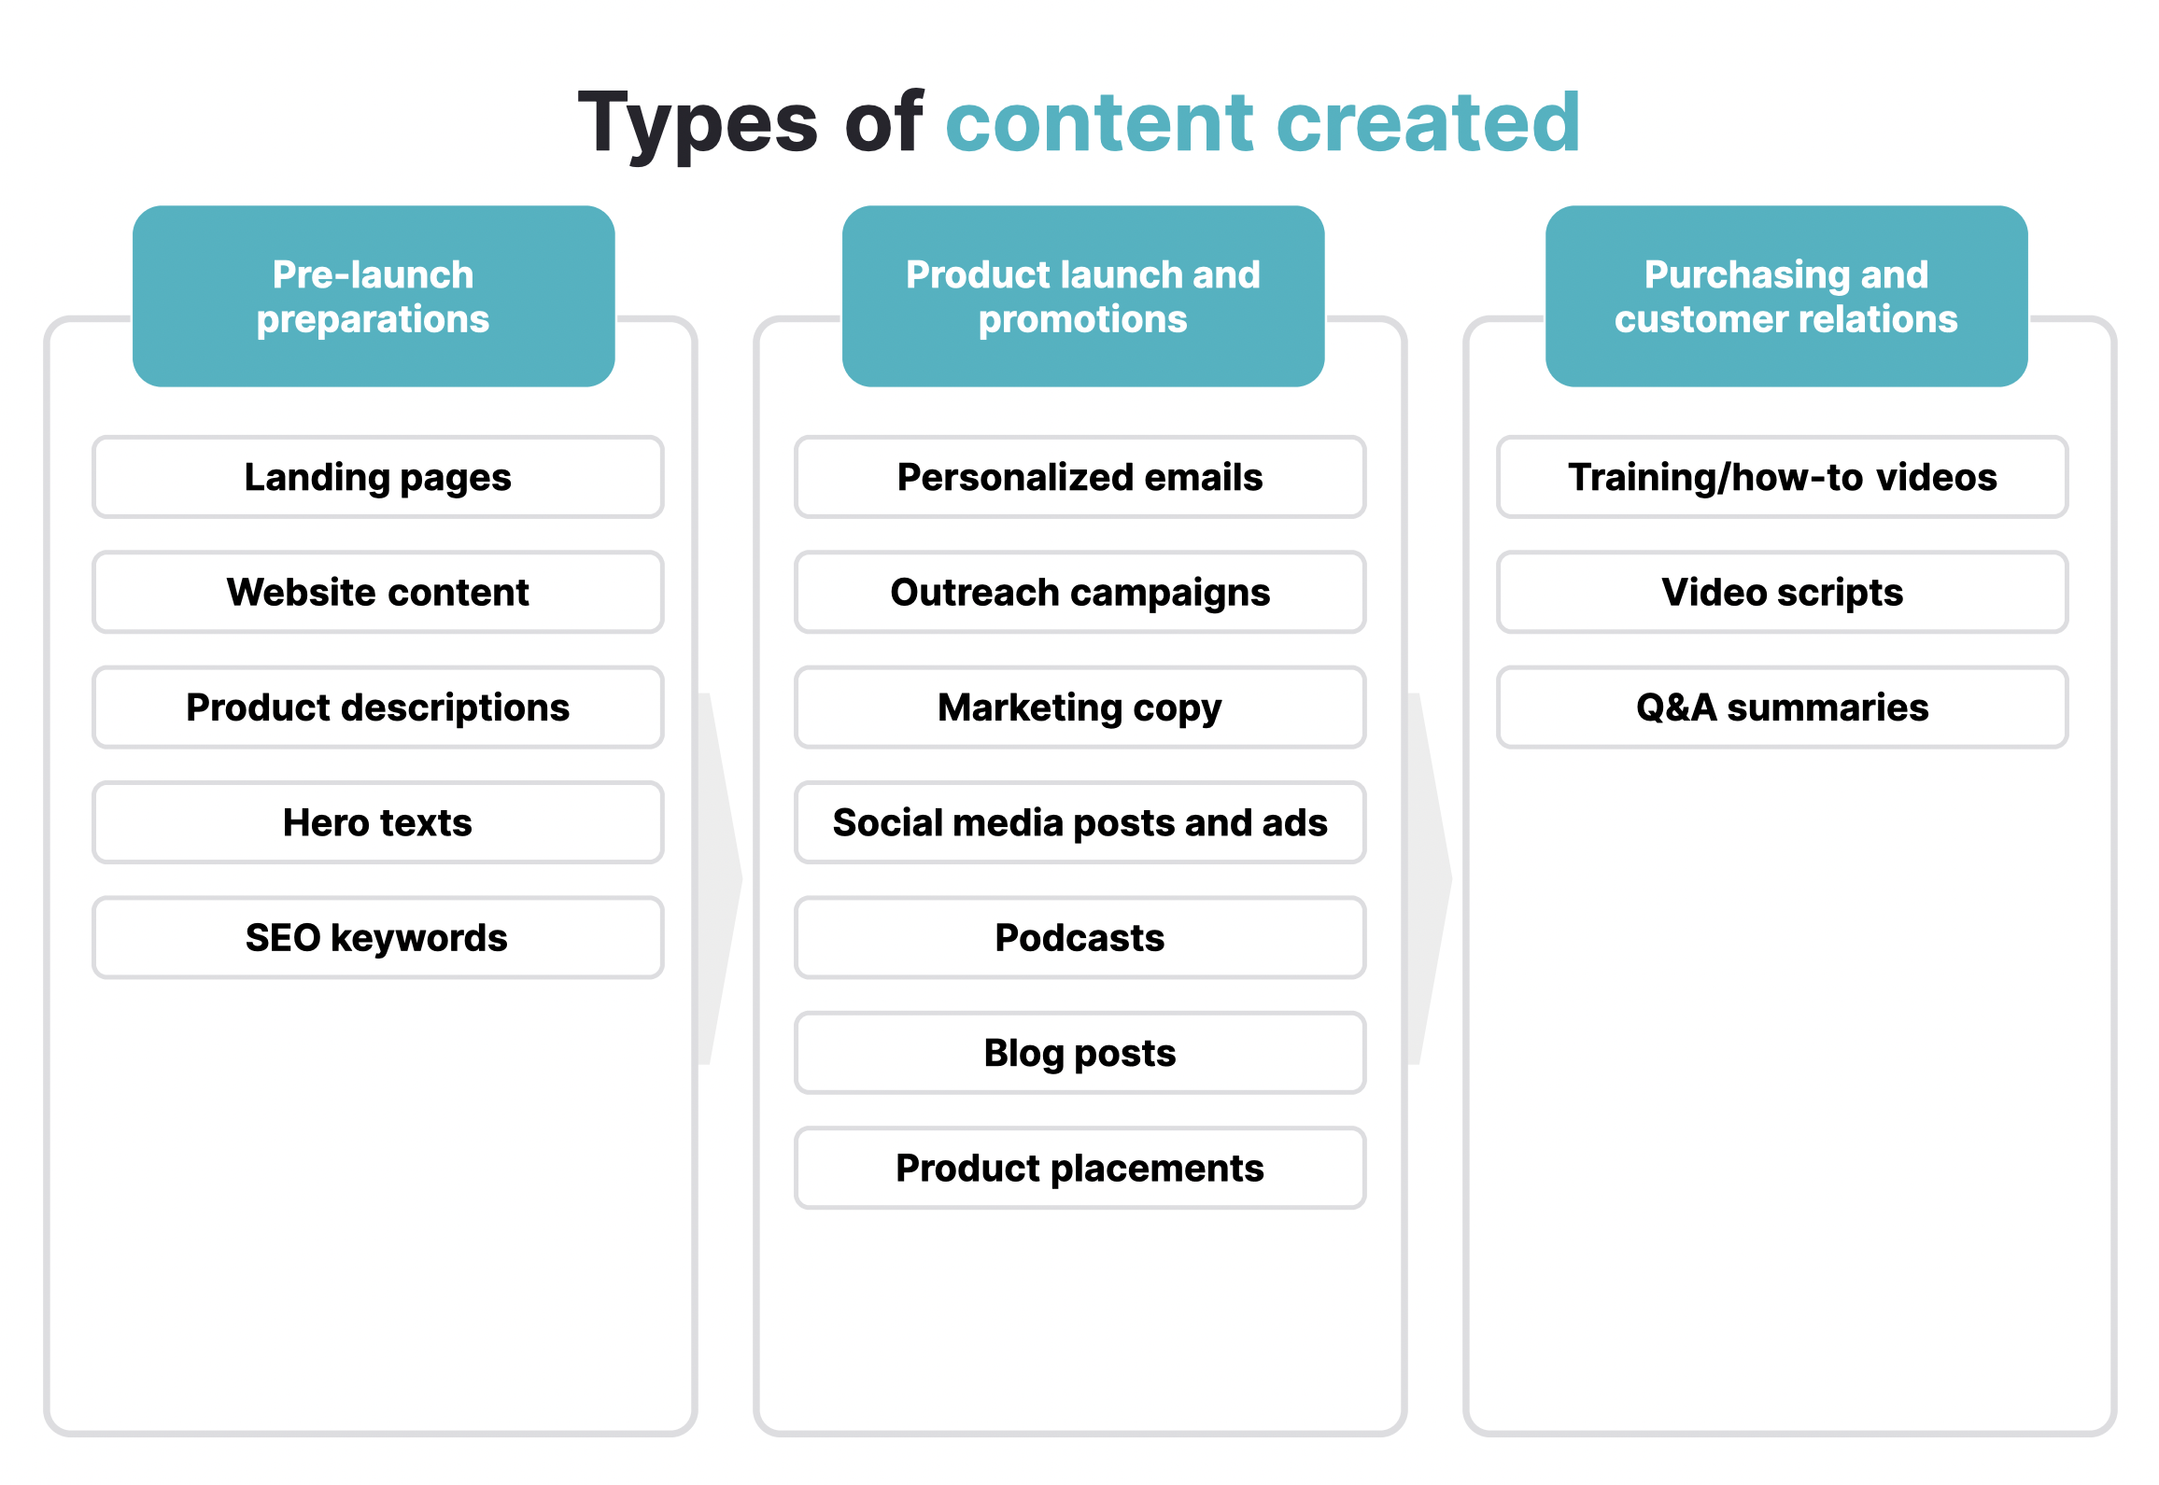

Source: Created by SPEEDA Edge

# **Risks to growth**

## **1. Privacy concerns leading to restrictive regulations**

With growing consumer concerns over privacy, and in response to legislative developments such as the General Data Protection Regulation (GDPR) and the California Consumer Privacy Act (CCPA), leading web browsers and search engine platforms have already or are in the process of phasing out tools such as third-party cookies embedded in websites that allow for the tracking of website visitors (known as data deprecation). Marketers at present are inadequately prepared to deal with this shift, which would greatly limit the granular analytics and insights due to the restrictions imposed on consumer data. While the market leader Google Chrome’s rollout of the [Privacy Sandbox](https://sp-edge.com/updates/21716) (in September 2023) represents a major shift away from third-party cookies to track user behavior, using advertising "Topics," has sparked controversy due to privacy concerns over direct access to users' browsing history for advertising purposes.

In addition, smartphone developers, such as Apple, are in the process of phasing out the identifier for advertisers (IDFA), which restricts the ability of firms to deliver personalized consumer marketing experiences and has impacted the revenue of social media platforms. See the Digital Privacy tools for further details on key developments in data privacy regulations.

In response to these developments, CDPs such as [Zeotap](https://sp-edge.com/companies/238083) have raised funds to develop its technological capabilities such as universal ID, which would improve visibility on third-party data to counteract the impact of the removal of third-party cookies.

### **Social media firms expected to lose USD 10 billion due to change in iPhone privacy settings**

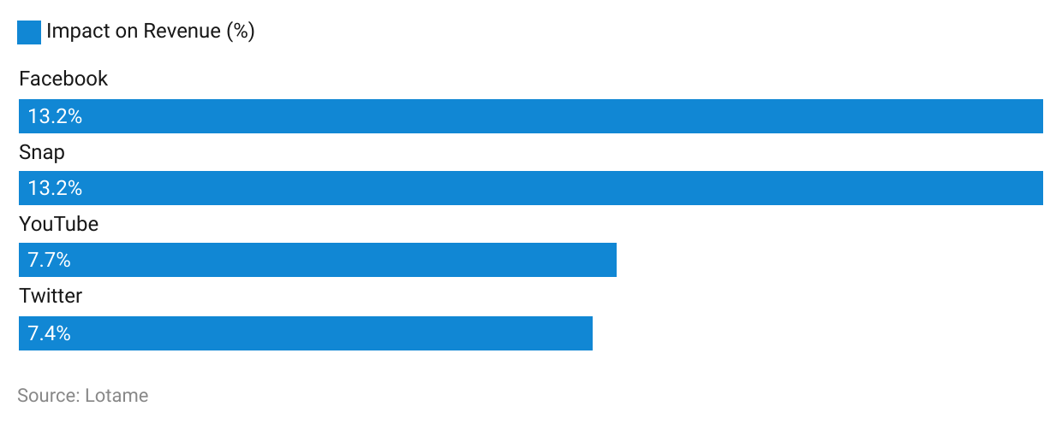

At the same time, this has also created new opportunities for marketing automation tools relating to data and analysis, with this segment recording the highest activity in 2019. With the data deprecation, demand for first-party data (data gathered with the customer’s consent) is expected to grow, with firms such as [Taboola](https://sp-edge.com/companies/1358) and [Blueconic](https://sp-edge.com/companies/204952) introducing their own first-party data platform. They have also been promoting the shift to first-party data as the future of marketing. In addition, there is a growth in demand for services that allow for the collection, storage, and monitoring of customer data to ensure compliance with the evolving regulations. For Instance, [Permutive](https://sp-edge.com/companies/297100) provides a CDP platform that makes use of edge computing to process and anonymize data on the customer’s device to enhance the security of the data.

## **2. Gen Zs dislike ads and pay to avoid them**

While digital channels have grown overall, Generation Z (those born after 1997) tends to choose media channels such as video gaming, paid music streaming, and paid video streaming services that typically present fewer opportunities for direct marketing to consumers. While there are marketing opportunities through cross channels, such as social media, where Gen Z consumption is high, studies show that they are less tolerant of ads (49% say they would pay to avoid advertising in gaming) while also being more mindful of data privacy matters, which may limit the scope for targeted marketing campaigns for this segment.

### 

### **Gen Zs have distinct media consumption preferences**

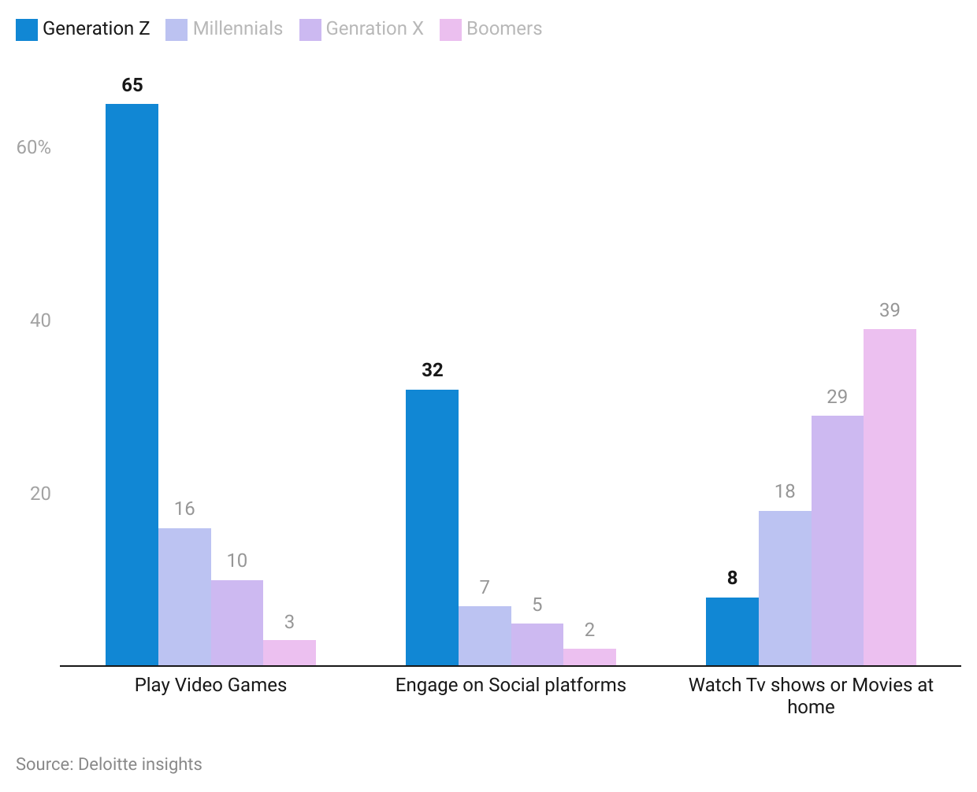

## **3. High churn rates and market saturation hurt investment allure**

The marketing automation industry is currently seeing a high degree of activity, which has led to a steep growth in the number of firms (some estimate as many as 8,000). This high degree of competition has led to a sharp growth in the number of tools to choose from, with some estimates suggesting that firms use 13 distinct tools in their marketing stack on average; other estimates are as much as 91 distinct tools. This has led to high churn rates for the services on offer, where firms have been known to frequently flit between various services or dispose of certain services altogether to find the right fit for their businesses. The ad personalization and marketing data and analytics subsegments have been particularly vulnerable to such actions, as firms view them as being “non-essential” for their marketing activities. In addition, industry consolidation has been taking place—615 firms were either consolidated or defunct in 2020, and this trend is expected to continue.

### **Significant growth in the number of MarTech firms over the past decade**

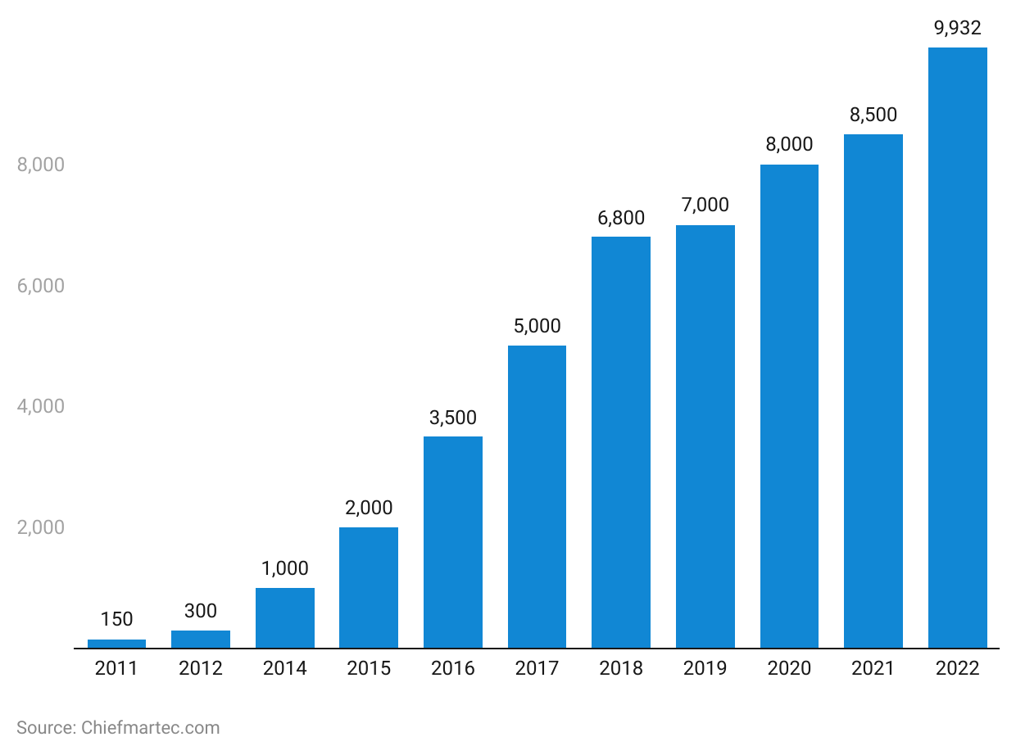

*Last updated: December 2023*

©2024 Uzabase, Inc. All Rights Reserved. The information contained herein: (1) is proprietary to Uzabase Inc. and/or its content providers; (2) may not be copied or distributed; and (3) is not warranted to be accurate, complete or timely. Neither Uzabase Inc. nor its content providers are responsible for any damages or losses arising from any use of this information.