# **Web3 Ecosystem: Overview**

## 

## **Web3–the next iteration of the world wide web powered by blockchain technology**

Web3 is the next iteration of the world wide web that aims to decentralize the web and move ownership of data and services from Big Tech corporations like [Google](https://sp-edge.com/companies/198735), [Amazon](https://sp-edge.com/companies/203208), and [Meta](https://sp-edge.com/companies/5) to developers and users.

The web’s very first iteration, Web1, emerged in the 1990s and consisted of a collection of static, read-only, text-based pages with little to no interaction between the content creator and consumer. This was the case until the development of Web2—the version of the web currently in use—in the early 2000s. Web2 offered internet users a more interactive experience, allowing them to consume, interact with, and publish content. Social media platforms would go on to elevate this concept, leveraging machine learning to deliver tailored content and drive engagement while converting user data into advertising revenues.

Web3 seeks to hand ownership of the web to its builders and users, using native platform tokens (digital assets) as a medium of exchange. It runs on blockchains—the same ones that power cryptocurrencies such as Bitcoin and Ethereum—to reduce dependence on a single entity. Web3 projects, be they lending operations or social media platforms, will operate under a [decentralized autonomous organization (DAO)](https://sp-edge.com/insights/9493) model, which is member-owned with democratized control and decision-making, delivering a level of corporate governance not provided by Web2.

### **The different iterations of the Web**

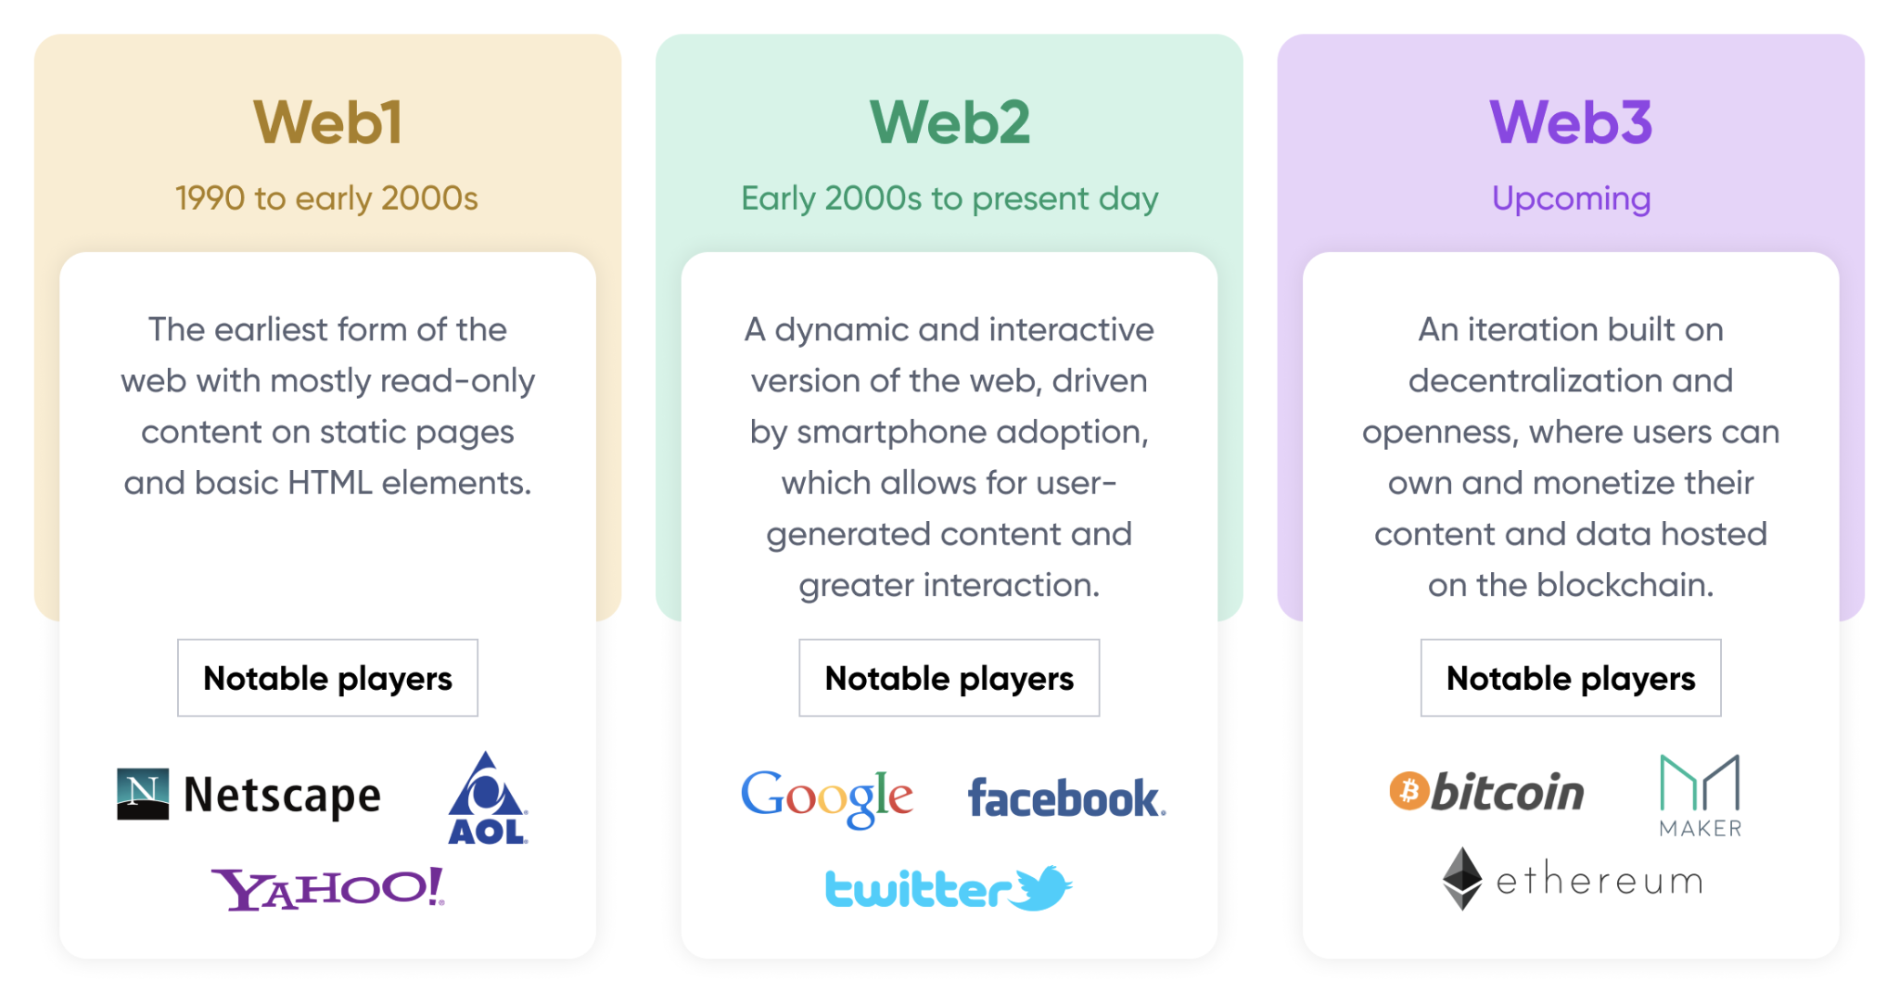

### Source: Compiled by SPEEDA Edge based on multiple sources

## **Scalability issues of the blockchain are set to be solved via layer-2 solutions and Ethereum’s own network upgrades**

The Ethereum blockchain is home to 60%–70% of Web3 projects, resulting in network congestion, and, in turn, high transaction (gas) fees even for small transactions. Ethereum in its current state can execute only 15 transactions per second (tps), when, in contrast, payment processors such as Visa are estimated to process around 24,000 tps.

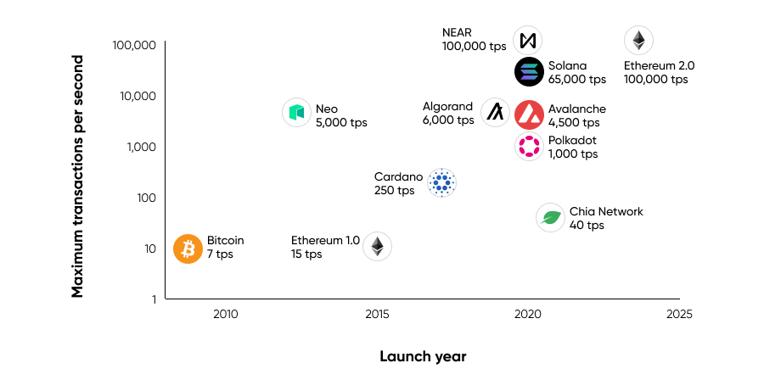*Y-axis uses a logarithmic scale*

Source: Compiled by SPEEDA Edge based on multiple sources

These limitations around scalability have given rise to disruptors such as [NEAR](https://sp-edge.com/companies/600556) and [Solana](https://sp-edge.com/companies/627394), which use technologies such as sharding and alternative consensus mechanisms such as proof-of-stake (PoS) to deliver transaction throughput of as much as 100,000 tps. In addition, the scalability issue is promised to be solved in two main ways:

## **1. Secondary frameworks built on top of the blockchains help with scaling at a lower cost**

Scaling solutions, also known as layer-2s, are built on top of an existing blockchain such as Bitcoin or Ethereum in order to help increase the throughput of these networks. Layer-2 solutions work by offloading the processing of certain transactions to a separate network before posting them to the layer-1 network. These solutions help process a much larger volume of transactions at lower fees (layer-2s effectively bundle multiple off-chain transactions to one) than what would otherwise be possible by the mainnet alone.

### **Notable types of layer-2 infrastructure**

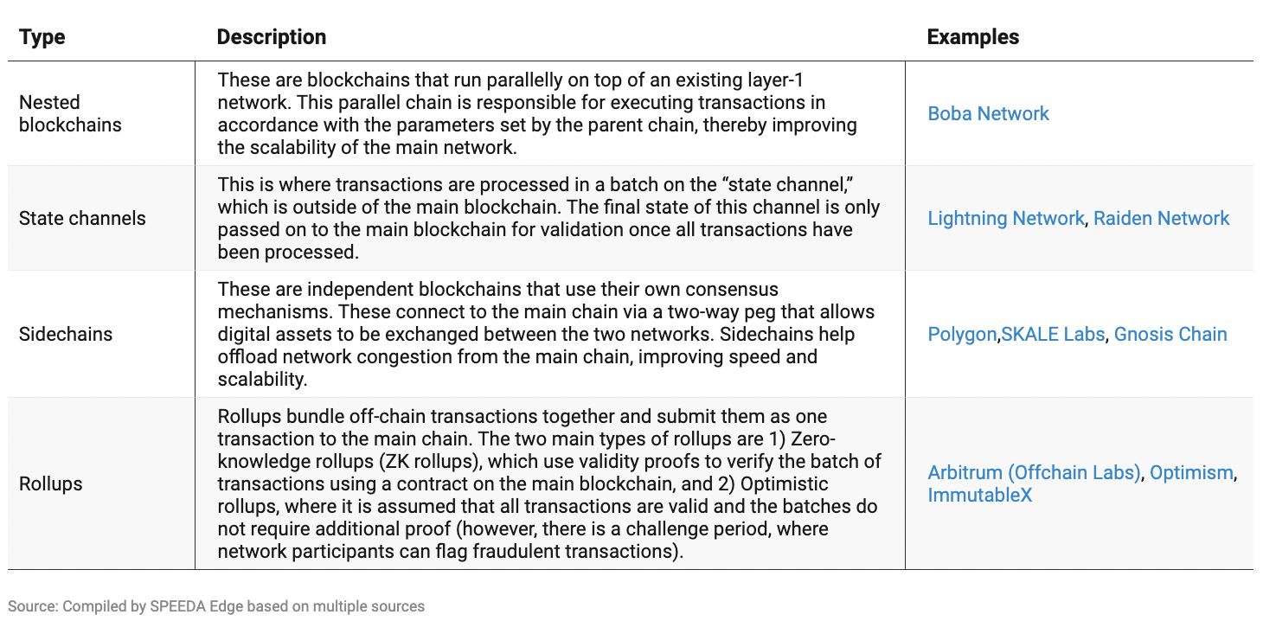

## **2. Ethereum’s planned upgrades**

Ethereum too is working on upgrades of its own with plans to eventually bring the network’s throughput to 100,000 tps by 2023. This is expected to be achieved through a series of planned upgrades, the first of which, dubbed as the Merge, went live in September 2022, where the blockchain was transitioned to a PoS consensus mechanism (for more details about consensus mechanisms, please refer Appendix 1). Subsequent network upgrades such as sharding are expected to follow in the future.

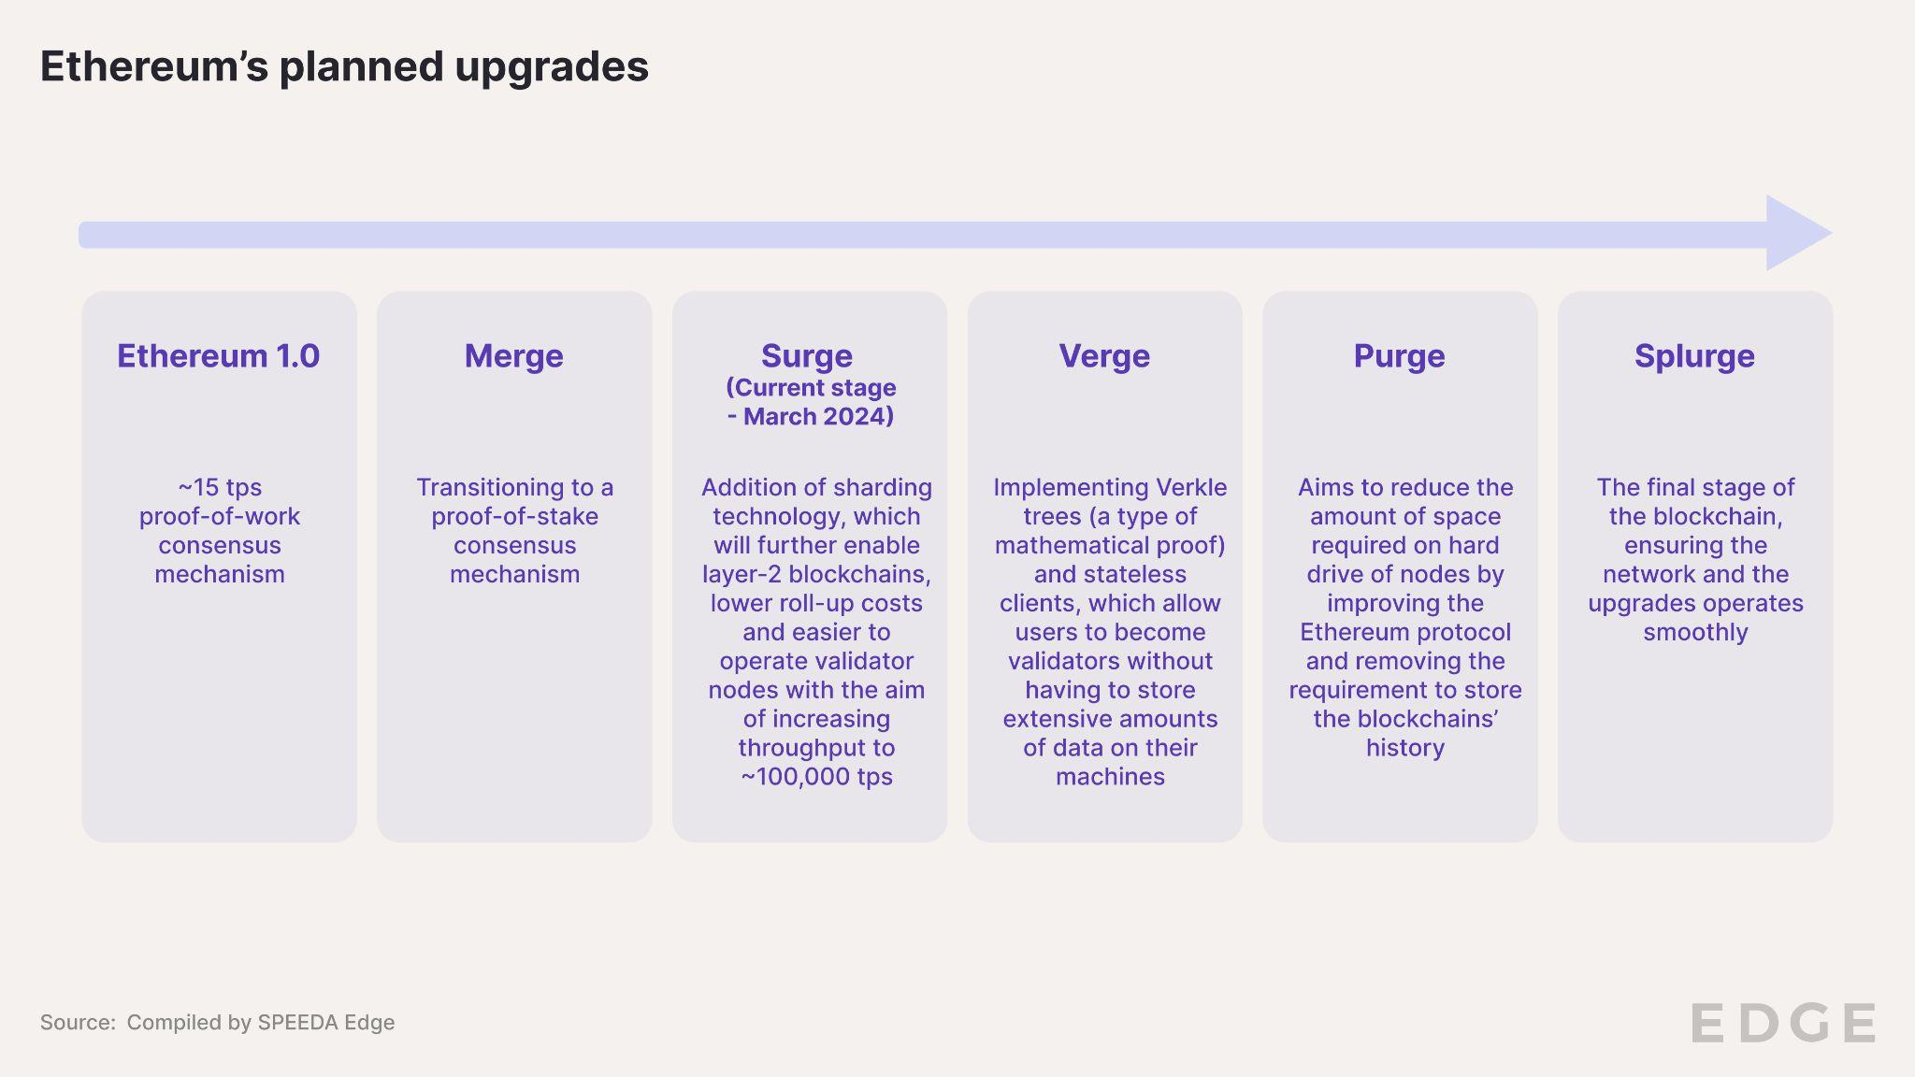

## 

## **An overview of the Web3 Ecosystem**

The Web3 ecosystem can be broadly divided into three: 1) the use case layer—comprises user-facing decentralized applications (dApps) and projects, often replacements of traditional services such as social networks; 2) the access layer—comprises dApp browsers and wallets to hold the tokens required to interact with the Web3 ecosystem; and 3) the infrastructure layer—comprises the blockchains (layer-1), scaling solutions (layer-2), and developer tools required to build applications on the blockchain.

The nascency of the Web3 space has shifted a lot of attention toward infrastructure and related segments, as foundations are being laid for developers to build fast and scalable Web3 applications that work across multiple blockchains. These developments are key if the industry is to move beyond just crypto enthusiasts to reach the mass market. This layer accounted for more than half of all the startups in the Web3 ecosystem and had attracted over 75% of all funding as of September 2022, more than 85% of which was after 2021.

### 

### **Key segments in the Web3 ecosystem**

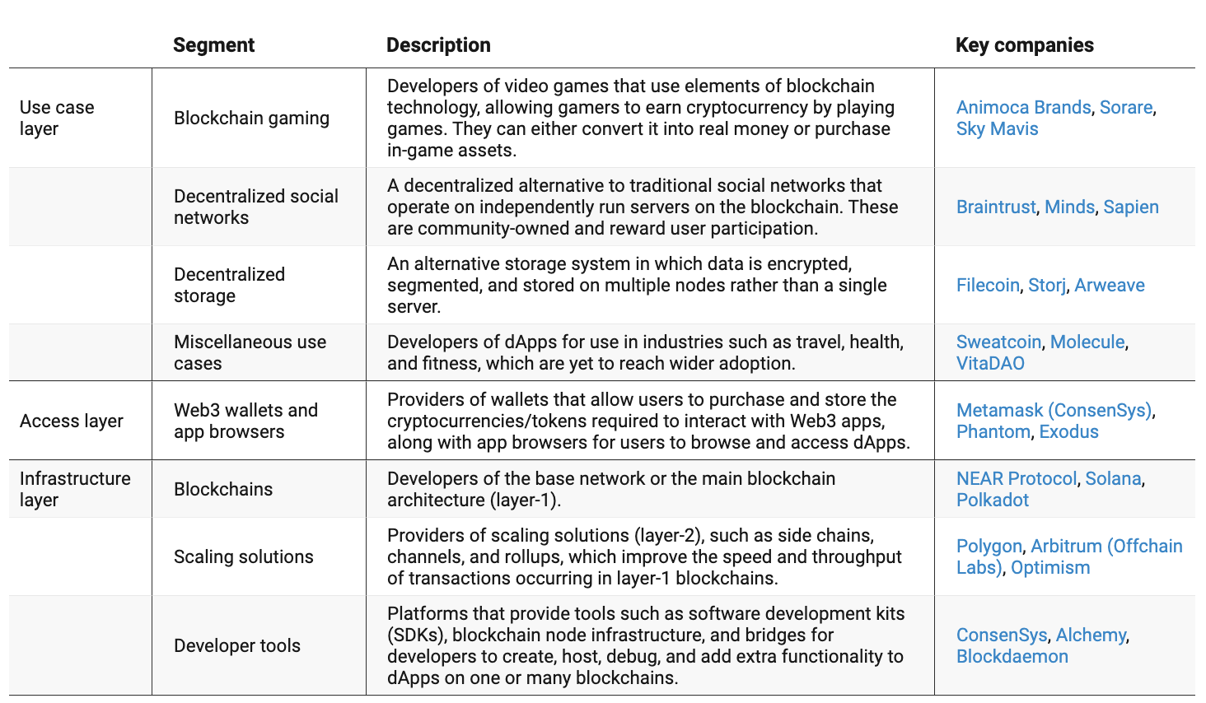

**Driving factors**

## **1. Decentralization and steering control away from Big Tech**

Web2 has become an integral part of our lives, and its exponential growth has led to an inevitable centralization of the web. Big Tech companies such as [Google](https://sp-edge.com/companies/198735), [Meta](https://sp-edge.com/companies/5), [Amazon](https://sp-edge.com/companies/203208), [Microsoft](https://sp-edge.com/companies/201465), and [Netflix](https://sp-edge.com/companies/2287) accounted for 57% of all network traffic in 2021. By generating such high levels of user traffic, these platforms also receive lots of information, such as personal data, preferences, and other behavioral patterns. Companies can not only improve their own offerings by mining this but also serve targeted advertisements and content to keep users engaged for longer.

While regulations such as the General Data Protection Regulation (GDPR) have been put in place to safeguard the privacy of this data through hefty fines, Web3 proponents argue that misuse of this data and Big Tech’s influence on how the information is presented can have dire implications. The Cambridge Analytica scandal and its impact on the 2014 US general election was an example of this. Americans in general also share the same sentiment according to a study by Variety Intelligence, with over 60% from all age groups stating that the Big Tech companies have too much power over the public and 81% believing [Meta](https://sp-edge.com/companies/5) to be too influential. While the share of US adults that want more regulation of major tech companies has been declining, there is a growing concern among them—regardless of party affiliation—that social media companies are intentionally censoring political viewpoints.

|  |  |
| --- | --- |

*For more information on digital privacy and tools that help organizations comply with regulations such as the GDPR, please visit the* [Digital Privacy Tools](https://sp-edge.com/industry/34) *industry hub.*

Web3 bills itself as the answer to the corporatization of the internet. By operating on permissionless blockchains instead of data centers controlled by a single entity, users do not need to know other entities on the network to transact with them. Users gain access through encrypted wallets, each with its own cryptographically generated address, helping preserve privacy.

## **2. Internet users can unlock new monetization opportunities with Web3**

Alphabet, the parent company of [Google](https://sp-edge.com/companies/198735) and YouTube, generates around 80% of its revenue through ads, while this share was as high as 98% for [Meta](https://sp-edge.com/companies/5). Overall, these tech giants accounted for nearly two-thirds of the USD 284 billion US digital ad spend in 2021.

In contrast, Web3 platforms adhere to a “value-share” model, encouraging participants, be they users, developers, or investors, to utilize the network in exchange for rewards. Similar to how Facebook makes money off user data, a Web3 version of the social network (like [Minds](https://sp-edge.com/companies/67287)) could allow users to earn "tips" in the form of the platform's native cryptocurrency, for posting content. A Web3 version of Spotify (like [TRAX](https://sp-edge.com/companies/3416976), [Sound](https://sp-edge.com/companies/1747556), and [AnotherBlock](https://sp-edge.com/companies/1837511)) could allow fans to “invest” directly in emerging artists in exchange for a share of their streaming royalties.

Content creators can issue NFT and social tokens to monetize their communities by cutting down on the number of middlemen, and, through [tokenization](https://sp-edge.com/updates/6443), physical asset owners can monetize their otherwise illiquid real-world assets. Research from VC firm Andreessen Horowitz suggests that content creators earned USD 3.9 billion through NFTs in 2021. While this number falls short of other content giants such as YouTube and Spotify, individual content creators made far more on average through this medium.

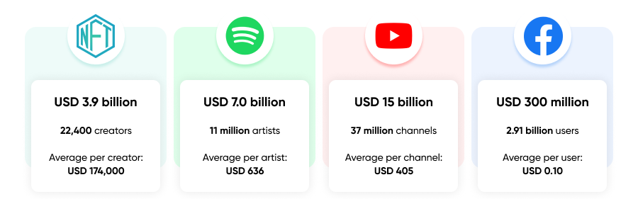

Source: Compiled by SPEEDA Edge based on multiple sources

*To know more about how NFTs are used in the* [creator economy](https://sp-edge.com/industry/42)*, refer our industry hub.*

*Web3 applications across decentralized finance (DeFi) are covered extensively in the* [DeFi](https://sp-edge.com/industry/64) *industry hub.*

# **Risks to growth**

## **1. Regulations key to protect the consumer; however, inconsistent application could stifle innovation**

Regulations in this space have lagged behind innovation, resulting in fraud and other scams relating to Web3 areas such as cryptocurrencies and DeFi, where unsuspecting victims lost USD 2 billion in 2023. Effective laws are key to restoring trust in an industry rife with speculation and scam and to ultimately drive adoption. However, the nascency of the industry and the lack of enough precedent have led to uncertainties and inconsistent application of the law. Institutions such as the Securities and Exchange Commission (SEC), Commodity Futures Trading Commission (CFTC), and the Treasury all look at and govern cryptocurrencies differently. A US executive order in March 2022 directed the agencies to coordinate their efforts in a bid to iron out disparities while also laying out a national policy for digital asset regulation, calling for the relevant institutions to study the legal ramifications and their impact on consumers.

In August 2022, the US Treasury Department’s Office of Foreign Assets Control (OFAC) sanctioned Tornado Cash, a solution that allowed Ethereum users to anonymize their on-chain transactions. The OFAC claimed that the sanction was due to the protocol being used for the laundering of hacked or stolen funds, notably by hacking groups with links to the North Korean government. The move saw significant backlash from Web3 proponents for sanctioning an entire technology instead of the individuals or entities using the tool for crime. Companies such as Coinbase are reacting by backing lawsuits against the US Treasury citing violations of free speech rights and regulatory overreach that could set a dangerous precedent for Web3 innovation.

## **2. Public awareness for Web3 is low with a user experience that lags behind Web2, keeping newcomers at bay**

Public awareness of Web3 is also low, with only 24% of over 15,000 respondents aged 18 to 65 across 15 countries being aware of the technology, according to a poll conducted by Consensys from April to May 2023. Another survey conducted by SurveyMonkey from May to June 2022 of over 3,000 US adult respondents found that only 13% had heard of this technology, and, among them, fewer than half (41%) believed that it would ever enter the mainstream. A roadblock for Web3 to enter mainstream is its lackluster user experience. Web2 is quite literally years ahead in terms of usability, and, more often than not, Web2 websites and applications will “just work.” In contrast, to engage with a Web3 application, a user needs to create a blockchain wallet that is denoted with a unique alphanumeric character and not memorable, buy cryptocurrencies, and transfer them to this wallet, and, in some cases, purchase another native token (all with transaction fees along the way). Some dApps are accessible only through particular wallets such as MetaMask; transferring between two different blockchains comes with challenges of its own.

While a lot of work is already being done to address a lot of the technical and usability challenges (such as the Ethereum Name Service for usable wallet addresses or bridges to connect separate blockchains), a streamlined user experience that does not require ordinary users to follow tutorials to simply transfer tokens to another network will be key for mainstream adoption.

## **3. Web3 might not be as decentralized as it claims to be**

Blockchains that use a PoS consensus mechanism have a risk of becoming too centralized, as a few validators with large stakes could gain control of the network. Validators are also rewarded in proportion to their staked value, which further increases their influence and likelihood of being selected in the following cycle, creating an unfair opportunity for other validators to participate in securing the network.

VCs have invested billions of dollars into Web3 startups. This has raised questions around the practicality of the decentralization Web3 promotes–whether in reality large VCs will be able to exert significant influence over how these protocols are run. Ethereum has allocated only around 15% of its token supplies to insiders; however, this trend is shifting with increased VC investment into infrastructure. This is evidenced by newer entrants such as Solana and Avalanche allocating more than 40% of their token supply to insiders, who will have more authority in the governance and operation of the blockchain in the future.

Notably, Big Tech companies such as [Microsoft](https://sp-edge.com/companies/201465), [Google](https://sp-edge.com/companies/198735), and [Amazon](https://sp-edge.com/companies/203208) are already involved in offering managed blockchain services and other developer tools required for the development of Web3 projects, and, with their already established footprint with Web2 infrastructure, they stand to gain as their clientele starts experimenting with Web3 projects. Whether this will eventually lead to similar centralization as Web2 is yet to be seen.

# **Appendix 1**

## **What is a consensus mechanism?**

The consensus mechanism in a blockchain is used to verify transactions, the current state of the network, and foster reliability and trust among members, with two of the most popular mechanisms being PoW (Bitcoin, Ethereum pre-merge) and PoS (Ethereum post-merge, [NEAR](https://sp-edge.com/companies/627394), [Solana](https://sp-edge.com/companies/627394)). PoW requires validators (also referred to as miners) to compete against one another to solve mathematical problems through trial and error for rewards in the form of the network’s native token. This requires significant computing power with a sizable upfront investment in high-end hardware and high energy consumption.

In contrast, under a PoS mechanism, validators are selected through a pseudo-random election process based on their invested capital (stake), where validators with larger stakes have a high probability of being selected. For each completed verification these stakers are rewarded in cryptocurrency. This approach significantly reduces the need for computing power to validate transactions resulting in lower energy consumption. The Ethereum Foundation claims a possible reduction in energy usage of over 99% following the Ethereum blockchain’s transition to PoS.

Some of the other notable consensus mechanisms include 1) proof-of-authority—which is a modified version of PoS, where validators stake their identity and reputation as opposed to a monetary amount, 2) proof-of-capacity—where minors commit hard drive space to earn the right to validate transactions, and 3) proof-of-spacetime—where validators have to prove that they have allocated storage capacity to the network for a period of time to be selected.

### 

### **How do the consensus mechanisms work?**

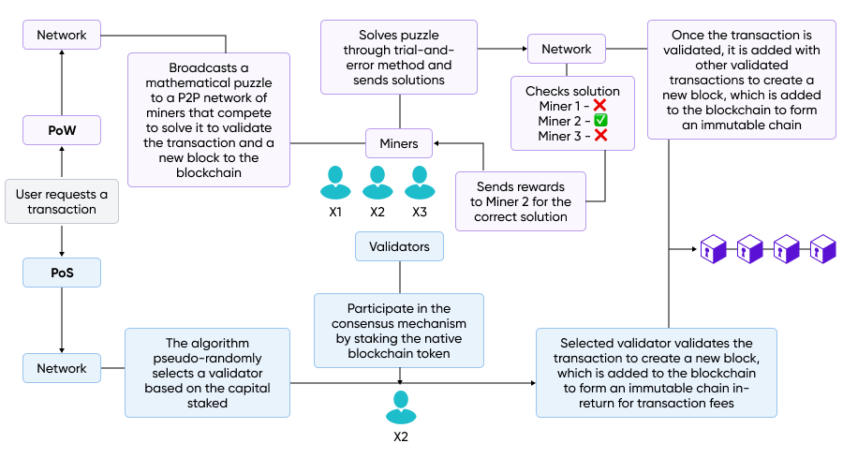

Source: Compiled by SPEEDA Edge based on multiple sources

# 

# **Appendix 2**

### **Key definitions**

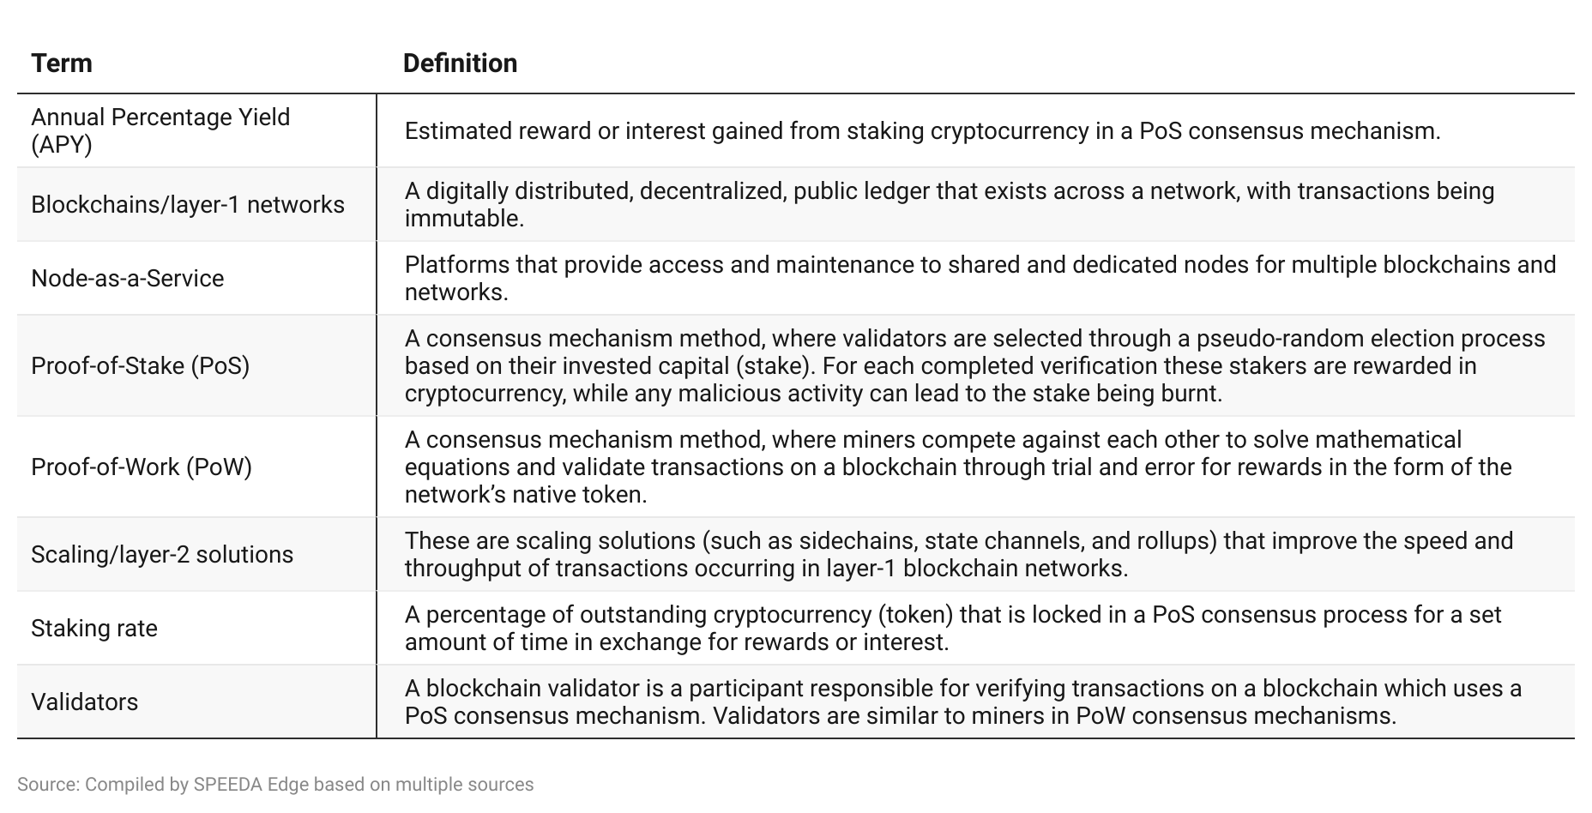

# 

# **Appendix 3**

### **SPEEDA Edge blockchain coverage**

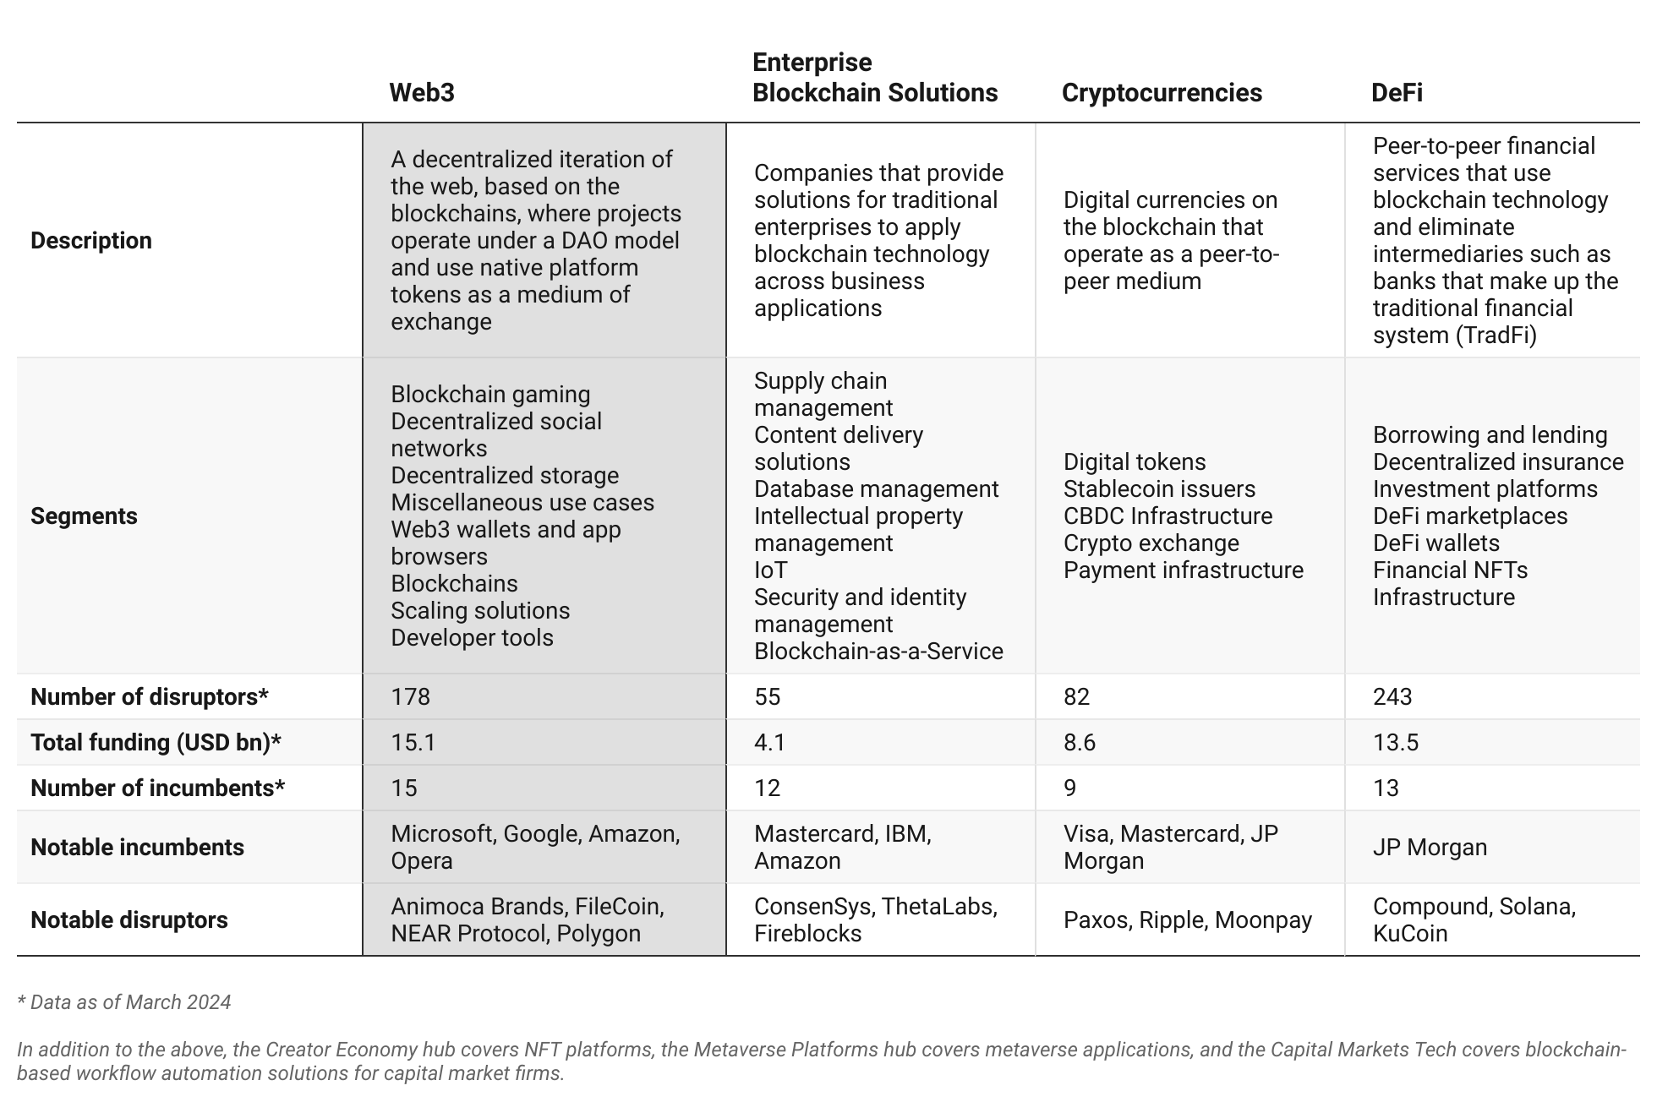

*In addition to the above, the* [*Creator Economy hub*](https://sp-edge.com/industry/42) *covers NFT platforms, the* [*Metaverse Platforms hub*](https://sp-edge.com/industry/132) *covers metaverse applications, and the* [*Capital Markets Tech*](https://sp-edge.com/industry/109) *covers blockchain-based workflow automation solutions for capital market firms.*

*Last updated: March 2024*

©2024 Uzabase, Inc. All Rights Reserved. The information contained herein: (1) is proprietary to Uzabase Inc. and/or its content providers; (2) may not be copied or distributed; and (3) is not warranted to be accurate, complete or timely. Neither Uzabase Inc. nor its content providers are responsible for any damages or losses arising from any use of this information.