# **EV Economy: Overview**



## **EVs still heavily underpenetrated with significant headroom for growth**

The electric vehicle (EV) economy represents a future where battery electric vehicles (BEV) are readily used in transportation. The hub covers the entire EV value chain from batteries to vehicles to charging solutions.

There are broadly four types of EVs: BEVs, plug-in hybrids, non-plug-in hybrids, and fuel cell electric vehicles (FCEV). The hub excludes both types of hybrid vehicles, as there are hardly any startups in this space; they are mostly manufactured by automotive incumbents. Additionally, since they are not 100% clean, they do not necessarily fit the “sustainability” definition. ​​FCEVs are covered in our [Hydrogen Economy](https://sp-edge.com/industry/57) (Hydrogen Vehicles segment) and [Truck Industry Tech](https://sp-edge.com/industry/47) (Electric and Fuel Cell Trucks segment) hubs.

### 

### 

### 

### 

### 

### **Overview of the EV Economy**

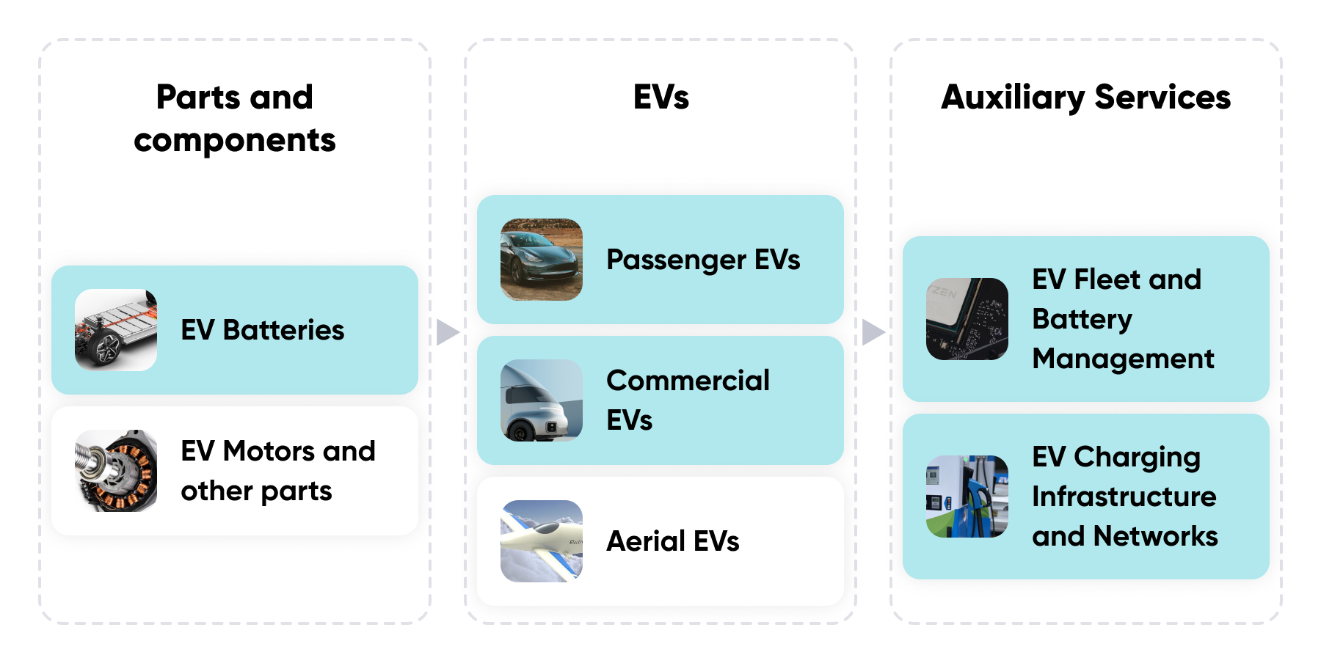

*Only the shaded segments are covered in the hub*

Source: SPEEDA Edge

There were around 18.3 million passenger BEVs on the road as of 2022 (less than one million in 2015)—still less than 2% of the total passenger vehicles in use (around 1.4 billion). Around 7.3 million passenger BEVs were sold globally in 2022. This was around 10% of all passenger vehicles sold during the year (~73 million). Global passenger BEV sales have increased at a strong three-year CAGR of 67.9% over 2019–2022, but there is still significant headroom for electrification.

China dominates the global market with a 58% share of all passenger BEVs in use and around 60% of passenger BEV sales. While China also holds the top spot in the growth of electric car sales (three-year CAGR of 76.5% over 2019–2022), both the US (49.0%) and Europe (58.7%) have also shown strong growth in sales, suggesting that BEVs are gaining traction in western markets.

Commercial BEVs are a relatively new industry with just under two million units on the road as of end-2022. Nevertheless, global commercial BEV sales have also increased at a healthy three-year CAGR of 23.3% (2019–2022).

### 

### **BEVs in use, BEV sales, and BEV penetration**

## 

## 

## 

## 

## 

## **Derived demand from EVs bodes well for batteries and charging**

Charging infrastructure lags compared to EV stocks. Both the US and Europe are behind the recommended ratio of 0.1 public chargers per EV (one public charger per 10 EVs). This gap would only widen as more EVs come to the market, creating further opportunities for charging infrastructure.

### **Public EV chargers in use per EV**

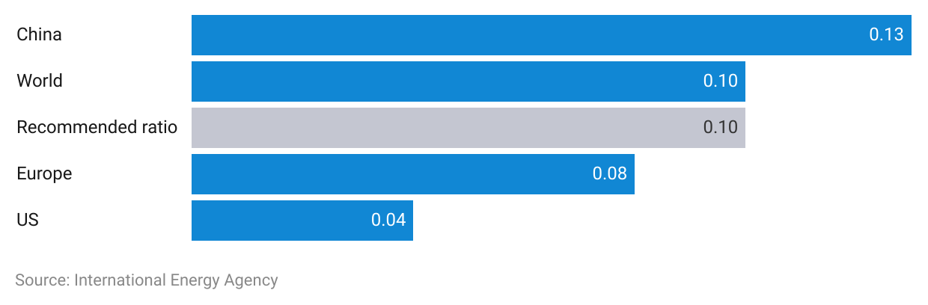

EV chargers in the US have increased at a three-year CAGR of 18.4% over 2019–22. DC fast-charging stations, which can charge most EVs in under 30 minutes, have increased at a faster CAGR of 28.8% over the same period (although from a smaller base). Globally, the number of slow and fast chargers has increased at CAGRs of 42.4%% and 49.4%%, respectively, over the same period.

### **Public EV chargers in use**

The EV battery market is dominated by a handful of large incumbents; the top-five players (CATL, LG Energy, Panasonic, SK On, BYD) accounted for a market share of around 80% in 2023. Nevertheless, opportunities exist in the next-generation battery space for startups and new entrants. The anode, cathode, and electrolyte materials account for around 70% of a battery’s cost. Therefore, most next-gen batteries attempt to use cheaper and more efficient active materials to reduce cost and improve performance.

### **Types of next-generation batteries**

## 

## **Declining battery cost and improving EV tech are key enablers**

Batteries account for nearly 40%—60% of the cost of a BEV. Battery technologies follow learning curves—with each doubling of cumulative capacity, battery prices decline by a relative fraction (similar to the fundamentals of Moore's Law). Lithium-ion battery costs have decreased to around a fifth of the cost from a decade ago to around USD 139/kWh in 2023. The costs are expected to decrease further to below USD 100/kWh over the next decade, making BEVs more affordable.

### **Lithium-ion battery cost**

The median BEV range (miles per full charge) in the US has increased from less than 100 miles in 2010 to nearly 300 miles in 2023. Some BEVs like the Tesla Model S have even bettered the 400-mile threshold, while disruptors like Lucid Motors launched models with a 500-mile range model in 2022. Moreover, disruptors like Lightyear and Fisker are focusing on developing BEVs with built-in solar range extenders.

### **US BEV range by model year**

These longer ranges have been supported by improvements in battery tech. Energy densities of lithium-ion batteries have increased from around 100 watt-hour/kg at the start of the last decade to around 250–300 watt-hour/kg in 2023. Disruptors like 24M Technologies and Amprius are furthering innovations into next-gen batteries, which promise energy densities of around 350–450 watt-hour/kg. These developments have been instrumental in making EVs competitive against their gasoline counterparts.

# 

# **Driving factors**

## **1. Aggressive government electrification targets**

More than 40 countries have announced internal combustion engine (ICE) vehicle phase-outs over the next two to three decades, while more than 140 countries (accounting for around 88% of the global vehicles in use) have announced net-zero emission pledges. The US also targets 50% of its new vehicle sales to be electric by 2030.

Most electrification targets are driven by sustainability goals, while some are also political. For instance, it has been theorized that China's interest in EVs is partially driven by its interest in reducing dependency on imported oil. To stimulate these targets, governments around the world have been subsidizing BEVs to bring the upfront cost closer to that of ICE vehicles (read more about EV subsidies in the “risks to growth” section below).

The International Energy Agency expected global EVs on the road to reach around 196 million by 2030 (from around 20 million in 2022) in a scenario where all proposed sustainability policies and electrification targets are met.

### 

### **Timeline of proposed ICE bans and net-zero targets**

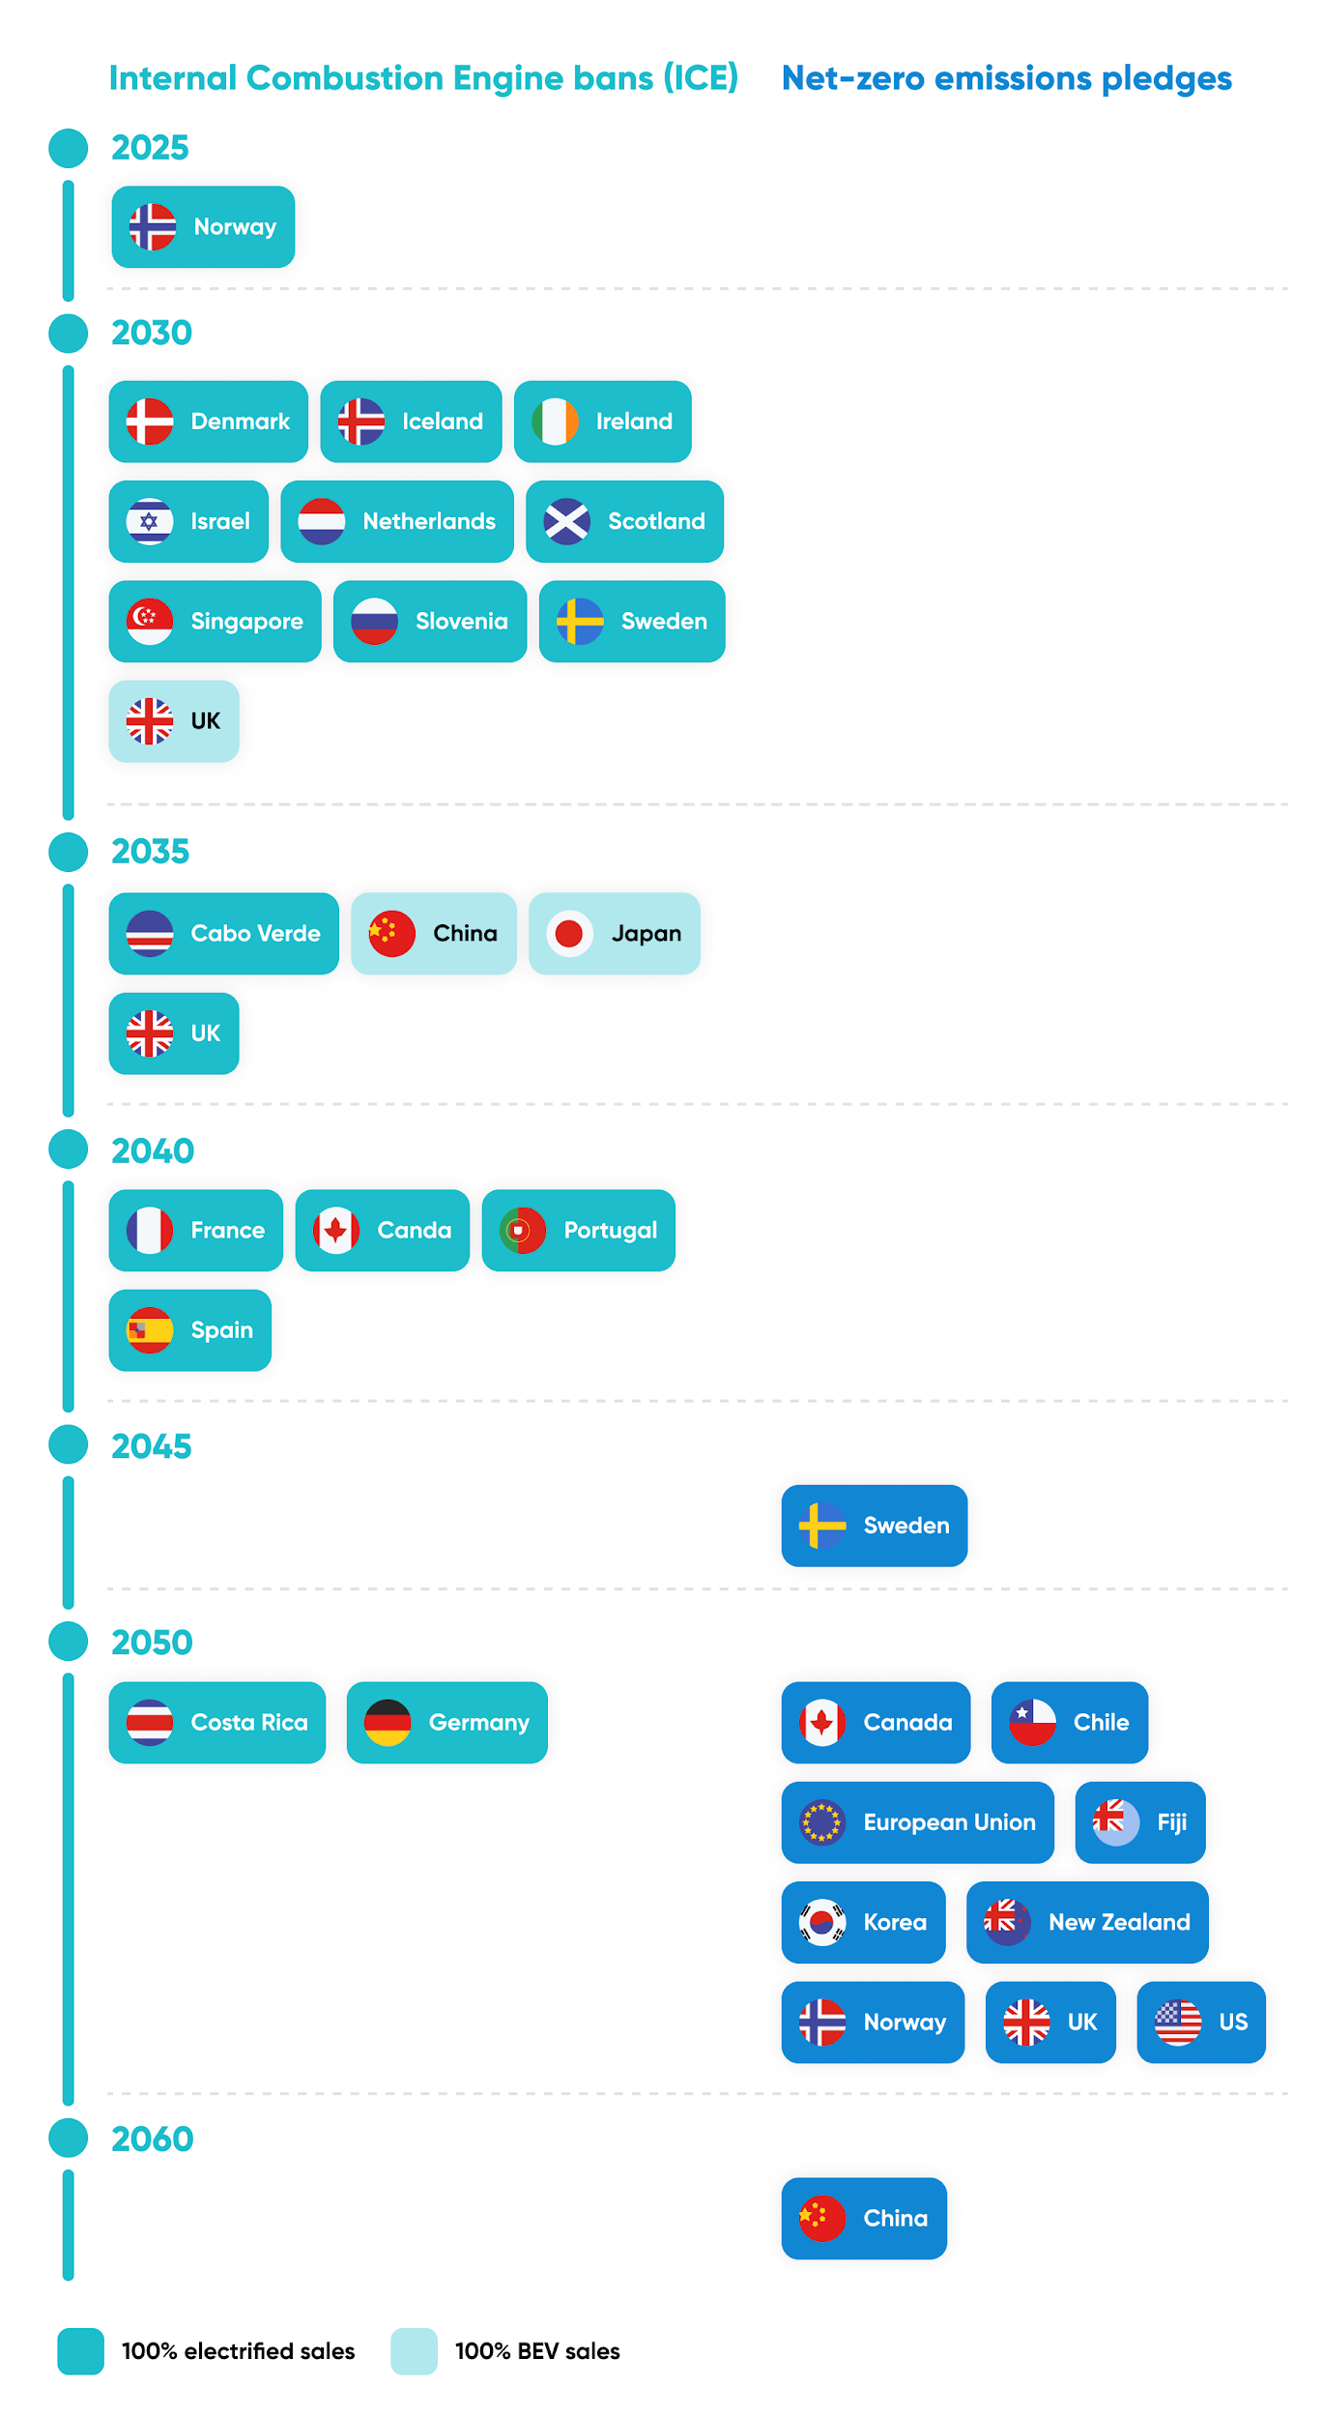

Source: International Energy Agency

### **Forecast for global BEVs in use (assuming all proposed electrification targets are met)**

## **2. Shift to a sustainable lifestyle**

Consumers have become more sensitive to the importance of climate protection and are adopting less resource-consuming lifestyles. A 2021 Yale University study showed that around 76% of Americans acknowledged global warming, an increase of around 11 percentage points from 2015 (65%). **A 2021 Forbes survey suggested that around 23% of Americans were considering a BEV as their next vehicle.** About 45% of them had mentioned environmental protection as the main reason for the purchase, followed by low fuel and running costs. Around 65% also agreed that EVs are the future of the auto industry.

### 

### 

### **Buyer sentiment for BEVs**

### 

## 

## 

## 

## 

## 

## 

## 

## 

## **3. Widespread renewable energy adoption**

EVs are only as clean as the electricity they run on. Renewables accounted for around 21% of the US electricity mix in 2023. This is expected to increase to around 44% by 2050 underpinned by falling solar and wind costs as well as next-gen renewable energy solutions (read more about this in our [Alternative Energy](https://sp-edge.com/industry/48) coverage). Widespread renewable energy adoption would further encourage the demand for EVs.

### **Share of renewables in the US energy mix**

# 

# **Risks to growth**

## **1. Higher upfront costs and expiring EV subsidies**

According to the 2021 Forbes survey, high upfront cost was the primary concern (32%) among Americans who did not consider buying a BEV as their next vehicle. Recent studies show that BEVs are now on par with their ICE counterparts in terms of the total cost of ownership. However, the upfront cost of a BEV is still around 20% higher than a similar ICE vehicle.

### **Total cost of ownership (TCO): BEVs vs ICE vehicles**

Moreover, the phasing out of government EV subsidies in China is pushing upfront costs even higher and has been cited as one of the main reasons for slowing Chinese EV sales. Comparatively, annual sales of EVs have been improving in the US following a slowdown in 2021.

### **Key EV subsidies across major markets**

To mitigate the problem of higher upfront costs, passenger and commercial EV makers like Fisker, Einride, and Nikola are planning to offer vehicles under a subscription model. Meanwhile, NIO has separated the ownership of the battery from the vehicle (and offers the former under a battery-as-a-service model).

## **2. Long-range constraints and competition from FCEVs**

BEVs are challenged for range and are somewhat less appealing for long-distance applications such as buses and trucks. This has also contributed to the slower adoption of commercial EVs required to travel long distances. Hydrogen FCEVs are thought to be a better gasoline alternative for long-range vehicles. For example, Tesla’s BEV truck Tesla Semi promises only a 500-mile range versus Nikola’s FCEV truck Nikola Two’s reported range of around 900 miles. Nikola began the commercial production of its FCEV trucks in July 2023.

## **3. Cheaper Chinese alternatives**

Chinese EV makers such as BYD, NIO, and Xpeng have begun their expansion into Western markets. The three companies have launched their models in several European markets including Norway, Germany, the Netherlands, Sweden, and Denmark. Xpeng targets half of its sales to be from overseas markets in the “long term,” while NIO expects to expand into 25 countries including the US by 2025.

Chinese EVs are known for their cost competitiveness. Xpeng’s entry-level model “G3” is offered at a price of around USD 22,000, while its mid-size sedan and Tesla Model 3 challenger “P7” is priced at around USD 38,000 (an entry-level Model 3 costs around USD 42,000). NIO’s crossover SUV and Model Y challenger “EC 6” is offered at around USD 49,000 and its full-size sedan and Model S challenger is offered at around USD 75,000. Both models were on par with their respective Tesla counterparts but NIO provides the option of leasing the battery separately to save upfront costs. Cost competitive Chinese models are likely to intensify the competition in the West.

## **4. Potential lithium shortage**

Lithium is one of the key active materials used in EV batteries. A typical electric car battery uses around 8 kg of lithium. This means, that to reach the International Energy Agency forecast of 196 million EVs by 2030, the total lithium requirement would be around 1.7 million tons. Global lithium production was around 130,000 tons per annum in 2022 and would be insufficient to fulfill the nearly two-million-ton requirement over the next decade.

Furthermore, to electrify all 1.4 billion passenger cars on the road, around 12 million tons of lithium will be required. At the current rate of production, this would take around 140 years to produce. This means that the EV industry is likely to see a potential lithium shortfall heading into 2050, where most net-zero pledges are expected to take effect. Higher demand could also make lithium somewhat expensive in the long run, leading to higher battery costs and higher EV prices.

*Last updated: February 2024*

©2024 Uzabase, Inc. All Rights Reserved. The information contained herein: (1) is proprietary to Uzabase Inc. and/or its content providers; (2) may not be copied or distributed; and (3) is not warranted to be accurate, complete or timely. Neither Uzabase Inc. nor its content providers are responsible for any damages or losses arising from any use of this information.