# **Clinical Trial Tech: Overview**



## **Telemedicine and AI lead to cheaper and faster clinical trials**

Clinical trial tech is the use of technologies like cloud computing, AI, machine learning, and the medical internet of things during the clinical trial process. As a result, the way pharmaceutical companies and drug developers operate is changing, with faster execution and lower clinical trial costs.

Clinical trials are typically the third stage in the overall drug development process, coming after drug discovery and pre-clinical testing, but before licensing approval. The clinical trial stage is the longest in the development of a pharmaceutical product, ranging between five and seven years before it can be proposed for regulatory approval and commercial sales. To find out more about technologies focused on improving drug discovery (the beginning of the drug development process), refer to our report on AI Drug Discovery.

**The clinical trials stage is the longest in the drug development process**

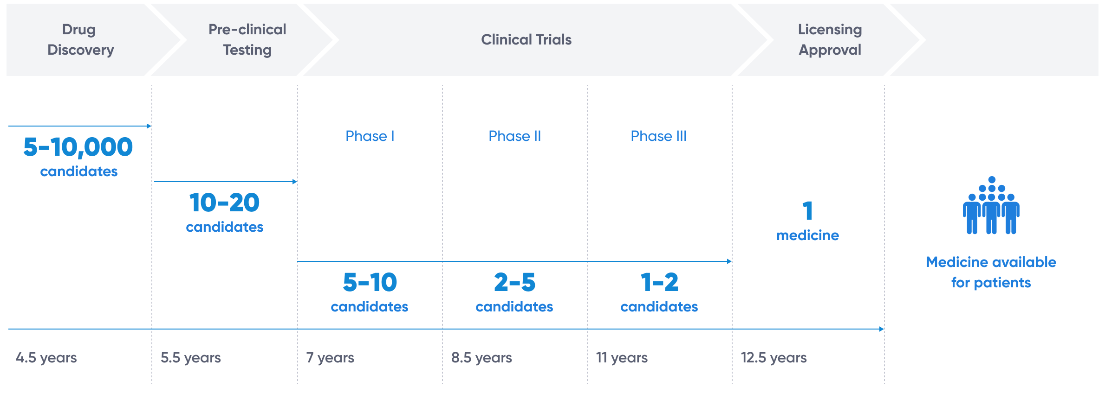

Source: GSK

Clinical trials can be broken into three broad phases, with each phase having different objectives.

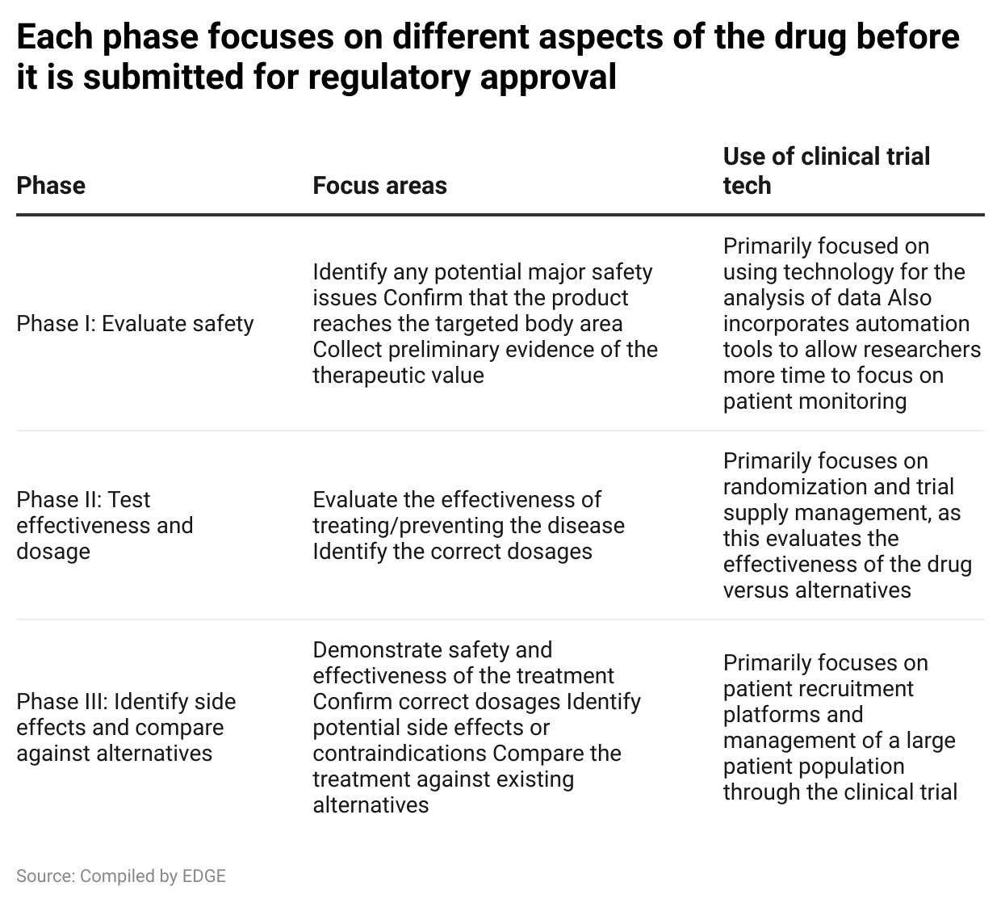

Since the clinical trials stage is the longest, it is the first stage that pharmaceutical companies examine when looking to speed up the drug development process. Any reduction in the time required to test and approve new drugs and treatments has a significantly positive impact on the financial returns for pharmaceutical companies.

## **Clinical trial technology: Segmental overview**

We clustered clinical trial technology startups into seven broad segments based on the standard process followed. These segments are relevant to all three phases of clinical trials, with the only difference between phases being the focus of the clinical trial and not the process followed.

The primary five segments relate to the specific stages of a clinical trial: protocol design and review, site selection and startup, patient recruitment, drug and supply logistics, and patient and outcome data management.

There are two additional segments that span these five primary segments. The clinical trial management segment consists of startups that provide platform and service solutions, which support two or more primary segments, in addition to providing workflow management solutions. The virtual trials segment refers to startups that develop solutions for virtual clinical trials, including the design and set up of remote trials, virtual patient recruitment as well as remote monitoring and patient data collection.

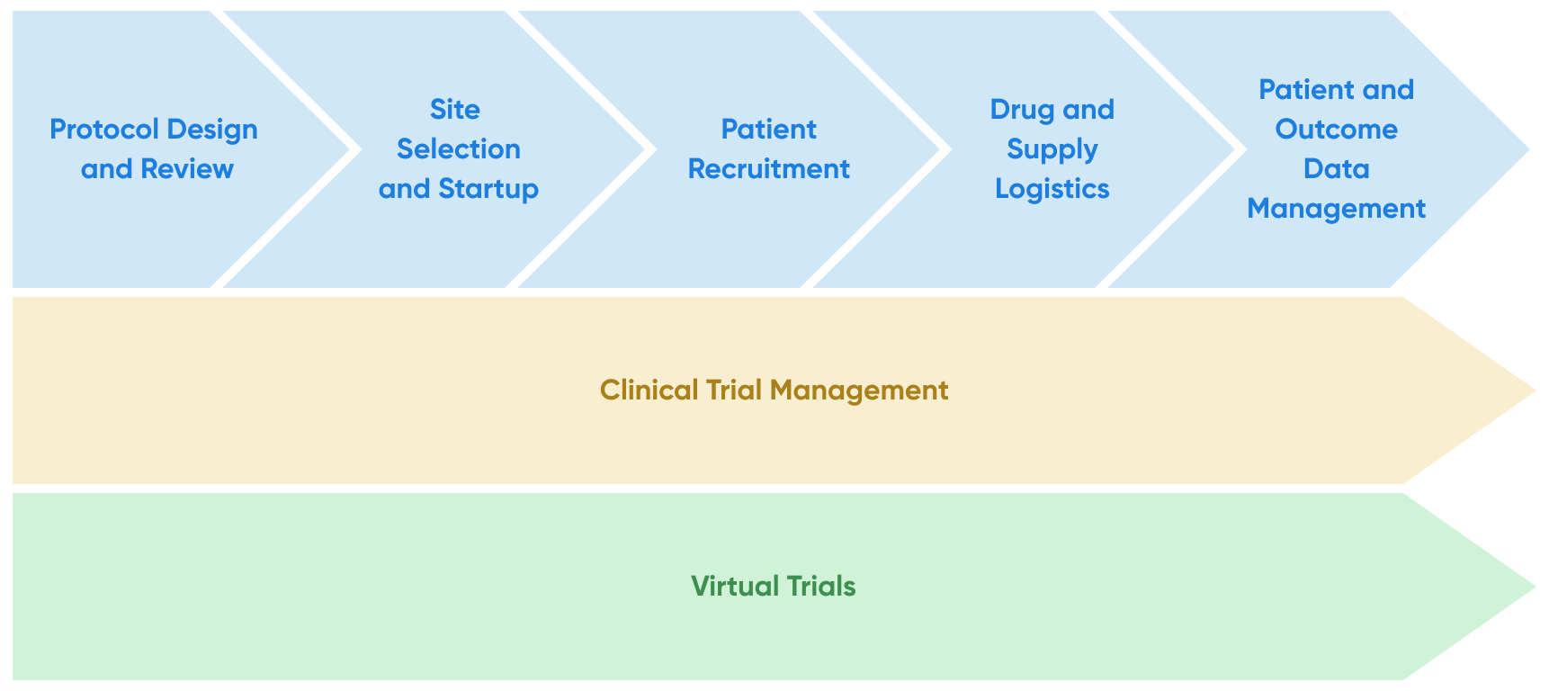

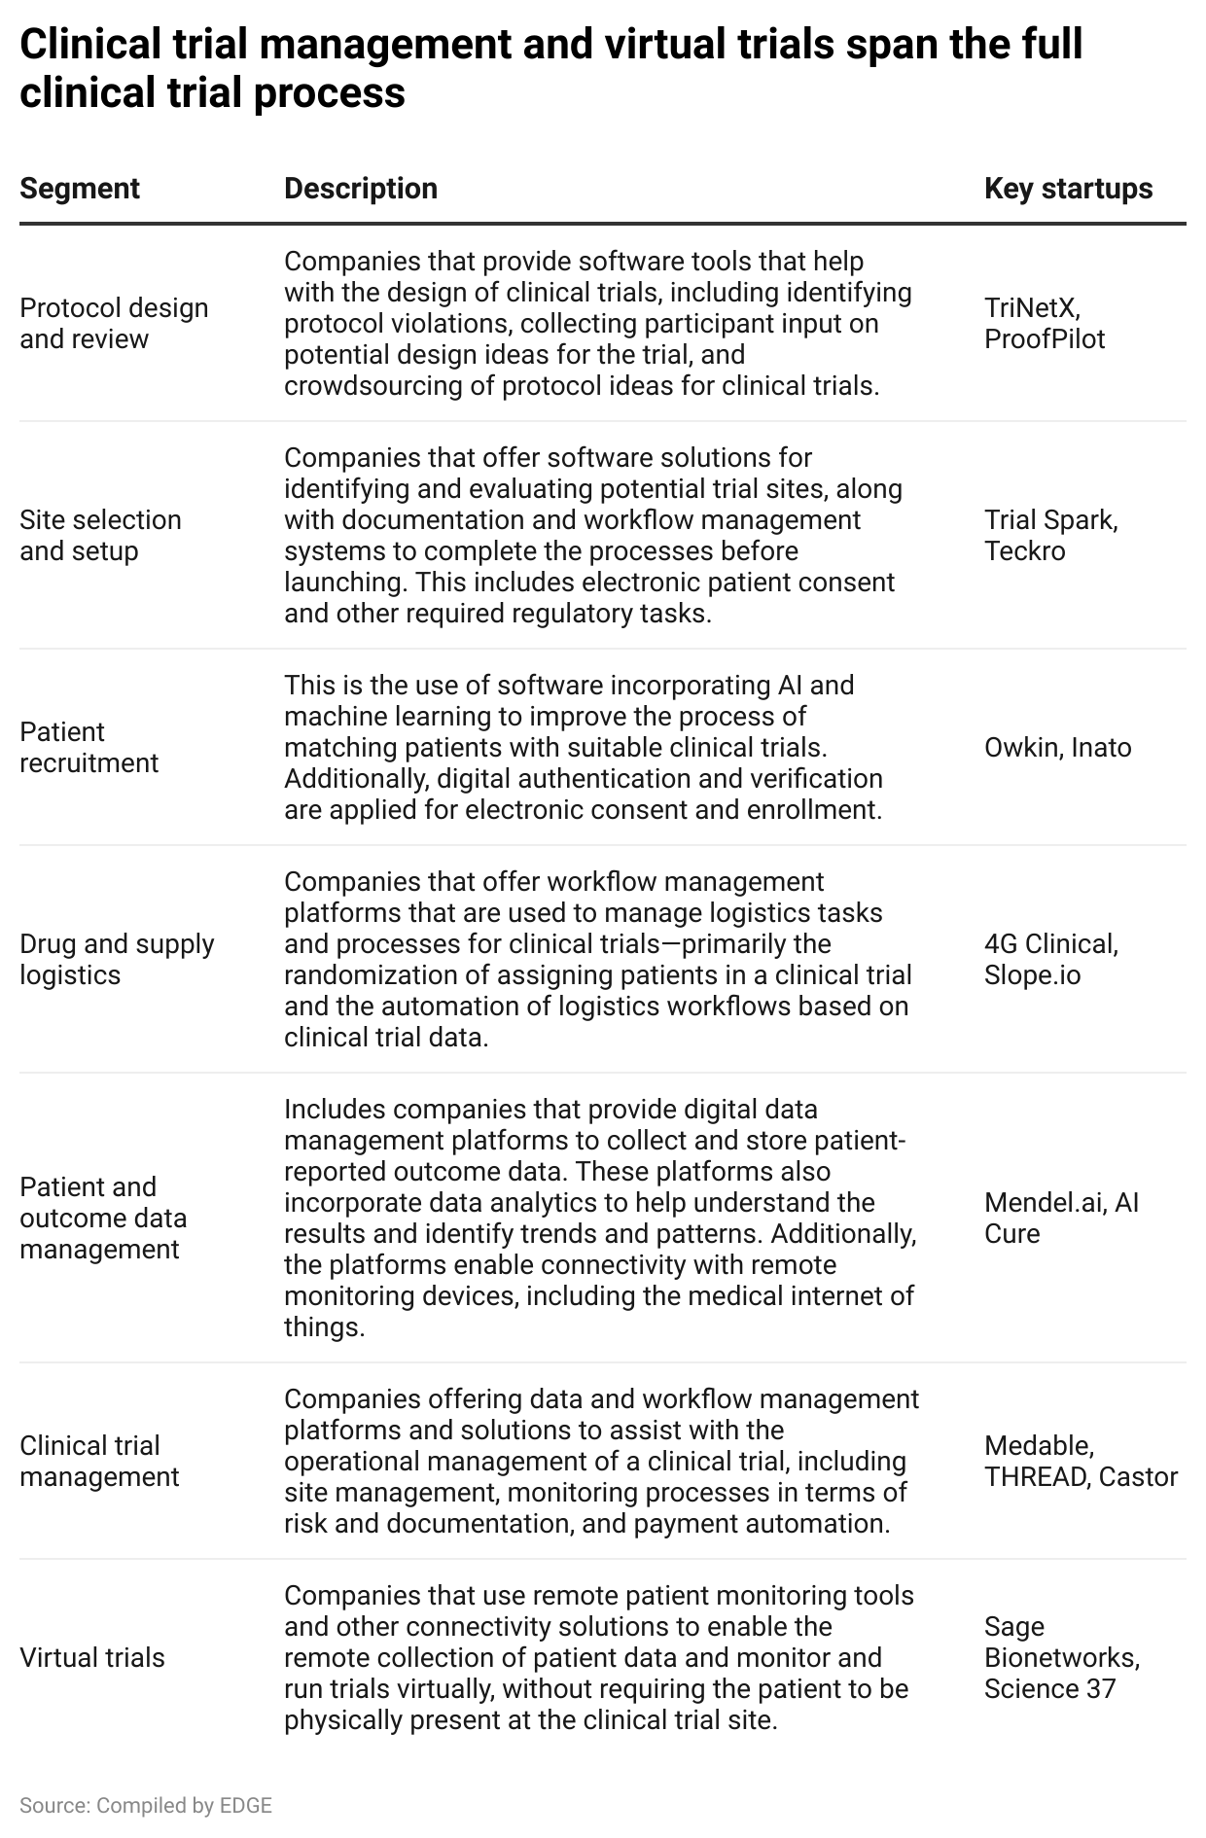

### **How different technologies are helping the clinical trial process**

Clinical trials are being improved through various technologies for different use cases. Some technologies, such as AI and telemedicine, are being applied for multiple uses, while others like crowdsourcing are more niche in their benefit to clinical trials.

The table below shows some of the key technologies and explains how they are being used in clinical trials.

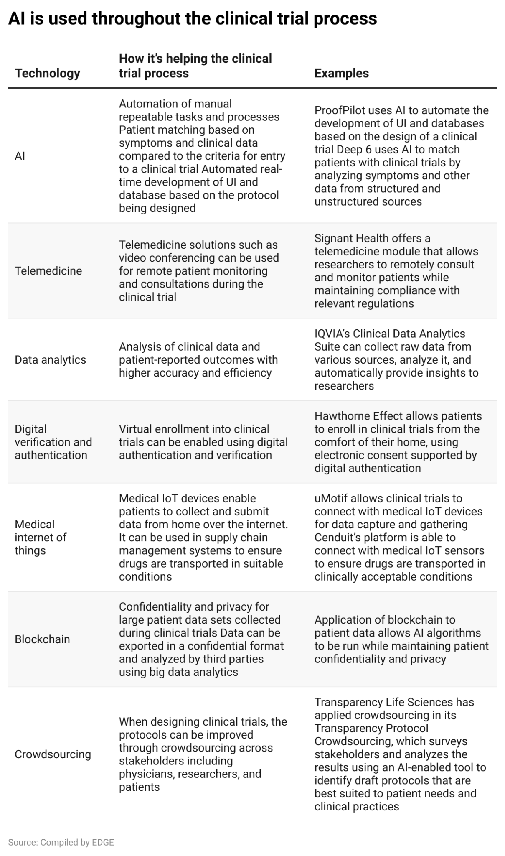

### **Where is technology driving clinical trials?**

In addition to varying use cases, disruptive technologies are being applied in different segments in the clinical trial. Clinical trial management and virtual trials have the largest number of technologies since they have the largest coverage of the clinical trial process, while other segments are more narrowly focused.

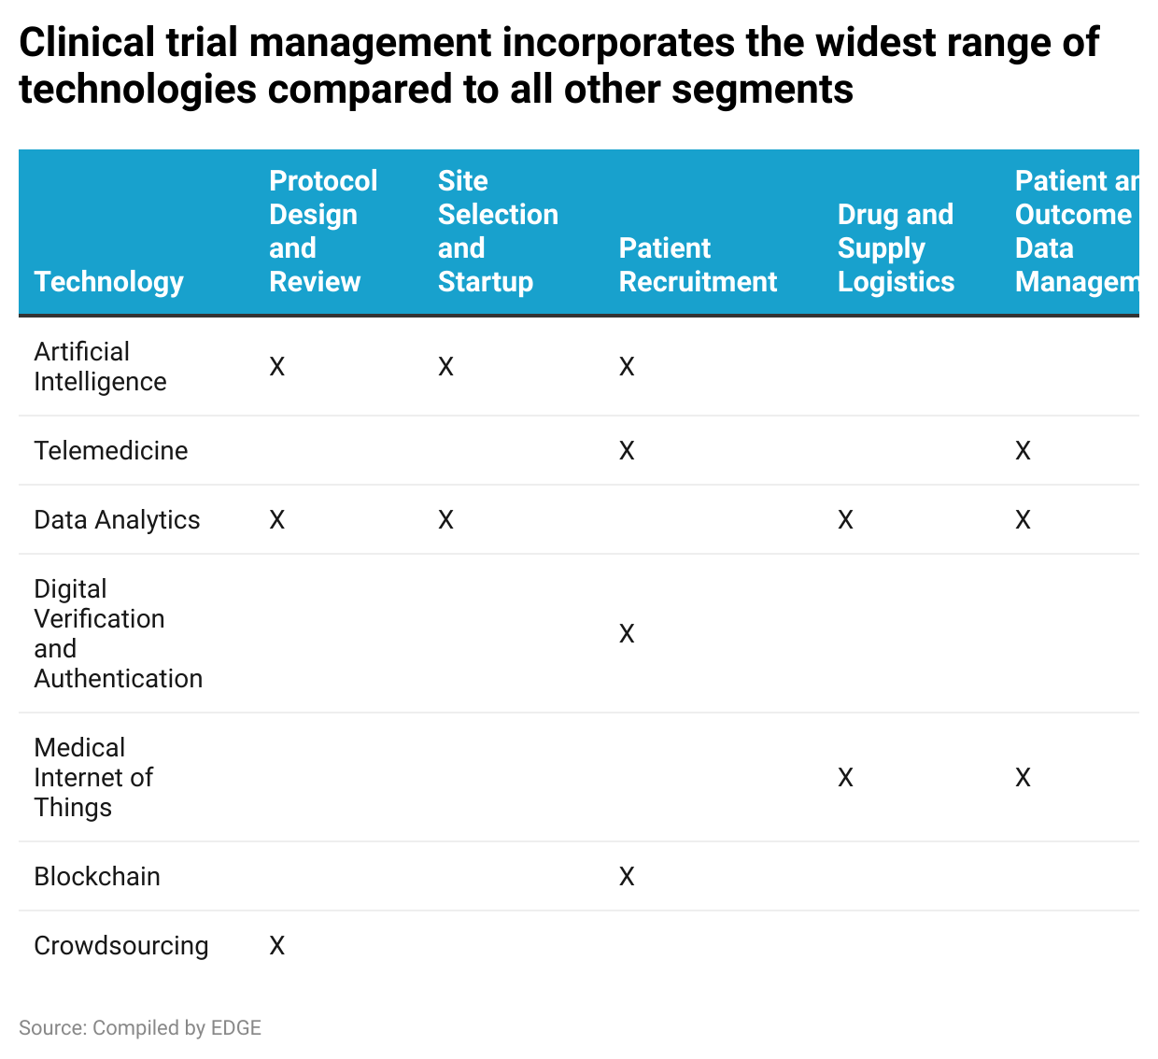

# 

# **Driving factors**

## **1. Automation and AI can expedite tasks and reduce time spent in clinical trials**

It takes an average of between five to seven years for a developmental drug to clear the clinical trial process, due in part to the highly regulated nature of the industry. This time spent in clinical trials has a negative impact on pharmaceutical companies in terms of the financial viability and returns on drug development due to the time value of money. By implementing technology into the clinical trial process, the time spent could be halved.

From a segmental perspective, gains could be made across the full clinical trial process. However, the areas with the highest potential for efficiency improvements are 1) site selection and startup and 2) patient recruitment. Currently, both require the evaluation of a large volume of potential candidates before a smaller number is selected for the clinical trial. Additionally, any mistakes in the selection process can force the trial back to square one.

As detailed in the table below, multiple startups from different segments apply technology to create tangible savings in time spent in the clinical trial process.

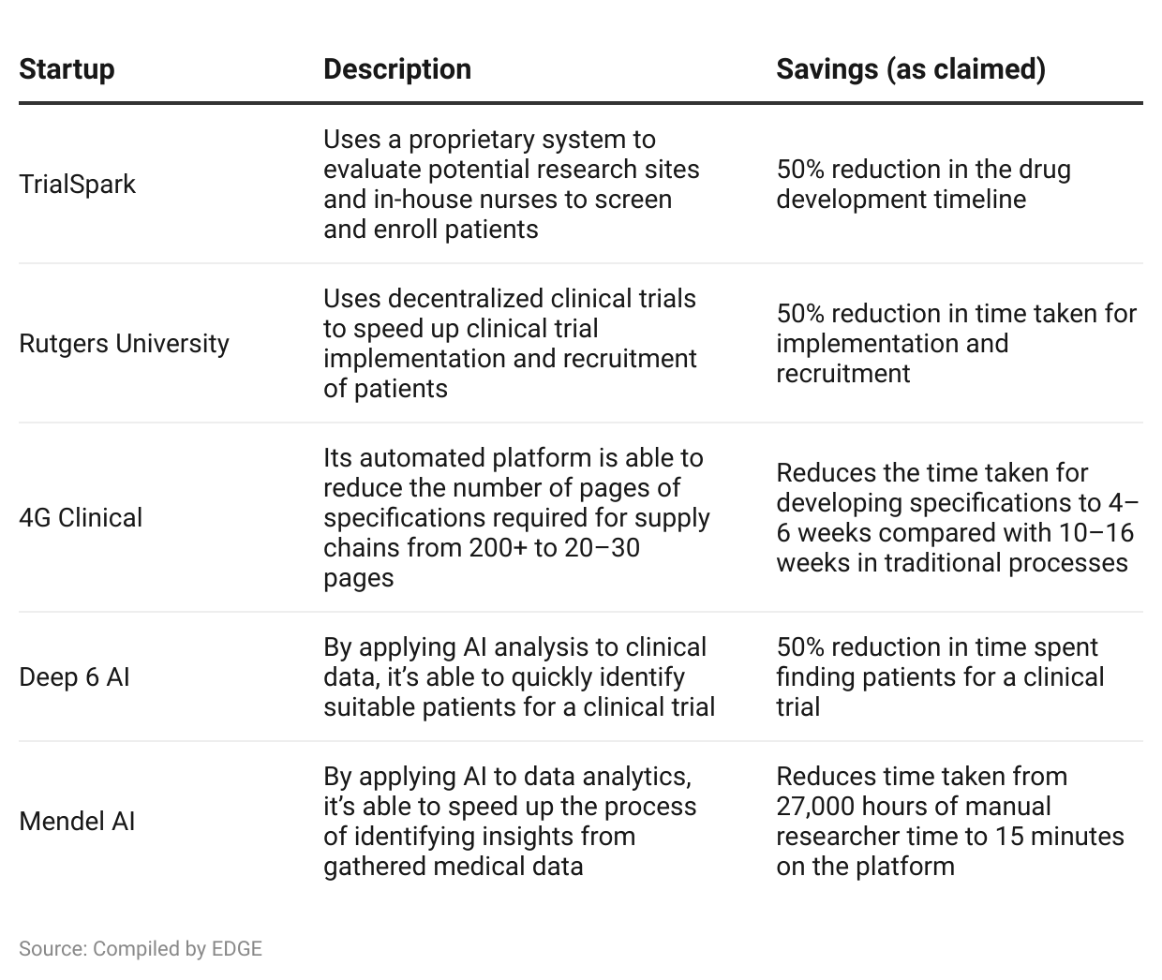

## **2. Decentralized clinical trials and electronic workflow management should reduce operating costs**

While dependent on the therapeutic area of the clinical trial, estimated costs of a clinical trial can range from USD 20 million to USD 80 million. The cost breakdown for a trial covers a range of factors, including the treatment protocol, number of research sites, and number of patients involved.

One significant cost reduction comes from the deployment of virtual clinical trials or decentralized clinical trials. By reducing the number of research sites required and the costs incurred for patients to visit research sites, the total cost of the clinical trial can be reduced. Furthermore, tools such as electronic documentation and consent can make it easier for clinical trials to comply with regulations and reduce the manual oversight needed.

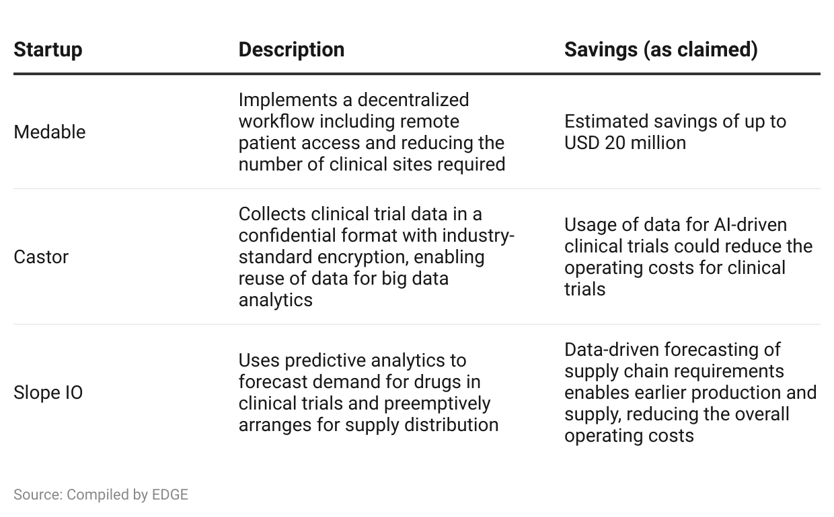

## **3. Machine learning and big data analytics to improve clinical trial success rates**

The latest research suggests that the success rate for drugs that enter the clinical trial process ranges between 10% and 20% depending on the therapeutic area. Even a minor improvement in the success rates would be significant in terms of the financial returns and savings in terms of opportunity cost.

According to an MIT study published in 2018, studies that incorporated an analysis of patients’ biomarker data were twice as likely to be approved by the regulatory body compared with studies that did not. Another example is from the University of Toronto, where a supercomputer was able to evaluate the effectiveness of drugs against a specific virus, along with analyzing other potential use cases. A further opportunity is predicting the success or failure of a potential drug or treatment using AI, which could significantly reduce the number of unsuccessful trials.

Big data analytics can be applied to the aforementioned patient biomarker data to derive insights across a large population in terms of the drug’s effectiveness, identifying potential risk factors based on demographics, etc. This enables researchers to proactively understand and manage clinical trials, leading to better success rates.

## **4. Changes driven by Covid-19 are shifting industry standards**

The Covid-19 pandemic had a negative short-term impact on the clinical trial industry due to patient reluctance to enroll. However, it opened up opportunities for startups in the space, as regulators and pharmaceutical companies explored new ways to continue operating clinical trials.The pandemic brought about strict restrictions on patient movement as well as health and safety concerns regarding visiting clinical research sites that were co-opted as emergency intensive care units.

Research by GlobalData suggested that 70% of clinical research sites were disrupted by the pandemic by March 2020. As a result, clinical trials and pharmaceutical companies were willing to explore decentralized and virtual trial models, where patients could participate from the comfort and safety of their homes. The use of electronic consent for clinical trials increased from 13% pre-Covid to an expected implementation rate of 88% by the end of 2022.

# **Risks to growth**

### **1. Stringent regulations and privacy concerns**

As a highly regulated industry, pharmaceutical companies are required to maintain a high degree of compliance with regulations across patient safety, protocols, and documentation. Technology can be applied to make compliance easier, but one historical challenge has been the speed at which regulations are updated to incorporate new tech and the clarity of existing regulations. For example, there remains a lack of clarity on the regulations for virtual clinical trials, including how the trial should be conducted, data collection protocols, and differences in regulations at a state level.

Additionally, GlobalData’s Digital Transformation and Emerging Technology in the Healthcare Industry surveys indicated that data security and data privacy were the main concerns of patients when considering virtual clinical trials.

### **2. Failure to improve drug development rates**

The success of clinical trial tech will depend on an improvement in drug development, where success rates and productivity have fallen over the past decade. The drop in success rates is noticeable from 2015, despite the number of submissions for regulatory clinical trials remaining stable (at around 90% before the Covid-19 pandemic). If the submissions do not recover to pre-Covid levels, the potential for clinical trial technology may be affected.

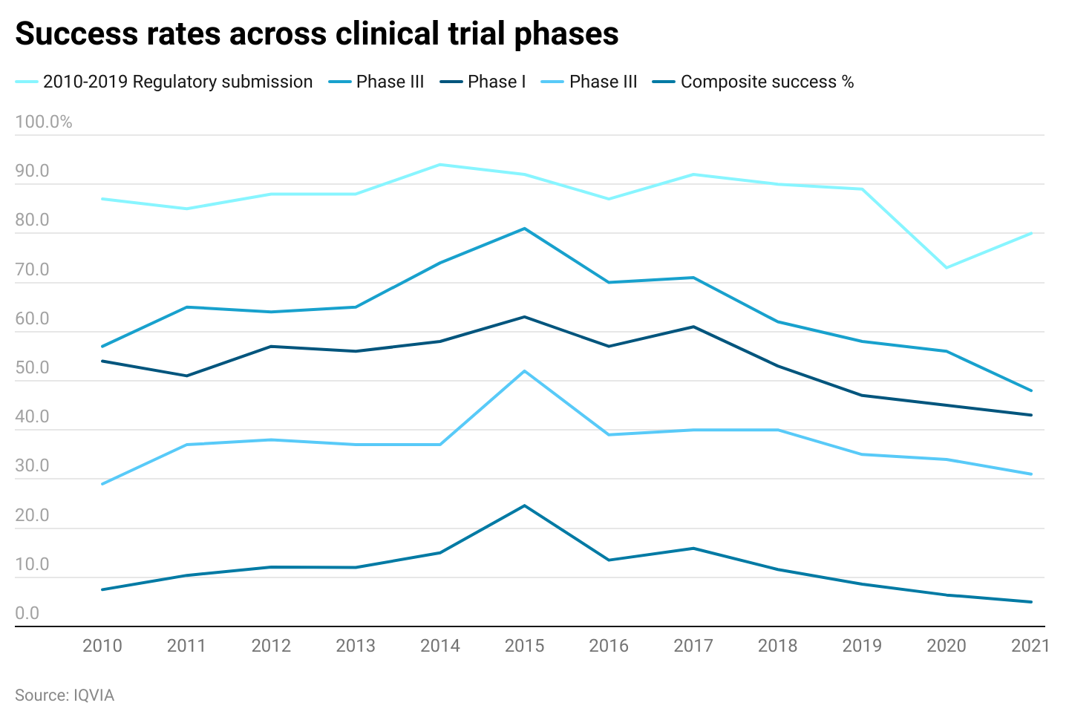

### **3. Technology for virtual evaluations remains limited**

Current telemedicine technology allows researchers to consult with patients remotely. When combined with the medical internet of things, researchers can collect patient biomarker data virtually, reducing costs and enabling higher participation rates. However, some clinical trials require additional evaluations, whether physical or visual, which are not currently supported by telemedicine technology.

For example, dermatologists have found that telemedicine solutions do not meet the minimum requirements needed to replace physical clinical trials. Specifically, the video quality that can be transmitted is not sufficient to make clinical observations. Furthermore, certain dermatological conditions require examination via touch in addition to visual examination. Failure to develop telemedicine technology capable of supporting higher-quality visual examination and physical tests would limit its scope for clinical trials.

*Last updated: November 2023*

©2024 Uzabase, Inc. All Rights Reserved. The information contained herein: (1) is proprietary to Uzabase Inc. and/or its content providers; (2) may not be copied or distributed; and (3) is not warranted to be accurate, complete or timely. Neither Uzabase Inc. nor its content providers are responsible for any damages or losses arising from any use of this information.