# **EdTech: Corporate Learning: Overview**

# 

The EdTech industry broadly encompasses the PreK-12, higher education (or post-secondary), corporate, government, and adult (or lifelong) learning end-user segments. The PreK-12 and higher education sectors were early adopters of EdTech, while corporates have come along more recently. Technologies and trends such as micro-learning, personalization, competency-based learning, gamification, and adaptive learning began in the education sectors before being adapted for the corporate audience.

Reliance on EdTech for enterprise-level workforce training is increasing, as organizations seek to onboard new employees, retain and motivate staff, and bridge skill gaps with limited learning and development (L&D) resources. Many specialized jobs also require continuing education and accreditation, which can be supported by EdTech tools and services.

The modern workforce’s drive to learn new skills and take on new challenges has also influenced the adoption of EdTech, with e-learning now representing 21%–40% of the median organization’s learning portfolio in contrast with 1%–20% seven years ago.

**Mandatory and compliance training and new employee orientation courses lead corporate learning content distribution and delivery methods**

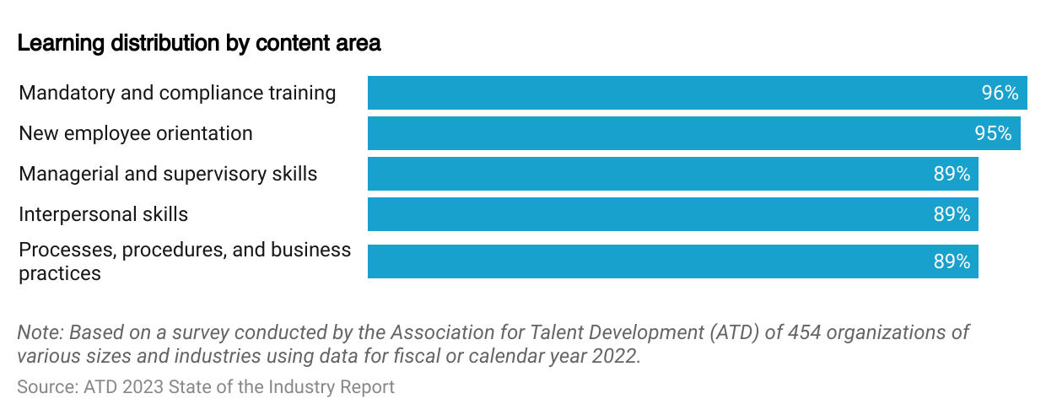

**High smartphone penetration and advancements in key technologies enabled the growth of EdTech in corporate learning**

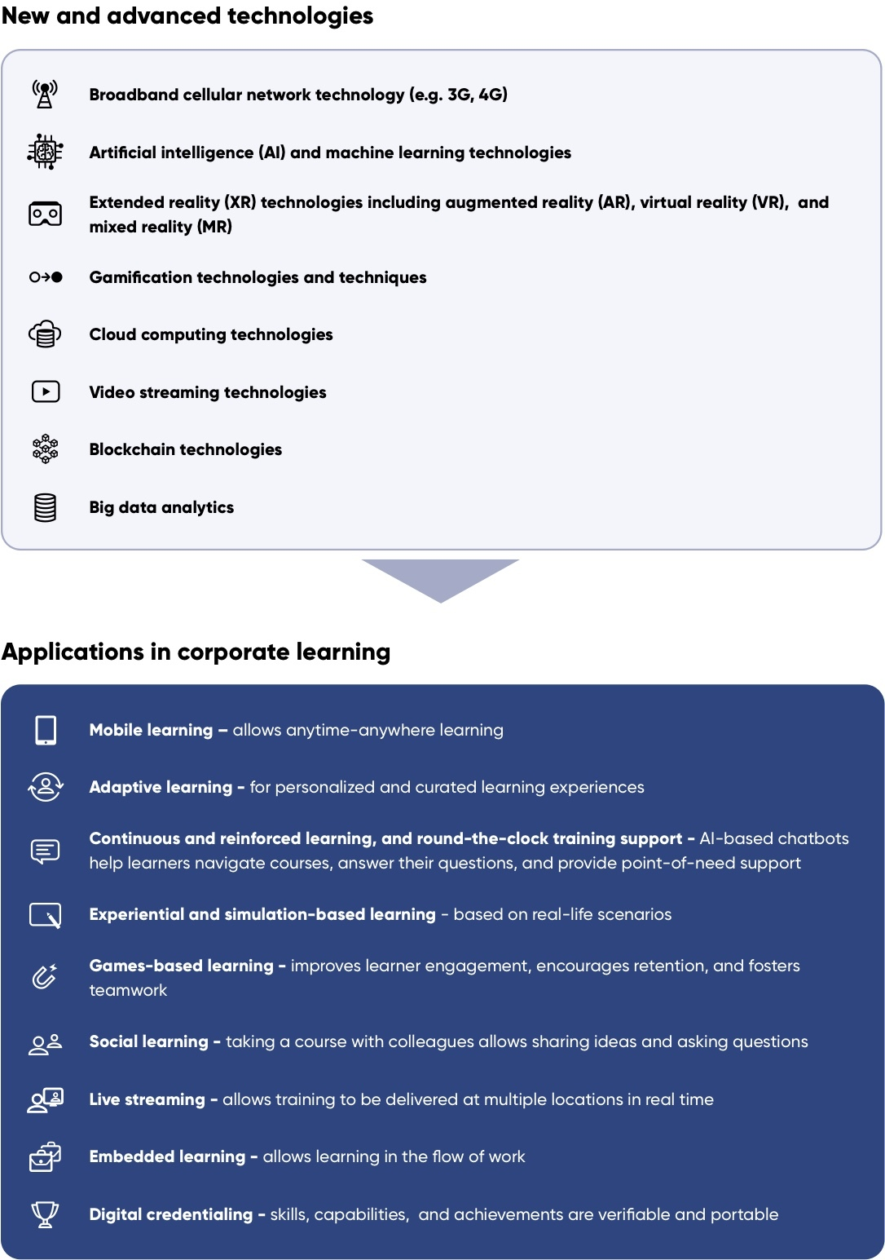

Source: Compiled by SPEEDA Edge

# **Driving Factors**

## **1. Expectations and preferred learning styles of the modern workforce**

A major portion of the current US workforce is made up of tech-savvy millennials and digital-native Gen-Z employees, who expect employers to rely on digital channels in the workplace. Millennials are more tech-literate than previous generations, and the Gen-Z generation, which has grown up surrounded by connected technologies, even more so. Therefore, organizations with digitized training platforms are perceived as being in step with their preferences.

### **Millennials and Gen-Z employees make up nearly half of the US workforce**

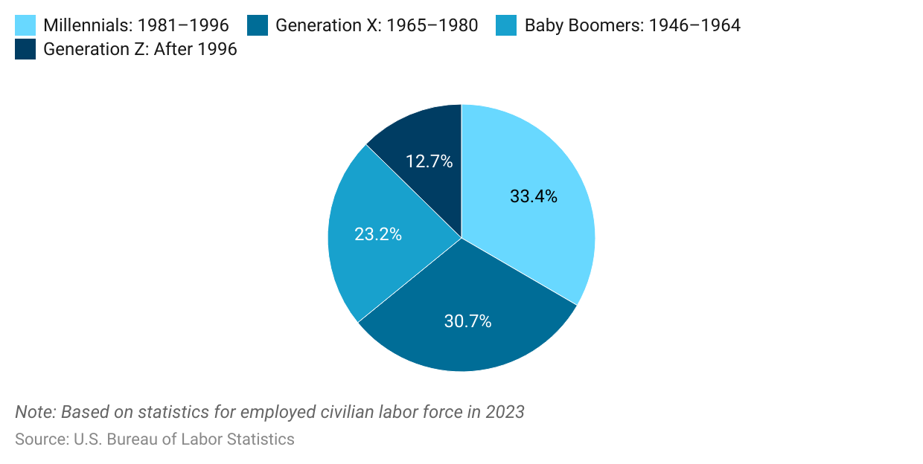

### 

### 

### 

### 

### 

### **US millennials are more technologically connected than previous generations**

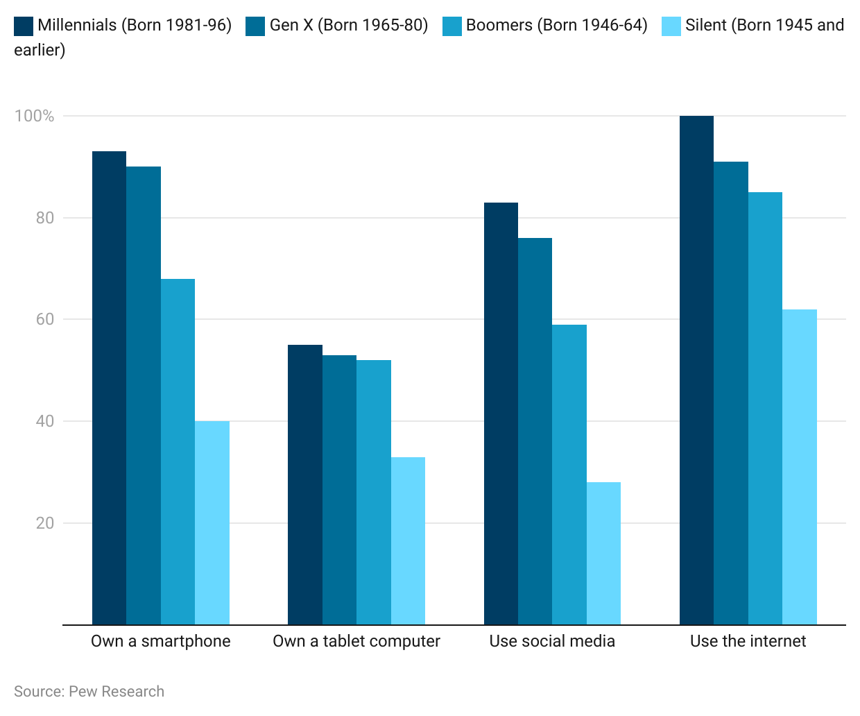

Thanks to shorter attention spans and high mobile phone dependency, millennials and Gen-Z employees prefer bite-sized training sessions that can be accessed any time and anywhere. In a survey conducted by Docebo of 2,400 employees in the US and the UK,

* *59% believed happiness at work is impacted by learning and development opportunities and*
* *36% (48% of millennials) said they would quit a job due to a lack of learning opportunities.*

Source: Docebo's ‘Fake It Til’ You Make It’ Survey 2019

## **2. Transition to hybrid and distributed teams**

Remote working has been on the rise in the US, particularly in industries that involve knowledge work. In 2019, 16% of the US workforce worked remotely at least part of the time. The Covid-19 pandemic accelerated remote work, leading to a shift to hybrid models. According to a McKinsey survey, three years after the pandemic, office attendance has rebounded: 37% go daily, 56% have hybrid arrangements, and 7% work fully remotely. This shift toward remote work has opened up opportunities for EdTech, which allows the delivery of training to distributed teams regardless of geographic location or travel limitations, either in real time or asynchronously.

## **3. EdTech delivers effective and scalable employee development**

EdTech yields distinctive advantages over traditional corporate learning methods.

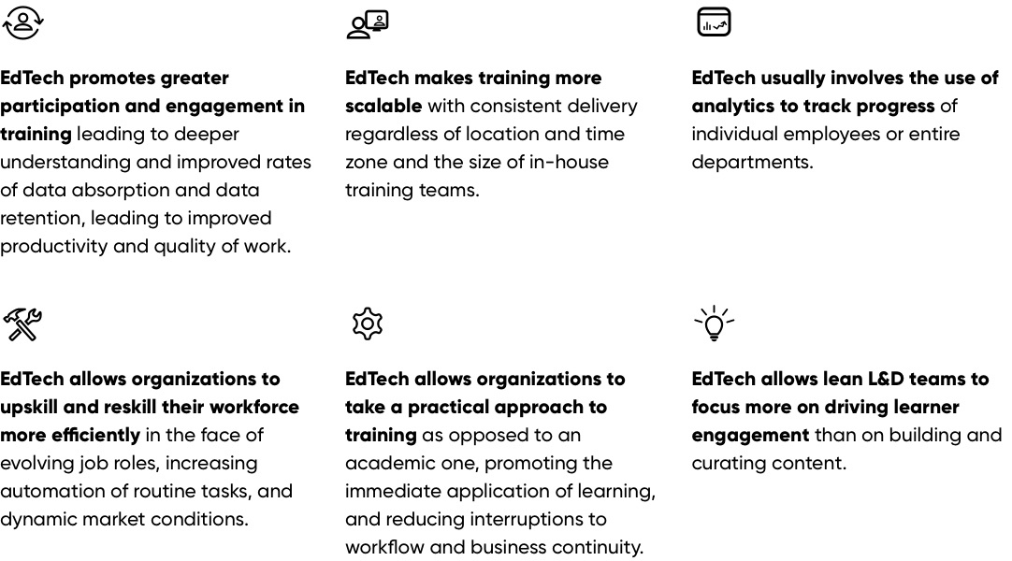

# **Risks to growth**

## **1. Face-to-face learning is still preferred**

Despite the growing usage of EdTech in corporate learning due to social distance concerns brought on by the Covid-19 pandemic, traditional face-to-face classroom training formats are regaining popularity in terms of average learning hours as normalization sets in. In 2022, the ATD survey found that 89% of organizations use traditional classrooms, 86% use live virtual classrooms, and 75% use self-paced online learning as their primary delivery methods.

### 

### 

### 

### 

### **Traditional live classroom instruction continues to prevail, representing 30% of time spent on corporate training**

## 

## **2. Driving and measuring learner engagement and impact remains a challenge**

Although using EdTech in corporate learning improves workplace engagement, learner engagement remains a key challenge for L&D professionals, with finding ways of driving engagement remaining a top priority.

Moreover, there is no industry standard for measuring learner engagement, with only 76% of L&D professionals tracking metrics such as course completions, learner satisfaction surveys, minutes learning per month, and repeat visits per month.

L&D professionals also struggle with measuring the impact of online learning, due in part to a lack of industry standards. Consequently, a combination of quantitative and qualitative measures are used, not necessarily specific to online learning such as qualitative feedback from employees and managers, course completions, and number of employees who consistently learn online.

*Last updated: April 2024*

©2024 Uzabase, Inc. All Rights Reserved. The information contained herein: (1) is proprietary to Uzabase Inc. and/or its content providers; (2) may not be copied or distributed; and (3) is not warranted to be accurate, complete or timely. Neither Uzabase Inc. nor its content providers are responsible for any damages or losses arising from any use of this information.