# **Overview**

# **Restaurant Industry Robotics: Overview**

## 

## **Robotics picks up pace in the restaurant industry**

Restaurant industry robotics is the integration of robots for full or partial automation of the restaurant industry value chain, from primary and secondary food processing to food preparation, as well as food service.

With labor costs rising steadily, the food industry has increasingly explored robotic solutions—made more attractive as technology has advanced and adoption costs have declined. Looking at the use of robotic units in North America by sector, food and consumer goods witnessed a 29% year-over-year (YoY) growth in units ordered in 2022. The total number of robot units sold in North America rose 28% YoY.

The role and nature of robotics have varied across the restaurant industry value chain over the years. Earlier robot products were better suited to secondary food processing such as pick-and-place for processed food and cake dispensing. Newer technology, such as advanced grippers (tools that mimic how a human hand grips food or items) and collaborative robots (called “cobots”), increasingly suit primary food processing as well, such as pick-and-place of fruits and vegetables.

Demand for non-customer-facing tasks like cleaning and dishwashing is also picking up pace; 47% of restaurateurs said they expected to see robots for cleaning tasks to become mainstream by 2025. For example, [Dishcraft Robotics,](https://sp-edge.com/companies/389488) a provider of robotic dishwashing-as-a-service for restaurants and corporate kitchens, is one of the first startups to grab the opportunity. Other top functions for robotics include kitchen prep, food quality checks, and staff training.

While incumbents offer robotic solutions for primary and secondary food processing as well as for downstream food preparation and service, startups tend to specialize downstream, in food preparation and service delivery.

### **How food robotics fit into the restaurant industry**

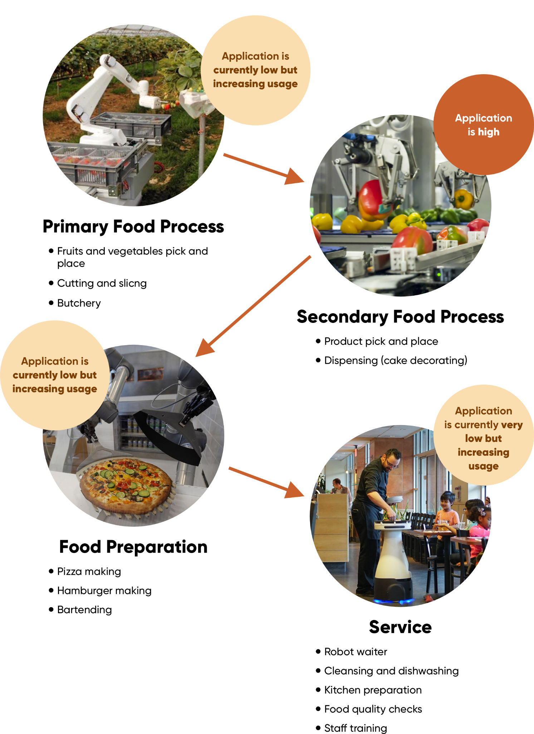

Source: Compiled by Edge

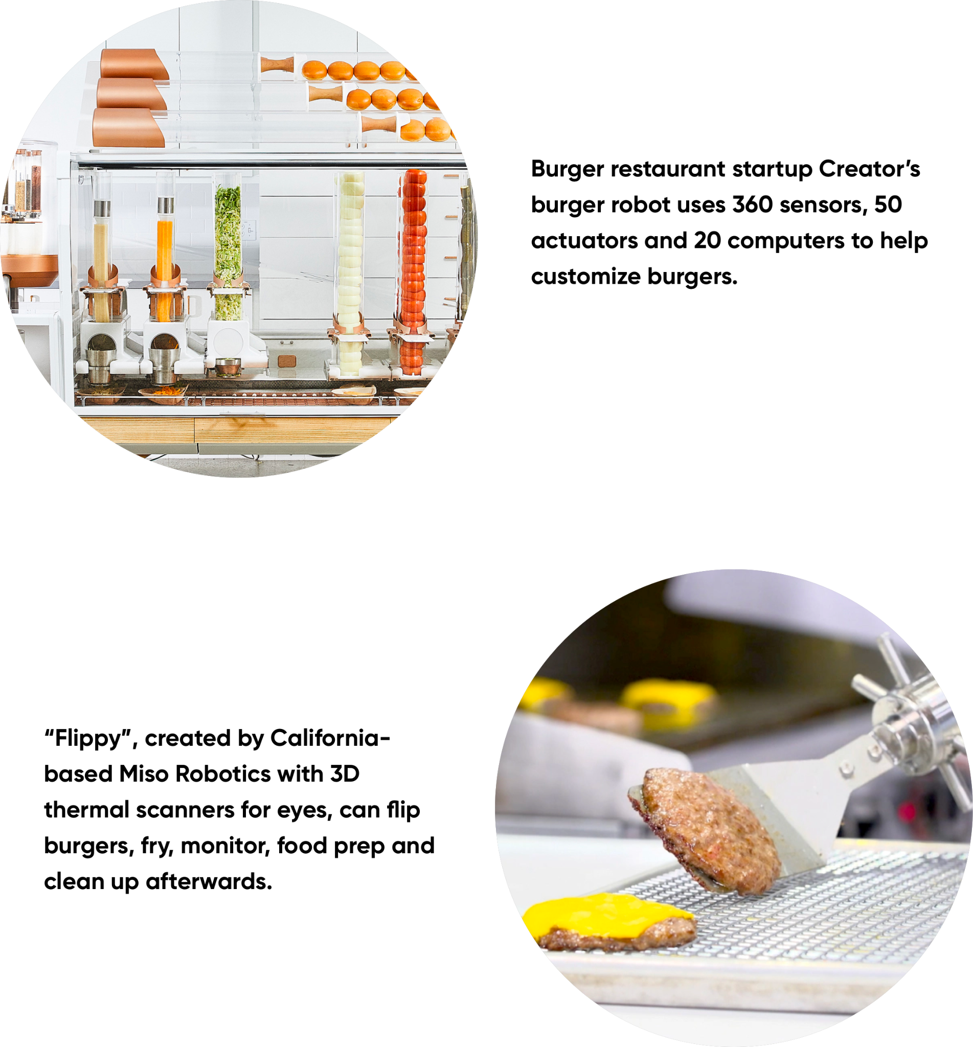

**Flippy’s price drops by more than 3x over 2016-2020**

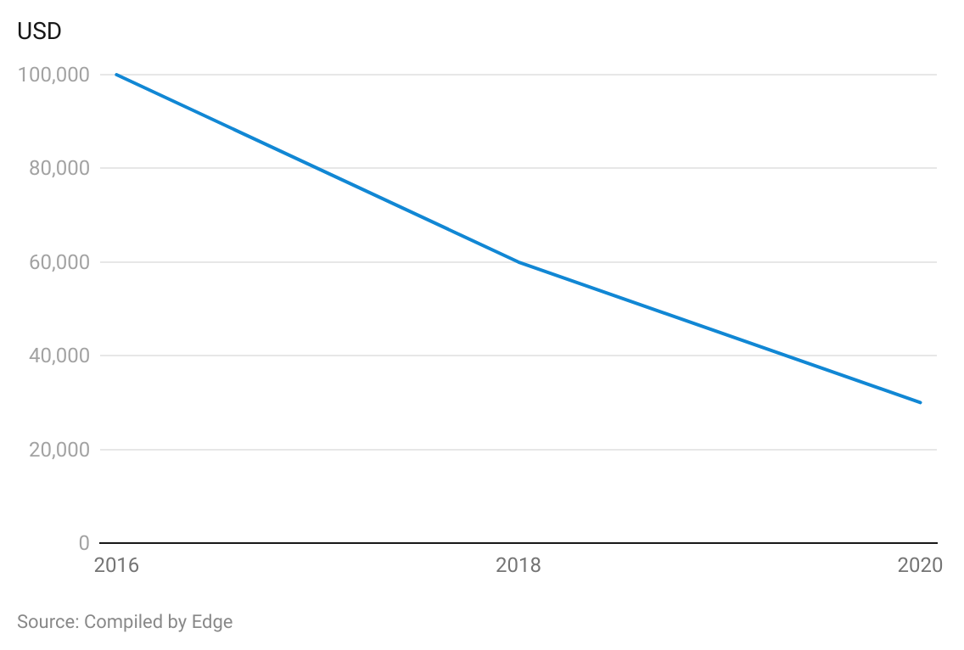

## **Most robotic solutions in the industry offered for a subscription fee**

The business models of industry players vary based on pricing (fixed versus subscription-based) and the nature of the business (third-party robotic suppliers versus restaurant-turned-robotics companies).

Most industry players are robotics suppliers that provide solutions at a fixed price. However, since more recently, a rising number of disruptors are offering solutions at a monthly subscription fee (Robotics-as-a-Service, or RaaS).

**Business models of robotic solutions providers**

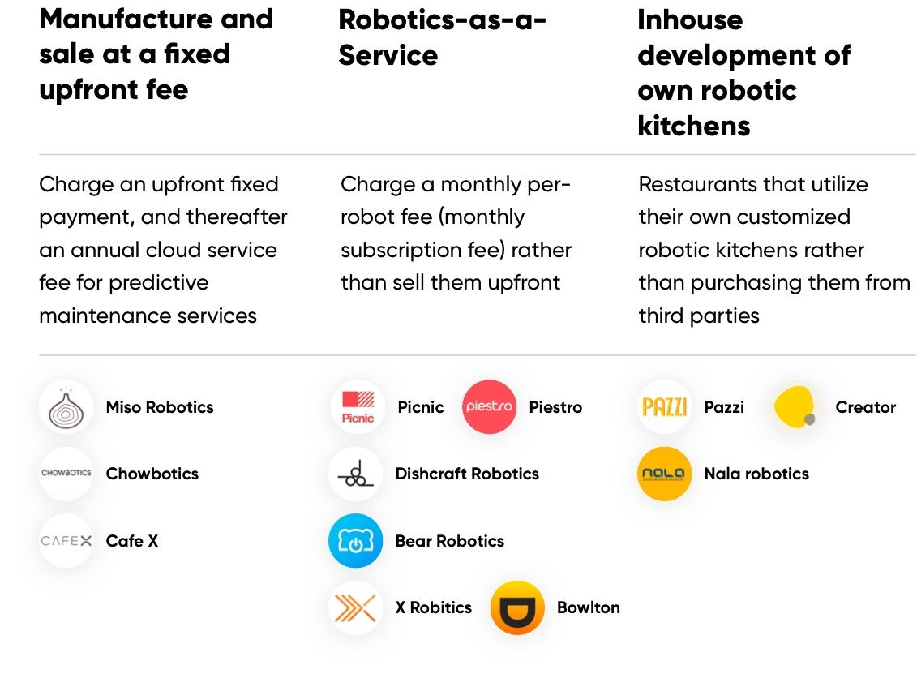Source: Compiled by Edge

# **Driving Factors**

## **1. Labor costs versus robot prices diverge in favor of robotics**

Labor is a key cost component for the restaurant industry, as it reportedly accounted for 31.6% of total restaurant operating costs in Q2 2019. Meanwhile, average hourly wages for the industry increased 21% during the span of February 2020 to November 2022, reaching a projected USD 18.99 in November. This is expected to further increase, as more than 26 US states have announced plans to implement higher minimum wages during 2023.

A 2022 survey by the National Restaurant Association revealed that 62% of restaurant operators do not have enough employees to meet customer demand. Furthermore, the demand for restaurant cooks is expected to grow 12% over 2016–2026, which would raise the potential for staff shortages and result in higher wages. Notably, the annual mean wage of restaurant cooks rose at a compound annual growth rate (CAGR) of 3.8% over 2016–2020 (slightly higher than the US annual mean wage increase), constraining restaurateur margins.

Accordingly, the draw of investing in robots is clear with the falling unit prices of robots and the potential to improve productivity. When integrated with kitchen staff, robot model Flippy (the burger flipping robot assistant developed by [Miso Robotics)](https://sp-edge.com/companies/461591) is expected to significantly lower labor cost and improve a restaurant’s earnings before interest, taxes, depreciation, and amortization (EBITDA) margin. Calculations show that investment in the original Flippy model could be recovered after the second year of integration, and in ROAR, after the first year of integration, indicating a highly attractive payback period.

### **Flippy is expected to lower labor cost to 16% of sales vs. 26% without**

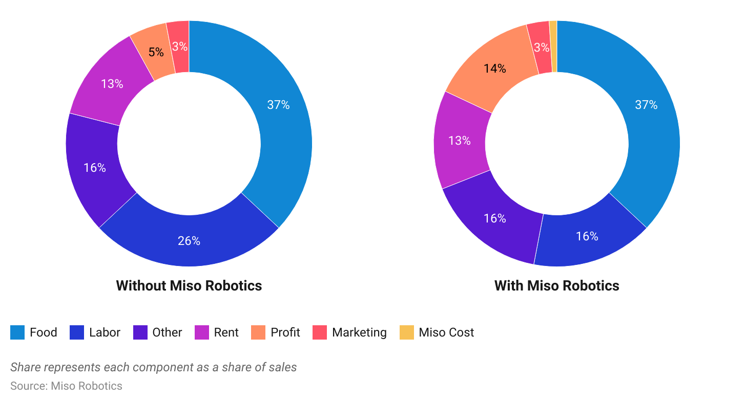

Similarly, Nala Robotics claims that “Wingman,” the company’s robot fryer technology will save the restaurants 20% on labor costs (calculated at a USD 7 minimum wage).

Beverage preparation robots also offer significant cost savings and improved margins compared to manual labor. For example, [Bobacino,](https://sp-edge.com/companies/1192708) a developer of a fully automated boba tea bar, claims its robot can bring down labor costs (by 16 percentage points), rent/utility payments (by six percentage points), and other costs (by five percentage points), improving restaurant profit margins (by 27 percentage points). Reportedly, the unit would take only one to two weeks to be installed and cost just USD 50,000, unlike a traditional coffee shop that takes roughly a year to set up, costing approximately USD 200,000–USD 375,000.

**Bobocino expects to lower labor costs to 10% from 26% of sales**

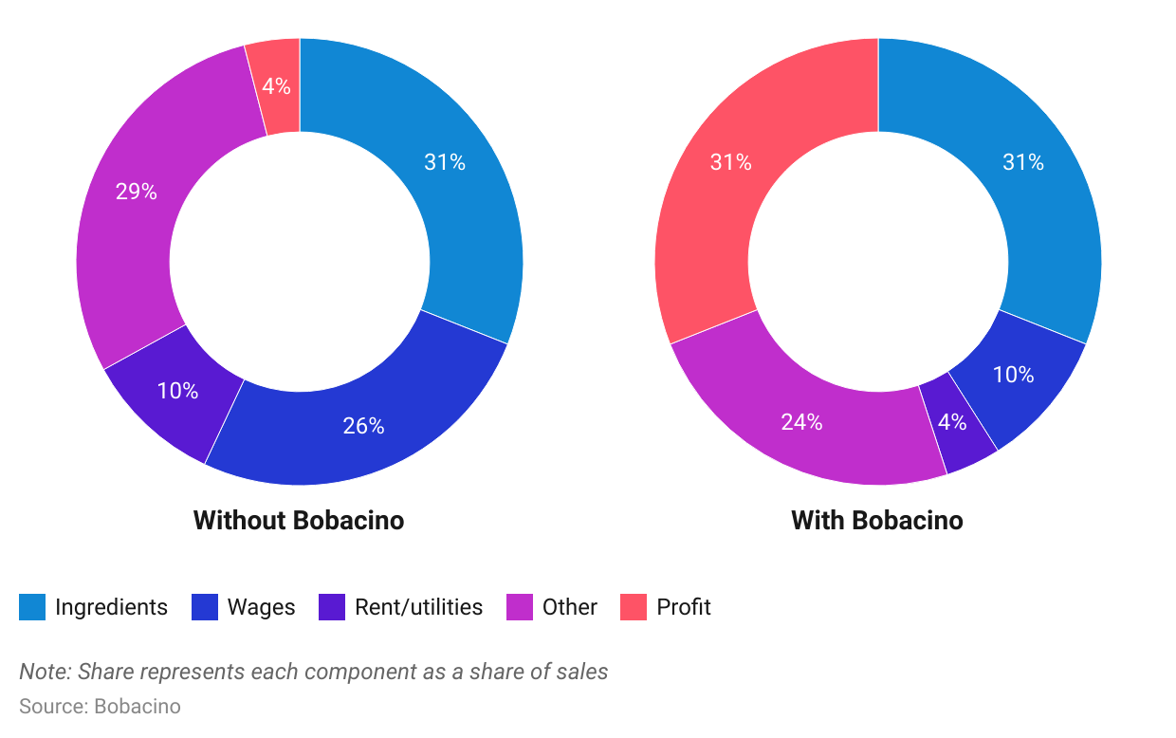

## **2. Rising food safety concerns**

Increased instances of food contamination, along with the enforcement of more stringent safety and hygiene regulations, as stipulated by the Retail Food Safety Action Plan by the US Food and Drug Administration (FDA) in 2011, support the adoption of robotics across the food industry. The manual handling of food has a high rate of error and probability of contamination. In fact, food-borne illnesses impact an estimated 48 million in the US on an annual basis, causing roughly 128,000 hospitalizations and 3,000 deaths each year on average as of 2019, with situations worsening during the Covid-19 pandemic. 80% of these reported cases of food-borne disease occur in food-service establishments. Furthermore, 62.8% of health and safety violations cited by health inspectors were due to human factors such as cross-contamination, time and temperature abuse, and poor personal hygiene. Robots are programmed to avoid cross-contamination, cook food to proper temperatures, and follow specific food safety protocols. Their embedded sensors help instantly detect potential food safety issues.

# **Risks to Growth**

## **1. System malfunctions**

One of the major risks from robotics adoption is system malfunctions, which can lead to erroneous food preparation and dissatisfied customers. For instance, in January 2020, [Café x,](https://sp-edge.com/companies/319014) an operator of robotic coffee shops, closed its three San Francisco locations due to operational malfunctions.

## **2. Repetitive taste and limited recipe repertoire**

Unlike humans, robots can reproduce only repetitive, similar-tasting dishes. Although some robotic solutions might be able to devise customized recipes and ingredients, robotic systems might limit the food choices restaurants can present to their customers. For this reason, use of robots might be limited to fast food restaurants, where menus are more standardized than in family or fine-dining restaurants. However, some robotic companies allow customers to customize their dishes using the available ingredients to avoid standardization. For example, pizza-making robot developer [Pazzi](https://sp-edge.com/companies/762422) offers the flexibility to customize their own pizza from over 500,000 recipe combinations.

## **3. Lack of human interaction**

Human interaction is important to customers dining out. This means despite speed of service and fewer human errors (qualities that make robots a compelling alternative), full automation could negatively impact customer satisfaction and the appeal of the experience of restaurant dining in the long run. A recent survey notes that consumers have mixed feelings toward use of robotics at restaurants — while they are not entirely opposed to the idea of having robots around, they are not too thrilled about it either, as robots lack the human touch and interaction. This is one of the reasons behind fine dining restaurants employing less or no robotic solutions as opposed to quick service restaurants where robotics are seen as a more viable solution. When [Pazzi](https://sp-edge.com/updates/13661), a manufacturer of robotics and machine learning-powered pizza-making robots closed down its operations, the company’s CEO listed “a general mistrust of the population towards robotics” as one of the reasons for the company’s failure.

## **4. Lack of safety regulations**

Integrating robotics with humans in the restaurant space raises issues of safety for employees and customers. Despite the growing use of industrial robotics, the federal Occupational Safety and Health Administration (OSHA) has not promulgated specific standards for the robotics industry. Its most comprehensive publication, “OSHA’s Guidelines for Robotics Safety,” is more than 30 years old. Restaurants will need to develop and convey their own safety guidelines. Robotics companies, too, will need to focus on the safety of their products. One of the safety aspects that needs to be considered is the privacy of customers and staff — which robots might hinder given their attached sensors, cameras, and biometric devices.

*Last updated: June 2023*

©2024 Uzabase, Inc. All Rights Reserved. The information contained herein: (1) is proprietary to Uzabase Inc. and/or its content providers; (2) may not be copied or distributed; and (3) is not warranted to be accurate, complete or timely. Neither Uzabase Inc. nor its content providers are responsible for any damages or losses arising from any use of this information.