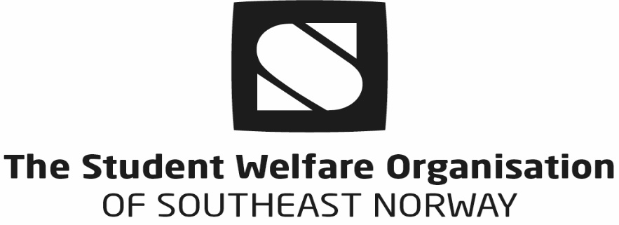

Documentation of financing for students applying for a student visa or a student residence permit to Norway – applies only to non-EU/EAA citizens.
One of the requirements for obtaining a student visa or a student residence permit for Norway is that the applicant must document access to NOK 126 360 for the first academic year (10 months) or NOK 63 180 for students accepted for only one semester. As a main rule, this money must be kept in a Norwegian bank account. In some cases, a bank statement / payment guarantee from a bank in the student’s home country is accepted, but this is seldom recommended as the Norwegian Immigration Authorities are fairly strict about the financial guarantee for studies in Norway. For the same reason, guarantees from relatives or others (except a bank or a university) are not recommended. Usually the lack of approved financial documentation makes the processing of the application for a student residence permit / visa take longer than usual, which might result in students not obtaining their residence permit / visa in time to start their studies.

It has proven difficult for students to open bank accounts in Norway on their own prior to receiving their personal number, which is provided after the residence permit is granted.
Therefore, the Student Welfare Organisation of Southeast-Norway (SSN) has opened a deposit account in the bank “Sparebank 1 Sørøst-Norge” for international USN students, where students can deposit the needed amount of money from their home country.

Instructions for deposit of money to SSN’s Deposit account for international students

- Conditions for depositing money to SSN’s deposit account for international students:
Please read the following carefully:
  - Only students accepted to studies at USN may deposit money to this account. The money must be deposited in the student’s own name.
  - According to Norwegian law, there is no interest on deposit money.
  - Please note that a banking fee may be deducted from the money deposited.
  - The student must notify SSN of his/her address in Norway and of his/her Norwegian bank account as soon as possible after arriving in Norway.

- If you want to accept the offer of transferring your money to SSN’s deposit account and accept the conditions stated above, please fill out the reply slip below, scan it and send it by mail to: okonomi@ssn.no.

- After sending the reply slip, please transfer the money (for one whole academic year if you are a degree seeking student, or for 6 months for Erasmus Mundus students) in your own name to the following account in the bank “Sparebank 1 Sørøst-Norge” as soon as possible:

Name of Bank: Sparebank 1
Account number: 24802791131
Iban number: NO8524802791131

Swiftcode: SPTRNO22
Account owner: Studentsamskipnaden i Sorost-Norge
Owners address: Raveien 189 B, 3184 Borre, Norway
Account title: Account foreign students
- When transferring the deposit to our account, remember to add an amount on approximately NOK 200. This is a fee the bank takes to transfer the money to an international bank.

- SSN will send you a statement confirming that you have deposited the actual amount of money to the deposit account.

- Please enclose the statement from SSN to the embassy when applying for a student residence permit to Norway.

- SSN will also send a list of students who have transferred money to SSN’s deposit account to USN.

- In addition to the deposit, you need to bring enough money for at least a week or more and preferably also a credit card / ATM card valid in Norway (check with your bank), since it takes a couple of days from arrival until you’ll get your BankAxept card (see below).

- Please notify SSN immediately after arrival at your address in Norway.

- To get a BankAxept card you need to sign a power of authority that you let SSN withdraw money from your deposit to pay for your housing contract period with SSN.
- If you sign you will get a BankAxept card at our local service center, and it will take 3-4 days before you will get the remaining amount to your card.
- If you don’t sign that we can pay the rent for your contract period, you will not get your deposit money before you get a Norwegian account or you want us to transfer the money back to your international account.
- However, this card cannot be used on all bank terminals. We therefore recommend that you apply for a Norwegian personal number as soon as possible after registering at the local Police Station (within 7 days after arrival). The personal number is vital for opening a bank account in Norway.

- Processing of the application for a personal number may take up to 5 weeks.

- Be sure to open a bank account in a Norwegian bank of your choice as soon as possible after receiving your personal number. This will make your funds easier available for you. After receiving your new bank account number, please notify SSN as soon as possible. We will then transfer your money from your BankAxept card to your Norwegian bank account.

- If you have already transferred money to the deposit account but change your plans about studying at USN in Norway, SSN will return your deposit as soon as possible, except for a small banking fee for the transaction.

- If you have signed a housing contract, the money you owe according to the terms of the contract will be withdrawn from your account by SSN before returning the deposit back to you.

Deposit Account for international students – Reply Slip

I, the undersigned, hereby declare that I have read and understood the conditions as stated in the letter above. I agree to the terms of the Deposit Account for international students provided by The Student Welfare Organisation of Southeast Norway, in order for international students at The University of South-Eastern Norway to obtain a residence permit in Norway.

Last name: …………………………………….. First name: ………………………………

Date of birth (ddmmyy) ……………………… Citizenship: ………………………..

Address in your home country:

……………………………………………………………………………………………………………
…………………………………………………………………………………………………………..

Application number…………………………………………………………………………….

Campus………………………………………………………………………………………………

E-mail: ……………………………………………………………………………………………….

This person is transferring the amount on my behalf: ………………………………………………………………………

Date: ……………………………. Signature: ………………………………………………..

Please scan this reply slip and send it to: okonomi@ssn.no

