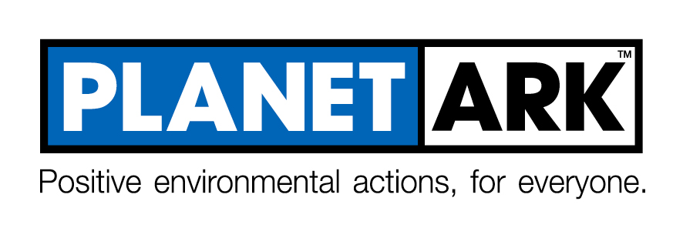

JOB DESCRIPTION
ROLE:  MANAGER:  DIRECT REPORTS:  HOURS:  DATE: | Visual Content Creator  Head of Communications  None  30  September 2021

ROLE OBJECTIVE
The primary objective of the Visual Content Creator role is to produce high quality and engaging visual content for all Planet Ark’s programs and platforms to maximise the impact of the Planet Ark brand.

PRINCIPAL DUTIES AND RESPONSIBILITIES
- Work with the Communications, Campaigns, IT and Partnerships teams to develop digital media communications for Planet Ark’s range of campaigns, programs and marketing activities.
- Create engaging image and video content for use across all Planet Ark’s campaign, communications and marketing activities including print, social media, publications, presentations, Electronic Direct Mail and web assets.
- Work with the IT team to create and maintain website stylesheets and assets to ensure consistent presentation across digital platforms.
- Offer guidance to campaign managers and the Executive team on best practice in brand design/consistency.
- Establish and maintain productive relationships with a range of key stakeholders and internal staff at all levels.
- Contribute to other organisational activities beyond the scope of the Visual Content Creator role as agreed, and any other duties as reasonably directed by your manager.
- Ensure personal adherence to Planet Ark’s HR Manual.

WORKING RELATIONSHIPS

INTERNAL | EXTERNAL
Communications team | Sponsors / Partners / Stakeholders
Campaign Managers | Service providers
IT team
Operations Team
HR Team

ESSENTIAL SELECTION CRITERIA
- Qualifications and/or relevant experience in visual design
- At least two years’ experience in online content production and developing digital engagement strategies
- Experience in using relevant software to produce digital collateral including proficiency in Adobe Creative Suite, especially Premiere Pro, InDesign, Illustrator and Photoshop
- Strong capability in graphic design, online design, and video production for an online environment
- Strong understanding of designing for responsive website environments
- Knowledge of brand development and the creation of brand style guides
- Knowledge of a broad range of social media platforms
- High level oral, written and interpersonal communication skills
- Strong time management skills, with an ability to manage ongoing, concurrent tasks, work under pressure and meet tight deadlines with a strong attention to detail
- Experience working effectively as part of a team as well as autonomously
- A strong alignment with Planet Ark’s mission and values.

DESIRABLE CRITERIA

- Technical experience in website content production (CMS, basic HTML, CSS, database skills, email, SEO, SEM).
- Experience using Campaign Monitor or similar.

