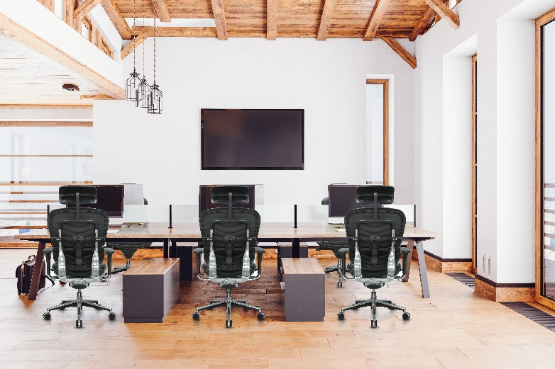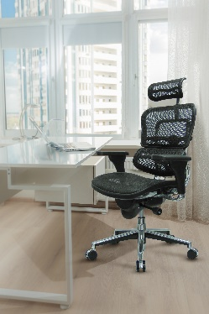­­

**THE RAYNOR GROUP/EUROTECH**

**aBOUT THE RAYNOR GROUP**

The Raynor Group has been the premier representative for quality and ergonomic design in office chairs since 1979 with our Eurotech brand of office seating. Our commitment to design, function, and form has resulted in over 1 billion dollars in cumulative sales.

All product can be seen on our website [www.eurotechseating.com](http://www.eurotechseating.com)

Product is in stock and ready to ship.

All product meets or exceeds BIFMA standards

**STATE AGENCY POLICY**

Our policy is the states policy. All state agencies are able to utilize this contract. Agencies included are the following but not limited to:

City, county, state, religious organizations, Labor, healthcare, higher ed, environmental

525 Hempstead Turnpike  
West Hempstead, NY 11552  
TF 1.800.637.0005 FX 1.516.481.8141

**Contract #:** 4400024117 **Valid:** 06/27/2020-12/05/202599846 - furniture

**Eurotech Seating Contacts**

Eric Gellman  
Phone: 516.267.7214  
Email: egellman@raynorgroup.com

Customer Service  
Phone: 1.800.637.0005  
Email: [customerservice@raynorgroup.com](mailto:customerservice@raynorgroup.com)

Website: [www.eurotechseating.com](http://www.eurotechseating.com)

**Price List**2020 Price List Effective 01/01/2020

**Additional Information**  
Purchase orders can be sent direct to Eurotech with a servicing dealer noted on the order or the orders can be placed with a servicing dealer. Please make sure if the order is coming from the servicing dealer to include the State order along with the dealer order.

Please include on ALL orders:

Contract number, valid date and servicing dealer

**End User Discount (Off List):**Discount off list price - 50%

Payment Terms Net 30 Days

**SOUTH CAROLINA**

**State**

**Contract**