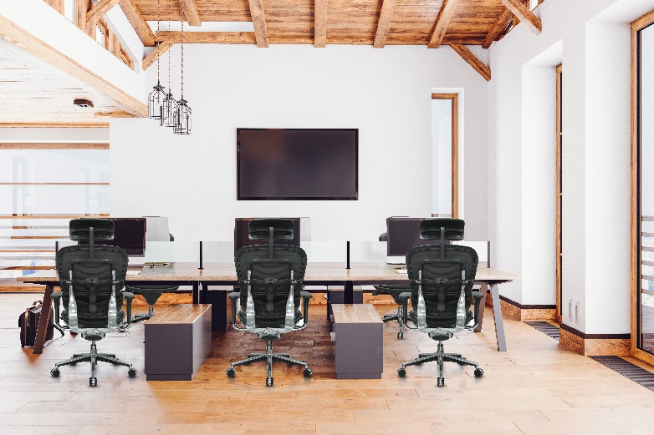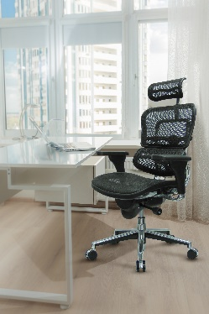­­

**Contract #:** PS20155 **Valid:** 01/01/2020-Furniture

**The Raynor Group Contacts**

Paul Hurty  
Phone: 800-637-0005 x 263  
Email: phurty@raynorgroup.com

Customer Service  
Phone: 1.800.637.0005  
Email: [customerservice@raynorgroup.com](mailto:customerservice@raynorgroup.com)

Website: [www.nppgov.com/join-now](http://www.nppgov.com/join-now)

**Price List**2020 Price List Effective 01/01/2020

**Additional Information**  
***Save money***

* Over 50% in savings on office seating and furniture
* Project level discounts on all orders
* Additional volume discounts for mid-to-large sized orders
* Free shipping with no minimums

***Save time***

* Simplified process to select and order office furniture
* Let us help by connecting you to one of our local authorized servicing dealers

**End User Discount (Off List):**Discount off list price **

$0 - $25,000 54%

$25,001 - $99,999 56%

$100,000 Plus – Negotiable

** showing basic discount click [HERE](https://raynor-npp.com/content/resources2/NPPGov%20Pricing%20Schedule%20Jan%202020%20.pdf) for full discount structure

Payment Terms Net 30 Days

**NPPGov**

**Contract**

The Raynor Group has been awarded a competitively solicited contract by National Purchasing Partners (NPPGov). Through contract number PS20155, the raynor group offers NPPGov members best-in-class office seating, furniture, and services

**THE RAYNOR GROUP/EUROTECH**

**aBOUT THE RAYNOR GROUP**

The Raynor Group has been the premier representative for quality and ergonomic design in office chairs since 1979 with our Eurotech brand of office seating. Our commitment to design, function, and form has resulted in over 1 billion dollars in cumulative sales.

All product can be seen on our website [www.eurotechseating.com](http://www.eurotechseating.com)

Product is in stock and ready to ship.

All product meets or exceeds BIFMA standards

**STATE AGENCY POLICY**

525 Hempstead Turnpike  
West Hempstead, NY 11552  
TF 1.800.637.0005 FX 1.516.481.8141