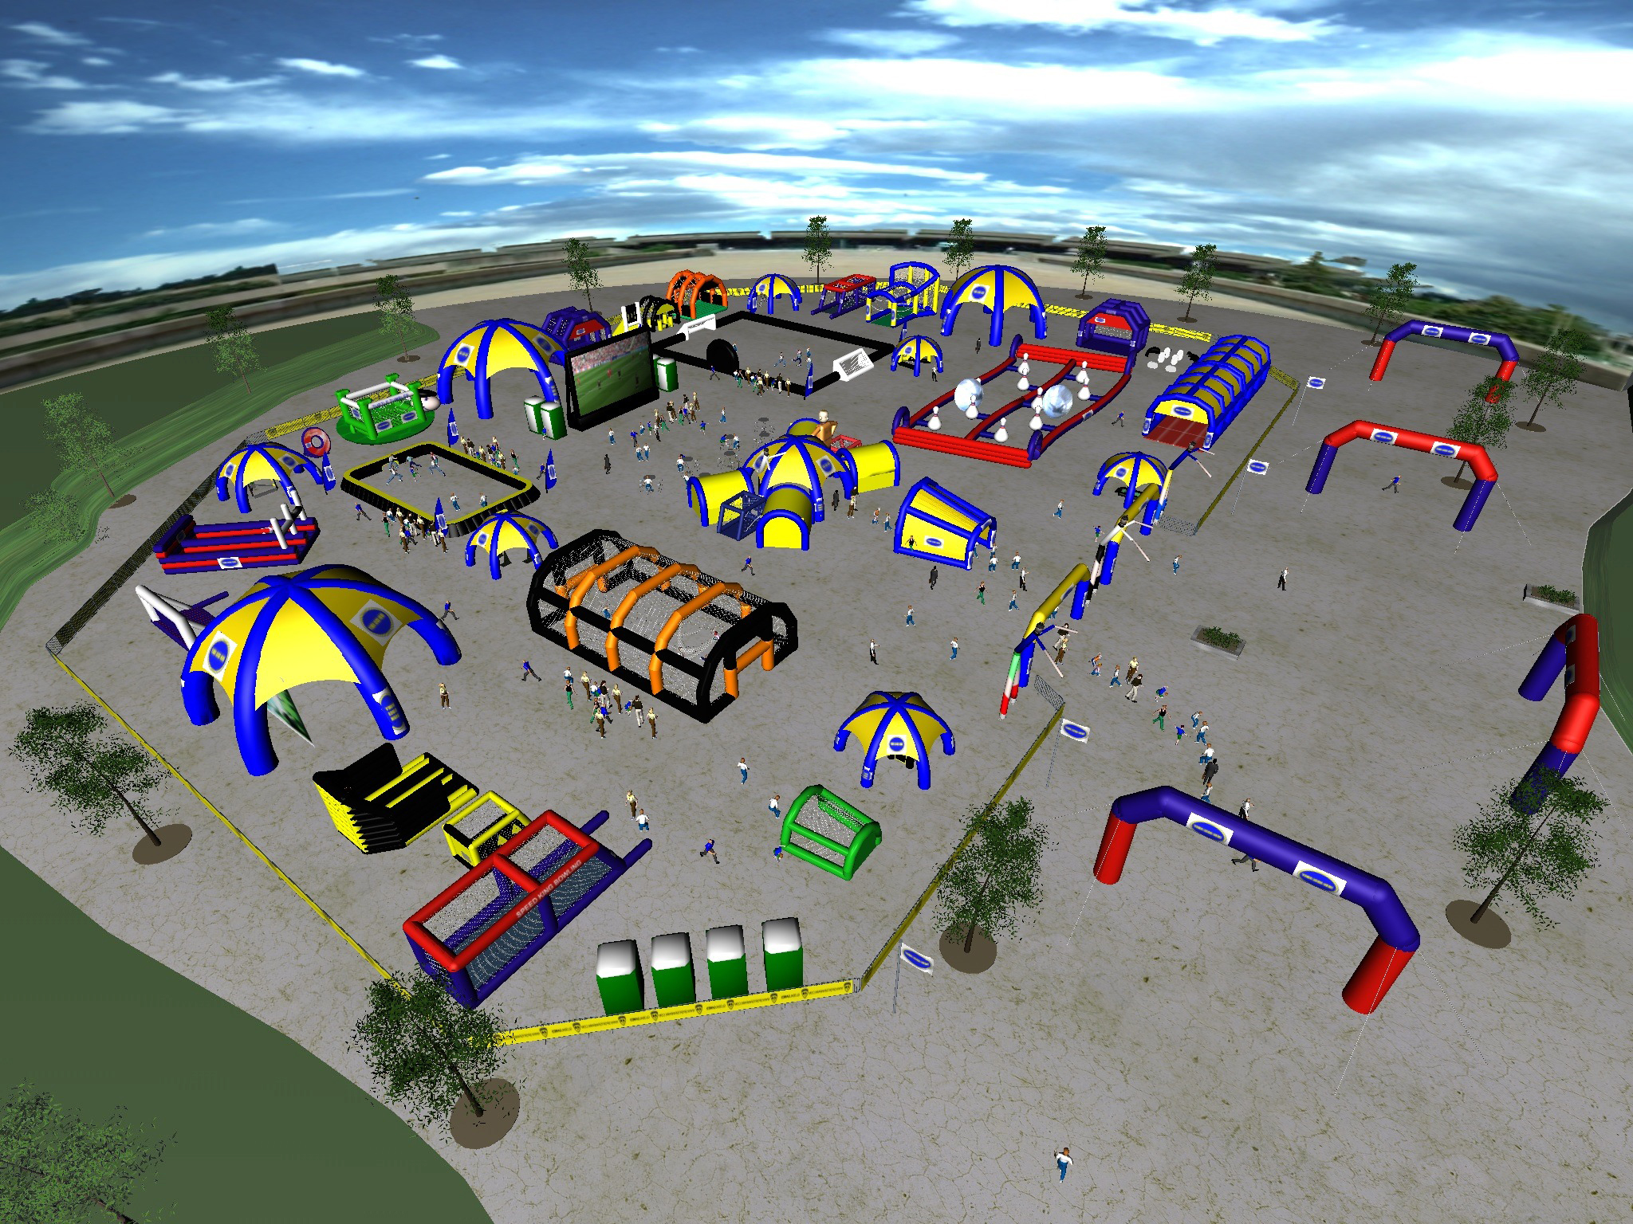

RENTAL AGREEMENT AND LIABILITY WAIVER

1. **PAYMENT:**

We accept payment by approved check (proper ID required) or cash. We DO NOT accept credit cards or debit cards. A deposit is required with the signed contract with the balance to be paid upon pick up at L.E.A.P. Diversify Cayman Ltd. or at time of delivery to your site (given to delivery person).

1. **TERMS OF RENTAL:**

Signed contract is binding rain or shine. Rental rates are quoted for single use rental to be used by the person or organization responsible for signing the agreement. The person or representative signing the agreement assumes the liability for the rental equipment. Sharing of equipment with another person or group for a separate use is subject to additional charges. If you require longer rental times, contact us for rate information. There is no refund for unused equipment.

1. **RENTAL PICK UP / RETURN TIMES:**

L.E.A.P. Diversify Cayman Ltd will be available for the pick-up and return of your rental items from 9am-4pm Monday – Saturday.

1. **DELIVERIES:**

Deliveries will be made to FRONT ground level door or garage; within 30 feet of street or driveway and accessible to a box truck. There will be additional charges to navigate steps and /or stairways, hills to lower levels or long sidewalks to back decks or porches. Drivers will not leave equipment in bad weather if proper protective cover is not available. Please make arrangements prior to delivery if you wish to have our crew deliver to other than front location or do set up and/or take down.

1. **LATE CHARGES:**

Late charges may be assessed if items required for additional time as agreed upon in the contract. Charges are waived if the additional time is due to acts of God or late pick up by L.E.A.P. Diversify Cayman Ltd.

1. **LESSEE RESPONSIBILITY:**

Lessee assumes full liability for the equipment from time of pick up or delivery until time of return. Lessee is responsible for any damage to the equipment and holds L.E.A.P. Diversify Cayman Ltd. harmless for any injuries that may arise from the use of the rental equipment. If rental items are lost, damaged or broken during the rental period, lessee will be responsible for payment for repairs or, if necessary, full replacement cost. It is strongly suggested lessee count the order upon taking possession as lessee is responsible for returning the items in the quantity listed on the contract. Items should be set up and/or stored in a secure weather protected place. Pick up and return of equipment must be in a protected and secured vehicle. Be sure to measure your vehicle space prior to arrival to determine if equipment will fit.

Lessee assumes all responsibility for the correct set up and consequent functionality of the equipment. If lessee does not want to take on this responsibility, L.E.A.P. Diversify Cayman Ltd. can be contracted to deliver and set up the equipment for an additional fee.

1. **RETURN OF RENTAL EQUIPMENT:**

All rental equipment must be returned free of materials such as food, ribbon, tape, mud and debris caused by use during rental. If cleaning is required, lessee will be charged at a rate of $25/hour.

1. **REPLACEMENT OF MALFUNCTIONING EQUIPMENT:**

If equipment becomes unsafe or in disrepair, lessee agrees to discontinue use and notify L.E.A.P. Diversify Cayman Ltd. immediately. L.E.A.P. Diversify Cayman Ltd. will make every attempt to provide replacement equipment as soon as possible upon being alerted of the issue. We regret any malfunctions, but will try to resolve the problem as efficiently as possible.

1. **GENERAL SAFETY RULES FOR INFLATABLES USAGE:**

**It is the responsibility of the person or organization renting/hiring this inflatable equipment to ensure that all possible precautions are taken to avoid injury to people or damage to the inflatable.** Please ensure that the following Safety Instructions are followed:

* + 1. No food, drink or chewing gum on or around the inflatable. This will avoid a choking risk and keep the unit clean. (Please note if the inflatable is collected in a dirty condition then the person hiring it will incur a cleaning charge).
    2. Shoes, glasses, jewelry, and badges MUST be removed before using the inflatable to avoid injury to people using the equipment and damage to the inflatable.
    3. No face paints, party poppers, coloured streamers or silly string to be used either on or near the inflatable. **(Please note these products will cause damage to the inflatable that cannot be repaired).**
    4. No smoking on or around the inflatable.
    5. No barbeques around the inflatable.
    6. **Climbing, hanging or sitting on walls is dangerous and must not be allowed.**
    7. **A responsible Adult must supervise the inflatable at all times.**
    8. Always ensure that the inflatable is not overcrowded, and limit numbers to the age and size of Children using it. Try to avoid large and small children from using it at the same time.
    9. Ensure Children are not pushing, colliding, fighting or behaving in a manner likely to injure or cause distress to others.
    10. **No pets, toys or sharp instruments on the inflatable at any time.**
    11. **Do not allow anyone to bounce on the front safety step as this is dangerous.**
    12. Do not allow anyone to be on the inflatable equipment during inflation and deflation as this is DANGEROUS.
    13. Please ensure that Children are not attempting somersaults and are clothed appropriately and that nothing can fall out of their pockets.
    14. **In the event that the blower stops working, please ensure all users get off the inflatable immediately and calmly.** Check your breaker(s) and make sure the blower tube or deflation tube has not come undone or something has not blown onto and is obstructing the blower. In the event that it overheats, or loses power, switch the blower off at the mains, then switch it back on again 1 or 2 minutes later and it should restart. If it does not, inform us immediately at (345) 916-9200.
    15. **THE MOST IMPORTANT RULE: DO NOT let children play on the inflatable without Adult supervision. Adult supervision is necessary to enforce these rules for safe operation of the inflatable.**
    16. If cleaning is required, lessee will be charged at a rate of $25/hour. If inflatable unit gets wet during the rental period, a $75.00 drying fee shall be automatically charged.

**X ______ INITIAL HERE AFTER READING RULES LIABILITY DISCLAMER**

LIABILITY DISCLAIMER

1. This rental equipment has been received in good condition and will be returned in the same condition (ordinary wear and tear accepted).
2. Customer accept all responsibility for injuries to persons or damage to property, and agrees to release and hold L.E.A.P. Diversify Cayman Ltd harmless for any and all claims, of whatsoever the nature, arising out of the use of the rental equipment while in his/her custody. In the event that the release and hold harmless as contained herein is held unenforceable for any reason. Customer hereby agrees to a limit on any damages claimed by the Customer to the total paid to L.E.A.P. Diversify Cayman Ltd. for the rental.
3. Customer agrees to company right to enter premises of customer at any time to repossess said equipment.
4. Customer agrees to reimburse L.E.A.P. Diversify Cayman Ltd. for all attorney fees, an amount not less than 50% of all sums due, court cost and expenses incurred by L.E.A.P. Diversify Cayman Ltd. to enforce collection or to preserve or enforce rights under this contract.
5. Customer agrees not to loan, sublet or otherwise depose of equipment or use it at any other location.
6. Customer agrees to pay in full the replacement cost, including labour, for all damage to rental equipment.
7. If the inflatable equipment is lost, stolen, or damaged beyond repair the renter agrees to pay cost of repairs or replacement cost.
8. Customer agrees to ensure that al users (and users’ guardians) of the rental equipment sign liability waivers.
9. **THERE ARE NO WARRANTIES OF MERCHANTABILITY OR FITNESS EXPRESSED OR IMPLIED.**

**The person(s) or organization renting this Equipment from L.E.A.P. Diversify Cayman Ltd. will be held responsible and liable for any and all damages or injury occurring for any reason whatsoever. I have read the above agreement and fully understand and accept the condition as above. I am aware that while in my care that I am responsible for the inflatable and will pay for any loss or damages that may occur.**

|  |  |
| --- | --- |
| **Name:** | **Driver License #:** |
| Signature: | Date:  ______/____________/____________ |