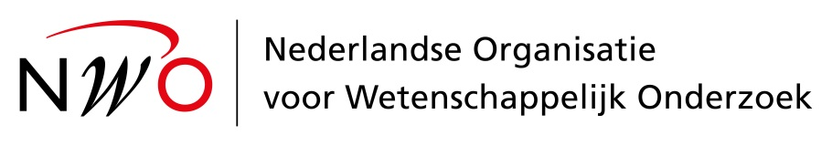

Sandpit Application Form

We kindly ask you to send a cv (max. 1 A4) together with this application form, to ci.sandpit@nwo.nl. Font style Verdana 10.

If you are selected for participation in the sandpit your information will shared with the other participants, some of whom are not Dutch. Therefore, we ask you to enter your answers in English.

Personalia and Affiliation
Title:
Name:
Initials:
Infix:
Surname:
Sex:
Correspondence address:
Telephone number:
Mobile telephone number:
Email:
Affiliation:
Website:
NAME SANDPIT: Flagship TALPA

[Insert CV]

Name
Title:
Name:
Initials:
Infix:
Surname:
NAME SANDPIT: Flagship TALPA
Motivation I
Expertise
What scientific expertise do you bring to the workshops that is relevant to this topic? (max. 150 words)
Motivation
What is your motivation for participating in the Sandpit? (max. 150 words)
Personal background
Could you provide a brief summary of your personal background relevant to this sandpit? (max. 150 words)

Name
Title:
Name:
Initials:
Infix:
Surname:

NAME SANDPIT: Flagship TALPA
Motivation II
Sandpit specific questions
Working in a team
What is your approach to team working? (max. 100 words)
The sandpit will be especially suited to individuals who are willing to step outside their particular area of interest or expertise, who are positively driven, who enjoy creative activity, who can think innovatively and who can settle in easily in the company of strangers. How well do you see yourself fitting in this profile? (max. 100 words)
Skills
How would you describe your ability to explain your research to non-experts? (100 words)
What’s in it for you?
What do you hope to gain from participating in this sandpit? (max. 100 words)

If selected to participate in the Sandpit, are you willing to share these pages with other participants? Yes/No

