Community engagement kit

Aboriginal and Torres Strait Islander peoples

9 February 2021

Dear Colleagues,

The Australian Government is working to deliver the national COVID-19 vaccination rollout program by the end of February 2021. The Australian Technical Advisory Group on Immunisation (ATAGI) has provided advice on the prioritization of the delivery of the COVID-19 vaccines. As you may know, Aboriginal and Torres Strait Islander adults have been identified as a priority group for vaccination. This is because there is a higher risk of getting and developing serious illness from COVID-19 due to a number of factors. This may include a higher rate of chronic health conditions and in some cases crowded-living conditions, which increases the risk of spreading the infection.

The Government has made it clear that the COVID-19 vaccinations will be voluntary in Australia. It is strongly encouraged that everyone is vaccinated to help protect against COVID-19 and to keep communities strong.

We have created a stakeholder kit that includes useful information on what the Government is doing to deliver COVID-19 vaccines. The kit also includes several communications materials, such as news articles, social tiles, video scripts and other items that you can share across your networks to help keep your community safe.

Approval of vaccines
Vaccines are a safe way of producing an immune response in the body without causing illness.

On Monday 25 January, the Government announced provisional approval of the Pfizer/BioNTech COVID-19 vaccine for use in Australia for people over 16 years. This registration means Pfizer’s vaccine has met the Therapeutic Good Administration’s (TGA) strict standards.

Just like any other drug, vaccine or therapeutic device, any approved COVID-19 vaccines will have passed through the TGA’s rigorous assessments for quality, safety and effectiveness.

The TGA also has the necessary systems in place to carefully watch for adverse events after vaccination. It is actively monitoring COVID-19 vaccine development both in Australia and around the world, and is also part of a network of international regulators that meet regularly to discuss the development of COVID-19 vaccines.

Your members and your communities can be confident that no shortcuts have been made regarding safety and approvals.

How will the vaccine be distributed?
The Australian Government is working closely with state and territory governments, the National Aboriginal Community Controlled Health Organisation (NACCHO) and state-based affiliates, and the Aboriginal and Torres Strait Islander Advisory Group on COVID-19 to ensure COVID-19 vaccines are easily accessible to everyone, including remote communities.

Planning is well underway to support access and delivery of TGA-approved COVID-19 vaccines to protect everyone in Australia. Government departments and peak organisations across jurisdictions are working cooperatively. Rest assured, we’re moving as swiftly and safely as possible.

The Pfizer/BioNTech COVID-19 vaccine will be managed through 30 to 50 key hospitals across urban, regional and rural Australia. Distribution to residential aged care and disability care facilities will be managed through a Commonwealth vaccination workforce in-reach program.

If the University of Oxford/AstraZeneca COVID-19 vaccine is approved by the TGA, this is expected to occur in the coming weeks. This vaccine will progressively be distributed through more sites, including Aboriginal and Torres Strait Islander Community Controlled Health Services, general practice clinics, existing Commonwealth GP respiratory clinics, state-run vaccination clinics and pharmacies.

The number of doses required depends on the vaccine. Currently, the advice is that both the Pfizer/BioNTech and University of Oxford/AstraZeneca COVID-19 vaccines require two doses.

More information about the above approach is outlined in:
- the Australian COVID-19 Vaccination Policy
- the COVID-19 Vaccines National Roll-out Strategy

Cost
COVID-19 vaccines will be free for everyone in Australia.

Voluntary vaccination
The Government has made it clear that COVID-19 vaccination will be voluntary in Australia, but strongly encourages people to get vaccinated.

Stay up to date
We are asking for your support in sharing the latest information about the COVID-19 vaccines with your colleagues, networks and communities. The community engagement (stakeholder) kit includes the following information for your use:
- newsletter article content
- social media content
- script for videos
- editorial example
- poster.
The Department of Health has developed a new vaccine website. We also invite you to subscribe to the COVID-19 vaccines updates.

Sincerely,

Dr Lucas de Toca  Co-Chair,  Aboriginal and Torres Strait Islander  Advisory Group on COVID-19  Acting First Assistant Secretary,  COVID-19 Primary Care Response  Australian Government Department of Health | Dr Dawn Casey  Co-Chair,  Aboriginal and Torres Strait Islander Advisory Group on COVID-19  Deputy Chief Executive Officer  National Aboriginal Community Controlled Health Organisation

COVID-19 vaccines – community engagement kit

How to use this kit
To support communication with your stakeholders, networks and communities, the Australian Government Department of Health has developed a suite of resources which includes:
- newsletter article content
- social media content
- script for videos
- editorial example
- poster.
Further resources will be developed in the lead up to and implementation of the vaccination rollout. The Department will continue to provide regular updates and communication materials as more information becomes available over the coming weeks.

Key communication messages
- The COVID-19 vaccines have shown good evidence that it will protect against serious illness from the virus
- An approved, safe and efficient COVID-19 vaccine has now been provisionally approved in Australia. This vaccine is called Pfizer/BioNTech
- All approved COVID-19 vaccines will have passed through rigorous assessment for quality, safety, and effectiveness by the Therapeutic Goods Administration (TGA), the Australian regulator that independently evaluates medicines and medical devices available in Australia.
- Vaccine priority groups are:
  - People who have an increased risk of developing severe illness or dying from COVID-19
  - People who are more likely to be infected or to spread COVID-19 to others, or are in a setting with high transmission (spreading) potential
  - People working in critical services, such as emergency service workers
- In that respect, the first priority group for COVID-19 vaccine are:
  - quarantine and border workers,
  - frontline health care workers,
  - and aged care and disability care staff and residents.
- Aboriginal and Torres Strait Islander adults have been identified as a priority group and will be able to get the vaccine soon after the first priority group
- This is because Aboriginal and Torres Strait Islander adults have a higher risk of getting and developing serious illness from COVID-19 due to a number of factors. This may include a higher rate of chronic health conditions and in some cases crowded-living conditions, which increases the risk of spreading the infection
- The vaccine will be free and voluntary but it is strongly encouraged
- Safe and effective COVID-19 vaccines have been developed faster than any other vaccine because of unprecedented funding, the availability of new technology and through the collaboration of researchers and developers around the world
- It is also because some clinical trial phases overlapped each other in timeframes. As soon as the preliminary data was available, the trials were able to progress. This process is giving us access to the vaccines as quickly as possible, to help protect people and communities from COVID-19
- You need to keep up with COVIDSafe behaviours, such as keeping two big steps away from others, good hand hygiene, staying home if unwell and getting tested for COVID-19
- Stay up to date with reliable and trusted information by visiting www.health.gov.au/covid19-vaccines

Thank you for sharing this content. If you need any of the below materials in another format or have a request for specific content, please contact CovidVaccineComms@health.gov.au.

Newsletter article – long version
This is an example of a newsletter story you could use on your channels. Feel free to adapt the wording according to the preferred communication style for your audience.

Update on Australia’s COVID-19 vaccines
Free, safe and effective COVID-19 vaccines will help protect our community from COVID-19.
A staged rollout of the vaccines will commence in February 2021. The Pfizer/BioNTech COVID-19 vaccine will be managed through 30 to 50 key hospitals across urban, regional and rural Australia.
Provisional approval of the University of Oxford/AstraZeneca COVID-19 vaccine is currently expected in February by the Therapeutics Good Administration.
Approved vaccines will be rolled out in phases. It is important that the first vaccines go to the people who need them most. The rollout will start with priority groups such as health workers, quarantine and border workers and some other services. Aged care and disability care residents will also be included in this first phase.
As you may know, Aboriginal and Torres Strait Islander adults have been identified as a priority group for vaccination. This is because there is a higher risk of getting and developing serious illness from COVID-19 due to a number of factors. This may include a higher rate of chronic health conditions and in some cases crowded-living conditions, which increases the risk of spreading the infection.
The Australian Government is working closely with state and territory governments and the National Aboriginal Community Controlled Health Organisation (NACCHO) to ensure COVID-19 vaccines are easily accessible to everyone, including remote communities.
The vaccine is free and you can choose if you want to get vaccinated. However, by getting it, you will help protect yourself, Elders, your loved ones and your community from COVID-19.
Rest assured that the approved vaccines will be safe and effective. Australia’s medicines regulator, the Therapeutic Good Administration (TGA), has strict standards when approving vaccines.
The TGA will continue to check vaccines for quality as they are produced. Health care services and the TGA will also continue to check for any unexpected side-effects following vaccination.
COVID-19 vaccines are just one part of keeping the community safe and healthy. People and communities have done a great job so far in staying COVIDSafe. It will be essential to continue practising COVIDSafe behaviours. This includes regularly washing your hands and keeping two big steps away from others.
Learn more at the Department of Health’s COVID-19 vaccines hub and subscribe to the COVID-19 Vaccines Update.

Newsletter article – short version

Update on Australia’s COVID-19 vaccines
Free, safe and effective COVID-19 vaccines will help protect our community from COVID-19. Approved vaccines will be rolled out in phases across Australia. It is important that the first vaccines go to the people who need them most.

As you may know, Aboriginal and Torres Strait Islander adults have been identified as a priority group for vaccination. This is because there is a higher risk of getting and developing serious illness from COVID-19 due to a number of factors. This may include a higher rate of chronic health conditions and in some cases crowded-living conditions, which increases the risk of spreading the infection.

The vaccine is free and you can choose if you want to get vaccinated. However, by getting it, you will help protect yourself, Elders, family and community from COVID-19.

Learn more at the Department of Health’s COVID-19 vaccines hub and subscribe to the COVID-19 Vaccines Update.

Social media content
Here are some examples of social media posts that you could use across your social media platform. Please feel free to change the content as you see fit.
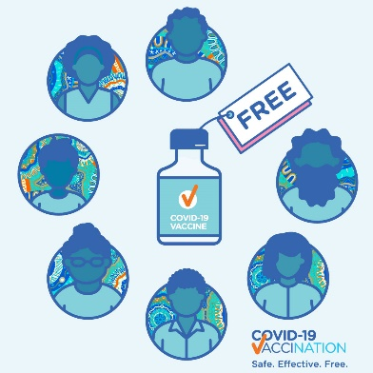 | Post 1  Safe and effective COVID-19 vaccines will help protect us from COVID-19.  The vaccines will be free and voluntary for everyone in Australia.  To keep their families and communities safe, Aboriginal and Torres Strait Islander adults will be able to get their vaccine soon after the first priority group, such as health workers and quarantine and border workers.  Learn more at  https://www.health.gov.au/initiatives-and-programs/covid-19-vaccines
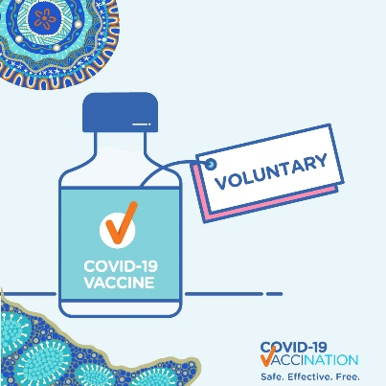 | Post 2  COVID-19 vaccinations will start at the end of February. Priority groups such as health workers and quarantine and border workers will be the first to receive the vaccine. Soon after that, the vaccine will be available to Aboriginal and Torres Strait Islander adults.  Please keep up to date at  https://www.health.gov.au/initiatives-and-programs/covid-19-vaccines
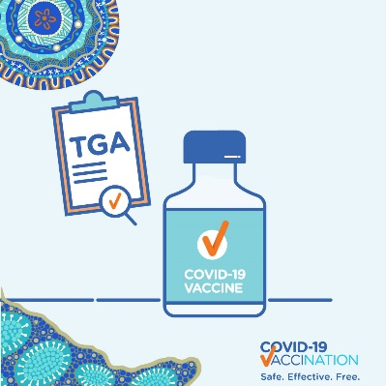 | Post 3  Are COVID-19 vaccines safe? Are they effective? All vaccines need to pass an assessment for quality, safety and efficacy. This is done by the Therapeutic Goods Administration (TGA). They only approve vaccines that are safe and effective.  Learn more about the vaccine approval process at  www.tga.gov.au/covid-19-vaccine-approval-process.
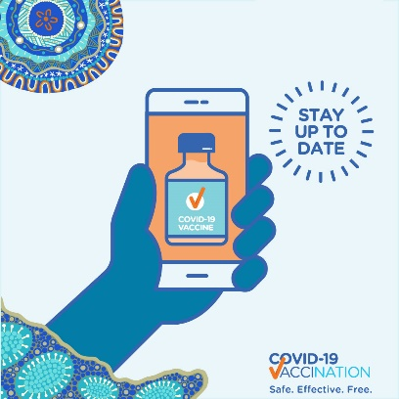 | Post 4  Aboriginal and Torres Strait Islander adults will be able to get their COVID-19 vaccine soon after the first priority group, such as healthcare workers and quarantine and border workers. Your vaccine will be available at your local AMS, GP and some other locations.  To find out more about the vaccine, call your local health worker or visit  https://www.health.gov.au/initiatives-and-programs/covid-19-vaccines
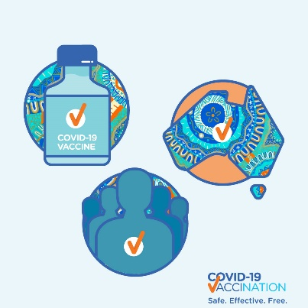 | Post 5  Coronavirus can make you really sick or you could even die from it. Aboriginal and Torres Strait Islander adults will be able to get their COVID-19 vaccine soon after the first priority group, such as healthcare workers and quarantine and border workers. Protect yourself, Elders and your community and get a COVID-19 vaccine when it’s your turn.  Learn more at  https://www.health.gov.au/initiatives-and-programs/covid-19-vaccines

Video scripts for community leaders
We have created a few different scripts that you could use for social media channels.

Video script: Explainer
We have done a great job to keep COVID-19 out of our communities. Safe and effective vaccines will continue to protect us from COVID-19. The vaccines will be free and voluntary.
Vaccines will be available for everyone in Australia.
The Australian Government has a plan on distributing the vaccines in Australia.
The plan outlines priority groups, the locations and the phases in which vaccine doses will be available in Australia.
Learn more by visiting health.gov.au or call the National Coronavirus Helpline on 1800 020 080.

Video script: Who are priority groups
The first available COVID-19 vaccines will go to the people who need it most.
Health experts have provided advice on who should be in priority groups for the first COVID-19 vaccinations.
The first group to receive the vaccination includes quarantine and border workers, frontline at-risk healthcare workers, aged care and disability care residents, and residential aged care and disability workers.
It will then be distributed to others according to the priority plan. This will include Aboriginal and Torres Strait Islander adults. You will be able to get your COVID-19 vaccine through Aboriginal Health Services, GP’s and other locations.
Learn more about the priority groups at health.gov.au or call the National Coronavirus Helpline on 1800 020 080.

Video script: Stay COVIDSafe
To keep you and your community safe during the COVID-19 pandemic, you should continue to:
- Stay two big steps away from other people.
- Stay home if you feel unwell and get tested for COVID-19.
- Wash your hands regularly with soap and water or use hand sanitiser.
- Always cough or sneeze into your arm or a tissue and put the tissue in the bin straight away.
- Have the COVIDSafe app to help health officials notify you if you have been in contact with someone who has COVID-19.
- Get vaccinated, to help protect yourself, community and Elders from COVID-19.

It is important to keep up-to-date through official sources.
Learn more at health.gov.au or call the National Coronavirus Helpline on 1800 020 080.

Video
In this video, Professor Tom Calma AO talks about how COVID-19 has changed our lives and why we need the added protection of vaccines for COVID-19.
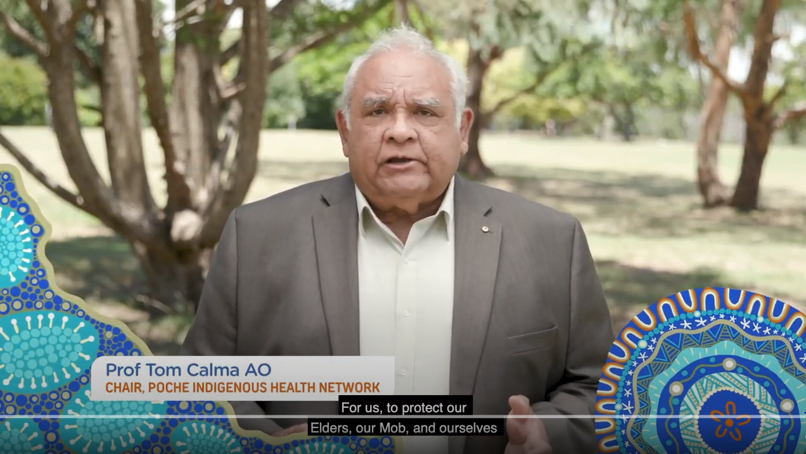

Editorial

Australia’s COVID-19 vaccines
Safe and effective vaccines will help protect you and your community from COVID-19. The vaccines will be free and voluntary.
Australia has agreements for three COVID-19 vaccines. This includes the Pfizer, AstraZeneca and Novavax. The number of doses required depends on the vaccine. Both Pfizer and AstraZeneca COVID-19 vaccines will require two doses.
Australia’s independent medicines regulator, the Therapeutic Goods Administration (TGA), has strict standards for reviewing possible COVID-19 vaccines. They will only approve vaccines that are safe and effective.
Australia has a plan for distributing the vaccines as quickly as possible when they are ready. The plan lists the order of groups to receive the vaccines first, and the locations where the vaccine doses will be available in Australia.

The first vaccines
Medical experts have advised on who should be the first to receive COVID-19 vaccination. It is important that the first vaccines go to the people who need them most.
The Pfizer/BioNTech COVID-19 vaccine has now been provisionally approved in Australia. Vaccination will begin in February 2021. The first vaccines will be provided to:
- quarantine and border workers,
- frontline at-risk healthcare workers,
- aged care and disability care residents,
- and residential aged care and disability workers.
Part of the next group to receive the vaccination includes Aboriginal and Torres Strait Islander adults.
At the moment, the best thing you can do is stay up to date and continue to be COVIDSafe. The Australian Government will provide information about when and where the vaccine will be available.

Locations
The Pfizer vaccine will be available through 30 to 50 hospitals across urban and rural Australia.
Other sites will be available to manage and distribute other vaccines as they are approved by the TGA. These sites include Aboriginal and Torres Strait Islander Controlled Community Health Services, general practice clinics, existing Commonwealth GP respiratory clinics, state-run vaccination clinics and pharmacies.

What to do to keep COVIDSafe
To keep you and your community safe during the coronavirus pandemic, you should continue to:
- Stay two big steps away from other people and avoid physical contact with people outside your household.
- Stay home if you feel unwell and get tested for COVID-19. You must stay at home until your results come back
- Wash your hands regularly with soap and water or hand sanitiser.
- Always cough or sneeze into your arm or a tissue and put the tissue in the bin straight away.
- Have the COVIDSafe app to help health officials notify you if you have been in contact with someone who has COVID-19.
- Get vaccinated, to help protect yourself, community and Elders from COVID-19

More information about COVID-19
It is important to stay informed through official sources. Learn more at health.gov.au or call the National Coronavirus Helpline on 1800 020 080.

Poster
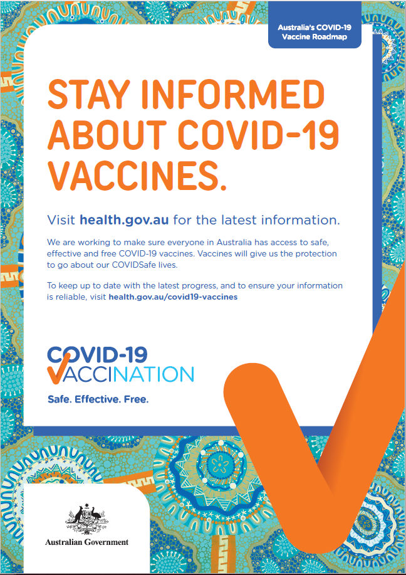
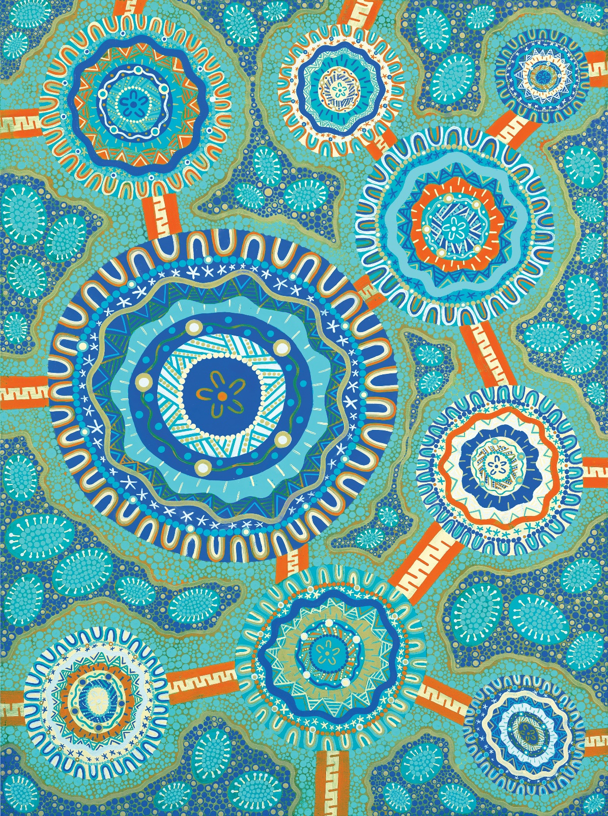
The artwork featured in this kit and throughout the resources was created by Wiradjuri artist Jordana Angus. Her traditional land is Narrandera, New South Wales, but she was born and raised in Redcliffe, Queensland. This location has given Jordana an innate connection to where the land meets the sea.
The artwork represents standing together to support each other in healthy living practices both physically and mentally. By being connected to community and staying informed on the latest reputable health advice we become stronger as a whole community.

