Table of Contents
1. Responsibilities ............................................................................................................................... 2
2. Context ............................................................................................................................................. 2
3. Personal Protective Equipment (PPE) ................................................................................. 3
3.1 Preventative Controls and Best Practices ........................................................... 3
3.2 COVID-19 Testing Personnel .................................................................................... 4
3.3 Cleaning / Decontamination .................................................................................... 4
3.4 Disposal of Contaminated PPE ............................................................................... 5
3.5 Management of Potentially Soiled Laundry ....................................................... 5
4. Social Distancing .......................................................................................................................... 6
5. Testing Process ............................................................................................................................. 6
5.1 Arrival at Work ............................................................................................................... 6
5.2 Temperature Testing .................................................................................................. 7
6. Response to High Temperature Reading ........................................................................... 7
7. Quarantine of Personnel ........................................................................................................... 8
8. Management Reporting Process ........................................................................................... 8
9. Return to Work ............................................................................................................................ 9
10. Sick Leave Payment ................................................................................................................. 9
11. Adherence to This Guideline .................................................................................................. 9
12. Medical Examinations ............................................................................................................... 9
Appendix 1 - Workflow for Temperature Screening .......................................................... 10
Appendix 2 - How to Hand Wash .............................................................................................. 11
Appendix 3 - 14-Day Self Quarantine Guideline .................................................................. 12
Appendix 4 - Temperature screening log .............................................................................. 13

- Responsibilities
This policy shall apply to all employees, contractors, sub-contractors and anyone visiting an Achieve Australia site and/or building. No personnel shall be exempt from testing procedures.
Every employee, contractor and visitor: must report any case of suspected COVID-19 if they have had close contact with a suspected or confirmed COVID-19 case.
Close contact is defined as:
Being within approximately 1.5 metres of a person confirmed as having a positive case of COVID-19.
A person can be contagious 48 hours before the symptoms show up as well as after symptoms are present.
Close contact can occur while:
- Caring for, living with, visiting, or sharing a room/health care waiting area
- Having direct contact with infectious secretions of a COVID-19 positive case e.g. being coughed on, etc.
Personnel that have any symptoms related to the virus, a temperature of 37.4°C or over, fever, dry cough, sore throat or respiratory issues shall self-isolate and not come to the workplace. They shall inform their manager and local health authorities for advice.
All personnel shall follow fundamental controls e.g. regular handwashing, no physical contact and follow the 1.5 metre physical distance (social distancing) rule to minimize close contact. If any symptoms develop, personnel must self-isolate.
2. Context
The coronavirus (COVID-19) is a rapid evolving respiratory virus. Symptoms range from a mild cough to pneumonia. Some people recover easily, others may get very sick, very quickly. It is highly contagious and there is evidence that it spreads from person to person.
People with coronavirus may experience:
- fever
- flu-like symptoms such as coughing, sore throat and fatigue
- shortness of breath.
As a preventative measure all sites shall have in place a formal, proactive testing procedure. Temperature screening shall ensure that personnel with a fever (37.4°C or more) are restricted from entry into sites and buildings.
Temperature screening is proposed as a pre-requisite to enter all site-controlled areas / activities.

3. Personal Protective Equipment (PPE)
3.1 Preventative Controls and Best Practices:
Personal Hygiene
Be socially responsible and practice good personal hygiene habits. Following the below recommendations can drastically reduce risk exposure.
- Wash hands often for 40-60 seconds every time, scrub hands with soap for at least 20 seconds:
- Before and after preparing food
- After going to the toilet
- Before and after eating
- After coughing and sneezing
- After removing personal protective equipment (PPE) such as masks and disposable gloves.
- Use hand sanitizers if soap and water is NOT available.
- Maintain good indoor ventilation.
- Avoid contact with live animals including poultry and birds, and consumption of raw and undercooked meats.
- Avoid crowded places and close contact with people who are unwell or showing symptoms of illness.
- Avoid sharing food, cutlery, crockery, utensils and other personal hygiene items.
- Avoid physical contact such as shaking hands, kissing and avoid touching your face or rubbing your eyes.
- Wear a surgical mask if you have respiratory symptoms such as a cough or runny nose. It is not recommended that people who are well wear a facemask to protect themselves from respiratory diseases, including COVID-19.
- Cover your mouth with a tissue when coughing or sneezing and dispose of the soiled tissue in the rubbish bin immediately and wash hands.
- Seek medical attention promptly if you are feeling unwell.
- Avoid unnecessary public gatherings
General Health & Hygiene
- Clean using alcohol-based wet wipes, screens, keyboard, mouse, phone, chairs and arm rests before usage.
- Clean and disinfect frequently touched objects and surfaces using detergents or disinfectants cleaning spray or wipe (i.e. screens, keyboards, mouse, chair arms, common areas).
- Provision and regular use of alcohol-based hand sanitizer dispensers.
- Maintain at least 1.5 metres distance between yourself and anyone who is coughing or sneezing.
- Open windows if possible.
- Do not come to work if you are unwell.
- Avoid organising gatherings in the office unless it is business critical.
3.2 COVID-19 Testing Personnel:
Appropriate PPE for testing staff shall be made available. No testing shall take place where PPE is not available. It is the responsibility of the relevant business/ organisation to have adequate and suitable PPE available at points of use.
All thermo-testers shall have at a minimum the following PPE available at the point of use. Where stock is depleted during testing the task will stop and replenishments sought.
Testing PPE shall include;
- Surgical N95 Respirators or P2 Respiratory masks
- Surgical or other approved gloves (note: non-medical gloves are not permitted or suitable in the prevention of COVID-19. It is suspected at this stage that COVID-19 may remain embedded in cloth surfaces)
- Long sleeve medical gown or approved medical apron shall be worn
- Eye protection is recommended in standard testing and mandatory for patients confirmed to be carrying or have been in contact with suspected COVID-19 cases.
3.3 Cleaning / Decontamination:
Appropriate PPE for cleaning staff shall be made available. No cleaning shall take place where PPE is not available. It is the responsibility of the relevant business / organisation to have adequate and suitable PPE available at points of use.
For all suspected or preventative environmental cleaning, a procedure shall be developed and used appropriately to reduce risk to both clients and workers. PPE is required to prevent:
- Exposure to microorganisms
- Exposure to cleaning chemicals (e.g., disinfectants)
- Reduce the spread of microorganisms from one staff to the other within the area (when used correctly) Guidelines: COVID-19 Temperature Screening 8 Cleaning should be performed by well trained staff, using the proper PPE.
The correct donning and doffing of PPE should be followed. The following PPE items are suggested for use when cleaning facilities likely to be contaminated by COVID-19:
- P2 dust disposable mask
- Other masks (according to SDS) will be used only if disinfecting is to be performed
- Goggles or face shield
- Disposable long-sleeved coveralls
- Disposable chemical gloves.
Best practice for PPE for cleaning staff is as follows:
- Perform hand hygiene immediately before putting gloves on and directly after removal
- Train cleaning staff on appropriate use, application, and removal of required PPE for all environmental cleaning procedures and tasks for which they are responsible
- Keep sleeves at or above the elbow to not interfere with glove use or hand hygiene
- Wear rubber-soled closed toe shoes or boots (i.e. not sandals), to prevent accidental injury (e.g. slips and falls) and exposure to cleaning chemicals, dirt, or bacteria
- Remove wristwatches and hand jewellery before starting cleaning tasks – these items can tear gloves and can also harbour microorganisms
- All PPE (reusable and disposable) should be in good supply, well-maintained (good quality, appropriately stored stocks), cleaned before use and in good repair
- Use chemical-resistant gloves (e.g. nitrile, latex) for preparation of cleaning chemicals.
Note. Poor fit of PPE components is an often-underestimated risk factor for PPE users. Coveralls, respirators, goggles, gloves are provided in a variety of sizes.
3.4 Disposal of Contaminated PPE
Disposable PPE should be treated as potentially infectious material and disposed in accordance with national rules. The use of disposable or dedicated cleaning equipment is recommended; non-single use PPE should be decontaminated using the available products.
When other chemical products are used, the manufacturer’s recommendation should be followed, and the products prepared and applied according to them. When using chemical products for cleaning, it is important to keep the facility ventilated (e.g. by opening windows) in order to protect the health of cleaning personnel.
3.5 Management of Potentially Soiled Laundry
Wear disposable gloves when handling dirty laundry from an infected person and discard after each use. If using reusable gloves, they should be dedicated for cleaning and disinfection of surfaces for COVID-19, should not be used for other household purposes and should be washed with soap and water before being removed.
- Wash hands immediately after gloves are removed.
- Avoid shaking dirty laundry to minimize the possibility of dispersing the virus in the air.
- Launder items as appropriate in accordance with the manufacturer’s instructions. If possible, launder items using the warmest appropriate water setting for the items and dry items completely.
- Dirty laundry from an infected person should not be washed with other laundry, and segregation of laundry is recommended.
- Clean and disinfect laundry container as per surface cleaning procedures. If possible, consider placing laundry in a liner bag that is either disposable or can be laundered with the clothing in it, as this minimizes contamination potential.
- All contaminated bedding and clothing must be treated as potentially infectious material.
- All bedding and clothing must be removed from all locations.
- Laundries exposed to contaminated bedding must be decontaminated in line with the abovementioned recommendations.
4. Social Distancing
Social Distancing
Maintain at least 2 metres distance between yourself and anyone who is coughing or sneezing (although the minimum recommendation is 1.5 metres, personnel should practice a 2 metre rule to avoid close contact).
Why? When someone coughs or sneezes, they spray small liquid droplets from their nose or mouth which may contain the virus. If you are too close, you can breathe in the droplets, including the COVID-19 virus if the person coughing is infected.
Avoid touching eyes, nose and mouth
Why? Hands touch many surfaces and can pick up viruses. Once contaminated, hands can transfer the virus to your eyes, nose or mouth. From there, the virus can enter your body and can make you sick.
Practice respiratory hygiene
Make sure you and the people around you follow good respiratory hygiene. This means covering your mouth and nose with your bent elbow or tissue when you cough or sneeze. Then dispose of the used tissue immediately and wash your hands.
Why? Droplets spread virus. By following good respiratory hygiene, you protect the people around you from viruses such as cold, flu and COVID-19.
5. Testing Process
5.1 Arrival to Work or Site
An arrival is deemed as any worker that is required to travel/depart or arrive at an operational site. These work groups shall be subject to mandatory temperature checks. Note that travel between ‘static’ locations shall be deemed as a NEW arrival and be subject to the following controls listed below.
This shall include employees, contractors, sub-contractors, government officials or any other person not covered in the list.
5.2 Temperature Testing
Testing must be done using FLIR infrared cameras. Social distancing requirements must be strictly observed by the screening personnel using the FLIR infrared cameras. A minimum distance of 2 metres must be maintained.
Temperature screening of employees, contractors and visitors to prevent the entry of people with elevated temperatures must be conducted daily & at each and every mobilisation/personnel change location prior to entry to a working site. After testing is conducted, each inspected employee test must be marked as “completed” and, if applicable, have a temperature recorded.
Temperature screening will be conducted at the entrance by an approved tester.
The testing process will be conducted using thermal scanners requiring no skin contact. For ease of screening, consider reducing the number of access and entry points to the location. 24-hour screening must be in place where necessary.
If the scanner’s reading result is within the normal range of body temperature (equal to or less than 37.3°C) then it is considered safe to allow access to the location. If a person’s temperature is equal to or in excess of 37.4°C, the designated screener must follow the procedure to manage a person with symptoms and the person will not be allowed to enter the location to commence work.
The person shall be placed in an approved location until reassessment occurs.
Re-testing time frames
• Temperature reading equal to or >37.4°C shall be subject to further testing after a period of 1 hour • Temperature reading after 1 hour equal to or >37.4°C will require a further 24- hour isolation
• Temperature reading equal to or >37.4°C for more than 24 continuous hours will be subject to further testing and the site-specific emergency response shall be enacted, and quarantine actioned for a period of 14 days.
In case of visitors or contractors, access to a location will not be allowed if the thermal scanner shows a temperature equal to or higher than 37.4°C. Assistance if required will be provided by an approved site management team.
Note: Where national or local authorities recommend action to be taken on detection of a lower temperature than 37.4°C, this shall be complied with.
6. Response to High Temperature Reading
If the high temperature reading was taken, the screening personnel will complete Appendix 4 – Temperature screening log. Ask the person to wear a face mask and wait in isolation for 1 hour before a second temperature check is conducted.
A minimum distance of 2 metres must always be maintained between the person and all other people.
If the second temperature check returns a temperature below 37.4°C, the person can commence work.
Should the second temperature check return a temperature of 37.4°C or more, the person will be asked to check in to return home. A face mask should be worn whilst in public places and a minimum distance of 2 metres must always be maintained between the person and other people. The person should remain isolated for 24 hours and monitor their symptoms.
After 24 hours isolation, the person can return with approval from management. If the third temperature check returns a temperature below 37.4°C, the person can attend work. Prior to commencing work an employee must complete a self-declaration.
Should the third temperature check return a temperature of 37.4°C or more, the person will be asked to check in to return home. A face mask should be worn whilst in public places and a minimum distance of 2 metres must always be maintained between the person and other people.
The person should remain isolated for 14 days and monitor their symptoms. Should symptoms match those of COVID-19 (see above), the person should contact their state health department for further advice.
https://www.health.gov.au/sites/default/files/documents/2020/03/COVID-19-nationalhealth-plan-primary-care-central-patient-COVID-19-triage-hotline_2.pdf
Further updates can be found here: https://www.health.gov.au/news/health-alerts
7. Quarantine of Personnel (minimum 14 days)
Personnel are not permitted to be demobilised from a work site without prior approval from regulators. All personnel suspected of or testing positive to COVID-19 must remained quarantined at an approved location (refer to your site-specific controls).
8. Management Reporting Process
Management shall act immediately if a high temperature reading is reported to them by screening personnel, and site emergency response plans must be initiated.
Management must notify the line manager of the person tested to advise that they will not be reporting/returning to work. In the case of onsite testing, all persons that may have been in contact with this person should be identified and temperature checked.
Twice daily temperature checks must be conducted whilst the individual is at home, and the person will not be allowed to return to work until their temperature returns to below 37.4°C and remains there for two consecutive days.
Where personnel are suspected to be COVID-19 positive and require medical intervention, all steps shall be taken to reduce exposure to all personnel and the general public.
There must be no interactions with any personnel during the isolation and evacuation process.
To manage the COVID-19 crisis, sensitive health information and other personal data will need to be collected to take protective measures (e.g. symptoms, positive for COVID-19, personal travel history).
However, this sensitive information is subject to data privacy and protection laws around the world. This collected data must:
- Only be collected if necessary, to manage the COVID-19 crisis
- Be strictly access-controlled and provided only to people with a need to know the information
- Be secure, in line with state and local regulation
- Be maintained in the strictest confidence
- While a positive employee’s identification may necessarily need to be disclosed to some people when performing contract tracing, such people should be reminded of the importance of confidentiality.
9. Return to Work
A person may only return to work once their temperature readings are below 37.4°C for a period of two consecutive days and no other symptoms of COVID-19 are present.
If a person has tested positive for COVID-19 by a medical professional, they must not return to site/work until they produce a negative test result.
A person confirmed with COVID-19 will be monitored by state health authorities during their isolation period and should follow the guidelines provided.
10. Sick Leave Payment
Provided the company’s temperature checking procedures and general terms relating to sickness absence are complied with, the person is entitled to be paid out of accrued sick leave hours, subject to the usual deductions for use of sick leave.
11. Adherence to this policy
Failure to follow this policy will result in disciplinary action up to and including dismissal.
12. Medical Examinations
Achieve Australia reserves the right to seek medical advice and personnel must submit to a medical examination by a company-nominated doctor or specialist, the results of which personnel will be required to provide to the company.
Examinations shall be conducted, and all medical correspondence shall be in line with state/local regulations including medical confidentiality.
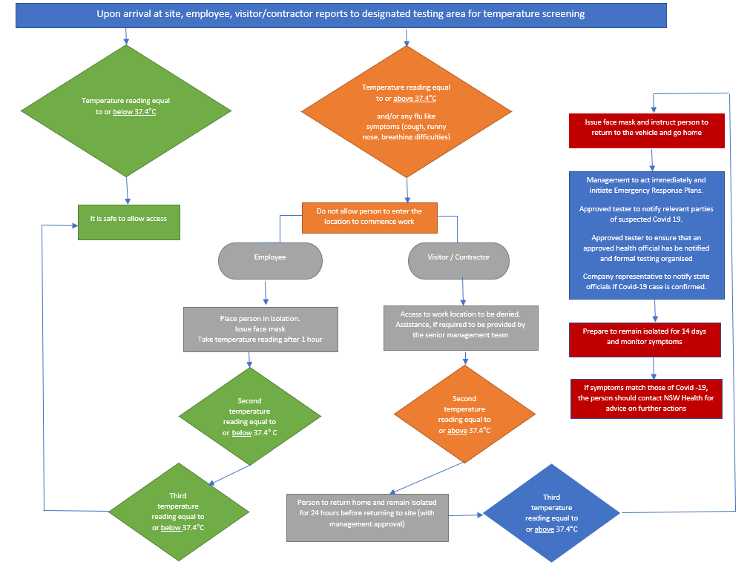
Appendix 1 – Temperature Screening Flowchart
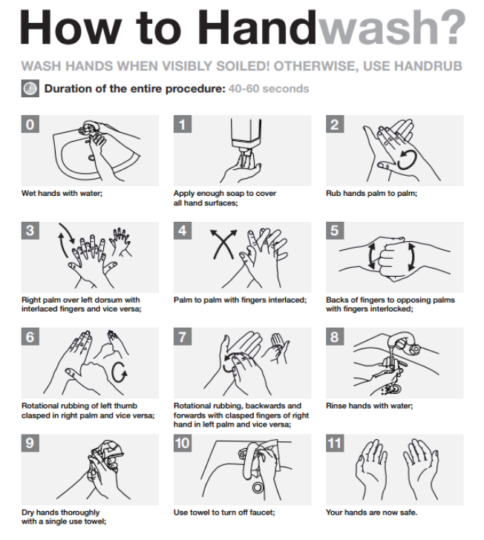
Appendix 2 – Hand Washing Guidelines

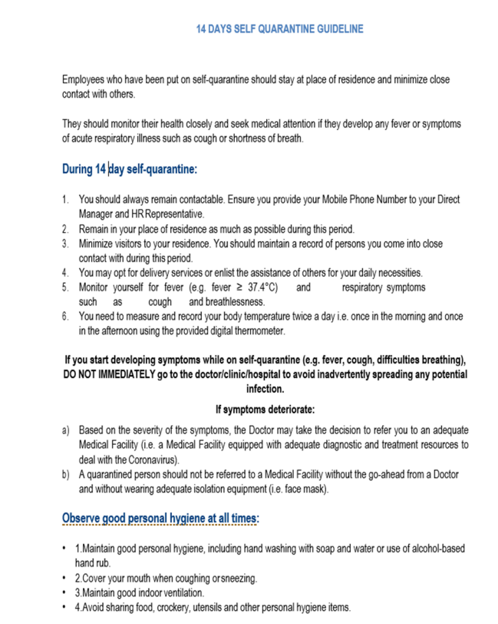
Appendix 3 – Self Quarantine Guideline

Appendix 4 - Temperature Screening Log
Site Name: _____________________________________
Completed by: __________________________________
Use this log when temperatures are 37.4°C or above
Date | Name of Personnel | Contractor /Visitor | Temperature Readings |  | Action Taken |  |  | Conducted by
 |  | Y / N / NA | FLIR Camera | Ear Thermometer | Access Granted | Access Denied | Management Informed

