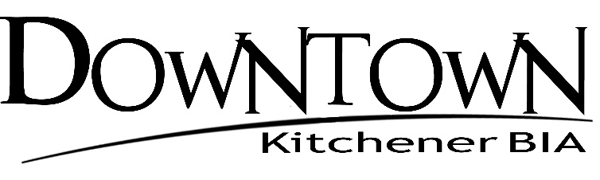

Board of Director Meetings
2022 Schedule

Date | Time | Location
January 26, 2022 | 8:30 a.m. – 10:30 a.m. | Zoom
February 23, 2022 | 8:30 a.m. – 10:30 a.m. | Zoom
March 31, 2022 | 8:30 a.m. – 10:30 a.m. | Zoom
April 27, 2022 | 8:30 a.m. – 10:30 a.m. | Zoom
May 25, 2022 | 8:30 a.m. – 10:30 a.m. | Zoom
June 22, 2022 | 8:30 a.m. – 10:30 a.m. | Zoom
August 10, 2022 | 8:30 a.m. – 10:30 a.m. | McCabe’s Irish Pub, Kitchener
September 28, 2022 | 8:30 a.m. – 10:30 a.m. | McCabe’s Irish Pub, Kitchener
October 26, 2022 | 8:30 a.m. – 10:30 a.m. | McCabe’s Irish Pub, Kitchener
November 23, 2022 | 8:30 a.m. – 10:30 a.m. | McCabe’s Irish Pub, Kitchener
December 7, 2022 | 8:30 a.m. – 10:30 a.m. | McCabe’s Irish Pub, Kitchener

