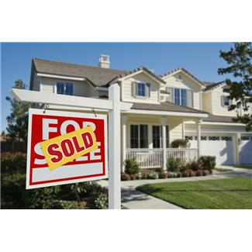

# Our Community’s Flood Hazard

***What Prospective Property Owners Should Know***

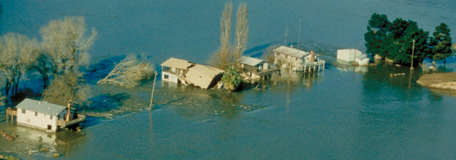\

01/05/11

Contact us at:

**[555-543-5432]**

***[www.yourwebsitehere.com]***

**[REAL ESTATE  
COMPANY]**

***[5432 Any Street   
West Townsville, State 54321]***

**[Jane Smith]**

*Ask Before You Buy:*

*Know Your Flood Risk!*

**Our Situation: *[SAMPLE LANGUAGE]***

***In Flood County, flooding and other drainage problems can result after several inches of rain in a short period of time or after several days of continued rain. Over the past 20 years, our community has experienced numerous storms or rainfall events causing flood damage. If you are looking at buying a property, it is a good idea to check out the possible flood hazard before you buy.***

* ***Know Your Local Floodplain Management Regulations***. **[*Flood County]*** regulates construction and development in identified floodplains to ensure buildings are protected from flood damage. Filling and similar projects are prohibited in certain areas. Houses that are considered substantially damaged (i.e., more than 50% of its market value) by fire, flood or other causes must be elevated to above the flood level when they are repaired.
* ***Flood Protection.*** A building can be protected from most flood hazards, sometimes at relatively low cost. New building and additions can be elevated above the flood levels. Existing buildings can be protected from shallow floodwaters with some simple retrofitting measures. Contact our building department for more detailed information.

# For Your Protection

***Know Your Flood Risk***

# Other Resources

***What You Should Know***

# Flood Insurance Rate Maps

***http:/msc.fema.gov***

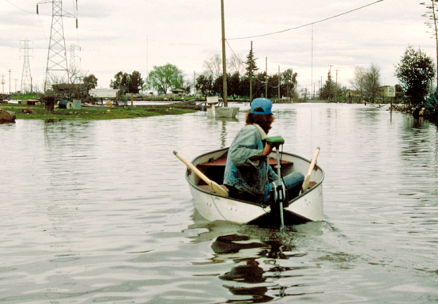air photo based flood zone map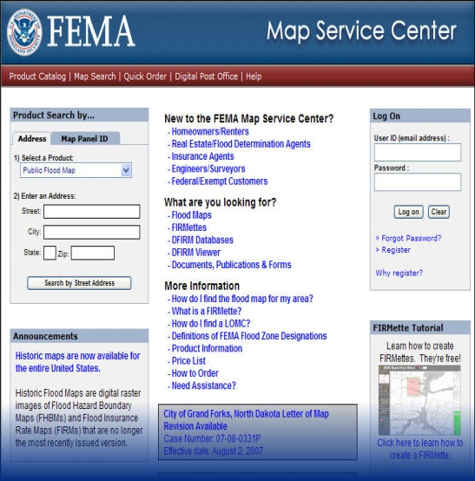

* You can check on Special Flood Hazard Areas in your neighborhood by looking at the Flood Insurance Rate Maps at FEMA’s Map Service Center: <http://msc.fema.gov>.
* Most city and county government building or planning departments have the FEMA maps, too. Call them and ask if there are any special land use, building, or floodplain management regulations that apply.
* To view additional flood hazard maps developed by the California Department of Water Resources visit: [http://www.water.ca.gov/  
  floodmgmt/lrafmo/fmb/maptypes.cf](http://www.water.ca.gov/floodmgmt/lrafmo/fmb/maptypes.cf).
* For information on all mapped hazards in your neighborhood visit the California Emergency Management Agency’s (Cal EMA) website and enter your property address: <http://www.myhazards.gov>.
* Looking for a new home? Have you checked out whether it has ever flooded or had a drainage problem? Even a shallow flood that is only a few inches deep in your house could cause thousands of dollars in damage, and loss of irreplaceable keepsakes. Deeper floods mean you will have to relocate until repairs are made.
* The Federal Emergency Management Agency (FEMA) has prepared Flood Insurance Rate Maps (FIRMs) that show Special Flood Hazard Areas (SFHAs). If your property is located in a Special Flood Hazard Area, it is five times more likely to experience a flood versus a fire, so flood insurance is advisable.
* If you need a mortgage that is regulated or insured by the Federal government (e.g., VA, FDIC, Farm Credit, OCC, FHA/HUD, OTS, SBA, NCUA), you will have to buy a flood insurance policy if the building is located in a Special Flood Hazard Area.
* California state law requires sellers or their agents to disclose knowledge of any natural hazards on their property, including flooding (CA Civil Codes § 1103 and 1102.6), so start your research by asking the seller and the agent. They may honestly say they don’t know of any flooding, but that does not mean it is not located in a Special Flood Hazard Area.

**D Zones = Undetermined**