Continue the Rhythm

10 min 1 participant

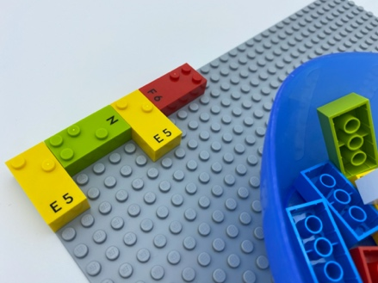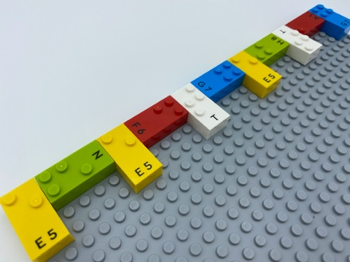

Let’s play
- Feel the bricks on the base plate. They are arranged in a rhythm.
- Pick bricks to continue the rhythm.

How to prepare
- 1 base plate
- 12 bricks or more
- 1 bowl
Start a simple left to right pattern on the top left of the base plate with 4 bricks: i.e. one vertical brick - one horizontal - another vertical - one horizontal…
Place the rest of the bricks in the bowl.

Facilitation tips
- Suggest setting the rhythm to music: e.g. a short sound for a vertical brick, a long sound for a horizontal one. Move your finger along the pattern and sing its song.
- Change perspective: ask the child to start a new rhythm for you to complete.

Possible variations
- Change the number of bricks.
- Vary the pattern: space between the bricks; 2 bricks next to each other, 1 separate, 2 next to each other…; a mini tower of 2 bricks, 1 alone, a mini tower of 2…

Children will develop these holistic skills
- COGNITIVE - Build a suite identical to a proposed ordered suite
- EMOTIONAL - Know the purpose of the activity
- CREATIVE - Reproduce and interpret a melodic and rhythmic model
- PHYSICAL - Develop bilateral hand use
- SOCIAL - Plan and carry out routine or non-routine activities requiring multiple steps

Did you know
- Emotional, social, creative and physical skills are of equal value to cognitive skills; they must feature prominently in assessment.
- This activity assists in development of the 5 holistic skills: cognitive, creative, emotional, physical and social.

