Number Wall

10 min 2 participants

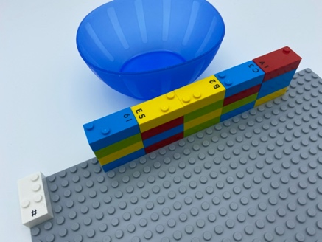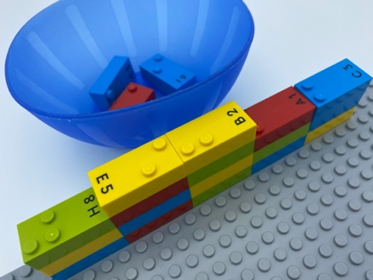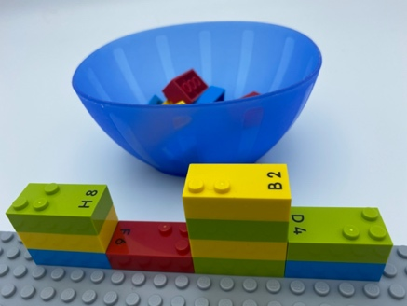

Let’s play
Both players, taking turn
- Find an odd number brick on top of the wall.
- Remove it and place it in the bowl.
- Continue play until no odd number bricks can be removed.

How to prepare
- 1 base plate
- 20 number bricks
- 1 number sign brick
- 1 bowl
Build a wall with all the number bricks.
Number sign is located on the top left corner of the base plate to indicate the bricks represent numbers.

Facilitation tips
- Ask children to help you find new selection ideas to play the game (only bricks with 2 studs, only even numbers, multiple of 2, multiple of 3…).
- Encourage children to make constructions with their selected bricks: e.g. house/car of even numbers.

Possible variations
- Increase/decrease the numbers of players.
- Add other bricks to the wall, for example letters or symbols.
- Let the children build the wall before starting.

Children will develop these holistic skills
- COGNITIVE - Calculate with numbers: recognize odd and even numbers
- SOCIAL - Understand, respect and enforce rules and regulations
- CREATIVE - Identify various leisure activities to be done alone or with other people
- EMOTIONAL - Follow courteous behavior: interrupt a speaker in a socially acceptable manner when necessary

Did you know
- Children learn more when they are actively engaged as opposed to passive, when activities are meaningful to them and when they learn together with others.

