Memorizing Letters

20 min 2 participants

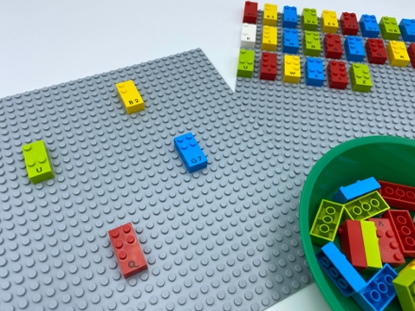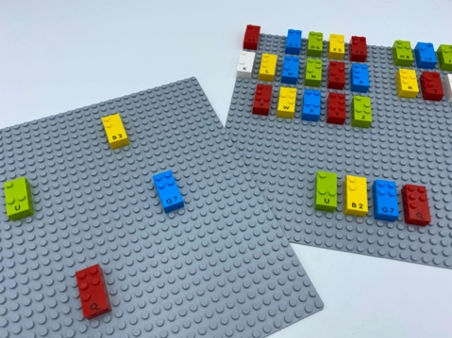

Let’s play
Player 1:
- Pick 4 letters from the bowl, place them randomly on the empty base plate and pass it to Player 2.
Player 2:
- Read the 4 letters.
- Remember as many letters as possible and return the plate to Player 1.
- Pick all the letters from the alphabetical base plate that you remembered and move them to the bottom.
Both players
- Compare and discuss the letters.

How to prepare
- 2 base plates
- 2 identical sets of letter bricks, from “A” to “Z”
- 1 bowl
Arrange a set of letters in alphabetical order on one of the base plates.
Place the rest of the bricks in the bowl.

Facilitation tips
- Ask “Compare strategy for remembering and finding the bricks”.
- Ask them “How can we make this activity easier/harder/for more players?”.

Possible variations
- Start with fewer alphabet bricks, from “A” to “J”.
- Change the number of letters to be remembered.
- Add a timer: more or less time to read / to find the correct letters.

Children will develop these holistic skills
- PHYSICAL - Discover the “spatial organization of a page”
- SOCIAL - Work together to facilitate individual learning
- COGNITIVE - Explore a braille page through touch: search with both hands over a page with a logical tactile strategy – top to bottom and side to side
- PHYSICAL - Organize: find objects; sort or categorize by placement, function, attribute
- EMOTIONAL - Identify consequences of behaviors in social interactions

Did you know
- Engaged learners demonstrate motivation and commitment towards their learning, often extending themselves beyond set goals and expectations.
- Iterative: when children have the opportunity to explore and investigate new concepts, they learn through the process of trial and error.

