Find the Crazy Duck

10 min 1 participant

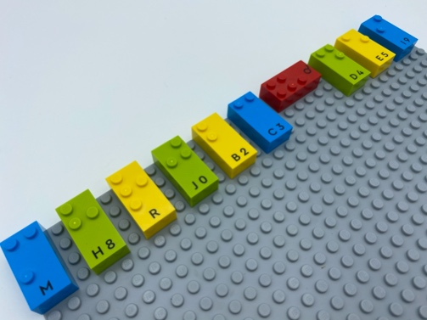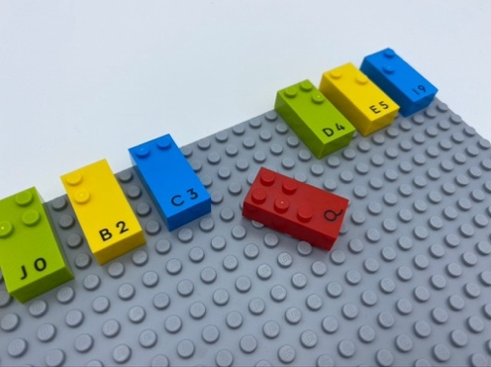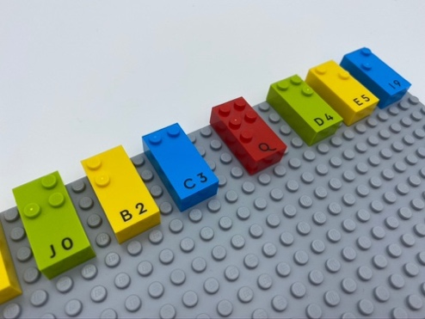

Let’s play
- Explore the base plate.
- Find the crazy duck who is out of order.
- Pick the crazy duck and replace it correctly in the row.

How to prepare
- 1 base plate
- 10 bricks or more
Make a line of spaced bricks in reading position, across the top of the base plate.
Place one of those bricks in the opposite direction.

Facilitation tips
- Ask “Why do you think the duck was out of line?”.
- Ask “Make a row with one crazy duck for me”.

Possible variations
- Change bricks orientation (allow enough space to replace ducks).
- Create columns.
- Change number of crazy ducks.
- Change number of rows.

Children will develop these holistic skills
- PHYSICAL - Name spatial relationships
Compare - discover similarities, differences and preferences: sort and match
- CREATIVE - Reproduce, assemble, organize, link graphic patterns and then create new ones
- SOCIAL - Follow rules in games led by adult, take turns

Did you know
- Because child development is beautifully complex, we take a holistic view and highlight the importance of children’s physical, social, cognitive, creative and emotional skills and how these complements and interact with one another.

