Guess the First Letter

20 min 2 participants

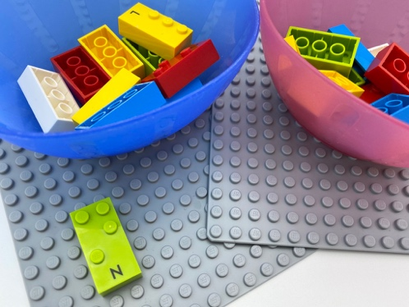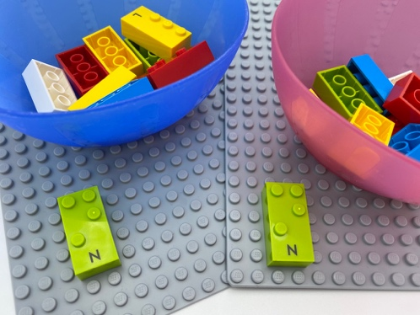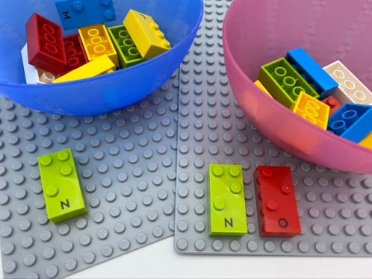

Let’s play
Player 1
- Pick a letter.
- Read the letter silently.
- Think of a word starting with this letter.
- Say the word aloud.
Player 2
- Guess the letter.
- Find it in the bowl.
Both players
- Compare your bricks to see if they are the same. If they are different, decide what the letter should be (a child might have the sound correct, but the corresponding brick) and find it.

How to prepare
- 2 identical sets of 10 bricks, each brick in the set has a different letter
- 2 bowls
Each player has their own bowl with the same set of letters.

Facilitation tips
- Ask “How much do you think you are right?”.

Possible variations
- Select letters easier to read by touch or have been previously learned.
- Increase or decrease the number of letters.
- Ask the child to pick 2 letters and make words that include those letters.

Children will develop these holistic skills
- COGNITIVE - Discover the function of the written word: request proofreading
- Identify the braille characters: letters
- EMOTIONAL - Be encouraged to link what is read to own experience
- SOCIAL - Plan and carry out routine or non-routine activities requiring multiple steps

Did you know
- Children tend to discuss detailed features during playful building activities with peers and demonstrate higher level of self-regulation during small-group activities and play.

