Cheat

10 min 2 participants

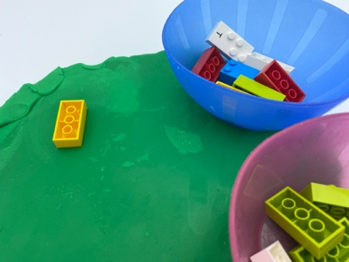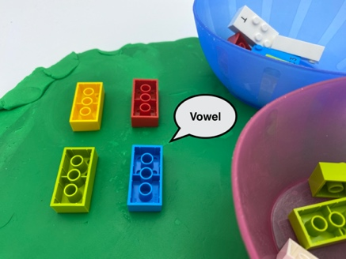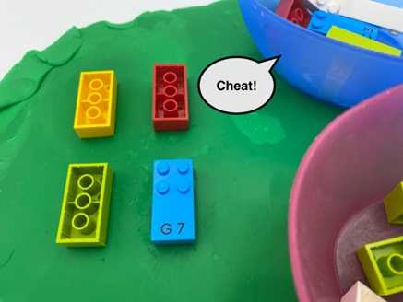

Let’s play
Player 1
- Stick a brick upside down into the dough declaring it is a “consonant” or “vowel”.
Player 2
- If you believe player 1 is telling the truth, place one of your bricks into the dough and declare “consonant” or “vowel”.
- If you don’t believe player 1, say “cheat” and remove the brick for examination together.
Both players
- If either player is caught cheating or wrongly accuses the other of cheating, that player must take all the bricks that had been played.
- The first to play all of their bricks, is the winner.

How to prepare
- 16 bricks: mix of vowels and consonants and 2 other signs (capital letter and number sign)
- Play-dough or other modeling clay
- 2 bowls
Randomly and equally distribute the 16 bricks and place them in the bowls.
Spread out a large flat piece of playdough to maintain the bricks upside down during the activity.

Facilitation tips
- The bricks are pressed into modeling clay to keep them in the same position during the activity.
- Encourage taking turns which can be difficult for young children.
- Ask “What is your strategy for winning?”.

Possible variations
- Increase the number of players by distributing more bricks.
- Change the number and/or types of bricks.
- Change the number of unusual bricks (punctuation signs).

Children will develop these holistic skills
- COGNITIVE - Discover the function of the written word: use the vocabulary to name the units of the language: word, letter, syllable, sound, sentence, text, line, capital letter
- SOCIAL - Read aloud
- PHYSICAL – Develop tactile tracking skills: locate, read an identified number of word or letter on a line
- EMOTIONAL - Understand rules

Did you know
- Adults have important roles to help young children learning games, including teaching rules and taking turns.

